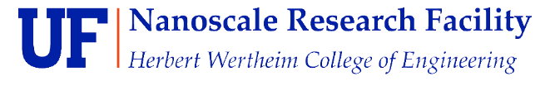
NRF PDMS Processing Tools

Standard Operating Procedure
Rev. 2026-01

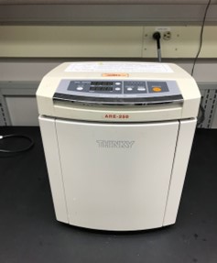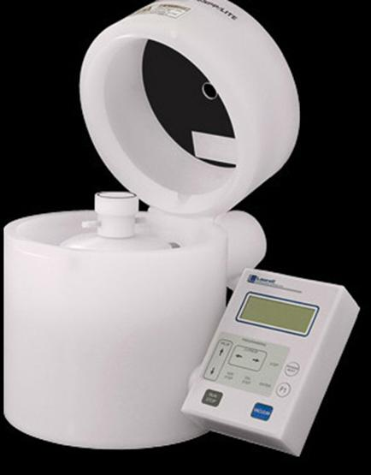

Contents
PDMS Processing Tools available at the NRF 2
Fabrication of Master Molds 2
Mixing and Preparing the PDMS 3
PDMS Master Surface Preparation for Release 4
Silicon Master 4
3D Printed ABS or Digital Materials Master 7
Pouring, Degassing, and Curing PDMS 7
Spin Coating PDMS 8
PDMS Surface Activation for Bonding 9
UV/Ozone Exposure and Heat – PDMS to PDMS, Si, SiO2 9

PDMS Processing Tools available at the NRF

PDMS is only allowed inside NRF room 235. All processing will take place there. PDMS processing is not allowed inside the cleanroom. Training for the equipment in this room will be provided by NRF Staff prior to use. Some of the PDMS processing equipment (see list below) will be on the Tumi System and will require Tumi access and login to use.
Room 235 Equipment (for PDMS Processing)
- Plastic Vials for mixing
- Weighing balance
- Thinky Mixer (TUMI-login “PDMS Process Tools”)
- Clean hood
- Laurell Spin coater (TUMI-RSC Staff Login Only)
- Blue M Curing oven
- Jeol Desiccator for Vacuum degassing TUMI-login “PDMS Process Tools”)
- 3D printer for producing masters
- Ozone Exposure tool
- Exhausted Lab Hood
- Vacuum desiccator inside hood

Clean Room Equipment (for Master Processing)

- Heidelberg Laser Writer
- Suss MA6, EVG 620 mask aligners
- Oxford and STS DRIE deep silicon etchers

Fabrication of Master Molds

Photomask Fabrication
Information on how to request training to produce your own photomask or have NRF Staff fabricate the mask can be found at https://rsc.aux.eng.ufl.edu/ccb/resource.asp?id=63

Patterning 4” Wafer Masters
- 4” wafers of various substrates may be used but Si is most common because of our ability to deep etch Si at the NRF. The substrate will be patterned with photoresist and then etched.
- SU8 Epoxy may also be used to create the Master on a flat substrate such as Silicon or glass using a photomask.

3D Printing Molds
Use the Objet 3D printer to create molds in digital and abs materials. The minimum resolution is 50um. https://rsc.aux.eng.ufl.edu/ccb/resource.asp?id=87

Mixing and Preparing the PDMS

  - Login TUMI-login “PDMS Process Tools”. You must log in to use the tool
  - Open the lid of the Thinky Mixer and remove the mixing vial insert block show below.
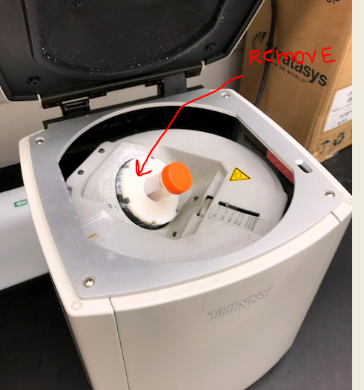
  - Insert a clean vial (supplied by the NRF) and place on top of the digital scale and insert new mixing vial, remove the orange top.
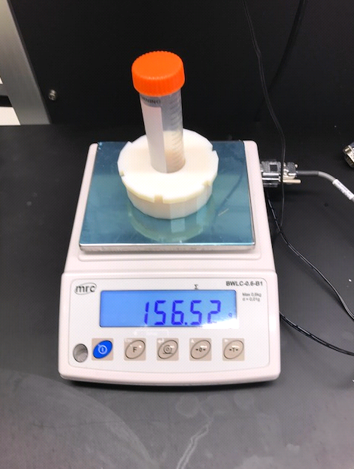
  - Power on the scale and wait until it’s ready. Then, place the Thinky holder bloc with vial (no lid).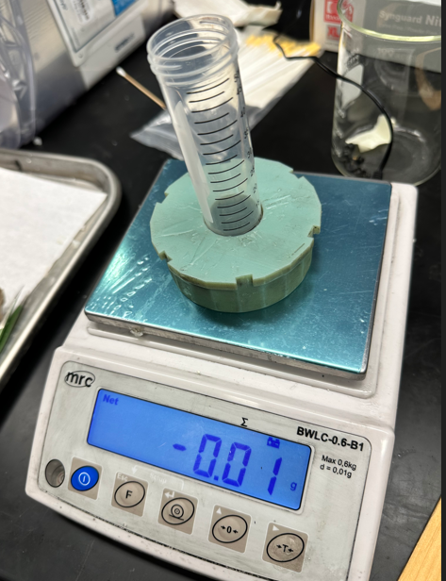
  - Tare the scale and pour PDMS in the tube. 10mg is usually enough for most jobs and is enough to easily cover two 4” wafers. Add 10% by weight of PDMS activating agent.
  - Remove everything from scale, zero the scale and weigh everything together. Record the total weight and subtract 30mg. Set the Thinky Balance dial shown below to this weight.
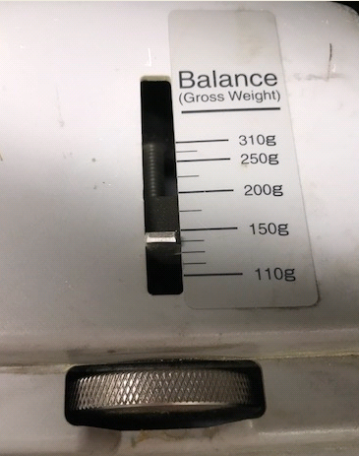
  - Place the mixing vial insert block and vial inside the Thinky.
  - Close the Thinky Lid and press “Start”. The PDMS will mix for 5 mins and degas for 5 mins.
  - Remove the Thinky vial holder block and vial and place inside the Joel Desiccator.
  - REMOVE THE LID OF THE VIAL. IF YOU FORGET, IT WILL EXPLODE INSIDE THE CHAMBER WHEN VACUUM IS APPLIED.
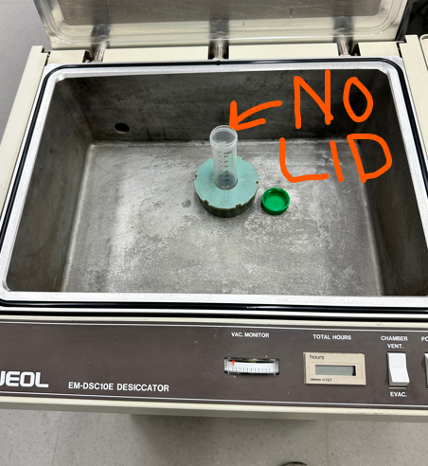
  - IF A MESS DOES OCCUR, NOTIFY STAFF IMMEDIATELY.
  - Close the lid. And check that the vent valve is pointed horizontal as shown.
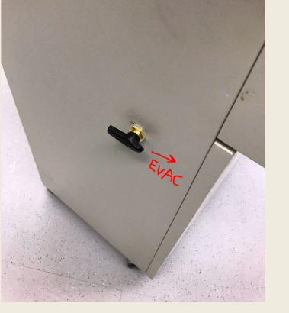
  - Turn on the power and toggle the switch “Evac” position. 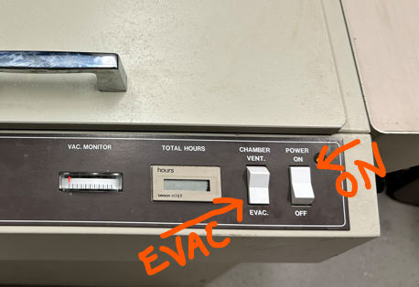
  - Leave PDMS in chamber for 20 minutes to remove microbubbles.
  - When done, press the toggle switch to vent position and turn the vent valve on the left side of unit to point UP (vent). You should hear air rushing in through the valve. The PDMS is ready for use.
  - Press the power toggle switch to OFF position.
  - Logout of TUMI-login “PDMS Process Tools”.

PDMS Master Surface Preparation for Release
Silicon surfaces must hydrophobic to allow the PDMS separation after curing. A sacrificial layer may also be used. This can be done by one of the following procedures.

Silicon Master

- C4F8 Treatment. Running a short C4F8 plasma in the DRIE
Full Procedure:
      - DRIE Si Etch
      - PRS3000 PR strip
      - Quick O2 Plasma in DRIE tool
      - DRIE “C4F8” recipe for 30 seconds
      - This will create a thin PTFE surface for easy PDMS release.

- Photoresist as a lift off layer
      - Coat the master with photoresist prior to curing the PDMS. Oven Softbake the PR.
      - After the PDMS is poured and cured, soak in acetone to dissolve the PR.
      - This technique is especially useful for PDMS films thinner than 200um that have been spun on.

3D Printed ABS or Digital Materials Master

      - 3D printed materials must be oven cured before exposure to PDMS. If not, PDMS at the ABS/PDMS interface will not cure and remain sticky. Oven cure the 3D printed piece for at least 4 hours @60°C followed by UV flood exposure. The UV exposure can be done for a few minutes in the Suss MA6 in flood exposure mode or left in sunlight for a few hours. Rinse with IPA, DI water and oven dry 5-10 mins as a final step.

Pouring, Degassing, and Curing PDMS

      - PDMS is always very messy and difficult to remove, cured and uncured. Do not use glass beakers unless there is no choice. Use aluminum foil fashioned as a beaker or bowl to contain the mess. If you are casting on a silicon wafer master, surface tension should be enough to hold the PDMS on top of the wafer.
      - Once the PDMS is poured, you may want to remove any trapped bubbles at the interface. This may be done in the Joel Desiccator.
      - For Sylgard 184, with PDMS thicknesses <2mm, Cure the PDMS at 100°C for 30 mins, or 125°C for 20 mins. For thicker films, cure for 10-20 hours at 60°C. You can also room temperature cure for >48 hours. Sylgard 182 will always require oven cure.
      - Higher temperature cures result in stiffer film. Shown below…..Sylgard184 tensile strength as a function of curing temperature base/curing agent ratio of 10:1).

      - Tensile strength can be increased by increasing the amount of curing agent.

Spin Coating PDMS

      - The Laurell spinner in room 235 will be used for PDMS. It is located inside the fume hood.
      - It may only be used from 8am-5pm, Mon-Fri..
      - RSC Staff will need to sign you into and out of the spinner.
      - Open the compressed air valve counter-clockwise on the front of the hood.
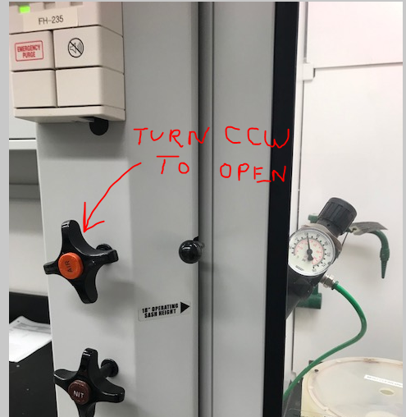
      - Refer to the SOP for operation at “Litho Process, Laurell E-Beam & Litho Bay & Hot Plate/Oven SOP” on the NRF web site for operating instructions.
      - PDMS thickness is determined by spin speed and spin duration since it outgasses and cures slowly at room temperature.
      - When done, contact RSC Staff as soon as you are done for help with the bowl cleanup.

PDMS Surface Activation for Bonding

There is a lot of good, conflicting and wrong information regarding PDMS bonding out in the world. We will only include methods that have proven effective for us at the NRF.

UV/Ozone Exposure and Heat – PDMS to PDMS, Si, SiO2

      - Turn on the Blue M oven and set temperature for 110°C. Continue when at (or close to) temperature. To set the temperature, press the up/down buttons and press the return arrow button.
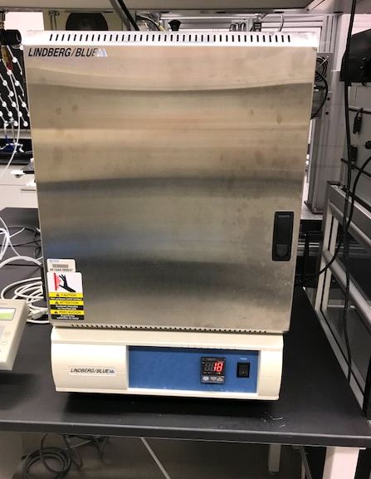
      - Set the timer on the Ozone tool for 30 minutes. Turn on the Ozone tool using the power button on the lower right and verify through the site window that the lamp is on. Wait 10 minutes for the lamp to warm up.
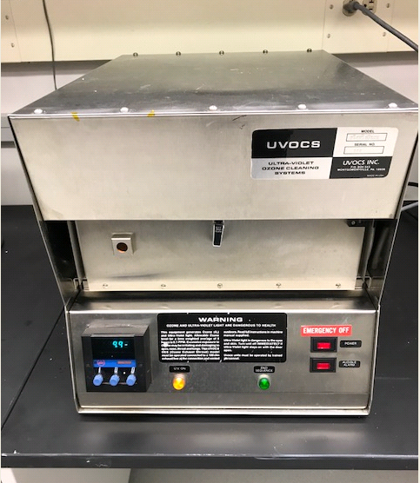
      - Open the door, slide out the tray and load sample. Shut door. Note: the timer must be on to enable lamp.
      - Expose sample for 5 minutes. Align and stick samples to be bonded together. If you need to align/move the surfaces after they have come into contact with each other, methanol may be used. Immediately place inside the Blue M oven for 10 minutes @110°C.

