
Unaxis 790 PECVD

Standard Operating Procedure
Rev. 2026-01
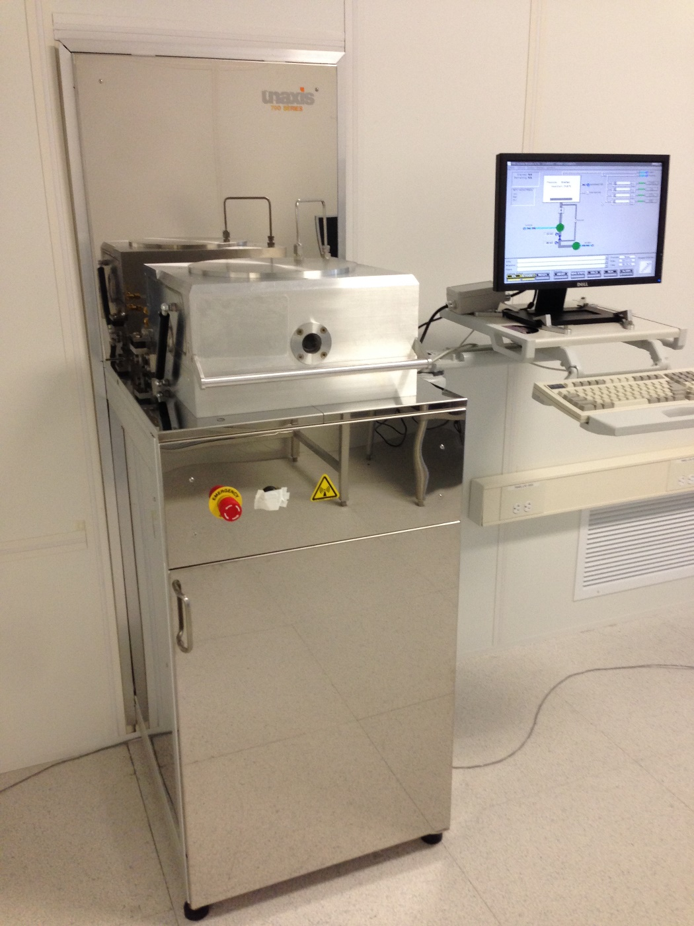
Contents
Description 3
Safety 3
Restrictions 4
Pre-Operation 4
Operation 4

Description
Unaxis 790 PECVD - Deposition Capabilities: SiO2, SiN, SiC. The system is equipped with one 13.56 MHz 500 Watt RF power supply. Process Gases Available: 5%SiH4/He, N2O, NH3, N2, He, SF6, CH4. The system is capable of processing samples up to 8” diameter.

Safety
- PECVD Byproducts – PECVD process may produce hazardous etch by products. Chamber Purge must always be done for 2 mins prior to opening the chamber. All recipes must be written to include a 2 minute post process purge.
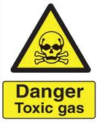
- High Voltage - High Voltage Radio Frequency is used throughout the system. System maintenance may only be performed by Unaxis or NRF Staff. Do not remove any tool covers or defeat any interlock on this system.
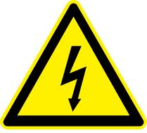
- Moving Components - The User must exert caution when opening and closing the chamber lid. Your fingers after being violently detached by the chamber lid will prevent the system from reaching base pressure.

- Hot Surfaces – The chamber is 300°C and will burn you badly if touched. ONLY metal tweezers may be used.
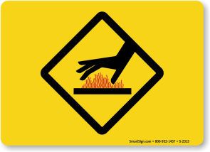

Restrictions
  - No Polymers/photoresists are allowed in the system. All samples must be stable to 400°C .
  - Only metal tweezers are allowed for transferring samples.

Pre-Operation
  - Tool Reservations may be made via the NRF web site.

Operation

  - Before logging into the Tumi, check that a “Clean” chamber process is not being run. 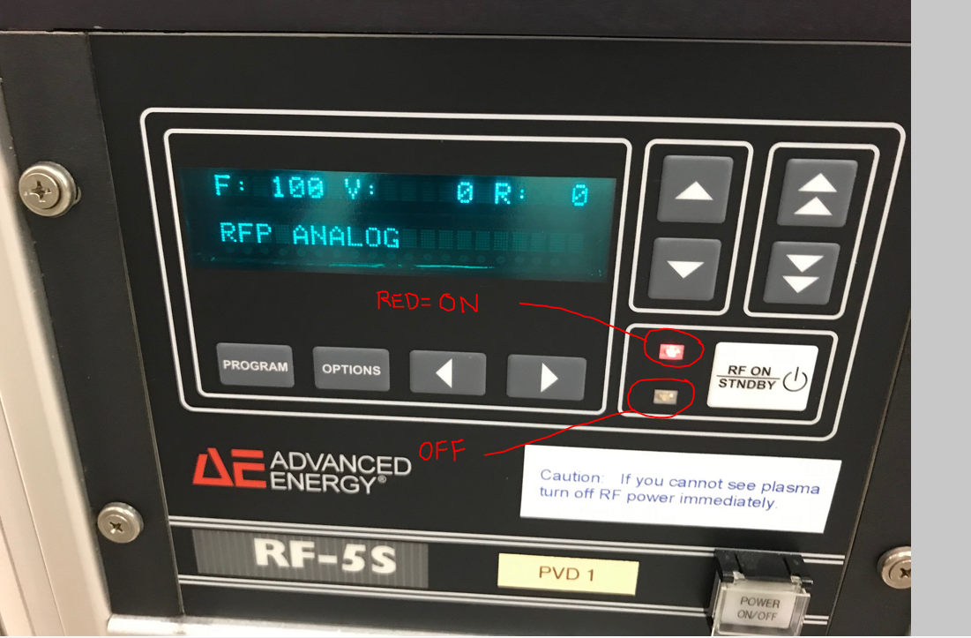
Open the front door to the tool and check if the RED light on the RF-S5 power supply is ON. If on, wait until the clean process is complete before logging on to the tool. Cleans usually last no more than 30 minutes.
  - Log back into the Tumi and continue.
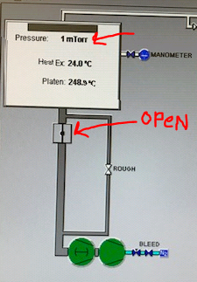

  - Click “Process/Load” and select the recipe for the film you wish to deposit and click enter. The standard user 350°C recipe choices are: _sio2 (silicon dioxide), _sin (silicon nitride).
  - If you load a recipe that requires a platen temperature change, you will need to wait for the platen to make it to that temperature. If you are lowering the temperature it cools faster if you vent the chamber and open the lid while the temperature drops to set point. When the setpoint temp is achieved, log out of the machine with Tumi comment “no charge for temperature change to (recipe name) recipe”. Then, log back into the machine for your process runs.
  - To vent the chamber to atmosphere, click Utilities/Vent.
  - Wait for the chamber to vent. The main chamber box will turn blue and “vent complete” will be displayed in the info box. It will take 1-2 mins.
  - Grasp the chamber lift handle with both hands and gently raise the chamber lid all the way up. It should feel very secure in the up position. If not, stop procedure and contact Staff immediately.
  - If you see flaking when you open the chamber, contact NRF staff.
  - Be very careful, the chamber lid is very heavy and could easily break your hand if it falls.
  - VERY HOT - The chamber is at 350°C and will burn your gloves and skin off if touched.

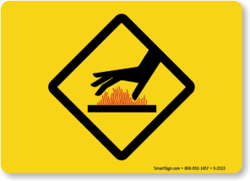
  - If the chamber is pumped down, vent it by clicking “Utilities/Vent”. Open the lid after it displays “atmosphere” on screen.
  - Using METAL Tweezers Only, Carefully Place your sample on the center of the cathode and carefully lower the lid.
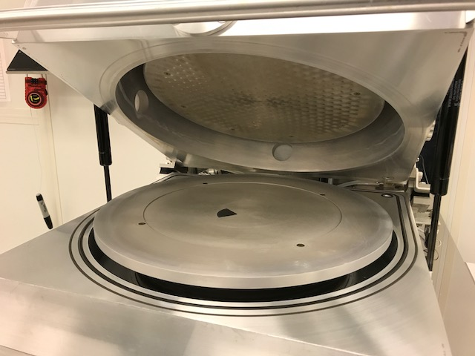
  - Click “Utilities”/”Pump Chamber” and using one hand, push down on the chamber handle. Continue to push down until the “Roughing” valve opens. It will take several minutes to pump down all the way. Do not continue until the pressure is <10 mTorr.
  - Click “Run”. The Variable Process Time Setup box will appear. The deposition rates are kept in a file on the NRF web site under “Docs” the tool page. Download the document “Unaxis 790 Film Properties”. Calculate time needed i.e. rate x time=thickness in nanometers. Enter the calculated process time in mins:secs and press “Enter”.
  - The recipe will run. Verify plasma is present during the deposition step #2. It may be difficult to see through the window.
  - After the process is complete, click “Utilities/Vent Chamber”.
  - The screen will turn blue when done venting and the chamber is at atmosphere.
  - Carefully open the lid and remove sample with metal tweezers. Take care to not scratch the anode surface when removing your sample.
  - Close the lid and click “Utilities/Pump Chamber”. Hold the lid down firmly when it starts pumping down.
  - Load the “clean” recipe and click “Run”. Enter 15 minutes for both high and low pressure recipes and start the recipe.
  - Log off the Tumi system and add comments to the logoff notes indication the each recipe that was run and the total thickness deposited for each recipe.

