

STS PECVD

Standard Operating Procedure Rev. 2026-01

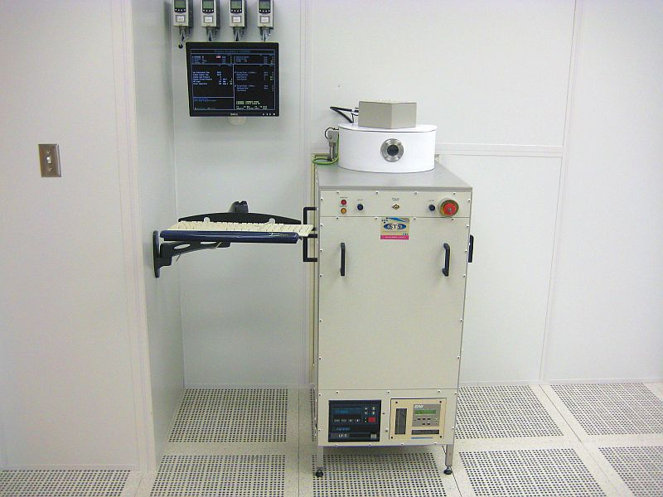

  - Application

The PECVD STS tool is used to deposit silicon nitride, silicon dioxide and amorphous Si films on substrates up to 8 inches in diameter. The system is equipped with 13.56 MHz and 187.5 kHz frequencies and is capable of mixed frequency recipes. The temperature of the system is normally kept at 300 °C.
  - NRF Contact

David Hays
Table of Contents
1. Safety information 3
2. Prerequisites for use 3
3. Sample Restrictions 4
4. Start Up 4
5. Tool Operation 4
5.1. Loading the sample & starting process 4
5.2. Selecting And Running A Recipe 5
6. Tool Operation 6
6.1. Sample Loading 6
6.2. Loading And Editing Recipes 8
6.3. Running a recipe 10
6.4. Unloading Sample 11
7. Ending The Session 11

- Safety information
- High Voltage Radio Frequency is used throughout the system. Do not remove any tool covers or defeat any interlock on this system.
- Hot surfaces - The chamber is 300° C and should never be touched.
- Hazardous Gases - This PECVD system uses Silane, 5% Anhydrous Ammonia/N2, Nitrous Oxide, Carbon Tetraflouride (Halocarbon 14) 80%/O2.
- Moving Components – Use caution when opening and closing the chamber lid.
- Prerequisites for use
- User of the RSC facilities.
- Up-to-date hazardous waste training.
- Training by staff.
- User will be responsible for lost or damaged equipment due to negligence. Negligence means not following the SOP, not asking staff for assistance, intentionally damaging items, etc.

- Sample Restrictions
    - Only materials that are stable at 300°C are allowed in the system.
    - No photoresist, polymers, etc.
    - Use only clean METAL tweezers.
- Start Up
    - Log in to TUMI
- Tool Operation
  - Loading A Sample
    - Use the arrow keys on the keyboard to Choose "vent" (F3) from the menu
    - Choose "open valve" (F1)
    - Watch the “Chamber Process Pressure” and make sure it goes to 2044. This will take a few seconds. If it reaches 2044 then proceed to step 1.3
    - If the pressure did not reach 2044 then you need to retry. Simply choose “close lid” (F1). The blue screen will appear and then select any standard process.
    - Wait for the purge to finish and you will see the option to vent again. Press the “vent” (F3) button again and it should vent properly this time.

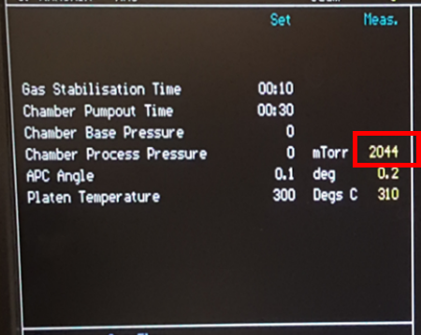

    - The chamber is vented when the 2 push button lid lights on the front of the system are illuminated.
    - Depress the 2 blue push buttons in unison and hold in until the chamber lid is completely up.
    - If the chamber is flaking, notify NRF Staff.
    - Use stainless steel tweezers to place sample(s). If you have multiple small samples it’s best to place them on top of a clean dummy wafer. WARNING: TAKE GREAT CARE NOT TO TOUCH ANYWHERE INSIDE THE CHAMBER. Gloves and fingers will melt.
    - When ready to close the lid. Depress "close valve" (F1) on the keyboard and depress the 2 blue push buttons in unison and hold until the lid is horizontal (as shown below).
    - Push on the right hand side of the lid gently to the left.

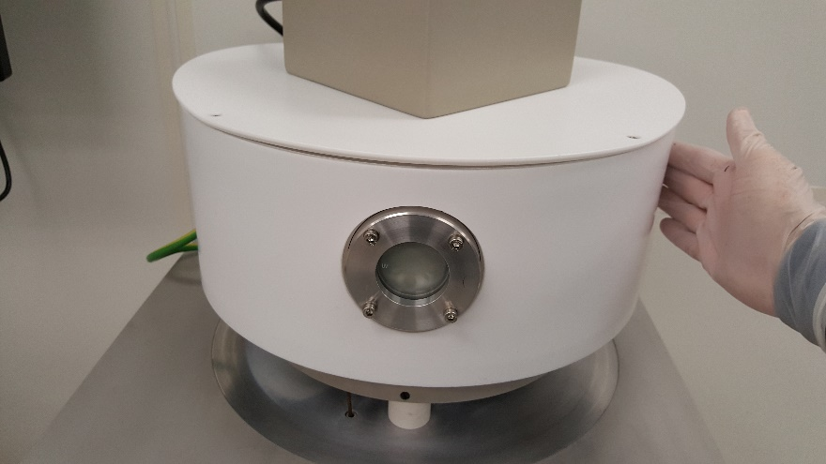

    - Again, push the 2 blue buttons until the lid is completely down and the blue screen appears.
  - Selecting And Running A Recipe
    - You are then prompted to select a recipe. Use the following rules for recipe selection.
The recipe naming convention is as follows:
1st character: L=low freq, H=high freq, M=multi freq
2nd character: O=SiO2, N=SiN
Remaining characters=thickness in Angstroms
EXAMPLE: 7500A of low frequency SiO2 would be LO7500A
    - If you need a thickness not provided, you may run more than one recipe on the same sample or contact NRF Staff.
    - Use the arrow keys to move to your recipe and press enter.
    - The chamber will automatically pump down. It starts with a slow pump down and will give an error “pump down time exceeded”. Ignore the error.
    - When pump down is complete, F1-F4 prompts will appear. Depress F1 “Deposit” to start your process.
    - To change the recipe without unloading the sample, depress F2 New Process.
  - Unloading A Sample
    - When the process is completed, the program will go through an automated chamber and gas line purge. Be patient, it takes approximately 15 minutes.
    - Then choose (F3) “vent”.
    - When the system is at atmosphere, the 2 blue lights on the front will illuminate. You may then press “Open Lid” and open the lid by depressing the 2 blue light switches until the lid is completely open.
    - Unload your wafer using metal tweezers. Caution the chamber surfaces are at 300 ° C.
    - Choose "Close Lid" (F1) and depress the 2 blue light switches until the lid is completely closed.
    - Reselect your recipe. This will start to pump down the chamber and then the system will be returned to standby mode
- Ending The Session
    - Record the total deposition thickness at the logsheet on the wall. This information is critical for NRF Staff to keep the system properly cleaned and seasoned.
    - Log off TUMI

