

Bruker Optical Profilometer

Standard Operating Procedure Rev. 2026-01

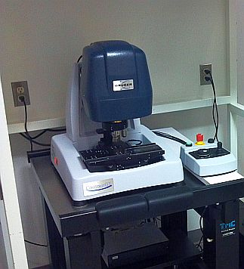

  - Application

The Contour GT-I, is a versatile bench-top optical surface-profiling system that utilizes white light interferometry, and can measure a wide variety of surfaces and samples. The optical profiler can measure surface topography (2D and 3D) with high accuracy in a range from fractions of a nm up to approximately 10mm. It features a fully motorized XY stage as well as tip/tilt of the head. Vertical resolution is rated at 0.1nm in PSI mode and lateral resolution ~500nm.

  - NRF Contact

David Hays

Table of Contents
1. Safety information 3
2. Prerequisites for use 3
3. Launch Software 4
3.1. Start Up 4
4. Sample Handling 5
4.1. Loading A Sample 5
4.2. Focusing Safely 5
4.3. Removing Tilt 6
5. Measuring A Surface 6
5.1. VSI Measurement 6
5.2. PSI Measurements 9
6. Data Analysis 11
7. Unloading or Exchanging Sample 14
8. Saving Data 15
9. Ending The Session 15
10. APPENDIX A 16

- Safety information
- Moving Components – The optical profiler is equipped with a motorized stage that can create pinch points – areas where a person’s fingers can get caught or crushed. Do not move the stage with your hands near it.
- Prerequisites for use
- User of the RSC facilities.
- Up-to-date hazardous waste training.
- Training by staff.
- User will be responsible for lost or damaged equipment due to negligence. Negligence means not following the SOP, not asking staff for assistance, intentionally damaging items, etc.
  - Do not scratch or allow the objectives to touch your sample. Doing so can result in damage to the objectives and cost close to $10,000.
  - Do not attempt to move the objectives by hand. Doing so can result in damage to the gear mechanism and cost close to $5,000.

- Launch Software
  - Start Up
    - Log on TUMI
    - Start the Vision 64 software by double-clicking the icon
      - Main screen and control box shown below
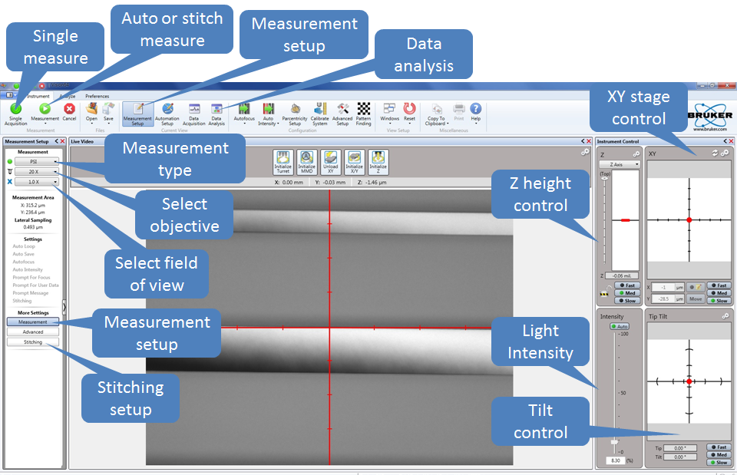

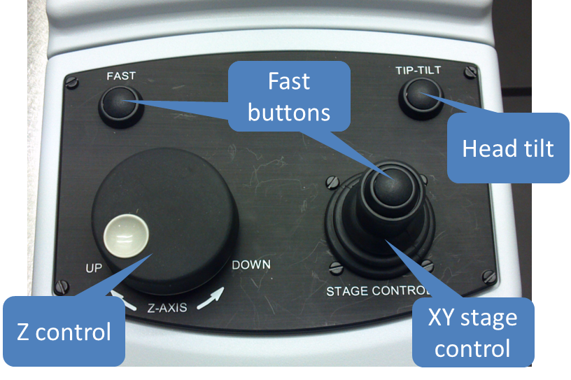
- Sample Handling
  - Loading A Sample
    - Ensure that the objectives are raised high enough to easily clear your sample.
CAUTION  CAUTION

ALWAYS ENSURE THAT OBJECTIVES WILL NOT STRIKE YOUR SAMPLE
Do not scratch or allow the objectives to touch your sample. Doing so can result in damage to the objectives and cost close to $10,000.
    - If the head needs to be raised, this can be accomplished in two ways.

      - Raise the head through the Vision 64 software by left clicking and pulling up on the red indicator in the z-control window. Control the speed by how high you pull the indicator and by the SLOW, MED, FAST buttons.
      - Raise the head through the control box by rotating the z-control knob clockwise. To increase speed, hold the FAST button while rotating.

    - Move the stage all the way to the front of the machine (if not there already) by pressing the Unload XY 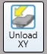 or by using the XY Control joystick on the control box.

    - Place your sample on the stage and move your sample beneath the objective.
      - By using software, left click and drag the red dot in the XY control window
      - By control box, move the XY josytick

  - Focusing Safely
    - Click Auto on the intensity control window.

    - While watching the objective carefully from the side, adjust the focus to lower the head so that the objective is a few millimeters above the surface of the sample.

    - Focus the system by slowly raising the head. As you raise the head watch the intensity and video windows:
      - To see when the sample features start to sharpen or,
      - To see when the intensity value reaches a minimum.

    - When any of the above occurs, you are very close to focus. Slow your adjustment and watch very carefully for fringes. Note that if the sample is highly tilted the fringes may appear over a very narrow band.

    - Continue to raise the head until fringes appear in the Video window. If the intensity starts to increase you have passed through focus and will need to lower the head again.

    - Turn off the Auto intensity

    - Now that the surface is in focus, you can move the XY stage and find your feature of interest. This can be accomplished in 4 ways.
      - Using the joystick on the control box
      - Using the XY Control Window by pulling the red dot in the direction needed
      - Double-clicking in the grid of the XY Control window
      - Double clicking in the Video Window

  - Removing Tilt
    - Your sample will always show some degree of tilt with respect to the measurement head. This tilt will need to be removed to get the correct number of fringes for the measurement type. For VSI, you need 0-15 fringes and for PSI you need <5 fringes.

    - Tilt is usually more visible at higher magnification. If the 20X objective is not selected then go to the drop down menu on the left and select it

    - The head tilt can be removed in two ways.
      - Using the Tilt Control Window, left-click and pull the red dot in a direction normal to the fringes. If fringes get smaller, then pull the opposite direction.
      - Using the control box, press and hold the TILT button while moving the joystick in a direction normal to the fringes. If fringes get smaller, then pull the opposite direction.
- Measuring A Surface
  - VSI Measurement
    - Vertical scanning interferometry (VSI) uses a broadband (normally white) light source. It is effective for measuring objects with rough surfaces, as well as those with adjacent pixel-height differences (steps) greater than 135 nm. Resolution is in the nm range and the maximum height is 10mm.

    - Select VSI/VXI from the pulldown menu in the left window

    - Select your objective (2.5X or 20X) from the pulldown menu
Do not attempt to move the objectives by hand. Doing so can result in damage to the gear mechanism and cost close to $5,000.
    - Select your field of view (0.55X, 1X, 2X) from the pulldown menu. Note that the approximate measurement area for the selected optics combination is automatically updated in the Measurement Area section.

    - Click on the Measurement Setup button 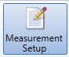and then the “Measurement” button in the left window and you will see the menu below

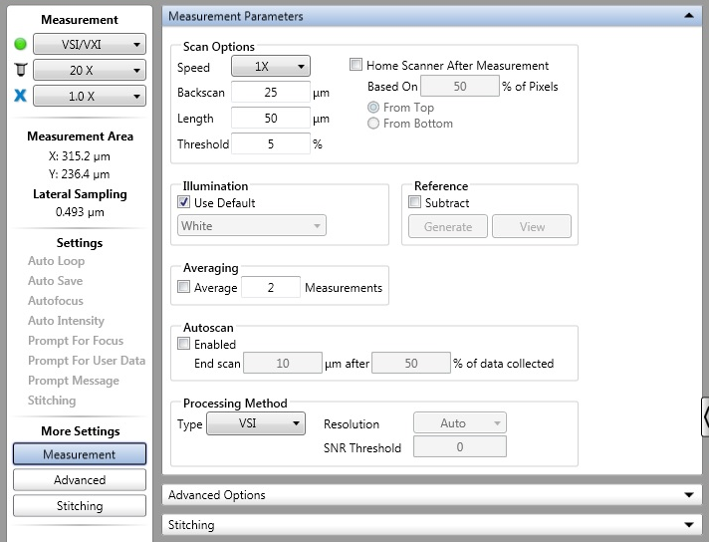

    - Measurement Parameters
      - Speed – Choose the speed that the scan head will move. 1X is fast enough for most applications. Will lose resolution as speed increases… 3X speed is roughly 3X lower resolution, etc.
      - Backscan - The distance that the system moves backward before it begins a scan. Set the backscan large enough to account for the greatest possible variation in feature height
      - Length - Enter the vertical length that the system will scan during a measurement. To determine the appropriate length, estimate the peak-to-valley height of the step/surface that you are measuring, and then set the length 10% to 20% higher.
      - Threshold - Enter a percentage value to determine the acceptable signal-to-noise level for which a given pixel is considered valid. Data points that do not meet the modulation threshold are marked as invalid and are not considered for analysis. Follow these guidelines:
            - If you lower the modulation threshold too much, poor-quality data points will be considered.
            - If you raise the modulation threshold too much, high-quality data points will be eliminated.
      - Home Scanner - check box to cause the scanner return to a given location (which is different from the start of the scan) at the completion of the current scan. After you make this selection, do the following:
            - In the “Based on % of Pixels” field, enter the percentage of pixels to be used to calculate the height to which the system will return the scanner. For example, a 50% setting returns the scanner to the position at which half the pixels have reached their maximum modulation. A 70% value returns the scanner to a lower position, where more pixels have reached their maximum modulation.
            - Click the From Top or From Button button to direct the system to return to the fringe position relative to the top or bottom of the previous scan.
      - Illumination - Select the Use Default check box to direct the system to apply the illumination filter that is most appropriate for the selected magnification and the VSI measurement mode. Otherwise, select White, Green based on the following considerations:
        - White illumination has a wide bandwidth (~200 nm) and is appropriate for most VSI measurements made at 1X and 3X speeds. This illumination mode provides a short fringe envelope from which height can be readily calculated.
        - Green illumination produces much narrower bandwidth illumination (~25 nm) that creates a substantially longer fringe envelope. This is helpful when measuring very rough surfaces. Green illumination should also be used when performing VSI measurements with 5X or greater speeds.
      - Reference – The reference file contains all errors caused by small aberrations in the system’s optics and was set at the factory. Checking the “Subtract” box will remove the error introduced by the system but is not useful for VSI measurements. DO NOT PRESS THE “GENERATE” OR “VIEW” BUTTONS!
      - Averaging - Select the Average check box to direct the system calculate a final result by averaging the number of measurements that you enter in the Measurements field.
      - Autoscan - Select the “Enabled” check box and then enter scan values for length and then percentage value. The percentage of data collected is the percentage of the field of view over which fringes modulate during the scan. The scan length is the user-defined limit of distance the scanner travels during a VSI measurement after the defined percentage of image or pixels get modulation data (fringes).
      - Processing Method - Select the type of Processing Method between VSI and VXI. Only when VXI has been selected from the drop-down menu will you be able to make the rest of the selections - Resolution, SNR (Signal to Noise Ratio) Threshold. The options in the drop-down menu for Resolution include: Auto, Standard, High Fidelity, and High Speed.
            - VXI is useful for <50µm scan ranges with minimal noise floor. It will show much better detail (lower noise) than a regular VSI measurement. But, since VXI captures every frame of data, it is a huge memory drain. Any steps or structure >50um should be measured with VSI.

    - Set the intensity.
      - Use either Z control to move the fringes across your sample to find the brightest area (white). If the detector is saturated, it will show red areas instead of white.
      - Select the Auto button in the Intensity Control window, or manually slide the bar to get the brightest image possible without red areas
      - Deselect the Auto button (Do not leave Auto Intensity on during your measurement!!!)

    - Press the Single Acquisition button 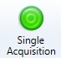 to start the scan

  - PSI Measurements
    - Phase-Shifting Interferometry (PSI) uses a narrowband light source. It is typically used to test smooth surfaces (roughness less than 30 nm), such as mirrors, optics, or other highly polished samples. It is very accurate, resulting in vertical measurements with sub-nanometer resolution. However, PSI cannot obtain a correct profile for objects that have large step-like height changes. It thus becomes ineffective as height discontinuities of adjacent pixels approach one quarter of the used illumination wavelength (about 135 nm when using green light).

    - Select PSI from the pulldown menu in the left window

    - Select your objective (2.5X or 20X) from the pulldown menu
***Never try to move the objectives by hand***

    - Select your field of view (0.55X, 1X, 2X) from the pulldown menu. Note that the approximate measurement area for the selected optics combination is automatically updated in the Measurement Area section.

    - Click on the Measurement Setup button and then the “Measurement” button in the left window and you will see the menu below

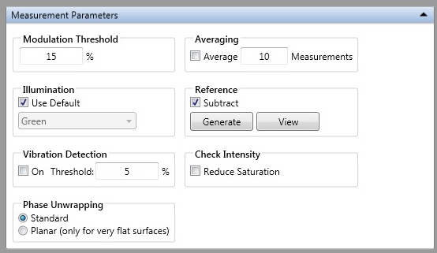

    - Measurement Parameters
      - Modulation Threshold - Enter a percentage value in the Modulation Threshold field to determine the acceptable signal-to-noise level for which a given pixel is considered valid. Data points that do not meet the modulation threshold are marked as invalid and are not considered for analysis. Follow these guidelines:
        - If you lower the modulation threshold too much, poor-quality data points will be considered.
        - If you raise the modulation threshold too much, high-quality data points will be eliminated.
      - Illumination - Select the Use Default check box (Always use green for PSI)
      - Reference - Select the Subtract check box to use a reference file to subtract the error from the system optics from the final measurement for the current selection of optics. DO NOT PRESS THE “GENERATE” OR “VIEW” BUTTONS!
      - Vibration Detection - Select the On check box and then enter a percentage threshold at which the system should detect vibration.
      - Phase Unwrapping - Select Standard for most measurements or Planar for very flat surfaces.
      - Check Intensity - Select the Reduce Saturation check box to direct the system to reduce saturation when the intensity level becomes too high to produce an accurate PSI measurement.

      - Set the intensity.
        - Use either Z control to move the fringes across your sample to find the brightest area (white). If the detector is saturated, it will show red areas instead of white.
        - Select the Auto button in the Intensity Control window, or manually slide the bar to get the brightest image possible without red areas
        - Deselect the Auto button (Do not leave Auto Intensity on during your measurement!!!)

      - Press the Single Acquisition button to start the scan
- Data Analysis
    - When the measurement is complete, it will go to the Data Analysis Window. You can get to this window anytime by pressing the Data Analysis button 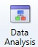 in the top menu.

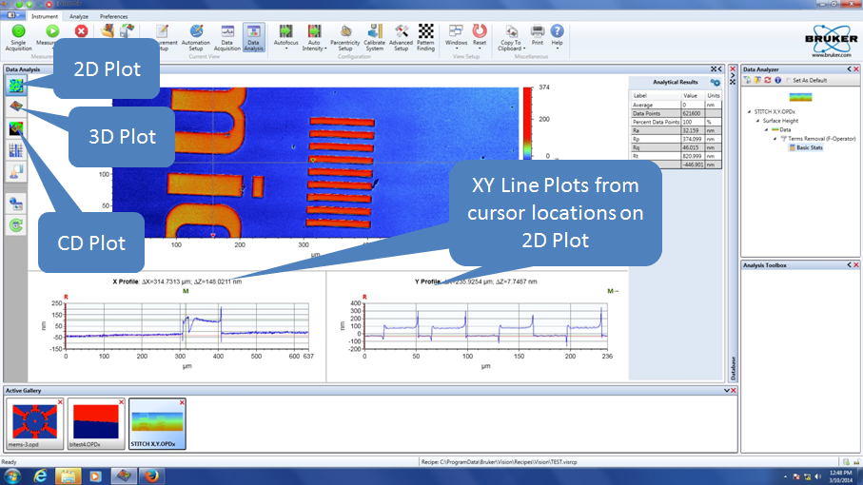

    - The contour plot (2D) is the default and is shown above. The Data Analyzer Window on the right side, shows all of the filters and analysis options that are active.

    - Clicking on “Data” in the Analyzer Window will activate the Analysis Toolbox options.

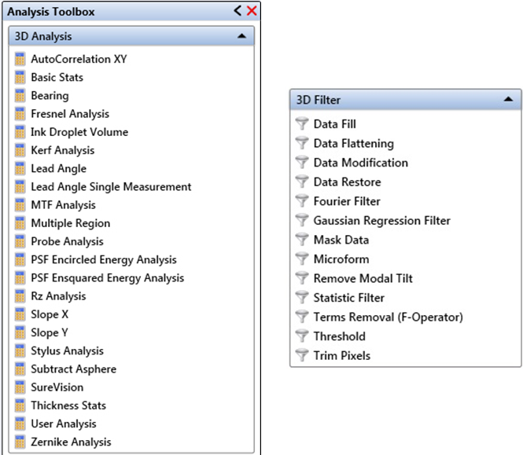

    - Analysis - To insert an analysis, simply click on it and it will be applied to the data. Please refer to the HELP menu for an explanation of what each analysis can perform.

    - Filters - There are a few filters that are used most often. Once a filter is added to the Data Analyzer Window, right-clicking on the filter will open the edit option. Be careful when you select filters and analysis options. They will be applied and calculated in the order you add them.
      - Data Fill - Fills in area of bad pixels with High Data (50% higher than the highest point in the dataset), Low Data (50% lower than the lowest point in the dataset) or a user-defined value.
      - Data Restore - Fills in small area of bad pixels using the height data surrounding the drop-out area.
      - Mask Data - Excludes user-specified areas from analysis. It has a number of uses, including: Eliminating a bad spot from sample surface; Isolating a single area of sample surface for repeated analyses; Showing only data points within a certain height range.
            - Analysis Mask: allow users to view or analyze only specific portions of a dataset.
            - Detector Mask: blocks pixel elements during a measurement.
            - Terms Mask: an analysis mask that acts like a filter
      - Terms removal (F-operator) – Is used to remove tilt and curvature.
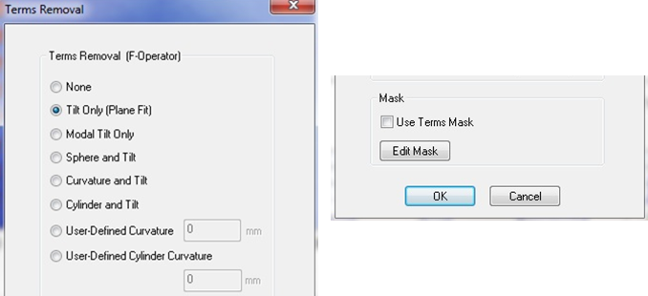

              - Tilt Only (Plane Fit) - To remove linear tilt from surface measurements. Since samples will usually have some inherent tilt, this term is almost always removed when new data is taken.
              - Modal Tilt Only - To adjust your results by removing the most common or most representative tilt throughout the entire measurement, calculated by comparing each point with its neighbor.
              - Mask - Select the Use Terms Mask check box to apply a Terms mask to the dataset. Useful if you have large steps or only a particular surface is flat. See Appendix A for how to apply a Terms Mask.

    - 3D Image – Press the 3D Plot button (3D window shown below)

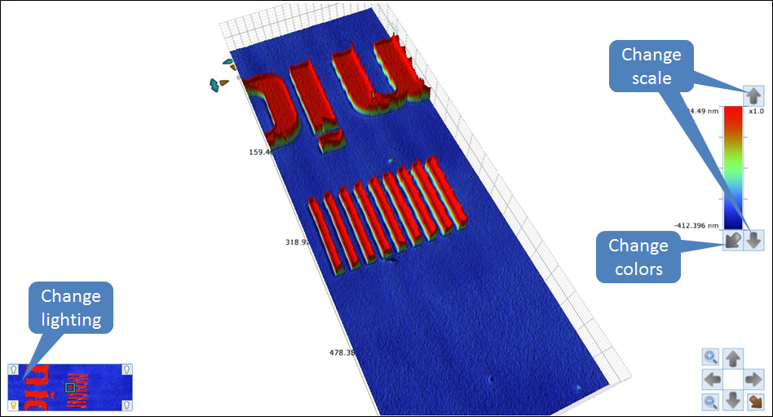

        - From this window you can rotate and tilt by left-clicking and dragging to get the desired look. You can also change the scale, image lighting, as well as the colors by using the functions highlighted in the image above.

    - Critical Dimension Plot - Click the Critical Dimensions icon 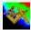 to display the active dataset as a Critical Dimensions (CD) plot (see the picture below). The Critical Dimensions plot provides Geometric Dimensioning and Tolerancing (GD&T) information on your data.

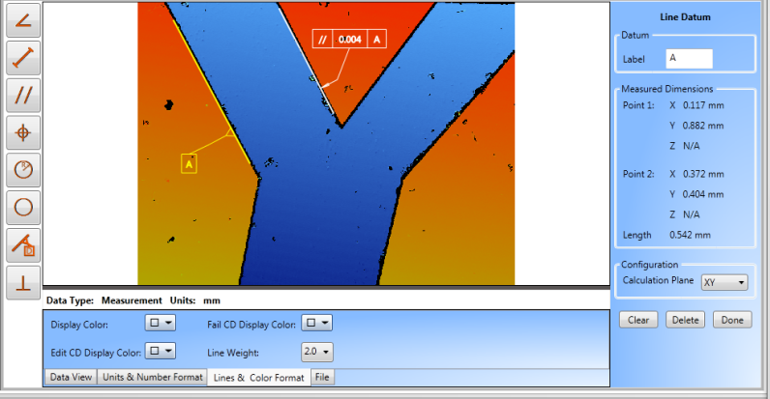

        - Use the tools on the left to measure lines, circles, angles, etc.

- Unloading or Exchanging Sample
    - Raise the measurement head about a centimeter above your sample.

    - Move the stage all the way to the front of the machine by pressing the Unload XY or by using the XY Control joystick on the control box.

    - Remove your sample and exchange with next if needed.

CAUTION CAUTION

NEVER TRY TO REMOVE/EXCHANGE SAMPLES WITHOUT FIRST RASING THE HEAD AND MOVING THE STAGE TO THE FRONT!

- Saving Data
    - You will need to save your data in three different formats; Raw data, images, and analyses
      - Raw data – In the top menu, click on ‘Save’’Dataset’ and choose the OPDx extension
      - Analyses – Any filtering, calculations or analyses will not be saved with the data. This is a separate file and must be opened with the raw data in order to merge the two. Click on the same ‘Save’ button in the top menu and select ‘Analyzer recipe’. I suggest that you name it the same as the raw data to show that the two go together.
      - Images – Any images, including calculation results, must be saved from the ‘Copy to clipboard’’Save as bitmap’ button in the upper right.
- Ending The Session
    - Exit the software

    - Log off TUMI

- APPENDIX A

- Level Using Terms Mask

  - From the Analysis Toolbox, click on “Terms Removal (F Operator)” to apply the filter to the Data Analyzer Window.

  - Right-click on the Terms Removal in the Data Analyzer. This will bring up another menu and now click on “Edit Settings”

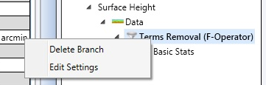

  - Select Tilt Only and check “Use Terms Mask”, then click on “Edit Mask” as shown from the steps in the SOP.

  - The Mask Editor is shown below and displays the unleveled data.

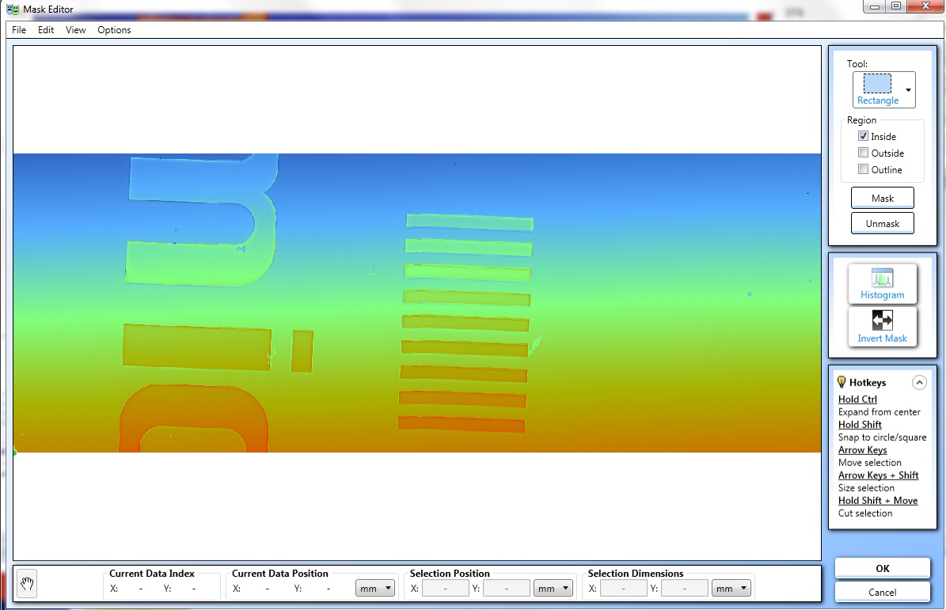

    - From the “Tool” dropdown menu, select whatever shape works best for your sample.

    - On the “Region” check the “Inside” box

    - Draw the box (or other shape) on an area you want to include in the levelling process and click “Mask”. Do this for a few regions and they will be grayed out as shown below.

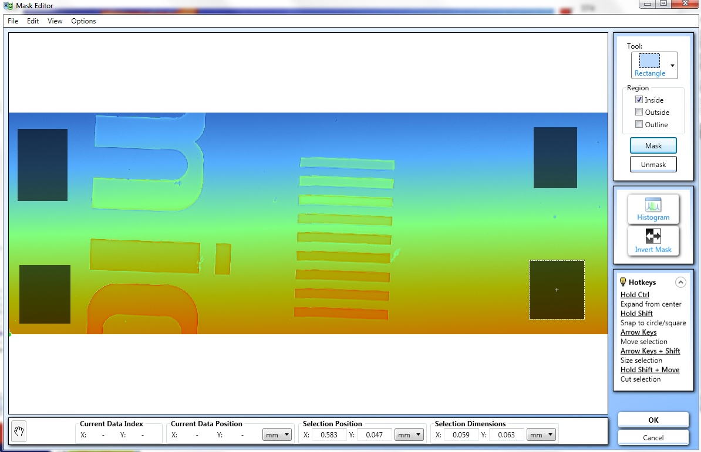

    - Now click on “Invert Mask”. This will make your selected areas active and the rest of the data inactive.

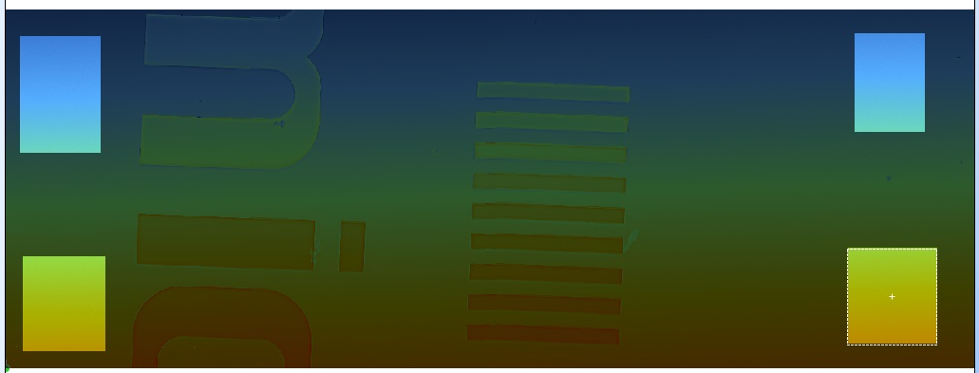

    - Now click “OK” and your sample will be leveled using the masked data

