

Tousimis Critical Point Dryer

Standard Operating Procedure Rev. 2026-01

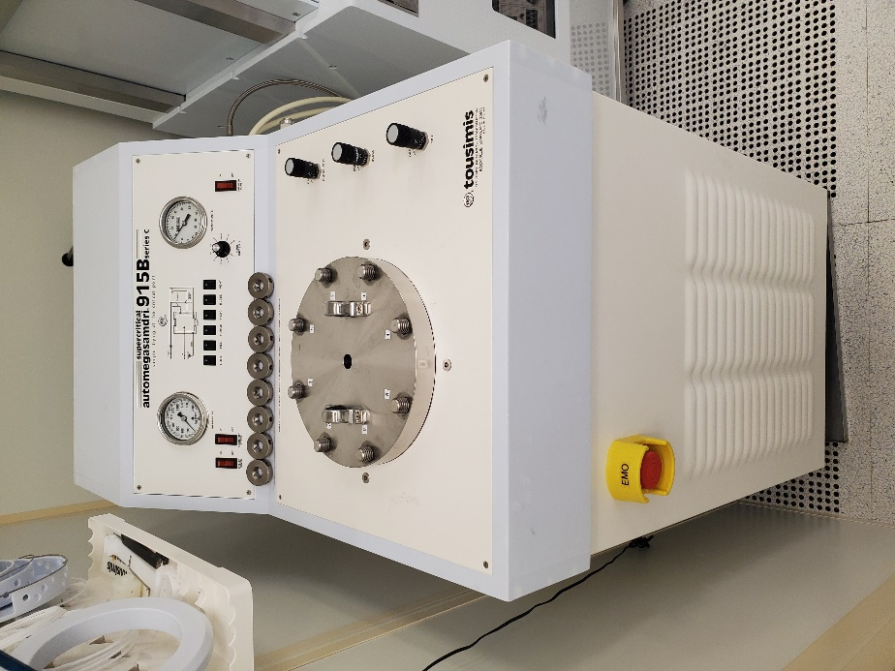

  - Application

The Tousimis critical point dryer is a fully automatic system used to dry fragile MEMS/NEMS samples after a wet release process. By using LCO2 as the transitional fluid at the critical point, it eliminates stiction and surface tension problems. The tool is capable of processing samples from 6 inch wafers to small pieces in about an hour. Up to 5 wafers can be stacked at and processed at once. Multiple small pieces can be processed at once, but cannot be stacked like the whole wafers, and requires the utmost care in handling.
  - NRF Contact

David Hays
Table of Contents
1. Safety information 3
2. Prerequisites for use 3
3. Sample Restrictions 4
4. Start Up 4
5. Releasing Devices at the CPD Prep Area (Right side of wet general wet bench) 4
6. Critical Point Dryer Operation 6
7. Ending The Session 8

- Safety information
- Chemicals – Isopropyl alcohol will be used as the dehydration solvent and is extremely flammable. Hydrofluoric acid, or buffered oxide etch, will be used to release structures and is very corrosive. Use of PPE is required.
- Extreme cold – Some components will become extremely cold due to expansion of LCO2. Do not touch any parts that become frosted during operation.
- High Pressures - Under normal operation, the process chamber will hold pressures as high as ~1500 psi. Extreme care must be taken to ensure that the top cover is properly.
- Prerequisites for use
- User of the RSC facilities.
- Up-to-date hazardous waste training.
- Training by staff.
- User will be responsible for lost or damaged equipment due to negligence. Negligence means not following the SOP, not asking staff for assistance, intentionally damaging items, etc.

- Sample Restrictions
    - No photoresist, tapes or adhesives can be used in this tool
    - Do not expose the chamber to ANY acids or damage will occur. Rinse parts extremely well as outlined in this SOP
- Start Up
    - Log in to TUMI
- Releasing Devices at the CPD Prep Area (Right side of wet general wet bench)
    - Before starting, look at the LCO2 scale on the wall by the CPPD and make sure there is enough LCO2 for you run. Above the scale is a sheet showing the weight for a bottle change. If the scale is within 4-5lbs of this minimum then you can continue.
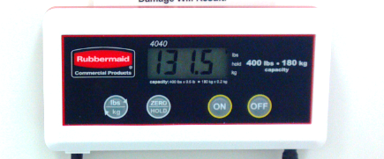
    - Gown in full PPE gear and pour enough BOE or HF/Water to cover parts using the CPD HF/BOE bucket. Only use the CPD dip baskets located on the wall next to the CPD for processing.
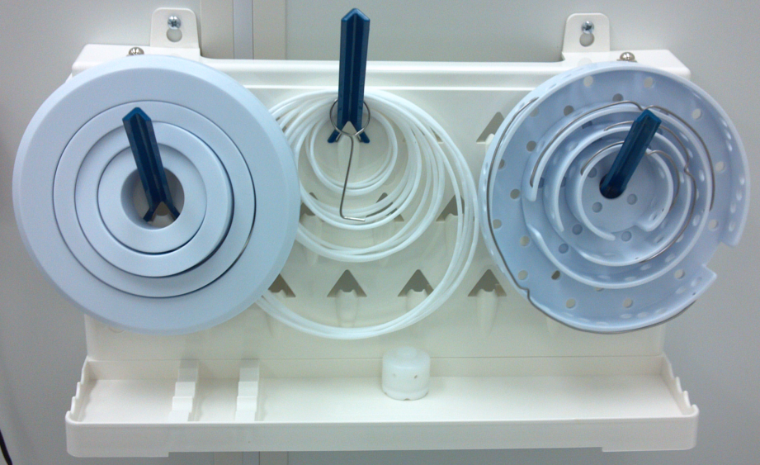
Note: The release etch can be extremely long and will depend greatly on the amount of undercut needed, size of openings, geometry, etc. Use the graph below (showing oxide undercut rate) to approximate your etch time.
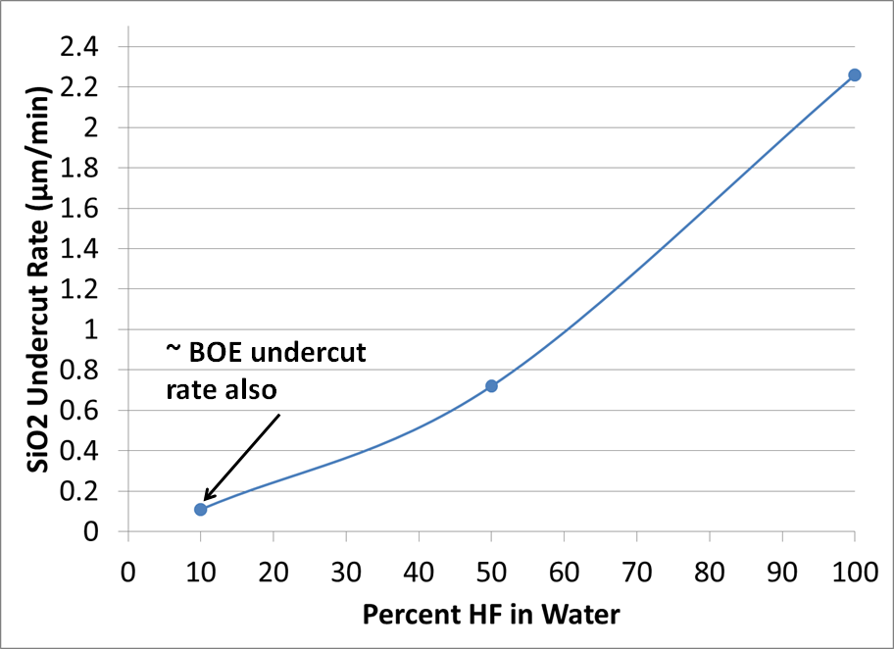
    - After the parts are released, they will need a very thorough rinse. The middle sink was designed for this process.
    - Using the “middle sink control”, place the toggle switch in the “CLOSED” position
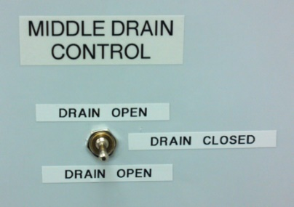
    - Turn on the faucet for the middle sink. The faucet is connected by a tube to fill from the bottom and minimize turbulence.
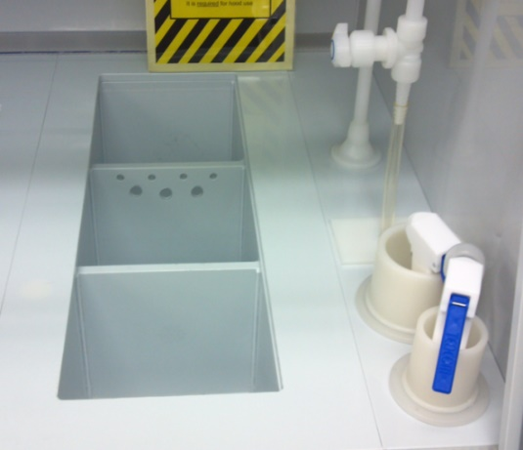
    - Wait until sink is overflowing through the holes in the back, then quickly remove your sample from the HF/BOE bucket and place in the sink.
    - You must rinse for a minimum of 20 minutes with the sink in constant overflow to remove all of the acid.

Failure to rinse for the full 20 minutes will result in a loss of privileges!

    - Fill 3 of the CPD IPA buckets with enough isopropyl alcohol to cover your samples. There are 3 buckets labeled for IPA rinse 1, 2, and 3. This step will dehydrate your sample and failure to follow this procedure can result in stiction issues.
    - After the 20 minute rinse is complete, quickly place your sample in the first rinse bucket for 5 minutes.
    - Remove from bucket 1 and place in bucket 2 for 5 minutes.
    - Remove from bucket 2 and place in bucket 3 for 5 minutes.
- Critical Point Dryer Operation
    - Turn “Chiller Power” ON. Must be turned on 30 minutes prior to using!
    - Turn “Condenser Power” ON
    - Turn “Chamber Power” ON. The VENT light will come on indicating that the unit is in the vent mode
    - Remove the nuts from the chamber lid and remove the lid. Place the lid on lint free cloth.
Always Protect The Chamber Sealing Surfaces!

    - Press the “VENT” button once. The VENT LED will blink, indicating the unit is in standby mode
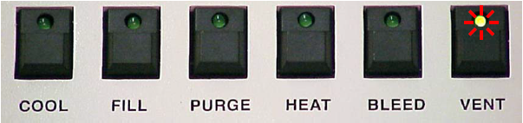
    - You can use the larger chamber ring to reduce the volume of IPA needed.
    - You can now fill the chamber with enough IPA to cover your wafer/devices. Do not completely fill chamber!
    - Carefully and quickly transfer your wafer/device from the IPA bucket into the process chamber.
Do Not Introduce Any Acids Into Chamber!

    - Carefully lower the chamber lid onto the chamber. Finger-tighten all 8 nuts then tighten using the “star pattern” shown below and on the CPD top. Repeat this rotation sequence until you are unable to tighten further.
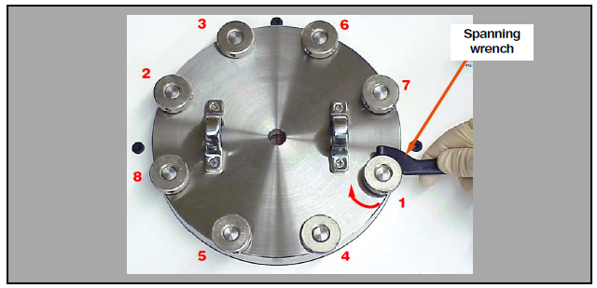
    - Ensure that the “PURGE TIMER” is set to 15 minutes. Do not change setting.
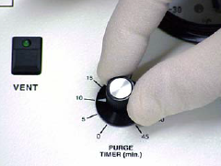
    - Press the “COOL” button. The cooling sequence will take about 3 minutes and will cool the chamber to 10°C. Once the chamber reaches 10°C you may proceed to the next step.
    - Press the “FILL” button and the unit will automatically begin to fill with LCO2. The fill step will take approximately 8 minutes.
From this point forward, the tool will automatically advance through all of the process modes until complete.
    - Summary of automatic steps
  - Purge Mode – The time for this mode is set by the purge timer knob and should remain at 15 minutes. During this step, the alcohol will be displaced from the chamber and exchanged with LCO2.
  - Post Purge-Fill Mode – This will fill the chamber with LCO2 for an additional 4 minutes. During this mode, BOTH the “FILL” and “PURGE” LEDs will be lit.
  - Heat Mode – This is the step where the process is carried through the “critical point”. Both the temperature and pressure will increase to the critical point parameters of 1072psi and 31°C. The pressure will continue to increase to 1300-1500psi.
  - Equilibrium – After the chamber reaches the critical point it will maintain equilibrium for the next 4 minutes. The “HEAT” button will begin to blink at this stage.
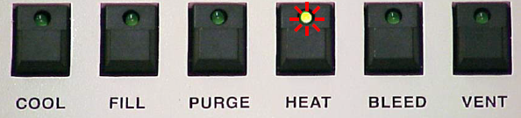
- Bleed Mode – During this mode, the CO2 pressure will be slowly reduced to approximately 400psi.
- Vent Mode – The chamber is vented to atmospheric pressure (0psi).
    - Ensure that the pressure is at 0psi. The chamber lid can now be removed using the spanning wrench in the. Remove samples and replace lid with nuts only finger tight.
- Ending The Session
    - Power off in the following sequence
        - Chiller Power Off
        - Condenser Power Off
        - Chamber Power Off

    - Log off TUMI

