
ZEISS Versa 620 XRM
  - Standard Operating Procedure (SOP)

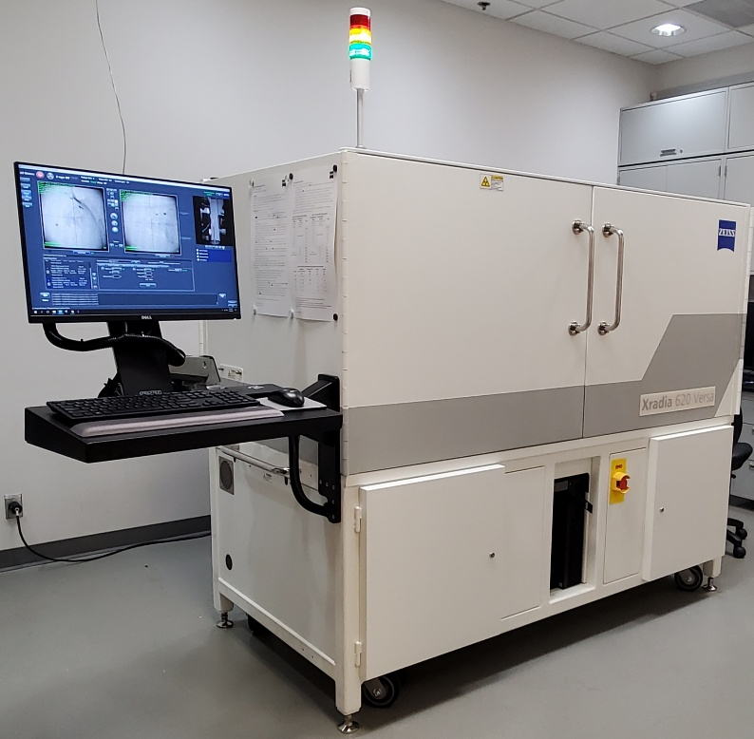
  - Application
The ZEISS Versa 620 is an X-ray microscope (XRM) for computed tomography (CT), having flat panel, 0.4x, 4x, 20x, and 40x objectives/detectors. It also has a 4x DCT detector for diffraction contrast detection. The Versa 620 performs X-ray absorption tomography. But as the source and detector can move in relation to the sample, it can also enhance phase contrast between materials with similar densities. Finally, with the Xnovo package and hardware it can do diffraction contrast/grain mapping for small samples with grains over 10 microns. Additionally, features with dimensions as small as 50 nanometers can be observed in the 3D output.


Quick Reference Guide for UF NRF
ZEISS Xradia Versa 620
With Scout-and-Scan™ Control System

Basic Steps
- Sample - Set the Sample’s directory and data folder. Open existing or create new recipe for ROI(s).
- Load - Load the sample, roughly align the ROI, create SmartShield virtual sample envelope.
- Scout - Scout the sample to find the desired ROI and determine imaging parameters using X-Rays.
- Scan - Set up 3D scan parameters for the recipe.
- Run - Run the recipe and acquire the projections.
Detailed Steps (begin with no sample and X-ray filter set to “Air”)
  - Open Scout-and-Scan™ Control System.
  - Select the directory where data will be saved and input a sample name. Select an existing recipe
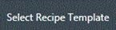
or add a new recipe by clicking the  button. Click and go to the Load step.
  - Move the Source and Detector away from the sample stage by clicking (safe zone for typical sized samples).
  - Set sample stage to X=0, Y=0, Z=0, θ=0°
  - Load sample and position roughly with the red crosshairs of the integrated visual light camera (VLC), using the sample controls, both at 0° and -90°. Close enclosure door. Go through the SmartShield procedure (in the upper right of the “Load” menu). Click the button and go to the Scout step.
  - To see the full sample in the X-Ray view: under the Acquisition tab, set Objective = 0.4X, Bin = 2, Exposure = 1, Source Filter = Air, Voltage = 80kV or 140kV (depending on sample), Power = Max power (as shown) and click Apply.
For FPX: set Objective =Flat Panel, Bin = 2, Exposure = 0.04, Number of frames = 5, Source Filter = Air.
  - Use 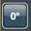 to turn the sample to θ=0° and click on the  button to start the continuous imaging.
  - Using the mouse, double click to position ROI to center of screen. ROI is roughly centered for sample X and sample Y axes. Stop continuous scan.
  - Rotate sample to -90° by clicking on 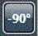 and then click the button to start the continuous imaging.
  - Double click along horizontal line to position ROI to center of screen. ROI is now roughly centered for sample Z axis.
  - Switch to desired objective (Table 3). If 20X or 40X, initially switch to binning = 4 to for easier setup.
(Change back to bin 2 before step 18). Follow ranges in Table 3 to avoid geometric unsharpness.
  - Fine tune ROI position at 0° and -90° (repeat steps 7 to 10 as necessary).

For steps 13-17, use the VLC to verify sample, source, and detector positions. Even though a Smartshield envelope is present it is still important to observe the relative positions of all components. Remember that as we can center any part of the sample, the sweep during rotation may be up to twice the sample diameter.
  - Rotate theta between -180° and +180° to find the angle where sample is closest to source.
  - Position source as close as possible to the sample at the angle determined in step 13.
  - Position detector at a collision free distance, to achieve the required voxel resolution.
  - Rotate sample between -180° and +180° to verify collision free rotation.
  - Determine filter and kV. (see page 2 for filter selection quick guide).
  - Determine image exposure time using the button. Best image quality obtained with counts >5000.
(Counts scale linearly with exposure time). Click the button and go to Scan step.
  - Change the number of projections to 1601 (FPX: 2401, # of frames = 5) for samples fitting in the FOV, for high image quality. For interior tomographies, use >2001 (FPX > 3501, # of frames = 5). Use default values for the other parameters. (For Binning settings of other than 2, please see the manual.)
  - If first scan of the day, create a new recipe point, bring it to the top, copy settings from 2 for warmup.
  - Click the button and go to the Run step. Click on the Start button to start the tomography.

Filter Selection Quick Guide
(Detailed instructions can be found in the user’s manual)
- Take an image of the sample by clicking  button using exposure (sec) = 1 (or exposure time which gives > 1000 counts). (Or, last image taken during continuous acquisition works.)
- Click on the reference button. Make sure the reference is collected on air. If the sample is too tall go to the “Reference for Scouts” tab and change the reference axis to ±X/±Z and try again.
- Select a filter based on the transmission values from the newly created image with the help of the correct filter table (see Table 1 or 2 depending on detector in use). This is now the final filter.
- With the final filter (selected in Step 3) in place, change kV to obtain an ideal transmission in the range of 20 – 35 %. for the most attenuating part of the sample. Note: increase or lower kV (by steps of 10) to increase or lower the transmission respectively.
Depending on the sample material and size, ideal transmission may not be obtainable. If this is the case, please image using a transmission closest to the ideal range.
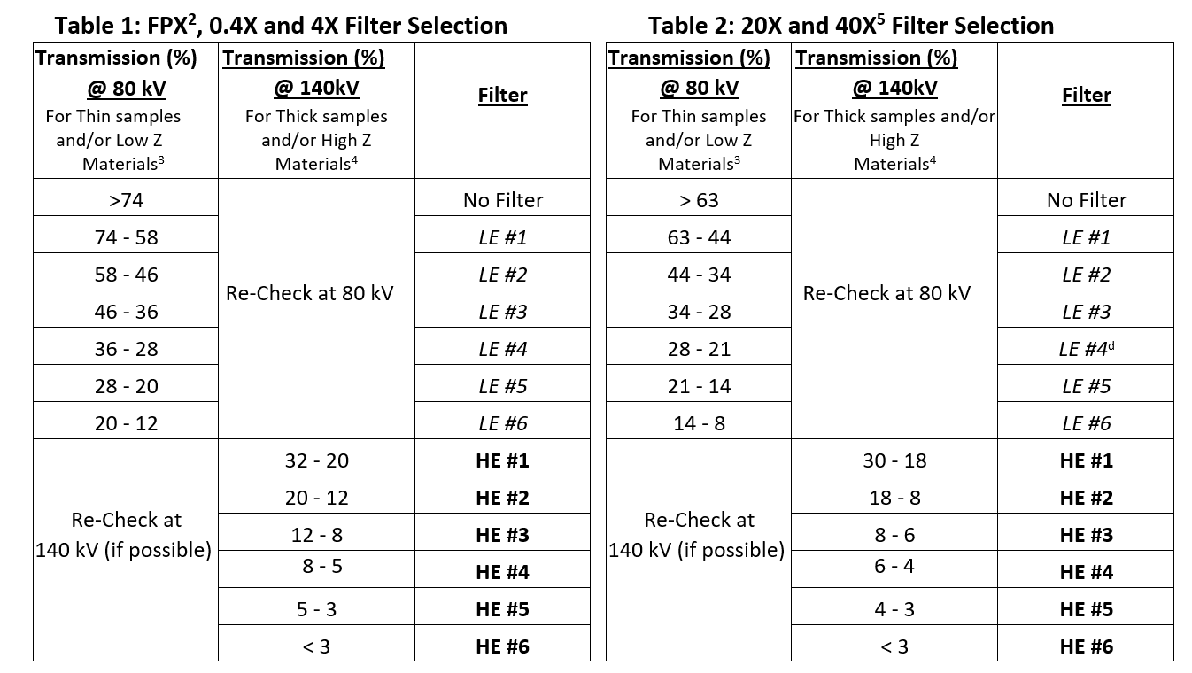
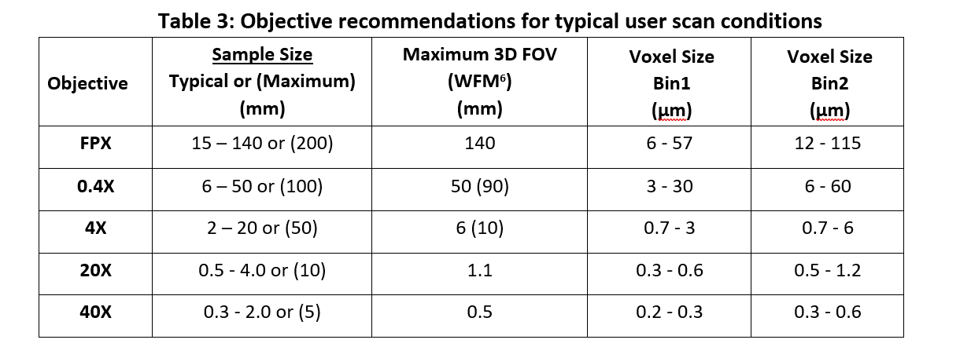
____________________________________
Footnotes for Tables above:
- For FPX scans only: if the required filter is HE#5 or higher, the sample should be scanned with HE#18.
- Low Z samples are typically biological or polymeric
- High Z Samples are typically metallic or contain metallic structures (i.e. semiconductor samples)
- For 40X only: If the required filter is LE#4 or higher; the sample should be scanned with the 20X instead. This indicates a relatively high absorption for the sample and the 40X will not provide any better resolution than the 20X.
- If present – Not all tools are equipped with Wide Field Mode
Carl Zeiss X-Ray Microscopy, Inc.

