Unaxis 790 RIE

Standard Operating Procedure
Rev. 2026-01
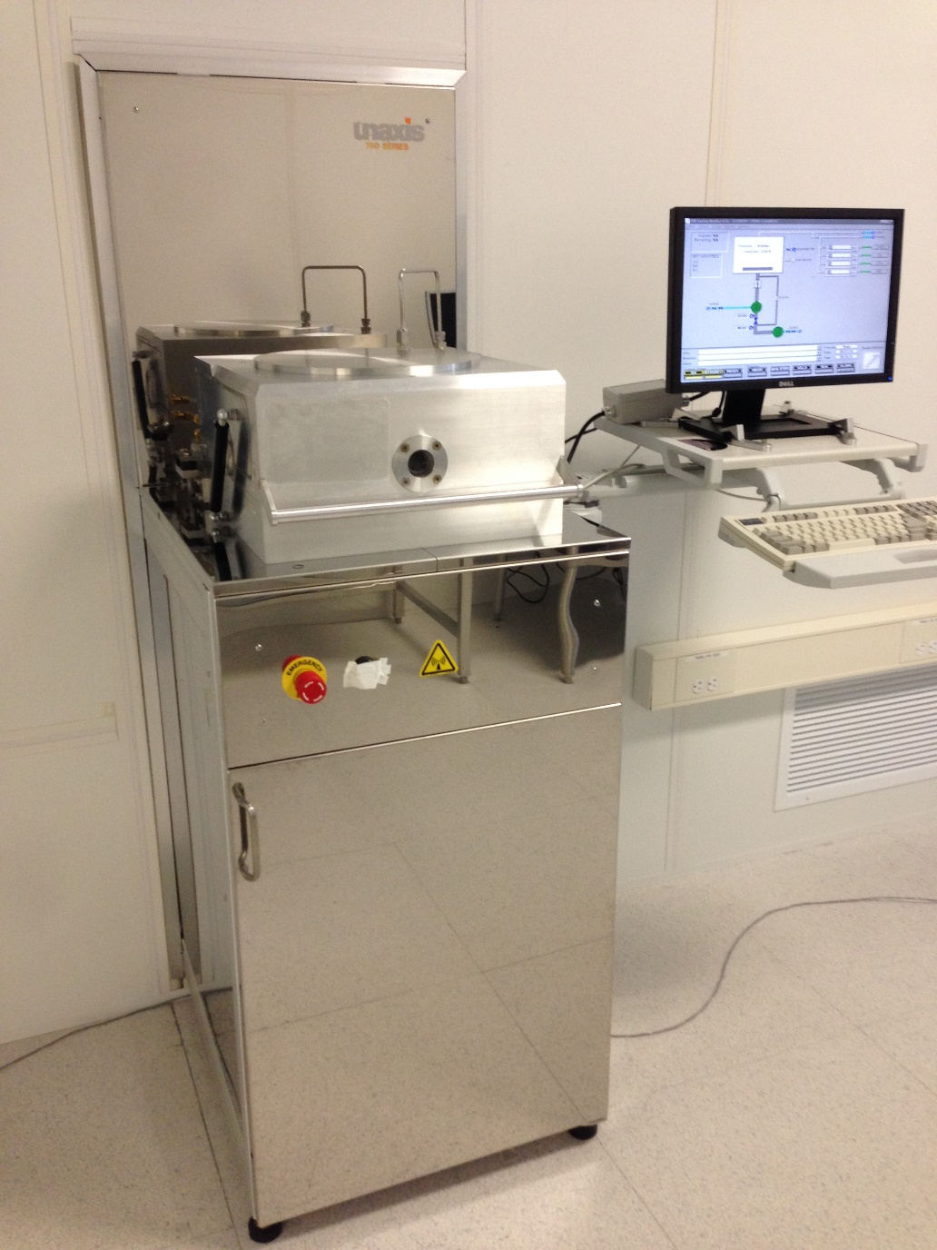

Contents
Description 2
Safety 2
Restrictions 3
Pre-Operation 3
Operation 3

Description
Unaxis 790 Reactive Ion Etcher - Etch Capabilities: SiO2, SiN, Si, photoresist, polyimide and other materials. The system is equipped with one 13.56 MHz 500 Watt RF RIE configured power supply. Process Gases Available: Ch1=CHF3, Ch2=O2, Ch3=CF4, Ch4=He,. The system is capable of etching samples up to 8” diameter.
ALL POLYMER ETCHING WILL BE DONE IN THIS RIE ALONE.

Safety
- Chamber – Do not attempt to vent the process (right) chamber for any reason. Contact NRF Staff for assistance.
- Etch Byproducts – Etch process may produce hazardous etch by products. Chamber Purge must always be done for 5 mins prior to opening the chamber.

- High Voltage - High Voltage Radio Frequency is used throughout the system. System maintenance may only be performed by Unaxis or NRF Staff. Do not remove any tool covers or defeat any interlock on this system.
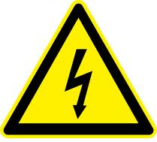
- Moving Components - The User must exert caution when opening and closing the chamber lid. Your fingers after being violently detached by the chamber lid will prevent the system from reaching base pressure.


Restrictions
ALL POLYMER ETCHING WILL BE DONE IN THIS RIE ALONE.

Pre-Operation

Change gloves. WARNING No solvents are allowed near the machine, change your gloves before operation!!

Operation

  - Before logging into the Tumi, check that a “Clean” chamber process is not being run. 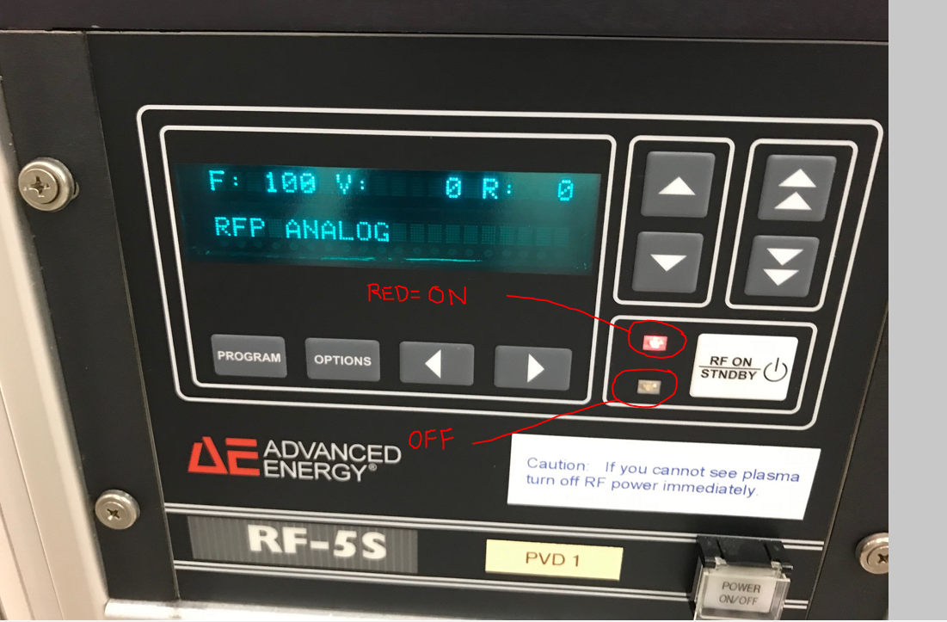
Open the front door to the tool and check if the RED light on the RF-S5 power supply is ON. If on, wait until the clean process is complete before logging on to the tool. Cleans usually last no more than 30 minutes.
  - When you log onto the system, it will mode likely have a pop up window stating “automatic process complete”. Which means the last user ran the “O2_clean” recipe. This also means the system is in ready mode. For normal operation the system must be in “Standby”. Click the “Standby” radio button to switch back to “Standby” mode.
  - To vent the chamber to atmosphere, click Utilities/Vent.
  - Wait for the chamber to vent. The main chamber box will turn blue and “vent complete” will be displayed in the info box.

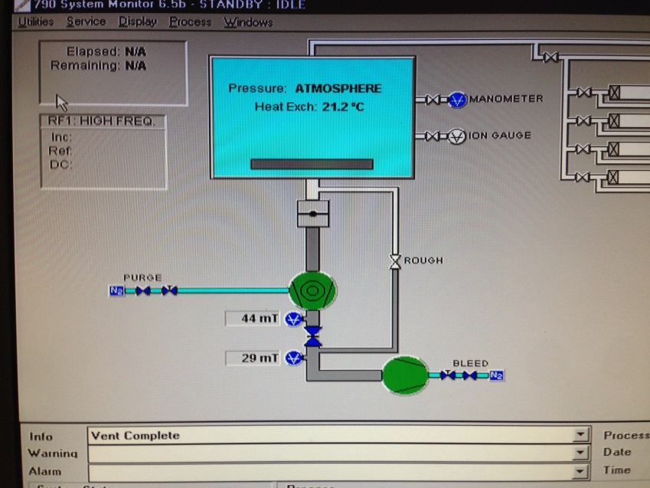
  - Grasp the chamber lift handle with both hands and gently raise the chamber lid all the way up. It should feel very secure in the up position. If not, stop procedure and contact Staff immediately.
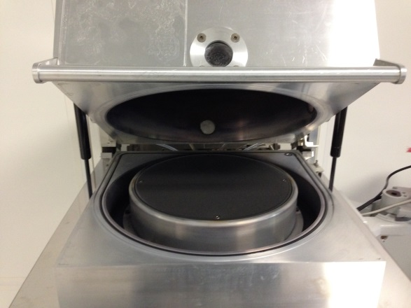
  - Be very careful, the chamber lid is very heavy and could easily break your hand if it falls.
  - Place your sample on the center of the cathode and carefully lower the lid.
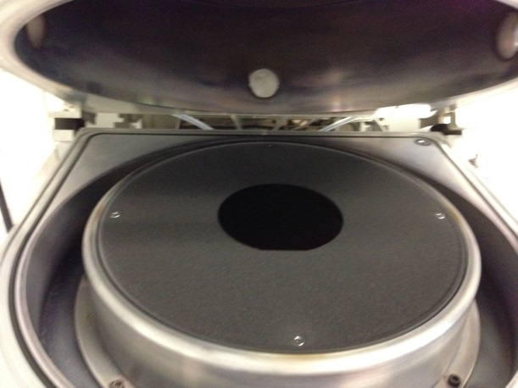
  - Click “Utilities”/”Pump Chamber (Turbo)” and using one hand, push down on the chamber handle. Continue to push down until the “Roughing” valve opens. You will be able to hear the chamber pump down. The lid has new air lift cylinders. This problem should go away eventually.
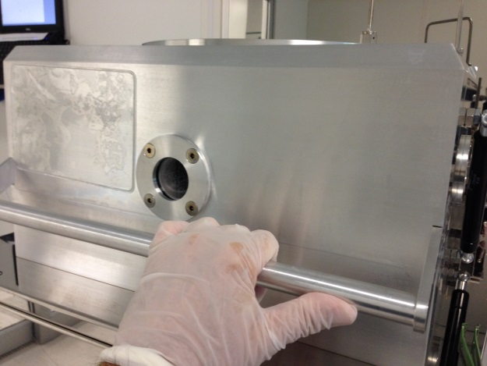
It will take several minutes to pump down all the way. Do not continue until the pressure toggles between 0 mTorr as displayed below.

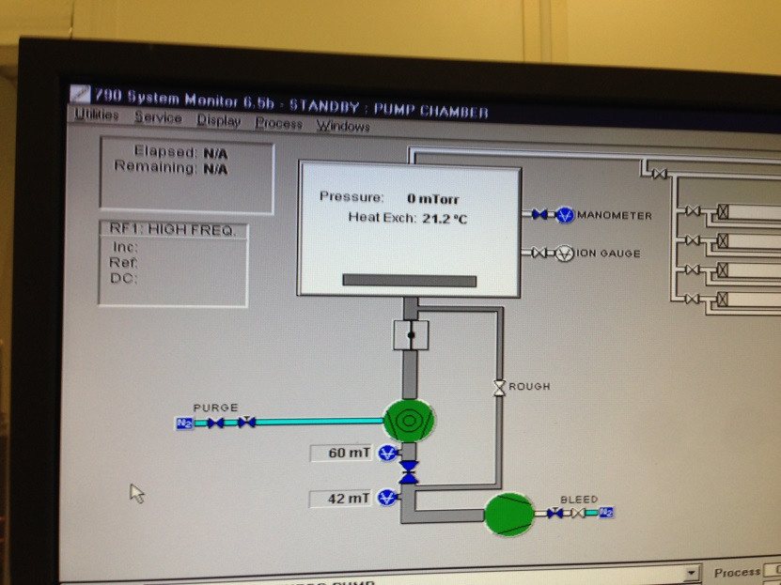

  - Click “Service” / “Manual Mode” to enter the manual process screen for processing.
  - On the Manual Mode screen, set the gas flow(s) needed and click the GAS “ON” button.

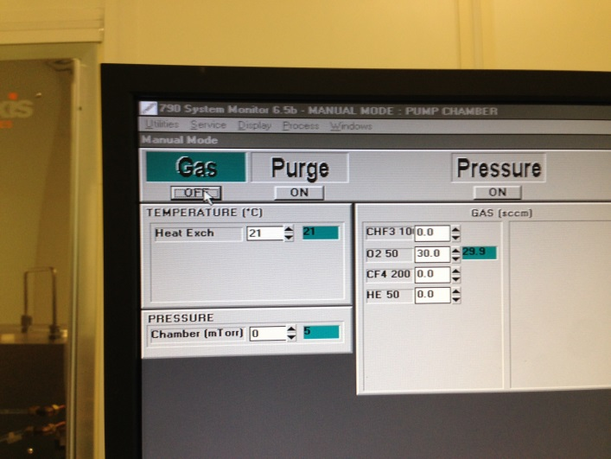

  - Set the pressure setpoint to the desired process pressure and click the “Pressure” “ON” button. Note: pressure is related to gas flow and pumping speed which is controlled by a throttle valve…i.e. you can overcome the pumping speed of the system and a particular pressure is not achievable. If the pressure controller will not make it to the pressure desired, you must change gas flow.

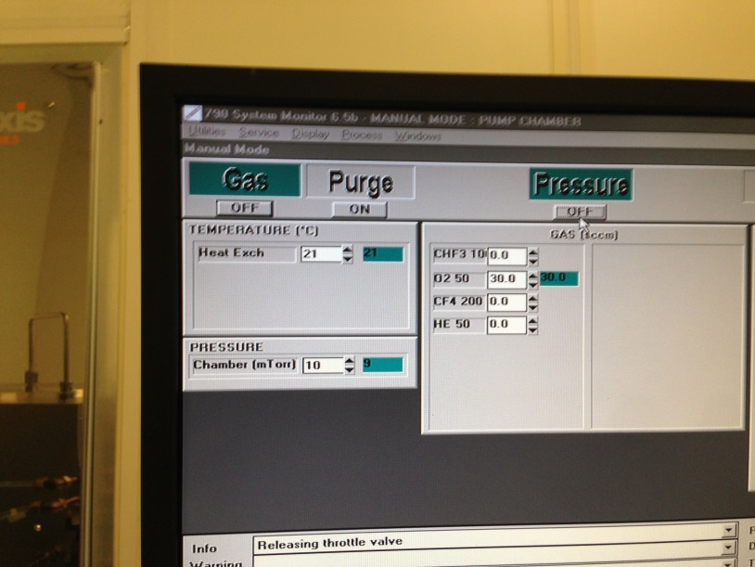

  - Set the RF process time in the “Time” field. Set the power in the “RF1” “Set” field. Click the “RF” “ON” button to start etching. The etch time will start counting down. When the time has expired, everything will shut off automatically. If you need to stop the process at any time press the “ALL OFF” button.

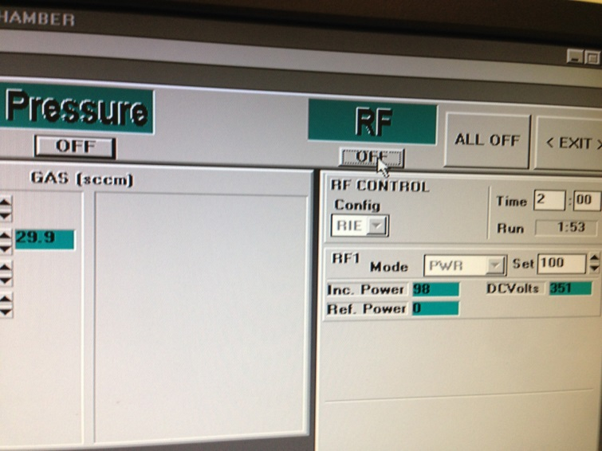

  - When the etch is complete, click the “Purge” button at the top of the screen and wait for 5 minutes before unloading your sample from the chamber. This will purge hazardous process by products that may be present from the chamber.

  - To vent the chamber to atmosphere, click Utilities/Vent.
  - Wait for the chamber to vent. The main chamber box will turn blue and “vent complete” will be displayed in the info box.

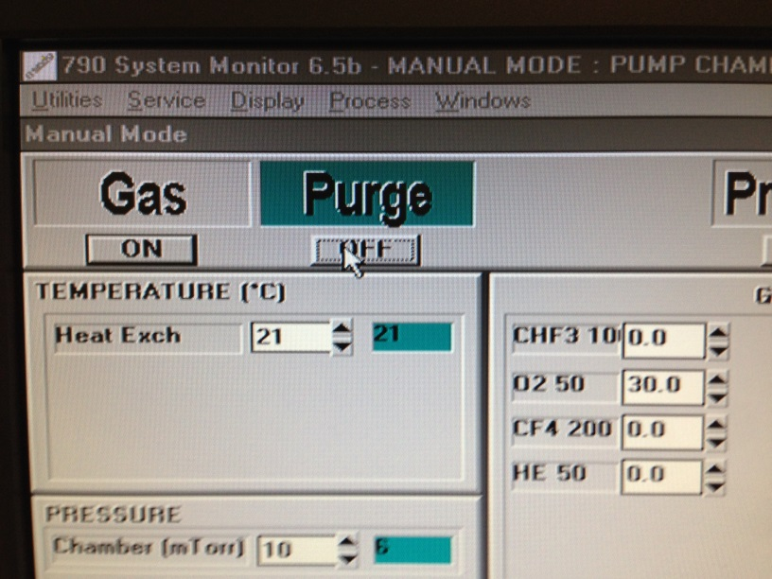

  - Open the lid and remove your sample and close the lid if done processing.
  - When done processing, load and run the O2_clean recipe. Click “Process”/”Load” and select the “O2_Clean_recipe”
  - Click “Ready” at the bottom of the screen. Click “Run” at the bottom of the screen to start the clean recipe.
  - Log off the Tumi.

