
Autosorb iQ
  - Standard Operating Procedure (SOP)
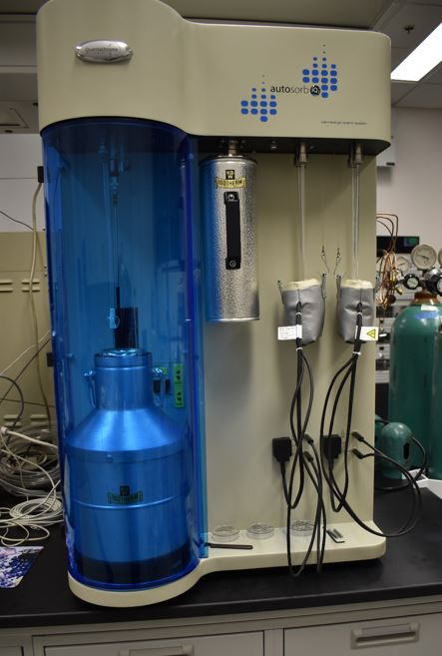
  - Application
This guide is designed for detailed step-by-step guide for a typical N2 isotherm, including BET analysis. Included are modifications needed for Kr , CO2, and Xe (must supply your own Xe gas cylinder).
Pore measurements valid for 0.35 nm - 500 nm
BET valid for 0.0005 $m^{2}/g$and greater.

Contents
Sample Prep 3
Logging in 3
Pick your sample cell size 3
Weigh Your Sample Cells 3
Outgassing 5
Outgassing Ends 8
Physisorption Setup: 9
Nitrogen Adsorbate 9
Starting The Analysis 13
Krypton Adsorbate 15
Xenon Adsorbate 17
Sample Prep 17
Analysis setup 17
Using the Vevor Chiller 18
CO2 Adsorbate 19
CO2 Checklist: 21
Chemisorption 22
Cleanup 23

Sample Prep

Logging in
Log into the Monitor Station TUMI login to unlock the PC
If you need to log into the computer, user password: paic2012
We recommend that you ensure there is at least 1L (approximately not an exact amount) remaining in the MAIC dewar, and request a refill if needed. You must have liquid nitrogen in the cold trap dewar during outgassing.

Pick your sample cell size
You should use the smallest sample cell that you can load and unload samples from. Minimizing extra volume will increase precision and decrease run time. There is a black funnel that is sized to aid in loading any of the 3 standard sample cell sizes: 6mm, 9mm, or 12mm. There are a couple of glass funnels that work for loading the 9 and 12mm cells. The stems on these are VERY fragile so be extra cautious with these.
You may use the NRF service cells, but it is recommended that each group purchase their own set to reduce errors from inconsistent cell use, possible cross contamination, or delays due to unavailable cell sizes. The NRF will not guarantee any specific stock of sample cells as they are re-ordered on an as-needed basis to complete service requests. If NRF glass cells break during your use you/your PI will be required to replace the cells.

Weigh Your Sample Cells
Sample cells should be clean, dry, and labeled prior to initial weighing. It is recommended users wear gloves to prevent accumulation of debris or grease on the cells during the preparation or analysis process. Safety glasses are recommended during sample prep.
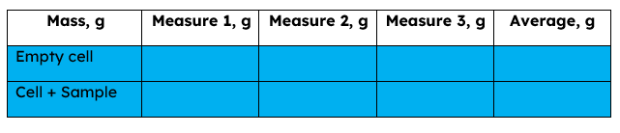
Weights should be taken in triplicate to ensure accuracy. If weights do not stabilize on the balance, you likely have static buildup, spray the glassware with the anti-static air and try re-weighing. To reduce error from airflow it is recommended you use the Starbucks balance lid (made by NRF staff not Starbucks) to cover your cell. Be sure balance enclosure side doors are closed.
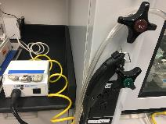
Figure 1: Antistatic air gun located next to the fume hood in 222.Gas valve is typically left open, check box power.
Re-weigh your sample + cell after you have added your sample material. Again, triplicate is recommended, using the average as the mass you input into the software. Check the balance is returning to zero between weighs, and tare as needed.

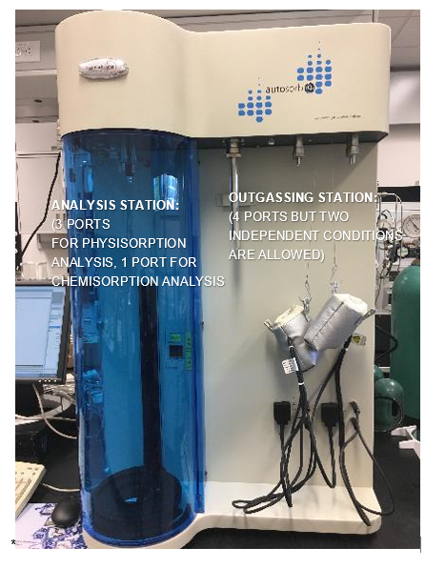

Outgassing
All samples must be outgassed before analysis
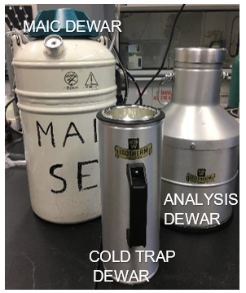
YOU MUST WEAR EYE PROTECTION AND CRYO GLOVES WHEN FILLING AND PLACING THE DEWARS ON THE TOOL.
You are REQUIRED to fill the cold trap dewar prior to loading samples for outgassing. Fill the dewar to the top (blue tape), this represents 24 hours of liquid nitrogen. If your outgassing will take longer than 24 hours you MUST come to refill the dewar before it empties. Outgassing without the dewar filled will damage the filters and potentially the turbopump on the tool.

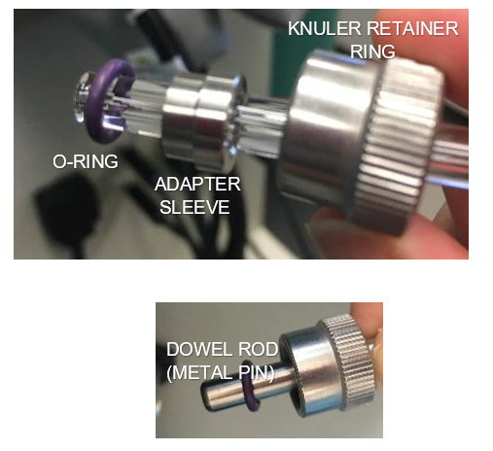
If you need additional liquid nitrogen, bring the MAIC dewar to the front desk. 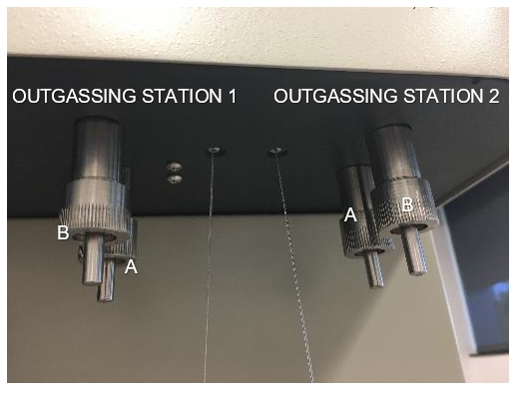 The Autosorb tool has 4 outgassing stations and can accommodate 2 unique routines. Ports A and B on a station will receive the same treatment, but stations 1 and 2 can be programmed independently of one another. To load your samples for outgassing, remove the knuler (holding the dowel so it doesn’t fall upon loosening of the fitting). Each knuler has an adapter fitting inside, a metal dowel used to plug the port when not in use and an o-ring to ensure everything seals. YOU MUST TRACK YOUR O-RINGS! Remove the knuler, adapter dowel and o-ring. If the o-ring is stuck inside the machine, use the metal dowel or PLASTIC tweezers to retrieve it. If needed, swap out the adapter and o-ring to the proper size for your sample cells. To load, place the knuler ring, then the adapter and finally the o-ring on your cell before loading and tightening the knuler on the tool. Finger tight is fine, overtightening can cause leaks. Check that the o-rings are not dry/cracked, Additional o-rings can be found in the drawer below the outgassing stations.
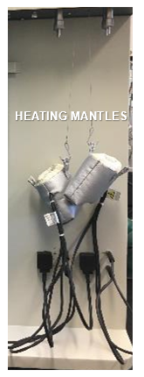
DO NOT USE FILLER RODS DURING OUTGASSING!
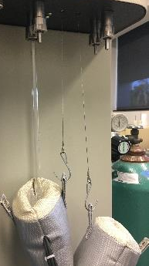
Once you have the sample cells in place, hang the heating mantles so they cradle the end of the sample cells in the basket. Be sure to keep the baskets on their correct side (check where they plug in, don’t cross the cords).
Now you are ready to program your outgassing routine:
If it’s not open, open the ASiQwin software. You may enter your name, or leave the user as NRF User. If not connected, you will need to select connect to establish communication between the PC and the tool.
Analysis and Outgassing routines are edited in the iQ default dropdown. Station 1 and Station 2 will need to each be programmed separately (if both are being used). Open the settings for outgassing by selecting edit program.
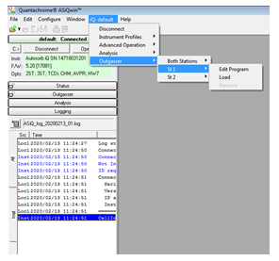
Generally, you want to have a 10 minute initialization step, set the temperature in this step to 30 degrees, usually a 5-10deg/min rate is acceptable.
Next program your desired outgassing duration, temperature and time will depend on your sample needs. Use the highest temperature that will not damage your sample for fastest outgassing.
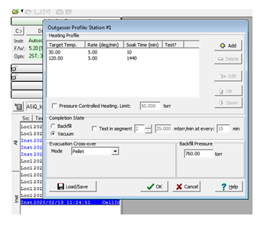
Finally add a step for testing, I usually duplicate the outgassing time and temperature and turn on the test for this stage. Once the pressure is no longer changing in the cell, the outgassing will be complete and the heating mantles will cool.
Completion State: set as vacuum
Evacuation Crossover: select based on material (when unsure, use fine powder to avoid elutriation).
You may save your settings for easy reloading later using the load/save button.
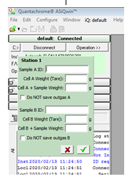
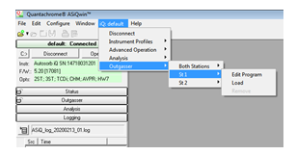
Once all stations you plan to use have been programmed, you can load an individual station, or load all to run both stations.
When you load a station, it will give you the opportunity to save your empty cell and cell+sample weights. This is helpful for later and recommended, but not required. If you chose not to save the sample data, or don’t have a sample loaded in a specific port you can check the Do NOT save outgas data box.

Outgassing Ends
You need to log into the analysis TUMI login before you proceed.
After your outgassing is complete, allow the cells to cool to room temperature before backfilling. This reduces risk of moisture getting into the sample cell, as well as reducing risk of burns. Remember PV=nRT, if we increase P, T will increase as well. Please do not place hot baskets on the cables, allow baskets to cool before removing them. Once cells and baskets are cooled you can select the remove all or remove specific station option to backfill the cell with He. Check the status log to ensure the backfilling is complete before attempting to remove the samples. If you did not log in, the backfill may not complete due to lack of gas access.
Remove the cells by removing the knuler, adapter and o-ring. If the o-ring is stuck use a metal dowel, or plastic tweezers to fish it out of the port, DO NOT LEAVE IT IN THE PORT.
Reweigh your sample cell, the outgassing process should have reduced the mass slightly and we want an accurate mass measurement before analysis.
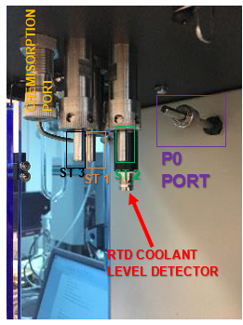
Insert the appropriate filler rod. It is recommended to use a filler rod unless you have a strong case for not using one, they reduce errors in the analysis.
Load your sample cell onto the analysis station. Analysis knulers should be tight, usually finger tight is good enough but you can use the tool to tighten/loosen these if needed. Because of the spacing of the stations, it may be difficult to get the knuler tight, however overtightening will cause leaks.
You are now ready to program and begin your analysis. Please check the process notes tab in the binder for recommended settings and any data parameter changes for your specific process.

Physisorption Setup:

Nitrogen Adsorbate
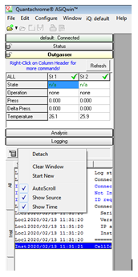
*N₂ is not recommended for surface areas below 1m²/g – Try Kr*
It is recommended you select start new on your log file. This will reduce log size and help staff track down issues more quickly should there be concerns about your data or problems during your analysis. The log is easier to read if you detach it and resize it.
For N₂ measurements you will be running the analysis at liquid nitrogen temperatures. Fill the analysis dewar, if the dewar is not at least half full the analysis may not begin.
Face shield and cryo gloves MUST be worn when filling the dewars.
It is recommended to fill the dewar to the blue tape line. Filling the dewar into the neck is overfilling it. In the neck the level may drop faster than the tool is checking for coolant, which may result in erroneous data. The blue tape line represents 36 hours of coolant, it is rare for non-micropore analysis programs to run longer than 36 hours.
You should be using the P0 cell, this should be installed using a 6mm o-ring (use the one on the metal dowel). The Coolant detector MUST be in place or the analysis will fail and glassware may be broken.
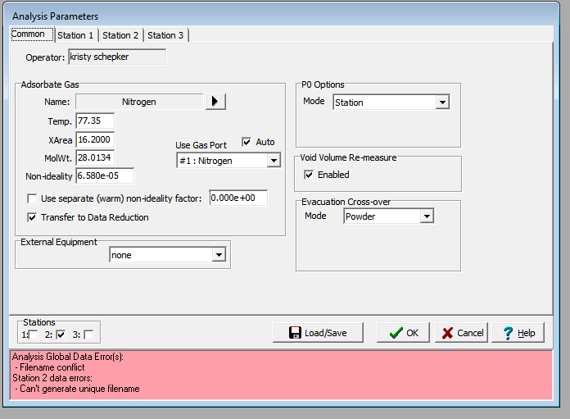
Use the iQ default dropdown to edit analysis parameters. This will open the conditions tab for the analysis.
To load the generic N₂ settings select the Load/Save and load 0NRF_Phys_N2 then verify settings as discussed below.
In the bottom left corner select which stations you have samples loaded on. The red status bar will go away when all stations have a unique name for saving and no other errors exist.
Select the Nitrogen adsorbate, and ensure port #1 is chosen as the gas port. You should not need to change gas parameter.
Select Station from the P0 Options, Void volume re-measure is recommended (it does extend the analysis time, but it is helpful). Evacuation crossover should be set to sample type.
Now set the station conditions for each station; not all samples have to run the same conditions, just the same adsorbate.
For the Station settings you have multiple tabs, ensure you double check all conditions on all the tabs:
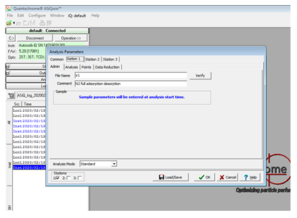
On the admin tab, your file will need a unique name or the program will not allow the analysis to begin. To ensure unique file names we recommend adding _<d>_<t> to append each analysis with the date and time of the run. Should a sample run need to be restarted for any reason this ensures you do not need to revisit the settings to update the file name.
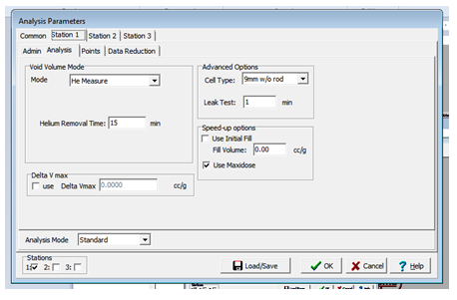
On the Analysis tab you will need to set the sample cell size and the leak test conditions desired.
There are cell options formatted as size, and size w/o rod. It is assumed if you select 9mm, you are using a 9mm cell WITH the filler rod.
A leak test time of 1 minute is recommended.
We recommend always using Maxidose.
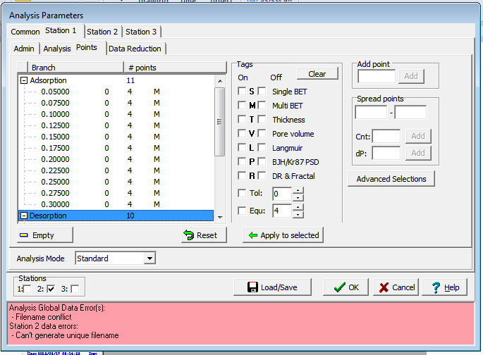
You will set your desired points on the points tab. Here you also set the equilibration time per point, and the tolerance.
Higher equilibration times result in longer runs.
Higher tolerance results in faster runs, but means you are accepting a larger error per point.
If unsure Equ 2 Tol 3 is usually a reasonable place to start.
Data tags can be adjusted after the analysis, but if you know points will be used in a specific calculation you may choose to tag then at this stage. If you need to add a range, use the spread points option, individual points can be added by highlighting adsorption or desorption and setting the specified P/P0 value.
Reset will clear the points, and if you right-click on the points window you can select some preset points, there are typical BET point ranges and specified # of point analysis routines preprogrammed for selection.
Data reduction parameters: You shouldn’t need to change these, but in some cases it will be helpful. Many of these options can be edited after the data acquisition is complete.

Place the analysis dewar on the lift – with the screw facing into the tool – before proceeding.

Ensure all empty stations are blocked with metal dowels.

Starting The Analysis
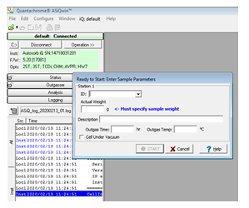
Be sure the dewar, P0 cell and coolant detector are all in place before selecting begin analysis.
Use the iQ default drop down to select start analysis. This will prompt you to enter the post-outgassing weight for each sample, if you saved the outgassing data you can select your sample from the dropdown, otherwise enter all 3 weights to determine the sample mass in the cell. You should have a prompt for each active station in your analysis program.

Once you have entered all the sample weights and selected Start, the initialization process will begin. It is very difficult to get the tool to abort a process during the initialization phase, double check cells are not angled, and all settings are correct before selecting start.
SAMPLE CELLS MUST BE VERTICAL AND STRAIGHT TO AVOID COLLISION WITH DEWAR LIP
Users should be prepared to remain in the lab until the bath rises. If you have changed gasses from the previous use of the tool this process may take up to 90 minutes. If you are not changing gasses this process should be 30-60 minutes. If a station fails the leak test the tool will return to idle in approximately 30 minutes from the failed test. Watch the tool status in the instrument log for details on the progress of the initialization process.
You can monitor the progress using the online screen capture, see tool page for link. This doesn’t always update instantly though, in person is easier.

Once the blue light behind the P0 cell is on indicating the sensor is in the coolant, you can expect the analysis to run. Unless a cell was broken during the bath rising, the analysis will begin at this point.
Be prepared to check on your progress after a maximum of 12-24 hours. You can always adjust your logoff time with notes indicating the actual end time (check the status log for actual end time).
At the completion of an analysis, users should allow cells to return to room temperature before unloading. Cold cells will be more brittle than room temperature cells and may fracture more easily.

Broken glassware should be reported to NRF staff immediately. DO NOT dispose of broken glass in the garbage. There is a box for broken glassware in labs 233 and 228, Staff should assist users when cleaning up and disposing of broken glassware.

Krypton Adsorbate
You need to log into the analysis TUMI login, And the Kr port login or gas will not flow. Open Kr tank before beginning analysis, it should be closed between uses.
Kr is usually used for measuring very low surface areas (<1m²/g) with more precision than N2 measurements can provide. For screenshots and more detailed descriptions of the settings options in the setup window visit the N2 setup instructions. The Kr analysis is similar with some modifications required as noted.
Use the iQ default dropdown to edit analysis parameters. This will open the conditions tab for the analysis. To load the generic Kr settings select the Load/Save and load 0NRF_Phys_Kr then verify settings as discussed below.
In the bottom left corner select which stations you have samples loaded on. The red status bar will go away when there are no parameter errors remaining (but this doesn’t mean it is set correctly for your process, just correct enough to be saved).
**Important Change from N2: The P0 setting must be changed to “User Entered” and the entered value should be 2.63 this is very important, incorrect values will result in broken labware or tool failures. Be sure to remove the P0 cell from the station and plug with a 6mm metal dowel.
**It is recommended to use the following point settings when running Kr: Tol 0 and Equ 5
Kr gas can not be run at P/P0 values greater than 0.30, the appropriate range for data points during a Kr analysis is 0.05-0.3.
Kr analysis is run at Liquid nitrogen temperatures (some facilities may run with liquid argon, we are not set up for this, but can accommodate if you’d like to bring your own liquid argon). If you require a different setup than we have in our lab, please discuss your needs with NRF staff.
As with N2 analysis, the thermometer is required to be in place before beginning the analysis. Place the filled dewar on the lift, double check all sample cells are vertical and not angled.
Users should expect the initialization process to take 60-90 minutes as you will likely be using a new gas. Please remain in the lab with your process until the blue bath light comes on. At this point it is likely the analysis will run as expected. Be prepared to check on your progress after 12-24 hours. You can always adjust your logoff time with notes indicating the actual end time (check the status log for actual end time).

Please close the Kr tank after use, this will help prevent leaks and helps keep costs down.

Xenon Adsorbate
Sample Prep
- Follow the typical weighing routine as outlined in base SOP
- Outgas samples as needed, ensure they pass the completion test (20-30 mtorr/min), if routine timed out before passing test, rerunning routine is suggested.
Analysis setup
- Select Xe gas on analysis window
- P0 options: User Entered (remove the P0 cell and store with thermometer) use value of 765 (or look up current atmospheric pressure in a weather app and convert to torr). Note: It is not recommended to run this process if strong pressure changes (storms) are expected during the duration of the run.
- Remove the blue door to analysis ports. Use the chiller dewar stage and ensure water is in the dewar connected to the chiller. Remove the cryo-thermometer and connect the float sensor. (see CO2 setup for images on what this should look like).
- Set the temperature on the circulator to Target Temp and ensure heating/cooling is selected as needed. Allow this to reach the target temp before any analysis is started. (We have gas parameters for Xe at 25C and 0C loaded in the adsorbate options)
- Select the P/P0 points needed to determine properties of interest.
- It is always recommended to run measurements with the filler rod whenever possible.
- Ensure Xe tank is open, and analysis login is activated before beginning the analysis
- Collected data should be viewed in absolute pressure (right click on graph, Graphs>Isotherm>Absolute pressure)

Using the Vevor Chiller
To use the Vevor chiller and attached water bath, you must remove the analysis chamber door. Open door ¾ of way and gently lift off the hinges. Store the door near the corner of the room under the window out of the walkway.
When using the water bath, you must replace the thermometer sensor with the liquid float sensor.
Double check if your routine needs the P0 cell or a specific pressure value to be input before starting our analysis.
Fill the water bath with solution, pure water is preferred for experiments above 1C, saltwater is recommended for experiments below 1C, experiments below -5C may need an ethylene glycol bath, contact staff to arrange this.
- To turn on the chiller, flip the main power switch on the back of the unit display.
- Turn on the display power on the front of the display panel
- Press “set” to set desired temperature, units are in degrees C. Use < arrow to select digit, then ^/v to set value.
- Press set again to set duration, leave as zero for continuous.
- Press set one final time to return to main display
- Press Circulate to begin circulation of coolant
- Place filled waterbath on stand on the dewar stage of the Autosorb
To ensure constant temperature, press the snowflake icon to ensure cooling is active. If cooling is not active, bath will not maintain constant temperature.
When ending a session with the chiller
- Turn off circulation
- Power off Display – button on front panel
- Turn off main power – back of display panel
- **EMPTY THE WATERBATH – salt water and pure water can go down the drain. Do not dump glycol mixture in drain, ask staff to assist in saving for reuse.

CO2 Adsorbate
Follow these steps prior to weighing and setting up your sample cells. It takes 60+ minutes for the system to cool before analysis should begin.
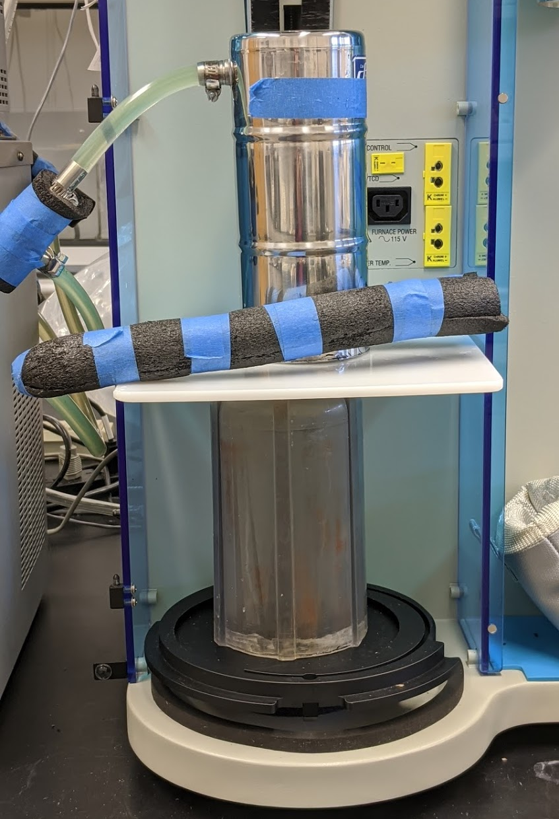
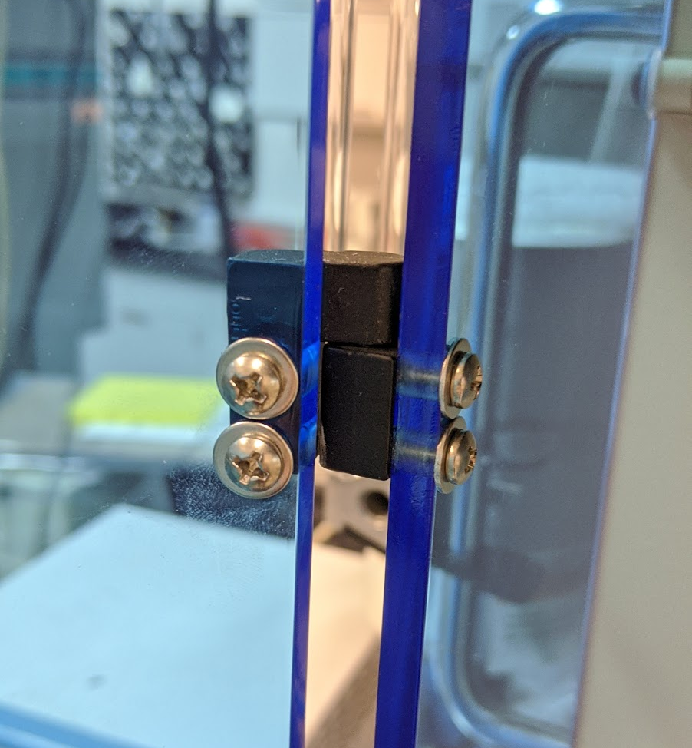
The Routine for CO2 is very similar to the routine demonstrated during training, however because of the low liquid nitrogen temperatures, it is not suitable as a coolant for CO2 routines. Instead, we will use cold water, and the recirculating coolant to keep the solution in the dewar at a consistent temperature. This requires the removal of the blue door. With the door open ¾ of the way, gently lift the door off the hinge and set aside in a safe place (in the corner near the H2 tank is a good out of the way place).

The dewar we will use should be placed on the clear plastic spacer as shown. There is assembly has raised features to ensure proper alignment. Be sure the clear plastic base is securely around the inner ring in the base, and the dewar is securely around the raised feature on the white plate.

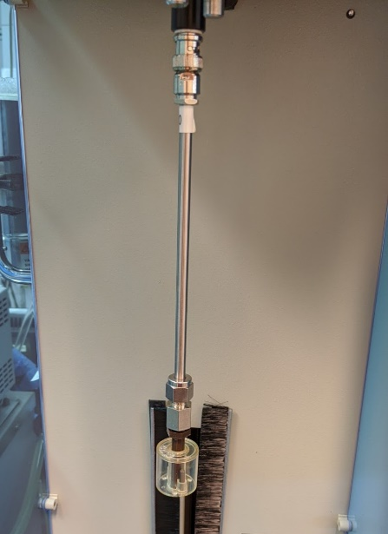
With this configuration we will not use the thermometer, but will instead use the float sensor, the float sensor should be place on the same connection that you would typically place the thermometer. This will ensure the cells are submerged in the cooled water during the experiment and should keep the dewar from lifting far enough to contact and damage the cells.

The internal temperature should be at target temp before you begin your analysis to ensure constant conditions.

The chiller will need to be turned on and allowed to cool prior to beginning your analysis to ensure constant temperature during analysis. You should fill the dewar with desired solution (saltwater is generally recommended), and turn on the chiller. The setpoint for CO2 analysis should be -1°C from target temp (set to -1 for a 0C analysis). It will take approximately 60 minutes for the coolant to reach 0°C. You can begin this process prior to setting up your analysis parameters.
**Be sure you set CO2 as your adsorbate in the software. The Po cell is not used during CO2 analysis, be sure to remove this if it is installed, and plug the port with a metal dowel.

CO2 Checklist:
- Float sensor in place
- Po Cell removed, and port plugged
- Dewar filled to fill line with CO2 Coolant Solution
- Chiller at target temp prior to beginning analysis
- Samples loaded, unused ports and outgassing stations plugged
- Correct adsorbate selected in program routine

When analysis is complete, place float sensor back in sensor drawer, turn off chiller, return coolant solution in dewar to storage container. The empty dewar can be stored between the autosorb and the chiller once it is empty. Return the door to the machine.

Chemisorption

NRF staff currently does not have a SOP for chemisorption. We have not had users ask for this process, yet. If you would like to run a chemisorption experiment, please work with staff to review settings and an SOP will be generated.

Cleanup
At the completion of your tool use, please return the tool to the following state:
- Coolant sensor (for liquid nitrogen) in place
- P0 cell on the station
- All analysis and outgassing stations plugged with 6 or 9mm metal dowels.
- Empty the dewars, saltwater should go into the sink, Leftover liquid nitrogen should go into the plastic disposal bin under the workstation.

** Sample cells should be rinsed and free of particulates from your samples. There are pipe cleaners and brushes available in lab 222 to aid in cleaning if necessary. A sonic bath is available in lab 239, the sample cells fit diagonally in this bath, but should be filled with water prior to adding them to the bath. Be sure the bath level is to the corner dent before starting (water level should be roughly 1cm or less below top of the bath).

Sample cells washed with water should get a DI water rinse followed by a final IPA rinse and wipedown of the external surface to avoid water spots from forming. Properly rinsed cells can be placed in the drying oven in lab 224. There is an aluminum boat that the sample cells can lay in inside while in the oven for drying. If you are using NRF sample cells, notify staff you have left cells in the oven to dry if you do not intend to stay in the lab while they dry. If you are using your groups cells, please return after drying to store your cells. You can use a sharpie to indicate which group owns the cells in the boat if leaving them unattended. Abandoned cells will be added to the NRF supply.
**We provide unattended sample forms, which should accompany any samples left unattended in the lab, but may also be repurposed to identify lab cells if you leave your groups cells unattended while drying.

Log off the analysis station, using the adjustment to adjust logoff time to actual run end time. Please verify in the log when tool returned to idle state and use this in your calculation. It helps if you include this end time in your logoff notes.
Log off the Kr station if used. An adjustment for time on the Kr logoff is not necessary, but it is helpful if you include the analysis time and # of samples in the notes. In the event of a necessary rate change, this helps us determine actual use per sample. We currently do not have additional charges for Kr, we use this for recordkeeping.

Log off the monitor station when done with the PC. Please do not adjust this time, there is no charge for use of the monitor station.

Clean counters of any sample debris, and please discard or remove your sample material from the lab.
Please send logoff notes to the staff, or email separately to NRFinfo indicating you have completed your work. The cold trap cell should be cleaned between users.

