

Ulvac PHI Versaprobe II XPS

Standard Operating Procedure Rev. 2026-01

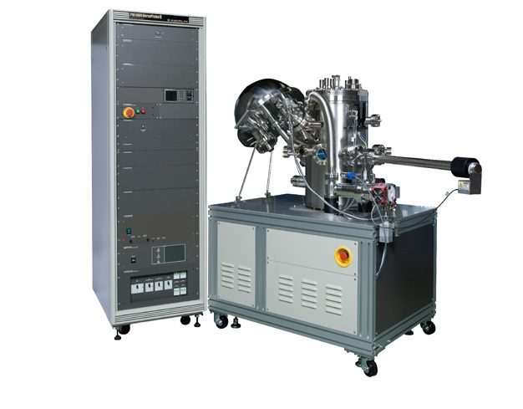

  - Application

The core technology of the VersaProbe II is PHI’s patented, monochromatic, micro-focused, scanning x-ray source which provides excellent large area and superior micro-area spectroscopy performance. Standard features include PHI’s patented dual beam charge neutralization technology, a floating column Ar ion gun for XPS sputter depth profiling, angle resolved XPS and a cold stage for temperature dependent studies.
  - NRF Contact

David Hays
Table of Contents
1. Safety information 3
2. Prerequisites for use 3
3. Sample Restrictions 4
4. Software Layout 4
5. Start Up 4
6. Sample Mounting 5
7. Tool Operation 5
7.1. Sample Loading 5
7.2. Sample Set-up 8
7.3. Collecting XPS Spectrum 10
7.4. XPS Depth Profile 13
7.5. Unloading Sample 13
8. Ending The Session 14

- Safety information
- High Voltage - High Voltage is used throughout the system. System maintenance may only be performed by NRF Staff. Do not remove any tool covers or defeat any interlock on this system.
- Prerequisites for use
- User of the RSC facilities.
- Up-to-date hazardous waste training.
- Training by staff.
- User will be responsible for lost or damaged equipment due to negligence. Negligence means not following the SOP, not asking staff for assistance, intentionally damaging items, etc.
- Sample Restrictions
    - Sample MUST be compatible with ultra-high vacuum.
    - No sample may extend past the edge of the sample holder.
    - Sample MUST be less than 5mm in height.
    - Height difference between samples on the same holder must be less than 1mm.
- Software Layout
    - The software features the main session tabs at the top of the window and application tabs on the right side. Selecting one of the session tabs will change the application tabs that are available.
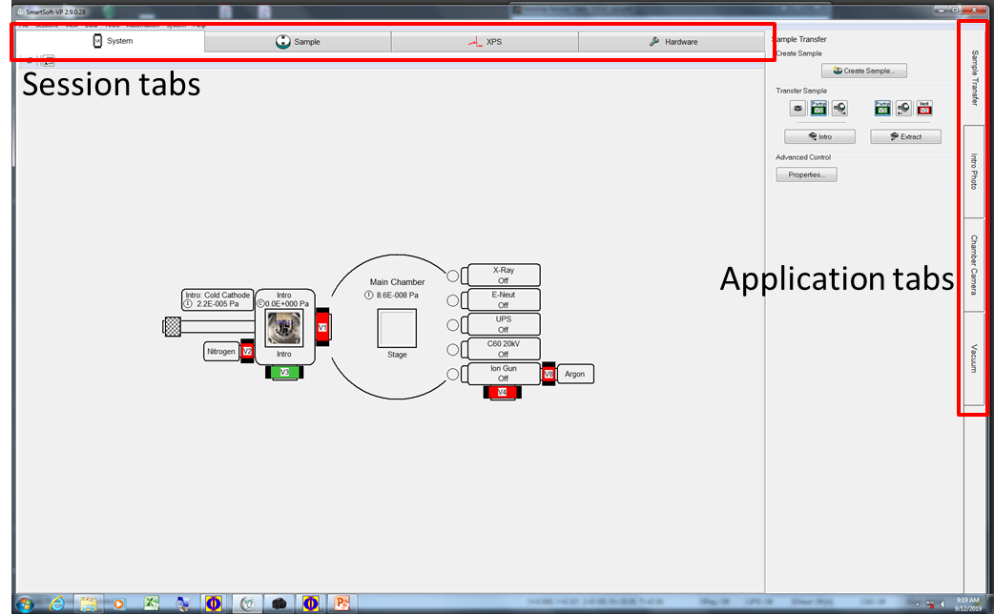
- Start Up
    - Log in to TUMI.
    - Start the Smartsoft software if not already open.
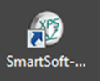
- Sample Mounting
    - Samples must be mounted on a holder using the double-sided tape that is provided, or use the metal masks. Users can only use the 25mm or 60mm holders.
        - 25mm holder - Normal use
        - 60mm holder - For large samples or to analyze a lot of samples at once (*Stage tilt angle is fixed to 45 degrees when in use*)
    - Do not touch your sample, the holder, or the business end of any tweezers with your bare fingers. Always use gloves and tweezers to mount and manipulate the sample and holder.
- Tool Operation
  - Sample Loading
    - Go to the ‘System’ session tab and click on the ‘Sample transfer’ application tab.
    - Click the ‘Create sample’ button and input a new platen name. The typical convention used is a YYMMDD format, but can be any text or numbers that you wish to use.
    - The ‘Data Manager Properties’ window will pop up and you can select the correct holder type (25mm or 60mm) from the pull-down menu.
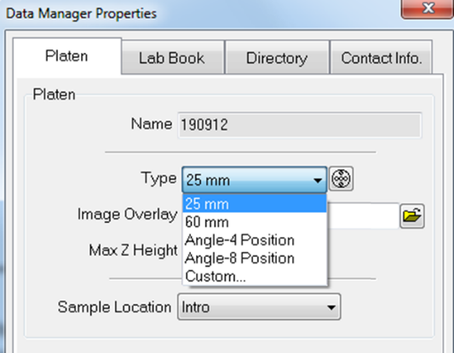
    - Click on the ‘Directory’ tab in the properties window to select, or create the location to store your data. All data must be stored in a subdirectory of C:\Data Files\Users. Use the ‘Browse’ button to open the file explorer window and close the ‘Properties’ window when done.
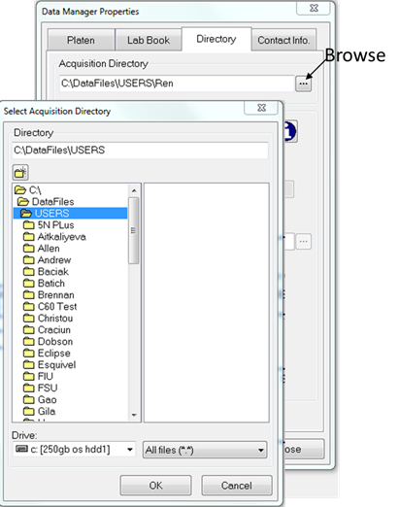
    - While still in the ‘System’ session tab, click on the ‘Vacuum’ application tab.
    - Select ‘Backfill intro’ from the ‘Task’ pull-down menu. Then click on ‘Process Task’. This will vent the intro chamber (loadlock chamber).
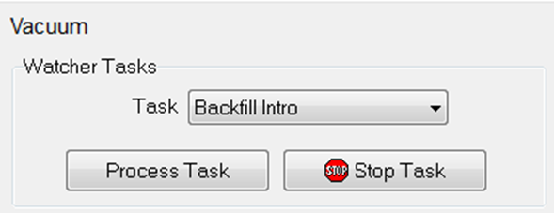
- Or right-click on the intro chamber and select “Backfill intro”.
    - Remove the cap and place upside down on a surface. Do not put the sealing surface of the cap in contact with another surface.
    - Use the large tweezers hanging from the transfer arm to grab the holder and place it on the fork of the intro rod as shown in step 3 in the image below.
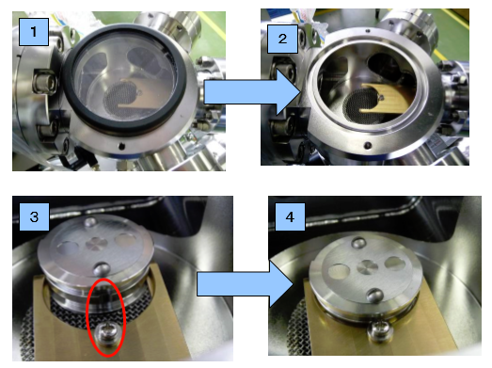
    - Ensure that the indented part of the holder is aligned to the screw as shown in the red circle. Slide the holder all the way back to the aligning screw as shown in step 4 above. Ensure that it is locked by trying to rotate the holder.
    - For the 65mm holder, look through the side viewport and confirm that the arm forks are in the slot of the holder (like image A) and not just sitting on top (like image B). Also ensure that it is locked on the aligning screw by trying to rotate the holder.
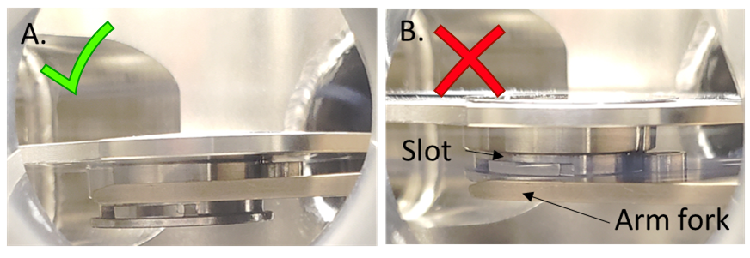
    - Leave the cover off and click the ‘Intro’ button.
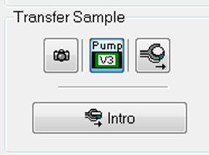
    - Click OK for the dialogue box. The Intro camera will take a photo.
    - Put the Intro lid back on, then click OK in the dialog box to start pumping.
    - After reaching the set pressure, another dialog box will open. Click OK and the stage moves to the transfer position and V1 opens then the dialog box below will open.
      - Watch inside the analysis chamber through the view port while slowly pushing the Transfer rod (red box) into the chamber until you hit the stop collar (red circle).
      - You can now click OK and the stage will move up to dock with the sample.
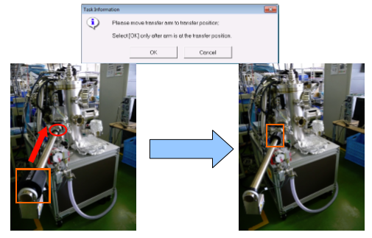
    - Watching through the viewing port, slowly pull the intro rod back completely. V1 should close automatically when the rod is completely withdrawn.
- If you see that the sample is moving back with the arm, then push it all the way back in and try pulling out again.

    - Click the OK button in the message dialog to center the stage.
  - Sample Set-up
    - Go to the ‘Sample’ session tab and click on the ‘Z-align’ application tab.
    - In the left region of the screen, you will see the photograph of the sample holder taken during the intro step. Place the cursor on a location you would like to analyze and right click on the mouse. Select ‘Create point’ from the menu.
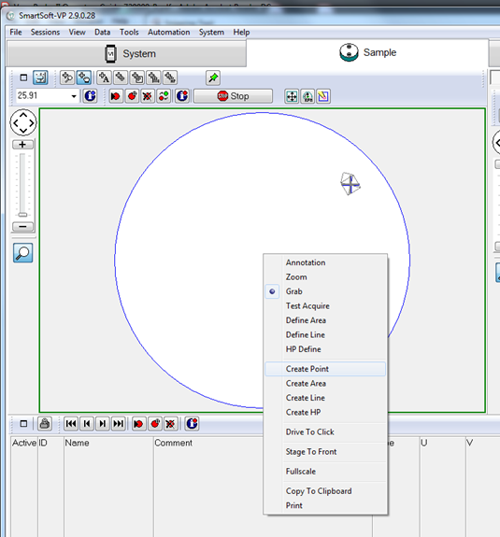
    - Measurement locations will be added to the table at the bottom. Repeat the process for other locations.
    - Z-alignment
- De-select all of the check marks in the ‘Active’ column on the list except for one.
- Press the ‘Drive to position’ button
- Press the ‘Properties’ button near the Z-align tab and graph window will appear.
- Press the ‘Z-align’ button.

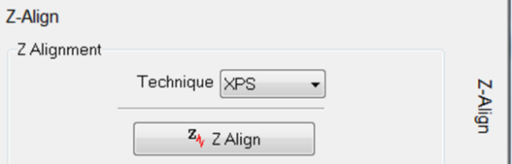
    - Ensure that the alignment was able to find the peak (green line passes through the peak) as shown below. It sometimes fails, so just press the ‘Z-align’ button again if it does.
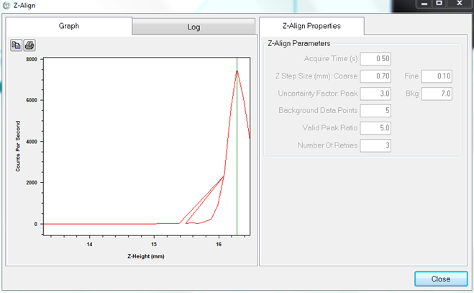
    - Press the ‘Update position’ button to save the new aligned position.
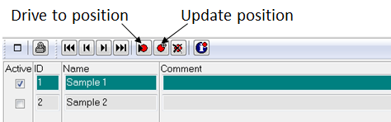
    - Repeat for all other locations.
  - Collecting XPS Spectrum
    - Go to the ‘XPS’ session tab and then the ‘Spectrum’ application tab.
    - Choose the Xray Setting from the drop-down menu that fits your analysis area and application
    - There are two modes to be used for analysis, Survey or Multiplex.
- Survey - used for surface qualitative analysis (i.e. what elements are present)
- Multiplex – used for quantitative or chemical state analysis

    - There are two ways to set up the survey and multiplex analysis regions.
- Go to the “regions” area of the screen and click on the periodic table
- On the new periodic table, click the ‘Acquisition setup’ tab.
- Select “Su” for a survey and select any elements that you wish to analyze
- Go to the “regions” area of the screen and use the plus/minus buttons to add or subtract region cells
- Select the first cell and right click on the mouse, hover over “All elements”, and select “Su” for a survey
- Do the same for all cells but select an element instead of Su
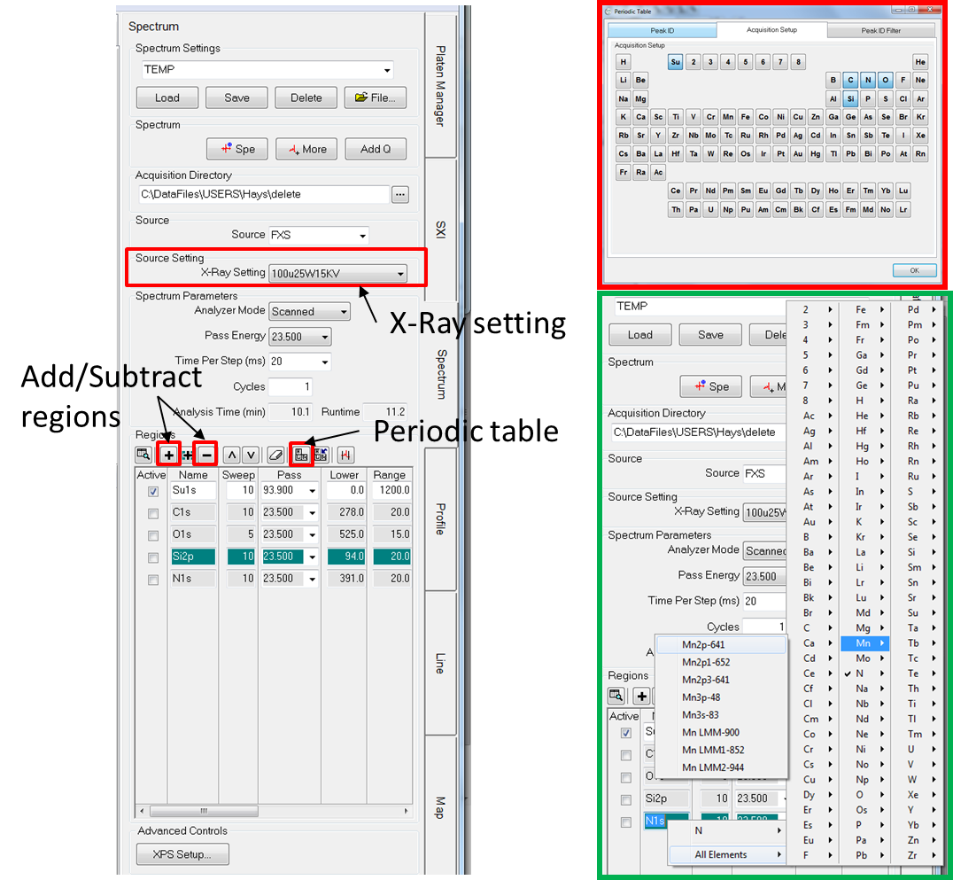
    - You can change the transition to be measured by right clicking on the element and choosing another transisition. For example, you can choose to measure the Si2s or Si2p peaks in the figure below.
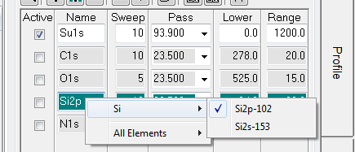
    - Set the analysis conditions.
      - Sweeps – The number of times to scan the energy range of interest. Typically 5-10
      - Set the energy range using the “lower, range, and upper” cells
      - Pass energy – Typically 93 or greater for survey, and 23.5 for multiplex. A higher number provides good signal to noise for qualitative analysis and lower numbers provide better resolution for chemical state analysis (at the cost of lower counts).
      - Typically keep the defaults for ev/step and time per step for multiplex, and make it 0.8ev/step for surveys.
    - Click on the box under “Active” for the survey
    - Ensure that charge neutralization is set to automatic.
- Click on the ‘XPS setup” button.
- Click on “Auto” for both E-neutralization and Ion gun.
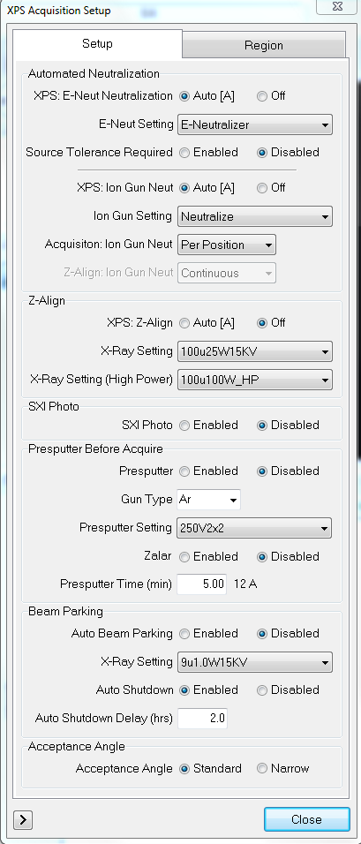

    - A pre-sputter can also be set up in this window to clean of any surface contamination.
    - Click ‘Enabled’ and select the Pre-sputter setting from the drop-down menu for a specific removal rate
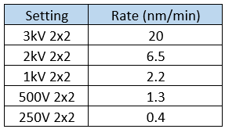
    - Enter a Presputter time and click ‘Close’
    - Click on the ‘Spe’ button the start the survey scan
    - Now de-select the box for survey and select all of the other elements for the multiplex analysis
    - Click on the ‘Spe’ button to start the multiplex scan
    - All data is immediately available in the PHI Multipak software for processing. See Appendix A for basic data analysis using Multipak.
  - XPS Depth Profile
    - Go to the ‘XPS’ session tab and then the ‘Profile’ application tab.
    - Set up the regions and conditions the same way as in Section 7.3.
    - Click on ‘Sputter rate table’
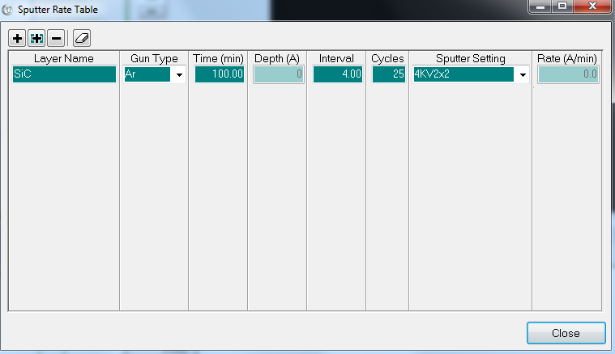
    - Select the ‘Sputter Setting’ from the drop-down menu. The selections and rates are the same as Section 6.
    - Enter a time, interval and number of cycles and click on ‘Close’.
    - Click on the ‘Profile’ button to begin the scan
  - Unloading Sample
    - Go to the ‘System’ session tab and click on the ‘Sample transfer’ application tab.
    - Click on the ‘Extract’ button.
    - After the intro chamber is pumped down, the gate valve will open and a dialog box will appear asking to move the arm in.
- Slide the transfer arm all the way until it touches the stop collar and click OK
    - The stage will lower the holder on to the transfer arm and another dialog box will appear asking to move the arm out.
- Watching through the viewing port, slowly pull the intro rod back completely. V1 should close automatically when the rod is completely withdrawn. Click the OK button in the message dialog to center the stage.
- If you see that the sample starts to come off the arm, then push it all the way back in and try pulling out again.
    - The intro chamber will automatically vent. When the lid pops up, use the metal tweezers and remove the holder.
- Ending The Session
    - While still in the ‘System’ session tab, click on the ‘Vacuum’ application tab.
    - Select ‘Pump intro’ from the ‘Task’ pull-down menu. Then click on ‘Process Task’. This will pump down the intro chamber (loadlock chamber).
- Or right-click on the intro chamber and select “Pump Into”
    - Log out of the TUMI

