
Perkin Elmer Lambda 800UV/Vis
  - Standard Operating Procedure (SOP)
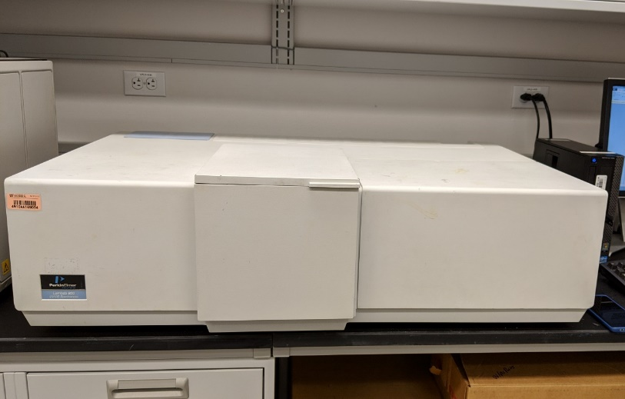
  - Application
The Perkin-Elmer Lambda 800 UV/Vis spectrometer is a twin beam research grade grating instrument. The Lambda 800 has a liquid module and an integrating sphere for measuring absorption/transmission, or reflection (integrating sphere only) on liquid or solid samples. The wavelength range is 175-900nm. NRF supplies acrylic and polystyrene cuvettes, for use with liquid module. Users must verify chemical compatibility with their samples before use. .**Please note our Spectralon standards are uncalibrated and reflection data acquired with this tool is considered relative and not absolute.

Contents
Lab Safety 3
Preparation 3
Module Selection 3
Instrument Preparation 3
Instrument Purging 3
Software Startup 3
Liquid Module Setup 4
Cuvette Selection 4
Cuvette Loading 4
Integrating Sphere Setup 5
Sample Preparation: Integrating Sphere 5
Alignment 6
Data Collection 7
Scan Setup 7
Running the Scan 9
Analyzing and Exporting the Data 10
System Shutdown 10

Lab Safety
This lab includes a mercury intrusion porosimeter (MIP). This tool, as the name implies, uses mercury and in some cases it may be under pressure. When the MIP is in use ALL room occupants should be wearing safety glasses.
The corner of the room the MIP is located in has been marked off by yellow caution tape. Please do not enter this section of the room if you are not using the MIP. If you inadvertently enter, remember to step on the tacky floor mats upon exiting to ensure no mercury leaves the space. If you need access to a hood there are hoods available for use in 222 and 224 across the hallway.

Preparation

Module Selection
NRF staff will attempt to keep the module status (Cuvette or Integrating Sphere) updated on the tool status page. If you need the module changed for your reservation please contact a staff member with date and time of reservation so we can ensure it is ready for you. If you arrive and the wrong module is in place, please ask for staff to change it, this only takes ~5minutes.
Instrument Preparation
Turn on the UV-Vis system using the green power toggle switch located on the top of the instrument housing in the back-right corner. The system should be given approximately 30 minutes to stabilize before use, to allow lamps and detectors to stabilize before collecting data. You can turn on the system without being logged in to the TUMI station.

Instrument Purging
For best accuracy on measurements below 190nm and water vapor adsorption, the instrument should be purged with N2. For analysis using N2, users will need to make arrangements with RSC staff as the N2 connection is inside the MIP caution area.

Software Startup
The desktop computer user UVV Administrator requires no password to log on. Open “PerkinElmer UV WinLab” on the Desktop. If you have just turned on the instrument, wait at least 1 minute before opening the UV WinLab software. Select Analyst from the user name selection dropdown. See Page 42 of the software user guide for detailed explanations of buttons and basic software functionality. The Software guide is available for reference C:Users/Public/Public Documents/PerkinElmer

Liquid Module Setup
Cuvettes Realize that for liquids or solids measured in transmission there are both absorbance and scattering phenomenon affecting the collected data. For best absorbance data the solution/sample should be transparent throughout the wavelength range. Recall, the maximum scattering occurs at flaws or particle sizes approximately ½ the wavelength being scanned. DI water is supplied (via gray faucets) for dilution. Disposable polyethylene transfer pipets and kimwipes are supplied in room 239 for use. Pipettes are available, but precision is not guaranteed as they are multi-user tools. Users are welcome to bring additional solvents/supplies for dilution; storage space in room 239 will be assessed on a case-by-case basis. See Section 7 for Waste Disposal.

Cuvette Selection
The NRF provides 4-sided polystyrene, 10mm path length acrylic or polystyrene cuvettes. It is the user’s responsibility to ensure chemical compatibility with the cells/cuvettes in use as well as wavelength range. Polystyrene (PS): 340-800nm, Acrylic (PMMA): 280-800nm. (PS in rack look slightly blue, PMMA are clearer to slightly yellow) Cells should be held by the top edges to avoid fingerprints on the optical surfaces. Ensure there are no bubbles in the sample in the cell, bubbles will influence results.

Cuvette Loading
Fill two cuvettes with your base solvent (reference), cap them and load them into the cuvette holders, close the lid to the sample compartment. With plastic cuvettes, the face of the cuvette (side with the arrow) should be facing to the left, towards the direction of the light source, as you insert. Only stoppered cuvettes should be loaded into the machine. If a spill occurs, blot immediately to avoid liquid damage to interior coating. Do not rub or scrub the black coating, do not try to remove any existing spots. With glass or quartz cuvettes, ensure orientation is preserved between calibration and analysis. Sample cell windows are Silica, an optical component, do not touch the windows, and do not attempt to clean the windows. Should a splash or spill occur on or near a window, optical lens wipes must be used for cleaning.
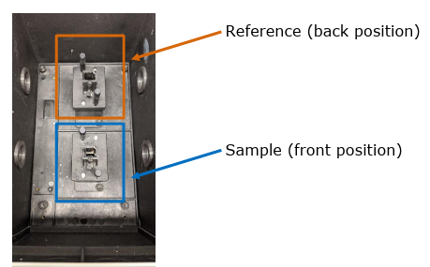
Continue to the Alignment section.

Integrating Sphere Setup

Sample Preparation: Integrating Sphere
Integrating sphere samples will need to be a minimum of 1-inch diameter to cover the sample port completely. Bulk solid samples can be taped directly onto the analysis port, no additional prep is required. Samples should not be loaded until after the alignment is complete. Contact RSC staff if you have powder samples or your sample does not meet the minimum dimensions. Smaller sample holders are available, samples needing smaller adapters may be more difficult to collect data from.
The integrating sphere has 3 ports with spring loaded sample/reference holders. Below each is a small piece of foam to help prevent slipping of samples or reference pucks. To perform an alignment you will need to place the two pure white reference standards on ports B and C.
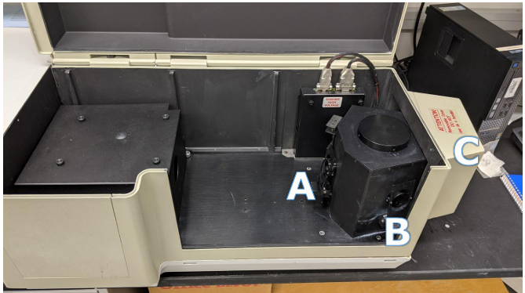

Alignment
Ensure proper beam alignment by using the Align icon in the top menu bar. To do this, select Align.
The button will go gray and not allow you to select again until the alignment has finished and the beam is now ON and visible light is moving through the system. Wait until alignment adjustments have finished, and machine is Idle, to check the location of the beam.
You will want to check the beam position by placing a piece of white paper:
- In front of the cuvettes if using the liquid module, then between the cuvettes and the Silica window to ensure the cuvettes are in proper positions in the beam.
- In the A position holder if using the integrating sphere, then remove the paper and look inside the integrating sphere at the standards in position B and C, you should see beam footprints, they may not be the same size/shape, this is fine as long as they are both rectangular.
Check that the beam is a rectangular shape and not being cut off on both the sample beam path and the reference beam path. If something looks cut off, please contact NRF staff.
Deselect the Align icon when you have confirmed the proper beam position to turn off the beam to return the tool to a ready state. Do not remove the cuvettes or reference standards yet, you will need these as they are for the corrections.

Data Collection
The system is designed to allow users to define specific methods, however we have a basic scan method preset and ready for use. If you need an experimental setup different from or more complex than a typical scan please consult with staff.

Scan Setup
There is a scan button on the left side of the software screen, this should be selected to open the scan parameters setup. The setup is the same for scans using the cuvette holders or the integrating sphere, and despite the illustrations not changing, scans using the integrating sphere will run correctly following this setup. Select Data Collection under folders list to adjust the measurement parameters shown below.
a. Method Settings: Scanning Range: Scans from higher to lower wavelength Available wavelength: 175 – 900 nm
b. Method Settings: Scanning Intervals/Speed: How much data to be received o Data interval range: 0.01 – 10 nm Ordinate mode options: A (absorbance), %T (transmittance), E1 (energy from sample beam), E2 (energy from reference beam), %R (reflectance)
c. Cycles: Number of Scans/Interval
d. Monochromator: Wavelength of pure light desired
e. Slits: Adjust the slit size
f. CBM: Adjusts the beam height to match different dimension samples
g. CBD: Beam correction for instrument polarization in birefringent samples
h. Attenuators: Adjust when measuring on high absorbing samples

The Program page is an “expert mode” that allows you to create a custom setup of the instrument. The following settings are available for programming: UV/Vis detector response, UV slit width, sample beam attenuator, and reference beam attenuator. The respective items must be set to “Programmed” on the Data Collection page to define settings on the Program page. See the Software guide (page 417) for additional information.
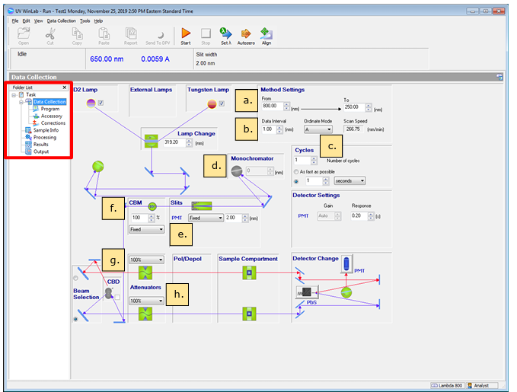
Notice: It can be helpful to attenuate the reference beam path in high absorbance materials so that the reference signal does not swamp the desired signal for analysis. Note the attenuator setting above. 1) Enter the Data Collection tab in the software 2) Set the attenuator on the reference beam path to 10%.
Select Corrections (under Data collection tab) to set the baseline and corrections desired. The suggestion is to always run a 100% correction at the start of each session. The 0% correction is difficult and often not necessary. If your sample is highly attenuating (<10% of the total beam is expected to pass through, a 0% correction is recommended). You can set the 100% correction to “as needed” and have it expire after 2-4 hours.
Select Sample Info under folders list to enter the number of samples you have for analysis. We do not recommend marking reference samples you have as standards, you can handle all that in postprocessing. Leave each entry as “sample” under type.
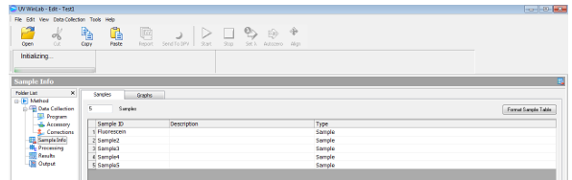
Next, go to Output under folders list and select <Print to file> and <Output to file>. Click the setup option for <Data Export>. You will now get a pop-up page <Export Data> as shown; select all boxes of interest. If applicable, change the <Spectrum Export File (Raw)> and <Spectrum Export File (Processed)> from .SP to .ASC.
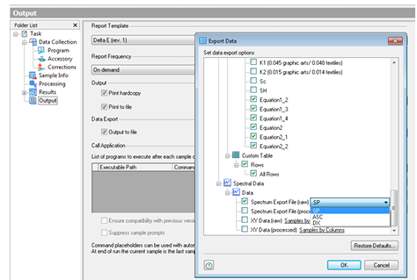
Now click the setup option for <Output> and browse for your destination folder, typically Computer/USER’s Documents/<Folder with your name>.

Running the Scan
When ready to continue, close the lid to the chamber and select the orange start button at the top of the screen. You should still have the standards in ports B and C if using the integrating sphere, or 2 pure solvent samples in the cuvette holders on the liquid module. The software will prompt for you to remove samples for a 100% baseline correction scan. Leave the standards/solvent samples in place and select “OK”. This will allow the instrument to take a reference scan on both beam paths to compare the analysis data to. It is important here to have the solvent in the cuvettes so that any effect from the solvent is not shown in your collected data. Your sample data will be shown as differences from this baseline scan.
After the baseline scan is complete, the software will prompt you to insert your first sample. For the liquid module, remove the cuvette from the front beam path, closest to where you are standing. Then insert the sample cuvette in that beam path. Be sure the solvent cuvette stays in the back beam path. For the integrating sphere, you will place a transparent sample in port A if measuring transmission, leaving the 2 white standard pucks in ports B and C. If you want to measure reflection instead, you will remove the white puck from port C and place your sample in its place, leaving port A empty and port B will still have the other white puck. Close the lid, and select “OK” to being the scan. Additional samples will be prompted for at the end of each scan.

Analyzing and Exporting the Data
Send your data to DVP (Dava viewer and processor) where you can modify your data as needed. The operations here are very basic, and overall manipulation and calculations are easier done in Excel or another software of your choice. To export your data you should create a new folder (on your flash drive) to export CSV data to. You can only export a file once into a given folder, if you need to export again (say you want %T and A) you will need to make a new folder for the second export. You can save your original data file and a copy of the exported data to your personal user folder if needed, however we are not set up for long term secure data storage, so take a copy with you.

System Shutdown
Exit out of the data collection and analysis software programs. Be sure all occurrences are closed. Remove all samples. Turn off the power to the spectrophotometer using the green toggle switch. Put the computer in sleep mode. Log off the instrument in the TUMI

