

Woollam Ellipsometer

Standard Operating Procedure Rev. 2026-01

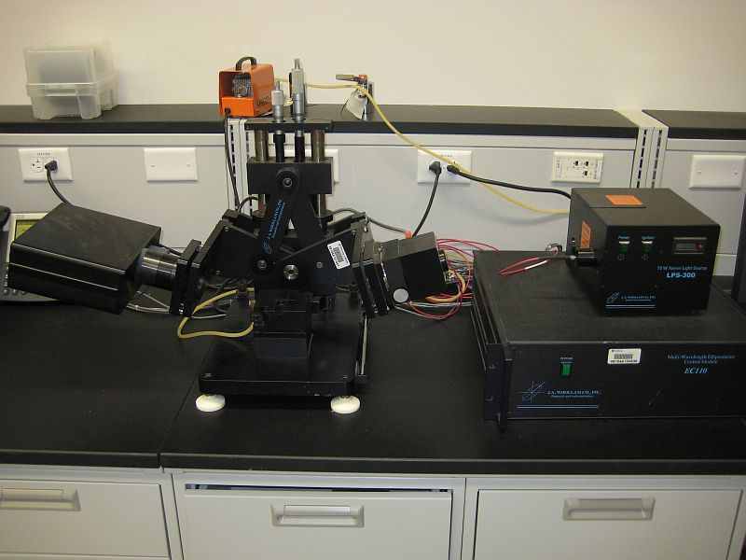

  - Application

The J. A. Woollam M88 is a spectroscopic ellipsometer used to measure film thickness and optical constants of transparent/semi-transparent thin films. It uses a Xenon arc lamp source and measures spectroscopic data over 88 discrete wavelengths from 280-763nm. The tool also offers variable angle of incidence and a spot size adjustment aperture (spot size from ~2cm to 8mm).

  - NRF Contact

David Hays

Table of Contents
1. Safety information 3
2. Prerequisites for use 3
3. Ellipsometer Components 4
4. Operation 4
4.1. Start Up 4
4.2. Sample Loading And Calibration 5
4.3. Scanning The Sample 6
5. Data Analysis 7
5.1. Modelling And Fitting Thickness (single layer, tabulated model) 7
5.2. Modelling And Fitting Thickness And Optical Constants (single, transparent layer, Cauchy model) 10
5.3. Modelling And Fitting Thickness And Optical Constants (single, partially absorbing layer, Cauchy model) 11
6. Saving And Removing Data 15
7. Ending The Session 16

- Safety information
- None
- Prerequisites for use
- User of the RSC facilities.
- Up-to-date hazardous waste training.
- Training by staff.
- User will be responsible for lost or damaged equipment due to negligence. Negligence means not following the SOP, not asking staff for assistance, intentionally damaging items, etc.
- Ellipsometer Components
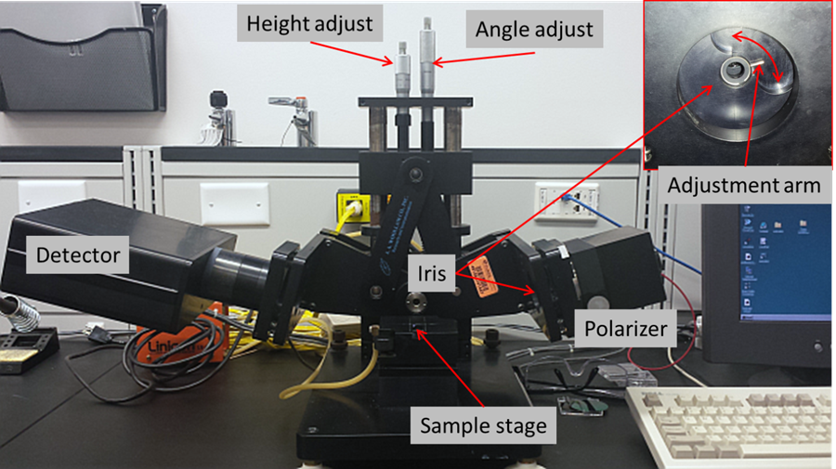
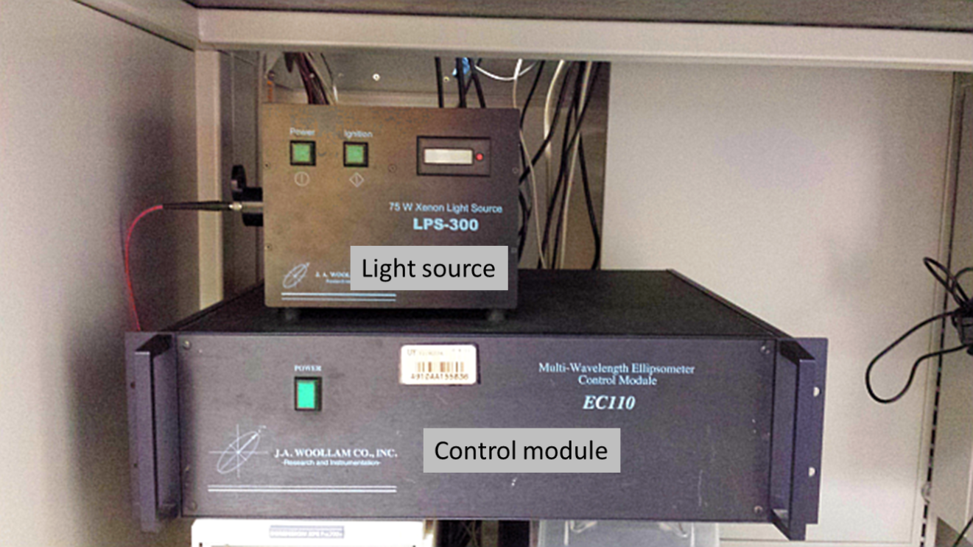
- Operation
  - Start Up
    - Turn on power to the light source LPS-300 and ignite lamp.
    - Note: For the best accuracy, let the lamp warm up for 30 minutes. Start the lamp prior to your TUMI login so you won’t be charged for warmup time.
    - Turn on EC110 control module.
    - Click the WVASE32 icon to start the software.
    - There are six different windows (Model, Hardware, Generated Data, Experimental Data, Fit, and Graph) that can be active and you will need to utilize most of them. The menu bar options will be different depending on which window is active.
  - Sample Loading And Calibration
    - Place the silicon calibration wafer on the stage.
    - Click on “Acquire data” and then “Align sample” from the menu bar.
    - Adjust the stage tilt knobs until the red crosshairs are centered as shown below
    - Press the escape (Esc) button to exit
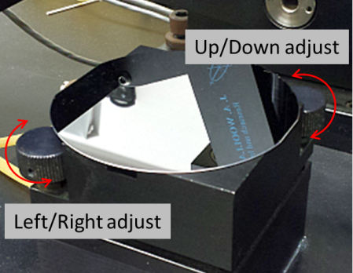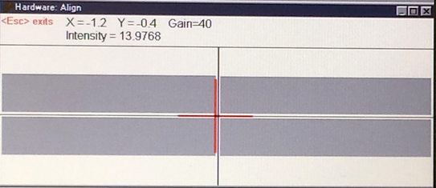
    - Click on “Acquire data” then “Calibrate system” from the menu bar.
    - Select “Normal” and ensure that the angle of incidence is 75° and click “OK”.
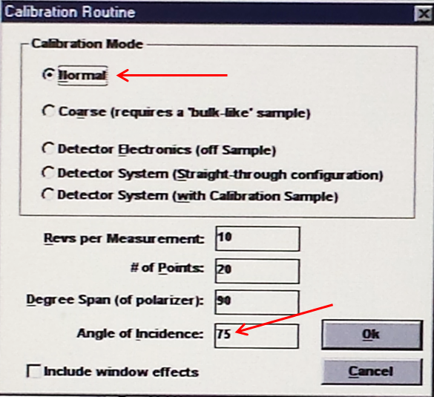
    - It will ask to verify that the angle micrometer is at 35mm (75°). Look at the angle adjustment knob (shown in the component overview) to verify
    - Contact NRF staff if it fails the calibration.
  - Scanning The Sample
    - When the calibration is complete, remove the silicon standard and place your sample to be measured on the stage.
    - Again, click on “Acquire data” then “Align sample” from the menu bar.
    - Center the red crosshair by using the knobs on the stage as before. Always align a sample when moving or replacing it.
    - The entire light beam must be within the sample. For small samples, close the iris until the beam is contained within the extents of the sample.
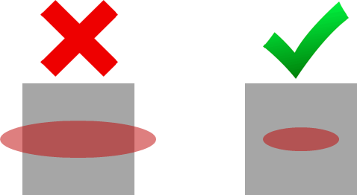
    - For very thick samples, you may need to adjust the height by using the height control knob so that the beam falls on the surface.
    - Click on “Acquire data” then “Spectroscopic scan” from the menu bar and a new window will appear.
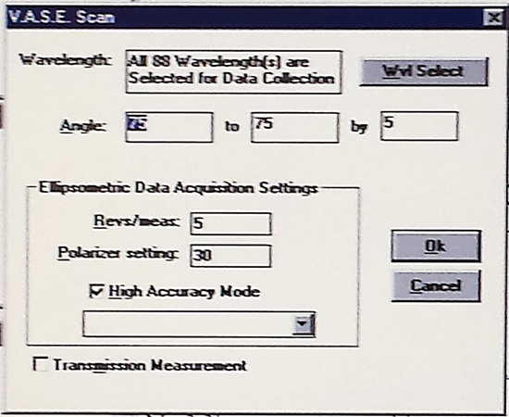
    - Most measurements can be taken at a fixed angle of 75°, and all of the default settings shown above.
Note: For difficult samples and when fitting optical constants, multiple angles may be needed. For multi-angle measurements, set starting angle in first box, final angle in second box and the degree increments in the third box. You will need to adjust the angle micrometer when prompted.
Note: Support the polarizer or detector arm when changing angles. Failure to do so can result in damage to the micrometer.
    - Ensure all 88 wavelengths are selected and click “OK”
    - The scan is extremely fast and the graph will now be populated with the experimental data (Psi and Delta)
    - It may be beneficial to turn off the double axes because the data can get very difficult to analyze as shown in the graph on the left. Single axis (right graph) will make model fitting much easier.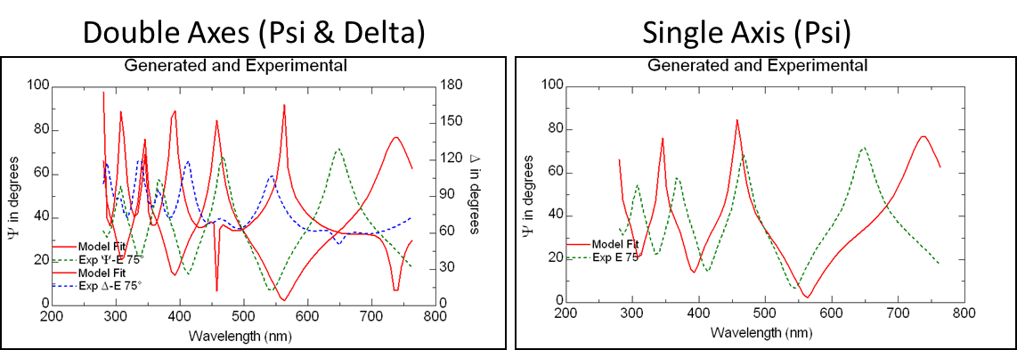
    - To turn off double axes, select the “Graph” window. Click on “Style” then “2D” and then remove the check mark for double Y-axis
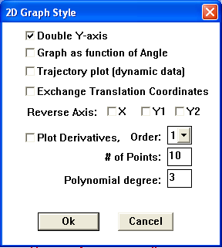
- Data Analysis
  - Modelling And Fitting Thickness (single layer, tabulated model)
    - Select the “Model” window
    - You will need to build a model that represents your sample by the layers that are present. Think of it as looking at your sample in cross-section. Build your model by selecting “Add layer” in the menu bar. The window that opens will contain some commonly used materials. More materials are located in the subfolders and organized by material type.
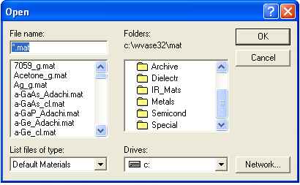
Note: Most material files are tabulated lists of index of refraction/extinction coefficient (n&k) – vs – wavelength. However, n&k can vary with film deposition conditions (or post processing) and your film may not match a specific material file, or your material may not be in the database. In this case, you will need to use a function based model. This will be explained in following section.
    - The following assumes you are using tabulated models. Start with the substrate first and select it from the materials in the list (Silicon shown as an example).
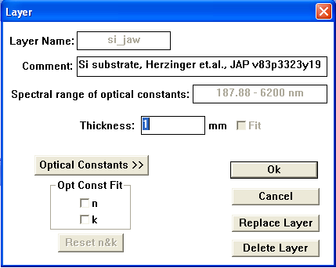
    - If the substrate is non-transparent, then the thickness does not matter (although some materials may become transparent near the IR or UV regions…consult with staff if unsure). Definitely, if it is transparent in the visible then you will need to know the thickness of your substrate
    - Select “Add layer” for the next material (SiO2 shown for example). Enter your initial guess for the thickness now and check the “Fit” box
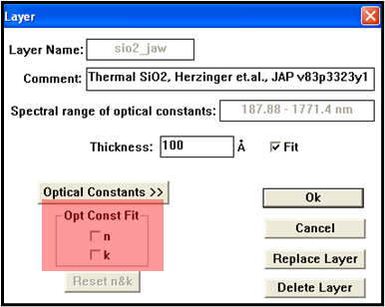
Do not check the n&k boxes!
    - Select the “Generated Data” window.
    - Click on “Generate data” in the menu bar. This will populate the graph with the modeled data and will be shown in red. In the example below, the model (red) does not fit the experimental data (green) very well. This indicates that the thickness guess is off.
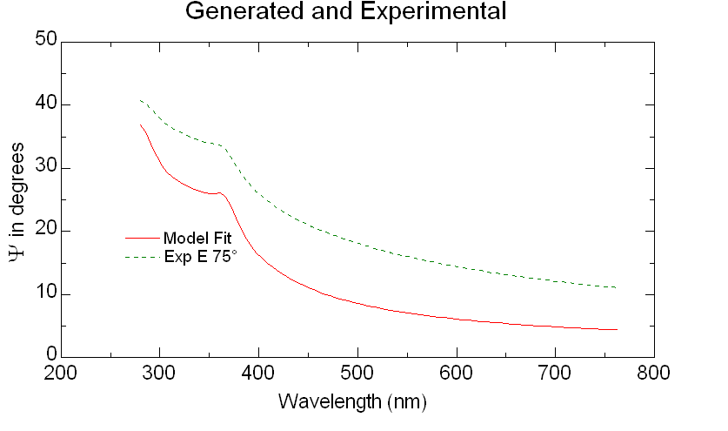
    - Select the “Model” window and click on the film layer. Adjust the thickness up/down.
    - Select the “Generated Data” window again, and click on “Generate data”. Observe if the two data sets begin to converge or not. Repeat until the two sets are closely fit
    - Select the “Fit” window.
    - Click on “Normal Fit” in the menu bar. This will automatically adjust any parameters that you have selected to fit. In this case, it only adjusted thickness. The data should now overlap if the material file constants are close to your film.
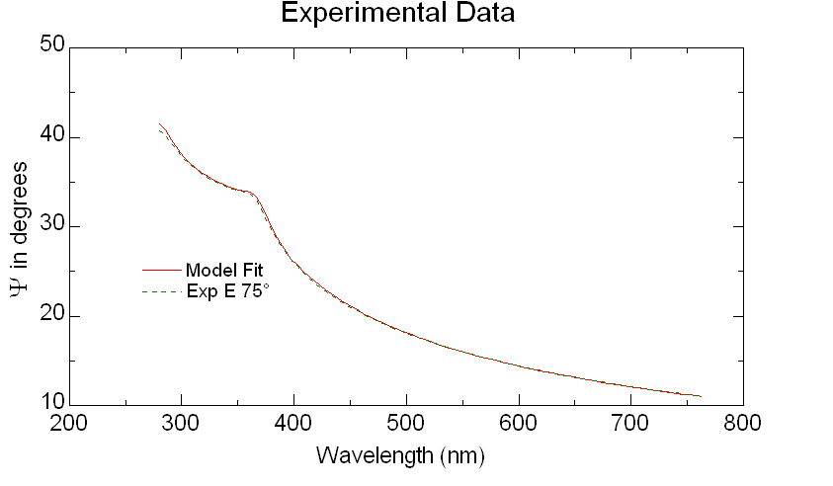
    - Check that the measurement makes sense and that the MSE is small.
  - Modelling And Fitting Thickness And Optical Constants (single, transparent layer, Cauchy model)
    - When fitting optical constants, it is highly recommended to take measurements at multiple angles.
    - The Cauchy model is the most commonly used approach to determine the thickness and index of transparent materials. It is an inverse power series that contains only even terms and creates the dispersion model for the index of refraction only.
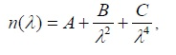
    - Select the “Model” window and load a substrate material, the same as above.
    - Again, select “Add layer” and load the Cauchy.mat file. Specify a value for the “A” term that roughly matches the expected index value and acts as an offset value. The “B” and “C” terms add curvature. Also specify the expected thickness.
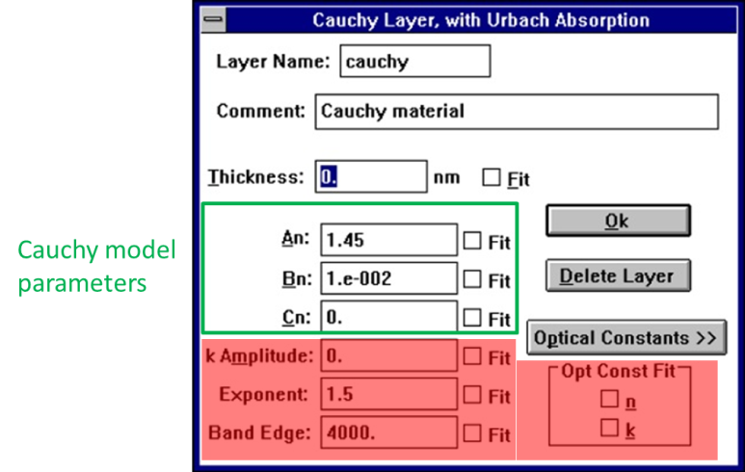
    - Select the “Generated Data” window, and click on “Generate data”. Observe the graph and adjust thickness and click “Generate data” until the model and experimental data are close.
    - In the “Model” window, click on the Cauchy layer again. This time, check the fit boxes for thickness, A, and B.
    - Select “Fit” then “Normal fit” and the two curves should converge.
    - Observe MSE, then open the Cauchy layer again and check the fit box for the “C” term and type a small positive number in the box.
    - Select “Fit” then “Normal fit” and see if the MSE changes significantly.
    - To observe optical constants, open the Cauchy layer, then click on the optical constants button and you will see something similar to the graph below. Verify normal dispersion! See pages 295-298 of the tool manual for interpreting if the index is valid.
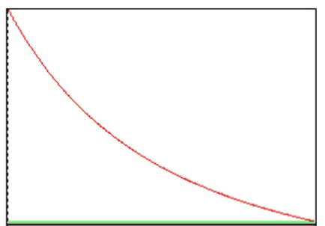
  - Modelling And Fitting Thickness And Optical Constants (single, partially absorbing layer, Cauchy model)
    - When fitting optical constants, it is highly recommended to take measurements at multiple angles.
    - For partially absorbing materials, you will need to divide the analysis into two parts.
      - Start with the transparent region where the Cauchy model is valid and determine thickness and index.
      - Then fix the thickness and fit n &k over then entire range using point by point fitting.
    - Select the “Model” window and load a substrate material, the same as above.
    - Again, select “Add layer” and load the Cauchy.mat file. Specify a value for the “A” term that roughly matches the expected index value. Also specify the expected thickness.
    - Select the “Generated Data” window, and click on “Generate data”. Observe the graph and adjust thicknessGenerate data until the model and experimental data are close.
    - In the “Model” window, click on the Cauchy layer again. This time, check the fit boxes for thickness, A, and B.
    - Select “Fit” then “Normal fit” and the two curves should converge in the transparent region. Shown below is a data of a photoresist at three different angles. The data from the transparent region matches the model, but it does not match in the absorbing region.
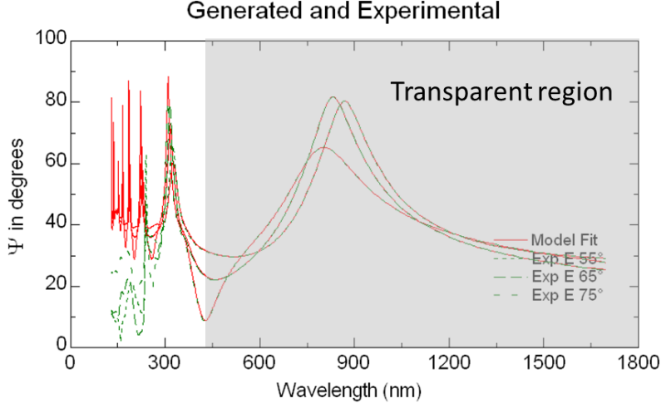
    - To focus on the transparent region only, select the “Experimental Data” window, the click on “Range Select”. Input the wavelength range the corresponds to the transparent region of your film
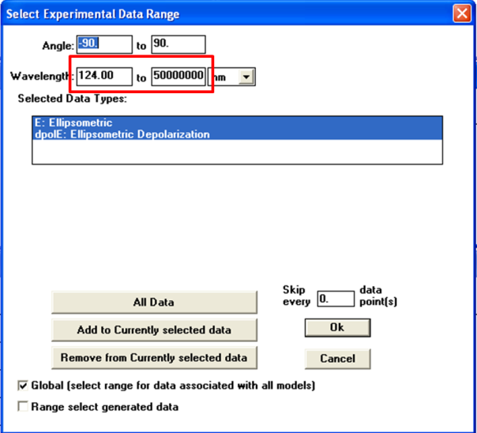
    - Select the “Generated Data” window, and click on “Generate data”. The graph will now update with the range that you specified.
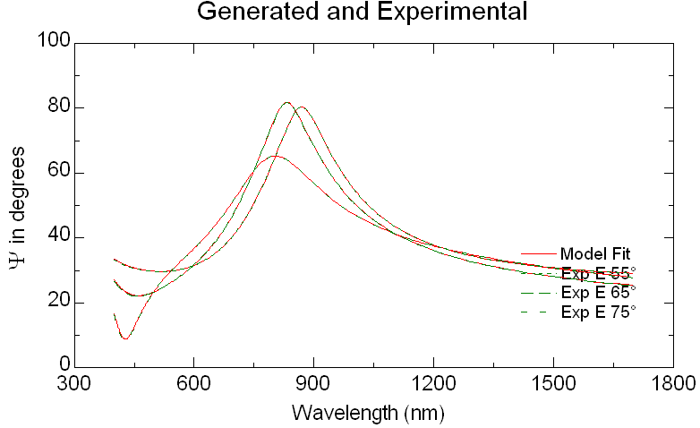
    - Select “Fit” then “Normal fit” (with thickness, A, B, maybe C to be fit) and it should be a much better fit since the model is now only using the data in the transparent region, and is not being influenced by absorption.
    - We now need to fit n &k over the entire range. Select “Experimental Data” then “Range Select”. Now click the “All Data” button.
    - Select the “Generated Data” window, and click on “Generate data”. The graph will now update with all of the data again.
    - In the “Model” window, click on the Cauchy layer again. Now deselect all of the thickness and Cauchy parameters, and select the n &k boxes.
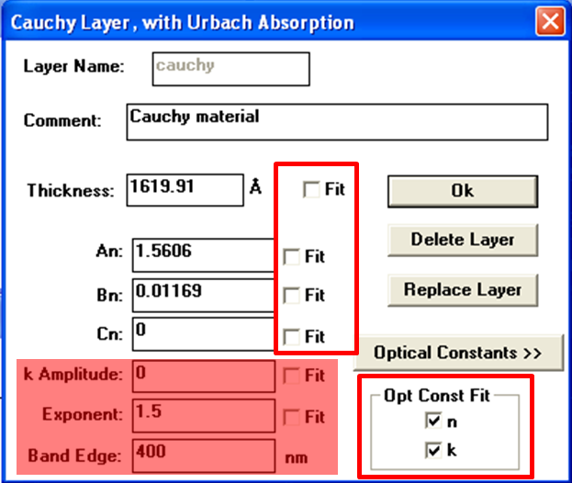
    - Select “Fit” then “Pt. by Pt.” fit and you will get another window. The only adjustment you need to make is the starting position. You need to start the fitting process where the model overlays the experimental data. In the example, that was at the longest wavelength. Click OK and it will ask again if you want to change the starting conditions, click No.
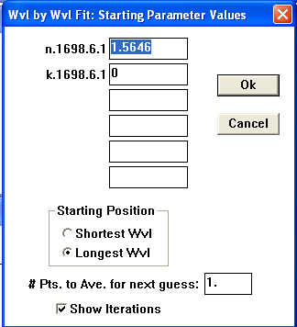
    - It will now adjust n & k at every wavelength and the fit should be very good, as shown in the example below.

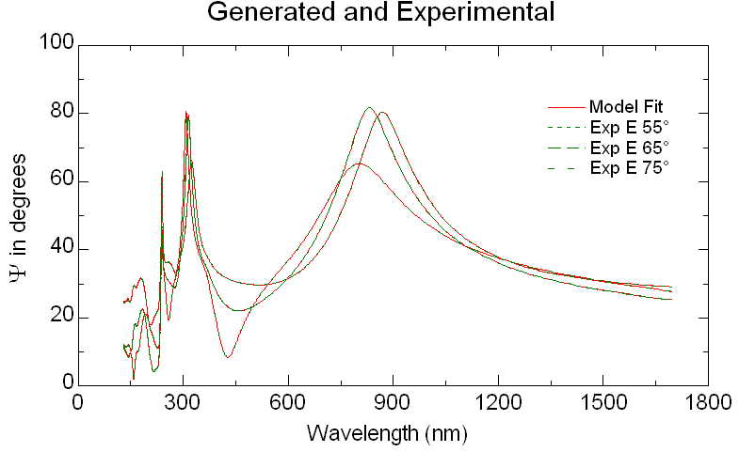

Note: A good fit does not mean it is a valid result. This method can result in physically impossible values for n & k if your model is not valid, or is missing something. Verification is difficult and requires the use of a consistency check. See pages 175-177 for details on using the Kramers-Kronig layer (KK.mat).

    - To view the optical constants, open the Cauchy model layer and click on optical constants. To save the constants, click the copy to clipboard button. Open Notepad and paste, then save as a text file. This can be opened in Excel or other graphing software.
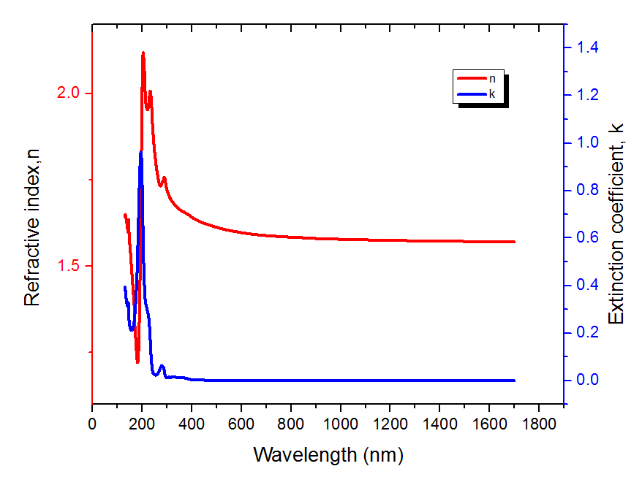
- Saving And Removing Data
    - Click The experimental data can be saved as just the raw data, or can include the model as well.
    - To save just the experimental data, select Experimental DataFileSave Exp. File
    - Make a folder in the User Data folder and type a file name to save it.
    - To save the entire session (all windows and model info), click on “Global” located in the upper right corner, and select Save Current Environment
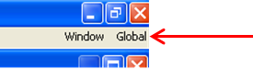
    - Again, make a folder in the User Data folder and type a file name to save it.
    - To remove data from the computer, you need to save it to the floppy disk that is provided
    - Remove the disk from the main computer and place it in the floppy drive of the offline computer.
    - The data can now be saved to a USB drive. The USB port is located at the bottom of the offline computer.
    - If you would only like to save the graph as a picture, simply right click on the graph and select copy to clipboard. You can now open Paint and paste it and save just the picture.
- Ending The Session
    - Exit the software
    - Turn off the controller module
    - Turn off the lamp
    - Log off TUMI

