

Lakeshore Hall Measurement

Standard Operating Procedure Rev. 2026-01

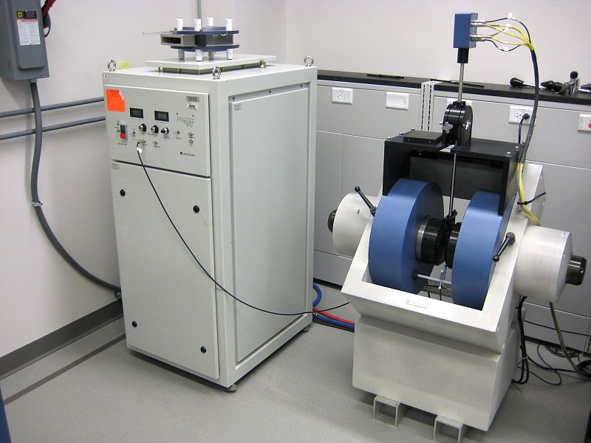

  - Application

The Lake Shore 7507 Series Hall effect/electronic transport measurement system (HMS) is designed to measure electronic transport properties of electrically conductive materials. It utilizes a 7 inch electromagnet and can produce magnetic fields of 10kGauss. The Hall system software controls the instrumentation (current, voltage, magnetic field strength) during an experiment and determines sample resistance, resistivity, Hall coefficient, Hall mobility, carrier concentration, or current-voltage characteristics. Hall effect measurements are the most frequently used means to determine carrier type (electrons or holes), mobility, and carrier density in semiconductor material. Hall effect measurements are used to characterize properties of a wide variety of electronic conductors, including semiconductors, metals, and superconductors, thin films, heterostructures, and bulk materials (single crystal or polycrystalline).
  - NRF Contact

David Hays
Table of Contents
1. Safety information 3
2. Prerequisites for use 3
3. Sample Preparation 4
3.1. Contacts And Mounting 4
4. Start Up And Sample Loading 6
5. Operation 7
5.1. Determine Excitation Current 7
5.2. IV Curve Measurement 9
5.3. Perform Hall Measurement 10
5.4. Unloading Sample 13
6. Ending The Session 13

- Safety information
- High voltage may be present at the sample contacts. Always use the box to cover the sample when performing measurements.
- The electromagnet produces high magnetic fields and may be hazardous to pacemakers and other medical devices. Stay outside of the marked area with caution tape and keep strong magnetic materials clear of the area.
- Prerequisites for use
- User of the RSC facilities.
- Up-to-date hazardous waste training.
- Training by staff.
- User will be responsible for lost or damaged equipment due to negligence. Negligence means not following the SOP, not asking staff for assistance, intentionally damaging items, etc.

- Sample Preparation
  - Contacts And Mounting
    - Much of sample preparation depends on the sample material and type. The user must develop specific procedures for their samples. Contact size, spacing, and metallurgy can have a significant impact on measurement accuracy. Sample preparation and contacting is the user’s responsibility. What follows are general guidelines.
    - Samples must be, nominally, 1X1 cm square to fit the sample card. Larger samples (or small samples if you don’t want to solder) can be mounted on the probe tip card that can be checked out at the front desk. No soldering or wire attachment is needed for the probe tip card.
    - Pattern the sample or identify contact regions. Refer to Appendix A (located in binder at the tool) to determine where to attach leads to the sample. Some common Van der Pauw geometries are shown below.
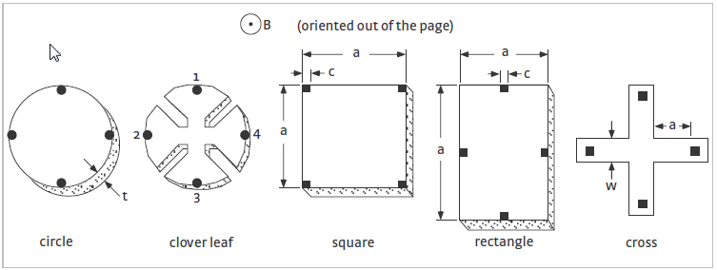

    - The contact regions must be ohmic. Some materials require etching of the surface prior to metallization. Other materials require alloying with a suitable contact metal followed by annealing. Appendix B (located in binder at the tool) lists some common contacts to semiconductors. Again, contact metallization is the user’s responsibility.
    - Attach wire leads to your sample using solder, silver paste, conductive epoxy, wire bonding, spot welding or other means (only indium soldering is covered here). Recommended wire is 50-100µm diameter copper, silver plated copper, or gold.
      - Heat soldering iron. Indium melts at 156.6°C (313.9°F) so it does not require a very hot iron. Excessive heat may damage your sample.
      - Using a soldering iron, melt solder onto the tip and place a small amount of solder at each contact point.
      - Using tweezers, place one end of the wire to a contact point and solder it in place. Ensure that wire is long enough to reach the contact points on the sample card.
      - Repeat for all remaining contacts.
    - Mount your sample to the sample card. The card can be purchased from the NRF or from Lakeshore (Part number 671-201). The samples cards are re-usable…do not permanently mount your sample to the card.

      - Hold the card up to a light to see the sample mounting indicator on the back side. The “X” marks the center of the sample mounting area, as well as the tail of the positive magnetic field vector oriented up through the sample. Use temporary mounting adhesive such as double sided tape, rubber cement, or vacuum grease.

Do not touch the gold plated contact regions on the sample card with your bare fingers. Fingerprints may change measurement readings on high resistance samples.

      - Using tweezers, place your sample onto the mounting adhesive. Using a cotton swab, press down gently on sample being careful to not scratch the surface.
    - To complete the mounting procedure, solder the other ends of your wire leads to a contact on the card. When finished, it should look similar to the picture below.
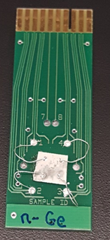

- Start Up And Sample Loading
    - Login using the TUMI system
    - Go to the electromagnet cabinet and turn the control switch to “Standby” and press the green button to enable.
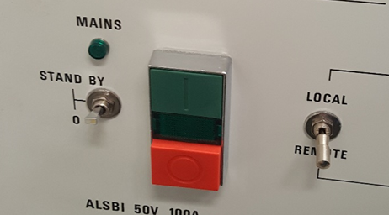

    - At the electromagnet, pull the t-lock handle out and swing the module arm out.

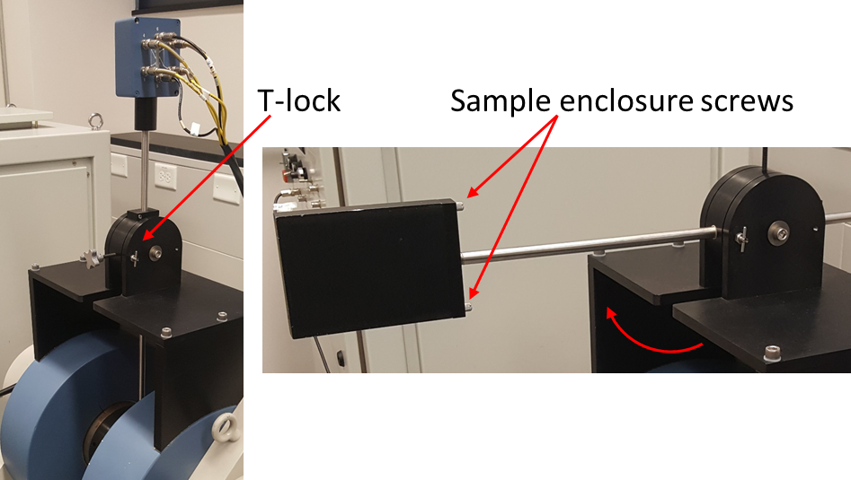

    - Remove the sample enclosure and place the sample card on the header block. Your sample should be facing the electronics rack with the computer.
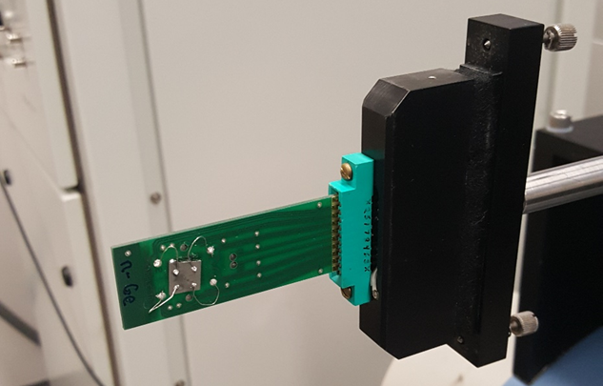

    - Replace the sample enclosure, tighten screws and move the arm back.
Do not run a measurement without the sample enclosure. There is live voltage at the contacts, and light can affect the measurement readings.

    - At the computer, click on the Hall Measurement System icon to start the software.
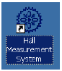
- Operation
  - Determine Excitation Current
    - We operate the tool in manual mode, and the only functions we will use are at the top of the screen called, ‘Resistance’ and ‘Field’.

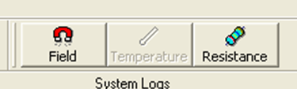

    - Press the ‘Resistance’ button and a new window will open. You will press the radio button numbers that correspond to the numbers on the Hall Measurement Worksheet

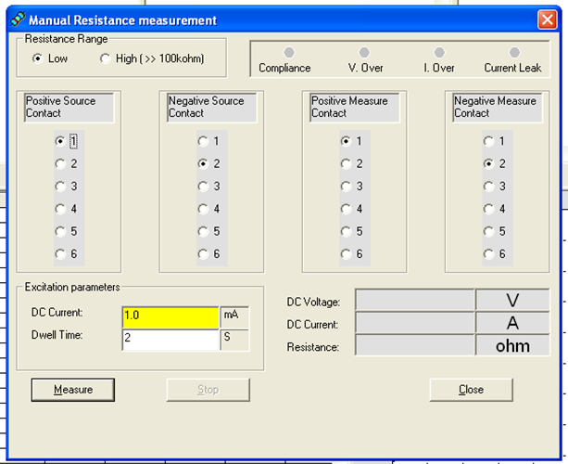

    - Determine excitation current and enter it in the yellow box in ‘Excitation parameters’. You want to have enough current to be in the ohmic regime, but not enough to cause heating within the sample.
    - Start with a low current…maybe the nanoAmp range. The software defaults to 1mA. For 10 nA, enter 10 in the ‘DC Current’ box and press the ‘n’ key.
n=nano
m=milli
p=pico
u=micro

    - Arrange the radio buttons in the order of 2-1-3-4.
    - Enter a dwell time. The dwell time is the time that it will apply current. This can be a few seconds, to a few minutes, depending on the type of sample. Start with a few seconds and press ‘Measure’.
    - You will see numbers appear for the DC Voltage, DC Current and Resistance on the right side. Take note of the voltage and resistance.
    - Now, double the current and see if the resistance stays the same and the voltage doubles. If it does not then begin increasing the current until this happens.
- For example, I started a sample with 100nA and got 2.34µV and 23ohms.
- Doubled it to 200nA and got 3.7µV and 18ohms…not ohmic
- I then jumped to 1µA and got 11µV and 11ohms
- Doubled it to 2µA and got 19µV and 11ohms…not ohmic
- Increase it to 100µA and got 0.872mV and 8.7ohms
- Doubled it to 200µA and got 1.74mV and 8.7ohms….ohmic region

    - Once you are in an ohmic region, open the Excel file on the desktop named ‘Standard Hall Worksheet’. At the top is a useful calculation to help avoid heating effects by ensuring that the total power delivered is less than 1 milliWatt.
    - Using the above example, with 8.7ohms resistance, I should keep the current less than 339µA. I would probably use 200µA since it is ohmic, and far away from delivering 1mW.

  - IV Curve Measurement
    - It is useful to perform an IV curve for all the contact pairs to ensure that all contacts are good and are showing ohmic behavior.
    - Close the resistance window and click on “Measurements” near the upper left corner. Then select “Add IV Curve Measurement”
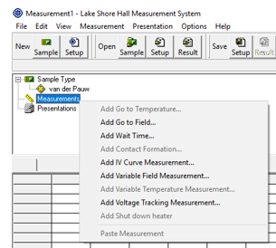
    - In the IV curve setup window, press the “Add Default Contacts” button, and this will populate all of the contact pairs. Using the current previously calculated, fill in the starting current (negative) and ending current (positive) with some current step to give you something like 7-15 data points.
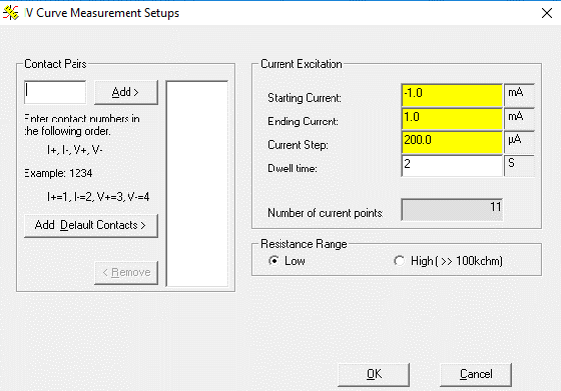
    - Click OK and the window will close.
    - Press the “Start” button, keep the current sample file, and press “Start”
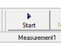
    - The software will now run the IV curve for all pairs automatically. Check all of the tabs to look at the curves for each pair.
  - Perform Hall Measurement
    - Once the current is determined and IV cure performed, we can begin performing the Hall measurements. Do not change the current during any of the measurements.
    - There should be copies of blank worksheets (shown below) near the tool. Using a blank worksheet, begin filling out the form starting with Resistivity measurements.
    - Click on the “Resistance” button again, and press the radio buttons for each current and voltage pair shown in the worksheet and press measure.
    - Record the resulting resistance. The units must be in Ohms. If it shows up as milli-ohms, then record it as 10-3 ohms, etc.
    - Perform this for all pairs shown
    - The worksheet also indicates which resistances should roughly be the same. If they are markedly different, then you likely have some issues with your contacts. Try re-soldering the contacts
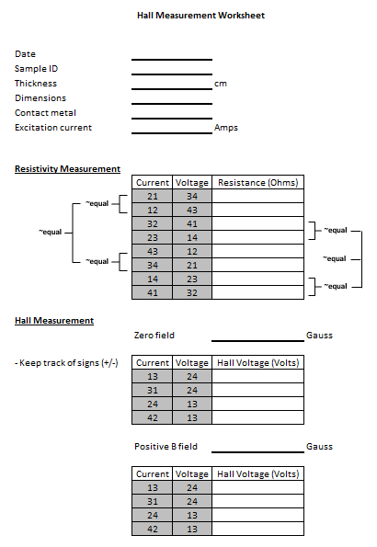

    - Now begin the Hall measurement section with zero field. Again, press the radio buttons for each current and voltage pair, but this time you record the Voltage, not the resistance.
- It is also very important to keep track of the signs.
- Units must be in Volts

    - When the zero field measurements are complete. Close the ‘Resistance” window.
    - Press the ‘Field’ button and a window will open that will allow you to control the electromagnet. The max field you can enter is 10,000 Gauss. Enter the desired field and press ‘Apply’.

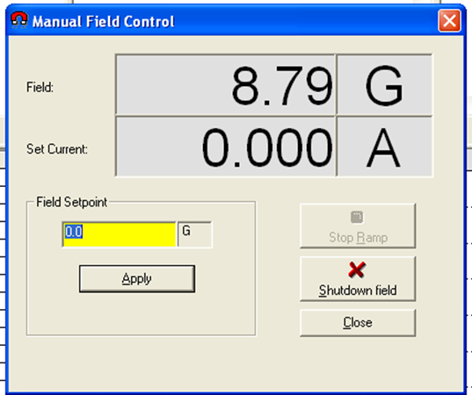

    - Wait for the field to stabilize and then press ‘Close’
    - Open the ‘Resistance’ window again.
Note that it will default back to 1mA and 2s dwell! Re-enter your excitation current and dwell time.

    - Again, go through each current and voltage pair for the positive field measurement and record the voltage. Be sure to keep track of the signs.
    - When complete, close the ‘Resistance’ window.
    - Open the ‘Field’ window again, and then press ‘Shutdown Field’ and then close the window.
    - Open the Excel worksheet again and enter all of the values that you recorded in the yellow fields of the corresponding sections.
      - Current must be in Amps
      - Thickness must be in centimeters. There is a calculation field at the top to help convert your dimensions from Angstroms (for films), or microns (for bulk samples).
      - Resistance must be in Ohms
      - Hall measurements must be in Volts…keep track of signs
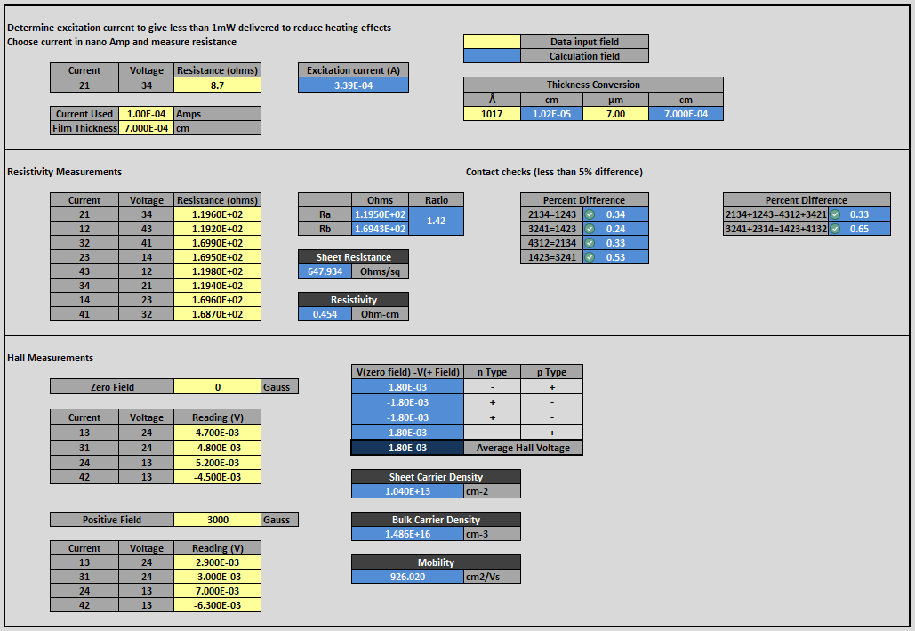

    - The sheet will calculate the following properties once all of the data has been entered.
- Sheet resistance
- Resistivity
- Sheet carrier density
- Bulk carrier density
- Carrier mobility
- p-type and n-type…if signs do not match for either type then you may need to increase the dwell time for the Hall measurements. Carrier type may not be able to be determined for all materials.
  - Unloading Sample
    - At the electromagnet, pull the t-lock handle out and swing the module arm out.
    - Unscrew and remove the enclosure cover.
    - Remove your sample and replace the cover.
    - Pull the t-lock handle and place the arm back between the magnets.
- Ending The Session
    - Close the software
    - Go to the electromagnet cabinet, press the red button and turn the control switch to “0”.
    - Log off TUMI

