

Tescan SEM MIRA3

Standard Operating Procedure Rev. 2026-01

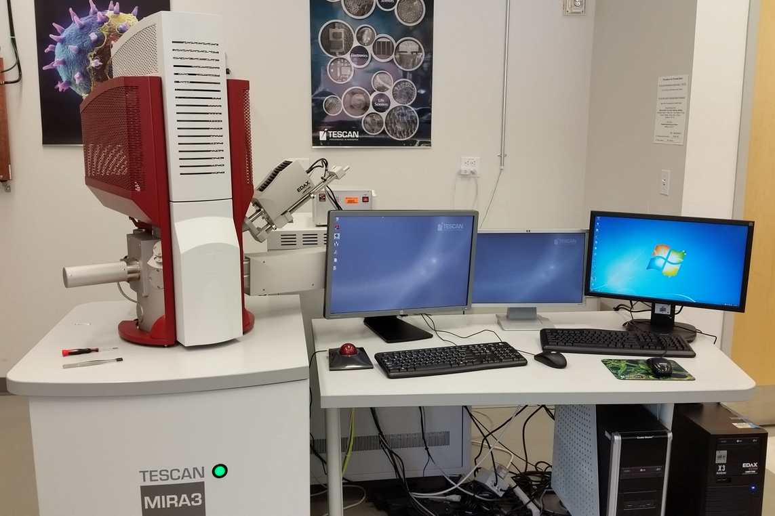

  - Application
The Tescan MIRA3 scanning electron microscope raster a focused energetic beam (probe) of electrons across a specimen surface. The signals that can be detected include secondary and backscattered electrons (for imaging), X-rays (for chemical analysis), and electron backscattered diffraction patterns (for structural analysis). Sample limitations are 2” wide by 1.5” tall.

  - NRF Contact
Andres Trucco, Nick Rudawski

Table of Contents
1. Safety information 3
2. Prerequisites for use 3
3. Sample preparation/mounting 4
4. Specimen loading 4
5. Turning on the beam, focusing, and navigating 6
6. Setting the Stage WD 10
7. Setting the beam intensity 10
8. Live imaging and alignment 11
9. Detector selection 14
10. Adjusting imaging parameters and acquiring final images 15
11. Finishing the session 17

- Safety information
- The User must observe caution when opening and closing the chamber door for possible pinch points.
- Prerequisites for use
- User of the RSC facilities.
- Up-to-date hazardous waste training.
- Training by staff.
- User will be responsible for lost or damaged equipment due to negligence. Negligence means not following the SOP, not asking staff for assistance, intentionally damaging items, etc.
  - No liquids
  - No biological materials such as plant or animal tissues, insects, etc.
  - Do not use double sided scotch or Kapton tape

- Sample preparation/mounting
    - Specimens should be mounted on standard pin stubs (Ted Pella #16111 or #16144, for example) or using conductive tape. If your sample is non-conductive, it may be given a light C coat (few nm) after being mounted on a stub to ensure a path to ground is produced or a path to ground can also be produced using conductive tape.

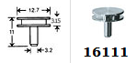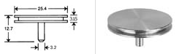

    - Assuming a flat sample with thickness t mounted on a standard pin stub, the shortest possible working distance that may be attained is WD = 10 – t mm. If a WD shorter than this is needed, it will be necessary to use a stub extender. That being said, unless you need to perform high-resolution imaging, it will not be necessary to use WD < ~10 mm anyways.

    - If you will be performing EBSD, there are additional constraints regarding specimen preparation that must be addressed (as described in the procedure for performing EBSD).
- Specimen loading
    - Log in to the MiraTC control software.

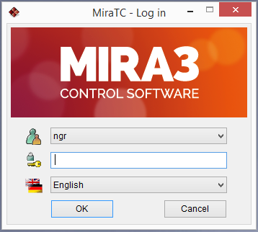
In the Stage Control, select Calibrate. Then in the “Vacuum” panel, select “VENT” to vent the chamber; the panel will indicate when venting is finished.

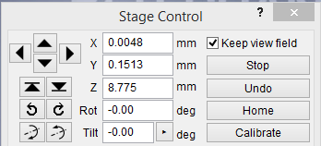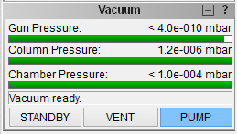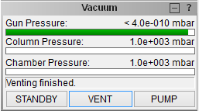

    - When venting is finished, open the chamber door and load your specimen in the “7” position of the carousel. Do not load specimens in any other carousel position other than “7”.

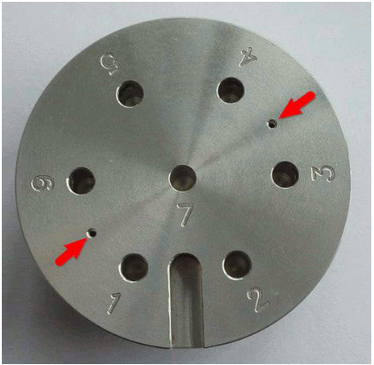

    - Close the chamber door; in the “Vacuum” panel, select “PUMP” to evacuate the chamber; apply light pressure during the initial stage of evacuation. The vacuum panel will indicate “Vacuum ready” when the vacuum level is satisfactory.

- Turning on the beam, focusing, and navigating
    - Setting Your Beam Parameters
The beam voltage is set in the “Pad” panel by selecting “High Voltage” from the pull-down menu and then entering in the desired value; the beam voltage will gradually ramp up/down to the input value from the current value.

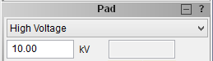

    - Turning Beam ON
In the “Electron Beam” panel, select “BEAM ON” to turn on the beam (the button will turn blue).

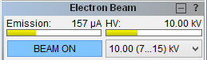

    - Initial SEM Image and Side Tools
A live image will appear in the “SEM Scanning window”; along the right side of the window will be a column of buttons used to adjust different parameters. If you loaded your sample properly, you should be positioned approximately over the middle of your specimen (and the image will probably be out of focus).

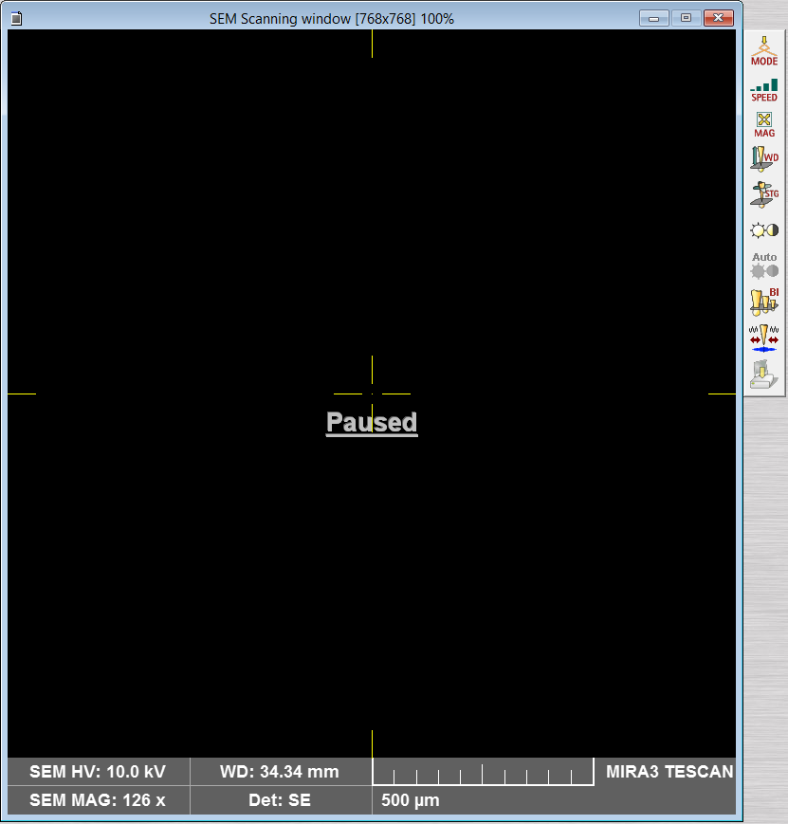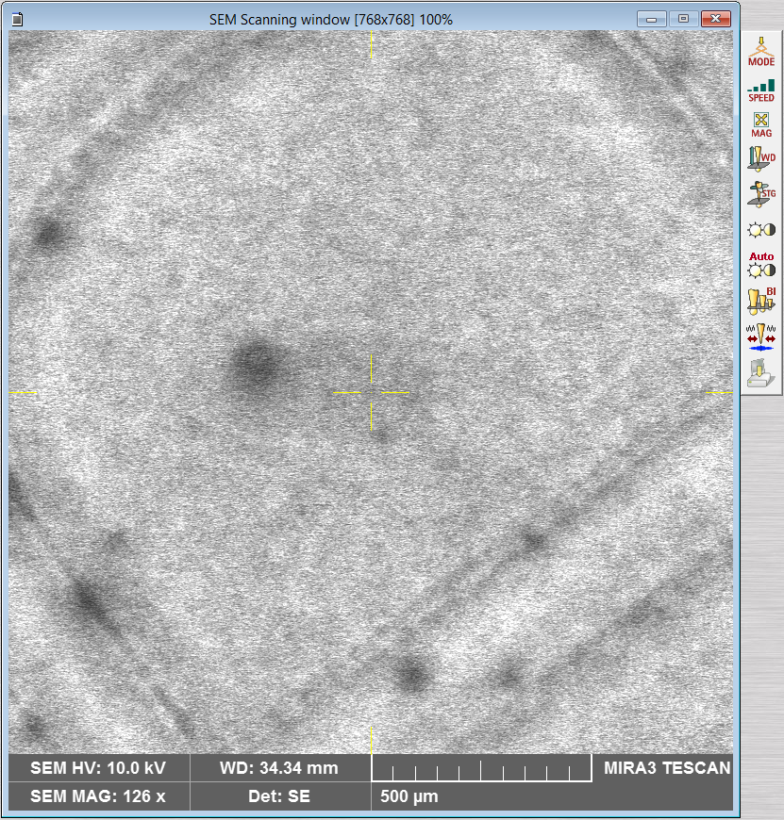

    - Contrast and Brightness
If the live image is difficult to see due to excessive or insufficient signal, select 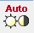 from the column of buttons to automatically adjust the detector contrast and brightness (this can be done as needed).

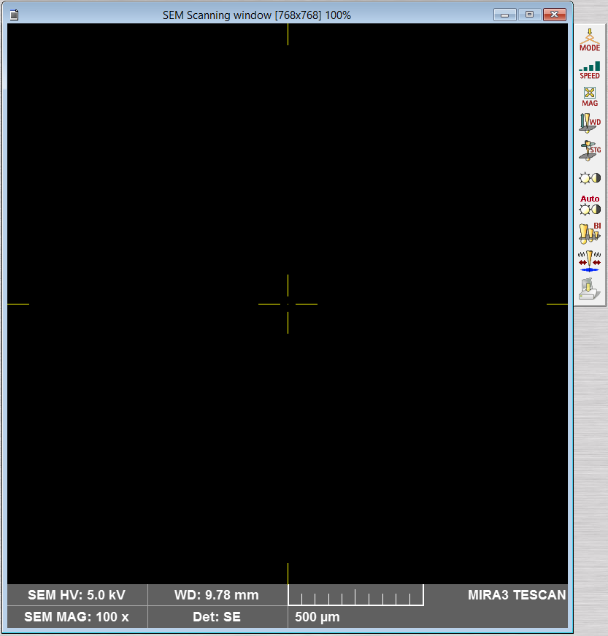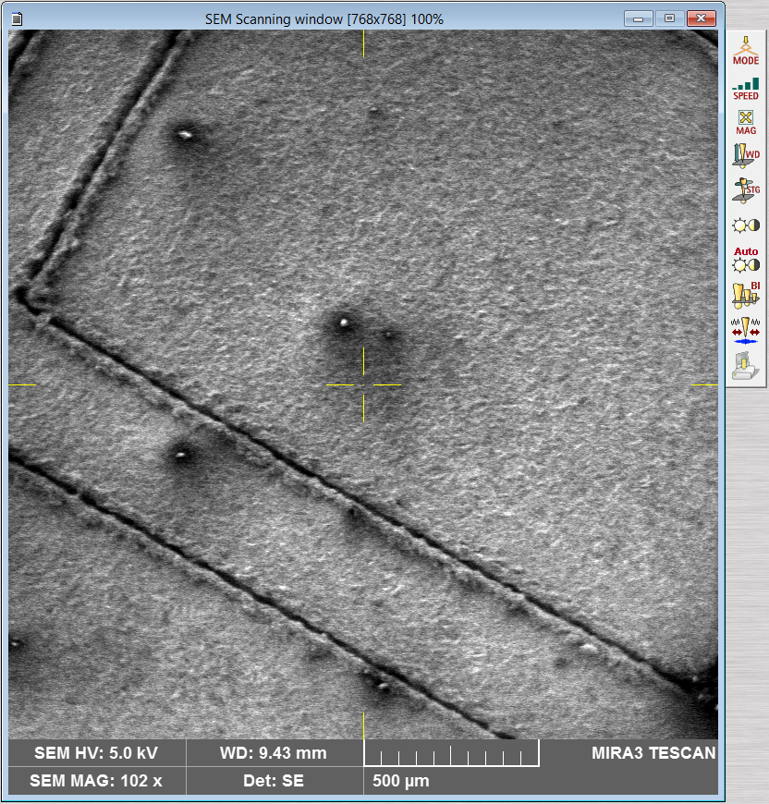

    - Setting Initial Magnification or Field of View
Next, set the view field to ~200 µm (1 kX Magnification) by turning Mag on the control pad (upper left knob). Look at the magnification values on the bottom of the SEM imaging window.
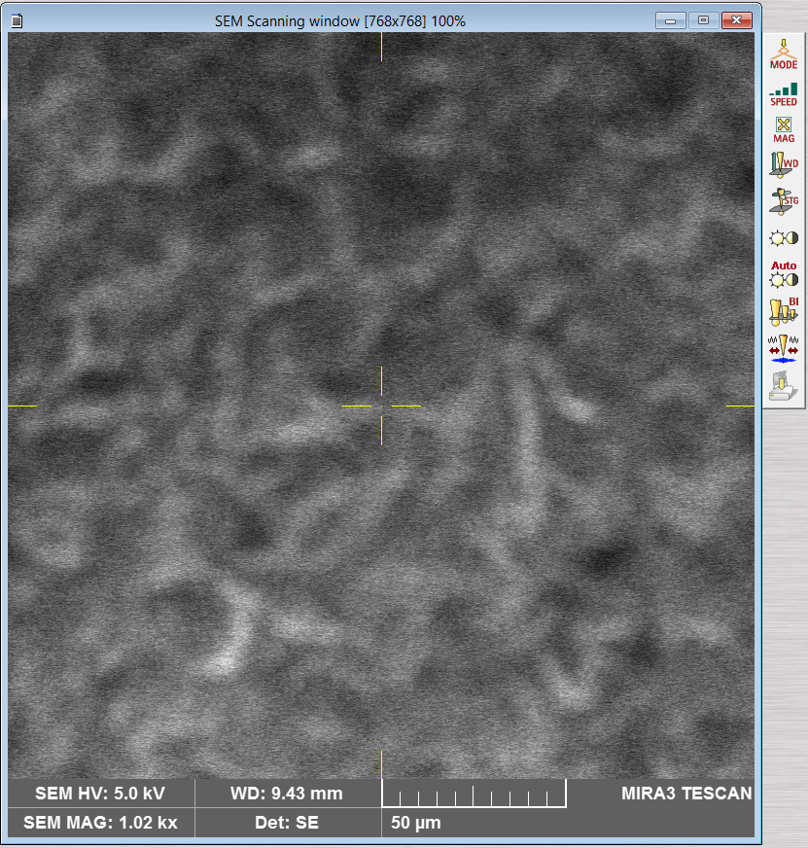

    - Focusing on the Sample
The specimen now needs to be roughly focused; use the bottom left knob WD on the control panel to focus the image. (note: this adjusts the focus of the objective lens, NOT the actual WD. The stage will not move on the Z direction)

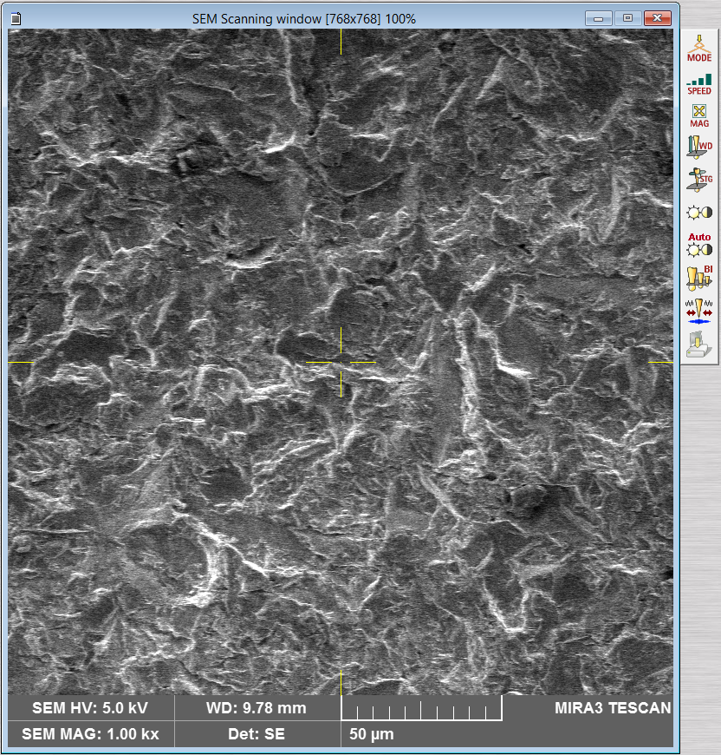

    - Reduced Raster Area.
- Sometimes, it can be helpful to use a reduced scanning area when focusing (as well as when performing some of the alignments as will be discussed later).
- To reduce the scan area, simply double left click on the image; a yellow box will appear and the scanning will be reduced to that area on the sample.
- To move the box, left click and hold in the box and then drag it to a new area.
- To change the size of the box, right click and hold in the box and then drag to change the size.
- To resume full area scanning, double left click anywhere on the image.

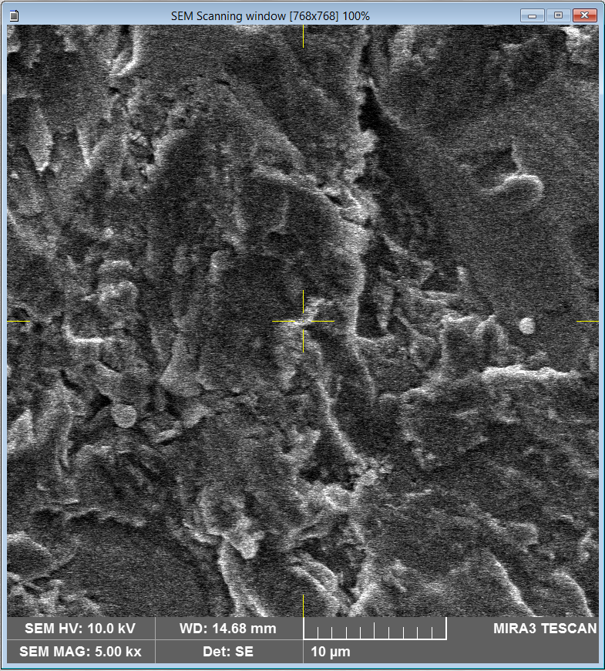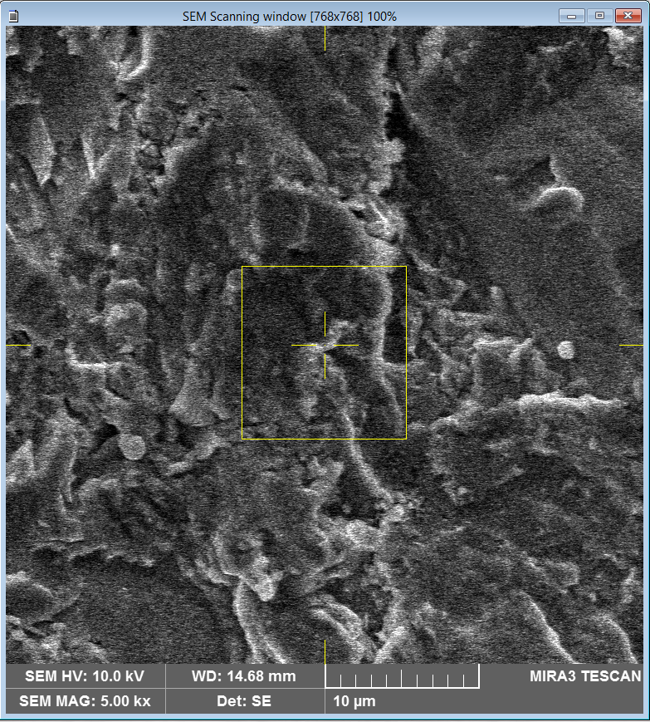

    - Sample Navigation
To move around the specimen, middle mouse click on a spot in the live image (you can mag in or out as needed) and the stage will move this spot to the center of the image; in order for this to be accurate, the sample must be reasonably focused.

- Setting the Stage WD
    - Once the sample is roughly focused and a region of interest centered in the live image, incrementally, adjust the WD to the desired value in the “Stage Control” panel via . Make sure the image is always focused before entering values in WD&Z
    - After each incremental stage movement, every 10mm, adjust the focus with the WD knob on the control panel. Observe the stage movement via the “Chamber View” panel and be prepared to stop the stage using “Stop” if any collision appears imminent. Do not attempt to adjust the WD unless the image is focused first. A good starting working distance for imaging is 15mm.

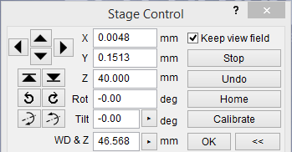

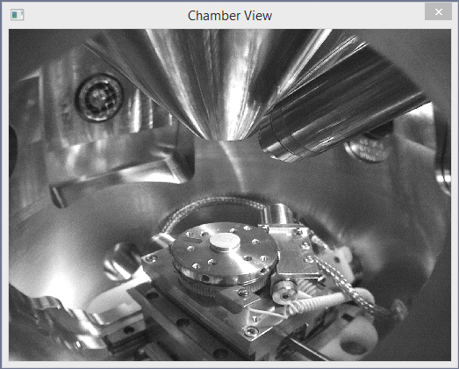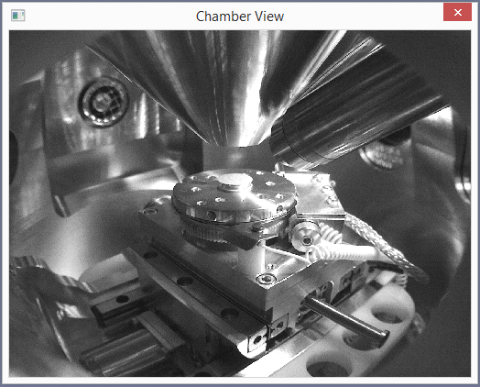

- Setting the beam intensity
    - The probe current can be adjusted using the “control pad” under “B I” knob. The intensity goes from(integers of 1 – 20). For a given beam voltage and WD, probe size will usually be minimized at beam intensity = 7 – 9; as the beam intensity is increased above this value (which is usually necessary if performing EDS or EBSD), the probe current will increase, but at the expense of a larger probe.

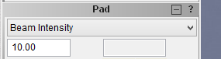
- Live imaging and alignment
    - Setting scan to live image
When performing alignments (particularly manual centering and stigmation), it can be useful to adjust the scan speed of the live image as needed. To do this, simply left click on the live image and then scroll up (down) with the middle mouse button to increase (decrease) the scan speed.

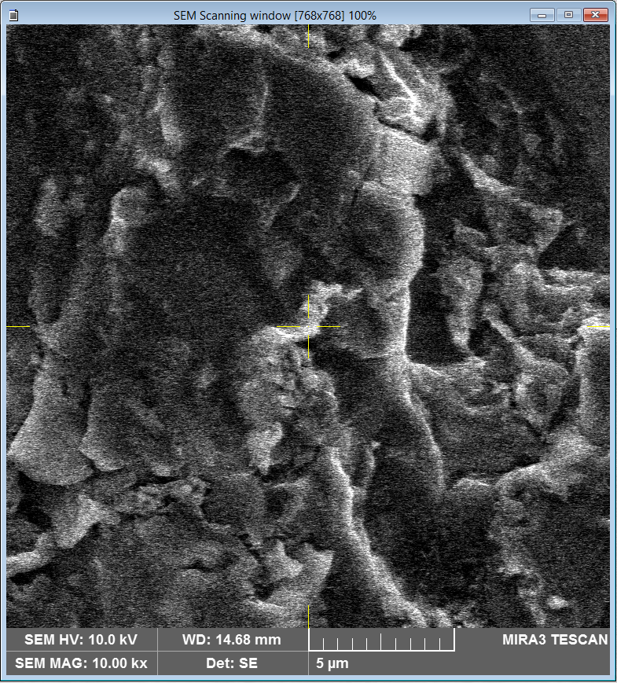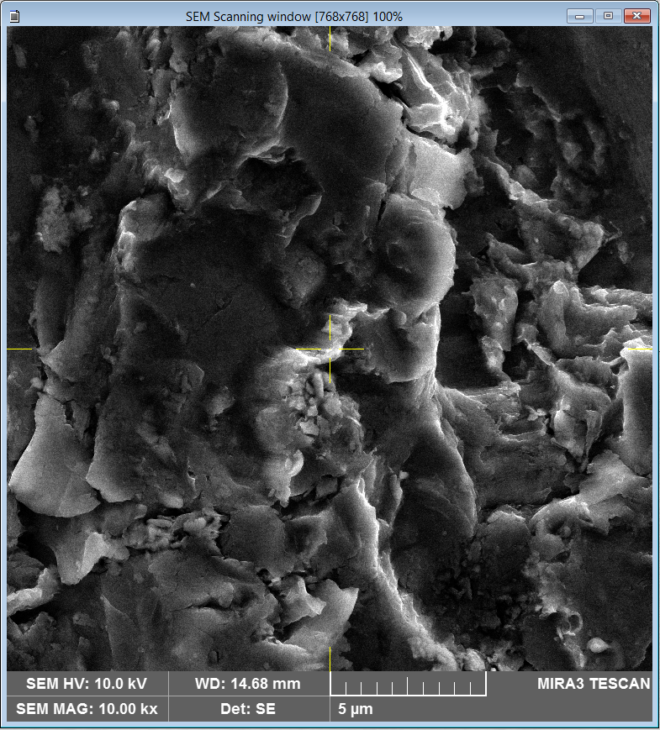

    - Running Auto Gun Centering
In the “Electron Beam” panel, select “Adjustment” and then “Auto Gun Centering” to align the gun (will take a couple minutes). It is recommended to image away from your sample over a carbon piece or the metal part of the aluminum stub. When the procedure is finished, immediately select  and focus the image to prevent any further modifications to the gun alignment.

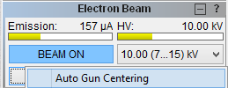

    - Manual Objective Centering
- Find an area of interest on the specimen surface and center it in the live image; then select MAG  and set the view field so it is smaller than what you intended to use for collecting your final images.
- Select 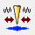 from the column of buttons to bring up the “Manual Centering Wizard”.
- Select (the objective lens will start wobbling) and use the X and Y knobs in the control panel to minimize shifting of the image during wobbling.
- When the wobbling is minimized, select to save the alignment and turn off the wobbling.

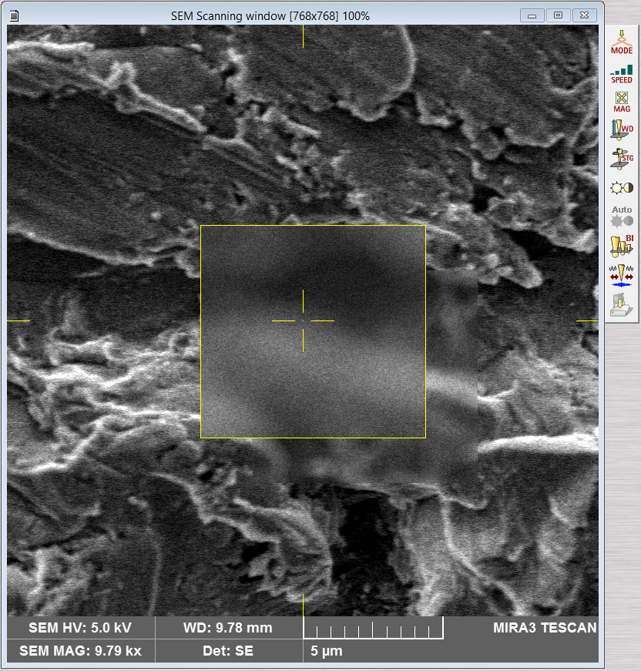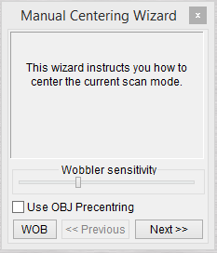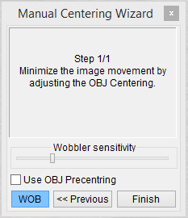

    - Correcting Stigmation
- Select MAG and decrease the view field so it is substantially smaller than what you intended to use for collecting your final images.
- Select STG  from the column of icons and then use control panel X and Y knobs to stigmate the image.
Focus - X - Focus - Y Repeat 2 to 3 times.
It also helps to do this using a reduced scan area with a slower scan speed.

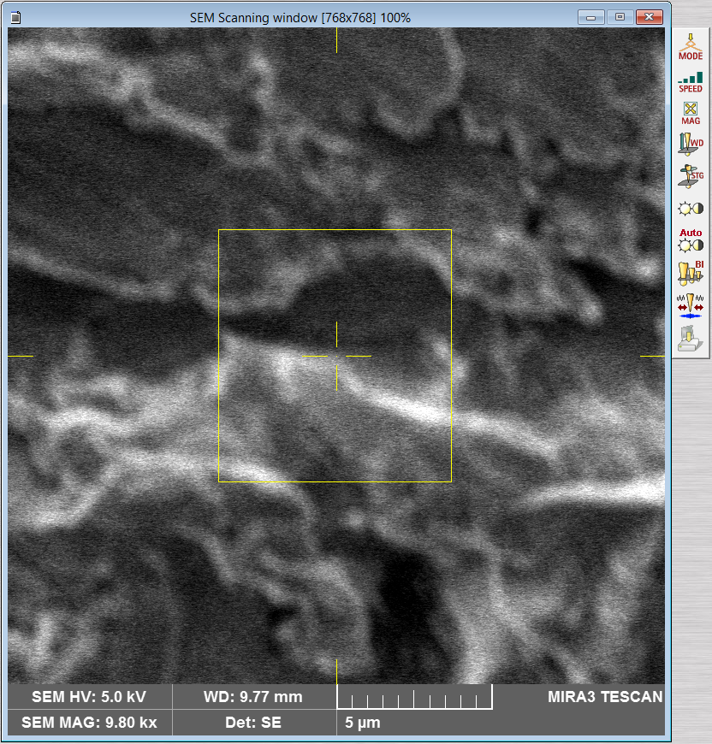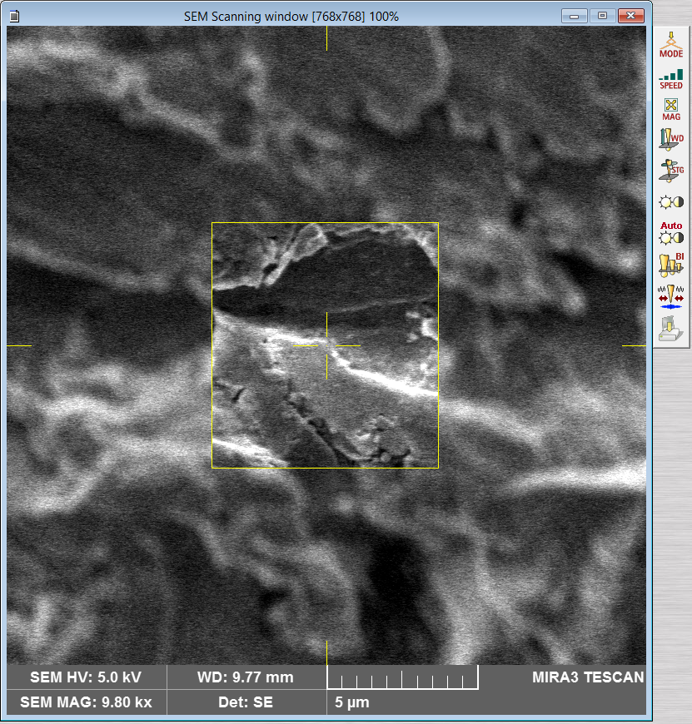

- Detector selection
    - In the “SEM Detectors & Mixer” panel, ETD (incorrectly named as “SE”) and dedicated BSE detectors can be selected from the “Channel A” pull-down menu.
    - The default setting is to use the SE detector mounted on the inside of the chamber. If the BSE detector is selected, it must be manually inserted as shown below in the “Chamber View” panel.
Do not attempt insertion of the BSE detector if the WD < 8.5 mm OR if you will be performing EBSD.

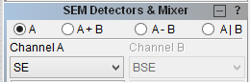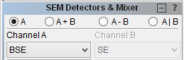

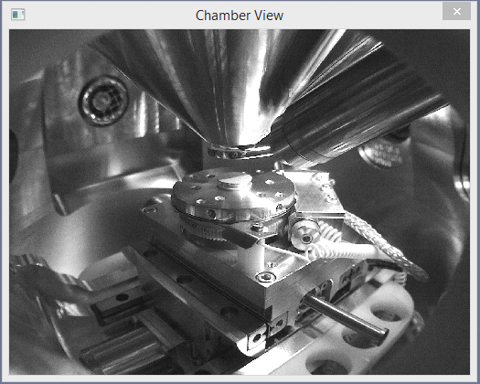

- Adjusting imaging parameters and acquiring final images
    - Image Parameters
- To adjust the various image parameters, select “SEM” from the pull-down menu and then “Image Parameters”.
- In the “SEM Imaging Parameters” dialogue box that pops up, you can select different options for the “Live” and “Save” imaging modes.
- The settings indicated below are usually sufficient, but make sure under “Averaging” that “Enable” is left gray to turn off averaging. These settings will be saved for your account the next time you log in.

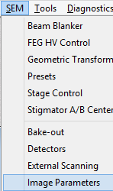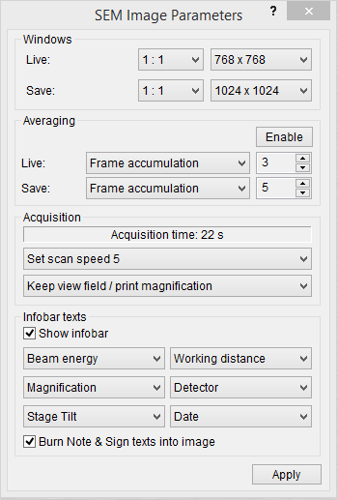

    - Acquiring an Image
- To acquire a high-quality image for saving, first decrease the view field MAG so it is smaller than what you intended to use for your final image
- Finely focus the image (use a reduced scan area to help with this, if desired)
- Select 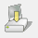 from the column of buttons. Or press acquire on the tool panel

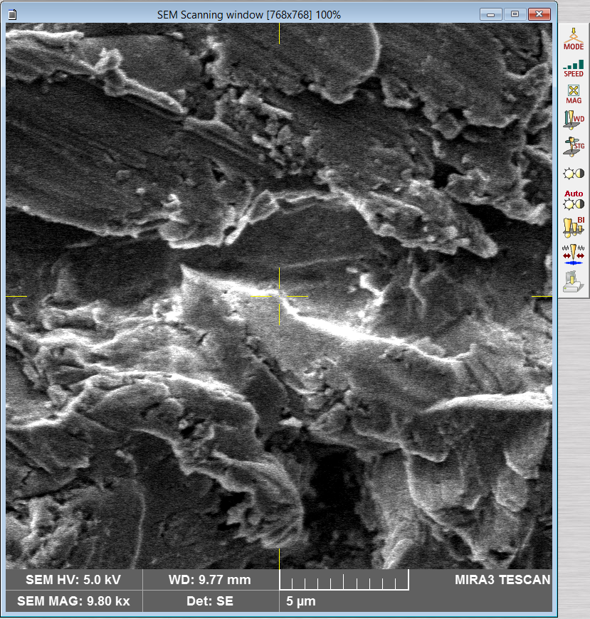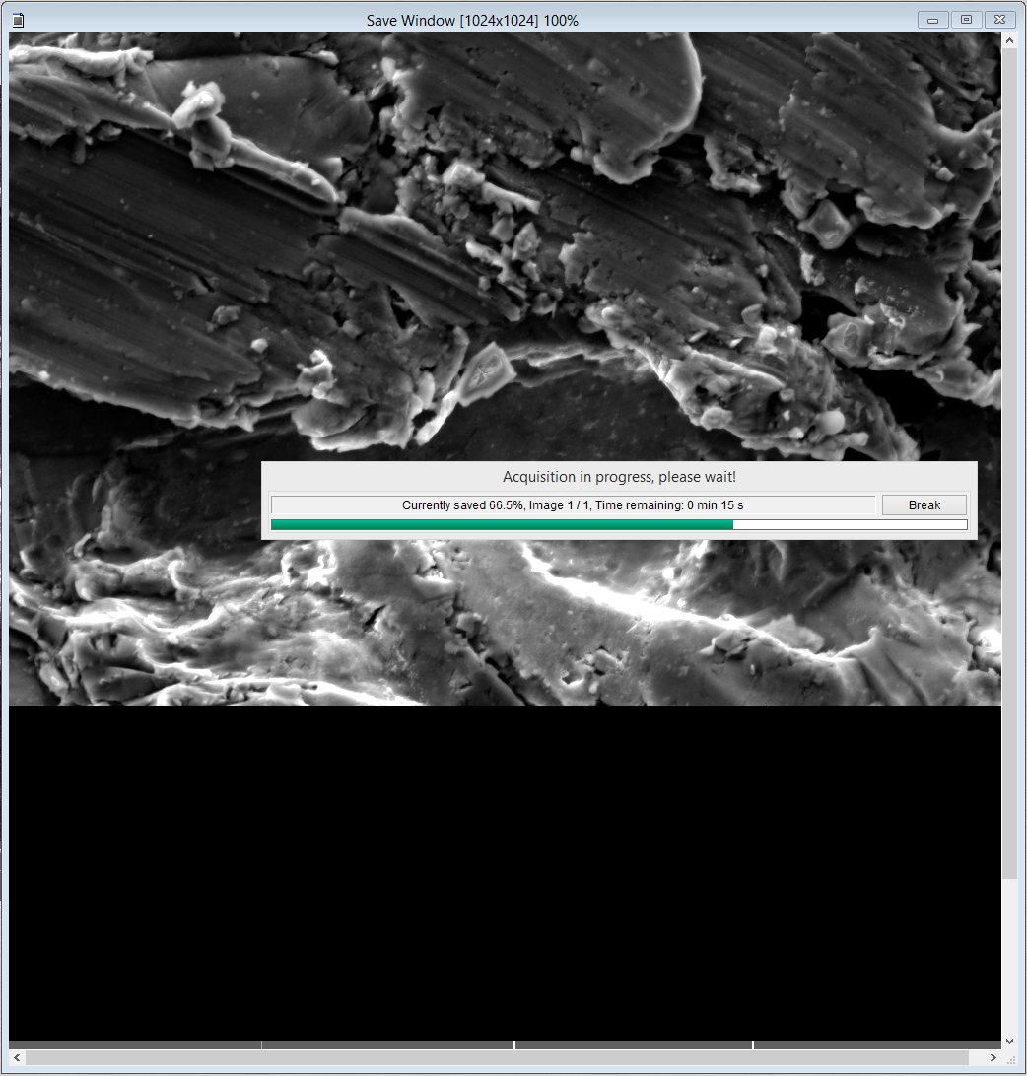

- Finishing the session
    - In the “Electron Beam” panel, select “BEAM ON” to turn off the beam (the button will turn gray). Note that the beam settings you leave the instrument at when you finish will be the beam settings that will be loaded the next time you log on to MiraTC.
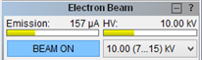

    - If necessary, retract the BSE detector, and in the “SEM Detectors & Mixer” panel, make sure “Channel A” is set back to “SE”.
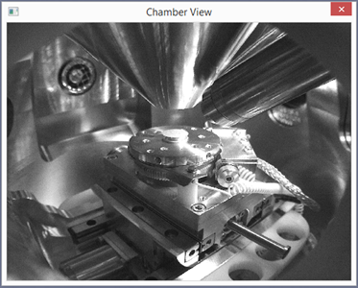
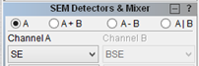

    - In the “Stage Control” panel, select “Home” to return it to the home position; “Chamber View” should look similar to shown below after Homing the stage.
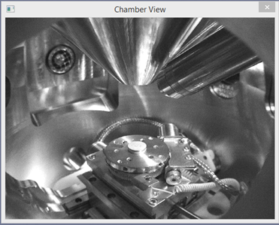
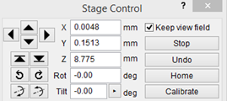

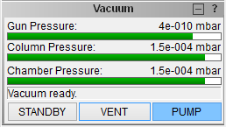
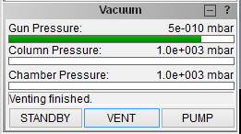
    - Once the stage is homed, the chamber can be vented. In the “Vacuum” panel, select “VENT” to start venting the chamber

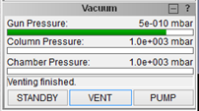
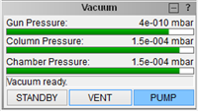
    - When venting is completed, remove your specimen, then close the chamber door, and select “PUMP” to return the chamber to vacuum; again, apply light pressure to the chamber door during the start of evacuation

    - Select “File” from the pull-down menu and then “Log Off” to log off MiraTC. In the “Log off” dialogue box that pops up, select “Yes”. In the dialogue box that subsequently pops up asking if you want to go to “STANDBY” mode, select “No” (this makes sure the chamber remains actively pumped).

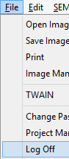
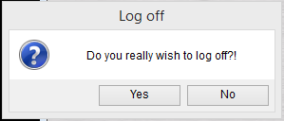
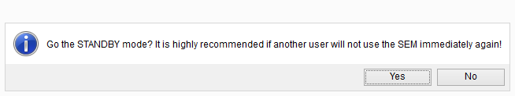

    - Remember to copy your images, log off the TUMI computer and close the room door on your way out.

