

JEOL 5700 SEM

Standard Operating Procedure Rev. 2026-01

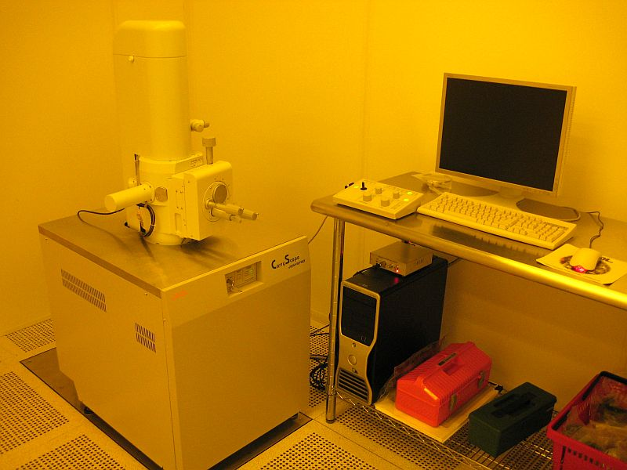

  - Application

The JEOL 5700 is a compact and portable SEM that utilizes a standard tungsten filament. It is to be used for inspecting and measuring samples processed in the NRF cleanroom. NO SAMPLES CREATED OUTSIDE THE CLEANROOM WILL BE ALLOWED. The 5700 is capable of imaging from 8X to 300,000X and up to 5nm resolution. Accelerating voltage can be varied from 500V to 20kV and the beam diameter can also be adjusted. It features manual XYZ stages with full 360° rotation and -10° to 90° tilt and can hold a full 4” wafer.

  - NRF Contact

David Hays
Table of Contents
1. Safety information 3
2. Prerequisites for use 3
3. Operation 4
3.1. Start Up 4
3.2. Sample Loading 4
3.3. SEM Operation 5
3.4. Saving Images And Measuring 7
3.5. Unload Sample 8
4. Ending The Session 8

- Safety information
- The User must observe caution when opening and closing the chamber door for possible pinch points.
- Prerequisites for use
- User of the RSC facilities.
- Up-to-date hazardous waste training.
- Training by staff.
- User will be responsible for lost or damaged equipment due to negligence. Negligence means not following the SOP, not asking staff for assistance, intentionally damaging items, etc.
  - No liquids
  - No biological materials such as plant or animal tissues, insects, etc.
  - Do not use double sided scotch or Kapton tape

- Operation
  - Start Up
    - Log on to the TUMI
    - Start the SEM software if not already open by clicking on the SEM icon
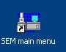
    - Also turn on the chamber IR camera by clicking on the IR Camera icon
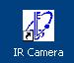

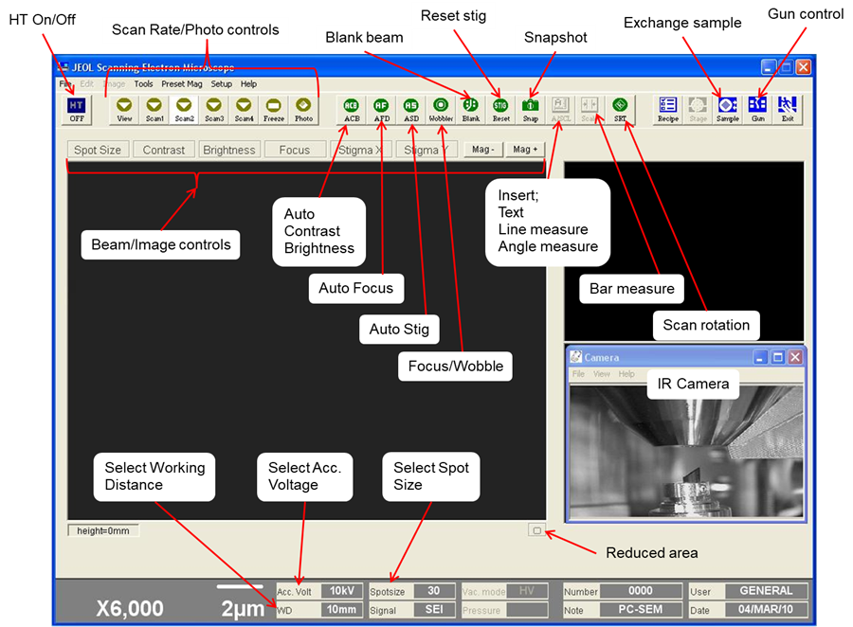

  - Sample Loading
    - Lower Z to 39mm (or more). Set the tilt to 0°.
- Z refers to the stage height read from the right side of the micrometer.
    - Press and hold the “VENT” button on the SEM, or in the software, press the “SAMPLE” button then “VENT”
    - Vent light will blink amber color. Chamber can be opened when light is steady.
    - Mount sample in holders with screws, vise clamp design, or 4” wafer holder.
NO CARBON TAPE, OR TAPE OF ANY KIND, TO BE USED UNLESS SPECIAL PERMISSION IS GRANTED BY THE STAFF.
    - Open chamber and remove adapter holder from stage by sliding away from raised line edge.
    - Loosen middle screw and remove adapter from the adapter holder.
    - Place the adapter back into the holder and tighten the middle setscrew.
    - Slide the adapter holder back on to the stage. Be sure the back of the holder is pressed firmly against the raised line edge.
    - Close the chamber and push hard on the door, press and hold the “EVAC” button on the SEM, or in the software, press the “SAMPLE” button and then the “EVAC” button.
DO NOT SELECT THE “Image appears automatically” BOX
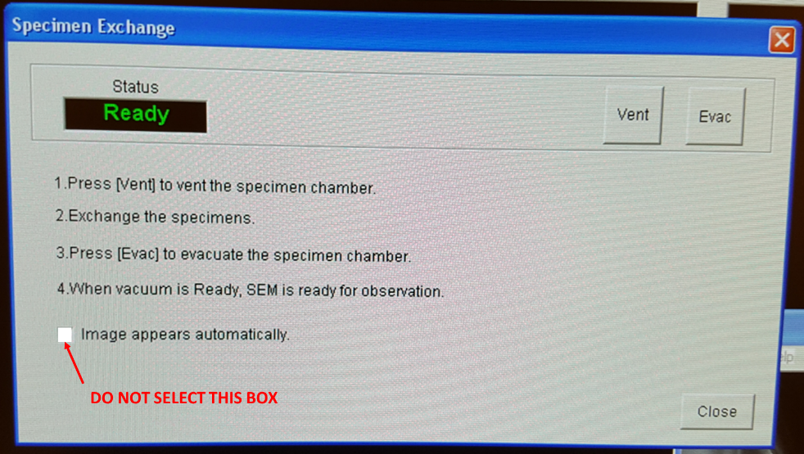
    - The EVAC light will blink green. When the light is steady, you can operate the SEM.
  - SEM Operation
    - Zero out the XY and tilt on the stage. X zero is ~22mm, Y zero is ~25mm.
    - Select accelerating voltage opening the drop down menu on the “Acc. Volt.” Button. Double click on the desired voltage.
    - Select beam spot size opening the drop down menu on the “Spot Size” Button. Click on the desired spot size from the preset values. Additional spot sizes are available from the slide bar. Do NOT use the “Set” button. Close menu,
    - Press FINE SHIFT on the knob set to center beam.
    - Press the “HT” Button to turn on the gun.
    - Press “Scan 1” or “Scan 2” buttons.
    - Press the auto contrast/brightness “ACB” button on the board or in the software.
    - Focus on the top surface of your sample using the “FOCUS” and “MAG” knobs.
    - Select the working distance by opening the drop down menu on the “WD” button. Double click the desired working distance.
CAUTION  CAUTION
THE MINIMUM WORKING DISTANCE FOR THE 4” WAFER HOLDER IS 25mm ON THE Z-SCALE.
    - FOR THE FLAT sample HOLDER WITH SCREWS, THE MINIMUM DISTANCE IS 13mm ON THE Z-SCALE.
    - Move the stage up using the Z control knob until the feature comes into focus.
    - Press the “WOBBLER” button to begin aperture alignment
    - Align the aperture by using the X-Y knobs on the SEM column. Move knobs until image no longer moves Up/Down and Left/Right.
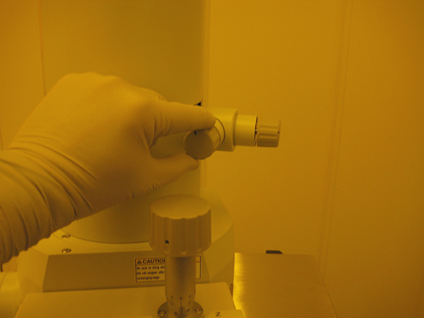
    - Adjust the “FOCUS”, “STIG”, and “MAG” knobs to obtain the best image. This works best at a faster scan rate like Scan 1 or using “Reduced Area” button on Scan 2.
NOTE: Contrast, Brightness, Focus, Stig, and Mag can also be adjusted with the Beam/Image controls on screen by mouse control.
Left/Right click on buttons above image and move mouse up/down.
Left click = fine control
Right click = coarse control
    - If different spot size or kV is desired, these can be changed without shutting down the HT. Simply select from the menus and double click. Typically, resetting stig and aperture alignment are required after changing the kV or spot size.
    - Find a region of interest and optimize focus. Adjust sample position, rotation, and tilt if required.
    - To make minor image position changes at high magnification, the FINE SHIFT joystick on the knob set will move the scan area rather than move the sample.
CAUTION CAUTION
DO NOT TILT with the 4” wafer holder when Z is at 25mm. To tilt up to 45° with the wafer holder, minimum Z is 55mm.
Watch the sample and holder in the IR chamber scope image while moving sample to ensure no contact is made with the column or detector.
    - When the image is optimized, press “Scan 4” or “PHOTO” button. You can also select FREEZE if the image is satisfactory.
  - Saving Images And Measuring
    - To save the image, simply click on the “SAVE” button that becomes available after the image is captured. Or go to File Save Image File. Enable the MERGE TEXT option to save the scale marker and data with the image. Save images to “Data” directory on the Desktop.
    - To input text or measurements on a captured or saved image, click on the “A/SCL” button. Another window will open that you can select TEXT, RULER, POLY RULER, and PROTRACTOR measurement. After the text/measurement has been added, it needs to be applied to the image by pressing the “WRITE” button. It can now be saved normally and will have the text/measurement with the file.
    - To make measurements by vertical or horizontal bars, press the “SCALER” button. Buttons will appear above the image to select X, Y, or D (diagonal) measurements. Again, move the bars to the desired location and press the “WRITE” button to apply it to the image. Save image.
    - Remove images via USB drive
  - Unload Sample
    - Lower the Z to 39mm (or more), set tilt to 0°, center X and Y.
    - Press the “HT” button to turn off the gun and let it sit for a while to cool off before venting the chamber.
    - Press and hold the “VENT” button on the SEM, or in the software, press the “SAMPLE” button then “VENT”
    - Vent light will blink amber color. Chamber can be opened when light is steady.
    - Open chamber and remove adapter holder from stage by sliding away from raised edge.
    - Loosen screw(s) and remove holder.
    - Close the chamber and push hard on the door, press and hold the “EVAC” button on the SEM, or in the software, press the “SAMPLE” button and then the “EVAC” button.
- Ending The Session
    - Minimize the IR chamber scope to turn off the IR LEDs and camera. There will be a click when this is off and a red LED on the power supply goes out. DO NOT close the JEOL SEM software.
    - Log off TUMI

