

Oxford PlasmaPro 100 DRIE

Standard Operating Procedure Rev. 2026-01

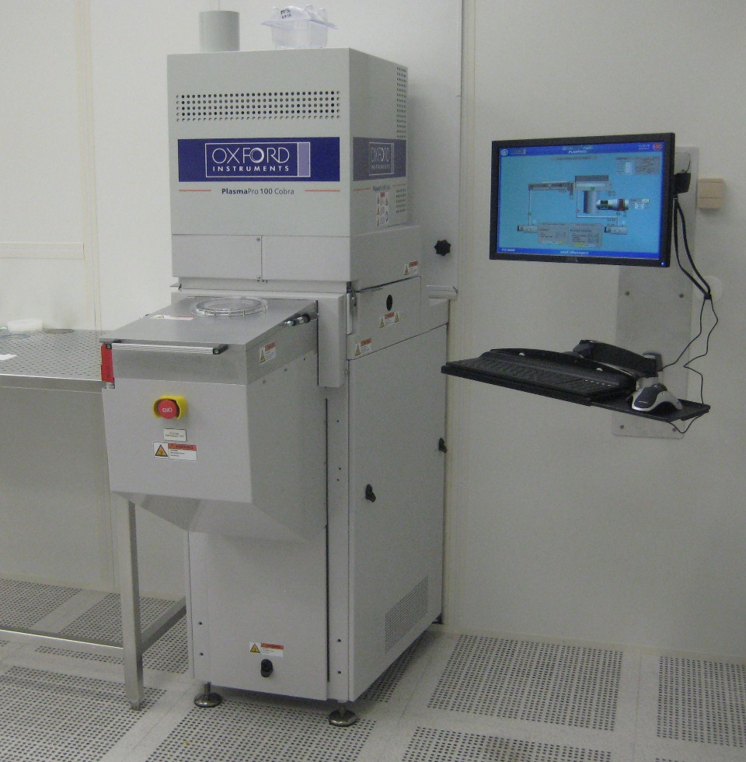

  - Application

The PlasmaPro 100 is a Inductively coupled plasma device (ICP) configured to provide effective high aspect ratio etching of 4 inch silicon wafers, and pieces when a carrier wafer is properly used. The unit has high and low frequency functions that make it suitable for high rate etching as well as etching to a SiO2 stop layer with minimal footing. The process chamber substrate electrode is precisely temperature controlled from -150C to 400C (in Cryo mode) and 0 to 80 C in standard mode. The primary process gasses are C4F8, SF6, Ar, and O2.
  - NRF Contact

David Hays
Table of Contents
1. Safety information 3
2. Prerequisites for use 3
3. Sample Restrictions 4
4. Start Up 4
5. Tool Operation 5
5.1. Sample Loading 5
5.2. Loading And Editing Recipes 7
5.3. Running a recipe 9
5.4. Unloading Sample 10
6. Ending The Session 10

- Safety information
- High Voltage Radio Frequency is used throughout the system. Do not remove any tool covers or defeat any interlock on this system.
- Prerequisites for use
- User of the RSC facilities.
- Up-to-date hazardous waste training.
- Training by staff.
- User will be responsible for lost or damaged equipment due to negligence. Negligence means not following the SOP, not asking staff for assistance, intentionally damaging items, etc.
- Sample Restrictions
    - Absolutely no exposed metal is allowed in the process chamber. Any metal on your substrate must be COMPLETELY covered by photoresist, SiO₂, Al₂O₃, etc.

CAUTION  CAUTION

METALS AND METAL MASKS ARE NOT TO BE
EXPOSED TO PLASMA IN THE CHAMBER.

    - No silicone based thermal compounds are allowed. Use only staff approved thermal compounds for carrier wafer mounting.
    - No wet samples are allowed in the chamber. All wet processed samples must be completely dry before placing inside the tool.
- Start Up
    - Log in to TUMI
    - Log on tool (if needed). The login screen can be found from the menu button near the top, left corner and selecting “User log in”
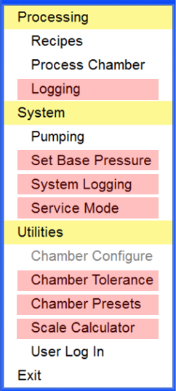
NOTE: Users are only allowed to access the menu items shown in white.

Any users caught modifying items shown in red, will have their privileges removed

    - The log in window shown below will appear.
    - Enter user – nrfuser
    - Enter password - nrfuser
- Tool Operation
  - Sample Loading
    - Press the Menu icon and select “Pumping”.
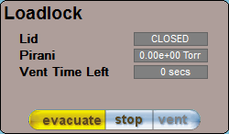
    - At the bottom of the Pumping page is the loadlock control panel. Click stop and then click vent

    - Wait until the Vent Time Left displays zero time (approximately 4 mintues).
    - Grip the loadlock lid by the handle at the front, and lift the lid upwards until it locks in the open position
    - Place the wafer on the load arm with the flat facing down, and resting against the two alignment pins as shown below
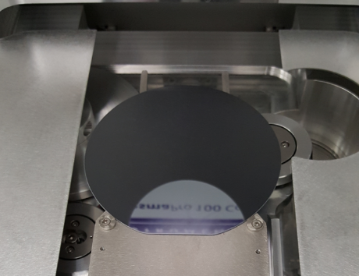
    - Grip the loadlock by the handle
    - Using the other hand, move the shroud on the right gas spring until it is free to move.
    - Lower the lid until it rests on top of the loadlock
    - A prompt will open, asking for a wafer identity. You can enter any letter or number combination to identify the wafer, or leave it blank.
    - Check that the loadlock panel indicates that the lid is closed
    - Click stop, then evacuate in the loadlock panel
    - The loadlock will now pump down. When it is ready, the indicator will turn green.
  - Loading And Editing Recipes
In this tool, a recipe consists of a set of discrete steps and is written similar to a basic program that consists of loops for repeated steps (i.e. etch/deposition steps).
    - Press the Menu icon and select “Recipes”
    - To select an existing recipe, press the Load button and select an existing recipe.
    - To edit the recipe, select the step you wish to edit and the window below will appear.
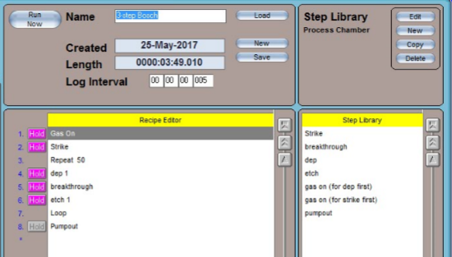
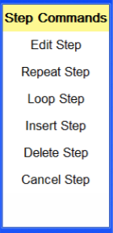
Edit Step – Opens the selected step to allow changes to parameters
Repeat Step – Inserts a repeat step or allows user to changes the number of repeats
Loop Step – Inserts a loop
Insert Step – Creates an empty row above the selected step to allow another step to be dragged into the list from the step library.
Delete Step – Deletes the selected step
Cancel Step – Cancels editing the step
    - Editing a process step. Input the following paramters:
      - Input a name for the step
      - Step time – typically 1.5s to many seconds long for etch/dep steps
      - Log interval – input 1s for steps that are many seconds long. For steps close to, or under 1s, put 250ms
      - APC/LPS – Select either Pressure and input a value in mTorr, or fixed Angle and input a value in %.
        - Deposition pressures are typically 25-40mT and etch pressures from 30-60mT.
      - HF – high frequency generator value in Watts.
        - Etch step typically 10-35W and deposition power from 0-5W
      - ICP – ICP generator value in Watts. This should be 1200W or greater (max 2500W) due to instabilities at lower power.
      - LF – low frequency generator value in Watts. Typically less than 30W. Used in place of high frequency to reduce “footing” when stopping on dielectric layers.
        - SOI Etching – Set HF power to zero in the recipe you used to perform the bulk etch, and set LF power to 8-10W and continue the etch.
      - Table – chiller temperature and should be set at 15°C
      - Helium Backing – helium backside pressure, and should be 10 Torr.
      - Gases – C4F8 (typically 100-200sccm for deposition), SF6 (100-200sccm for etching)
    - Press Save, to save the step
    - If you changed anything besides the number of loops, rename the recipe at the top of the page and click Save
    - Editing a step from the Step Library is performed the same way and can be dragged over to the Recipe Editor list
    - Step types
- Etch
- Deposition
- Breakthrough – a short etch step to only remove polymer
- Gas on – turns on gases for stabilization
- Strike – Short step to assist plasma ignition (mainly O2)
- Pumpout – all gases off and pumps on chamber
- Descum – short O2 step to clean surface (typically 10s)
Etch step example
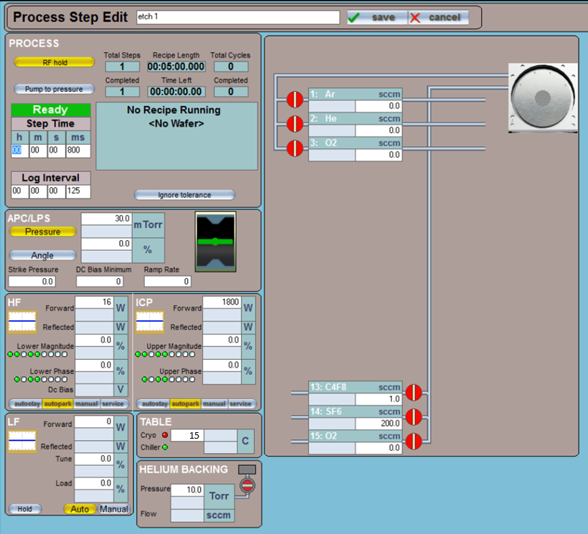
  - Running a recipe
    - From the recipe page, ensure that Automatic is selected. This mode will allow it automatically load the wafer from the loadlock, run the recipe, and then unload the wafer.
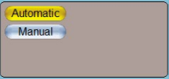
    - Ensure that the “Fast Rec” button is not active (not yellow). If it is active (yellow), then press the button to deactivate it. Running in “Fast” mode will not run any faster, but will ignore all tolerances so you will not know if there was a problem during your process.
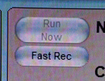
    - Press the Run Now to run the selected recipe. The wafer will now be loaded and processed.
    - If you wish to watch the process, the press the Menu icon and select Process Chamber. From the page, you can view all of the process variables as it is run.
    - When the process is finished, a window will appear saying the process is complete. Click the OK button
  - Unloading Sample
    - Vent load lock – See section 3.0
    - Remove your sample and place the O2 Clean wafer on the load arm
    - Evacuate the loadlock – See section 4.0
- Ending The Session
    - Run Standard O2 Clean
    - When all of your runs are complete, load the “O2 Clean With Wafer”recipe.
    - Ensure that the “Fast Rec” button is not active (not yellow).
    - Ensure that Automatic is selected, and then press Run Now.
    - Log off TUMI

