
Panalytical MRD X-Ray Diffraction SOP
  - Standard Operating Procedure (SOP)

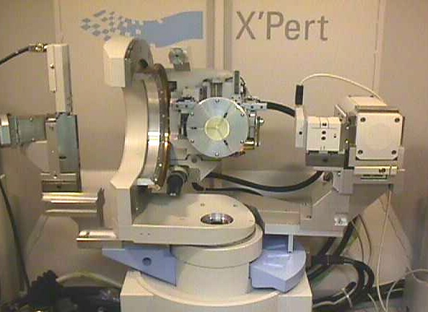

  - Application:
X-ray crystallography is a technique in crystallography in which the pattern produced by the diffraction of x-rays through the closely spaced lattice of atoms in a crystal is recorded and then analyzed to reveal the nature of that lattice. The MRD is specifically optimized for analysis of thin films and materials deposited on single crystal substrates. Polycrystalline samples can also be run with the MRD, but may have better results when run in the MPD XRD. If you are unsure what XRD to use, please consult with staff about your samples and needs and we can determine the best course of action for you.

Contents
Panalytical MRD X-Ray Diffraction SOP 1
Safety 3
Training 3
Logging In 3
Sample Preparation 3
Checking the Tool Status 4
Using the Software 4
Set X-ray Tube to Use Condition 5
Check Optics and Prefix Modules 6
Sample Height Adjustment 6
XRR Requires an Extra Alignment 7
Running an XRR Scan 8
Running a GIXRD Measurement 9
Additional Technique: Rocking Curves 11
Sample Unloading 12
Post-Operation 13

Safety
High Voltage This machine uses high voltages, especially to generate the X-ray beam. Do not touch any parts of the machine aside from those specifically mentioned in this SOP.

X-rays X-rays are a very harmful form of radiation and care should be taken to minimize exposure. Never attempt to break a tool safety interlock.

Moving Components This machine has heavy moving parts. Although these parts only move inside the machine while the X-ray is on (and thus should be out of the user’s path), care should be taken to ensure you do not get in the way of a moving part. Please wait for all movement to stop before opening the doors.

Training
Training for this machine is scheduled on demand. Please use the RSC website to request training if you would like to use the machine.

Logging In
Before you begin your session, you will need to log in to the TUMI laptop on the sample prep bench. It is not necessary to log in before loading your sample, unless you need to move the stage, or detector to ease the loading process. If the computer will not wake, double check that you have successfully logged in. The MRD XRD tool at the TUMI should say “IN USE” if you are logged in completely.

Sample Preparation
Samples can be clamped or taped onto the sample stage. You may use a glass slide as a base if you prefer. Using a glass slide is helpful for small samples to ensure the stage does not contribute to the diffraction pattern. Samples larger than ~2cm square likely will not have beam spill to the stage so glass backer is at the discretion of the operator. A glass slide will not introduce too much additional signal, and as an amorphous material will not produce diffraction peaks. If using poster tape your sample MUST cover the tape completely. Exposed tape will cause additional diffraction peaks in your collected sample. Users are responsible for selecting masks and slits to ensure the X-Ray beam doesn’t spill off their sample at low angles. Calculation references are found in the ”Useful Information” folder on the desktop of the workstation

Glass slides used for sample support should have all tape removed and be returned to the supply box for future use. Broken glass slides should be deposited in the sharps box next to the sink.

Absolutely no glass slides or wafers in the Hazardous waste bucket.

IPA is available in the lab for cleaning, acetone and other solvents can usually be found in the hood in lab 222 across the hall if needed. Tap water is also sufficient for final rinsing of materials used. Currently the DI water tap in 233 is off.

Please message staff if supplies run out, are missing or damaged, or waste containers are filled. You can email us directly, text the XRD specific staff, or leave a comment when you log off the TUMI computer (be sure to select email message to staff or we will NOT see it).

Checking the Tool Status
Before beginning any work, ensure the tool is ready for use. The standby conditions for the x-ray tube at 45kV and 20mA, if the tool is not in standby when you log in, please notify staff so a reminder can be sent to the previous user. If the X-ray tube condition is 30kV and 10mA, the tool lost power at some point and staff should be notified. In this case, at the Set X-ray Tube to Use Condition stage below you should instead: change the current to 20mA, then the voltage to 45kV, then finally the current to 40mA.

Using the Software
Usually, the Data Collector software will remain open. If it is not (computer restart, or previous user closed it) you will need to:
- Open the Data collector program: username and password are on the front of the SOP binder.
- Select the Instrument drop down menu, select connect
- Select the MRD Cradle (if more than one is on the list, select the most recently edited version).
- A warning looking pop-up opens, select OK.
- You’ll be asked if you want to save the last entered offsets. Unless you just power cycled the machine and need to keep your previous offsets you should be selecting NO.

If the software was already open, you will begin here

Set X-ray Tube to Use Condition
On the left panel you will find three tables with the furthest left being instrument settings select this tab if it is not selected.

Under X-ray double click any option to open the x-ray control window.

Raise the current to 40mA, type 40 in the current box and select OK. Listen for any popping sounds, if you hear any contact staff (this is extremely rare). Leave the current at 45kV, it should never be changed. The current should never be raised above 40mA.

For our X-ray Tube
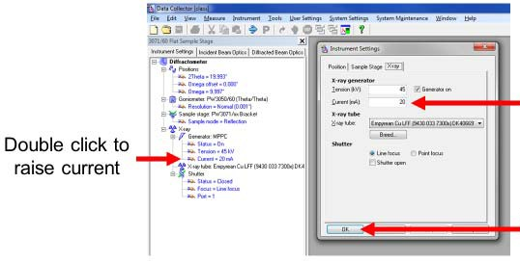
45-20 is standby conditions, 45-40 is scanning conditions. If you find the tool in any other state please contact staff before using.
NOTE: The tool has a shutter indicator on the front panel. NEVER attempt to open the doors while parts are moving, this will result in an error message. If the machine is unsafe to enter due to active x-rays, the doors will be locked and the indicator below will be shown.
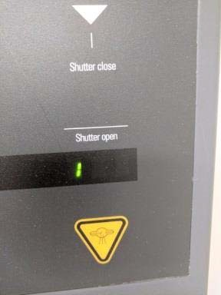
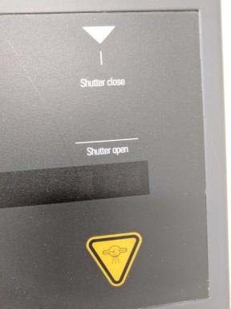
No 1: Safe to open, no active x-rays 1 visible: Not safe, active x-rays

Do not attempt to open doors if the lock is engaged. No significant force should be applied to the doors at any time, when safe the doors should open easily.
If you did not yet load your sample, now is the time to do so.

Check Optics and Prefix Modules
The user is responsible for keeping all Prefix module, slits, masks and any other manually changed part up to date in the software settings. The tool does not detect these changes automatically. Before beginning any work, check the Prefix module on the incident beam tab, if you need to change (this will be referred to as Announce the change in text below) double click on the item that needs changing and select the correct item from the dropdown. You should always align with a 1/32° slit on your incident optic. Check your prefix module on the diffracted beam tab, when using the PPC you should always align with eh receiving slit in place.
Users must visually check in the machine that the 1/32° slit and receiving slit are in place before beginning the alignment. Failure to install these may lead to detector damage, and negligent users may have their project billed for repairs.

Sample Height Adjustment
If using manual alignment be sure to clear all coarse and fine offsets in the User settings before performing any scans. Auto alignment programs do this in the routine.
- Sample height must be adjusted any time you place a new sample in the instrument. We use the direct beam method to ensure the sample is aligned with the X-Ray beam.
- Insert the 1/32º Slit into the Incident beam path and the Parallel Plate Collimator slit into the diffracted beam path (if using the PPC). Announce these changes in the data collector software.
- We have a Batch Process (program) set up for automatic height adjustment, you may use the program designed for the current “default” optic configuration: Mirror + PPC.
- If using the batch process, ensure all slits are in place, if prompted to add a slit, add it as indicated and select “OK”. Please do not ignore prompts to insert slits, this may result in oversaturating the detector.

- If you prefer to height align manually (OR if auto height align didn’t work as expected):
  - Ensure automatic attenuator is set to ACTIVE anytime you are running manual scans, Automatic mode or always on both fine settings, but it must be ACTIVE.
  - Set X, Y, Z, Omega, 2Theta, Psi, Chi to 0
  - Measure -> Manual Scan
  - 2Theta scan axis
  - Range ~0.4
  - Step size (range/100)
  - Scan time: low enough for a ~1min scan
  - On resulting graph, right click, peak mode, move to.
  - Save the offset as the new zero position. (User settings)
  - Move Z position to 5.5mm
  - Manual Scan, Z axis scan
  - Range 10mm
  - Step size 0.01
  - Time per step can be low (2-5) aim for a 30 second to 1-minute scan time, or less.
  - In the resulting graph, right click and select move mode and drag the line to the midpoint of the dropoff. This places the sample directly in the beampath.
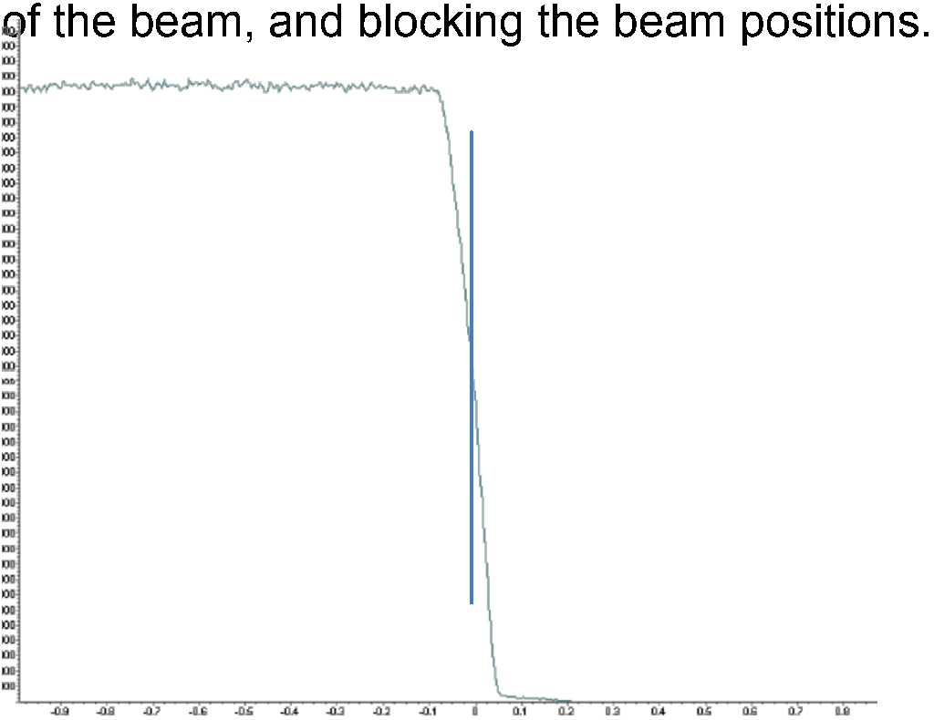
- Measure -> Manual Scan
- Omega Scan axis
- Range can be ~0.4
- Step size should be (Range/100)
- Time per step can be small enough for a ~1 minute scan.
- On resulting graph, right click, peak mode, select move to.
- Repeat Z scan with smaller (~4) range
- Repeat omega scan
- Alternate Z and omega until change is insignificant (2-3x each)
- Set the offsets in User Controls, select Fine Offsets, set offsets in user settings, fine offsets, “set new=0

XRR Requires an Extra Alignment
If running XRR scans for this sample, execute the batch program for XRR alignment to align the Chi orientation to ensure reflection is directed back to the detector.
- This can also be done manually by:
- Ensure automatic Attenuator is set to ACTIVE when running manual scans.
- Manual scan
- Omega axis, range 0.4, step size 0.004, time to make scan time ~1 minute
- In graph, right click, peak mode, move to
- Manual scan
- Chi axis, range 4, step size 0.04, time to make scan time ~1min
- In graph, right click, peak mode, move to
- Repeat Omega and Chi scans 2-3x each until not changing significantly
- Save the offsets in user settings

Running an XRR Scan
You will need to insert the PPC Collimator slit from the diffracted beam path if it is not already there. Please start with the 1/32º receiving slit in to ensure your lowest angles aren’t oversaturating the detector. Announce any hardware changes to data collector.

You may use the example XRR program, however please don’t
modify anything other than the 4 scan parameter boxes in the example program. If you want to create your own, please save as and create a new file before editing any settings. NRF staff are not responsible for the behavior of any user created scan programs.
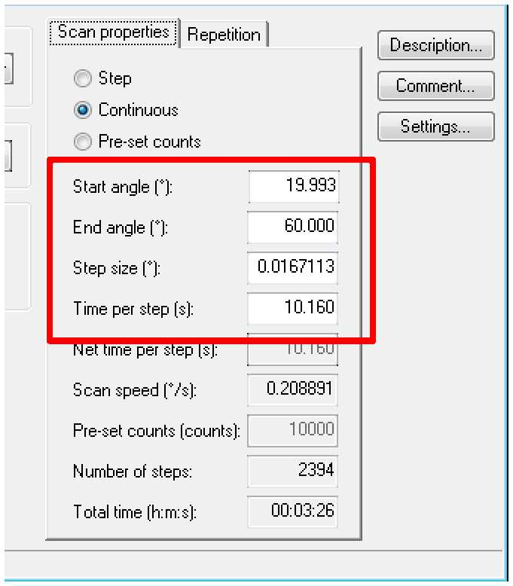
Generally, XRR scans have a start angle near zero (~0.1) and an end angle near 3-5 degrees. If only looking for critical angle, reduce scan to 0.1 to 2 for start and end angles.

Please check the program settings to ensure the automatic attenuator is set to “at preset intensity”

Close the program window and save changes.

Measure -> Program, select your XRR program. Save to your user folder and make any needed notes in the spots available (these save to the report).

Right click on the axis of the plot and change it to logarithmic scale to see the data as typically reported.

Use data viewer to convert data to XY format, or we have Reflectivity software designed to process these types of files. Reflectivity software requires some learning; it is also available for use on the JCPDS machine. You will need to tell the software what you know about your sample, and then help it model your curve.

Running a GIXRD Measurement
You will need to remove the PPC Collimator slit from the diffracted beam path. It is recommended you use a slit and mask appropriate to the size of your sample. Announce these changes to data collector. Example programs are set to take any slit/mask combination announced in data collector.

You may use the example GIXRD program, however, please don’t modify anything other than the 4 scan parameter boxes.
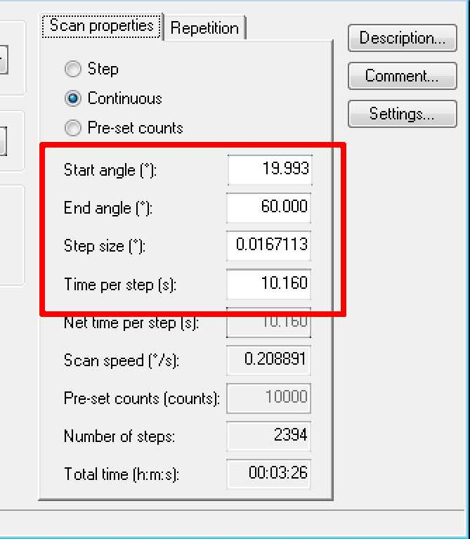
The range should be similar to a powder scan, typically 20-100 is sufficient.

PANalytical indicated at their last visit, step sizes lower than 0.03 are overkill for GIXRD, and do nothing but increase scan time. Take that as you wish, this is by no means a rule, was their suggestion.

You may use the example GIXRD program and change other settings (masks, slits, etc) but BEFORE making changes, File-> save as… and give it a new name.

Please check the program settings to ensure the automatic attenuator is set to “at preset intensity” if using anything other than the example program.

Close the program window and save changes.

Before executing your GIXRD program, set omega in the instrument settings panel to desired incident angle. The example program is set to use the current setting as the incident angle. If you write your own program you can change this.
*You can use XRR to determine the critical angle (which is an ideal angle for GIXRD)

Measure -> Program, select your GIXRD program. Save to your user folder, and make any needed notes in the spots available (these save to the report).

Use data viewer to convert data to XY format, or Highscore to process as you would a Theta-2Theta scan.

After you select to run a program:
This will open the measurement window
Select the large folder icon to choose where to save your scan data
Data should be stored in the XRD User Data library in a folder with your name
The folders and subfolders in your named directory can be whatever you like
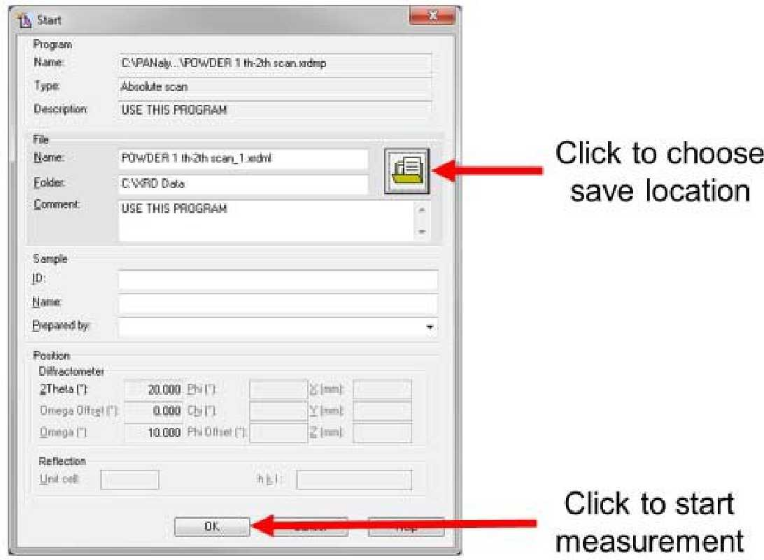
Before beginning the run, ensure the machine doors are completely closed

Select OK to begin the scan

The tool will lock the doors. DO NOT attempt to open the doors.

The scan will run autonomously at this point. A graph will pop up and plot data as it comes in. There is no alert when the scan finishes. When all data is compiled, the machine will return the X- ray source back to the start angle and unlock the doors.

Once the doors are unlocked, you may proceed. Do not attempt to open the doors at any time while any pieces inside the machine are in motion. This will result in an error message and can damage the gears that move the parts.

Additional Technique: Rocking Curves
High resolution rocking curves are best collected using the hybrid and triple axis optics. Lower resolution rocking curves can be collected with the mirror or Hybrid and the PPC. A 1/2° slit is recommended on the incident beam side, and masks if your sample is less than 25mm. A 1/2° slit is recommended for the diffracted beam path as well. Announce all changes in data collector.
This technique describes rocking a sample on the omega axis to collect the rocking curve.
Modify as needed :

There is no example program for rocking curves because they are sample dependent and require performing a manual scan. You need to manually center 2theta on a known peak, or select one in the Instrument settings to have the instrument move to the peak location for you.

Ensure your sample is appropriately height aligned and necessary offsets are applied and saved. (see Basic SOPs for this procedure).

Double check the Attenuator is set to automatically activate at preset intensity (do not modify values) and ensure it is ACTIVE.

Manually move to the 2theta position you are interested in observing... OR

Under Instrument Settings, adjust the Unit Cell box to match your sample material.

Enter the h k I peak you would like to observe (place a space between each value. Click Apply to move the detector to the correct position.

Scan omega and move to maximum. (peak mode, move to)

If the peak is very sharp, consider rescanning with smaller step size and range.

Scan Chi and move to maximum. (peak mode, move to)

Repeat the omega and chi scans until neither changes significantly

Scan 2theta with a range of 1°, step size of 0.01, and 0.1 time per step.

Only move 2theta position if necessary to center on the peak. The 2theta resolution is low in this configuration.

Save sample offset omega=1/2(2theta), Chi=0

Perform a manual omega scan with high resolution and small steps. This will be your rocking curve data.

If the scan is sufficient for your needs SAVE THE DATA.

Manual scans do not automatically save, you will need to click on the graph, then select file-> Save As to save your rocking curve data.
Additional MRD Techniques: "Powder" Scans, Gonio (Theta-2Theta)

Running a Theta-2Theta Measurement- *This is what the Powder machine does, it is over 10x faster to run one there because of the detector type.

You will need to have the fixed divergent slit optic installed on the incident beam side, and programmable receiving slit on the diffracted beam side. Run a sample height alignment using the 1/32° slit and beam attenuator.

Remove attenuator after alignment, insert beta filter. Announce these changed in data collector incident beam settings.

Select mask and slit combination necessary for your sample size and composition. Request assistance if you need suggestions, or start small and use larger ones if necessary. Announce changes in data collector.

You may use the example Th-2Th program, however please don't modify anything other than the 4 scan parameter boxes: Start Angle, End angle, Step size, and Time per step.

You may use the example Th-2Th program and change other settings (masks, slits, etc) but BEFORE making changes, File-> save as... and give it a new name.

Close the program window and save changes.

Measure -> Program, select your Th-2Th program. Save to your user folder, and make any needed notes in the spots available (these save to the report).

Use data viewer to convert data to XY format, or Highscore to process as desired.

Sample Unloading
It is recommended you set the Chi rotation to 90 before loading or unloading samples. You may leave the Chi setting at 90 upon logging out.

Once the doors are unlocked (there will be a loud click), you should be safe to open the door. However, ensure the X-ray is blocked with the indicator on the front of the machine.

If the X-ray is blocked (shutter is closed), open the doors slowly to retrieve your sample.

If you are running additional samples, you may load them at this point, close the doors, and run more measurements

If you are finished with all your scans, remove all samples and loading/buffer slides from the machine and close the machine doors

Post-Operation
When finished with the machine, you will need to return it to standby power

If someone is going to use the machine immediately after you and are present in the room, you may leave the tool at full power

Double click the current in the left window to adjust the current to 20 mA

Ensure the 1/32º slit is inserted and announced in data collector

Ensure the PPC receiving slit is inserted in the diffracted beam path and announced to software.

Close all open windows in the Data Collector program, BUT DO NOT CLOSE THE DATA COLLECTOR PROGRAM ITSELF

