

STS DRIE

Standard Operating Procedure Rev. 2026-01

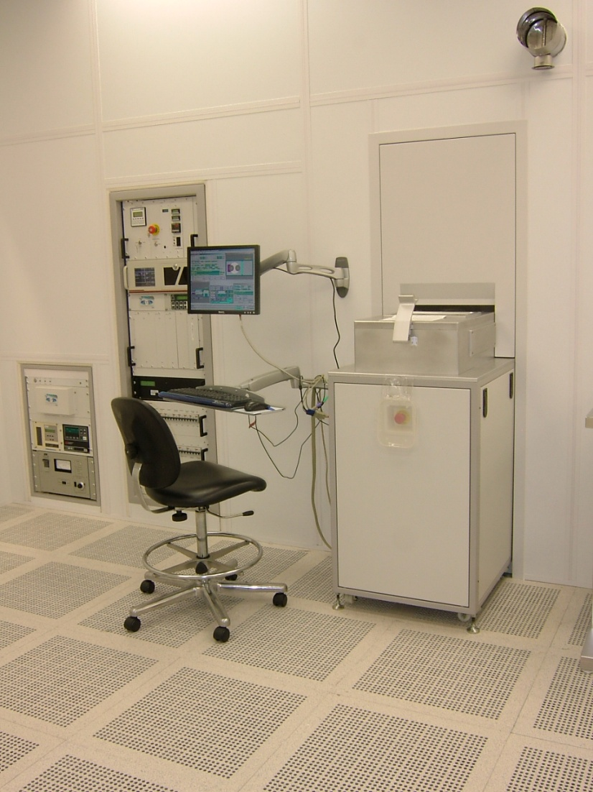

  - Application

The STS DRIE is an Inductively Coupled Plasma Process etcher designed and configured to etch deep high aspect ratio features in silicon only. The process provides high selectivity for etching Si with most common photoresist and SiO2 masks. ICP RIE uses RF magnetic field to further excite electron cloud and reactive ions and increase density of ions and neutrals which increases etch rate. By combination of alternate SF6 etch and C4F8 protection (deposition) process cycles with ICP RIE, high etch rate, high directionality silicon etch is realized.
  - NRF Contact

David Hays
Table of Contents
1. Safety information 3
2. Prerequisites for use 3
3. Sample Restrictions 4
4. Start Up 4
4.2. System hardware checks 4
4.3. Software checks 4
5. Tool Operation 5
5.1. Sample Loading 5
5.2. Loading And Editing A Recipe 6
5.3. Running The Recipe 10
5.4. Unloading Sample 10
6. Ending The Session 10
7. Recover From Communication Fault 11

- Safety information
- High Voltage Radio Frequency is used throughout the system. Do not remove any tool covers or defeat any interlock on this system.
- Prerequisites for use
- User of the RSC facilities.
- Up-to-date hazardous waste training.
- Training by staff.
- User will be responsible for lost or damaged equipment due to negligence. Negligence means not following the SOP, not asking staff for assistance, intentionally damaging items, etc.
- Sample Restrictions
    - Absolutely no exposed metal is allowed in the process chamber. Any metal on your substrate must be COMPLETELY covered by photoresist, SiO₂, Al₂O₃, etc.

CAUTION  CAUTION

METALS AND METAL MASKS ARE NOT TO BE
EXPOSED TO PLASMA IN THE CHAMBER.

    - No silicone based thermal compounds are allowed. Use only staff approved thermal compounds for carrier wafer mounting.
    - No wet samples are allowed in the chamber. All wet processed samples must be completely dry before placing inside the tool.
- Start Up
    - Log in to TUMI
  - System hardware checks
    - Check that the LCD display on the ILD module is not showing any coolant errors.
    - Check that the lid temperature is at setpoint, 45°C.
    - Check that the turbo pump is operational and showing ‘Norm’ and the rotation is at 32,500rpm.
  - Software checks
    - Check that the software is running and is in active mode.
- If the operator station software is not running, then double click on the operator station icon and allow the software to boot up.
- Select the ‘Administration’ Mode and click ‘Change’; the Password is “adm”.
- If the software boots in the active mode, then the tool is ready to process. The mode can be found on the right side of the “Process Control Window.
- If it is “Unknown” or “Inactive” then call staff to assist you.
    - The lower bar of the operator’s station window should not be RED; if it is, click in the red and a pop-up window will appear that describes the problem(s) in detail. Try clicking ‘Accept’ and see if it clears the error. If the error persists, then contact staff.
- Tool Operation
  - Sample Loading
    - To load the properly prepared wafer (See Sample Preparation in Appendix section 1.1) , follow the procedure below.
    - Click the ‘Vent’ button on the transfer window, and this will vent the loadlock.

    - Once it reaches atmosphere, lift up on the lid handle. The lid is heavy and must be held open while placing the wafer on the carousel; be careful.
      - Place your wafer in any open slot on the carousel (removal of maintenance wafers may be necessary, remember to replace them when finished). Align the wafer flat with the flat markers.

      - Take care when placing wafers in the carousel slots that you do NOT press down on the carousel arm.

      - NOTE: Maintenance wafers are NOT to be used by users for anything but running O2 cleans.

      - Close the lid and pull the latch handle forward, it will click and lock the lid.

CAUTION CAUTION
Always check the underside of the wafer for particulate
debris and irregularities just before loading to prevent
contamination of the o-ring.

    - Select ‘Pump+Map’. Carousel loadlock will be pumped. Wait for the status bar to say “Ready
    - Select wafer slot number (1 or 2) and select ‘Load’. The wafer will be transferred to the process chamber. The status will change to ‘Transfer of (wafer) from carousel to ICP complete’
  - Loading And Editing A Recipe
    - At the Operators Station “process control” window press ‘Select’ button and a small pop-up will appear. Users may select their own recipes or one of our basic recipes to use as a starting point. The basic recipes are:
O2CLEAN – Used for cleaning the chamber
BAO2CAL – Most widely used template for deep etching
SOI_ETCH – Used to stop on dielectric layer without “footing”
PROA
PROB
CONT_ET – Mixed gas process (non-switching) for shallow etches without “scallops”
NOTE: No user will ever modify and save a recipe and fail to rename it unless they created the recipe in the first place.

    - Once a recipe is highlighted, press ‘Select’ and the machine will load the recipe and prepare the chamber to run it. The recipe name will appear in the process window.
NOTE: Never command the machine to do anything unless the word “READY” appears in the lower left part of the Operators Station window. Failure to do so will cause the software to lock up.

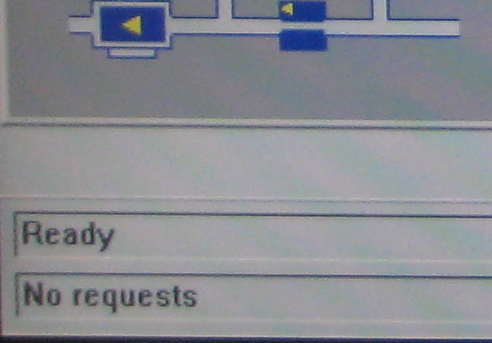

    - Click on the ‘Recipe’ button to bring up the Recipe editor and display the recipes parameters.
    - The first window displayed by default shows the Standby Step; never modify this.
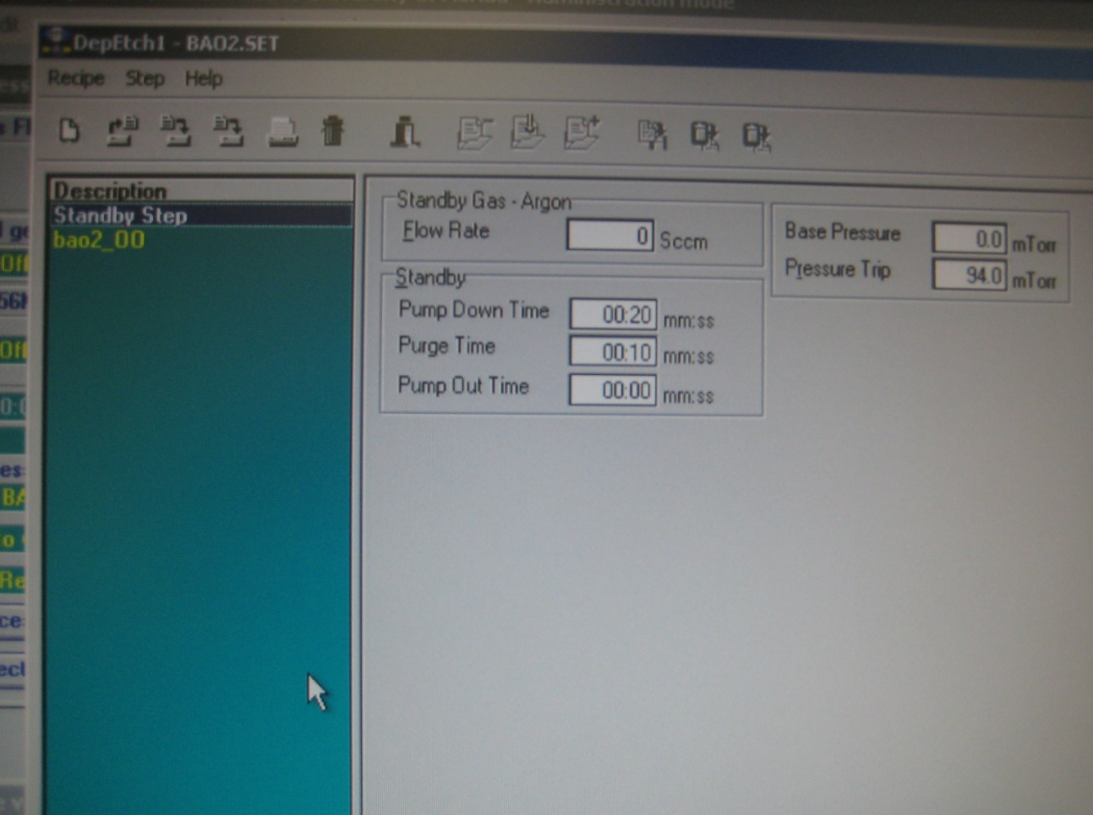
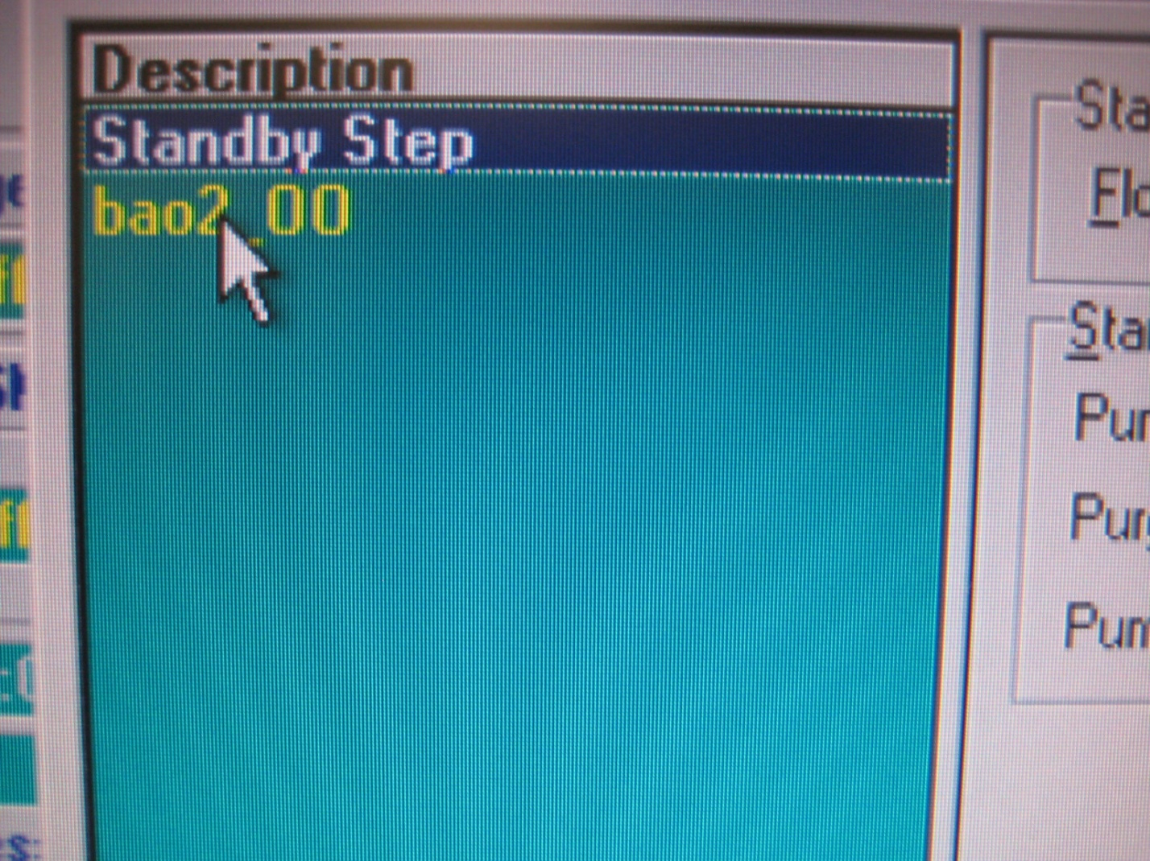

    - The recipes process tabs will be displayed; General, Pressure, Gases, RF, HBC and HLUR.
    - On the General tab process time, cycle phase times, and process modes can be entered into the recipe.
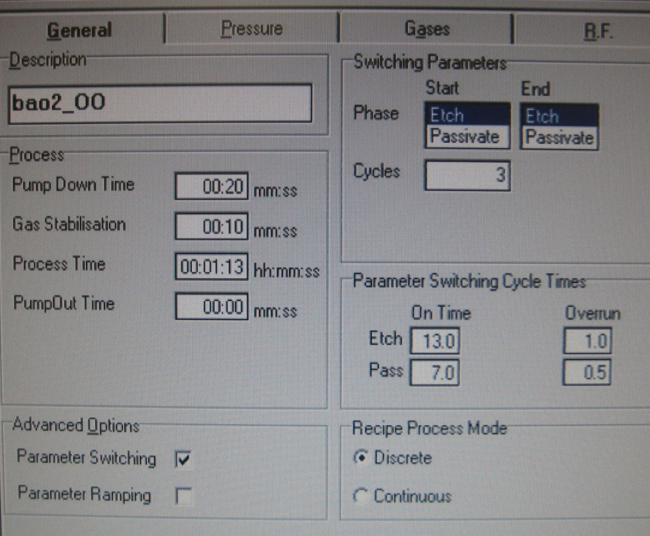

    - In the pressure tab the chamber pressure and APC valve mode can be set. Tolerances in the recipe should be 5%

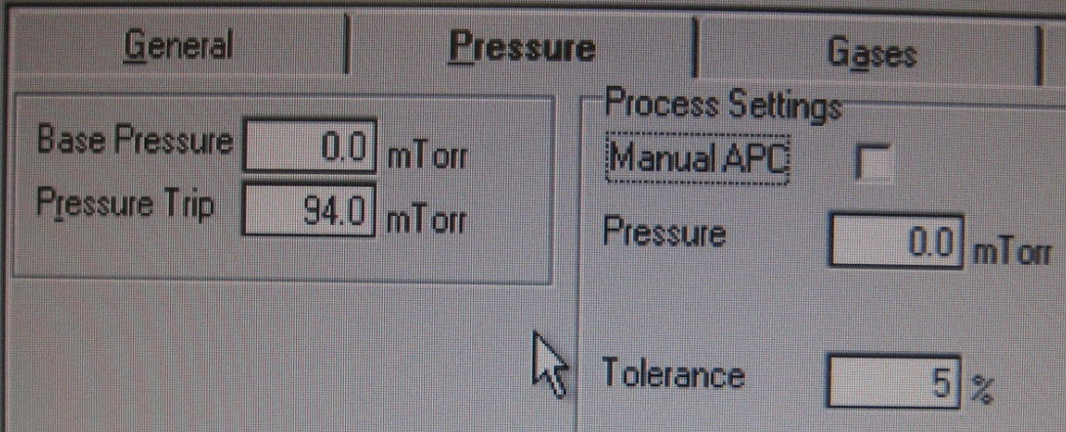

    - The gas flows and mixtures are set on the Gases tab
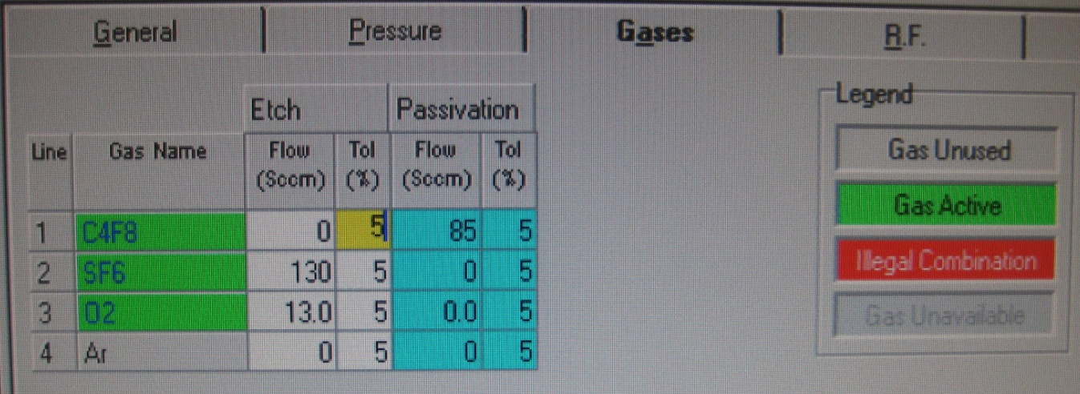

    - The RF energy tab allows the RF wattage to be set do not change the other parameters.
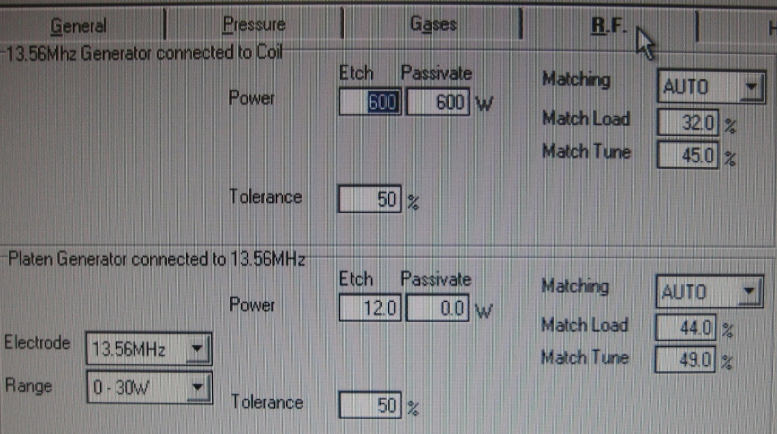

    - The parameter for Helium Backside Cooling can be set on the HBC tab; adjustments are device specific.

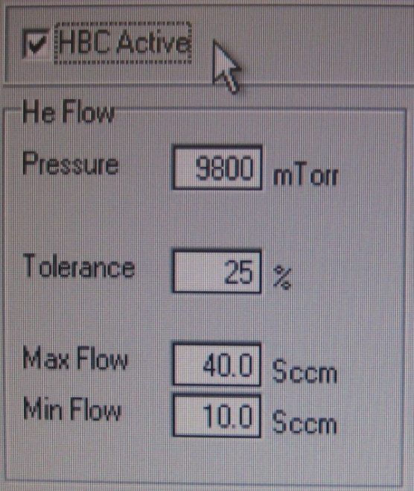

    - The helium leak up rate test parameters are set in the HeLUR tab; max should be 20 to 25 mTorr/min. LURs over 10 will however will cause process variation, a clean fresh wafer should be in the 5 to 6 range.
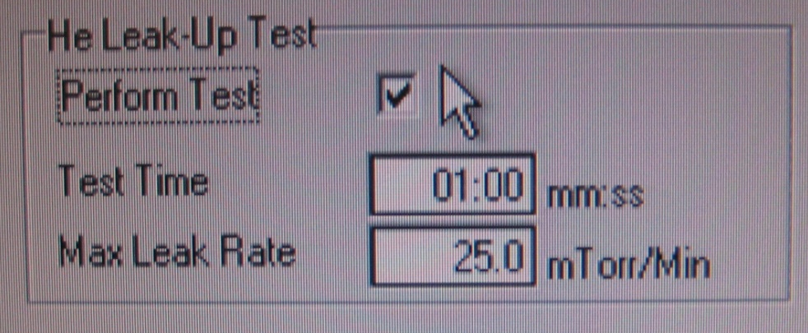

    - Save the recipe using a personal file name if the originals was one of the basic recipes or was authored be someone else.

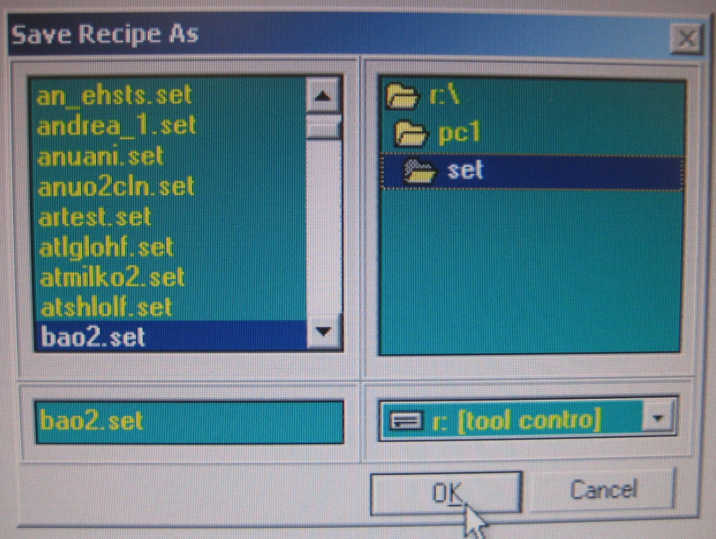

    - After editing is finished click on the exit icon.

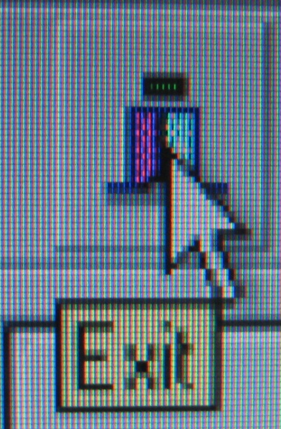

  - Running The Recipe
    - In the “Process Control” window, click on ‘Process’ and your recipe will run until complete showing a green wafer icon. If the process aborts for any reason the wafer icon will be red
  - Unloading Sample
    - Unload by pressing ‘Unload’ in the transfer window, wait for the unload process to complete and the machine to be in the ready state.
    - Press the ‘Vent’ button to vent the loadlock to atmosphere.
    - Lift the lid and remove your samples. Place the chamber clean wafer back on the load arm if you removed it. Click ‘Pump+Map’ and wait for sequence to finish.
- Ending The Session
    - Run When finished with all of your wafer processing, run the O2 chamber clean by clicking the ‘Run’ button on the “Sequencer” window. Another window will pop up that says it will run on the already mapped wafer…Click ‘Run’.
    - If the Sequencer window is not open then look at the top menu bar and click on ‘Control’ and then ‘Sequencer’
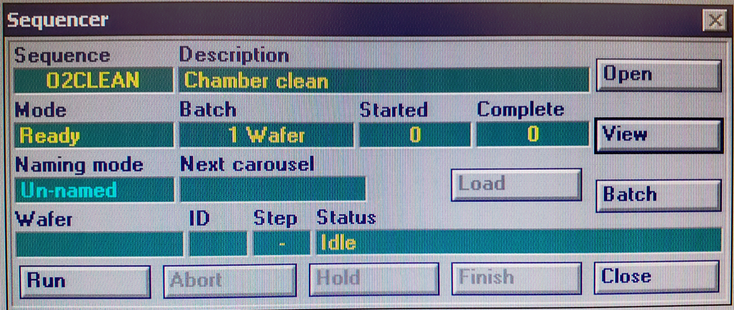

    - Log off TUMI
- Recover From Communication Fault
    - In the event of a Red box error of serial communications error use the following procedure to re-establish communications between the system computers.
    - If the error interrupted an active process during any plasma phase record the process times and conditions at the time of the failure so that the process can be restarted where it left off.
    - Reset and accept any process errors that are active and allow the machine to reach ready state.
    - Take the system to inactive mode. (click the mode button and select inactive)
    - Open the door of the computer located in the upper third of the Electronics Control rack on the wall behind the operator’s computer. Behind the door you will find some storage drives, a red ‘Reset’ button…press the ‘Reset’ button twice. The two main control computers will reboot; wait for the Operator Station to come up to the Windows desktop, as always sign on as “Administrator” password=adm. If the system fails again to establish communications, then a staff engineer must be called to reset other systems.

