

Trion Minilock ICP Etcher

Standard Operating Procedure Rev. 2026-01

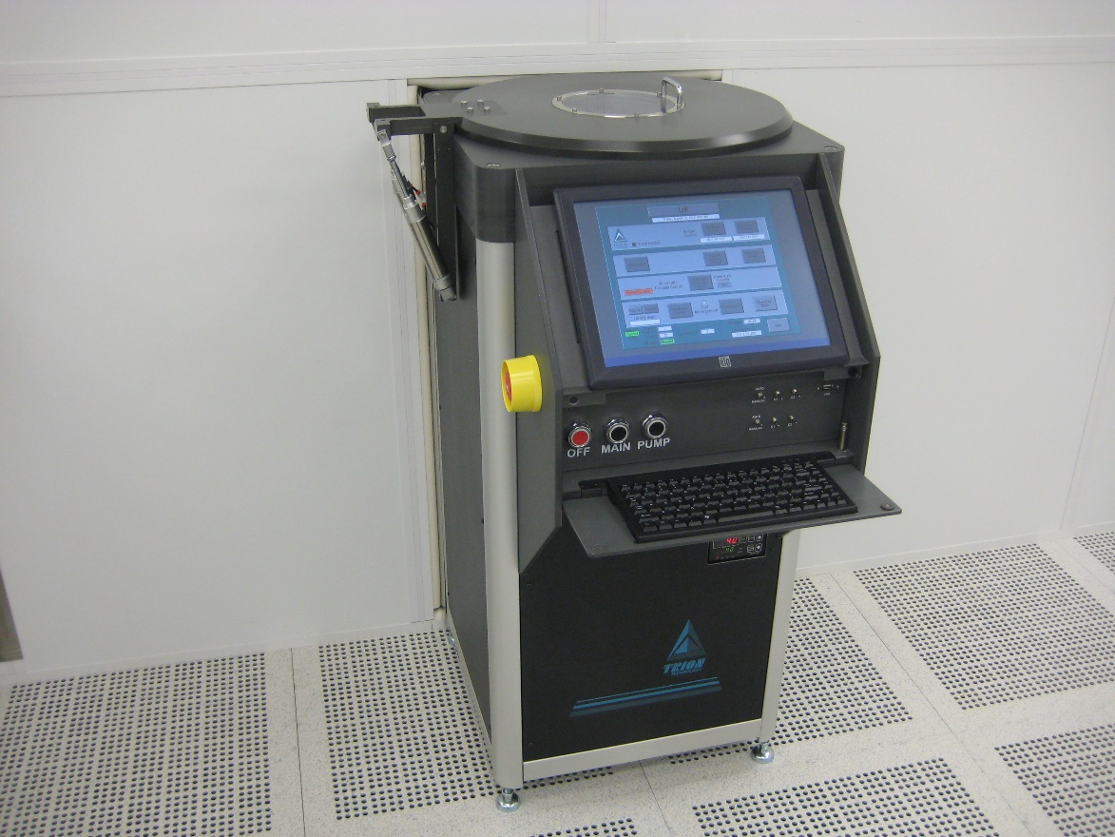

  - Application

The Trion etcher is loadlock equipped and operated via a touch screen interface. The user may employ either RIE (Reactive Ion Etching) RF power applied at the sample stage or ICP (Inductively Coupled Plasma) The system is configured to use both chlorinated and fluorinated gases to perform a wide variety of etch recipes. The following gasses are available for use on the Trion etcher: O2, CHF3, CF4, Ar, BCl3, Cl2, and SF6. The tool will only process 4” wafers, or pieces on a 4” wafer carrier. It does have the capability to process 6” wafers but a hardware change is required.
  - NRF Contact

David Hays
Table of Contents
1. Safety information 3
2. Prerequisites for use 3
3. Sample Restrictions 4
4. Software Layout 4
5. Start Up 4
6. Tool Operation 5
6.1. Loading And Editing Recipes 5
6.2. Processing In Full Auto Mode 5
6.3. Processing Automatic Single Process Mode 6
7. Ending The Session 8

- Safety information
- Lab Gas Detection Alarm -The gases supplied to this system (among others throughout the lab) are monitored by leak detection sensors inside the lab and gas cabinets in the service corridor. If an alarm occurs, EVACUATE IMMEDIATELY. NRF Staff will be notified immediately.
- High Voltage - High Voltage Radio Frequency is used throughout the system. System maintenance may only be performed by Trion or NRF Staff. Do not remove any tool covers or defeat any interlock on this system.
- Moving Components – The loadlock lid will raise and lower automatically. The user must not place hands anywhere near the lid when closing. Do not place any items on the lid itself.
- Prerequisites for use
- User of the RSC facilities.
- Up-to-date hazardous waste training.
- Training by staff.
- User will be responsible for lost or damaged equipment due to negligence. Negligence means not following the SOP, not asking staff for assistance, intentionally damaging items, etc.
  - Users are not allowed to touch ANY of the controls behind the keyboard. Those caught doing so will have their privileges removed.

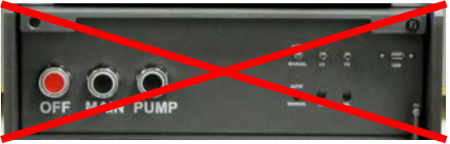
- Sample Restrictions
    - For high powered processes, no photoresists, tapes or adhesives can be within 5mm of the 4” wafer edge…or the wafer will stick to the clamp, will not unload, and most likely be broken.
      - NRF has a 4” wafer edge exposure mask you may use to remove wafer edge photoresist.
- Software Layout
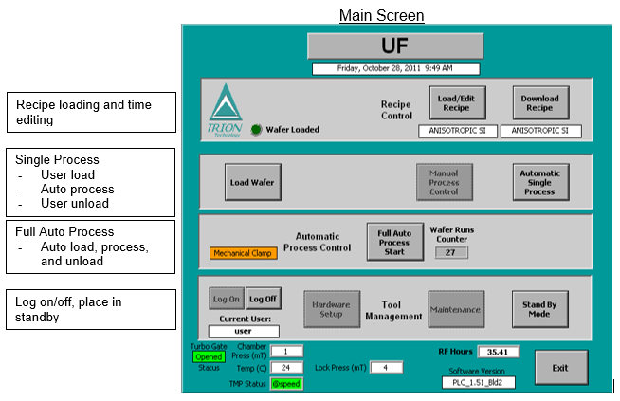
- Start Up
    - Log in to TUMI
    - Press the “CANCEL” button to remove the tool from standby.
    - Press the “LOG ON” button
- Name is “user”
- Password is “user”
- Tool Operation
  - Loading And Editing Recipes
    - Press the “LOAD/EDIT RECIPE” button
    - Press the “RECIPE FROM DISK” button
    - Select the desired recipe from the list
    - Enter the process time.
    - Press the “EXIT” button. This will download the recipe for processing.
  - Processing In Full Auto Mode
This will load the sample, run the selected process and unload the sample automatically.
    - Press the “FULL AUTO PROCESS START” button.
    - Press the “VENT LOCK FIRST” button when prompted.
    - The lid will open automatically (approximately 45s).

ENSURE THAT NO ITEMS ARE ON TOP OF THE LID!!!
    - Place the wafer/sample on the load arm within the wafer outline. The tool will only process 4” wafers. If the sample is smaller than 4”, then a carrier wafer must be used.
    - Press the “OK” button to close the lid. The lid will now close automatically.

DO NOT PLACE HANDS ANYWHERE NEAR THE LID WHILE IT IS CLOSING.
    - The wafer will now be transferred to the etch chamber automatically and run the recipe.
    - When the recipe is complete a message will appear. Press the “OK” button to unload and vent.
    - When the lid opens, remove the wafer/sample.

    - TO ETCH ANOTHER WAFER/SAMPLE
      - Again, place the wafer/sample on the load arm within the wafer outline.
      - Press the “OK” button to close the lid.
      - Press “OK” to pump down the loadlock.
      - See section 3 to Load/Edit a recipe if needed.
      - Press the “FULL AUTO PROCESS START” button.
      - This time press the “DO NOT VENT LOCK” button because you already loaded your wafer/sample during the unload of the last run.
      - Again, when the process is complete. Press the “OK” button to unload and vent.
      - Remove your sample when the lid opens.

    - WHEN FINISHED WITH ALL PROCESSING
      - Press the “OK” button to close the lid.
      - When prompted, press the “OK” button to pump down the loadlock.
  - Processing Automatic Single Process Mode
The user will load using a single click button, press a process button, then unload the sample using a single click button. This is intended to be used when etching multilayers that need different recipes for each layer without having to remove from the chamber each time.
    - If a recipe is not loaded, then see Section 3 and load a recipe.
    - Press the “LOAD WAFER” button.
    - When prompted, press the “VENT LOCK FIRST” button.
    - The lid will open automatically (approximately 45s).
ENSURE THAT NO ITEMS ARE ON TOP OF THE LID!!!
    - Place the wafer/sample on the load arm within the wafer outline. The tool will only process 4” wafers. If the sample is smaller than 4”, then a carrier wafer must be used.
    - Press the “OK” button to close the lid. The lid will now close automatically.
DO NOT PLACE HANDS ANYWHERE NEAR THE LID WHILE IT IS CLOSING.
    - Press the “OK” button to pump down the loadlock.
    - Once the wafer transfer is complete, press the “AUTOMATIC SINGLE PROCESS” button. The recipe you selected will now run.
    - When the process is complete, a message will appear. Press the “OK” button.
    - To unload the wafer, press the “UNLOAD WAFER” button and the “OK” button to vent.
    - Remove your sample when the lid opens.

    - TO ETCH ANOTHER WAFER/SAMPLE
      - Again, place the wafer/sample on the load arm within the wafer outline.
      - Press the “OK” button to close the lid.
      - Press “OK” to pump down the loadlock.
      - See section 3 to Load/Edit a recipe if needed.
      - Press the “LOAD WAFER” button.
      - This time press the “DO NOT VENT LOCK” button because you already loaded you wafer/sample during the unload of the last run.
      - Once the wafer transfer is complete, press the “AUTOMATIC SINGLE PROCESS” button. The recipe you selected will now run.
      - When the process is complete, a message will appear. Press the “OK” button.
      - To unload the wafer, press the “UNLOAD WAFER” button and the “OK” button to vent.
      - Remove your sample when the lid opens.

    - WHEN FINISHED WITH ALL PROCESSING
      - Press the “OK” button to close the lid.
      - When prompted, press the “OK” button to pump down the loadlock.
- Ending The Session
    - Press the “LOG OFF” button.
    - Press the “STANDBY” button.
    - Log off TUMI

