
FEI Themis Z S/TEM
  - Acquiring Selected Area Diffraction Patterns using the Ceta Camera Standard Operating Procedure Rev. 2026-01
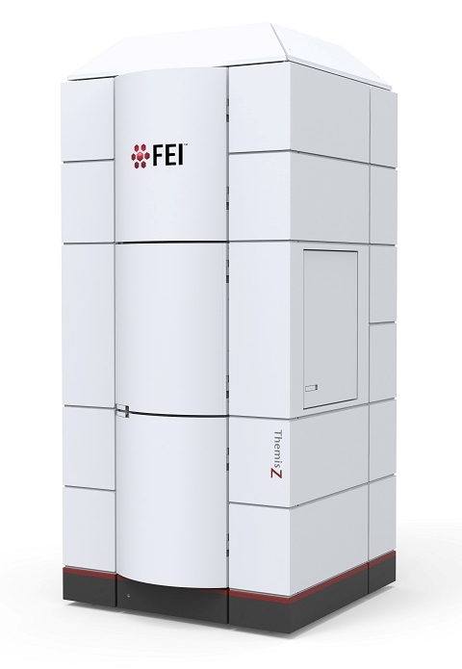
  - Application
The FEI Themis Z S/TEM is a state-of-the-art C_{s} probe-corrected field emission gun scanning/transmission electron microscope capable of providing micro- to pico-scale structural, morphological, magnetic, and chemical information. This document covers use of the instrument for acquiring selected area diffraction patterns (SADPs) with the Ceta camera. Please see separate SOP documents on the NRF instrument page regarding other applications.

  - NRF Contact
Nicholas G. Rudawski

Table of Contents

1. Safety information 3
2. Prerequisites 3
3. Voltage settings 3
4. Instrument settings 4
5. Adjusting crystallographic alignment (single crystal ROIs). 4
6. Focusing and stigmating the diffraction pattern 5
7. Acquiring SADPs (particulate specimens) 10
8. When finished acquiring SADPs (particulate specimens) 17
9. Acquiring SADPs (single crystal ROIs) 19
10. When finished acquiring SADPs (single crystal ROIs) 30

- Safety information

  - Due to stipulations of the instrument service contract as well as contamination concerns, analysis of radioactive and/or biological specimens with this instrument is strictly prohibited.

  - Due to the high potential for damage to the Ceta camera when collecting SADPs, particularly when working with a single crystal region of interest (ROI), collection of SADPs with the Ceta camera may only be performed by users who have received hands-on training from NRF staff.

    - NOTE: receiving cross-training from other users, receiving training to do this using related NRF instruments, or having experience doing this using similar instruments at other facilities are not acceptable substitutes.

- Prerequisites

  - Proficient in conventional TEM mode operation of the FEI Themis Z.

  - Extensive familiarity with use of the Microscope Control user interface software and Velox imaging software.

  - NOTE: as per the prerequisites, many associated details and images that could otherwise be included here are omitted for purposes of clarity (“…as described previously”).

- Voltage settings

  - SADPs may be collected effectively at any of the three possible operating voltages for the instrument. However, 300 kV (used for this document) is generally preferred when the specimens are thicker due to the increased penetrating power compared to 60 or 200 kV

- Instrument settings

  - After locating an ROI and setting it to eucentric height, set the instrument in SA mode and configure the instrument for normal TEM mode operation as described previously.

    - Set spot number = 4.

    - Align the monochromator shift and set “Focus” = –40.

    - Turn off the C3 lens, align the 70 μm C2 aperture, and turn the C3 lens back on.

    - Correct condenser astigmatism.

    - Perform C2/C3 alignment (“Condenser center TEM”).

    - Balance the beam tilt pivot points (“Beam tilt pp X/Beam tilt pp Y”).

    - Align the rotation center (“Rotation center”).

- Adjusting crystallographic alignment (single crystal ROIs).

  - Use the stage to move the ROI to the center of the FluCam.
]
  - Enter diffraction mode and set the camera length as desired.

  - Adjust the α and β stage tilts to crystallographically align the sample as accurately as possible.

    - NOTE: it is best to iteratively tilt the stage while in diffraction mode and then return to SA mode and reestablish eucentric height until the final desired crystallographic alignment is obtained. Again, when finished tilting, the sample should be at eucentric height.

    - NOTE: it is not necessary to obtain precise crystallographic alignment using only the α and β stage tilts; this can be more precisely aligned when adjusting the incident beam tilt (described later).
- Focusing and stigmating the diffraction pattern

  - Set the indicated magnification = = 7500×.

  - Select the “Beam/Tune” tab and navigate to the “Beam Settings” control panel.

    - Adjust the “Intensity” knob until the beam diameter = 6.00 μm.

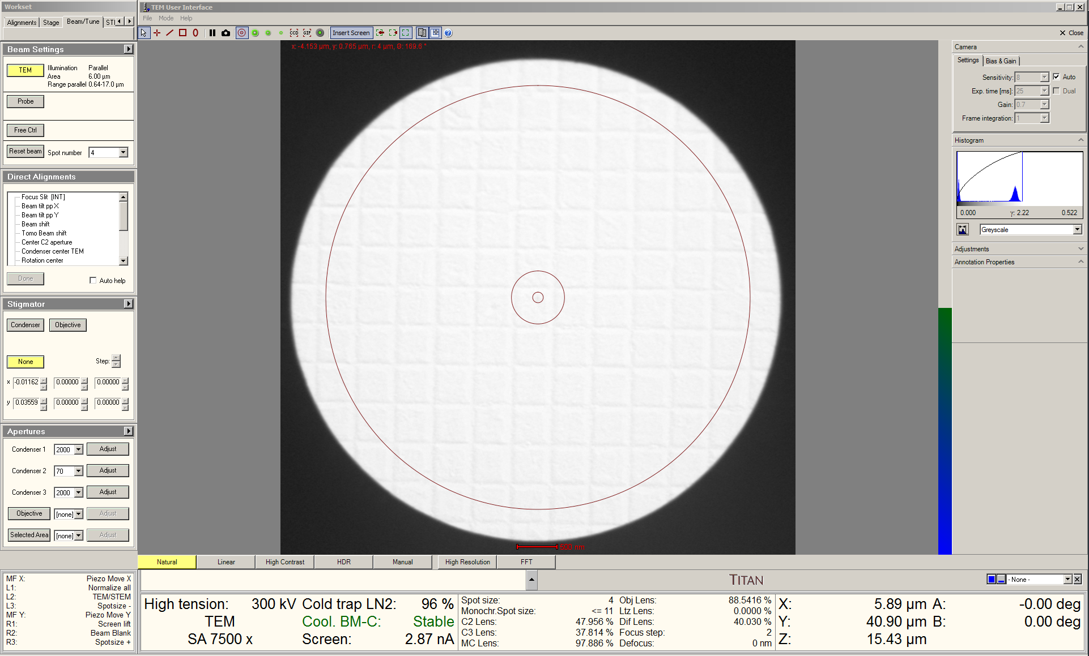

  - Enter diffraction mode; use the “Magnification” knob to set the indicated camera length as desired.

    - NOTE: the higher the indicated camera length, the safer it will be to use the Ceta camera to collect SADPs.

  - Remain in the “Beam/Tune” tab and navigate to the “Direct Alignments” control panel.

    - Select “Diffraction alignment” and use the “MF” knobs to center the DP on the FluCam.

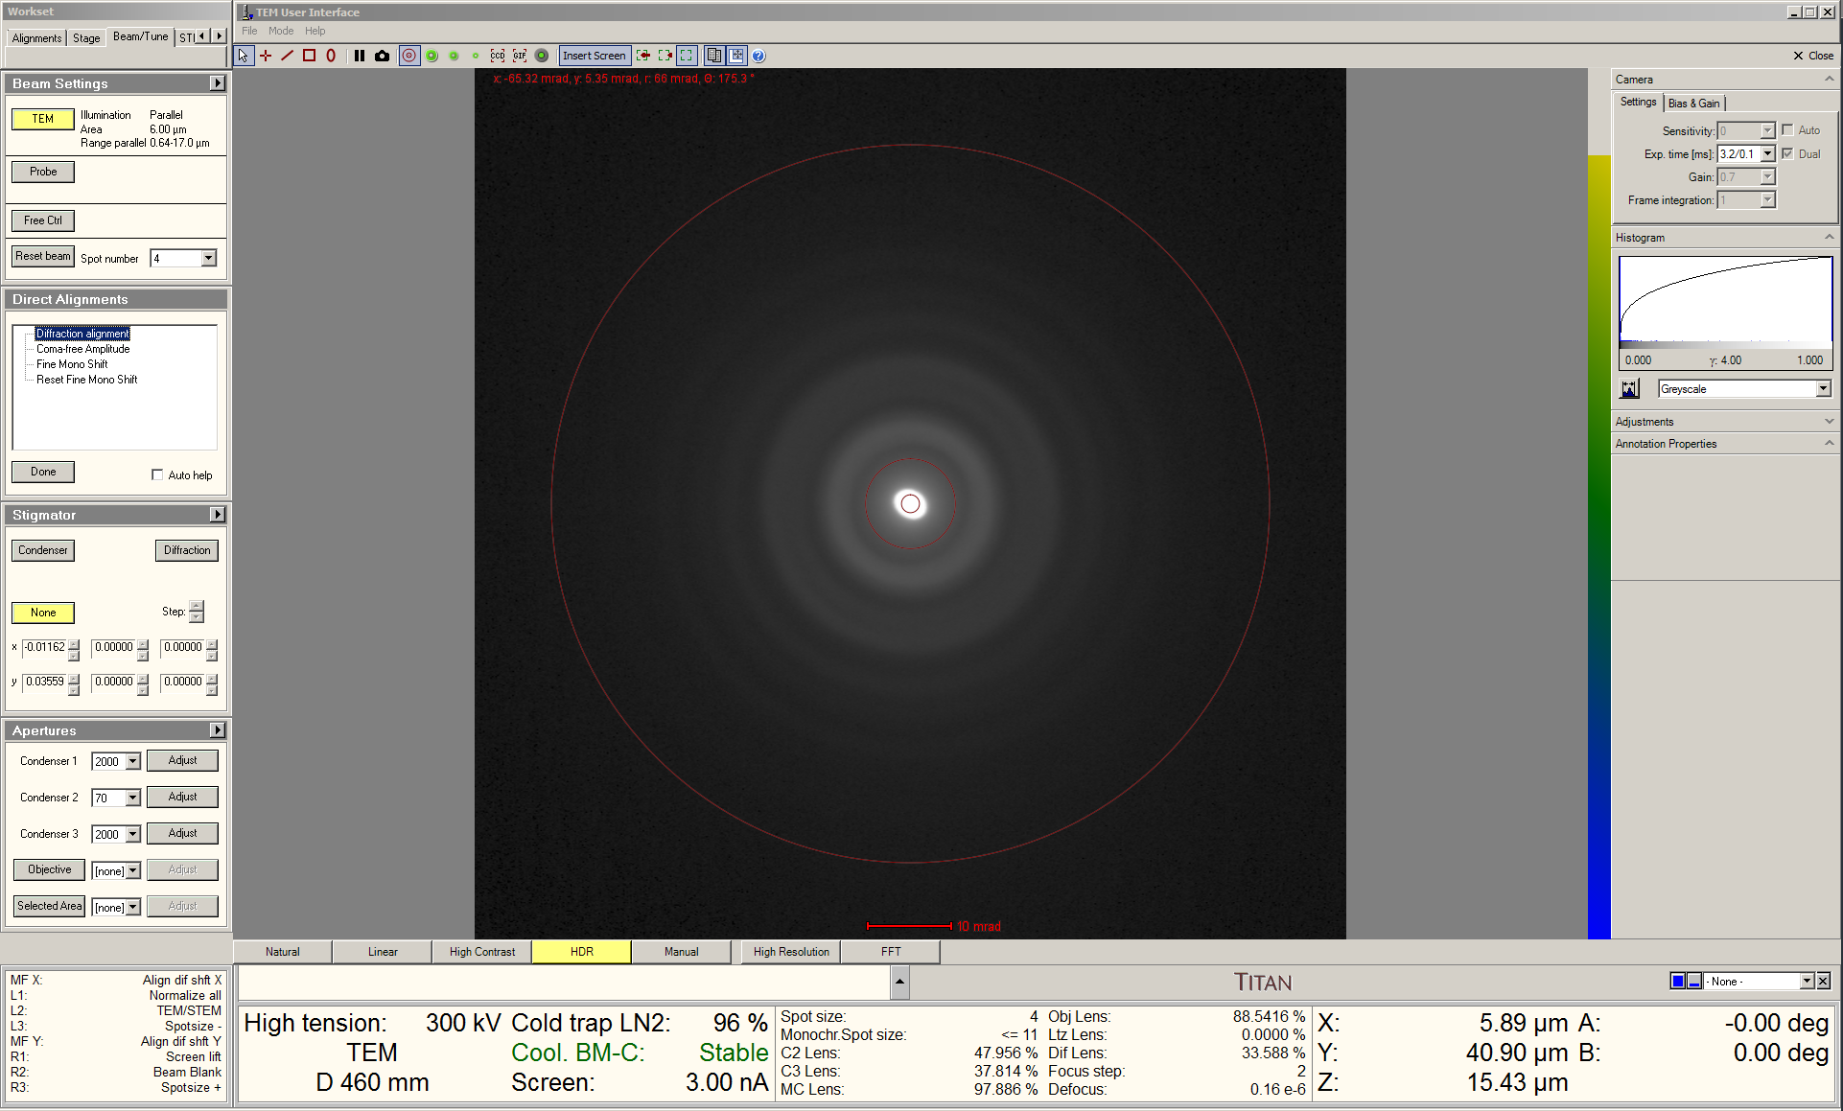

  - Activate the “High Resolution” option for the FluCam.

  - Insert the 20 μm objective aperture; shift the aperture position so the direct beam is not contained inside of it.

  - Remain in the “Beam/Tune” tab and navigate to the “Stigmator” control panel.

    - Select “Diffraction” and adjust the “MF” knobs to obtain the sharpest possible image of the edge of the objective aperture.

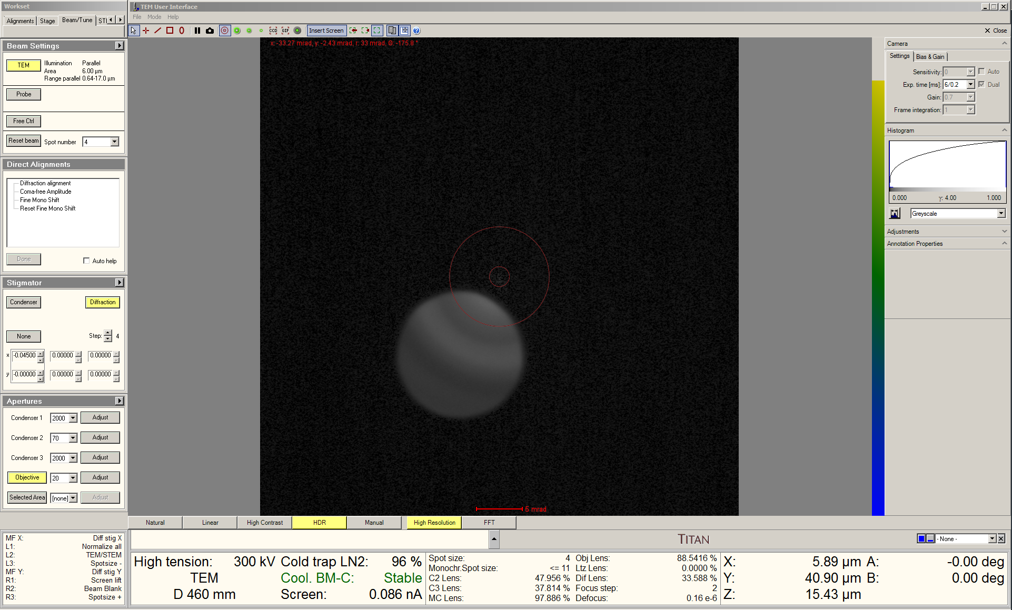

    - Use the “Focus” knob to focus the edge of the objective aperture; retract the objective aperture when finished.

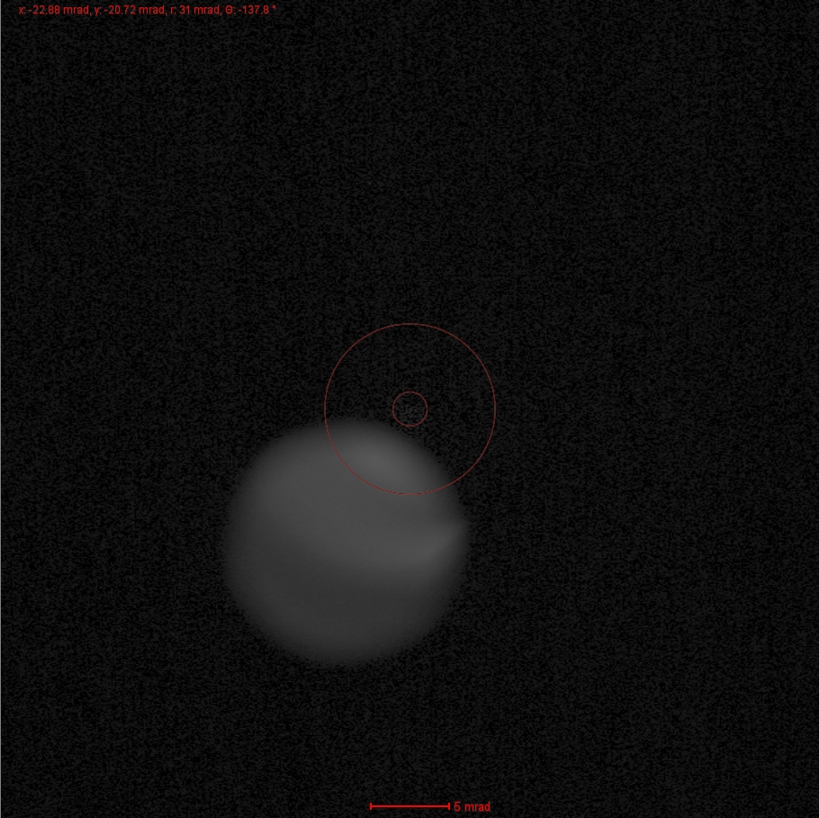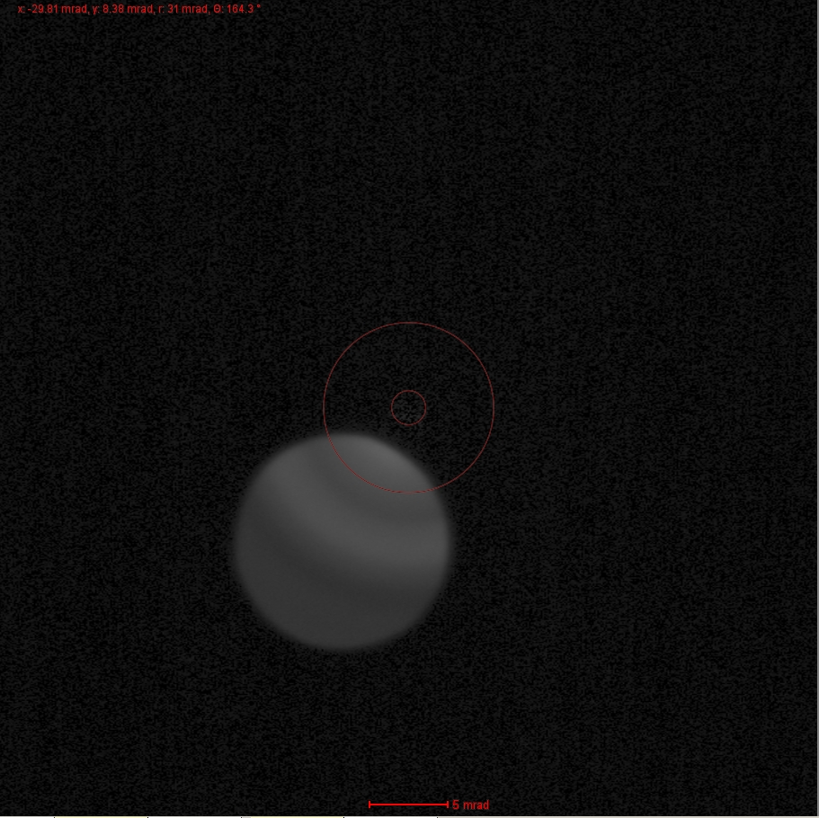

Above: before (left) and after (right) correcting diffraction astigmatism.
  - If any astigmatism still appears in the direct beam, this must be corrected with the condenser stigmators; navigate to the “Stigmators” control panel and select “Condenser”.

    - Use the “MF” knobs to make the direct spot as circular as possible.

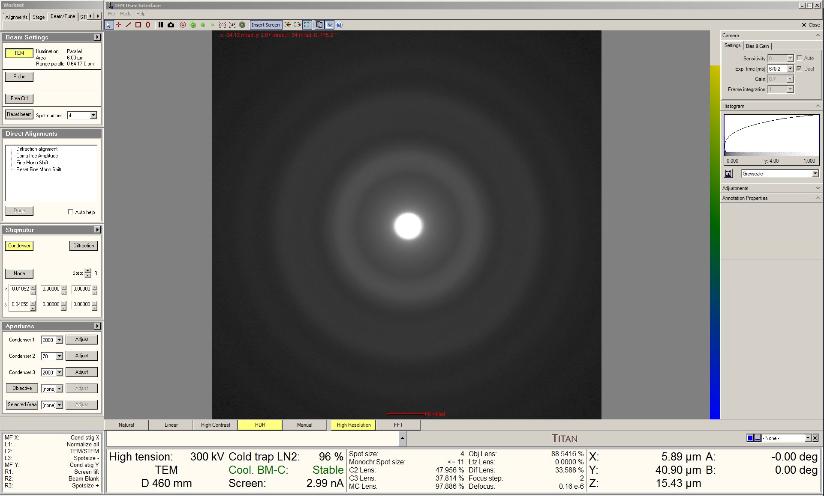

  - Switch the FluCam display mode to “Natural”.

  - Remain in the “Beam/Tune” tab and navigate to the “Beam Settings” control panel; select the flap-out arrow in the upper right corner.

    - In the flap-out panel, select the “Tune” tab and then check “MF-Y Fine focus back focal plane”.

    - Use the “MF-Y” knob to focus the direct spot as precisely as possible.

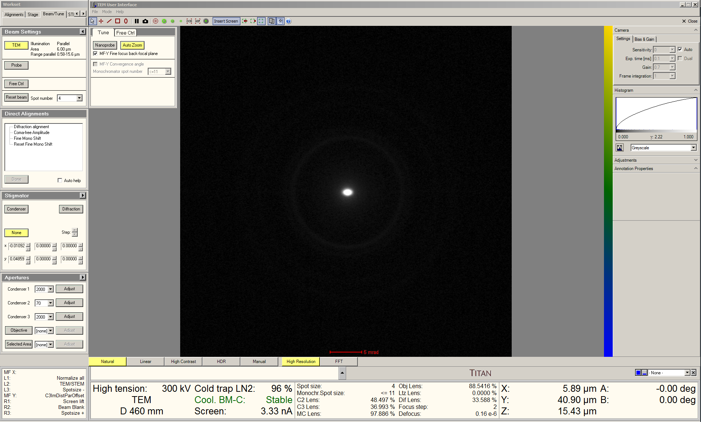

    - When finished, deactivate the “High Resolution” option for the FluCam.

  - Exit diffraction mode and return to TEM mode.
- Acquiring SADPs (particulate specimens)

  - Set the indicated magnification = 17000×.

  - Select the “Beam/Tune” tab and navigate to the “Beam Settings” control panel.

    - Adjust the “Intensity” knob to set beam diameter = 2.00 μm.

    - NOTE: without an SA aperture inserted, the beam diameter effectively defines the “selected area”.

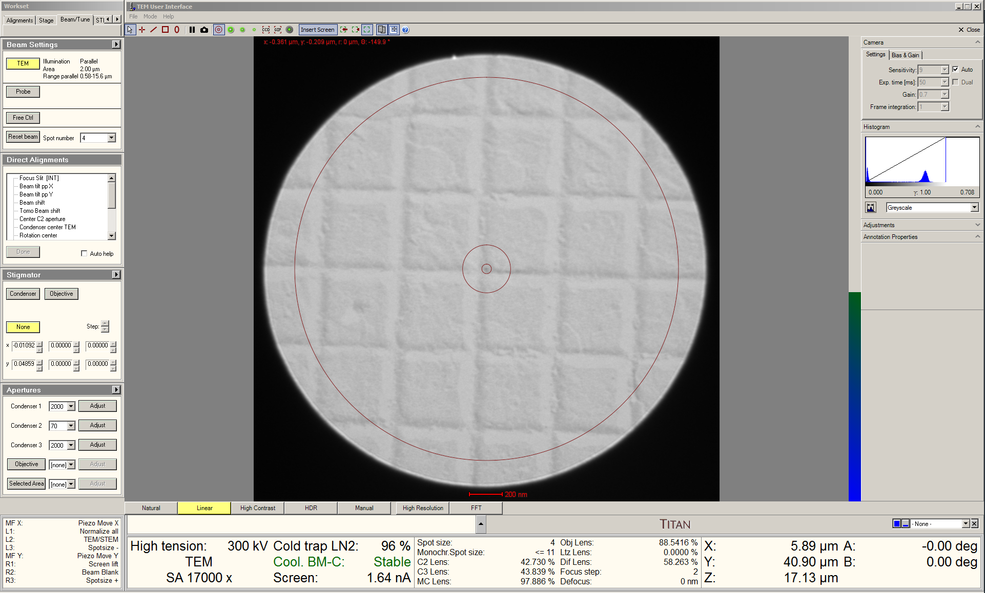

  - If the particles are concentrated in an area much smaller than the beam diameter, it is advisable to insert a SA aperture to better isolate the contribution of the particles to the SADP.

  - Move the stage to center the ROI on the FluCam.

  - Remain in the “Beam/Tune” tab and navigate to the “Apertures” control panel.

    - Insert the 40 μm SA aperture; select “Adjust” and use the “MF” knobs to center the aperture on the FluCam (which should also center the aperture on the ROI).

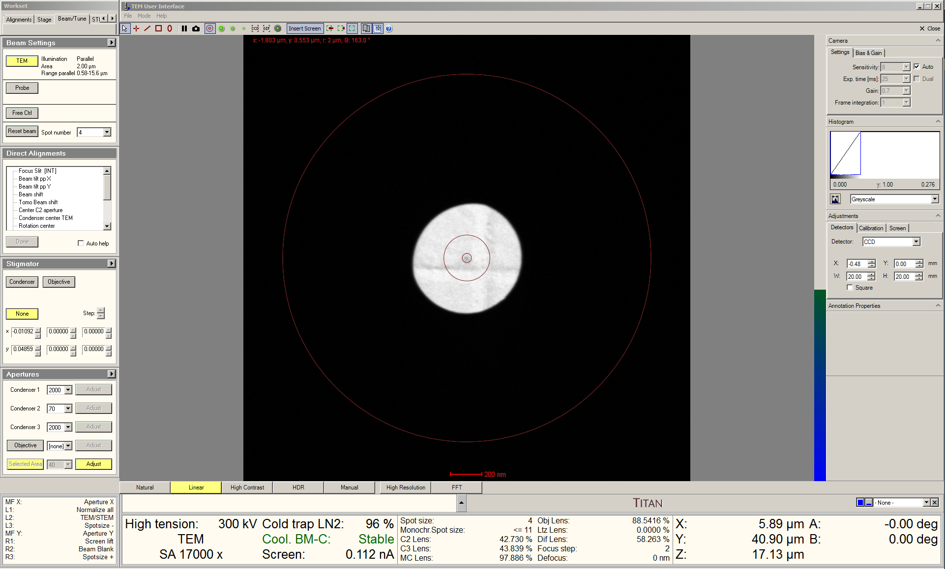
  - Enter diffraction mode and fully insert the beam stop using the FluCam toolbar.

  - Remain in the “Beam/Tune” tab and navigate to the “Direct Alignments” control panel.

    - Select “Diffraction alignment”; the “MF” knobs will now be set for shifting the SADP as needed.

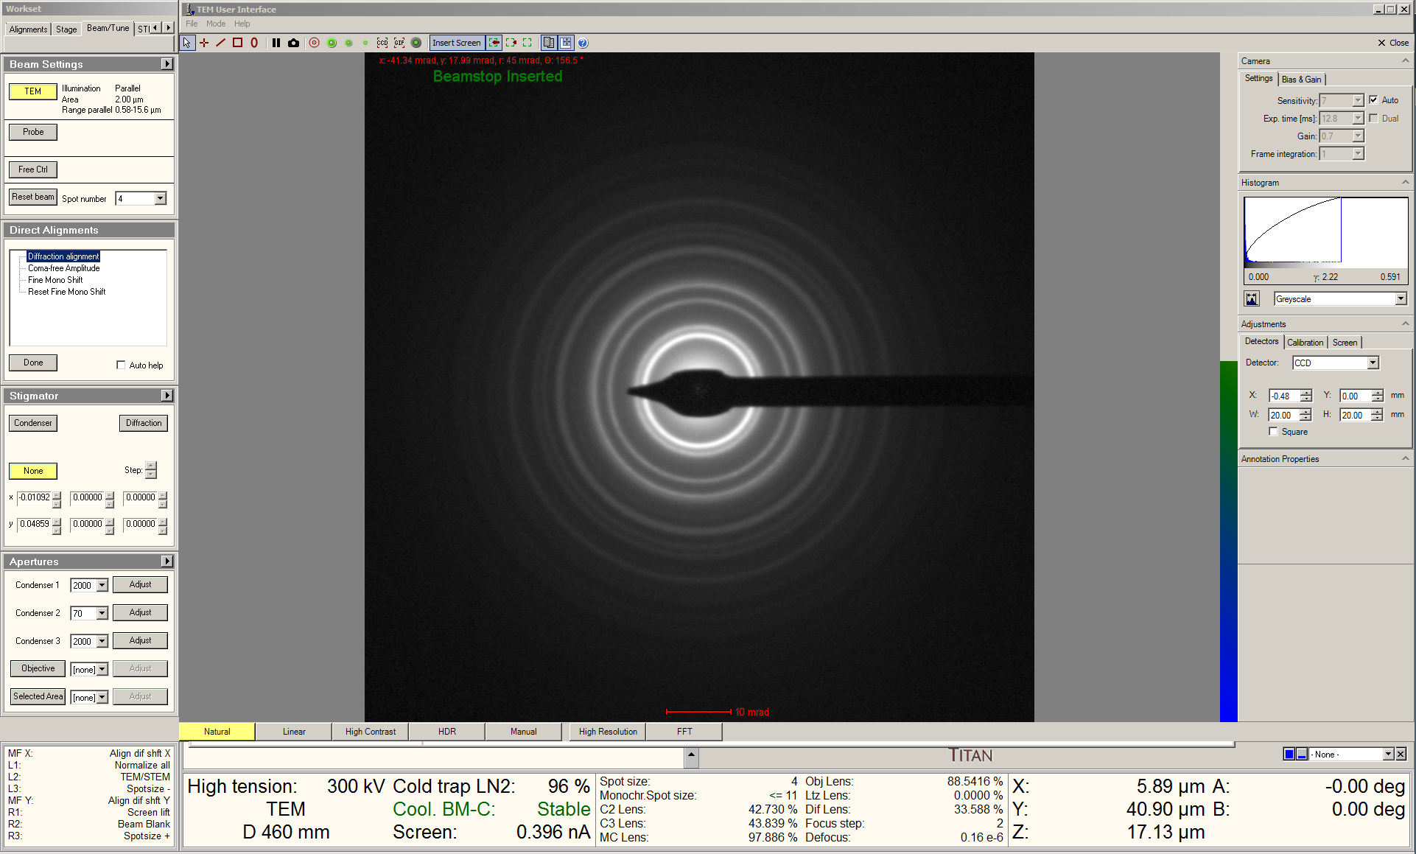

  - Navigate to the Velox Acquisition window and start live imaging with the Ceta camera with exposure time = 25 ms (shortest possible value).

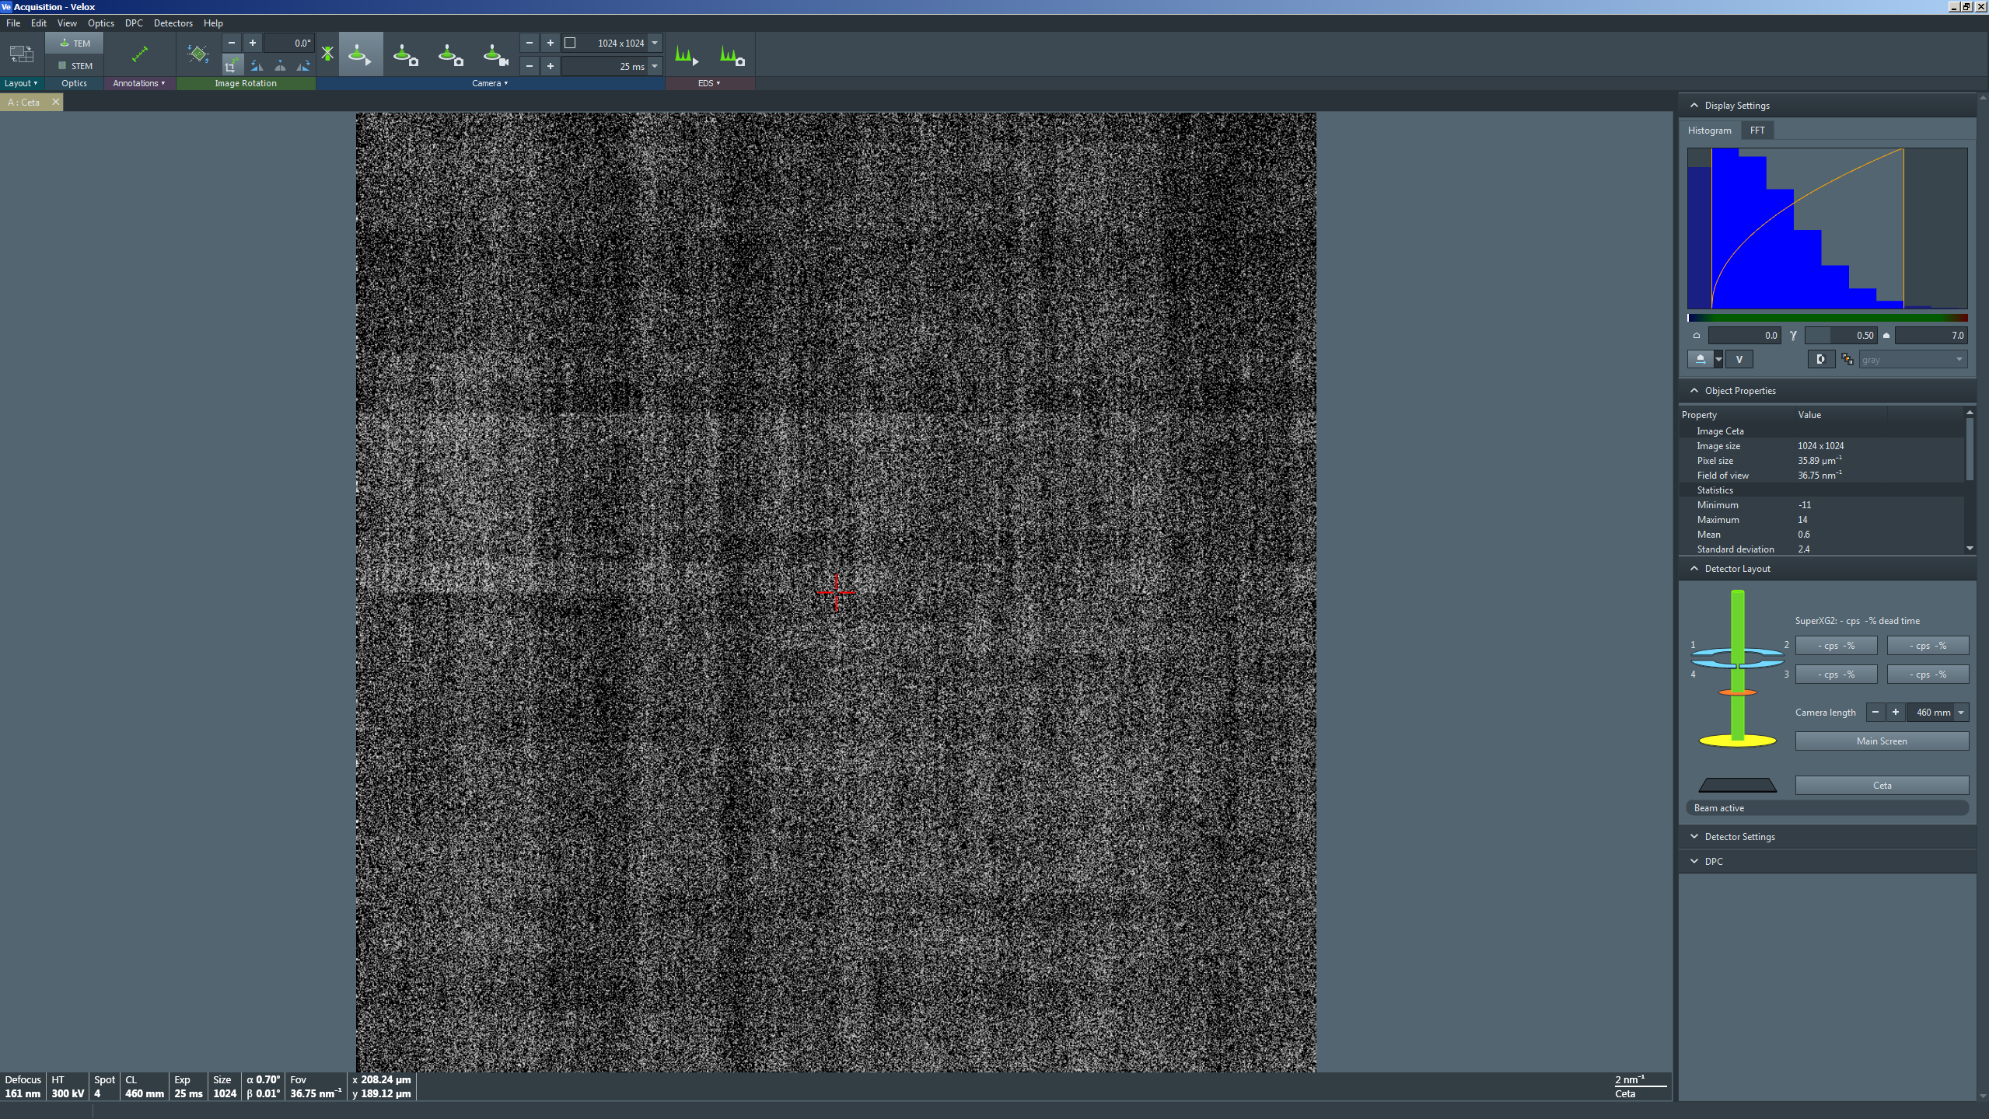

  - Retract the viewing screen to view the SADP live with the Ceta camera; in the “Object Properties” side panel, note the value for “Maximum” counts.

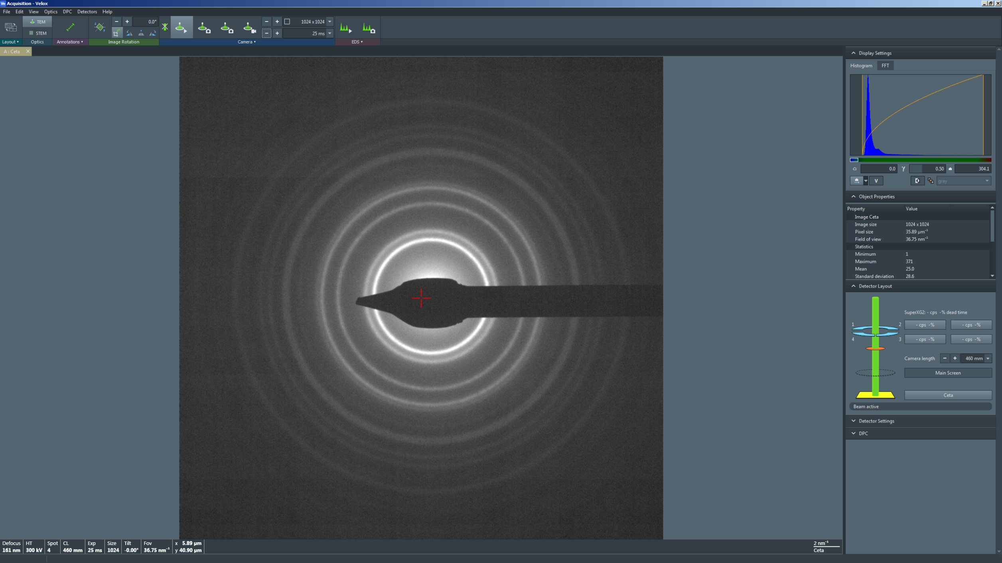
  - If desired, use the “MF” knobs to shift the SADP so it is centered on the Ceta camera (the direct spot should always remain covered).

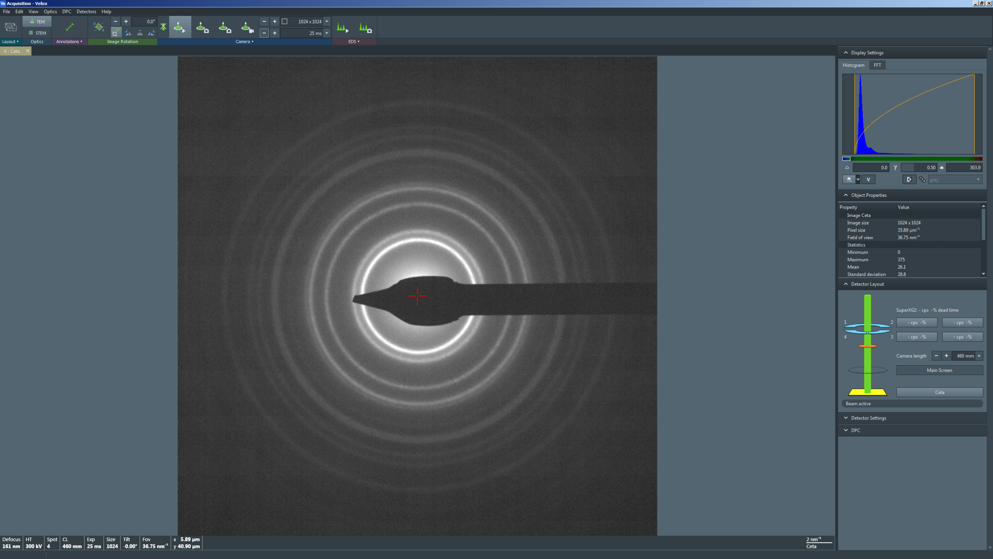

  - Adjust the exposure time until the value for “Maximum” counts is 3000 – 4000 counts as viewed in the “Object Properties” side panel.

    - NOTE: to avoid potentially permanently damaging the Ceta camera “Maximum” counts should never exceed ~8000.

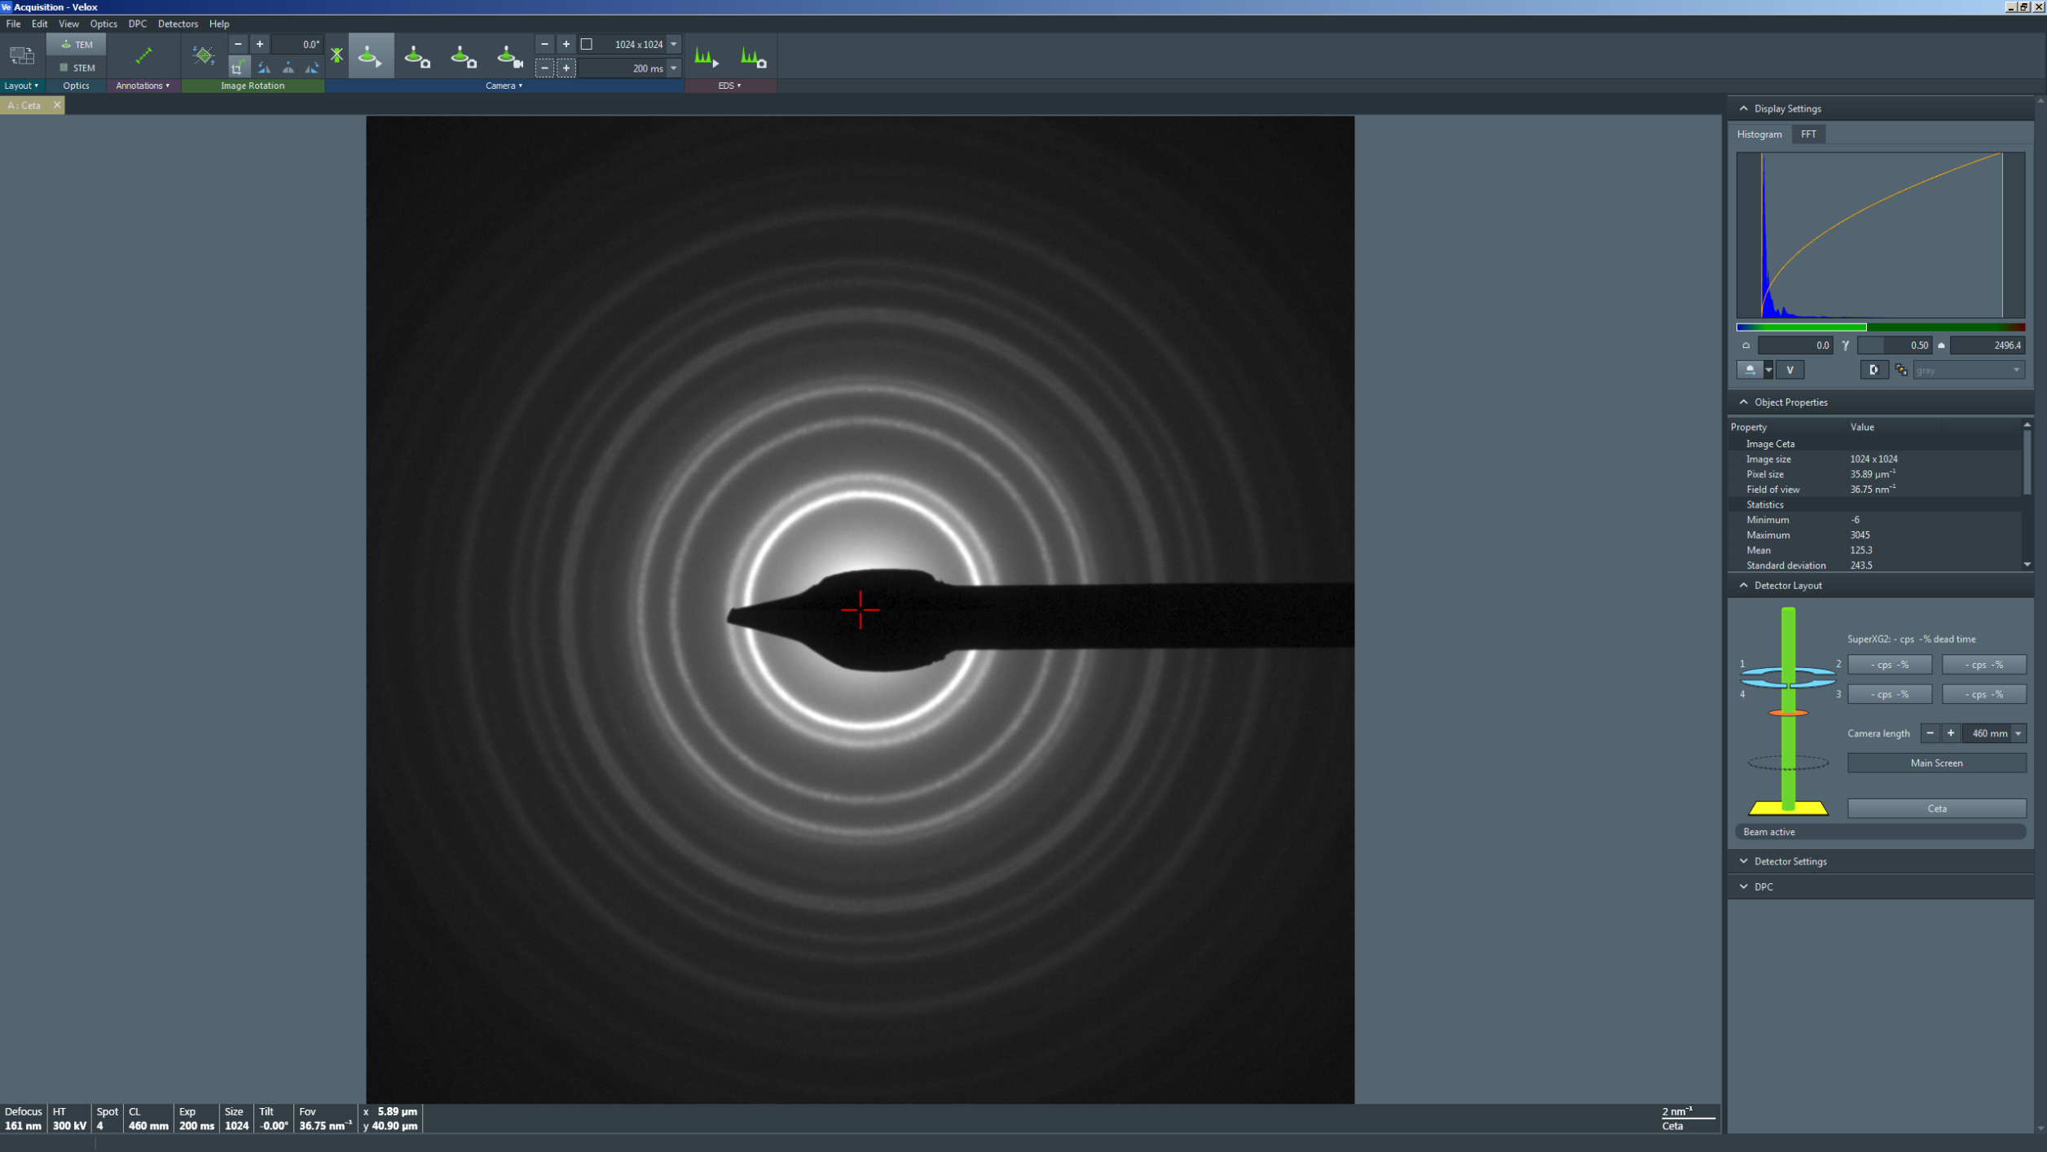
  - In the Velox Acquisition window toolbar, select the “Camera” tab and then the second “Acquire” option (third tab).

    - Set “Exposure time” = 10× the value of “Exposure time” currently set for live imaging; e.g., 100×200 ms = 2000 ms = 2 s.

    - NOTE: DO NOT adjust any other parameters.

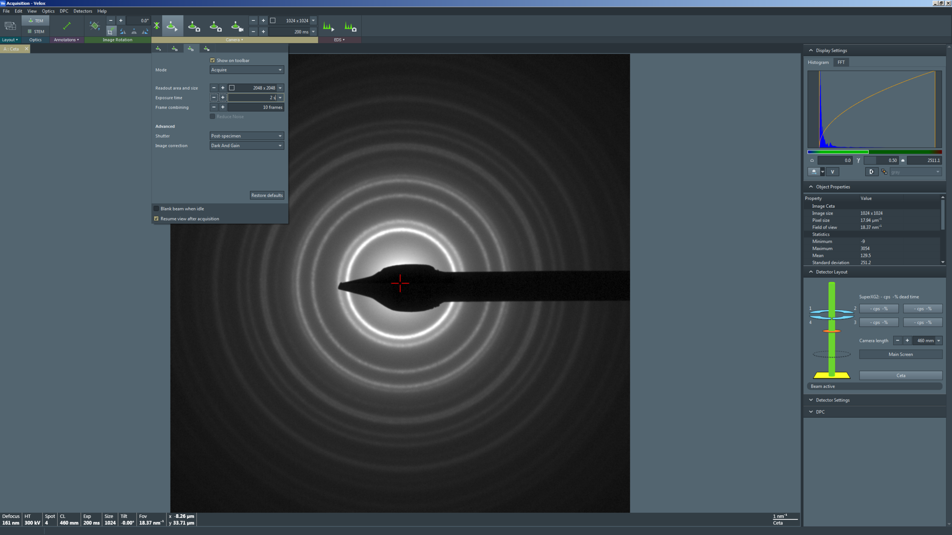

  - In the Velox Acquisition window toolbar, select the second “Acquire” option (third button) to acquire the final SADP.

    - The acquired SADP will populate in the Velox Processing window.

- When finished acquiring SADPs (particulate specimens)

  - Stop live imaging in Velox Acquisition and insert the viewing screen.

  - Exit diffraction mode and return to TEM mode.

  - In the Velox Acquisition window toolbar, select the “Camera” tab and then the “View” option (first tab).

    - Set “Exposure time” = 200 ms.

    - NOTE: DO NOT adjust any other parameters.

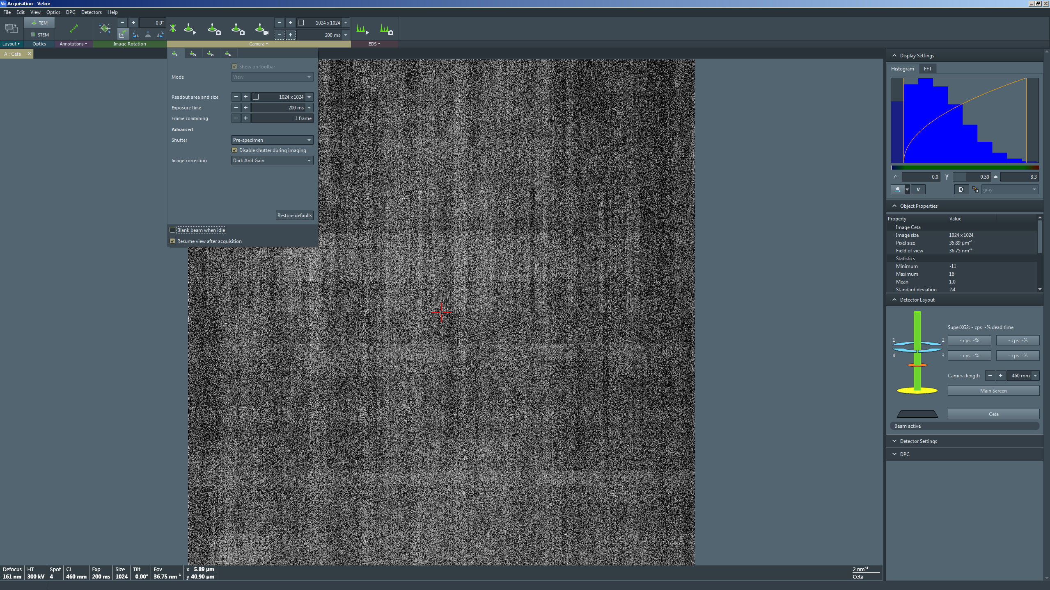

  - In the Velox Acquisition window toolbar, select the “Camera” tab and then the second “Acquire” option (third tab).

    - Set “Exposure time” = 1 s.

    - NOTE: DO NOT adjust any other parameters.

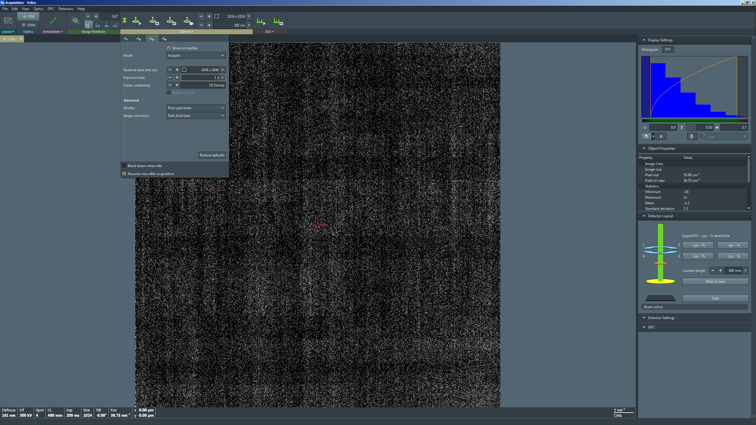

- Acquiring SADPs (single crystal ROIs)

  - Set the indicated magnification = 17000×.

  - Select the “Beam/Tune” tab and navigate to the “Beam Settings” control panel.

    - Adjust the “Intensity” knob to set beam diameter = 2.00 μm.

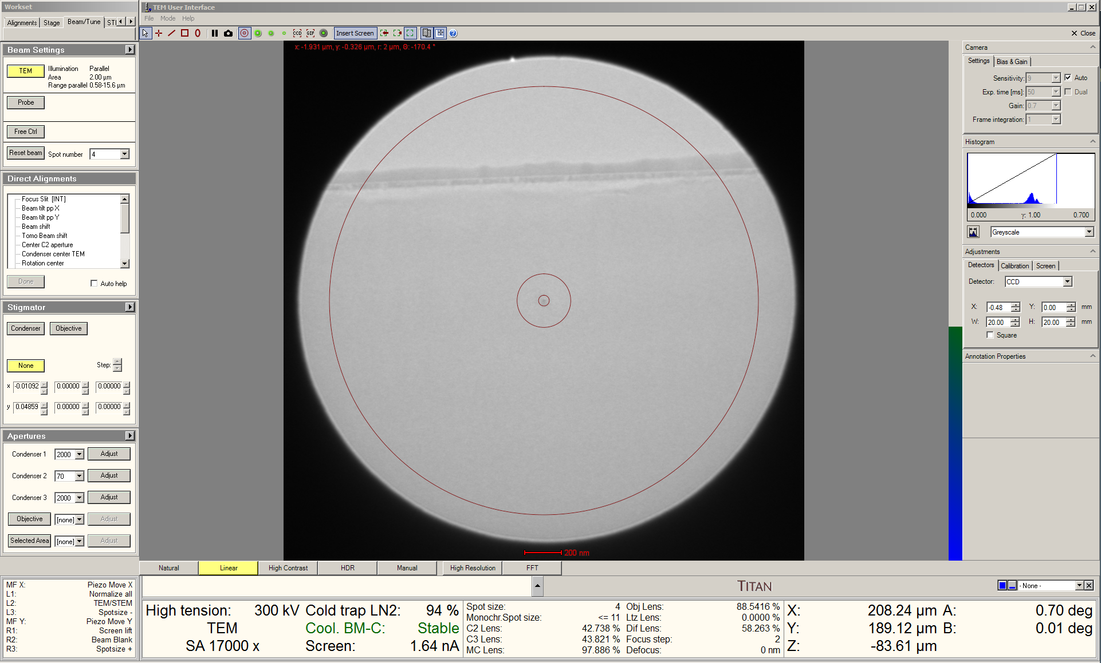

  - As the spots in DPs from single crystals can be very intense, an SA aperture should always be used when acquiring DPs to reduce the current reaching the Ceta camera.

  - Move the stage to center the ROI on the FluCam.

  - Remain in the “Beam/Tune” tab and navigate to the “Apertures” control panel.

    - Insert and center the 40 μm SA aperture on the FluCam (which should also center the aperture on the ROI).

    - NOTE: the 40 μm SA aperture is only used initially; before the final SADP is acquired, the 10 μm SA aperture will be inserted to further reduce the current reaching the Ceta camera.

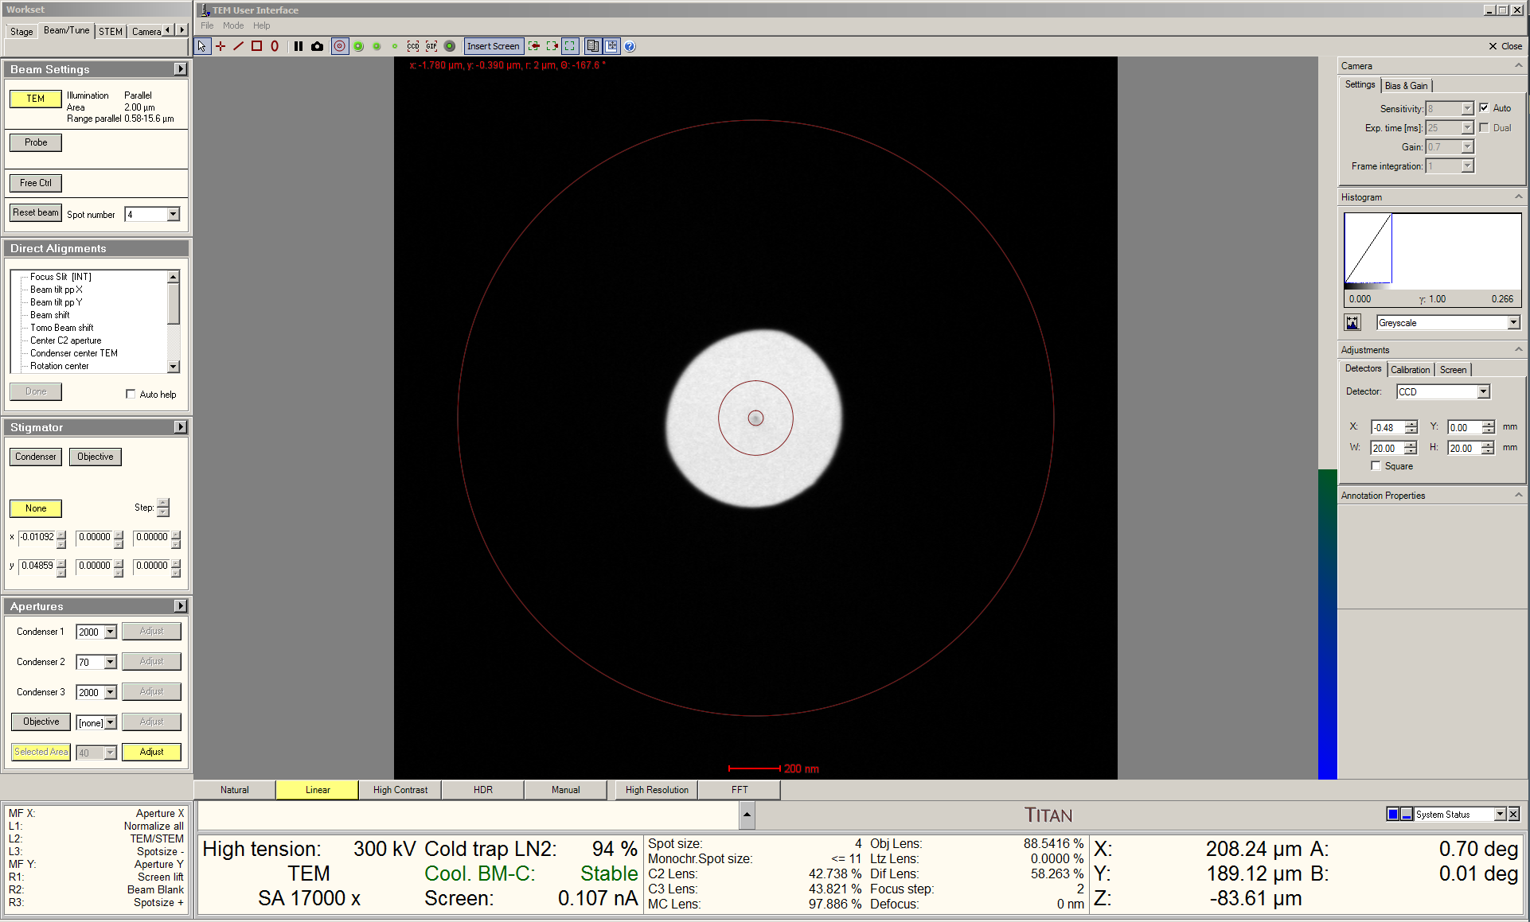
  - Enter diffraction mode and switch the FluCam display lookup table to “Temperature” (this will facilitate easier adjustment of the crystallographic alignment by adjusting the beam tilt).

  - Select “Dark Field” on the RH control panel.

  - Select the “Dark Field” tab and navigate to the “Dark Field” control panel.

    - Verify the “XY” radio button is selected.

    - Use the “MF” knobs to fine tune the crystallographic alignment.

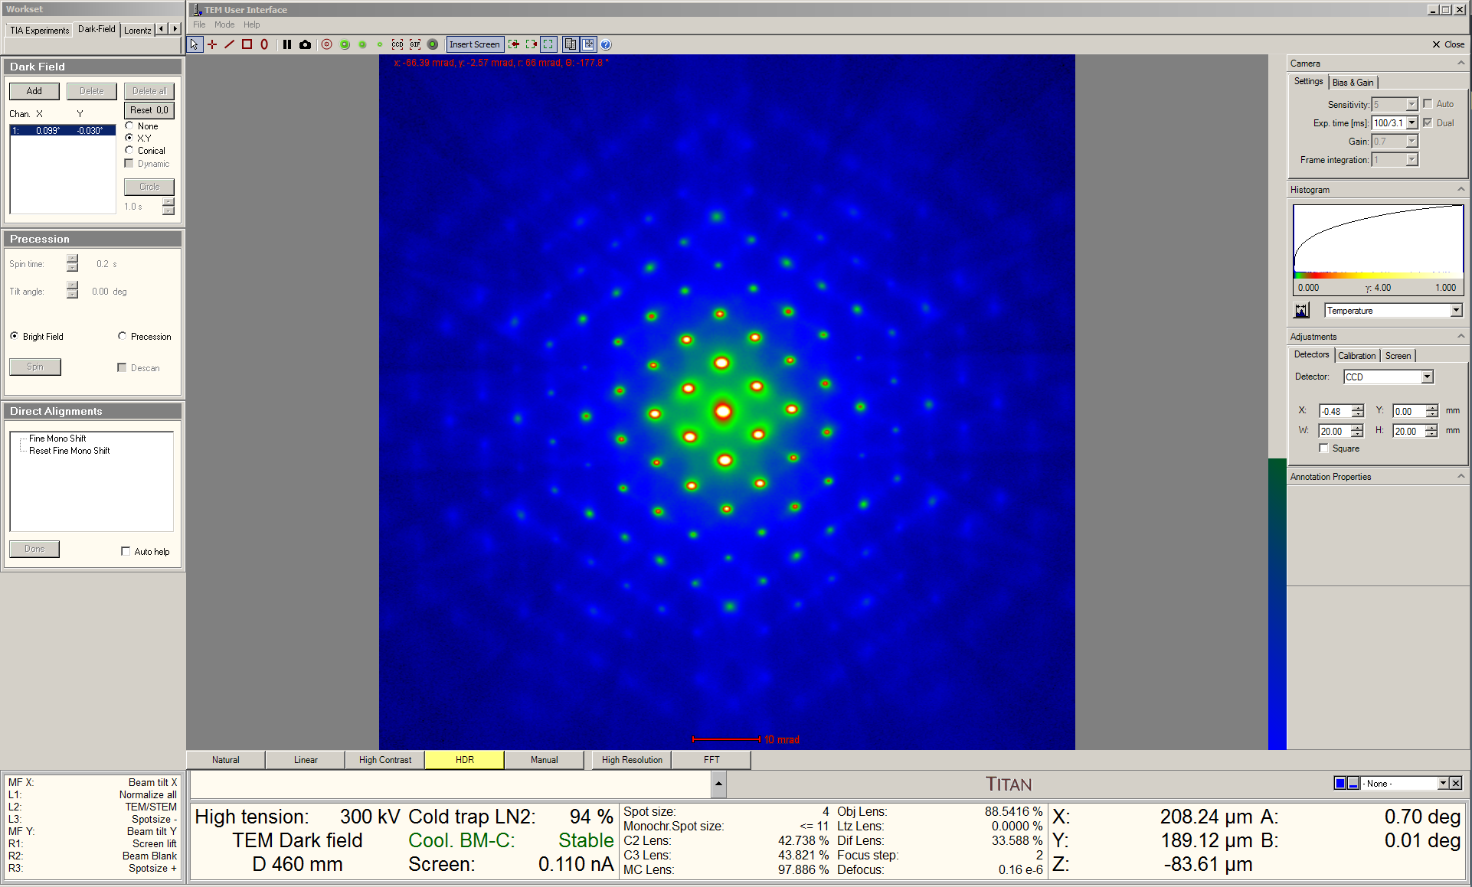

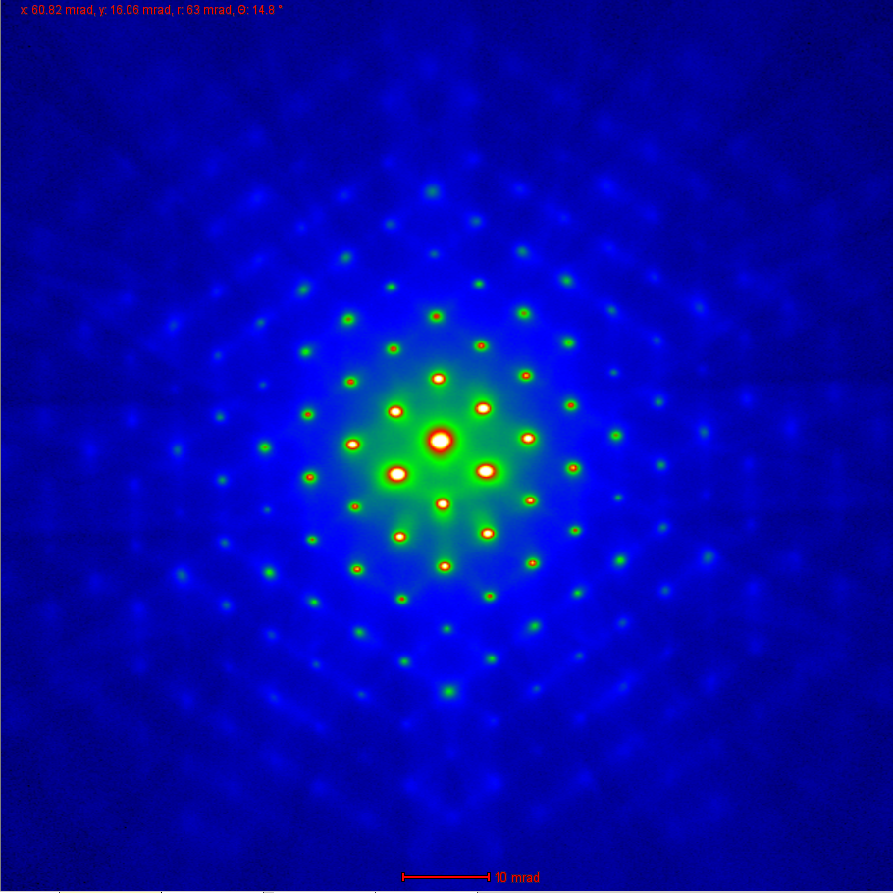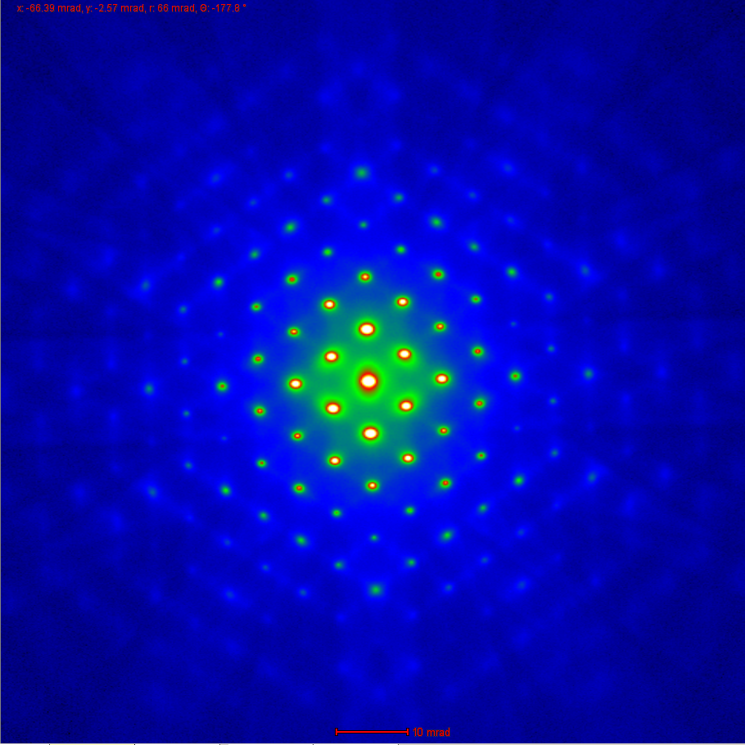

Above: before (left) and after (right) slightly adjusting the beam tilt.
  - Return to TEM mode.

  - Select the “Beam/Tune” tab and navigate to the “Apertures” control panel.

    - Insert and center the 10 μm SA aperture on the FluCam (which should also center the aperture on the ROI).

    - NOTE: the measured screen current should be reduced to only a few pA.

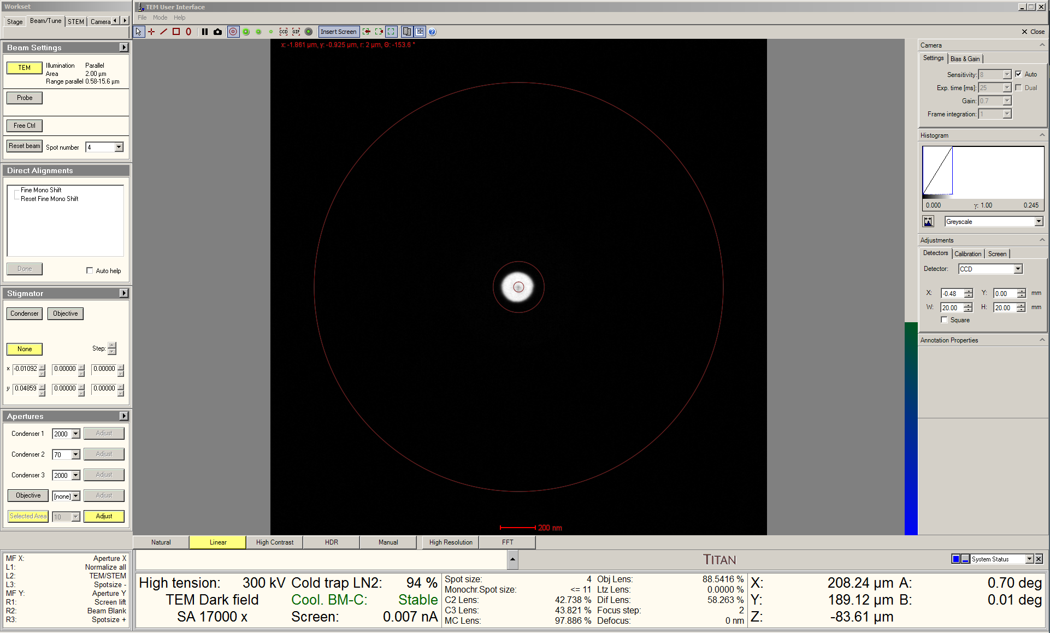

  - Return to diffraction mode.

  - Navigate to the bottom left information panel, find the “MF X” line, right click on the right side of the line, and select “Diffr shift X”.

    - The “MF” knobs can now be used to shift the position of the SADP without altering the previously adjusted beam tilt.

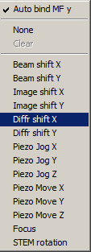
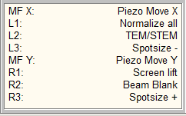
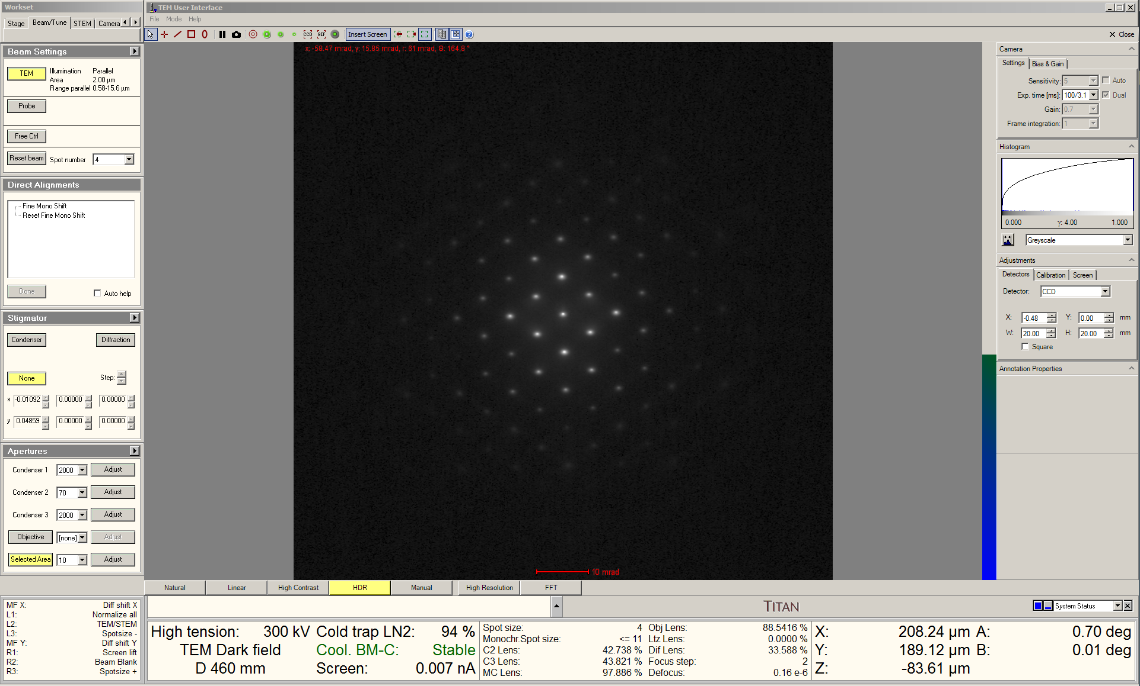

  - Navigate to the Velox Acquisition window and start live imaging with the Ceta camera with exposure time = 25 ms (shortest possible value).

  - Retract the viewing screen to view the SADP live with the Ceta camera.

    - Use the “MF” knobs to center the SADP.

  - In the “Object Properties” side panel, note the value for “Maximum” counts.

    - If the value exceeds ~8000 counts, the beam stop should be partially inserted and the “MF” knobs used to shift the direct beam under the tip of the beam stop (not shown here).

    - If the value is between 4000 – 8000 counts, inserting the beam stop is not necessary, but the exposure time should not be increased.

    - Otherwise, if the value is significantly below ~4000 counts, gradually increase the exposure time in 25 ms increments until the value is 3000 – 4000 counts.

    - NOTE: to avoid potentially permanently damaging the Ceta camera, “Maximum” counts should never exceed ~8000.

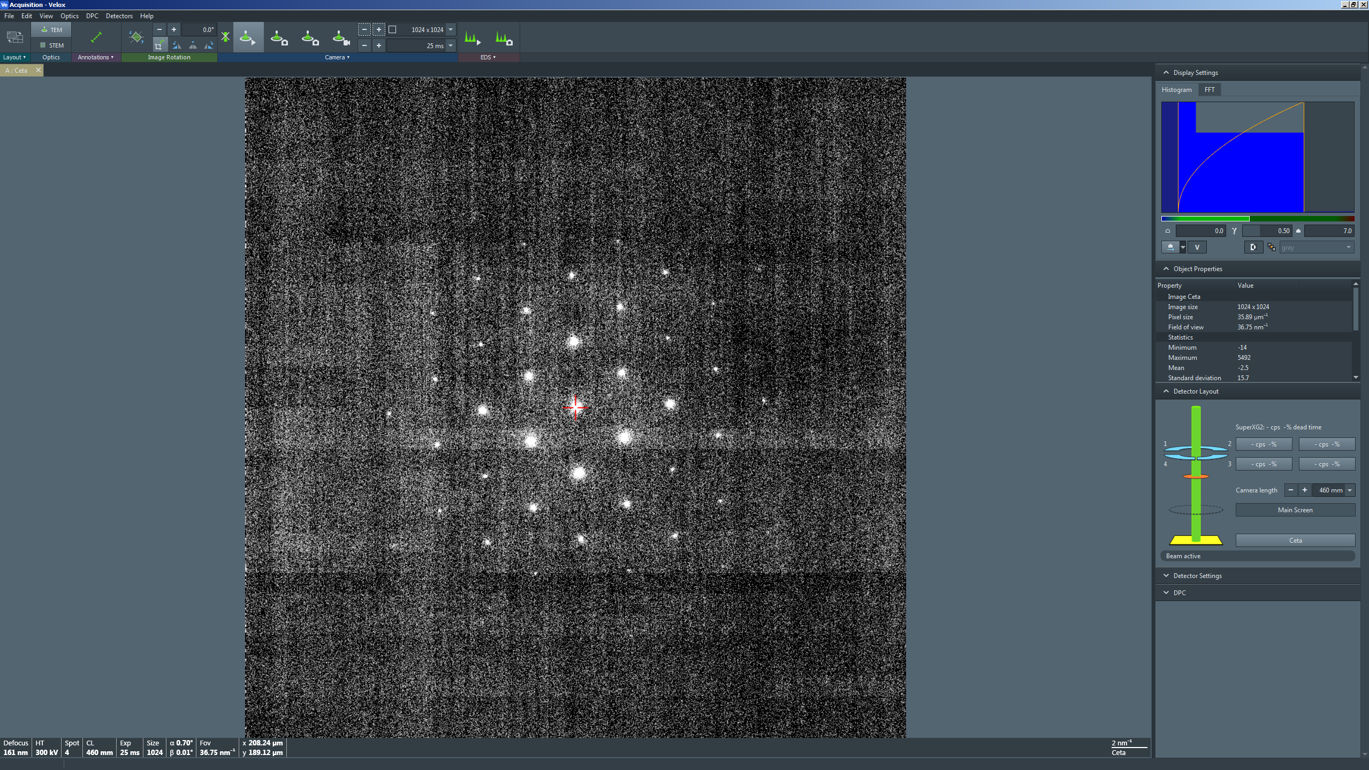

  - In the Velox Acquisition window toolbar, select the “Camera” tab and then the “Series” option (fourth tab).

    - Set “Readout area and size” to the full area and 1024×1024.

    - Set “Exposure time” = 100× the value of “Exposure time” currently set for live imaging; e.g., 100×25 ms = 2500 ms = 2.5 s

    - Set “Frame combining” = 100 frames.

    - NOTE: DO NOT adjust any other series parameters.

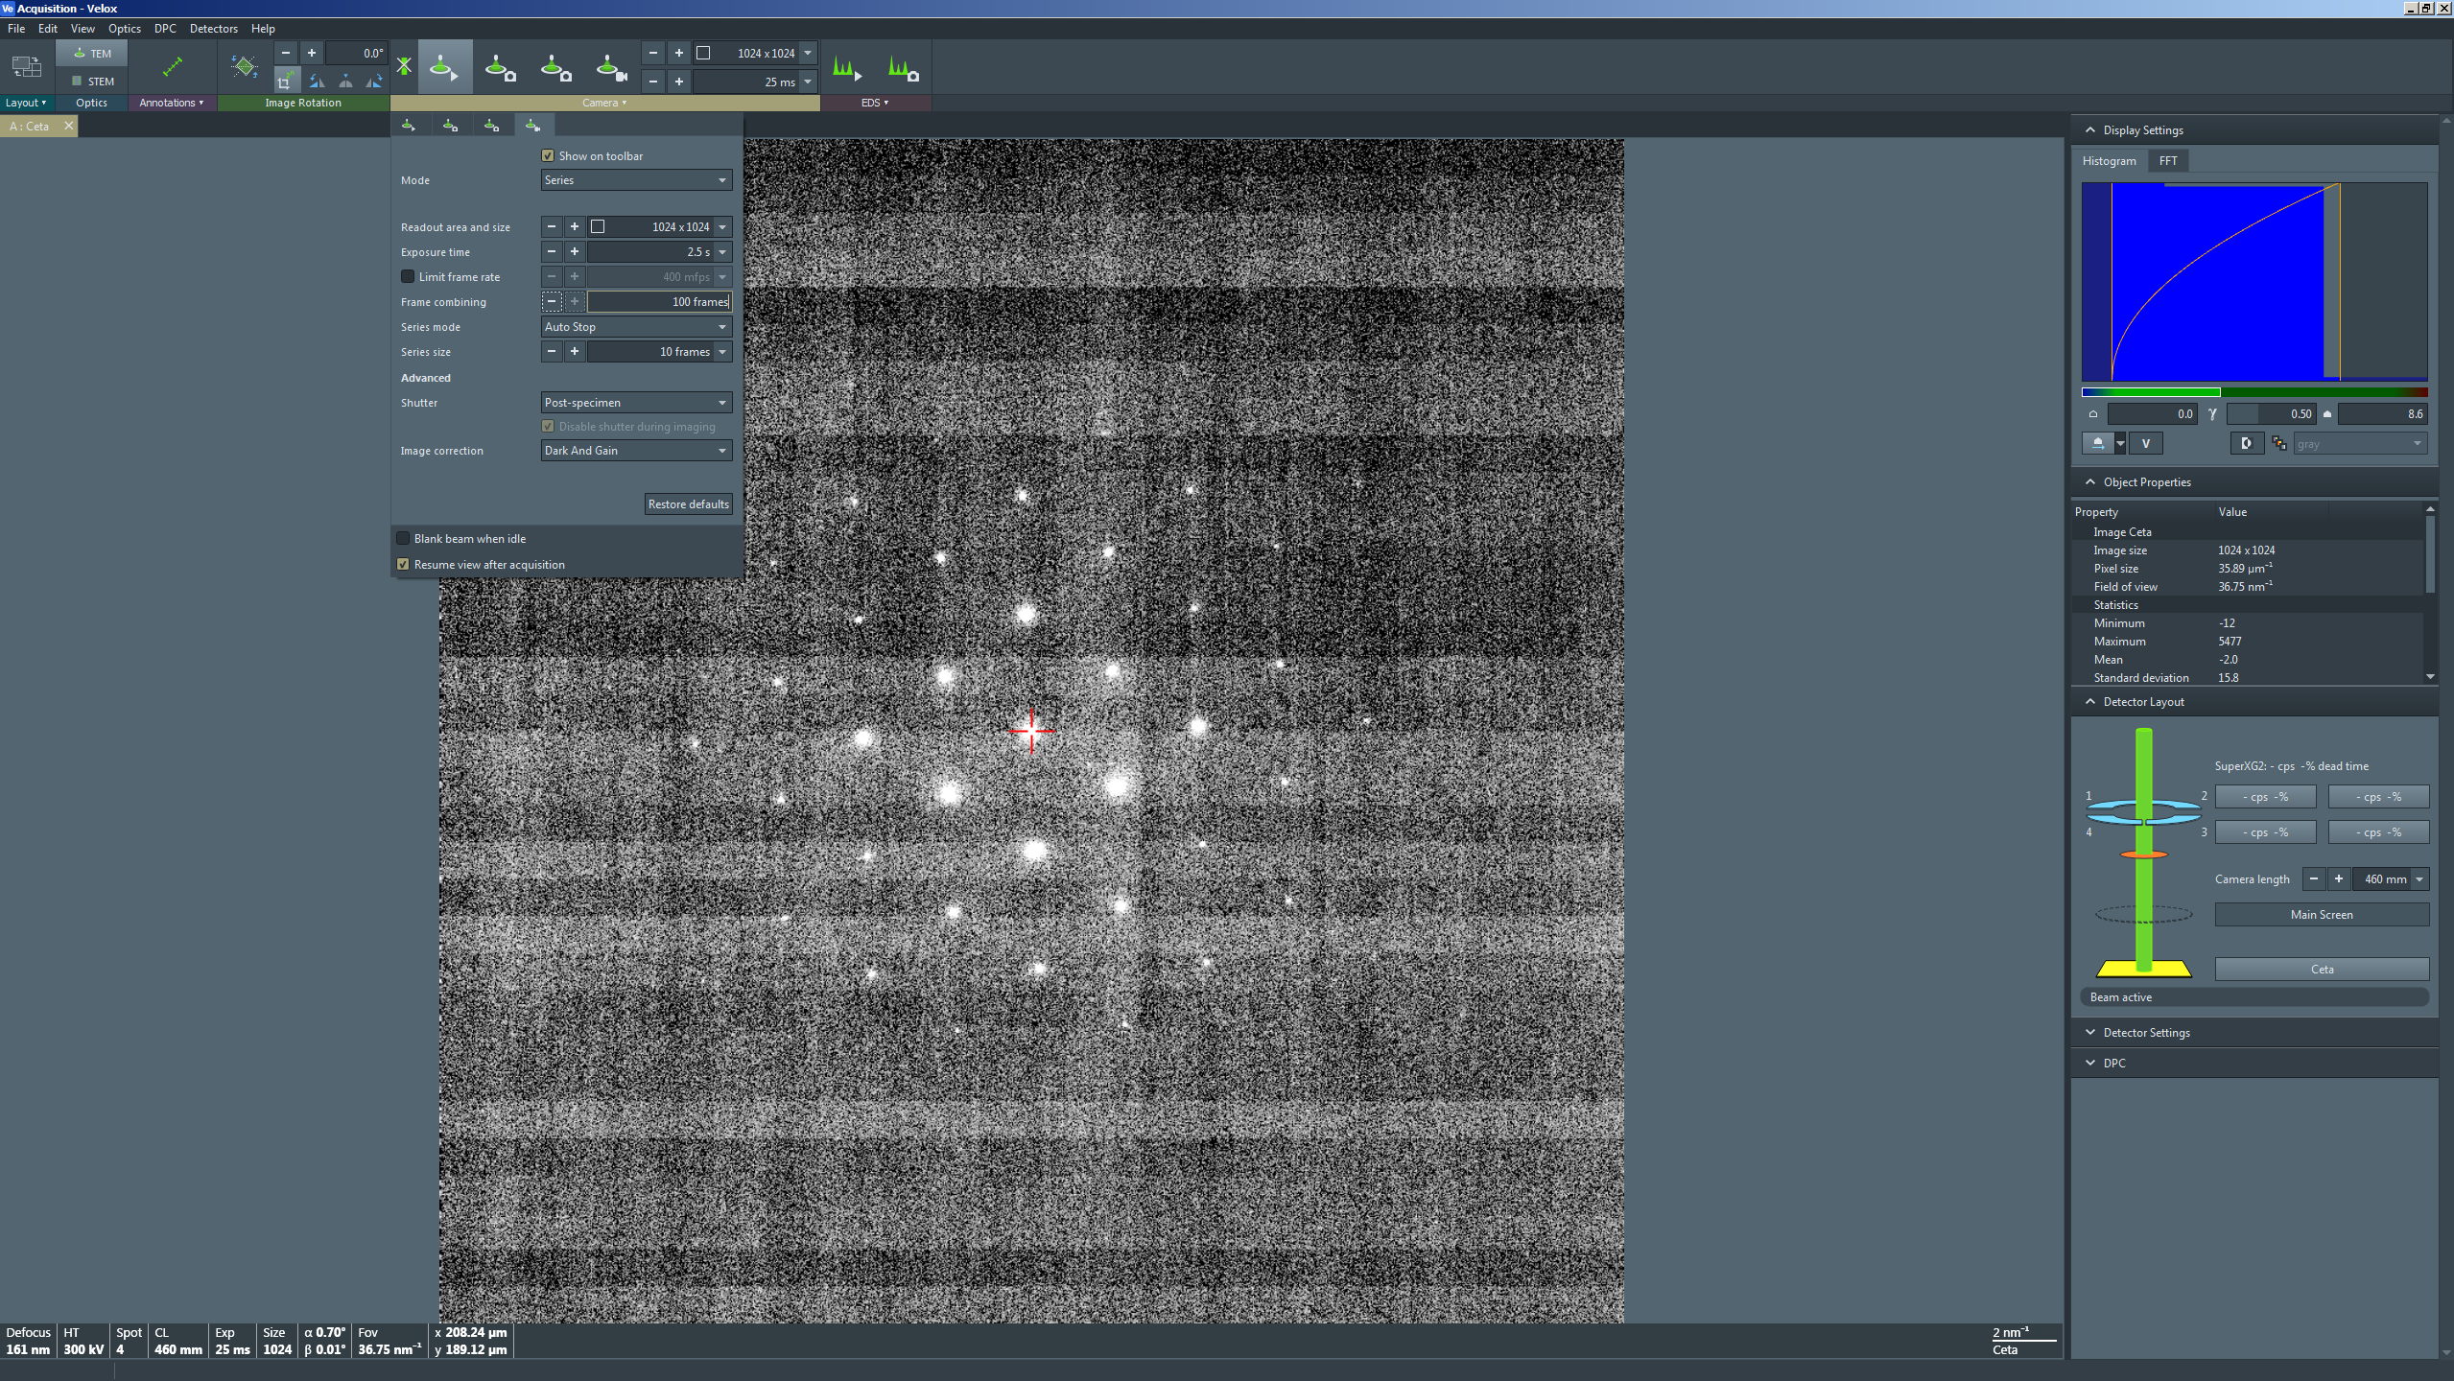

  - In the Velox Acquisition window toolbar, select the “Series” option (fourth button) to acquire the SADP series.

    - Insert the viewing screen and/or blank the beam after series acquisition is complete.

  - Open the Velox Processing window and select the SADP series that was just acquired.

  - From the pull-down menu, select “Processing”, then “DCFI”, and then “DCFI”; a new panel with the frame integrated SADP will be produced.

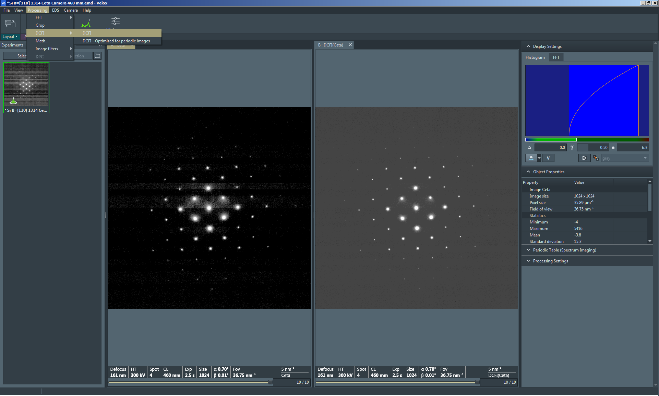

  - Select the panel containing the frame integrated SADP; in the “Display Settings” side panel, digital adjustments can be performed to improve the appearance of the SADP.

    - Manually set the lower contrast limit (black level) equal to 0.

    - Manually increase the upper contrast limit (white level) to make the spots tighter and smaller.

    - If desired, slightly decrease the gamma value to improve visibility of lower intensity features.

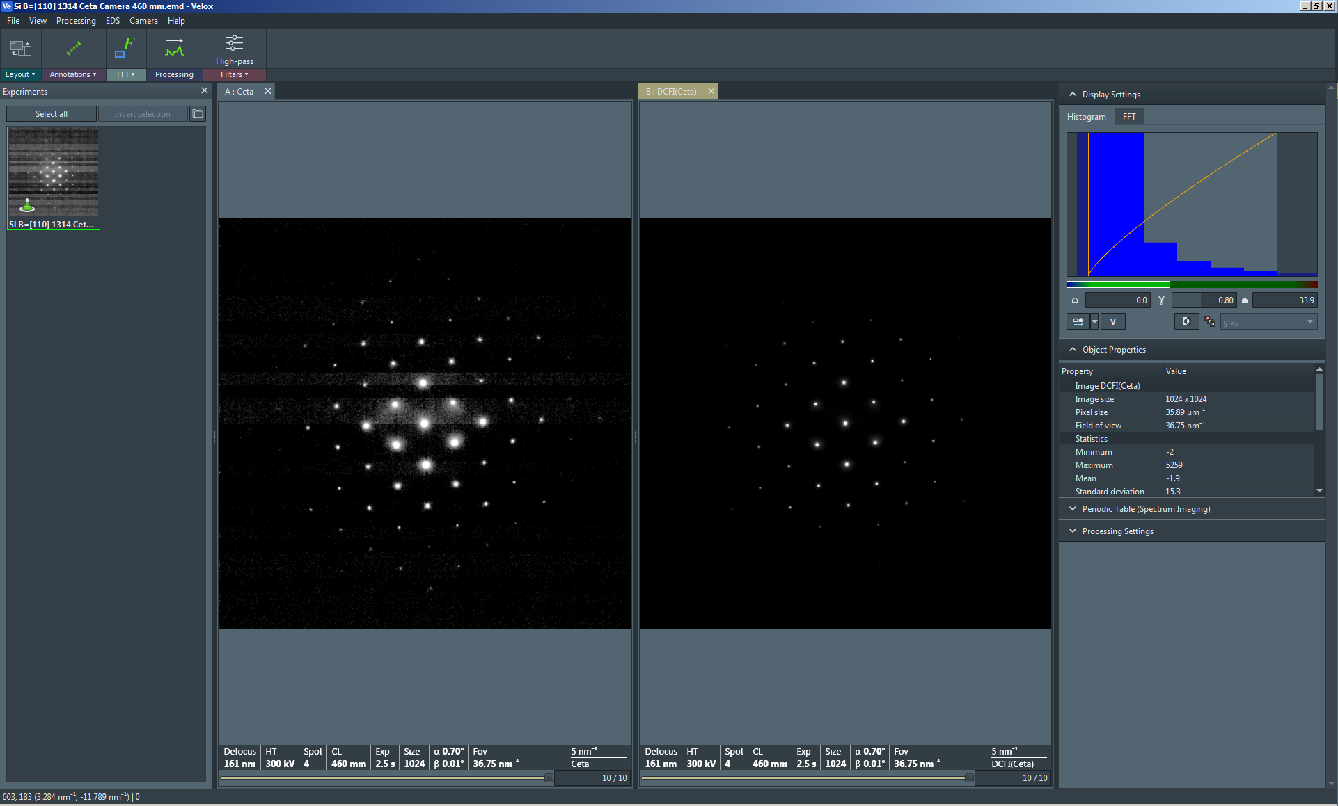

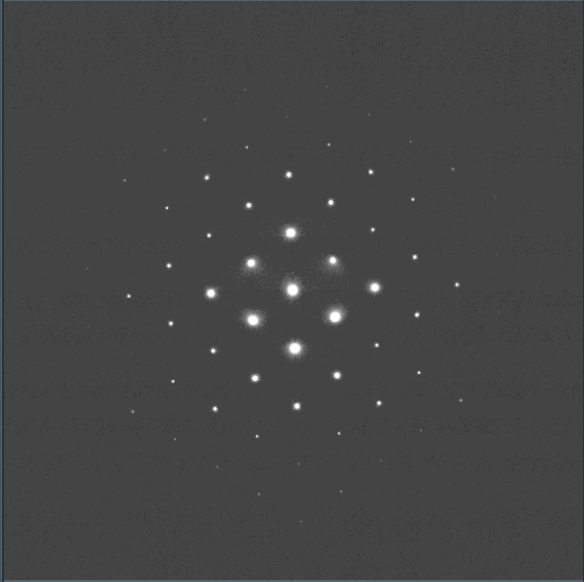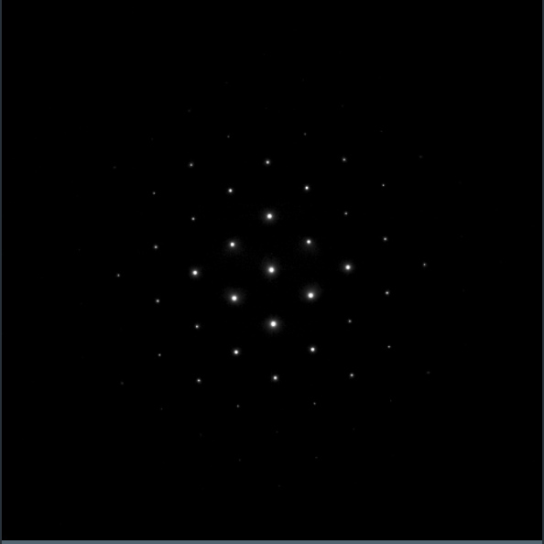

Above: single crystal SADPs before (left) and after (right) digital adjustments.
- When finished acquiring SADPs (single crystal ROIs)

  - Stop live imaging in Velox Acquisition and insert the viewing screen.

  - In the Velox Acquisition window toolbar, select the “Camera” tab and then the “View” option (first tab).

    - Set “Exposure time” = 200 ms.

    - NOTE: DO NOT adjust any other parameters.

  - In the Velox Acquisition window toolbar, select the “Camera” tab and then the “Series” option (fourth tab).

    - Set “Readout area and size” to full area and 2048×2048.

    - Set “Exposure time” = 200 ms.

    - Set “Frame combining” = 1 frame.

    - NOTE: DO NOT adjust any other parameters.

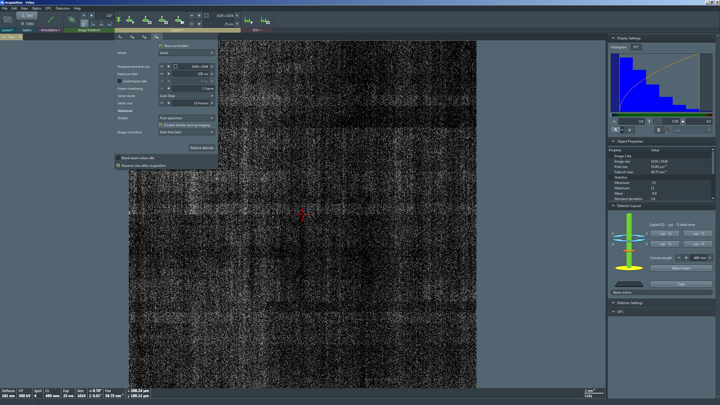

  - Return to Microscope Control; navigate to the bottom left information panel, find the “MF X” line, right click on the right side of the line, and select “clear”.

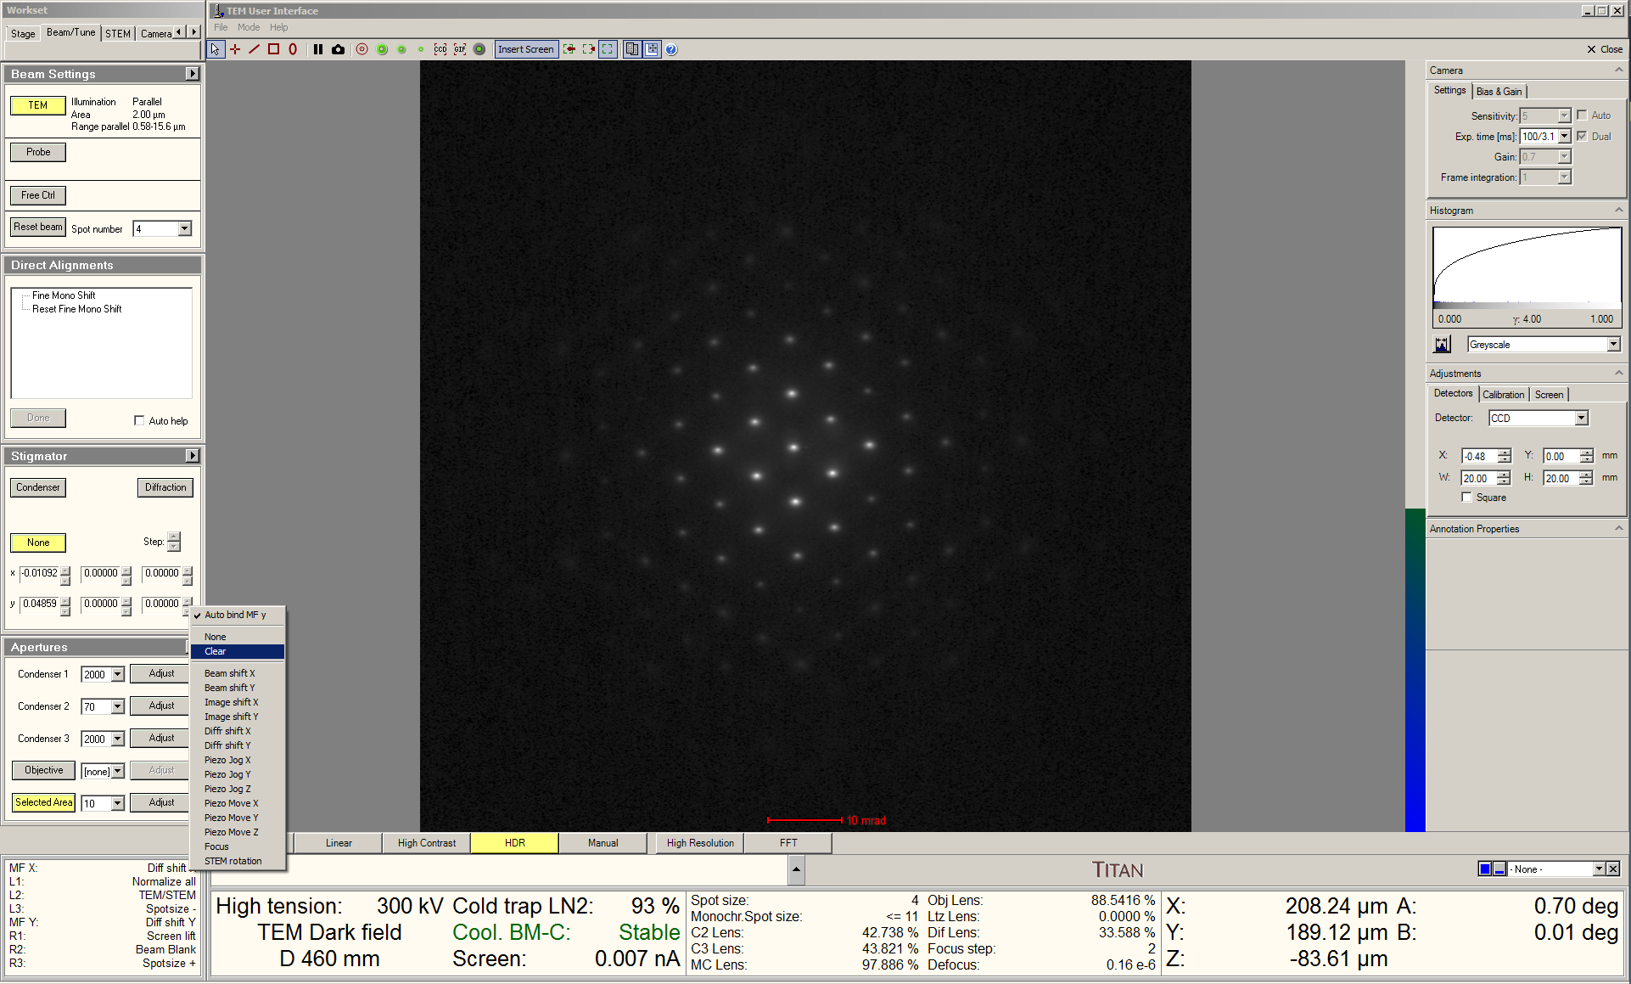

  - Select the “Dark Field” tab and navigate to the “Dark Field” control panel; select “Reset 0,0” to reset the beam tilt.

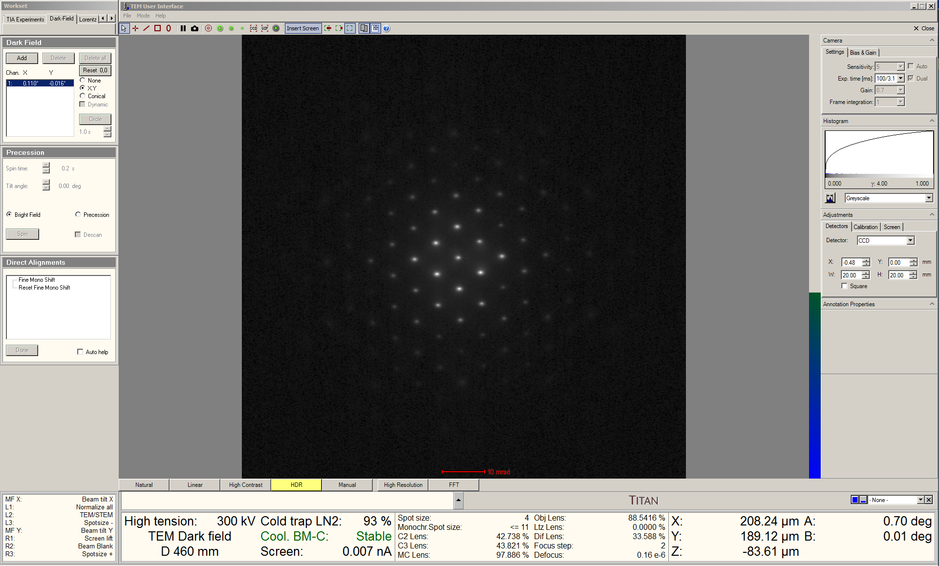
  - Select “Dark field” on the RH control panel to exit dark-field mode.

  - Exit diffraction mode and return to TEM mode.

  - Select the “Beam/Tune” tab and navigate to the “Apertures” control panel.

    - Select “Selected Area” to retract the 10 μm SA aperture.

