
FEI Talos F200i S/TEM
  - STEM mode standard operating procedure Rev. 2026-01
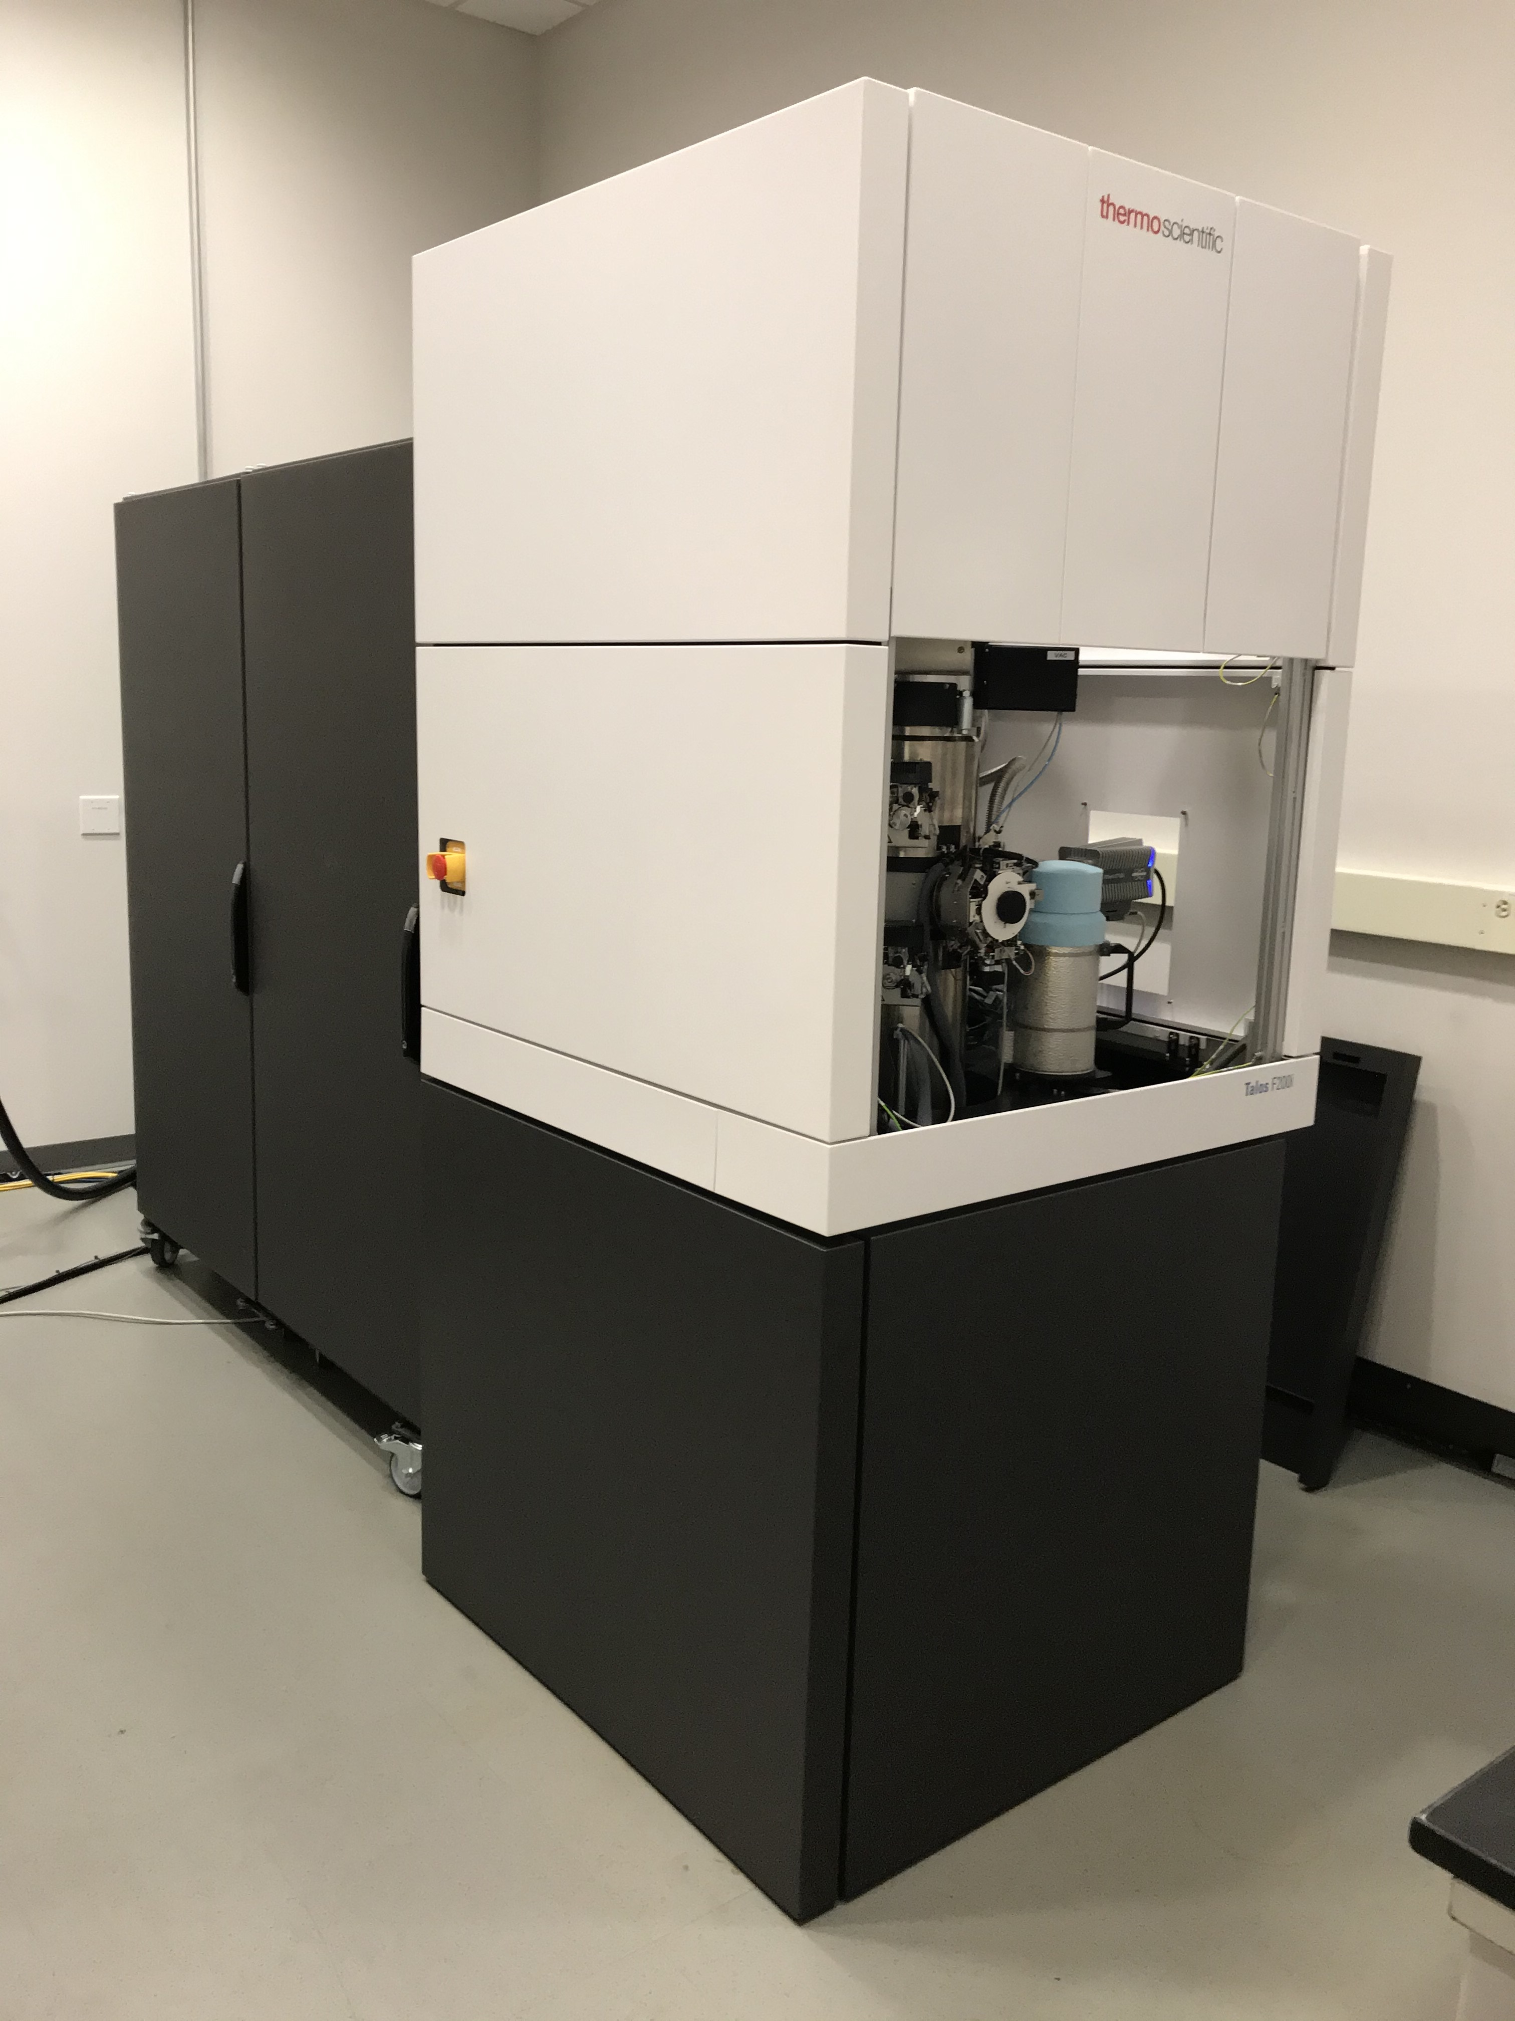

  - Application
The FEI Talos F200i S/TEM is a state-of-the-art non-corrected field emission gun scanning/transmission electron microscope capable of providing micro- to sub nm-scale structural, morphological, and chemical information. This document covers operation of the instrument for scanning (STEM) mode imaging. Please see separate SOP documents on the NRF instrument page regarding other applications, including STEM-EDS analysis.

  - NRF Contact
Nicholas G. Rudawski

Table of Contents

1. Safety Information 3
2. Prerequisites 3
3. High tension settings 3
4. Prior to entering STEM mode 4
5. Entering STEM mode 5
6. C2 aperture alignment 8
7. Setting “Eucentric Focus” 10
8. Initial probe astigmatism correction 11
9. Beam tilt pivot points 12
10. Rotation centering 13
11. Setting camera length; diffraction alignment 14
12. STEM imaging in Velox 16
13. Blanking the beam (as needed) 23
14. Additional considerations for atomic-resolution STEM imaging 25
15. Series acquisition 31
16. Finishing in STEM mode 35

- Safety Information

  - Due to stipulations of the instrument service contract as well as contamination concerns, analysis of radioactive and/or biological specimens with this instrument is strictly prohibited.

  - Please use caution when inserting the holder into the airlock for a possible pinch point between the holder base and the airlock cover plate.

  - Specimen cleanliness is critical for effective STEM imaging (particularly for atomic resolution STEM imaging); thus, it is best that specimens be plasma cleaned prior to analysis (even if just for a few seconds) to remove organic contaminants.

    - If the specimen cannot be subjected to (even brief) plasma cleaning, contact NRF staff to discuss some alternative methods for sample cleaning.

- Prerequisites

  - Familiarity with the use of the Microscope Control user interface software and Velox imaging software.

  - Proficient in independent operation of the instrument in TEM mode and performing high-quality HR-TEM imaging.

  - NOTE: as per the prerequisites, many associated details and images that could otherwise be included here are omitted for purposes of clarity (“…as per usual”).

- High tension settings

  - As stated previously in the TEM mode SOP, the default high tension (HT) = 200 kV, but the instrument may also be operated at HT = 80 kV as described elsewhere. However, on this instrument, atomic-resolution STEM imaging is only possible at HT = 200 kV.

    - NOTE: the instrument was set to HT = 200 kV for this entire document.

- Prior to entering STEM mode

  - Load a grid into the holder, insert the holder into the column, load the appropriate alignment file, and load a gun alignment as per usual.

  - Load the appropriate FEG register for STEM mode operation.

    - For STEM mode operation at 200 kV, select and apply the “200kV_nP” gun alignment.

    - For STEM mode operation at 80 kV, select and apply the “80kV_nP” gun alignment.

    - NOTE: these are different than the FEG registers for TEM mode operation and are specifically optimized to produce the smallest possible probes.

  - Find a region of interest and bring it to eucentric height as per usual.

  - If needed, crystallographically align the approximate ROI (using diffraction mode); finer adjustments to crystallographic alignment will likely need to be performed in STEM mode (particularly if attempting atomic-resolution STEM imaging) but set this as close as possible while in TEM mode.

  - Verify the objective and SA apertures are both retracted.

  - If possible, move the specimen a few hundred nm to the left of center of the FluCam; this will result in the beam being initially in vacuum for STEM alignment; the specimen will be moved back under the beam later.

- Entering STEM mode

  - In Microscope Control, select the “STEM” tab and navigate to the “STEM Imaging” control panel.

    - Select “STEM” to enter STEM mode; a stationary CBED pattern (direct disc only) should be visible on the FluCam.

    - Set the indicated STEM magnification = 1.25 M×.

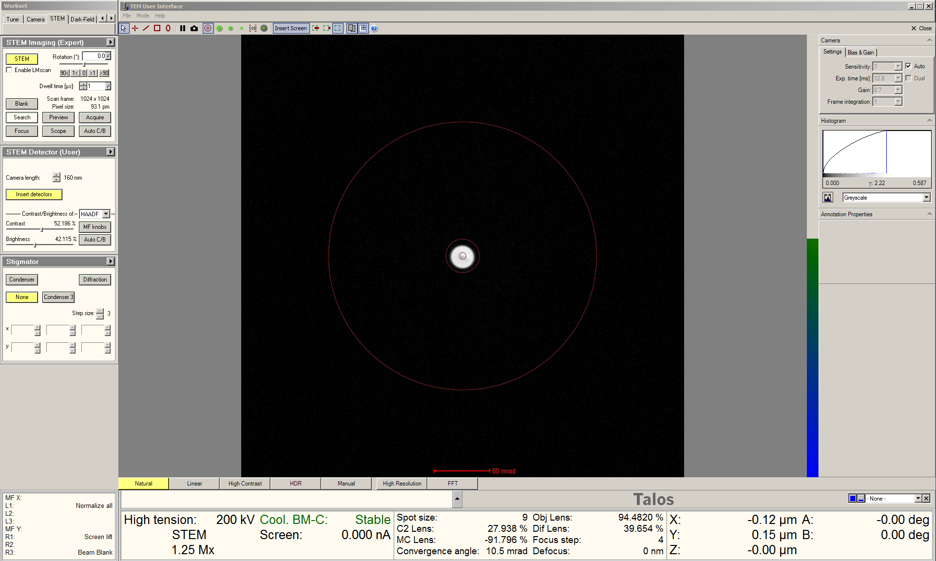

  - In Velox Acquisition, select “HAADF” from the toolbar to start live STEM imaging.

    - Right click on the beam position marker and select “Center beam”.

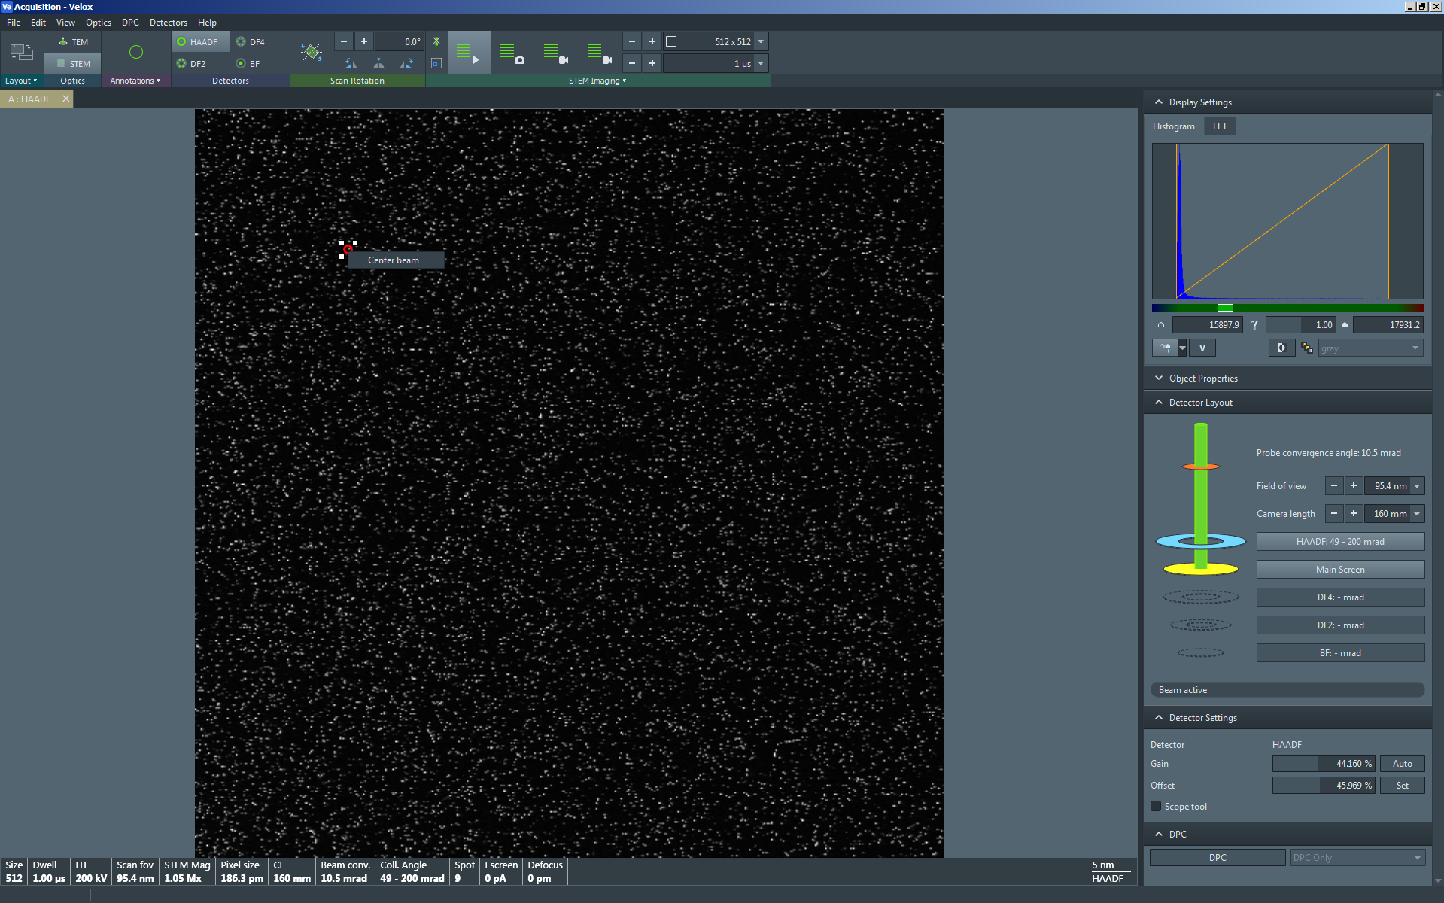

  - After verifying the beam position marker is centered in the STEM image, select “HAADF” from the toolbar again to stop the live STEM image and retract the HAADF detector.

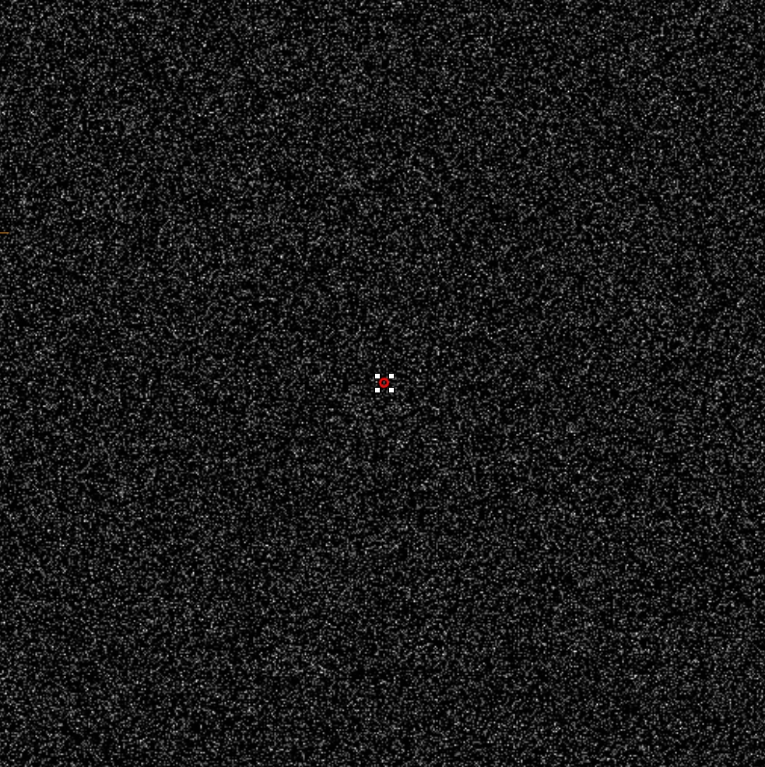

  - Select the spot size to be used for STEM imaging (shown below; identical to TEM mode operation).

    - Spot size = 9 is recommended for atomic-resolution imaging; with the 70 µm C2 aperture, this will produce ~15 pA of probe current.

    - Spot size = 2, 3, or 4 is recommended for performing EDS; with the 70 µm C2 aperture, this will generate ~1.03, 0.67, or 0.47 nA of probe current, respectively.

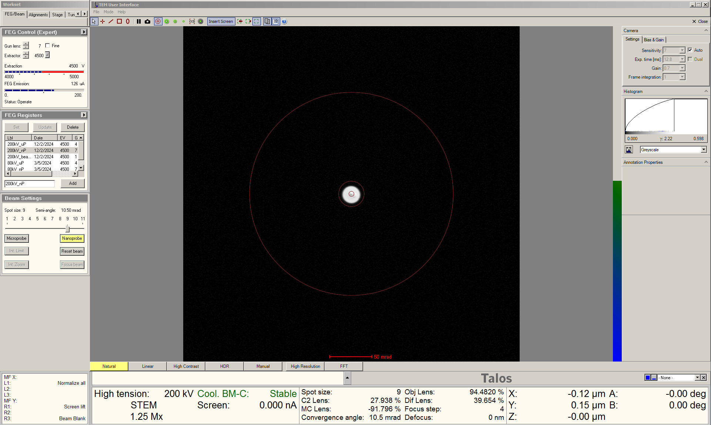
- C2 aperture alignment

  - Press the “Diffraction” button on the right-hand control panel; this will result in an image of the probe appearing on the FluCam; the microscope will now be in “SA” mode.

    - Reduce the magnification until the probe is visible.

  - Select the “Tune” tab and navigate to the “Direct Alignments” control panel.

    - Select “Beam shift”; use the “Multifunction” (MF) knobs to shift the beam as needed; do not use the trackball to shift the beam.

    - Increase the indicated magnification = 630k×; use the MF knobs to recenter the beam.

    - Use the “Focus” knob (coupled to C2) to expand the beam clockwise from crossover until it is slightly larger than the 4 mm circle marking.

    - Precisely center the (expanded) probe on the FluCam using the MF knobs.

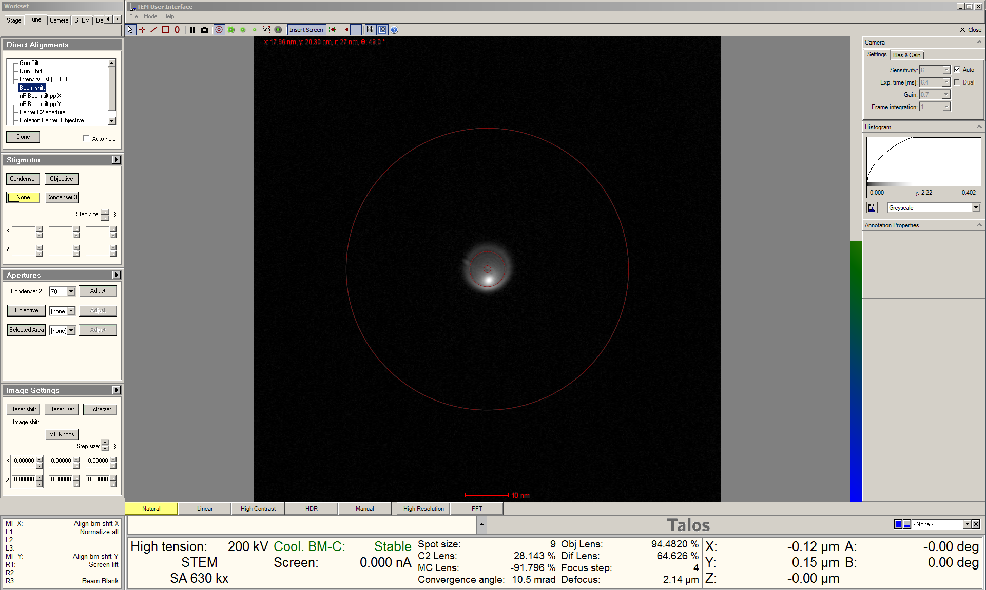
  - Remain in the “Tune” tab and navigate to the “Apertures” control panel.

    - Verify the 70 µm “Condenser 2” aperture is inserted, then activate “Adjust”.

    - Turn the “Focus” knob clockwise to expand the beam so it is slightly larger than the 40 mm circle marking.

    - Use the MF knobs to recenter the (expanded) beam on the FluCam via shifting of the C2 aperture.

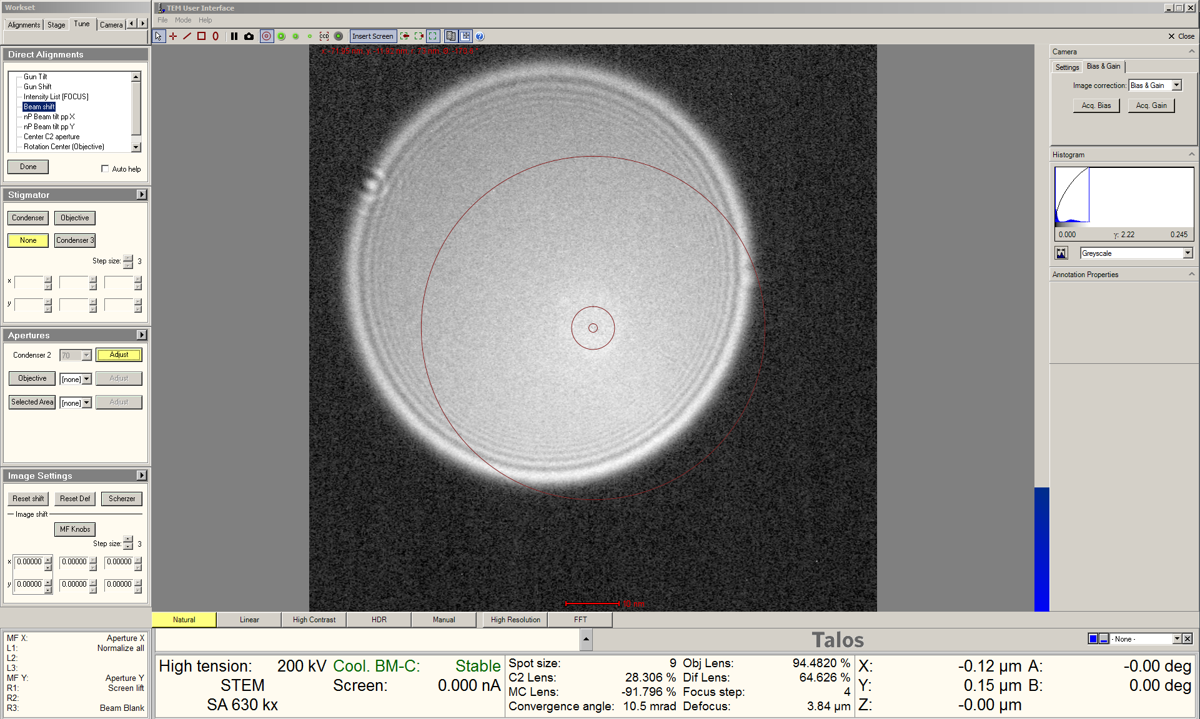

  - Repeat the previous two steps iteratively until the probe expands while remaining centered on the FluCam (3 iterations is usually sufficient).

    - When finished, navigate to the “Apertures” control panel; next to “Condenser 2” deactivate “Adjust”; the MF knobs should automatically return to controlling beam shift.
- Setting “Eucentric Focus”

  - Remain in the “Tune” tab and navigate to the “Direct Alignments” control panel.

    - As needed, select “Beam Shift” and use the MF knobs to center the beam on the FluCam (this need not be precise).

    - Select “Intensity List [FOCUS]”.

    - Use the “Focus” knob to focus the beam to a probe: this should appear as a small, bright (caustic) spot surrounded by a diffuse halo (shown below).

    - Select “Done” when finished to store this setting for the C2 lens for “Eucentric Focus”.

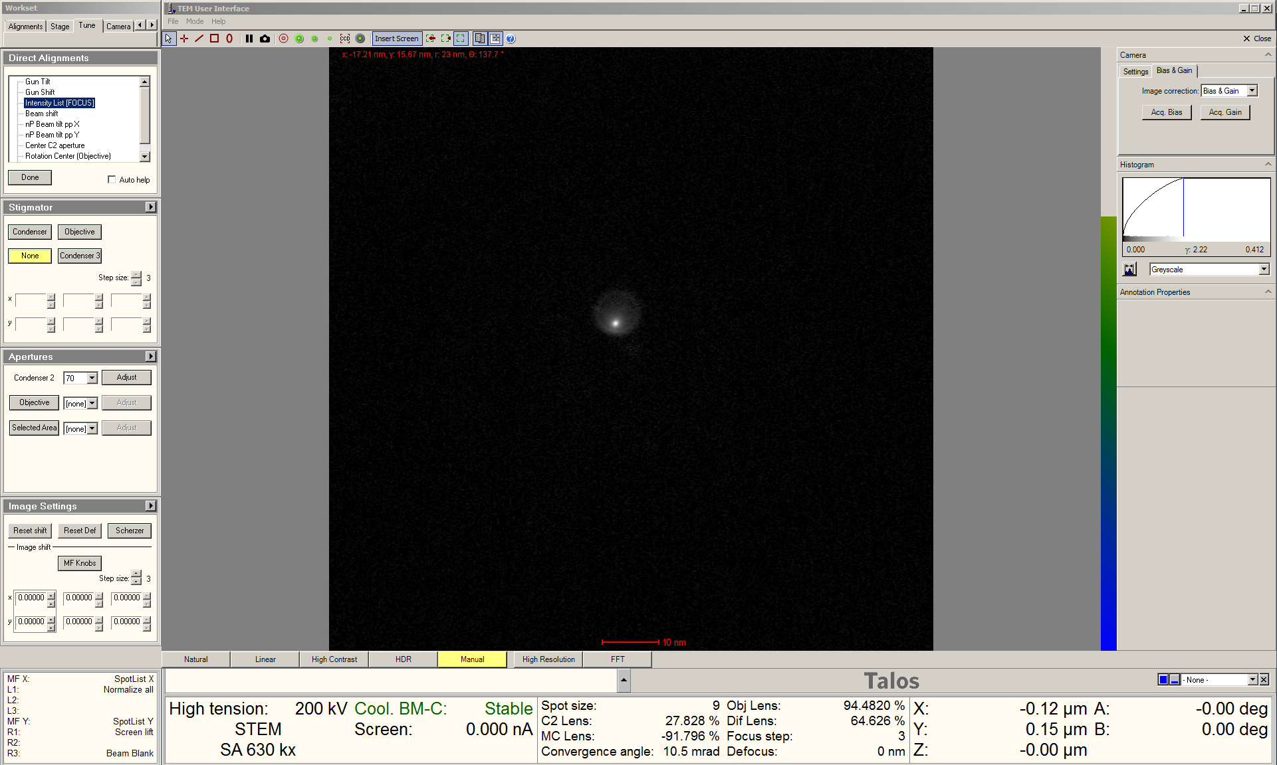

- Initial probe astigmatism correction

  - Remain in the “Tune” tab and navigate to the “Stigmator” control panel.

    - Select “Condenser” and use the MF knobs to make the probe as circular as possible.

    - NOTE: further probe astigmatism correction is best performed during STEM imaging.

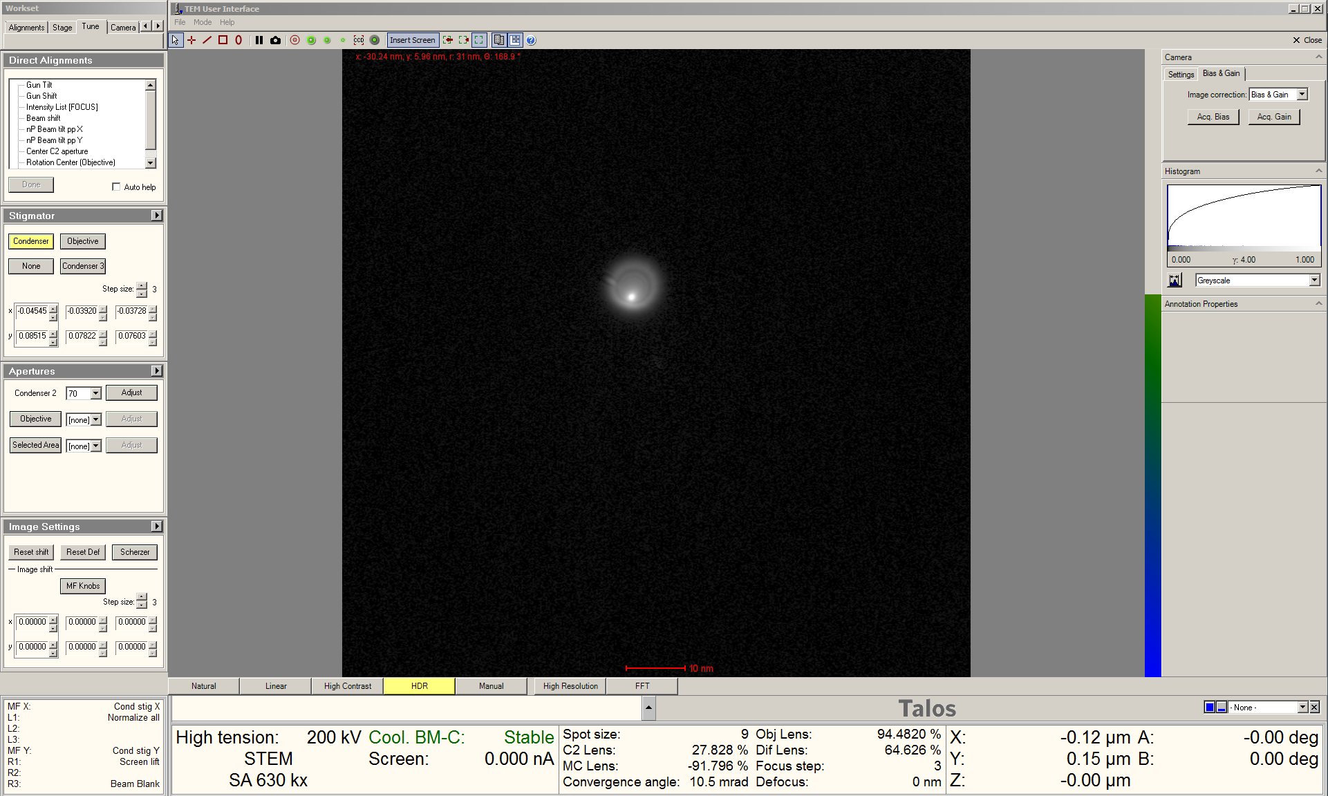

- Beam tilt pivot points

  - Remain in the “Tune” tab and navigate to the ““Direct Alignments” control panel.

    - Select “nP Beam tilt ppx”; the probe will separate out into two “wings”.

    - Use the MF knobs to align the “wings” so the bright tips touch together and create what looks like a figure 8.

    - If the “wings” shift off the FluCam while doing this, select “Beam shift” and use the MF knobs to recenter, then reactivate “nP Beam tilt ppx” and continue.

    - Select “Done” when finished.

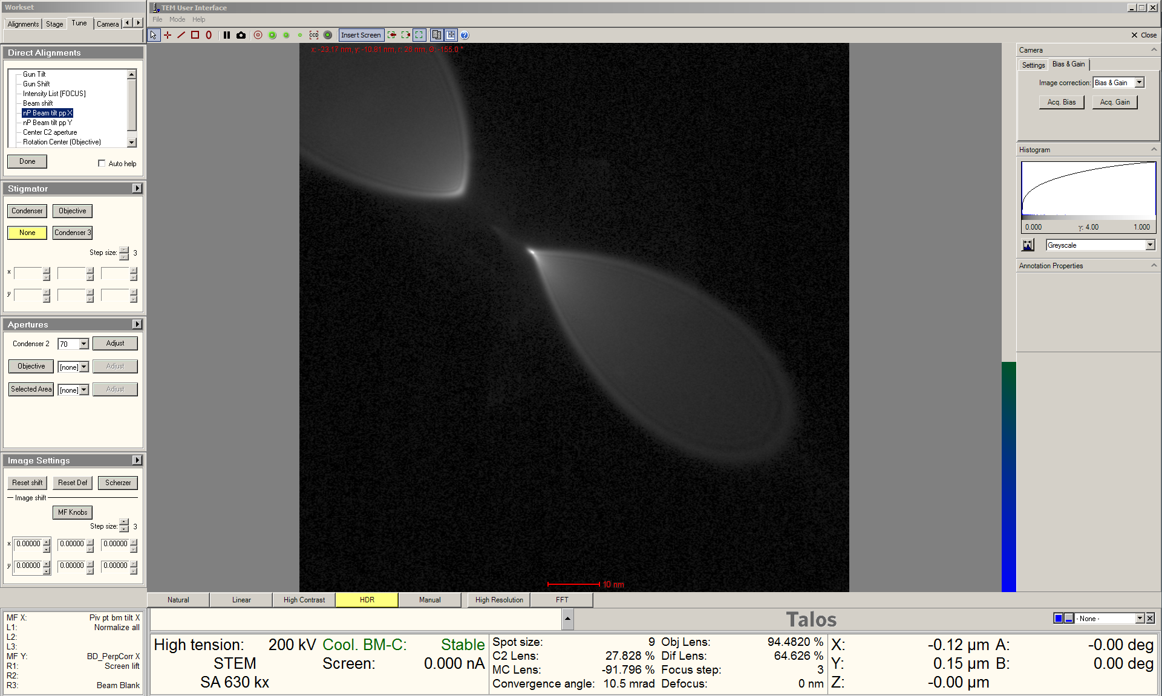

    - In the “Direct Alignments” control panel, select “nP Beam tilt ppy” and repeat.

- Rotation centering

  - Remain in the “Tune” tab and navigate to the “Direct Alignments” control panel.

    - If needed, select “Beam shift” and use the MF knobs to center the probe.

    - Select “Rotation Center (Intensity)”, the probe will start expanding and contracting.

    - Turn the outer “Focus” knob (ring) counterclockwise until the expansion and contraction stops.

    - Use the MF knobs to precisely center the caustic spot inside the diffuse halo.

    - Select “Done” when finished.

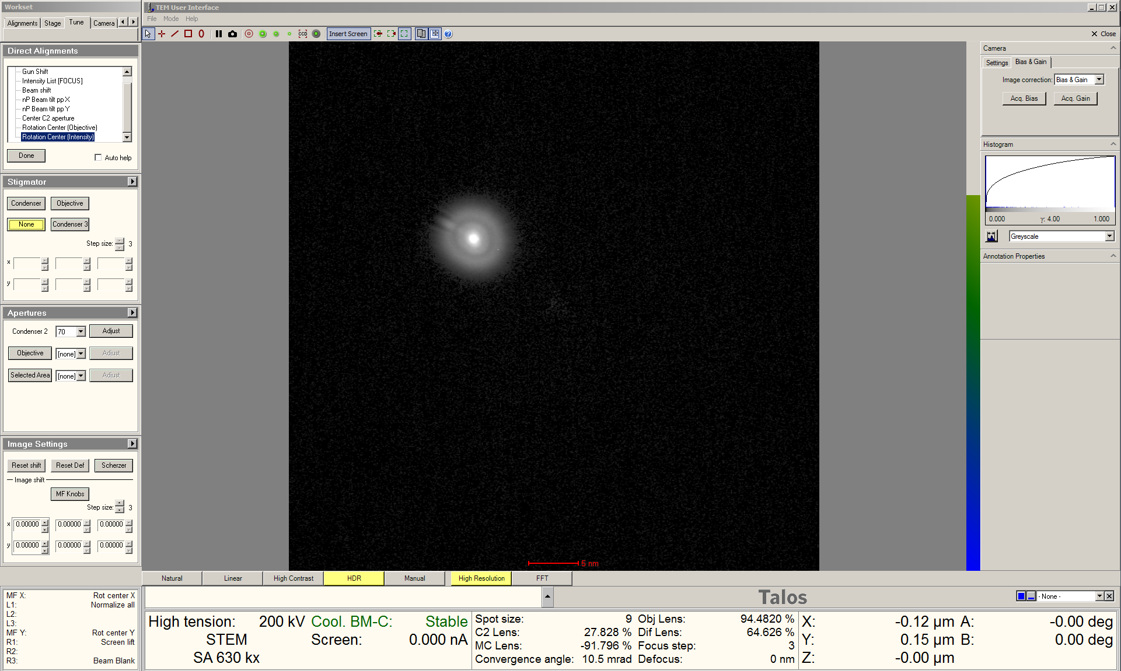

  - If the probe appears noticeably astigmatic after correcting the rotation center, correct the astigmatism again via the condenser stigmators (described previously).

  - Select “Diffraction” on the right-hand control panel to switch back to showing a stationary CBED pattern (direct disc only) on the FluCam (not shown).
- Setting camera length; diffraction alignment

  - In Velox Acquisition, select “HAADF” from the toolbar to start live STEM imaging (512×512 resolution).

  - Decrease the indicated magnification and use the Joystick as needed to move the specimen into the field of view.

  - In the “Detector Layout” side panel, verify “Camera length” = 160 mm (suitable for HAADF-STEM imaging); if not, adjust accordingly.

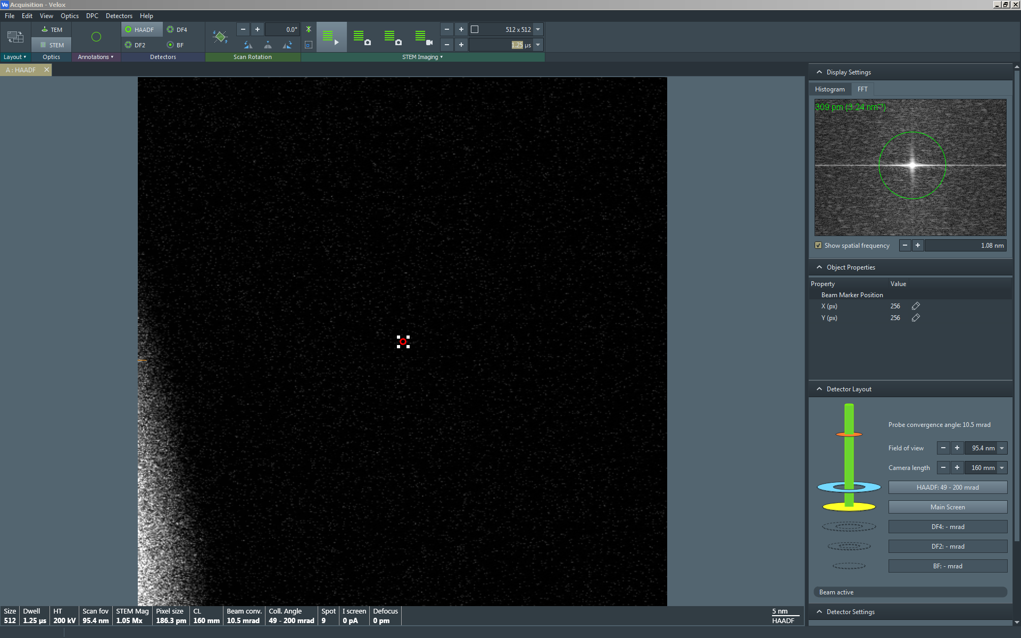
  - In Microscope Control, select the “Tune” tab and navigate to the “Direct Alignments” control panel.

    - Select “Diffraction alignment”

    - Use the MF knobs to center the direct disc of the CBED pattern inside the inner rim of the HAADF detector (indicated by arrow).

    - Select “Done” when finished.

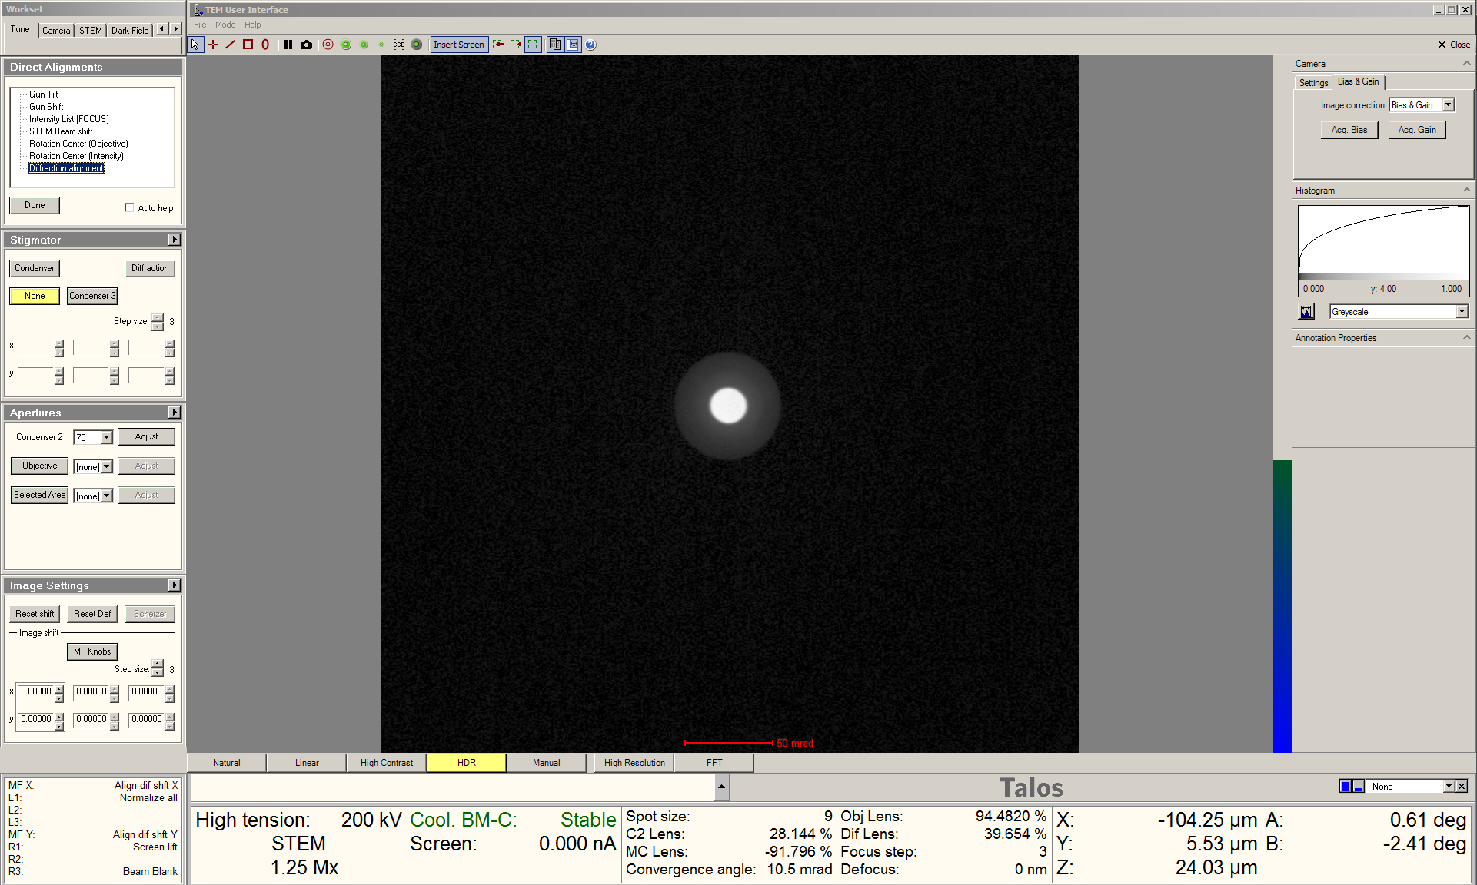
- STEM imaging in Velox

  - Return to Velox Acquisition; while live imaging, adjust the dwell time on the toolbar as needed.

    - Shorter dwell times (1 – 2 µs) tend to work better for navigating around the specimen.

    - Longer dwell times (≥10 µs) tend to work better for focusing, fine astigmatism correction, and detector gain/offset adjustments.

  - To properly set the detector gain and offset; navigate to the “Display Settings” side panel and select “Histogram” to see the image histogram.

    - Navigate to the “Detector Settings” side panel and adjust “Gain” and “Offset” until the range marker under the image histogram takes up approximately the middle of the dynamic range.

    - NOTE: optimal gain and offset settings will depend on focal state, contents of the field of view, and dwell time; the gain and offset must therefore be adjusted as needed.

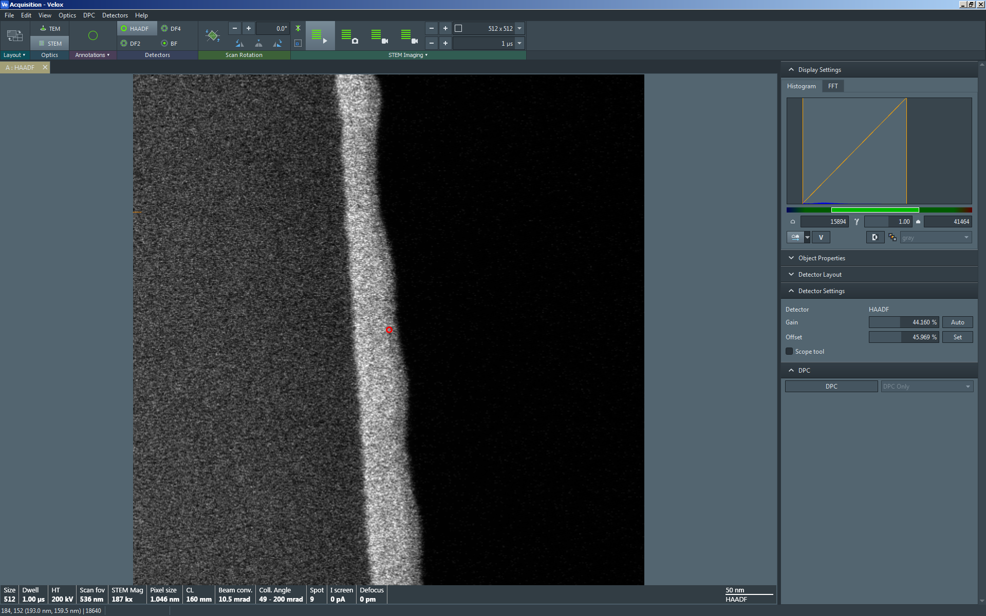
  - Use the “Z axis” buttons on the right-hand control panel to focus the STEM image as accurately as possible.

    - Finer focusing of the STEM image may be performed with the “Focus” knob (subject to the caveats noted below).

    - It should be possible to focus using only the “Z axis” buttons such that a deviation (defocus) from “Eucentric Focus” of only Δf = ±100 nm is needed.

    - If the value of Δf necessary for accurate focusing is significantly outside these limits, push “Eucentric Focus” and then focus the image as accurately as possible using only the “Z axis” buttons before using the “Focus” knob again.

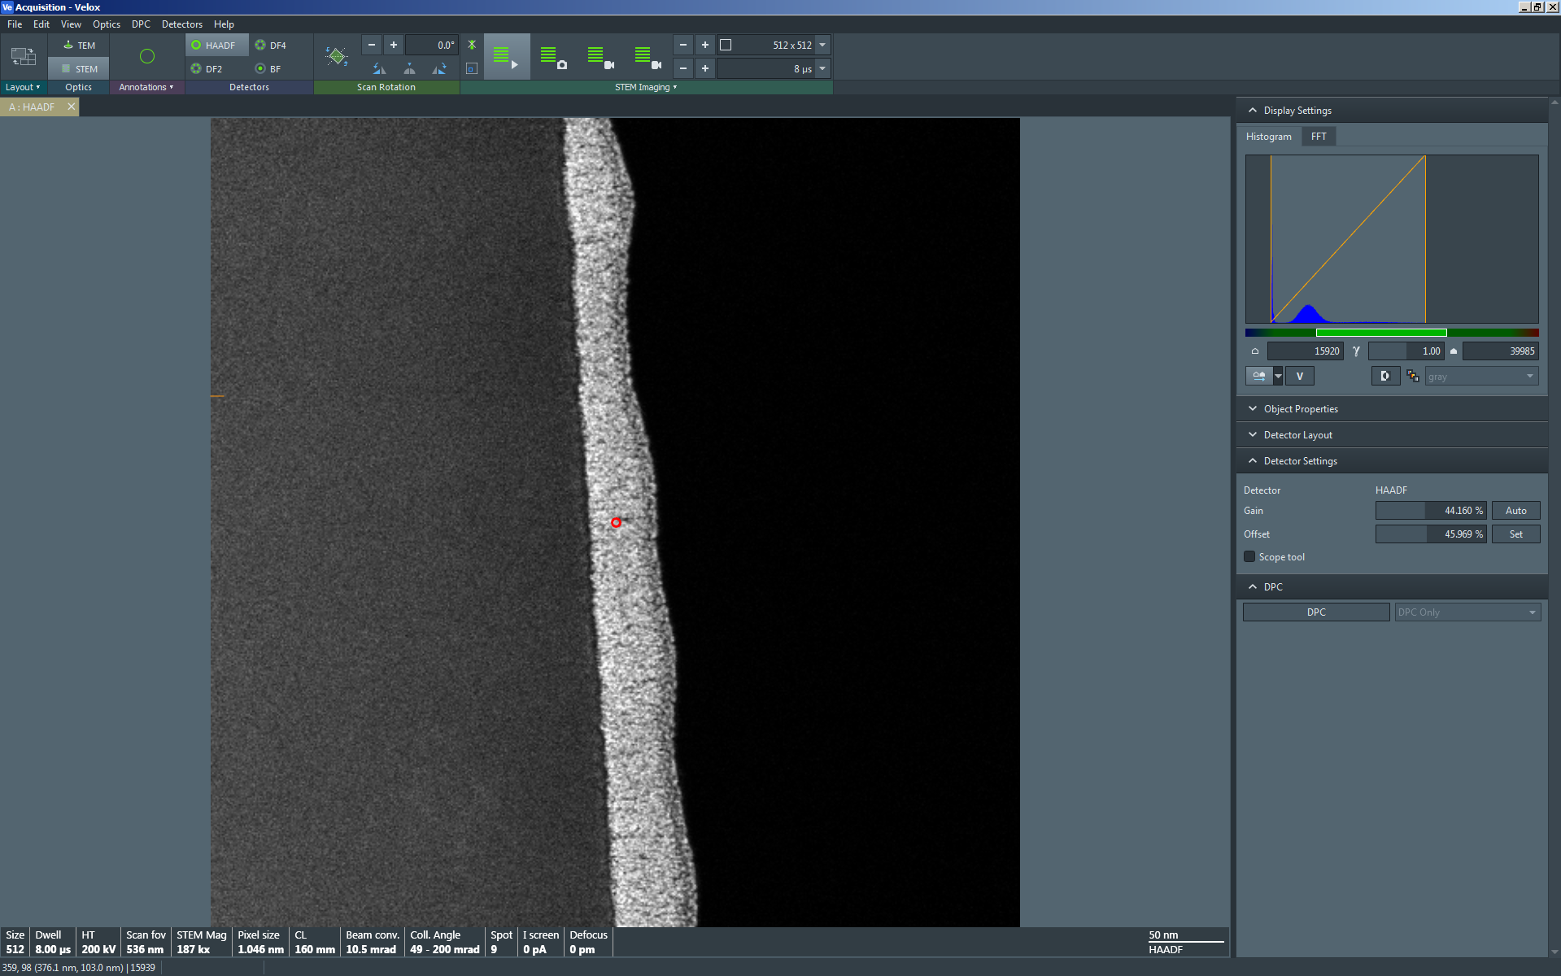
  - From the toolbar, adjust “Scan Rotation” to rotate the live STEM image as needed.

    - NOTE: scan rotation adjustments tend to be more accurate when 1) specimen drift is minimal and 2) the dwell time is ≥ 10 µs in the live image.

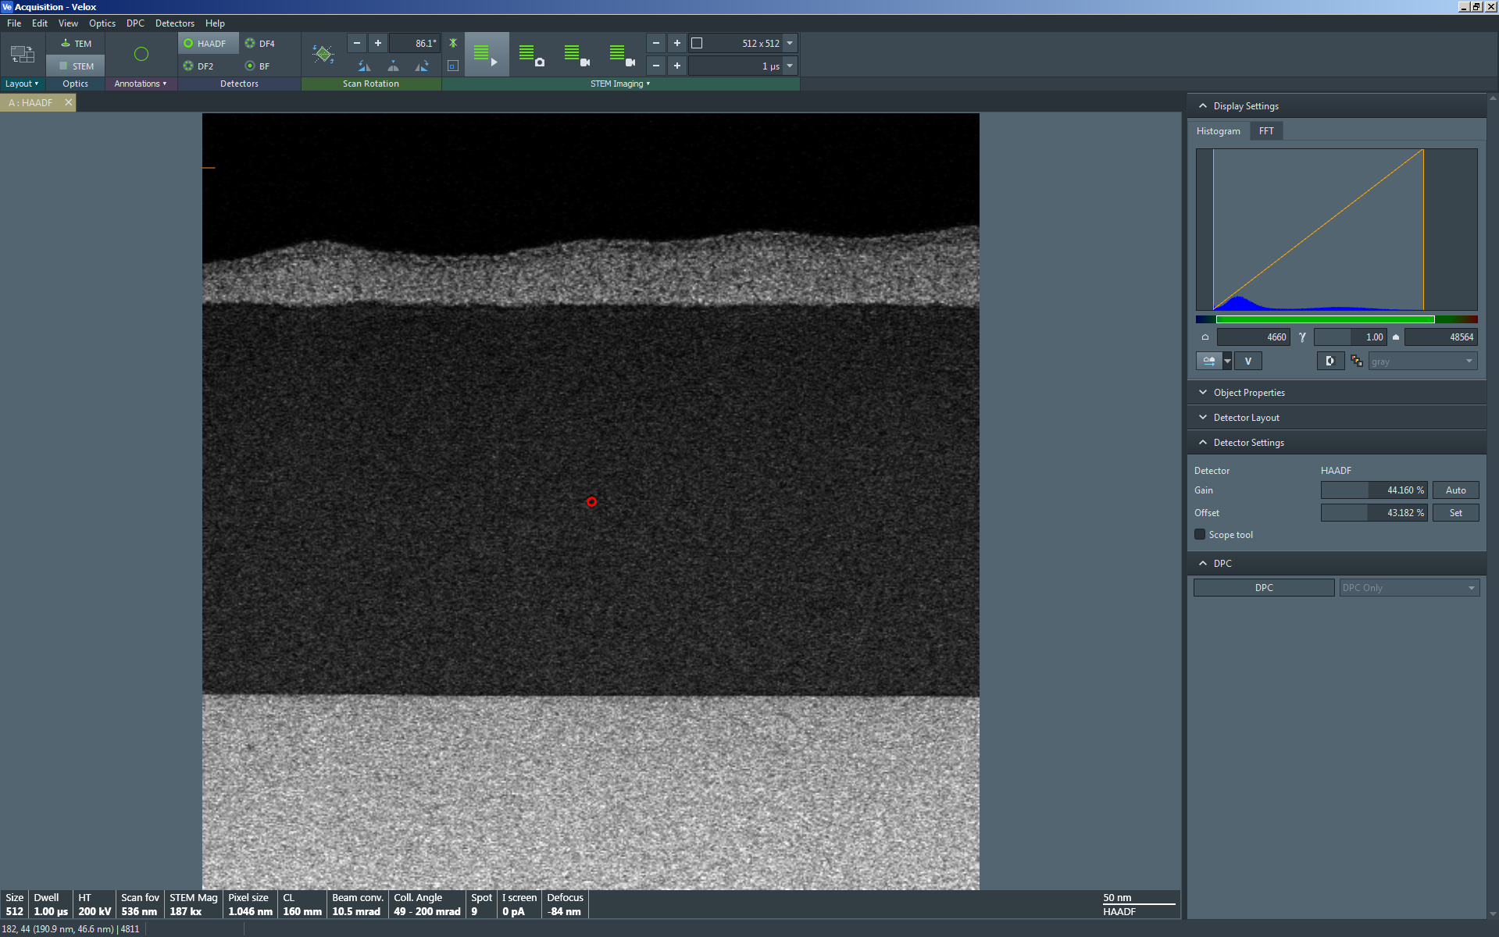

  - To fine tune the focus and correct any remnant astigmatism, use the joystick to center a region of the specimen with very fine features (e.g. protective Pt grains) in the STEM image.

    - Use the “Magnification” knob to set the indicated magnification in Microscope Control to ~1M×.

    - If the image is significantly out of focus after moving the stage, focus as accurately as possible using only the “Z axis” buttons before proceeding.

    - Select “Reduced Area” from the toolbar to open a reduced area scan window in the live STEM image (indicated by arrow); adjust/position the box as needed.

    - Set the dwell time ≥10 µs; NOTE: the dwell time for the reduced area may be set differently than the dwell time for the full frame.

    - Use the “Focus” knob to (finely) focus the image as best as possible and note the presence of any streaking (astigmatism).

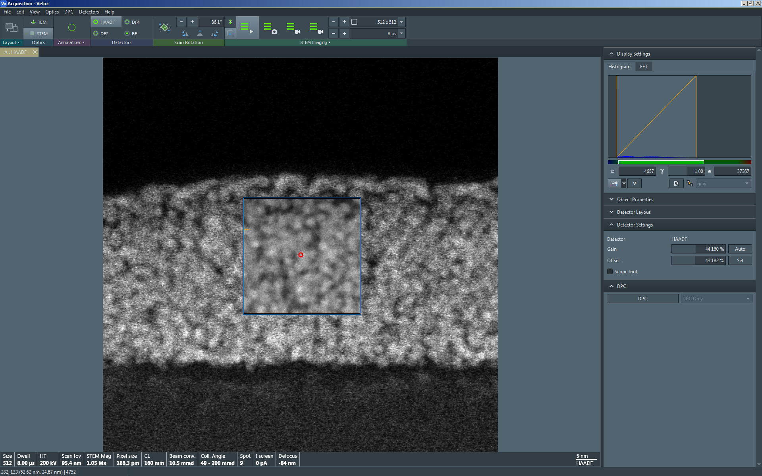
    - In Microscope Control, return to the “STEM” tab and navigate to the “Stigmator” control panel; select “Condenser”.

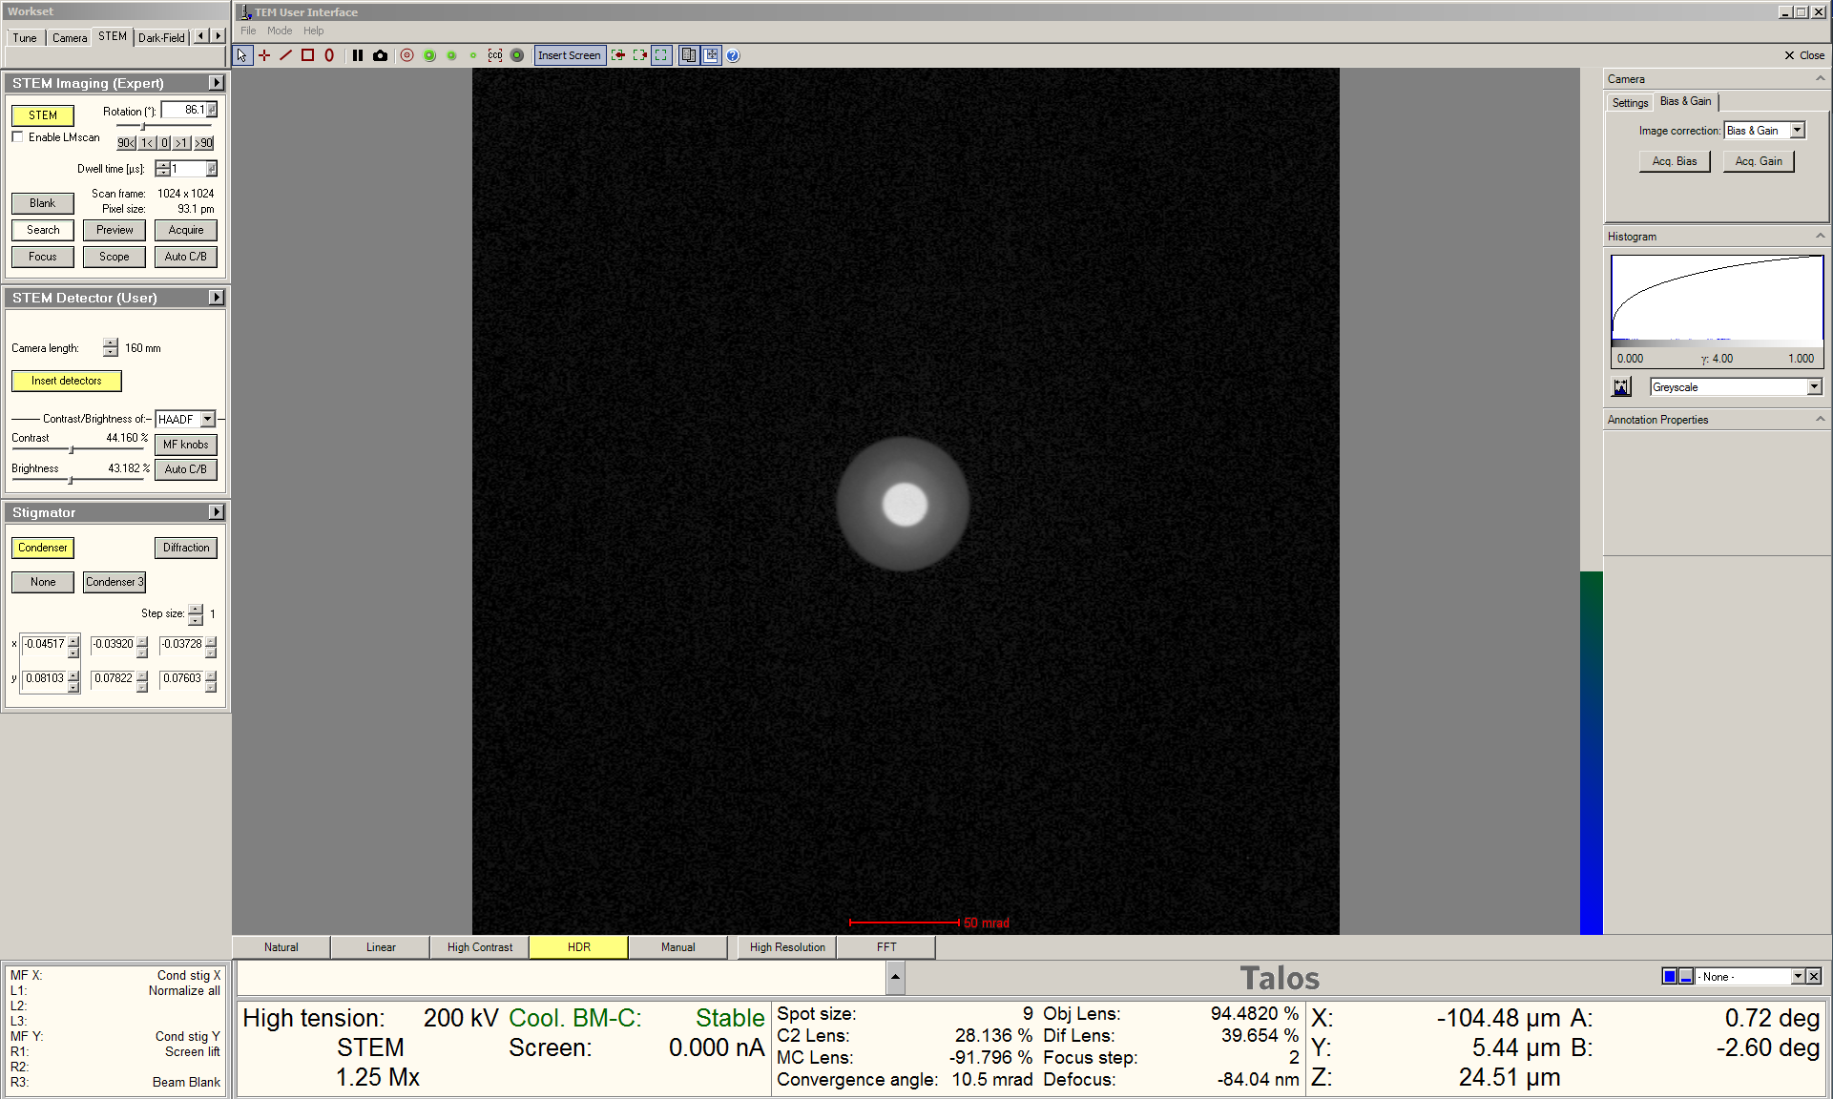

    - Navigate back to Velox Acquisition; use the MF knobs to make the STEM image as sharp as possible.

    - After correcting the astigmatism, finely focus the image with the “Focus” knob.

    - When ready, select “Reduced Area” from the toolbar to resume full frame imaging.

  - When ready to acquire the final image, use the joystick to center the region of interest in the live image.

    - Use the “Magnification” knob to set the indicated magnification higher than will be used for final image acquisition (not shown).

    - If the live image is noticeably out of focus, refocus using the “Z axis” buttons (not shown).

    - Use the “Focus” knob (along with the “Reduced Area” window, as needed) to finely focus the image (not shown).

    - `NOTE: if the alignment was done properly and image properly focused first by adjusting the “Z axis” buttons and then by finely adjusting the “Focus” knob, “Defocus” should be within ±100 nm.

    - Use the “Magnification” knob to set indicated magnification as needed for the final image (not shown).

    - In Velox Acquisition, select “Acquire” from the toolbar to capture the final STEM image (1024×1024 resolution with dwell time = 50 µs).

    - If either the pixel dimensions or dwell time are adjusted before acquisition is completed, a new acquisition will start with the adjusted parameters.

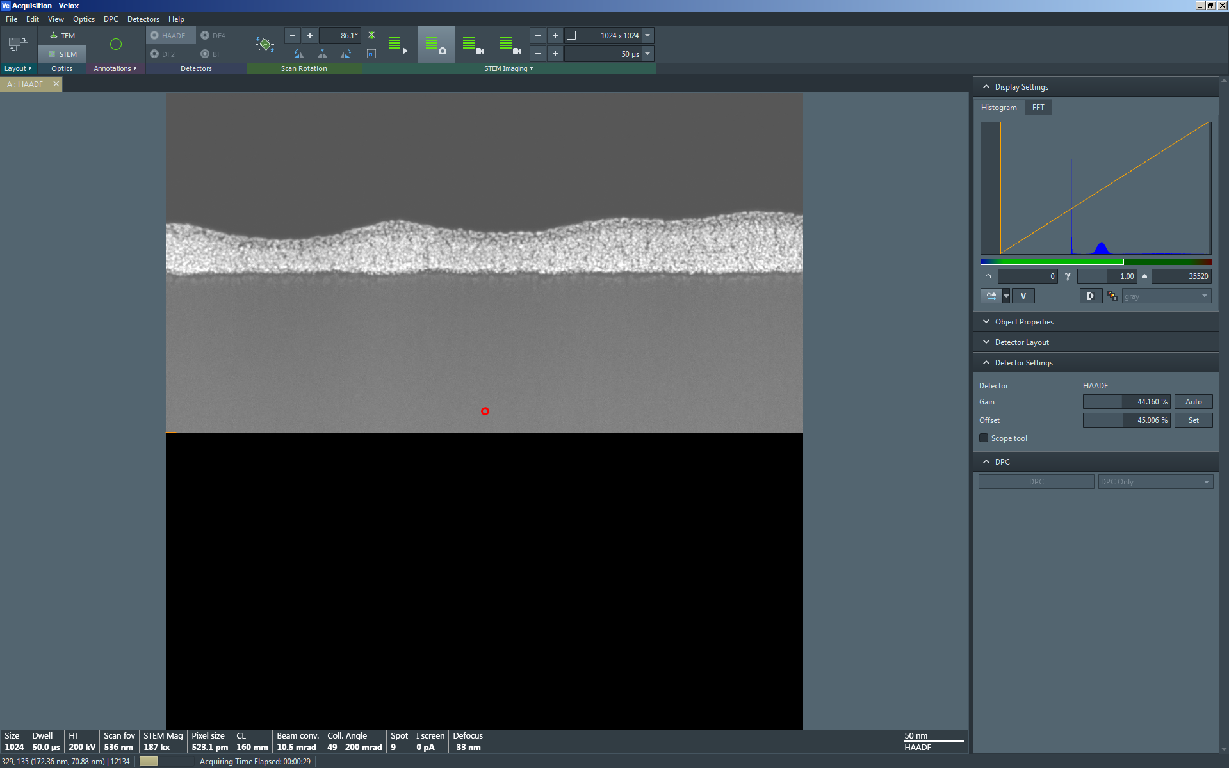

- Blanking the beam (as needed)

  - If it is necessary to leave the instrument for only a few minutes, it is best practice to blank the beam to minimize specimen irradiation.

    - If it is necessary to leave the instrument for more than a few minutes, it is best practice to close the column valves (not shown).

  - In Velox Acquisition, select “Beam Blank” from the toolbar to blank the beam (the live image will continue, but will be only noise).

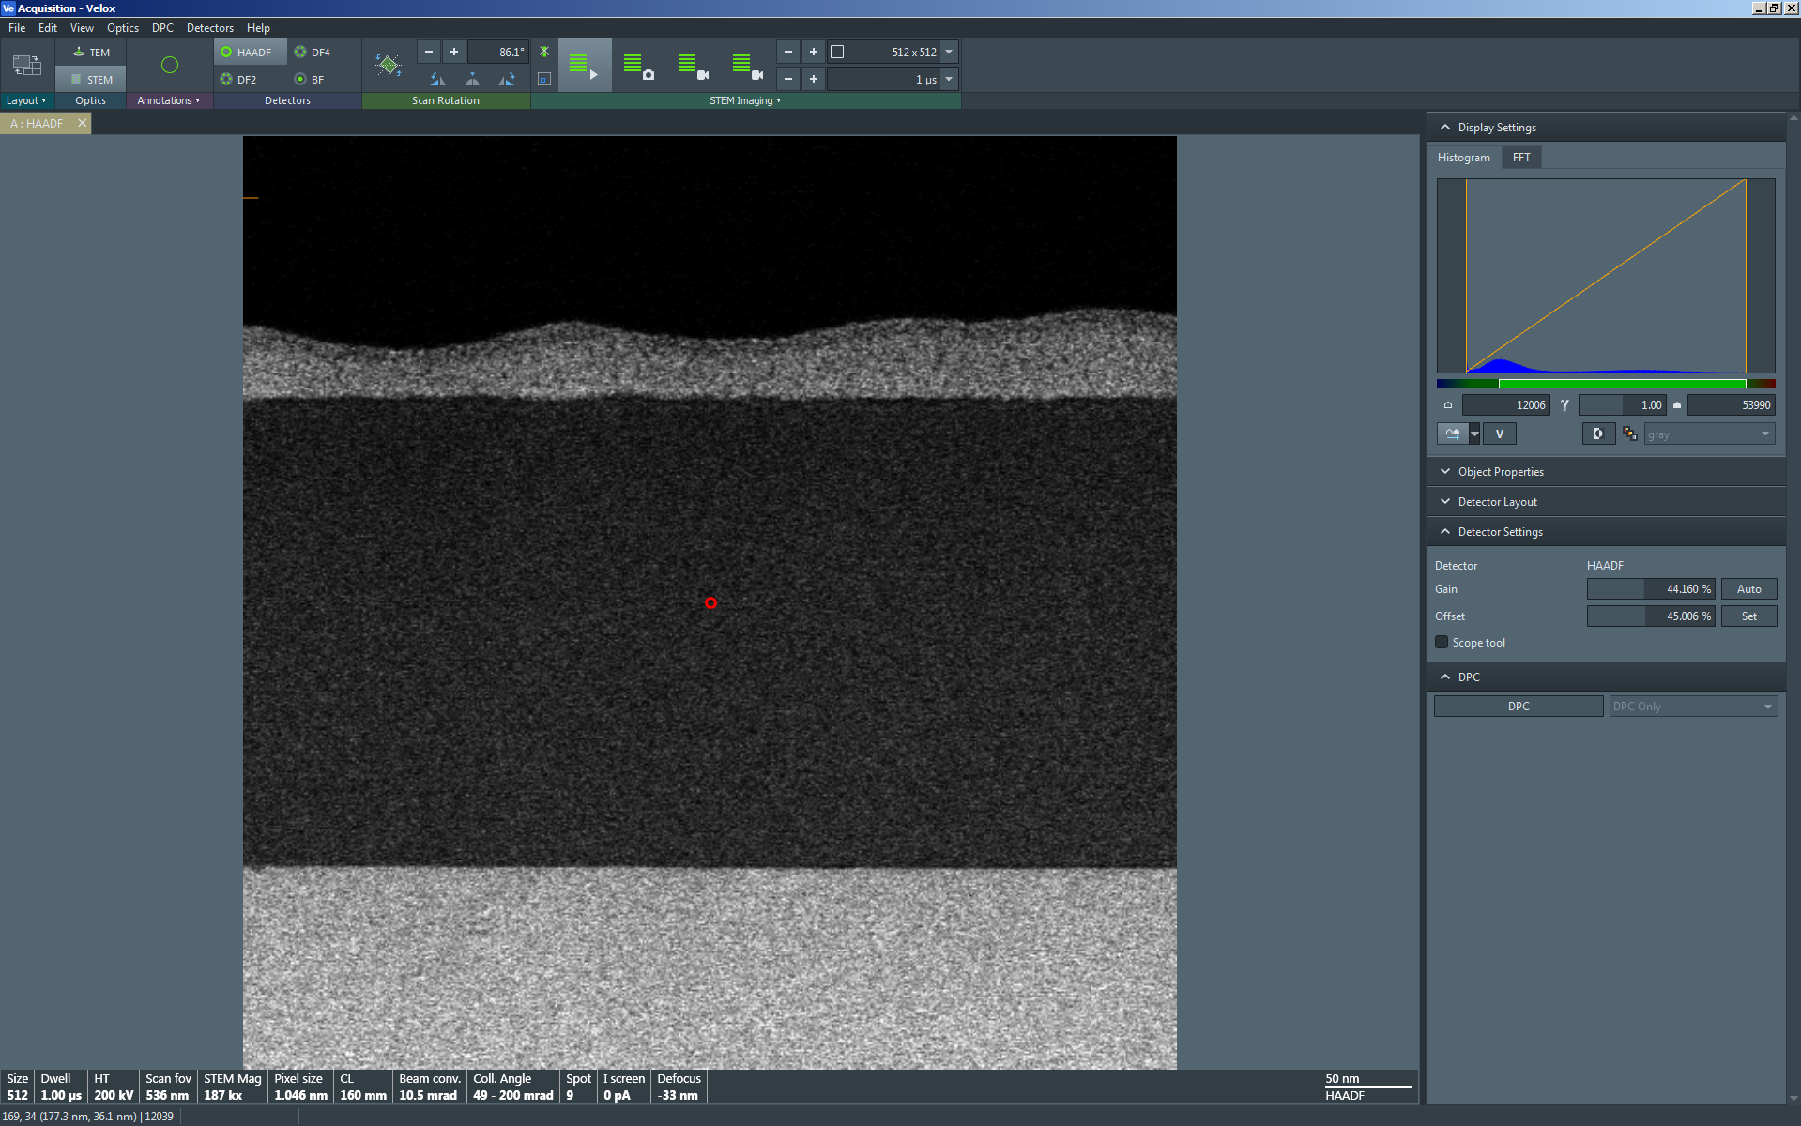

  - When ready to un-blank the beam, simply select “Beam Blank” from the toolbar and the live image will reappear in Velox.

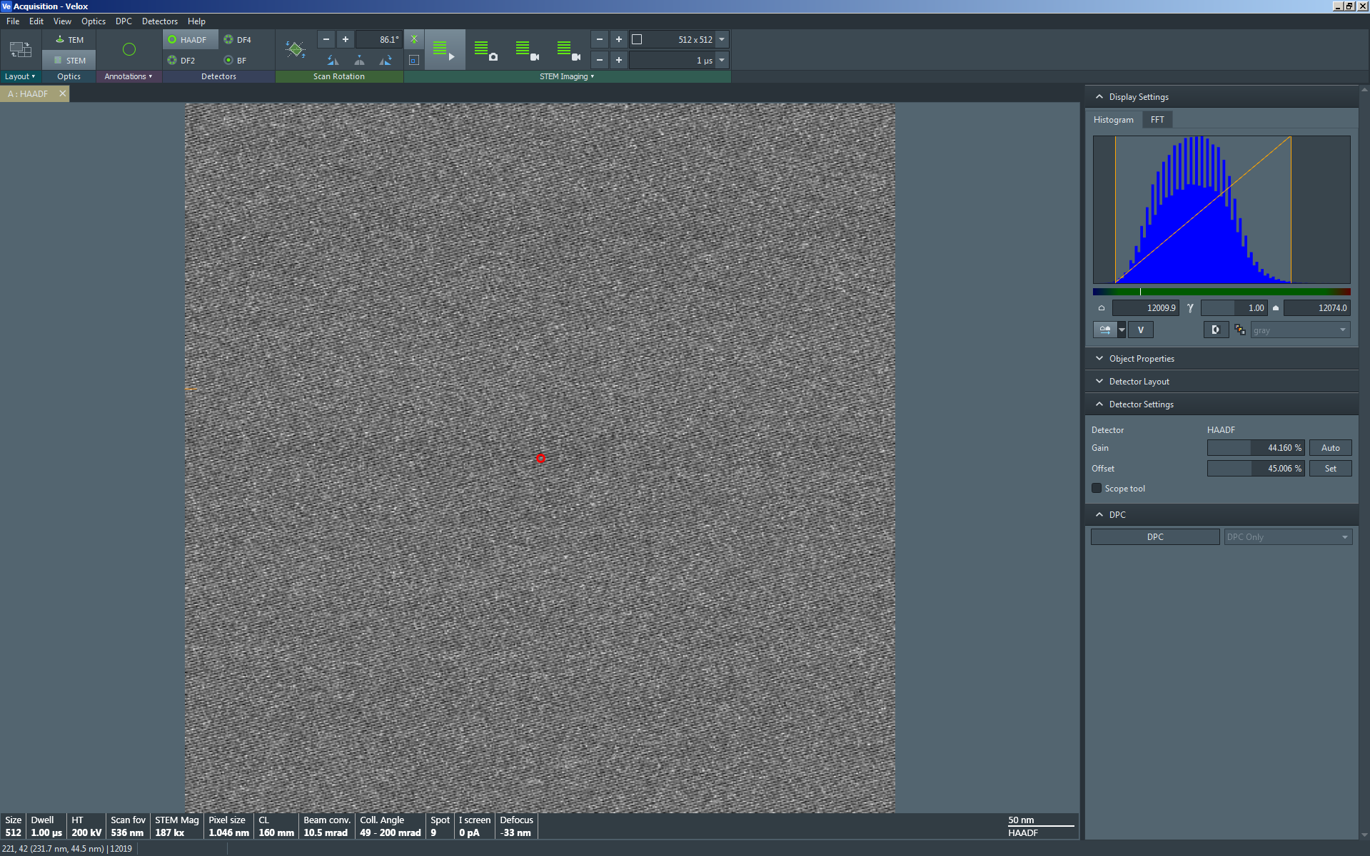
- Additional considerations for atomic-resolution STEM imaging

  - A stable specimen with minimal drift is necessary to obtain high-quality atomic-resolution STEM images with minimal distortion.

    - It may take 1 – 2 h (or longer) after inserting the holder into the column for the specimen drift to reduce and stabilize for optimal atomic-resolution STEM imaging.

  - The best atomic-resolution STEM images are obtained when the sample is as closely aligned along a major crystallographic zone axis as possible. Obtaining this alignment is most feasible in single-crystal samples or very large grains in polycrystalline samples. To complicate matters, this alignment must be achieved at the desired ROI (e.g. at a film/substrate interface).

    - If the ROI was crystallographically aligned previously in TEM mode, then only a small amount of tilting (few mrad) in STEM mode may be necessary.

  - Prior to performing any tilting, verify the live STEM image is focused as accurately as possible using the “Z axis” buttons.

  - While acquiring a live STEM image in Velox Acquisition, select “View” from the toolbar to freeze the live image.

    - Click and drag on the beam position marker onto the frozen STEM image and position it at the desired ROI.

    - The CBED pattern observed on the FluCam corresponds to the beam position marker location.

    - The indicated STEM magnification need not be very high to perform crystallographic alignment; 50 k× – 200 k× will be sufficient for doing this.

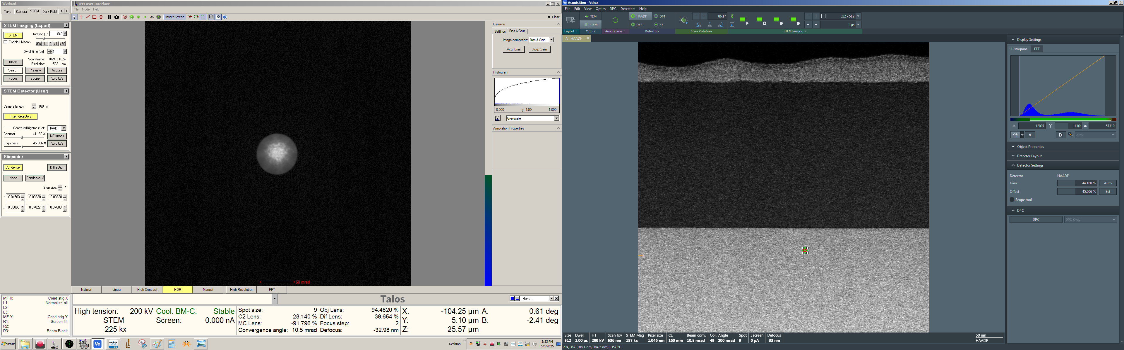
  - Use the following iterative process to align to the zone axis:

    - Move the beam position marker to the ROI and observe the CBED pattern on the FluCam.

    - Make an appropriate change in either the α or β tilt based on the observed CBED pattern (noting the curvature of the disks) and the below zone axis tilt map (L ≥ 98 mm).

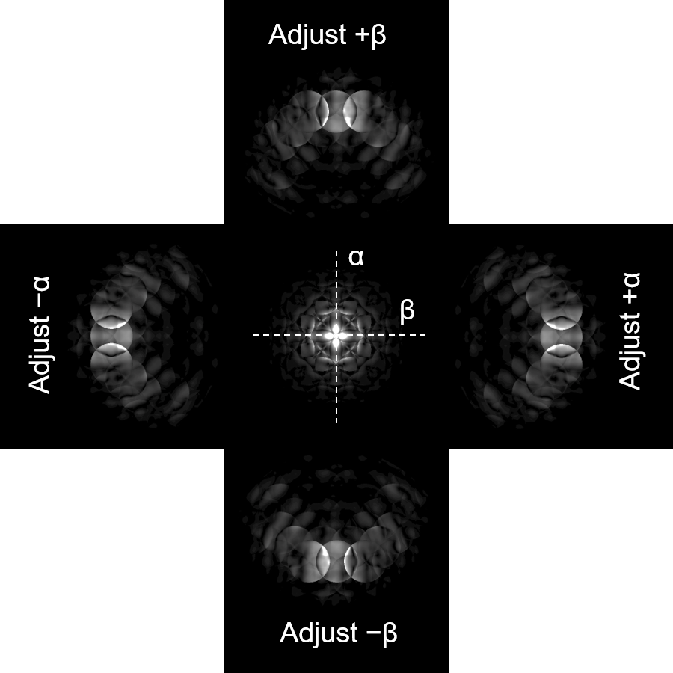

    - Return to Velox and select “View” to resume the live STEM image; use the joystick to re-center the ROI in the image.

    - As needed, refocus the image using the “Z axis” buttons and then freeze the live STEM image again.

    - Move the beam position marker back over to the ROI and observe the CBED pattern on the FluCam again (it should be closer to being aligned to the zone axis than before).

    - Repeat until alignment with the zone axis for the ROI is achieved as indicated by the CBED pattern (this may take several iterations). With skill and patience, zone axis alignment with ~1 mrad precision is possible.

    - Once zone axis alignment is complete, resume live STEM imaging; once again, focus as accurately as possible using only the “Z axis” buttons.
  - While live imaging, center the region of interest in the image.

    - Set indicated STEM magnification in Microscope Control to 7.2 M× (appropriate for fine tuning of atomic-resolution imaging).

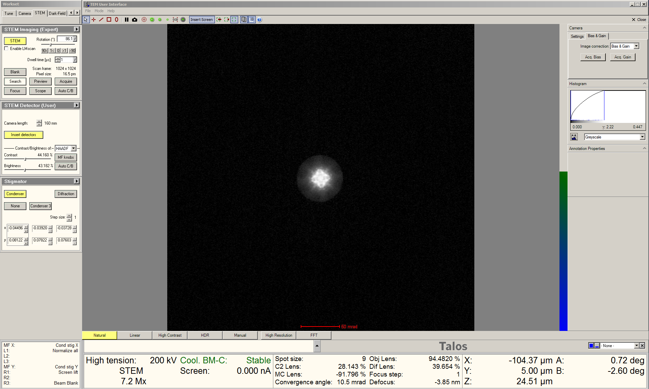

  - Freeze the live image and observe the CBED pattern on the FluCam (not shown).

    - Adjust the “Focus” knob (focus step = 2) to obtain a “blow up” condition; this corresponds to the probe being focused.

    - At the “blow up” condition, the CBED pattern will not exhibit any features resembling lattice fringes (see below).

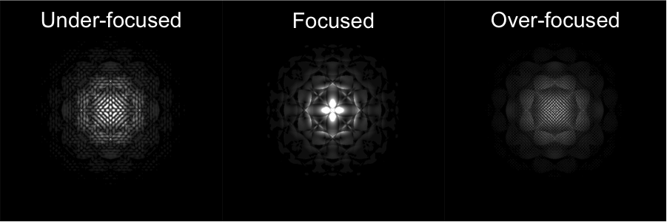

  - Restart scanning to resume the live STEM image; atomic-level detail should be evident in the image.
  - In Microscope Control, activate the condenser stigmators; set the sensitivity to the finest possible setting.

  - In Velox Acquisition, select “Reduced Area” and use the “Focus” knob (focus step = 1) to change the focal state between under- and over-focus.

    - Use the MF knobs to obtain the sharpest possible image; astigmatism presents as directional streaking that reorients by ~90° as the focal condition changes from under- to over-focus.

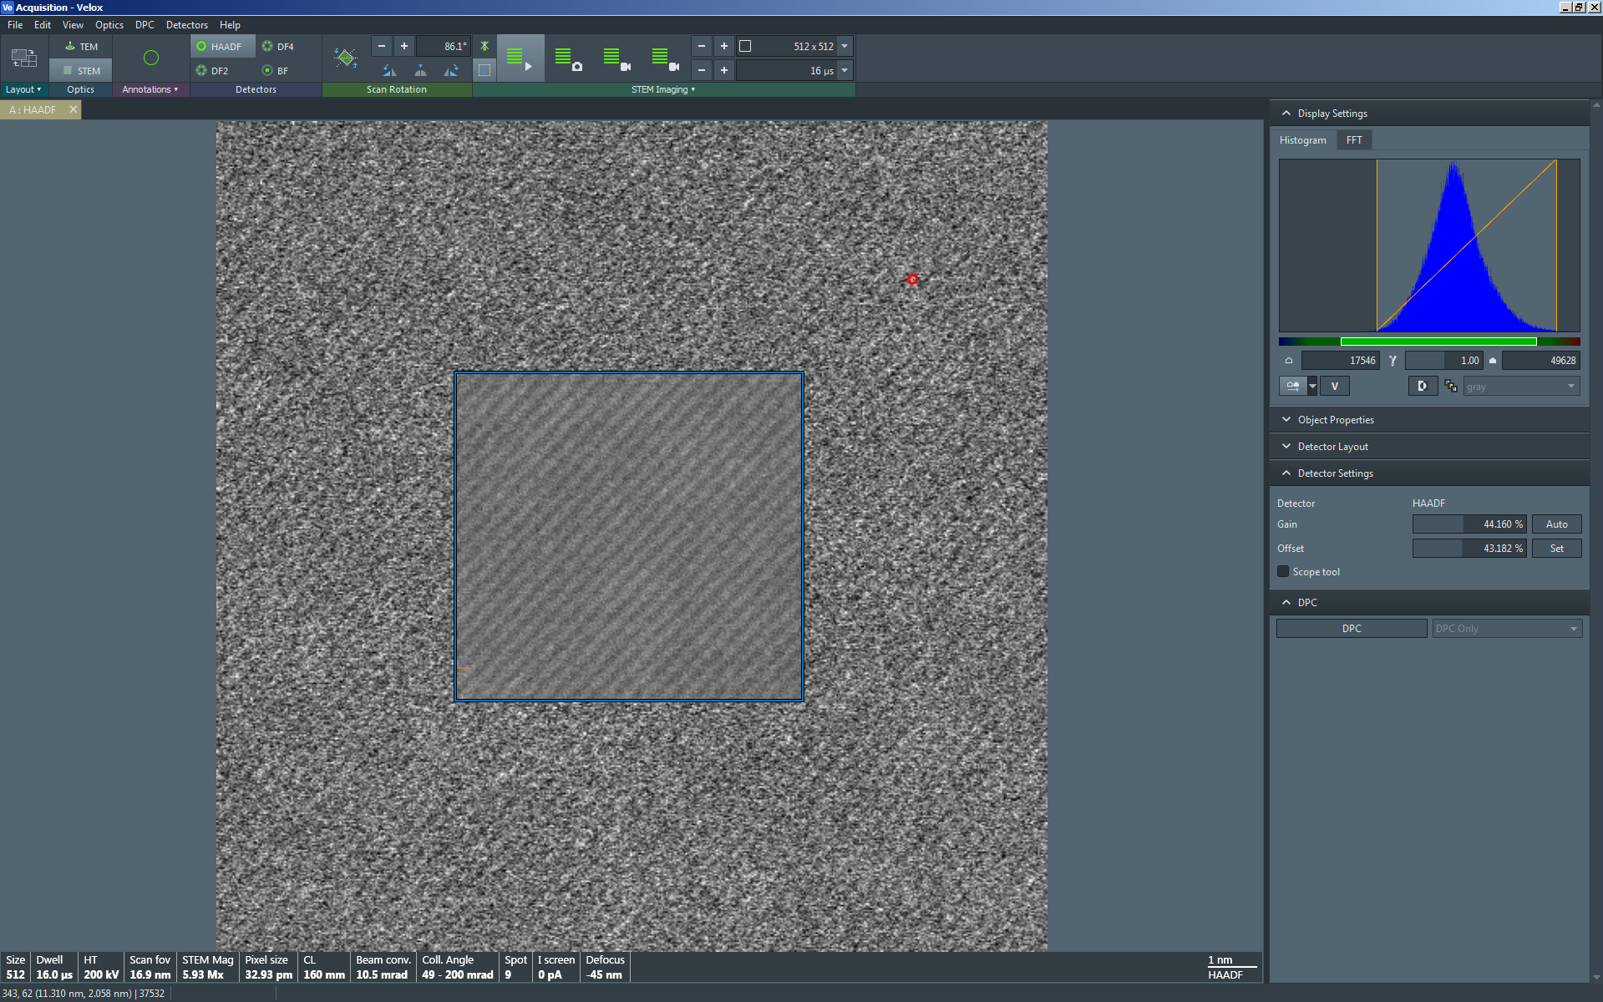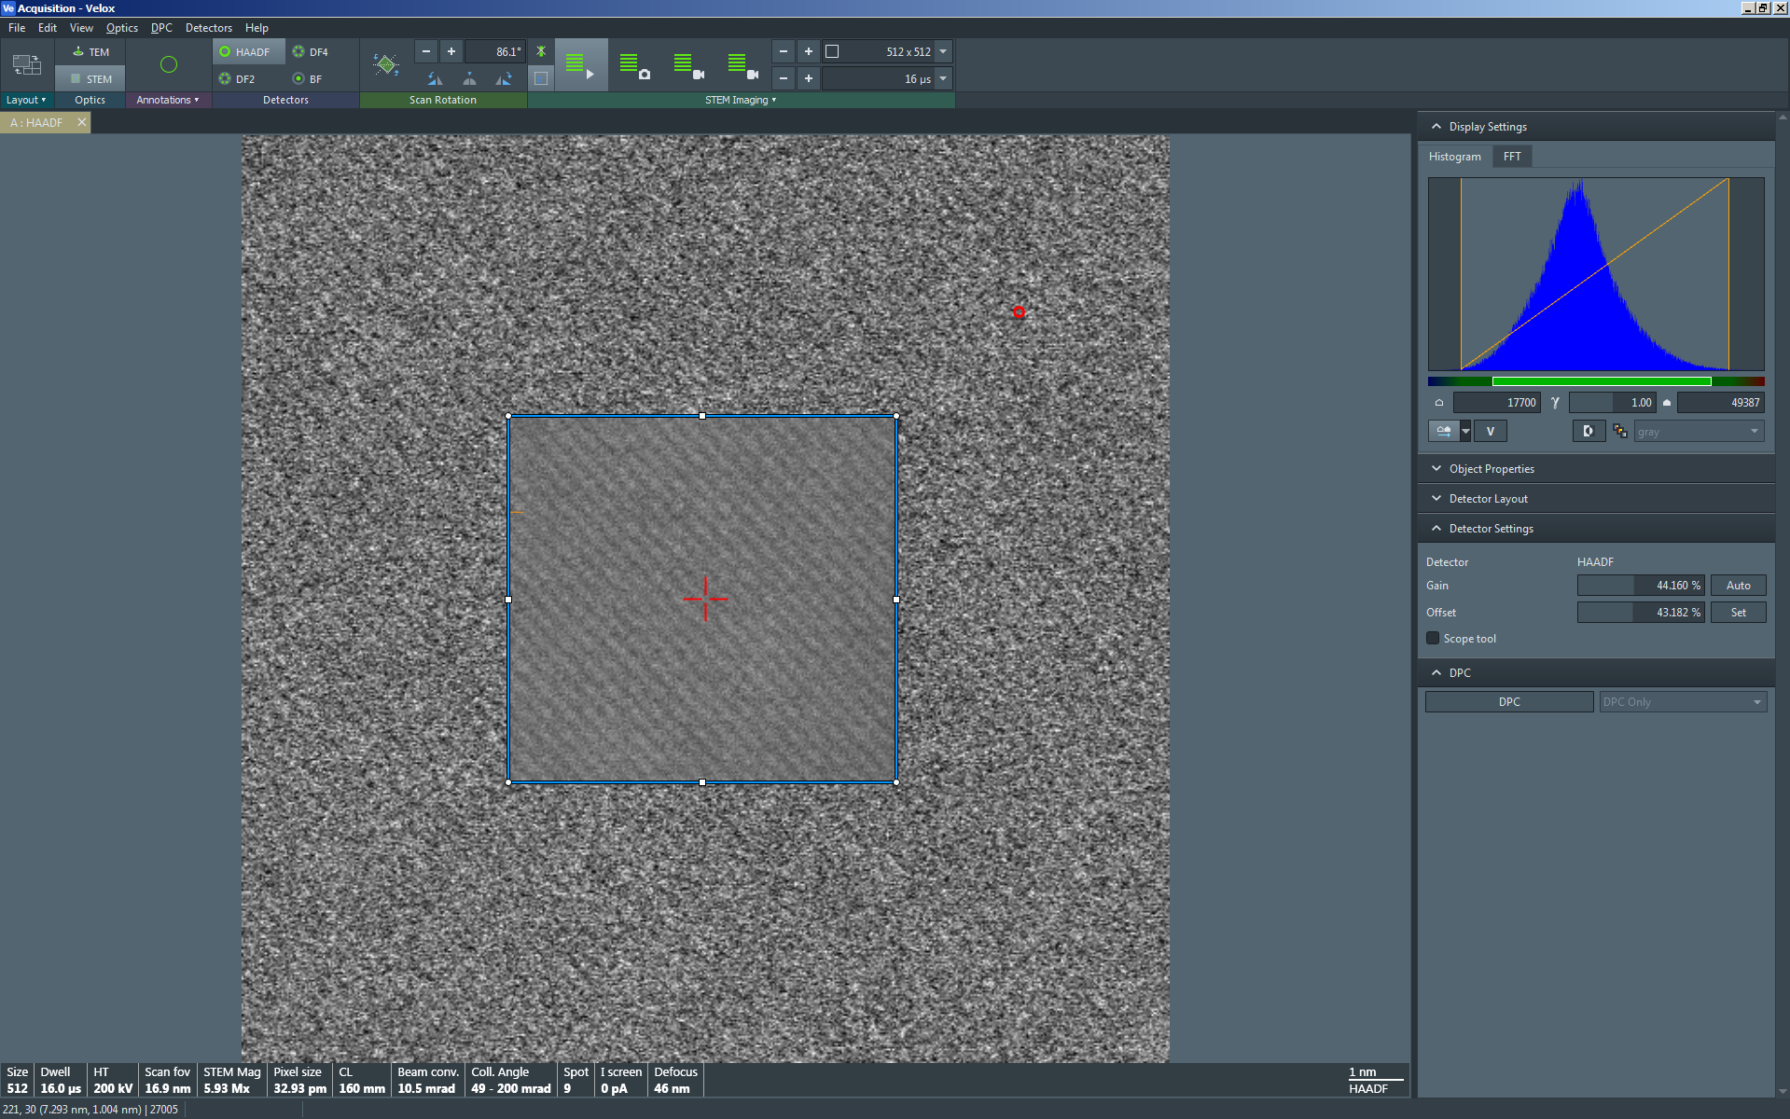

Astigmatic atomic-resolution STEM images (reduced area): under- (left) and over-(right) focused; directional streaking is indicated by white arrows.

    - If no such streaking is evident as the focal condition is changed, then the astigmatism is properly corrected.

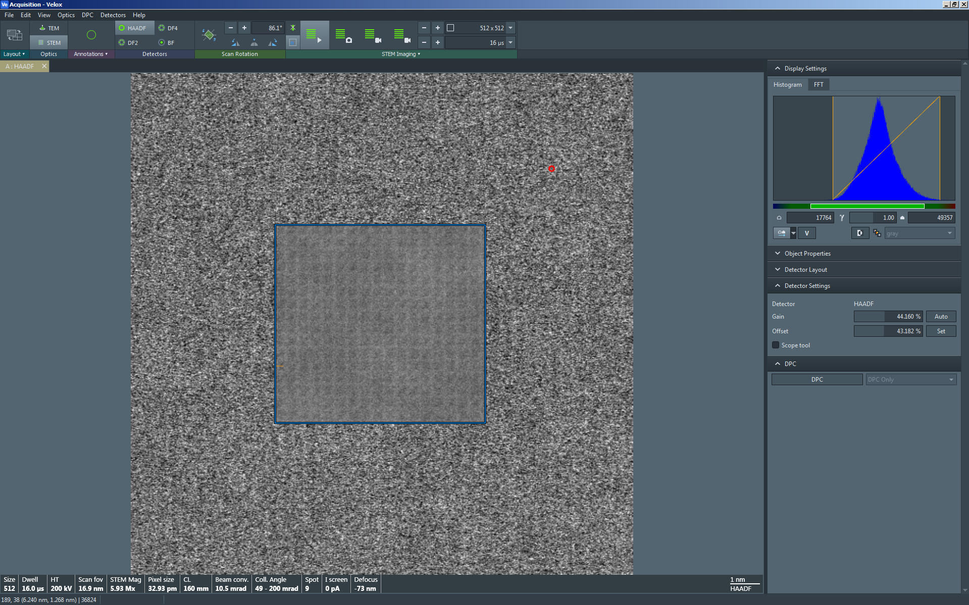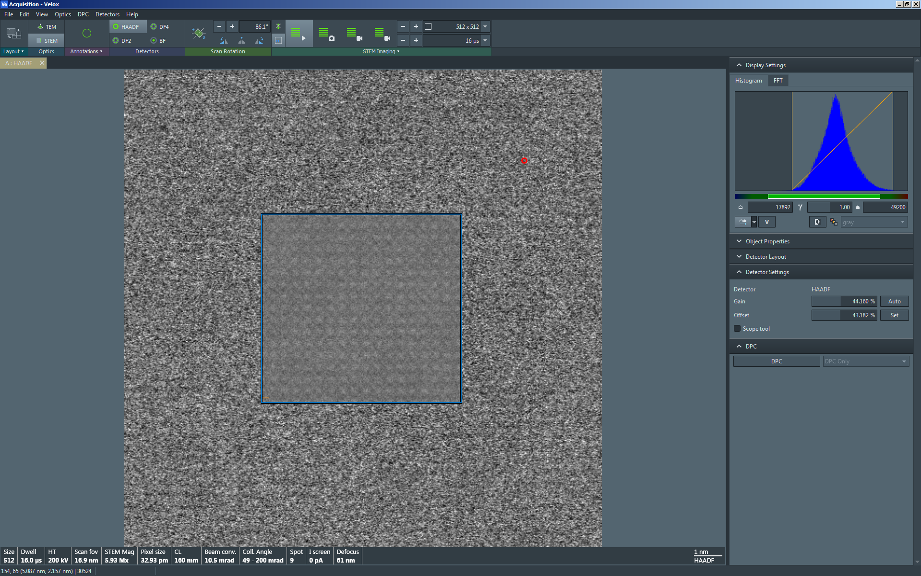

Non-astigmatic atomic-resolution STEM images (reduced area): under- (left) and over- (right) focused.
  - Once the astigmatism is corrected, use the “Focus” knob to precisely focus the live image and then set the indicated magnification as needed.

    - NOTE: the lowest indicated magnification for effective atomic-resolution STEM is ~1.25 M×.

  - Check the detector dynamic range and adjust the “gain” and “offset” accordingly (described previously).

  - Velox Acquisition, select “Acquire” to capture the final image (as described previously)

  - While atomic-resolution STEM images may be captured using single-frame acquisition (as described previously), a more effective approach is usually to capture an image series and perform drift-corrected frame integration as described subsequently.

- Series acquisition

  - Series acquisition is used to sequentially capture a series of STEM images each with a short dwell time; the series of images may then be integrated and aligned to create a drift-corrected, frame-integrated (DCFI) image series.

  - Set up the live STEM image just as if preparing to capture a normal single frame acquisition; in the Velox Acquisition toolbar, select one of the two options for series acquisition.

    - The first option uses 1024×1024 resolution and tends to work better for low resolution (non-atomic level) imaging

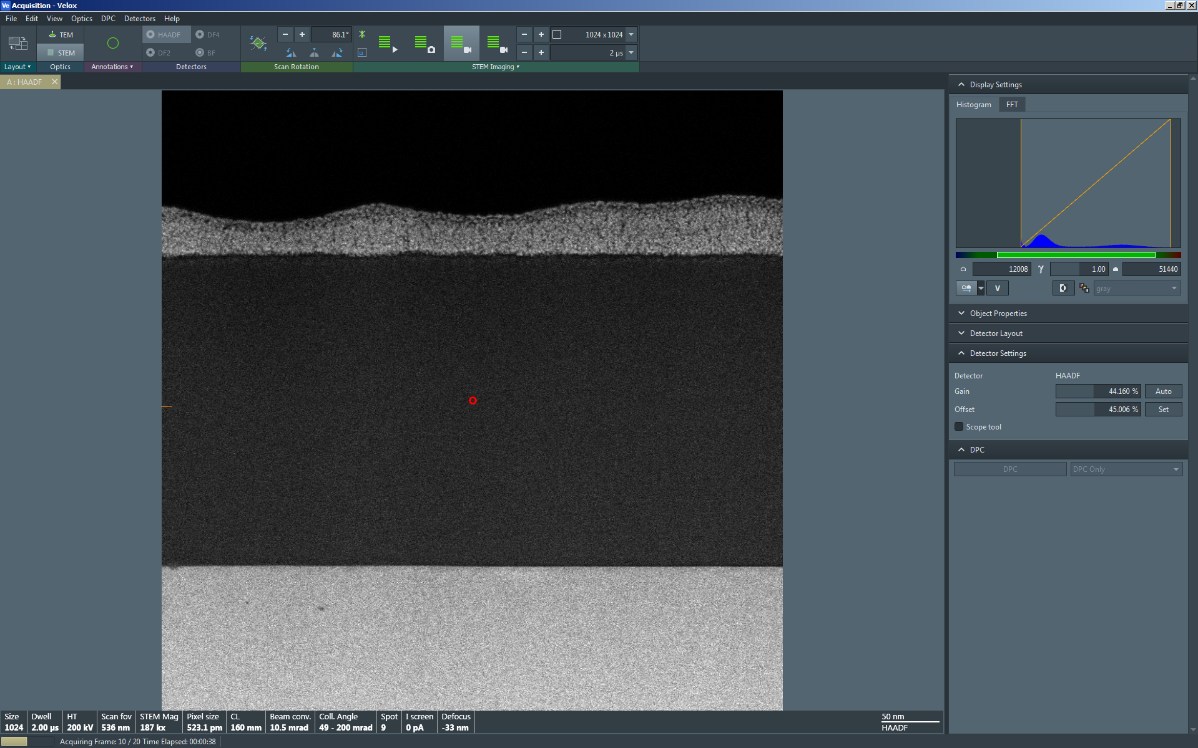

    - The second option uses 512×512 resolution and tends to work better for high-resolution (atomic level) imaging

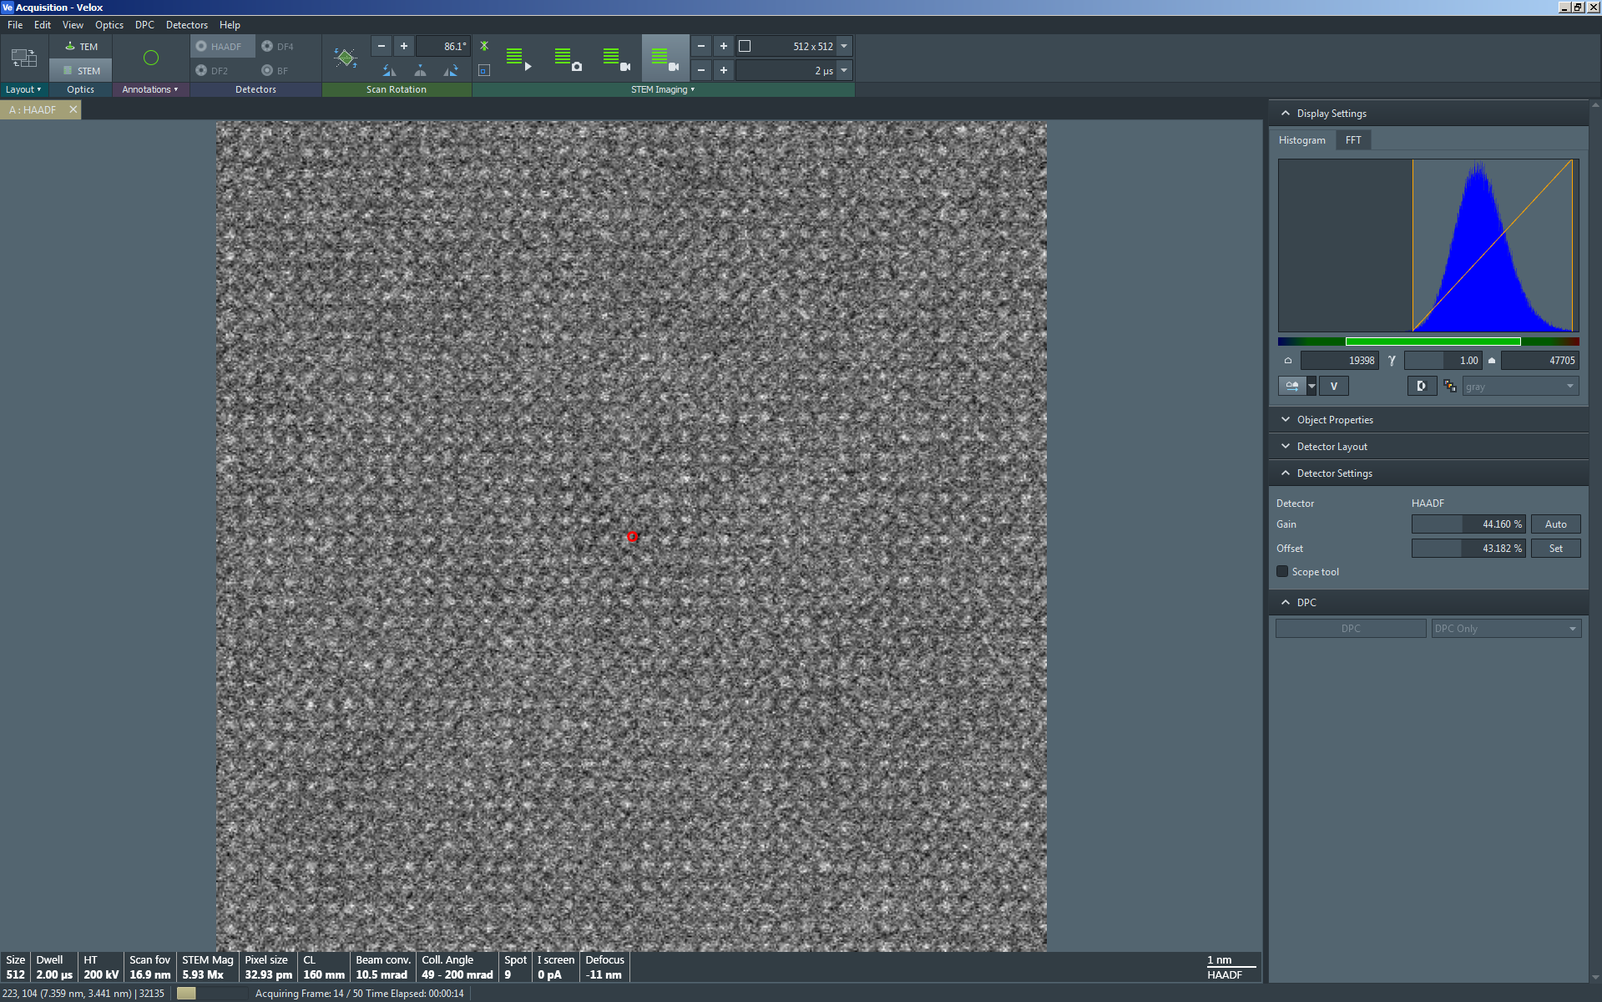

  - To generate the DCFI image series, switch to Velox Processing and make sure the series of interest is selected and open.

  - Select “Processing” from the pull-down menu and then “DCFI”; there are two further options: “DCFI” and “DCFI – Optimized for periodic images”.

    - If the series contains periodic, atomic-level detail, select “DCFI – Optimized for periodic images”.

    - To the right of the panel containing the raw image series, a new panel is generated with the DCFI image series.

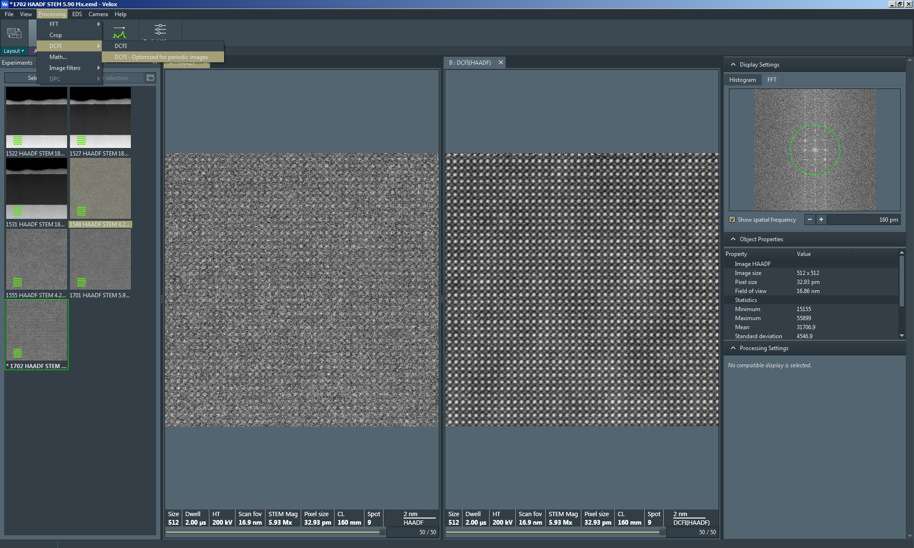

    - If the series does not contain periodic, atomic-level detail, select “DCFI” and then evaluate the result (unfortunately, the result here is blurry).

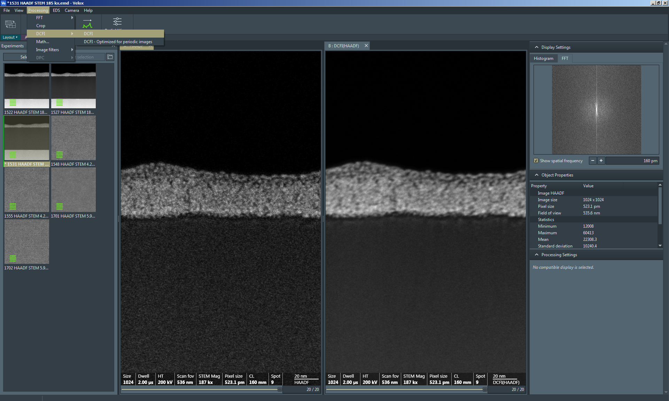

    - If selecting the “DCFI” option produces a less-than-optimal result, select “DCFI – Optimized for periodic images” instead (now, the result is much better).

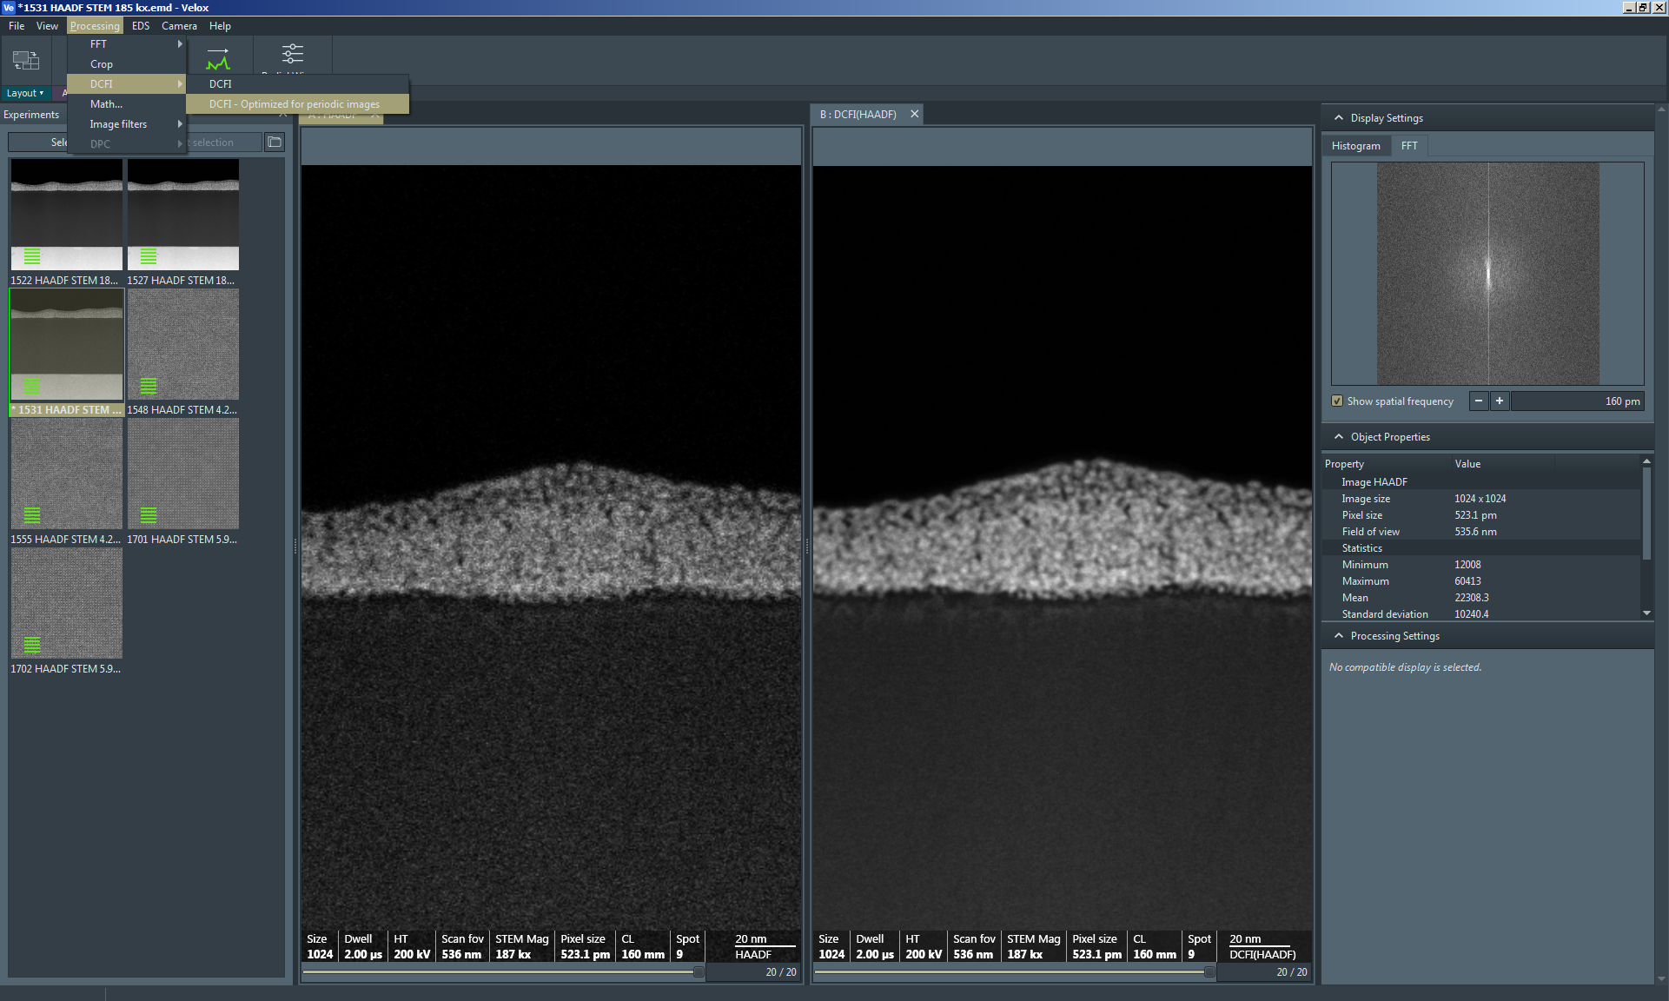

- Finishing in STEM mode

  - In Velox Acquisition:

    - Verify “Beam Blank” from the toolbar is not activated (the beam is not blanked).

    - If needed, set “Scan Rotation” = 0° in the toolbar.

  - In Microscope Control, select the “STEM” tab and navigate to the “STEM Imaging” control panel.

    - Select “STEM” to exit STEM mode and enter TEM mode; the live STEM image will stop and the HAADF detector will retract automatically.

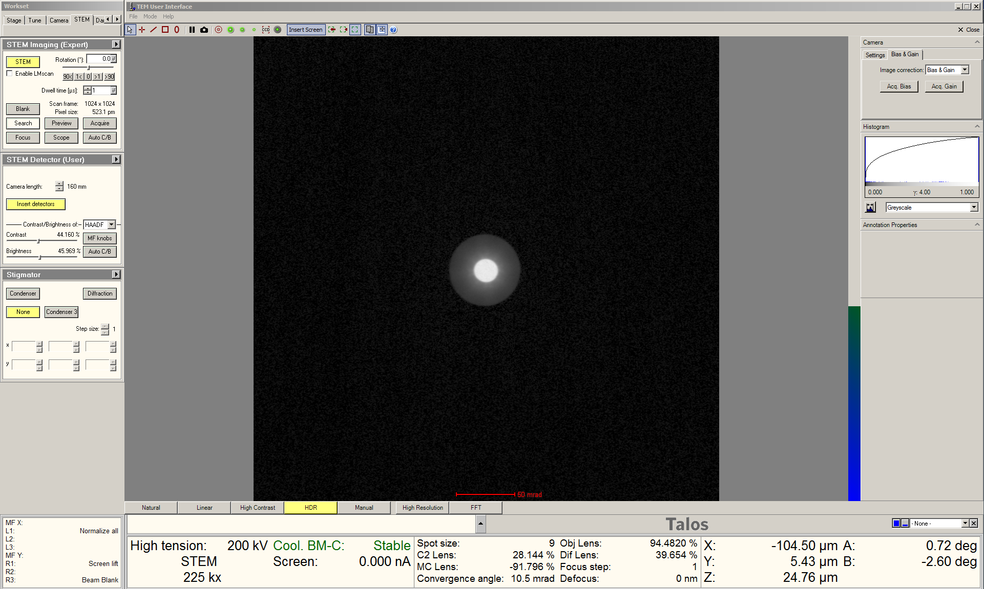

  - If performing TEM imaging, full TEM alignment should be performed; as alignment is very sensitive to the operating mode of the instrument.

    - Remember to use the appropriate FEG register for TEM imaging.

  - If no additional TEM imaging is needed, simply finish the session as per usual (close column valves, reset holder, remove holder, etc).

