
FEI Themis Z S/TEM
  - Microprobe STEM Mode Standard Operating Procedure Rev. 2026-02
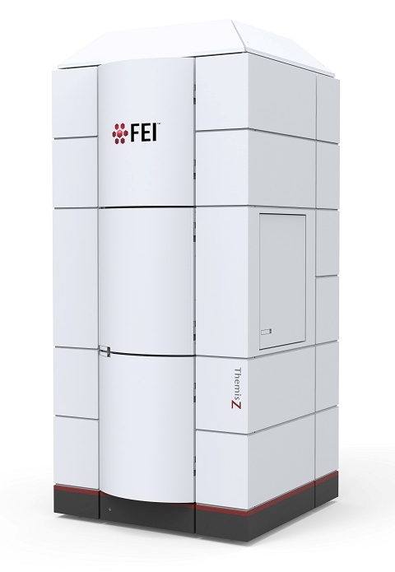
  - Application
The FEI Themis Z S/TEM is a state-of-the-art C_{s} probe-corrected field emission gun scanning/transmission electron microscope capable of providing micro- to pico-scale structural, morphological, magnetic, and chemical information. This document covers operation of the instrument for microprobe scanning mode (μP-STEM) imaging only. Please see separate SOP documents on the NRF instrument page regarding other applications.

  - NRF Contact
Nicholas G. Rudawski

Table of Contents

1. Safety 3
2. Pre-requisites 3
3. Voltage settings 3
4. Scope of use 3
5. Alignments in TEM mode 4
6. Entering μP-STEM mode; selecting beam settings 5
7. Condenser centering (C2/C3 centering) 9
8. Condenser astigmatism correction 13
9. Setting “Eucentric focus” 14
10. Condenser deflector balancing 15
11. Rotation centering 16
12. Setting camera length; diffraction alignment 19
13. μP-STEM imaging in Velox 21
14. Blanking the beam (as needed) 28
15. Fine tuning crystallographic alignment (if needed) 30
16. Finishing in μP-STEM mode 32

- Safety

  - Due to stipulations of the instrument service contract as well as contamination concerns, analysis of radioactive and/or biological specimens with this instrument is strictly prohibited.

- Pre-requisites

  - Extensive familiarity with use of the Microscope Control user interface software and Velox imaging software for TEM imaging.

  - Proficient in independent operation of the FEI Themis Z S/TEM for TEM imaging.

  - Prior experience with use of the Microscope Control user interface software and Velox imaging software for STEM imaging is preferred but not required.

  - NOTE: as per the prerequisites, some associated details and images that could otherwise be included here are omitted for purposes of clarity (“…as per usual”).

- Voltage settings

  - The voltage setting is switched between 200 and 300 kV on an approximately biweekly basis. If wanting to operate the instrument at 60 kV, please contact staff and a week will be reserved for this.

  - As per the TEM mode operation SOP, it should not be necessary to load an alignment file at the start of the session.

- Scope of use

  - In μP-STEM, the probe semi-angle of convergence (α) is very small compared to normal STEM mode operation (as small as ~0.5 mrad); this results in a high depth of field with probe sizes on the order of nm with very small CBED disks. As a result of this, μP-STEM mode is well-suited for imaging samples with a high degree of topographical variation, when nm-scale (or coarser) STEM-EDS or STEM-EELS analysis is needed, and for 4D-STEM analysis requiring large separation of disks in CBED patterns.

- Alignments in TEM mode

  - Navigate to the specimen as per usual; then, retract it from the FOV (if possible).

  - Perform monochromator centering and set the monochromator focus = –40 (negative); as would be the case for normal TEM mode operation.

  - With the C3 lens off, insert and center the desired C2 aperture.

    - On this instrument, if the C2 aperture is properly aligned in TEM mode, it will be properly aligned in μP-STEM mode.

    - The lower limit of possible values for α in μP-STEM mode scales directly with the size of the C2 aperture; if the goal is to obtain the smallest possible value of α, select the smallest C2 aperture.

  - Turn the C3 lens back on.

  - Move the specimen back into the FOV and bring it to eucentric height.

  - If needed, enter diffraction mode and tilt the stage to crystallographically align the area of interest and then re-establish eucentric height.

    - Finer adjustments to the crystallographic alignment can be performed in μP-STEM mode.

  - Verify the objective and SA apertures are both retracted.

  - If possible, retract the specimen from the FOV (again); this will facilitate the initial steps of μP-STEM mode alignment as described subsequently.
- Entering μP-STEM mode; selecting beam settings

  - In Microscope Control, select the “STEM” tab and navigate to the “STEM Imaging” control panel.

    - Select “STEM” to enter STEM mode.

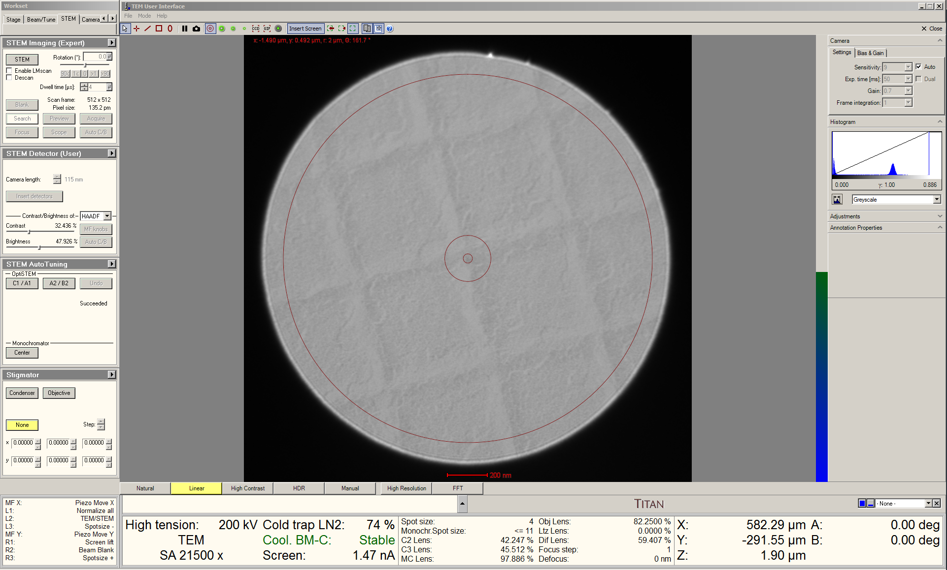

    - Initially, the instrument will be in nanoprobe (normal) STEM mode; this will be subsequently changed to μP-STEM mode.

  - Remain in Microscope Control; select the “Beam/Tune” tab and navigate to the “Beam Settings” control panel.

    - Select “Free Ctrl”; the control panel will flap-out to the right automatically.

    - In the flap-out panel, select the “Microprobe” radio button to switch to μP-STEM mode.

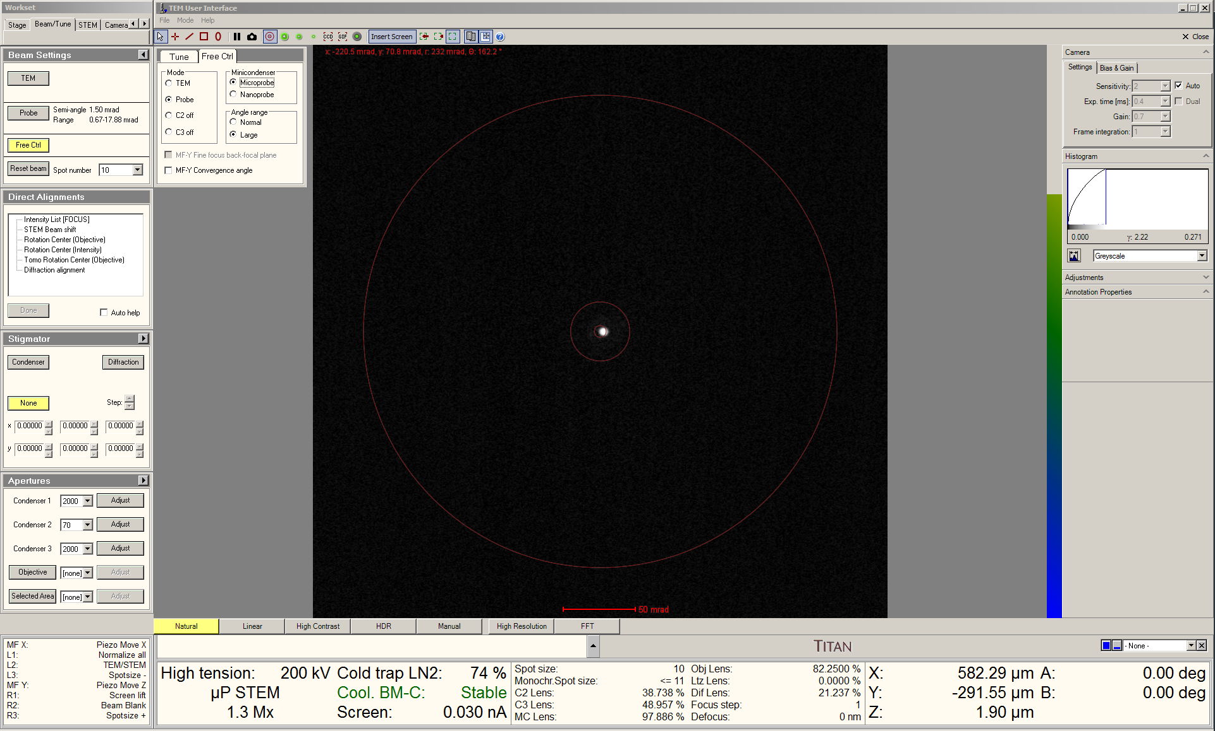

  - Remain in the “Free Ctrl” tab; check the box next to “MF-Y Convergence Angle”.

    - Use the “Multifunction” (MF) Y knob to set the indicated value of α as desired within the range specified in the “Beam Settings” control panel.

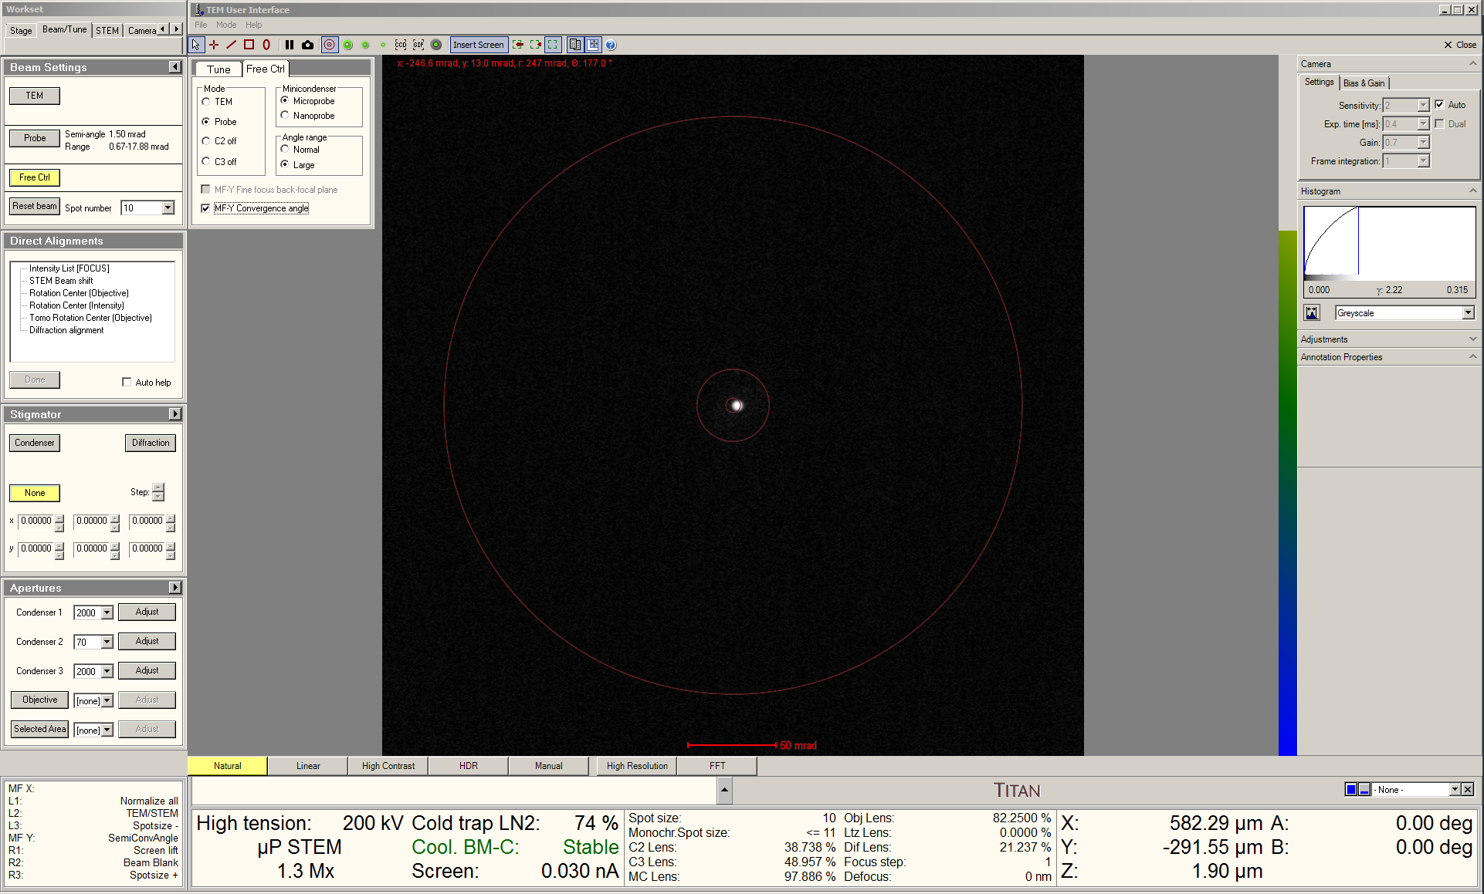

    - NOTE: the lower limit for the indicated value of α is dictated by the size of the C2 aperture; for the 70, 50, and 20 μm C2 apertures, this is 0.67, 0.48, and 0.19 mrad, respectively.

    - NOTE: the actual value of α is approximately 2× the indicated value; e.g., an indicated value of α = 0.5 mrad yields and actual value of α ~ 1.0 mrad.

  - Remain in the “Beam Settings” control panel and set “Spot Number” as desired.

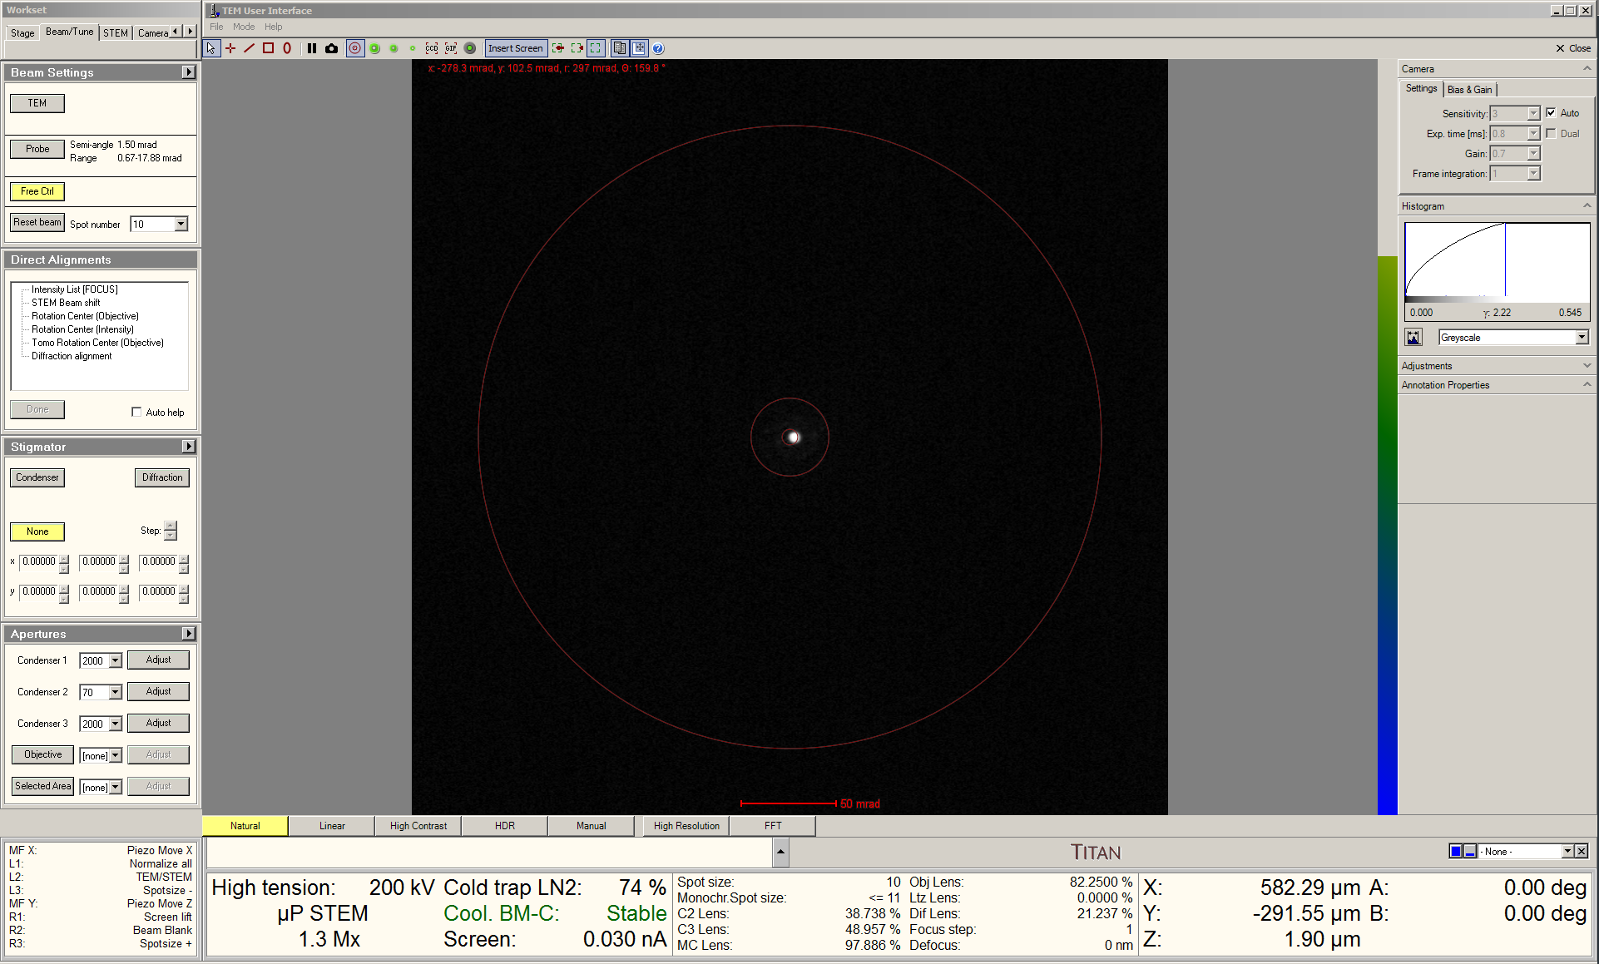

  - NOTE: if intending to collect a 4D-STEM dataset with the EMPAD, the probe current must be set such that saturation does not occur based on the actual value of α and the indicated camera length used for acquisition; see separate the SOP covering EMPAD operation for more details.

- Condenser centering (C2/C3 centering)

  - In Microscope Control, set the indicated magnification ≥ 1M×.

  - In Velox Acquisition, select “HAADF” from the toolbar to start live STEM imaging.

    - Right click on the beam position marker and select “Center beam”.

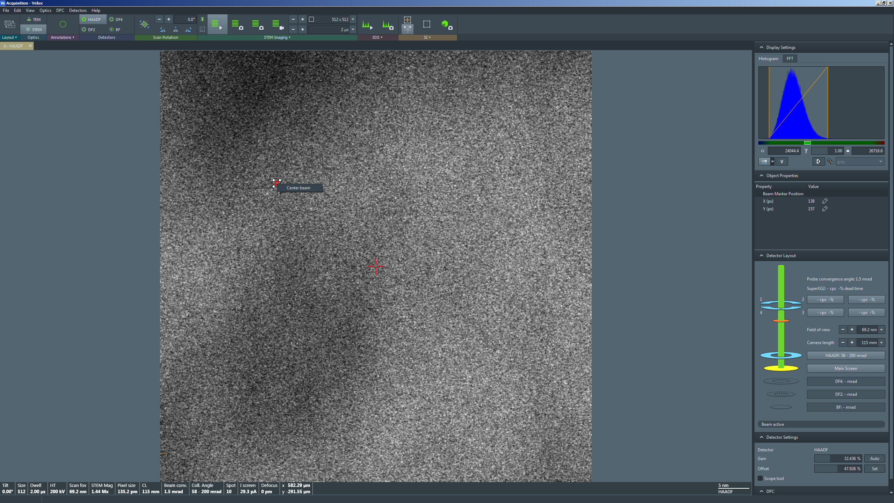

    - After verifying the beam position marker is centered in the STEM image, select “HAADF” from the toolbar again to stop live STEM imaging and retract the HAADF detector.

  - Select “Diffraction” on the right-hand (RH) control panel to switch the projection system from diffraction to SA (imaging) mode.

  - In Microscope Control, set the indicated magnification = 44000×.

  - Select the “Beam/Tune” tab and navigate to the “Direct Alignments” control panel.

    - Select “Beam shift” and use the “MF” knobs to center the probe; do not use the trackball to shift the beam.

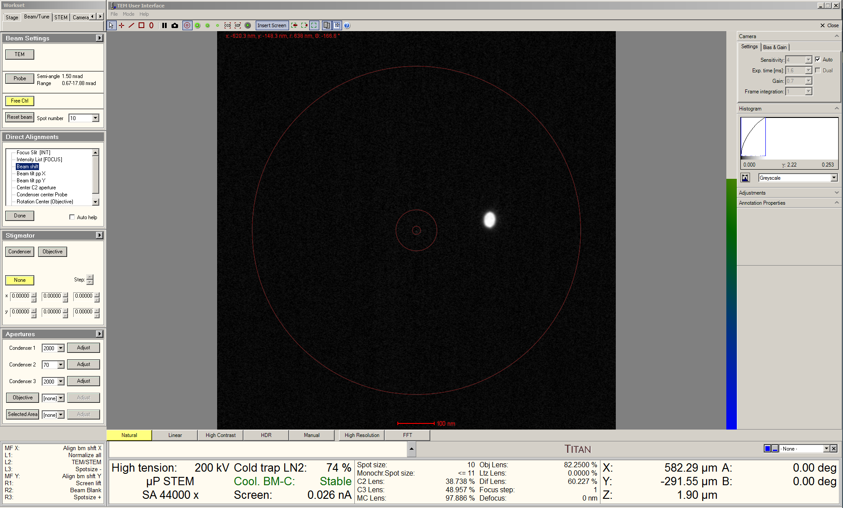

    - Feel free to turn the FluCam screen markings on and off as needed to aid with this and future alignment steps.

    - If needed, use the “Focus” knob to coarsely focus the probe.

    - Return to the “Direct Alignments” control panel and select “Condenser center Probe”; the beam will start expanding/contracting.

    - Turn the ring on the “Focus” knob counterclockwise to reduce the limits of expansion and contraction.

    - Adjust the “MF” knobs so the beam expands and contracts concentrically.

    - NOTE: the beam may shift while performing this alignment; if it stays within the viewable area of the FluCam, this is otherwise not of concern

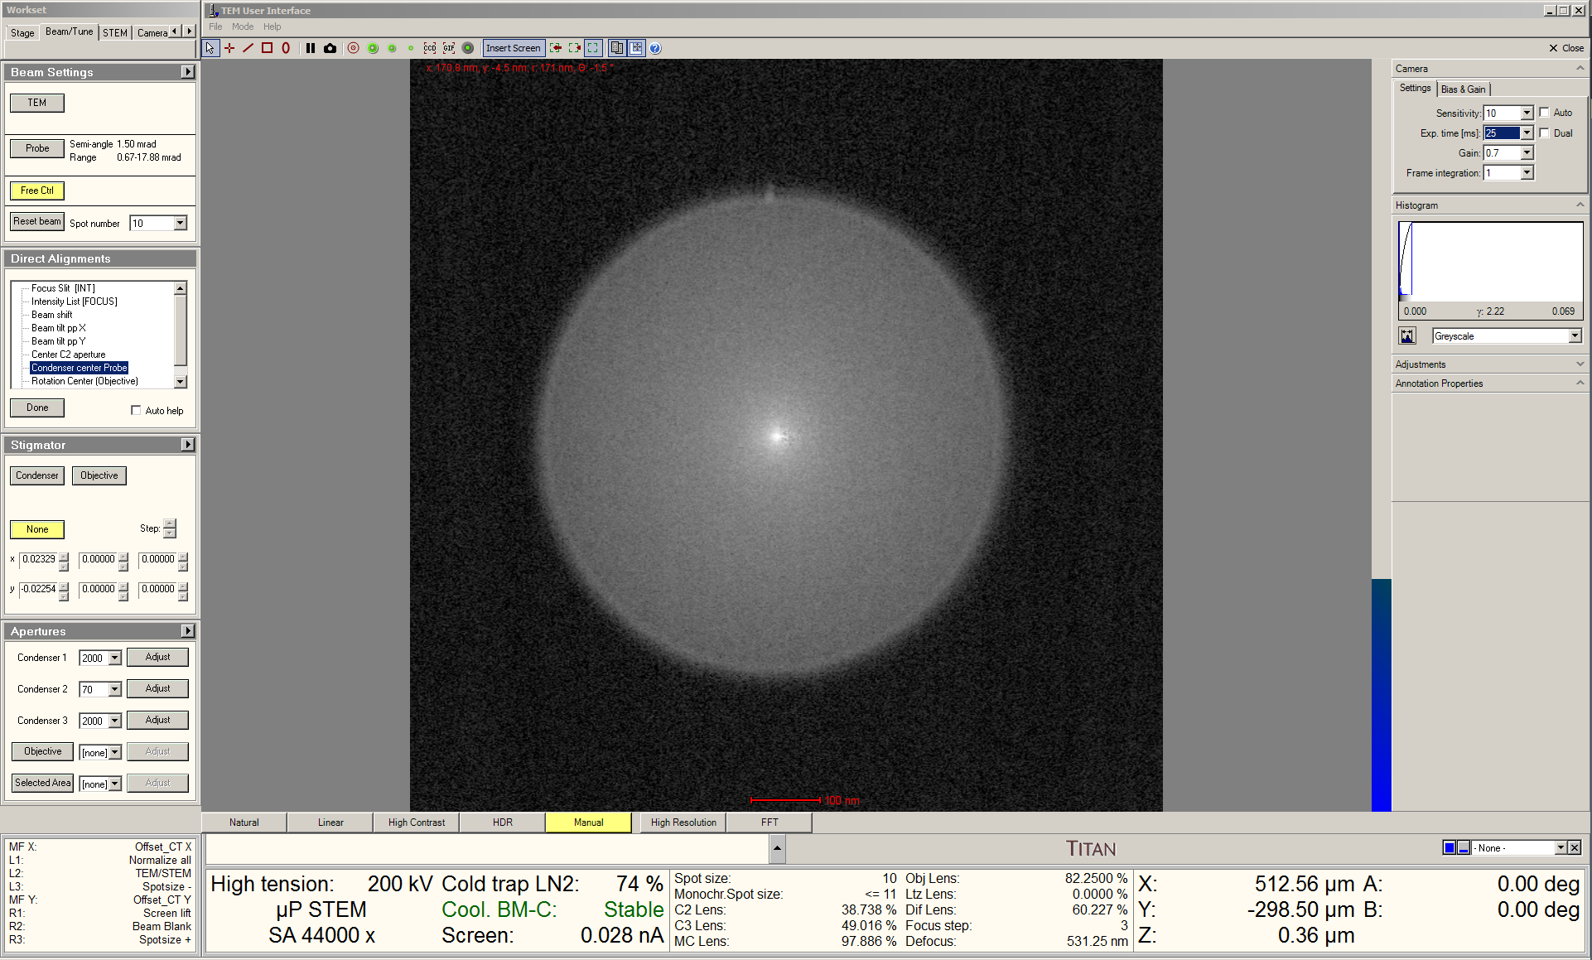

    - If the response of the FluCam is not fast enough, the exposure time can be manually reduced by unchecking the “Auto” box and then selecting a smaller value under “Exp time”.

    - When finished, return to the “Direct Alignments” control panel and select “Beam shift” to recenter the beam as described previously.

- Condenser astigmatism correction

  - In Microscope Control, set the indicated magnification = 380 k×.

  - Use the “Focus” knob to focus the probe as precisely as possible.

  - Navigate to the “Stigmator” control panel and select “Condenser”.

    - Use the “MF” knobs to remove 2-fold astigmatism and make the probe circular.

    - Use the “Focus” knob to slightly defocus the probe as needed to aid in detecting any remaining astigmatism.

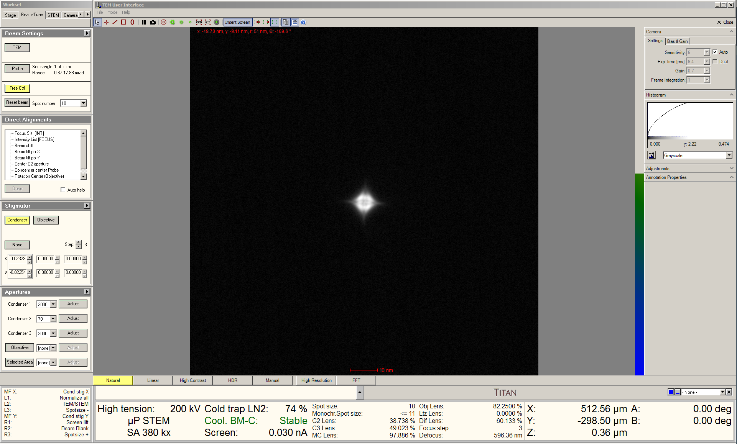

- Setting “Eucentric focus”

  - Remain in the “Beam/Tune” tab and navigate to the “Direct Alignments” control panel.

  - Select “Intensity List [FOCUS]”

    - Use the “Focus” knob (coupled to C3) to focus the probe as precisely as possible.

    - Setting the FluCam to “Natural” mode and then manually increasing the histogram white level can aid with this; the FluCam mode will then switch to “Manual”.

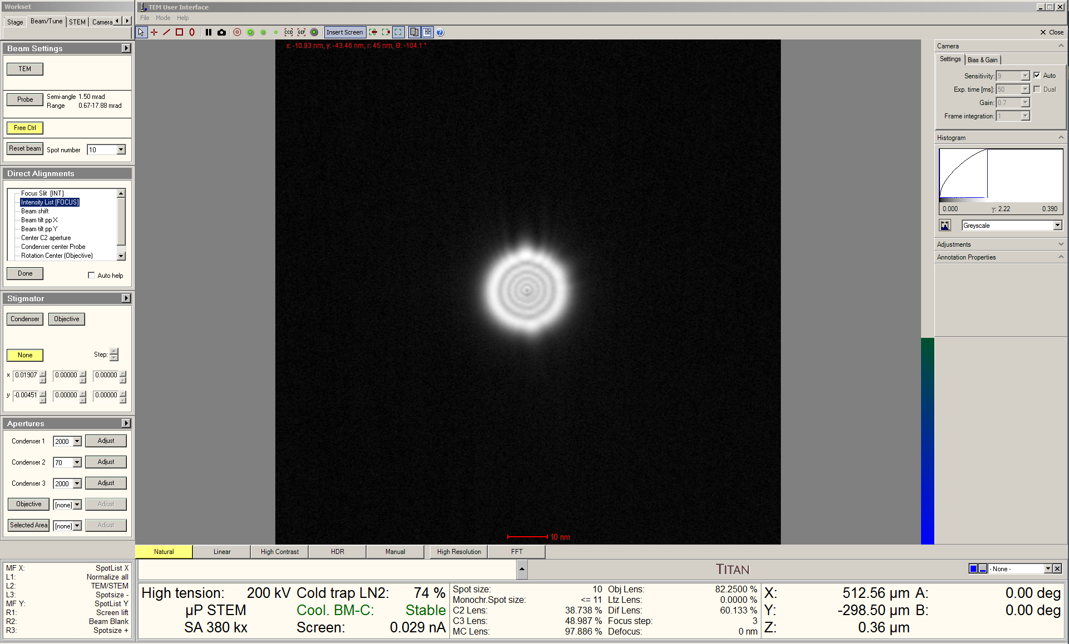

    - This setting for the C3 lens is now stored for “Eucentric focus” for the chosen spot number.

- Condenser deflector balancing

  - Remain in the “Beam/Tune” tab and navigate to the “Direct Alignments” control panel.

    - Select “Beam tilt pp X”.

    - Use the “MF” knobs to make the bright tips of the two “wings” touch.

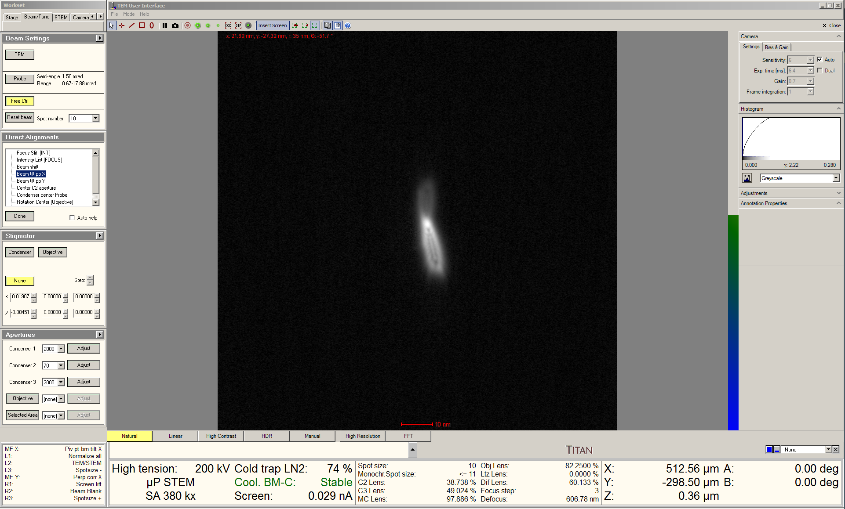

    - NOTE: as the indicated value of α decreases, the wings will become smaller and less evident; when this occurs, simply overlap the two beams.

    - Select “Beam tilt pp Y” and repeat the same process.

    - As needed, return to the “Direct Alignments” control panel and select “Beam shift” to recenter the beam as described previously.
- Rotation centering

  - In Microscope control, set the indicated magnification =-185 k×.

  - Use the joystick to move the specimen back under the probe.

  - Use the down “Z axis” button on the RH control panel to move the specimen down and produce an overfocus condition; this will result in a diffuse halo of intensity surrounding the probe.

    - If the specimen is crystalline, a diffraction pattern may also be evident.

    - Setting the FluCam display to HDR and manually increasing the value for “Exp time” can aid in visibility of the halo.

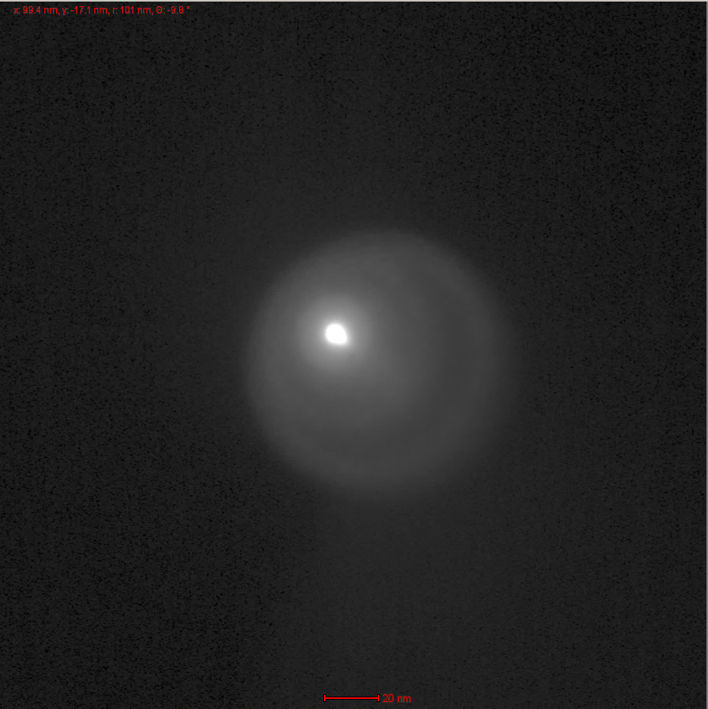
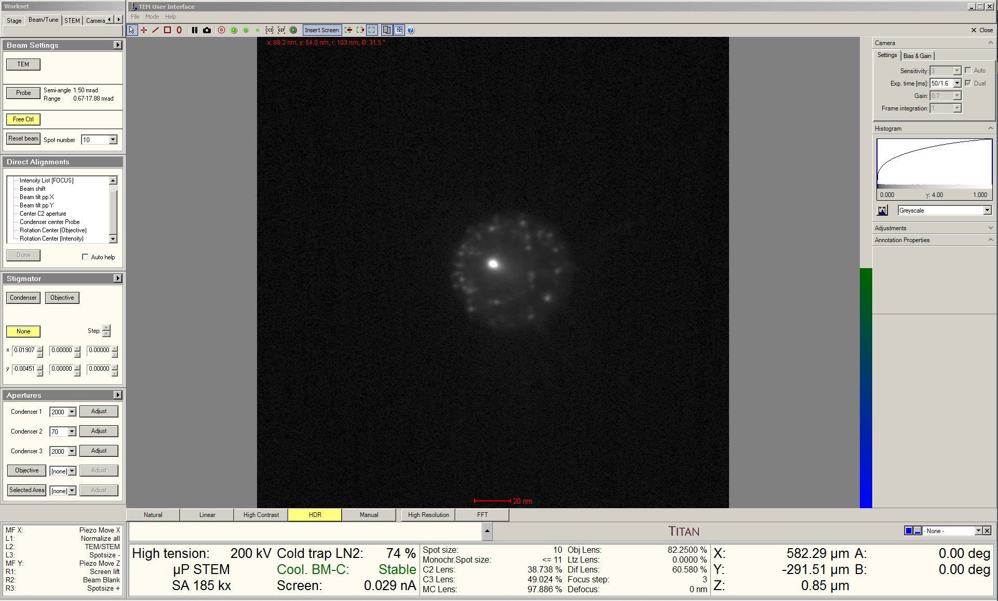

  - Remain in the “Beam/Tune” tab and navigate to the “Direct Alignments” control panel.

    - Select “Rotation Center (Intensity)”.

    - Turn the ring on the “Focus” knob counterclockwise to stop any oscillation of the beam.

    - Use the “MF” knobs to center the probe inside the diffuse halo.

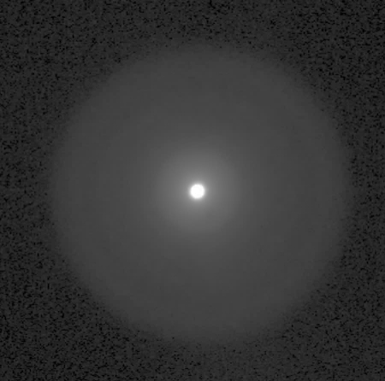
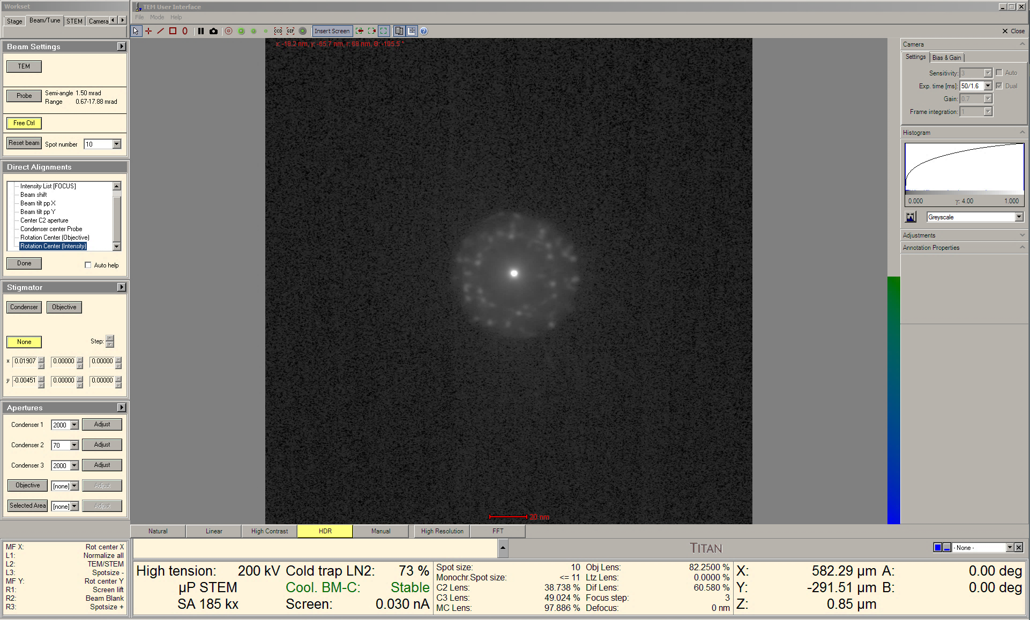

    - When finished, use the “Z axis” buttons on the RH control panel to collapse the halo around the probe to as small as possible.

    - When starting STEM imaging, this will result in the image being very close to optimal focus.

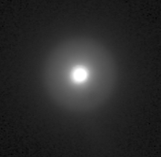
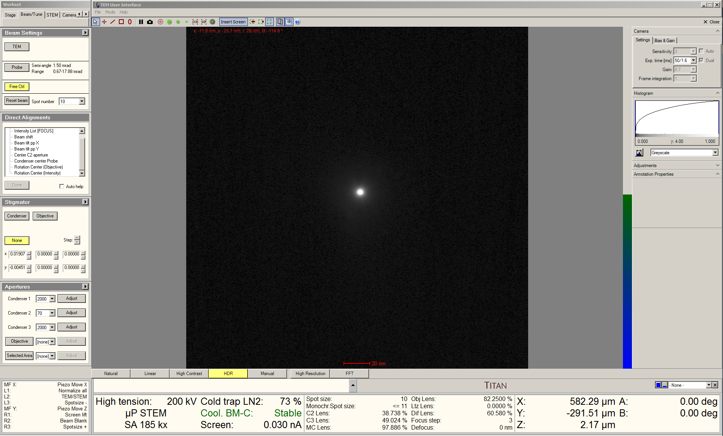

  - Select “Diffraction” on the RH control panel to switch the projection system back to diffraction mode for STEM imaging.

- Setting camera length; diffraction alignment

  - In Velox Acquisition, select “HAADF” from the toolbar to start live STEM imaging (512×512 resolution).

  - In the “Detector Layout” side panel, set “Camera length” = 115 mm (suitable for HAADF-STEM imaging).

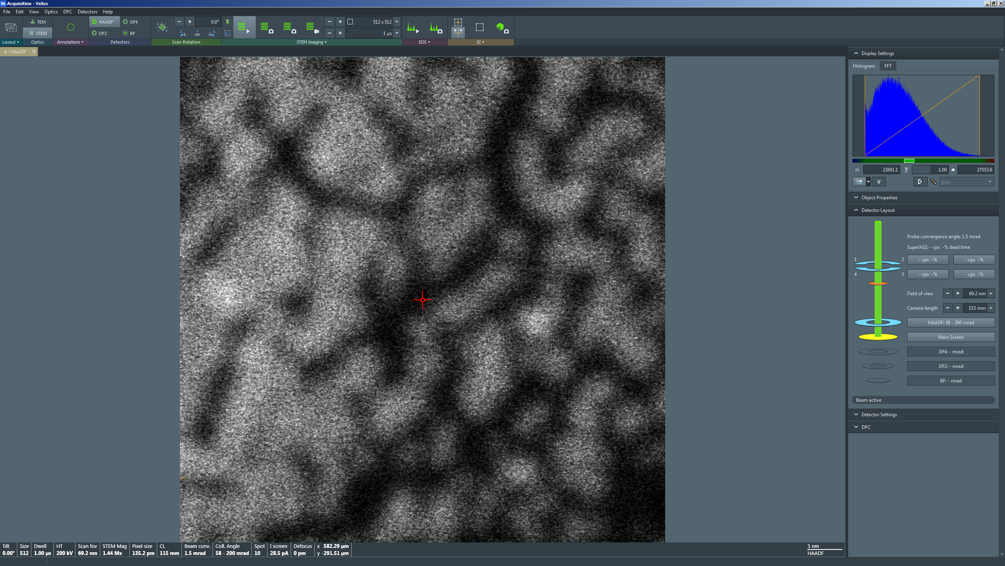

  - In Microscope Control, select the “Beam/Tune” tab and navigate to the “Direct Alignments” control panel.

    - Select “Diffraction alignment”.

    - Use the “MF” knobs to center the direct disc of the CBED pattern inside the inner rim of the HAADF detector (indicated by arrow).

    - Setting the FluCam display to HDR and manually increasing the value for “Exp time” can aid with visibility.

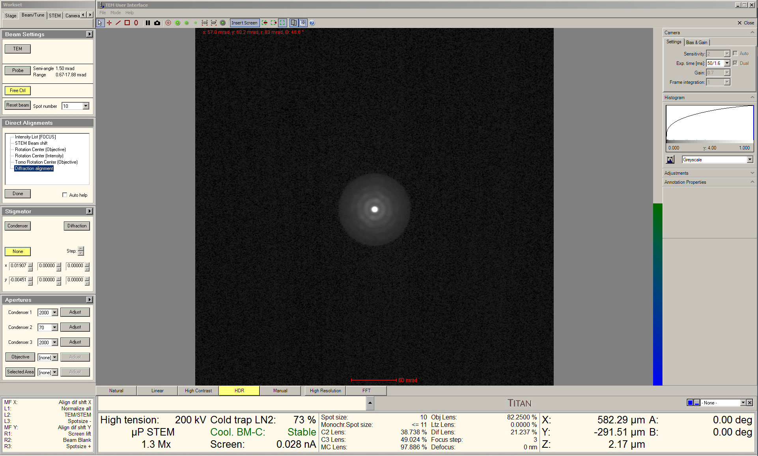
- μP-STEM imaging in Velox

  - Return to Velox Acquisition; while live imaging, adjust the dwell time on the toolbar as needed.

    - Shorter dwell times (1 – 2 µs) tend to work better for navigating around the specimen.

    - Longer dwell times (≥10 µs) tend to work better for focusing, fine astigmatism correction, image rotation, and detector gain/offset adjustments.

  - To properly set the detector gain and offset; navigate to the “Display Settings” side panel and select “Histogram” to see the image histogram.

    - Navigate to the “Detector Settings” side panel and adjust “Gain” and “Offset” until the range marker under the image histogram takes up approximately the middle of the dynamic range.

    - NOTE: optimal gain and offset settings will depend on focal state, contents of the field of view, and dwell time; the gain and offset must therefore be adjusted as needed.

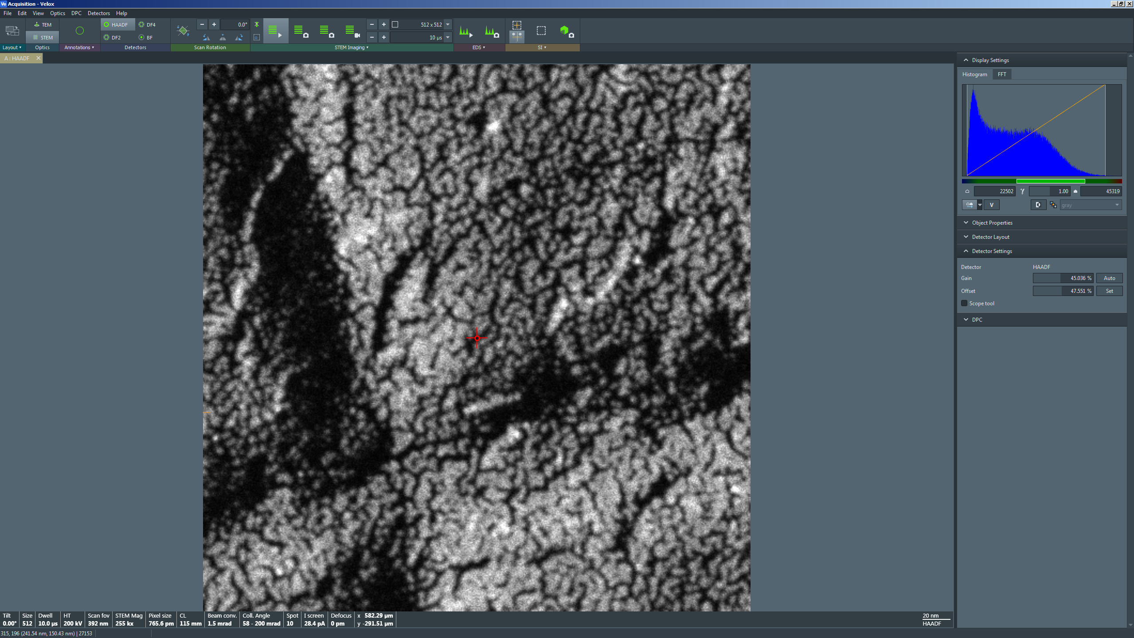

  - From the toolbar, adjust “Scan Rotation” to rotate the live STEM image as needed.

    - NOTE: scan rotation adjustments tend to be more accurate when 1) specimen drift is minimal and 2) the dwell time is ≥ 10 µs in the live image.

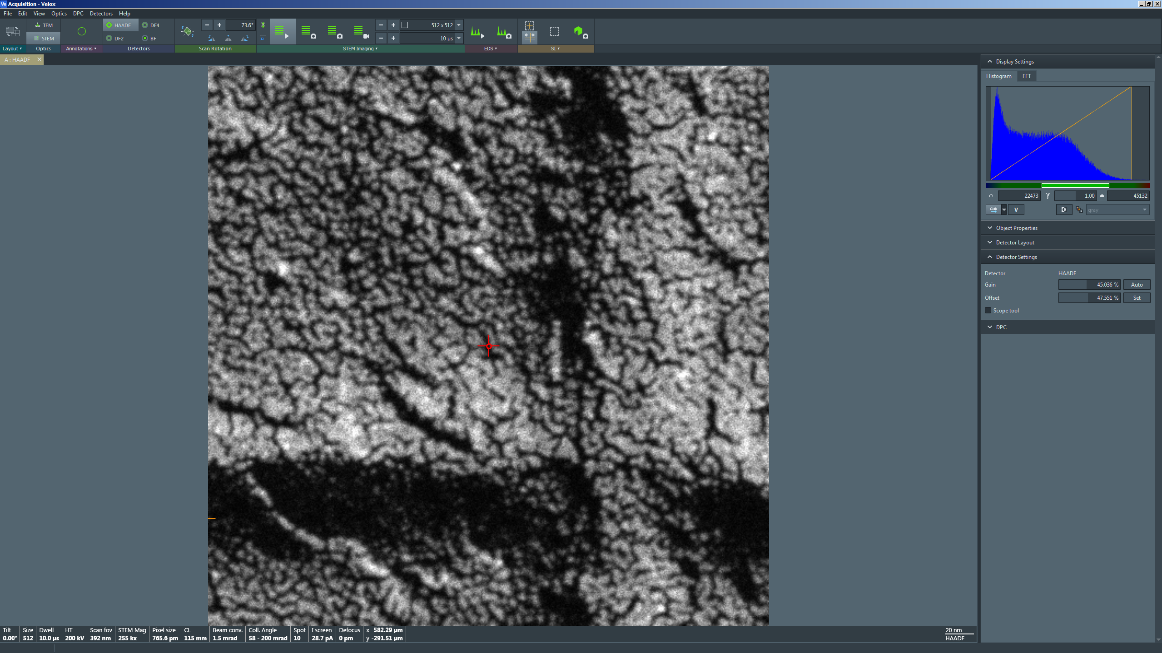
  - To fine tune the focus and correct any remnant astigmatism, use the joystick to center a region of the specimen with very fine features (e.g. protective Pt grains) in the STEM image.

    - Use the “Magnification” knob to set the indicated magnification in Microscope Control ≥ 450 k×.

    - Select “Reduced Area” from the toolbar to open a reduced area scan window in the live STEM image (indicated by arrow); adjust/position the box as needed.

    - Set the dwell time ≥10 µs; NOTE: the dwell time for the reduced area may be set differently than the dwell time for the full frame.

    - Use the “Focus” knob to (finely) focus the image as best as possible and note the presence of any streaking (astigmatism).

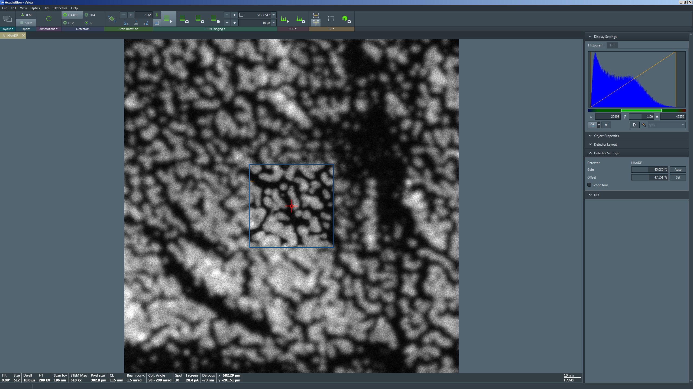
  - In Microscope Control, return to the “Beam/Tune” tab and navigate to the “Stigmator” control panel.

    - Select “Condenser”.

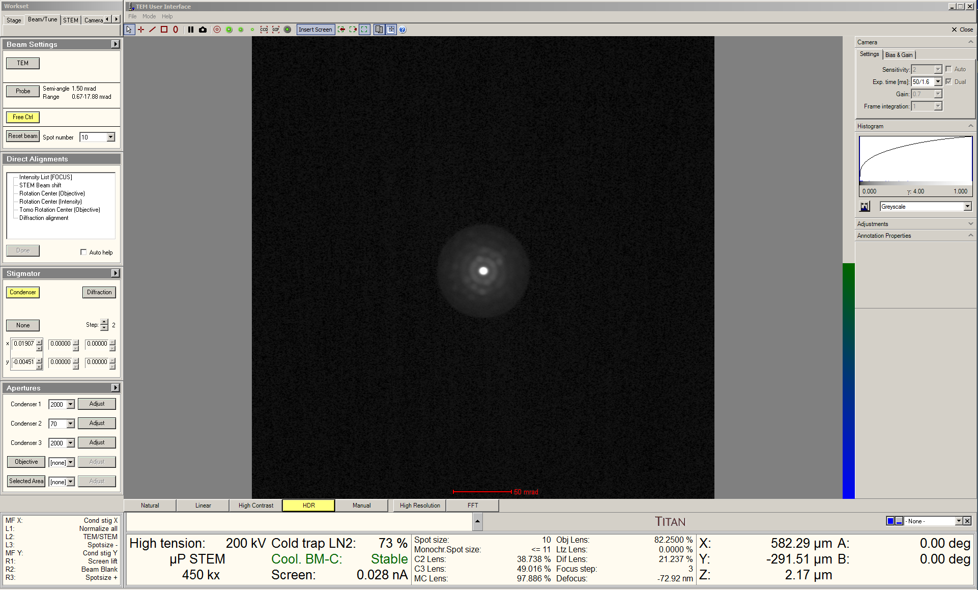

    - Navigate back to Velox Acquisition; use the “MF” knobs to make the STEM image as sharp as possible.

    - After correcting the astigmatism, finely focus the image with the “Focus” knob.

    - When ready, select “Reduced Area” from the toolbar to resume full frame imaging.

  - When ready to acquire the final image, use the joystick to center the region of interest in the live image.

    - Use the “Magnification” knob to set the indicated magnification higher than will be used for final image acquisition (not shown).

    - Use the “Focus” knob (along with the “Reduced Area” window, as needed) to finely focus the image (not shown).

    - NOTE: if the alignment was done properly and the sample properly brought into focus by first by adjusting the “Z axis” buttons and then by finely adjusting the “Focus” knob, “Defocus” should be within ± a few hundred nm.

    - Use the “Magnification” knob to set indicated magnification as needed for the final image (not shown).

    - In Velox Acquisition, select “Acquire” from the toolbar to capture the final STEM image (1024×1024 resolution with dwell time = 10 µs).

    - If either the pixel dimensions or dwell time are adjusted before acquisition is completed, a new acquisition will start with the adjusted parameters.

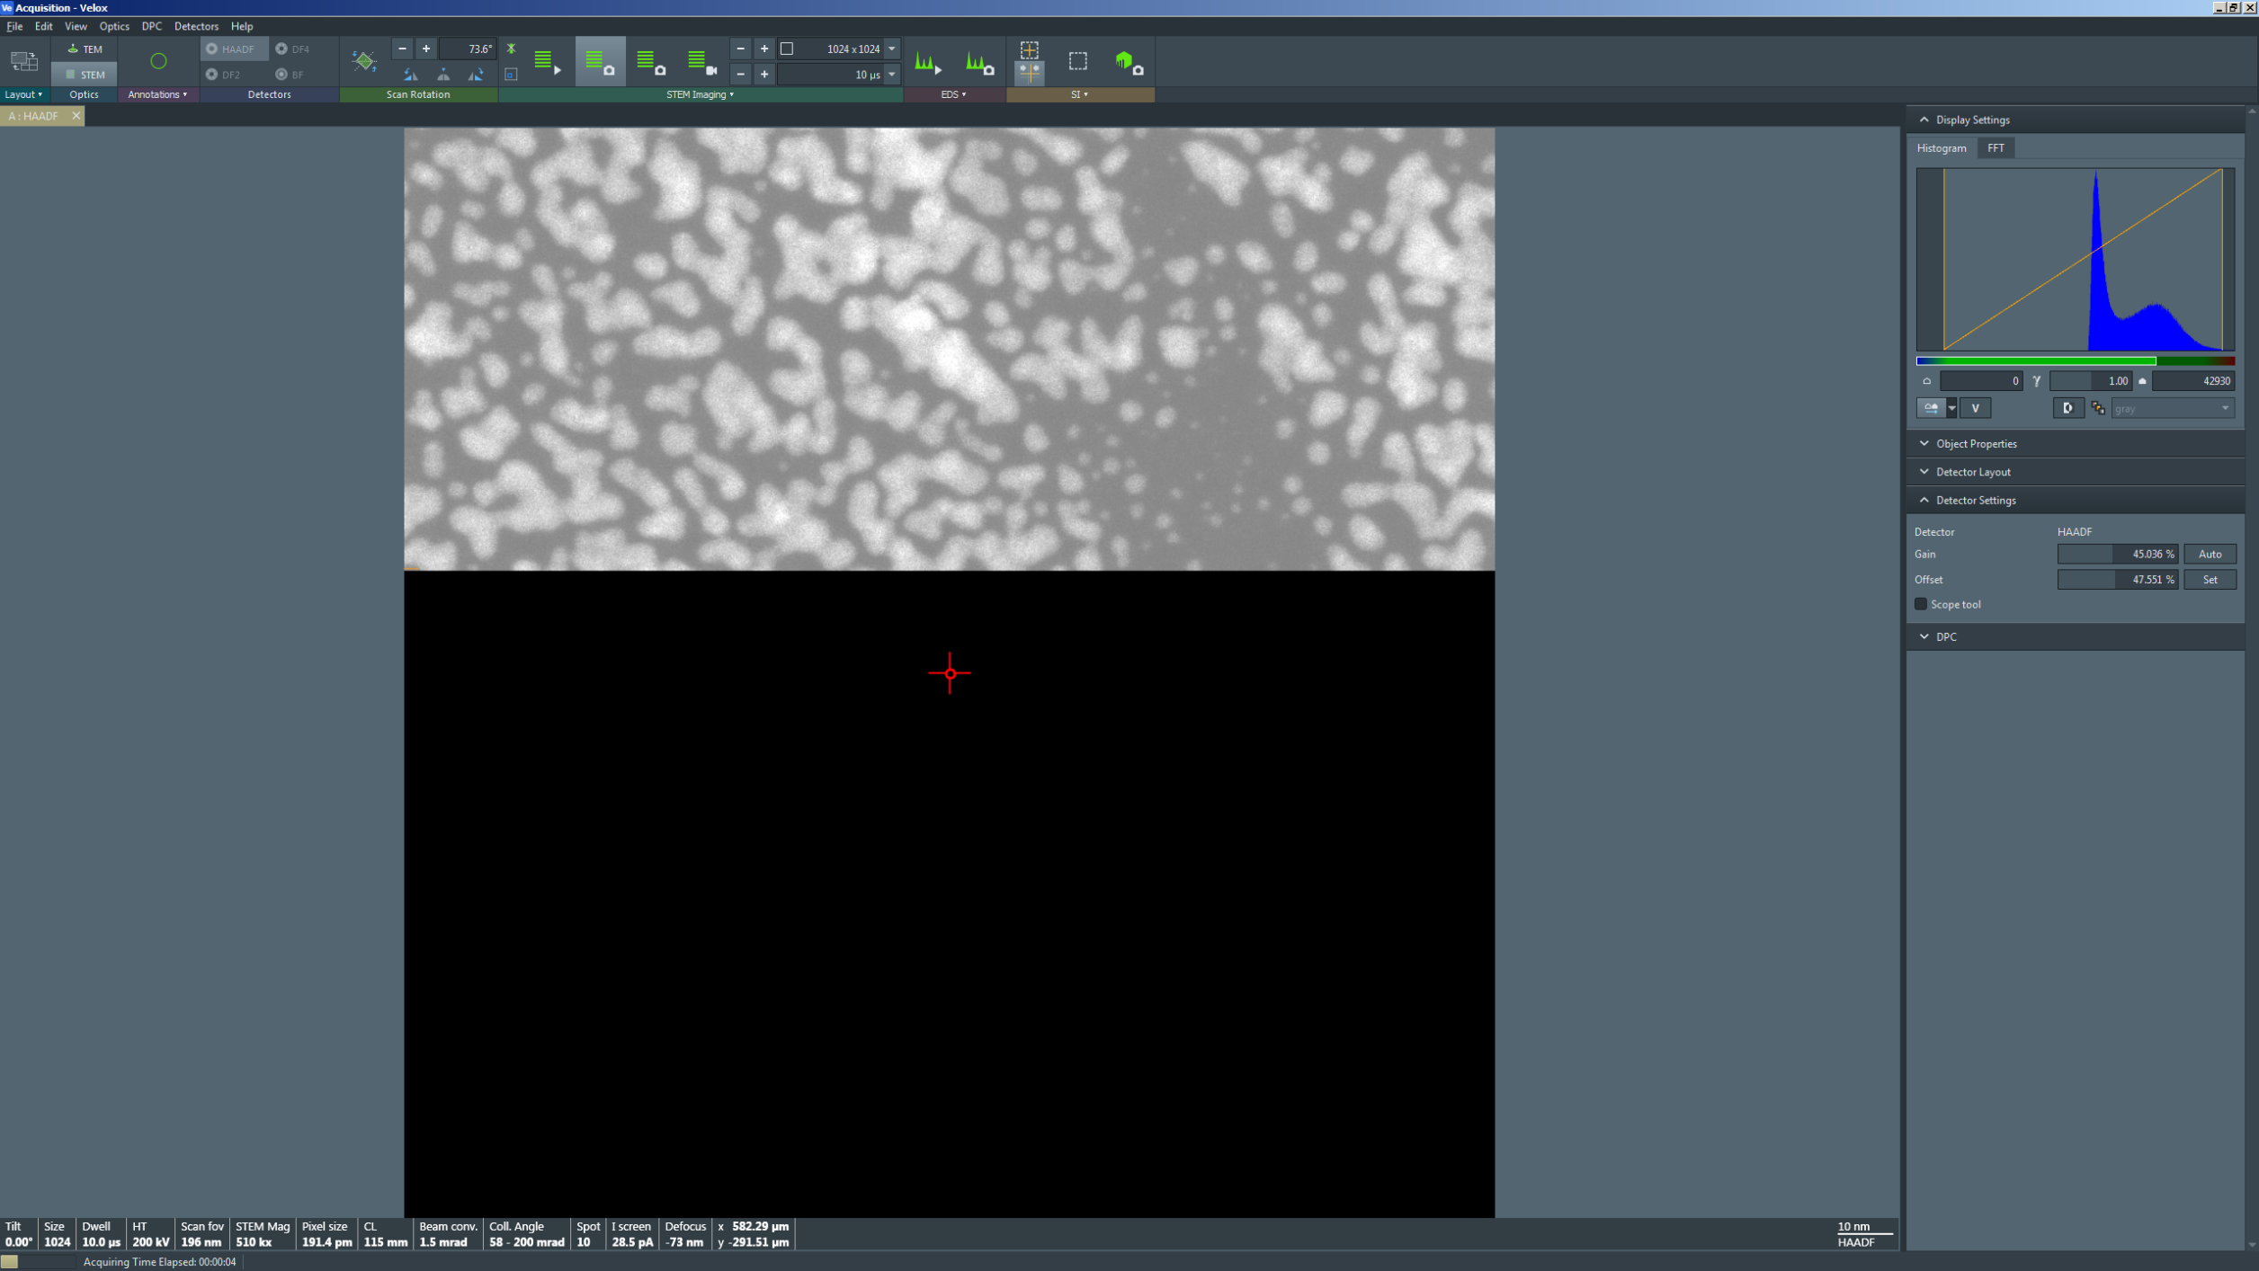

- Blanking the beam (as needed)

  - If it is necessary to leave the instrument for only a few minutes, it is best practice to blank the beam to minimize specimen irradiation.

    - If it is necessary to leave the instrument for more than a few minutes, it is best practice to close the column valves (not shown).

  - In Velox Acquisition, select “Beam Blank” from the toolbar to blank the beam (the live image will continue, but will be only noise).

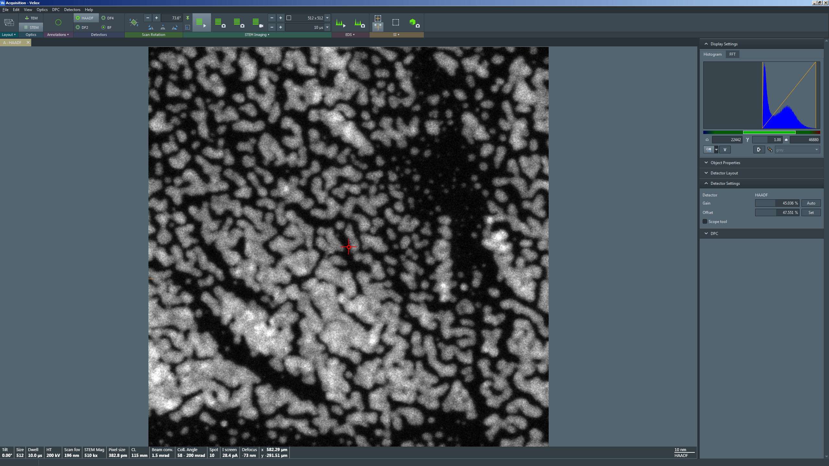

  - When ready to un-blank the beam, simply select “Beam Blank” from the toolbar and the live image will reappear in Velox.

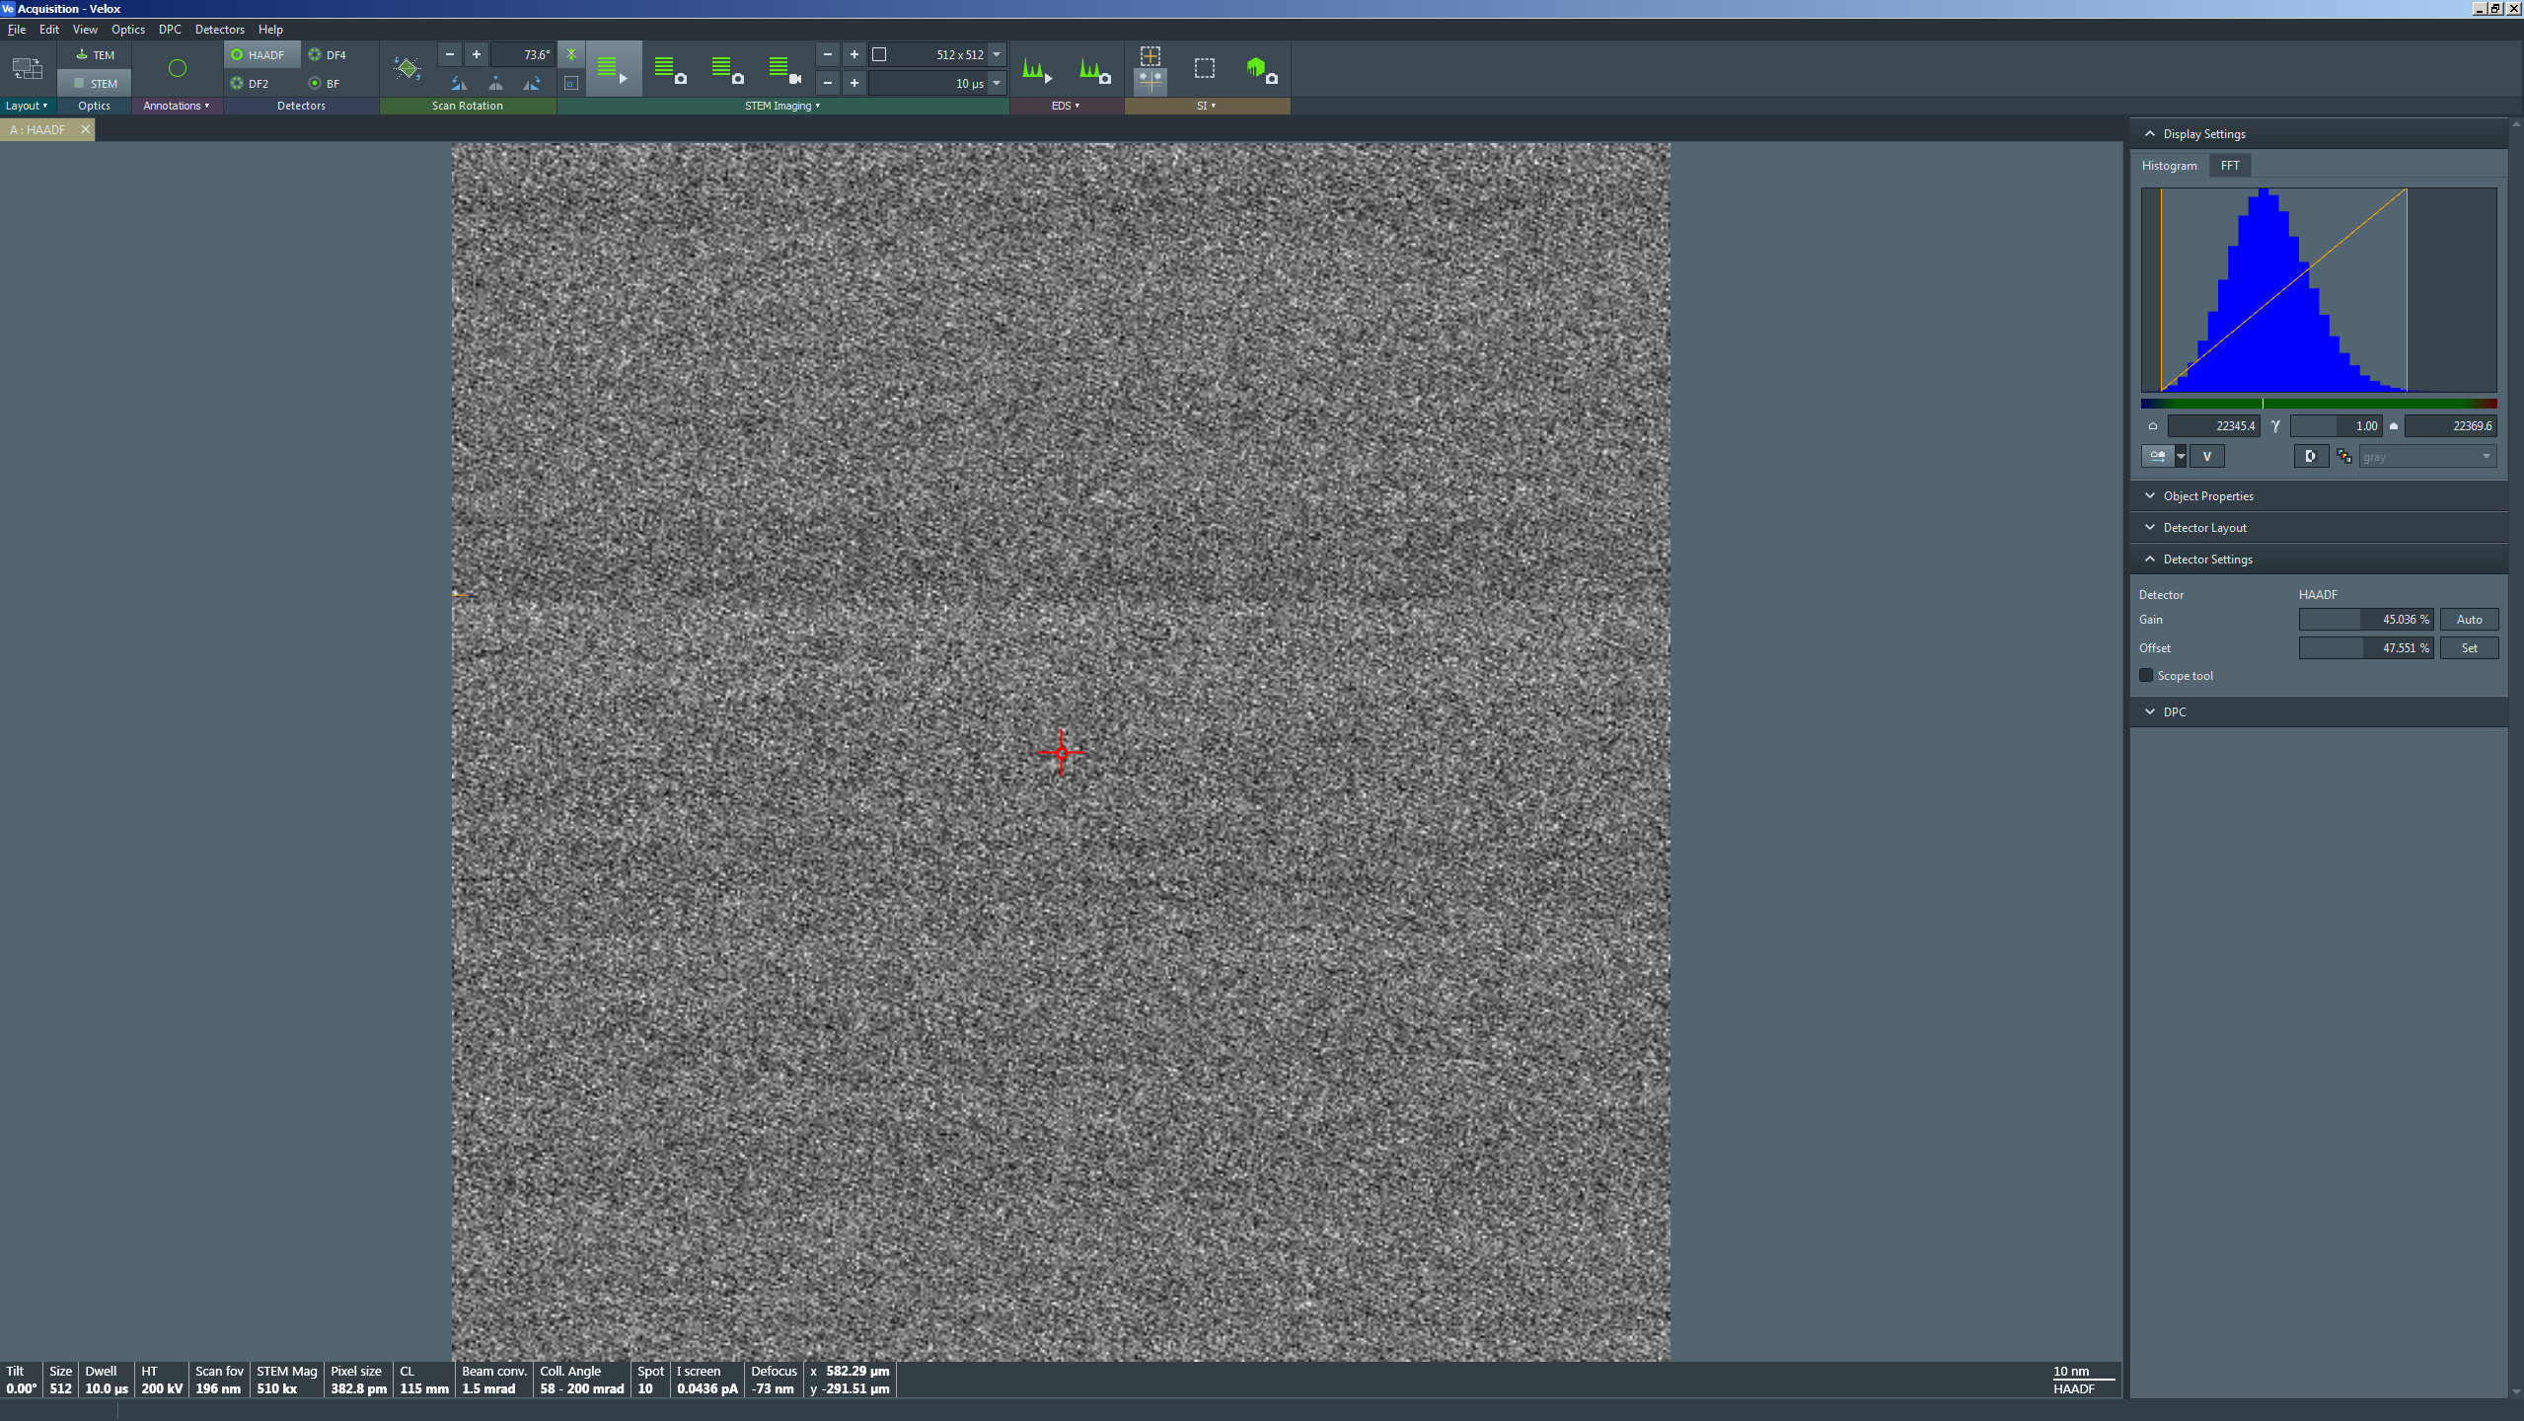

- Fine tuning crystallographic alignment (if needed)

  - In Velox acquisition, center the region of interest in the live STEM image and place the reduced area scanning window within it; observe the CBED pattern on the FluCam.

  - Make an appropriate change to either the α or β tilt based on the observed CBED pattern and the zone axis tilt map below.

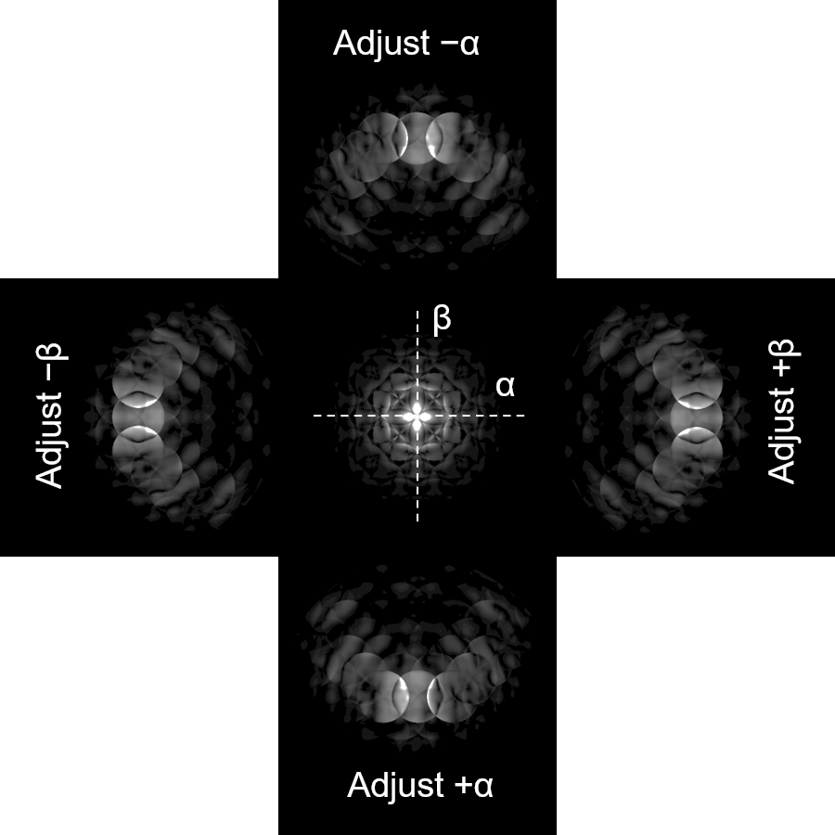

  - Resume full frame imaging in Velox acquisition, recenter the region of interest in the image, center the beam position marker (if not already centered), select “HAADF” from the toolbar to stop live imaging and retract the HAADF detector

  - Select “Diffraction” on the RH control panel to switch the projection system from diffraction to imaging mode; in Microscope Control, set the indicated magnification as needed.

  - Use the “Z axis” buttons on the RH control panel to collapse the diffraction pattern as described previously to refocus the STEM image.

  - Select “Diffraction” on the RH control panel to switch the projection system from imaging back to diffraction.

  - In Velox acquisition, select “HAADF” from the toolbar to resume live STEM imaging.

  - As done previously, center the region of interest in the live STEM image, place the reduced area scanning window within it, and observe the CBED pattern on the FluCam (it should now be closer to the zone axis).

  - Repeat the previous steps iteratively until satisfactory zone axis alignment is achieved for the region of interest.

- Finishing in μP-STEM mode

  - In Velox Acquisition:

    - Verify “Beam Blank” from the toolbar is not activated (the beam is not blanked).

    - If needed, set “Scan Rotation” = 0° in the toolbar.

  - In Microscope Control, select the “Beam/Tune” tab and navigate to the “Beam Settings” control panel.

    - Select “Probe” to return the instrument to normal STEM mode operation.

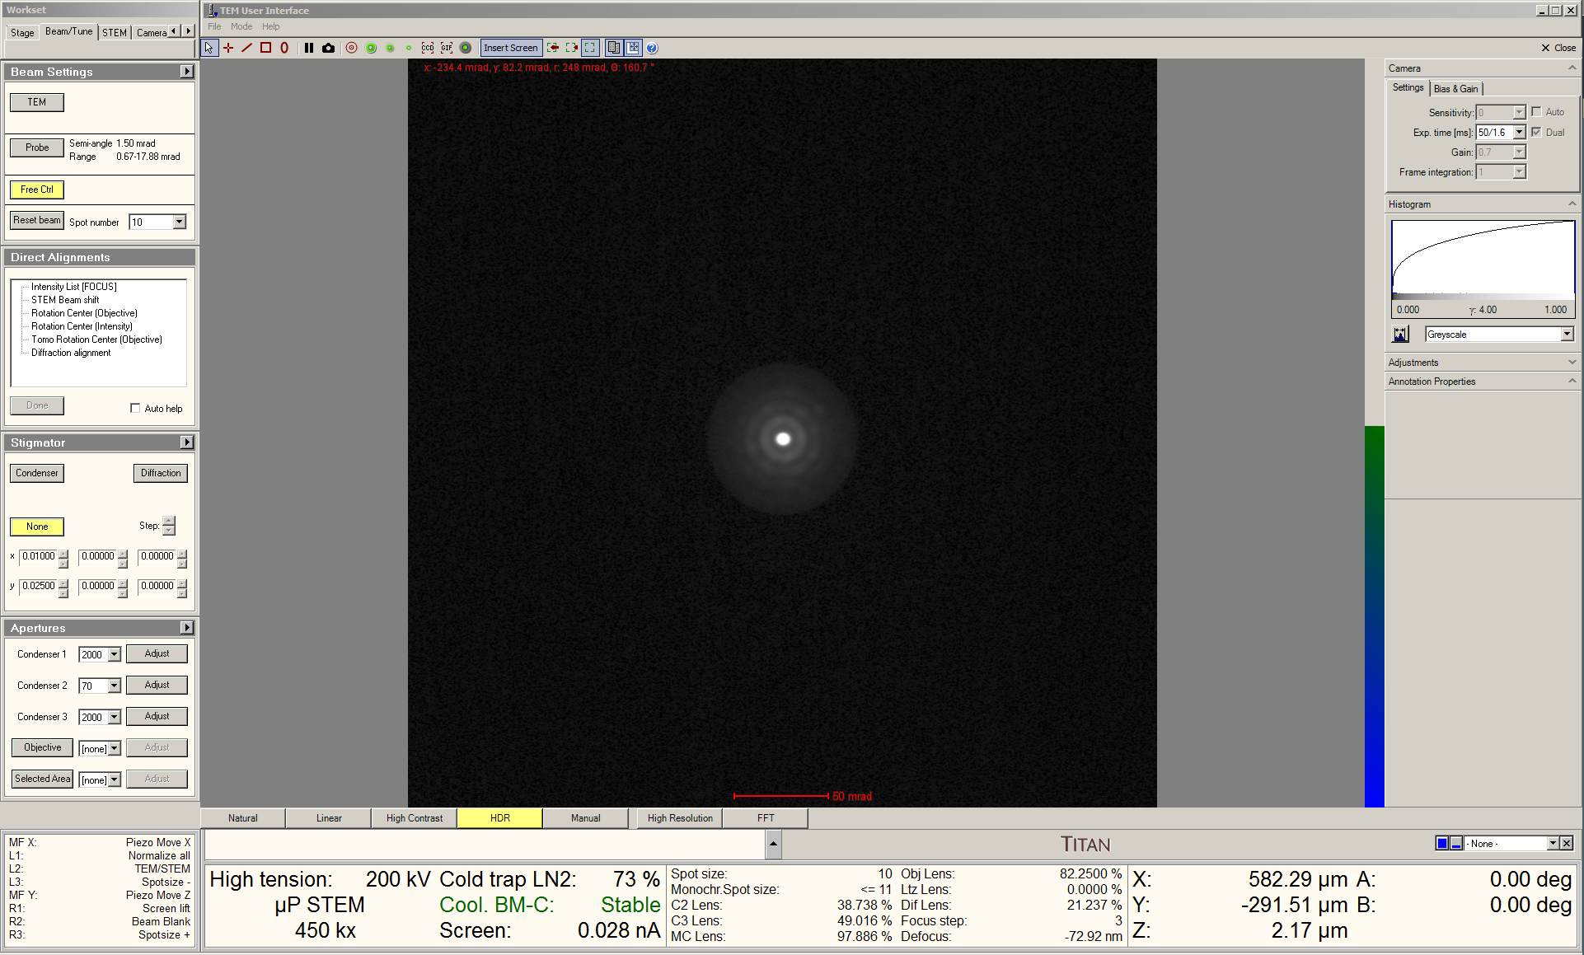

  - In Microscope Control, select the “STEM” tab and navigate to the “STEM Imaging” control panel.

    - Select “STEM” to exit STEM mode and enter TEM mode; the live STEM image will stop and the HAADF detector will retract automatically.

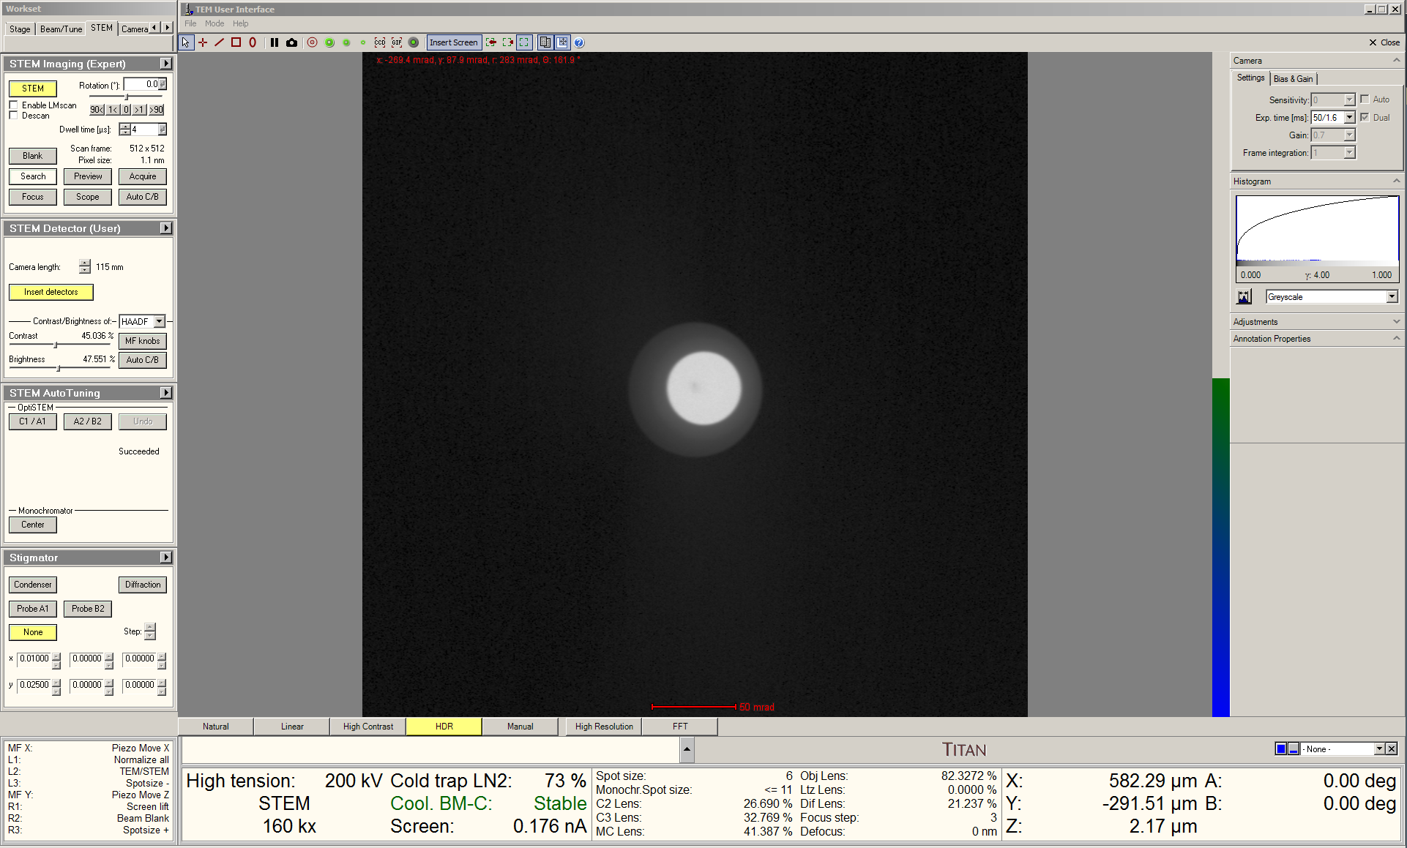

  - If needing to perform TEM imaging, full TEM alignment should be performed as described elsewhere.

  - If no additional TEM imaging is needed, simply finish the session as per usual (close column valves, reset holder, remove holder, etc).

