
FEI Themis Z S/TEM
  - Electron microscope pixel array detector (EMPAD) Standard Operating Procedure Rev. 2026-01
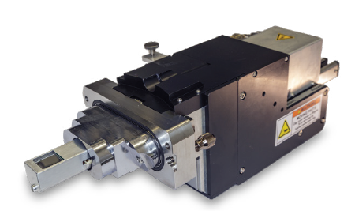

  - Application
The FEI Themis Z S/TEM is a state-of-the-art C_{s} probe-corrected field emission gun scanning/transmission electron microscope capable of providing micro- to pico-scale structural, morphological, magnetic, and chemical information. This document covers operation of the instrument for collecting 4D-STEM datasets using the electron microscope pixel array detector (EMPAD). Please see separate SOP documents on the NRF instrument page regarding other applications including C_{S}-corrected STEM (AKA “STEM”) and microprobe STEM (μP-STEM) mode operation.

  - NRF Contact
Nicholas G. Rudawski

Table of Contents

1. Safety 3
2. Pre-requisites 3
3. Voltage settings 3
4. Scope of use 3
5. Considerations for using STEM mode 4
6. Considerations for using μP-STEM mode 4
7. Setting up the STEM image 6
8. Starting the EMPAD 7
9. Background collection 10
10. Centering CBED patterns on the EMPAD 11
11. Search scan settings 13
12. Virtual STEM detector settings 15
13. Fine tuning (as needed) 17
14. Acquiring a 4D-STEM dataset 18
15. Finishing with the EMPAD 21
16. Locating and transferring datasets 22

- Safety

  - Due to stipulations of the instrument service contract as well as contamination concerns, analysis of radioactive and/or biological specimens with this instrument is strictly prohibited.

  - The EMPAD is radiation hard and very robust to high intensity electron irradiation so there is very little concern about damaging it during operation; that being said, it is still critical to stay at or below the threshold of 2 pA/pixel as this will avoid clipping the 32-bit dynamic range of the detector (discussed subsequently in greater detail).

- Pre-requisites

  - Extensive familiarity with use of the Microscope Control user interface software and Velox imaging software for STEM imaging.

  - Proficient in independent operation of the FEI Themis Z S/TEM for imaging in STEM and/or μP-STEM modes.

  - NOTE: as per the prerequisites, some associated details and images that could otherwise be included here are omitted for purposes of clarity (“not shown; described elsewhere”).

- Voltage settings

  - The EMPAD can be effectively used for any of the three voltage settings for the Themis; no modifications to the EMPAD are required when the microscope voltage is changed.

- Scope of use

  - The EMPAD is used to collect so-called “4D-STEM” datasets where a 128×128 diffraction pattern (32-bit dynamic range) is collected at each pixel in a defined rectangular area scanned by a focused STEM probe; thus, each DP will be a convergent beam electron diffraction (CBED) pattern. If the dataset is collected from the full (square) scanned area, it may have dimensions up to 512×512.

- Considerations for using STEM mode

  - STEM mode is used to form sub 0.1 nm atomic-scale probes; thus, it is typically used for 4D-STEM datasets where atomic-resolution analysis is needed.

  - Due to the large values for the probe semi-angle of convergence (α), there is little practical concern about exceeding the 2 pA/pixel EMPAD saturation threshold.

  - STEM mode can therefore be configured as it would be for normal atomic-resolution STEM imaging in preparation for 4D-STEM dataset collection with the EMPAD.

- Considerations for using μP-STEM mode

  - μP-STEM is used to form nm-scale probes; thus, it is typically used for datasets where nm-scale (or larger) resolution analysis is needed.

  - Due to the small α values used in μP-STEM mode, there is greater concern about exceeding the 2 pA/pixel EMPAD saturation threshold.

  - The max probe current to avoid saturation (i_{sat}) can be calculated as a function of α in mrad (α_{mrad}) and the calibrated field of view in mrad (FOV_{mrad}) for the CBED patterns collected by the EMPAD for the indicated camera length using the following formula:

$i_{sat}= \frac{2 pA}{pix}π{\left(\frac{128 pix α_{mrad}}{{FOV}_{mrad}}\right)}^{2}$.

    - From this equation, it is evident that i_{sat} decreases rapidly with decreasing α_{mrad} and increasing FOV_{mrad} (or decreasing camera length).

  - If it is not possible to set the probe current at or below i_{sat} for the specified conditions by modifying the spot number, the monochromator focus can be directly adjusted to obtain this (not shown; described elsewhere).

    - If there is a significant deviation from monochromator focus = –40, this can affect overall μP-STEM alignment.

    - Thus, it is best practice to first specify α, then adjust the monochromator focus to modify the current (if needed) and finally perform μP-STEM alignment (not shown; described elsewhere).

  - Here is a table of the calibrated FOV_{mrad} for the EMPAD DPs as a function of indicated camera length (L) for each voltage setting:

- Setting up the STEM image

  - If needed, crystallographically align the specimen (not shown; described elsewhere).

  - Correct condenser astigmatism and optimize focus (not shown; described elsewhere).

    - Again, the goal being to keep the value of defocus as small as possible while keeping the image in focus.

  - If needed, adjust scan rotation (not shown; described elsewhere).

  - Adjust the magnification to obtain the desired field of view (FOV) for subsequent 4D-STEM dataset collection (not shown; described elsewhere).

    - NOTE: the FOV observed in Velox will typically be the same FOV over which a 4D-STEM dataset is collected using the EMPAD.

    - It will be possible to collect a 4D-STEM dataset from a subset of this area.

- Starting the EMPAD

  - On the EMPAD PC desktop, select “PAD” to open the EMPAD GUI.

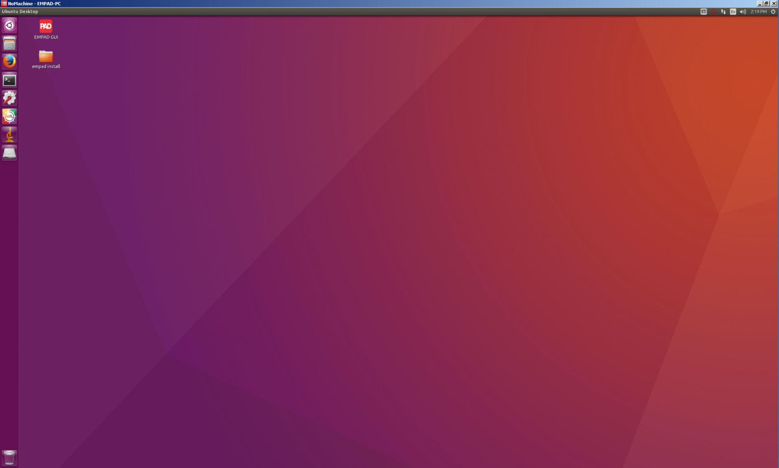

  - In the EMPAD GUI window, above “Project Settings”, select “New”.

    - In the “Create Project” window under “New Project Name”, enter a project name.

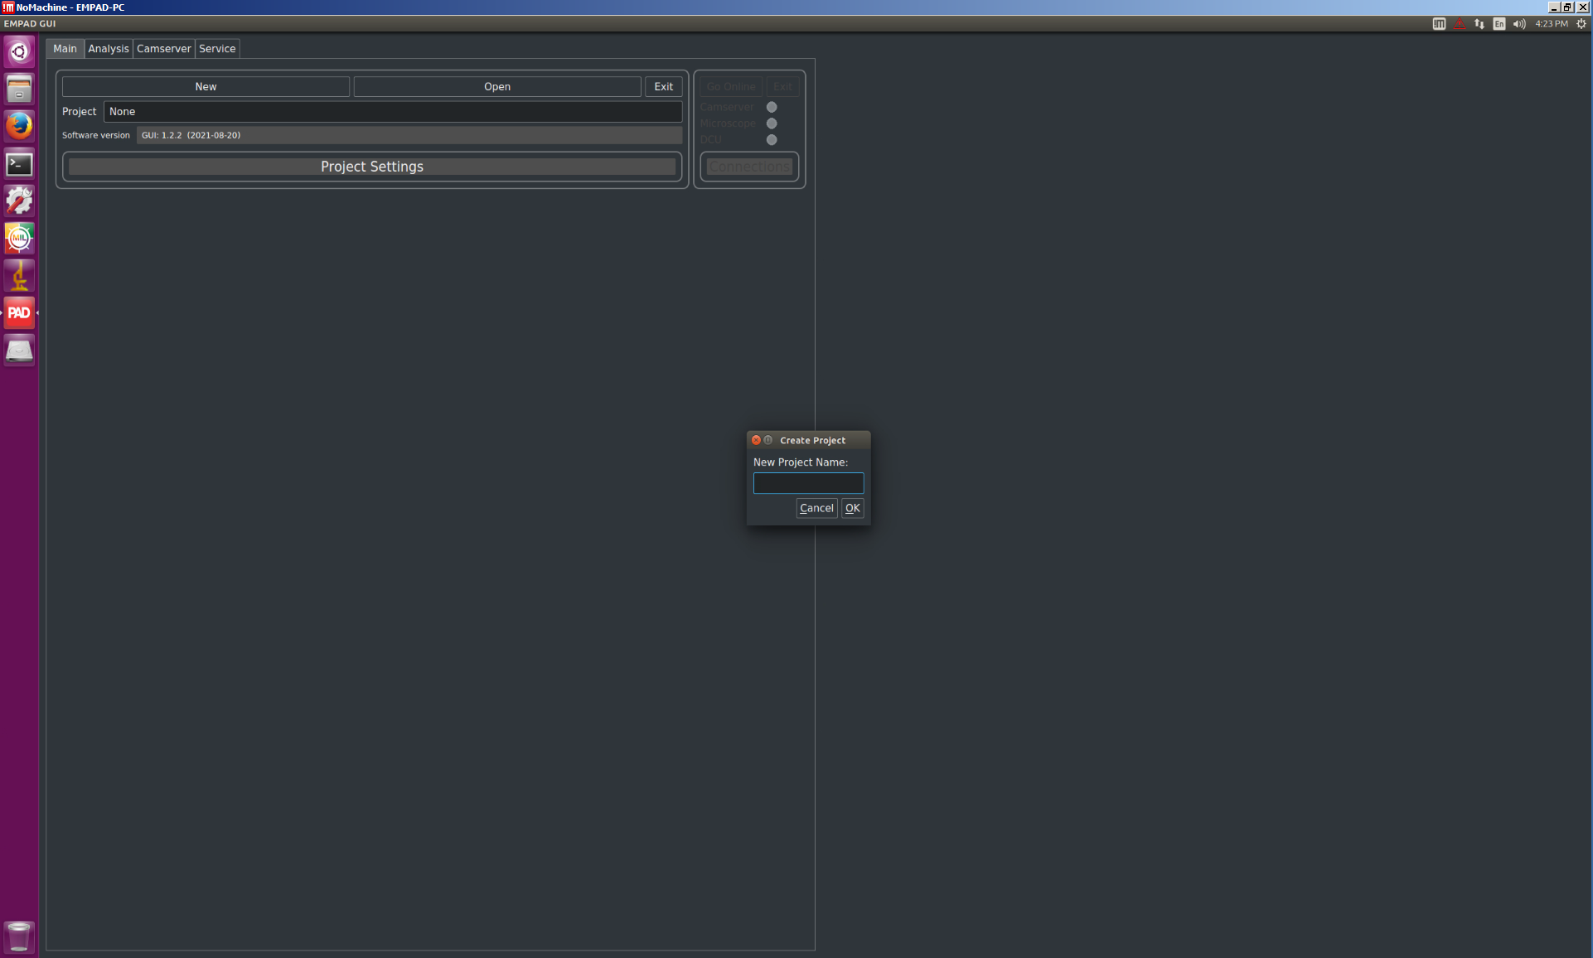
  - Above “Connections”, select “Go Online”.

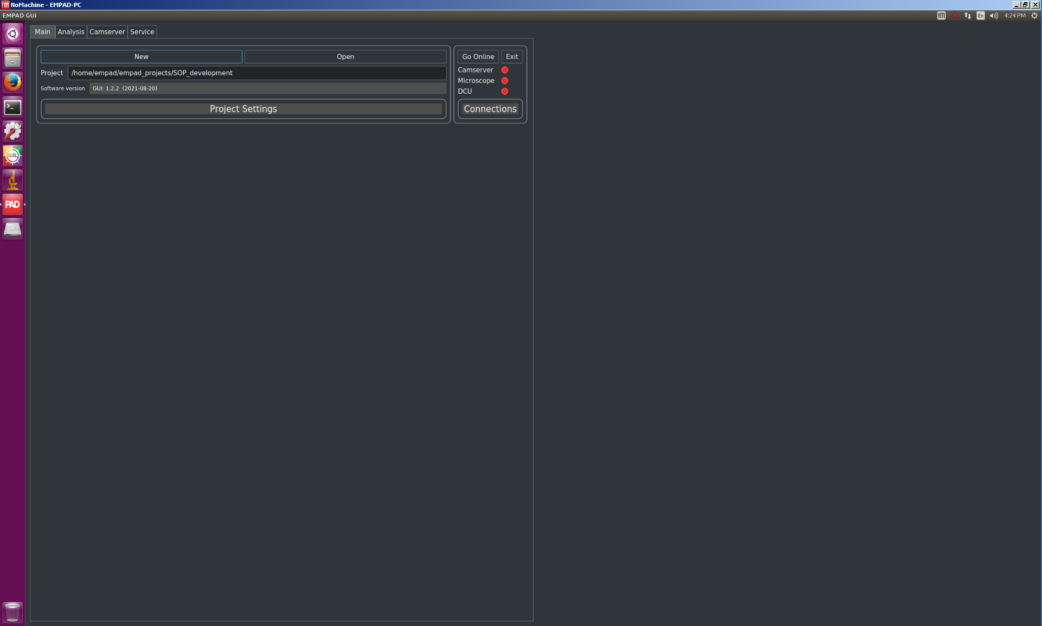

  - Above “Detector”, select the box next to “Power on” to power up (and start cooling) the EMPAD.

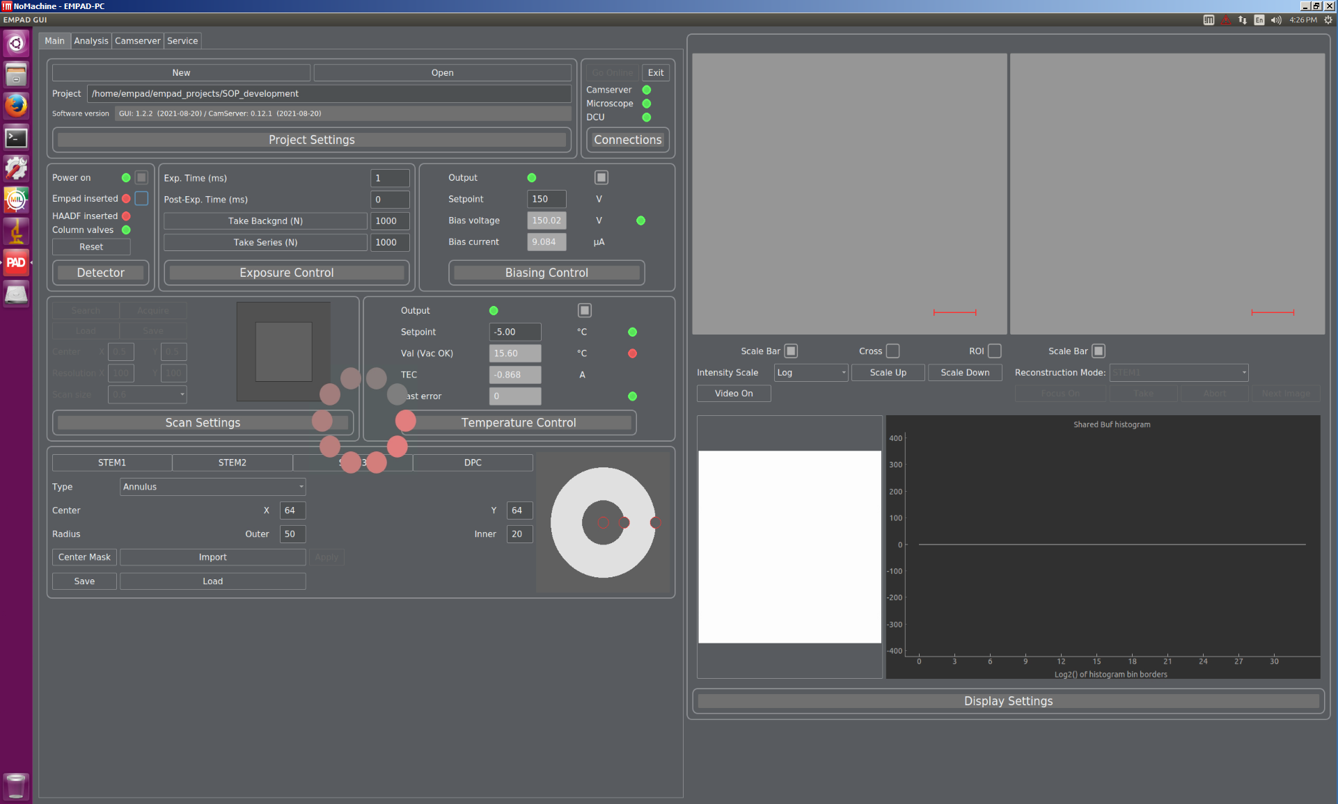

  - Above “Temperature Control”, wait for the system to reach the T = –5 °C (negative 5 °C) setpoint before proceeding.

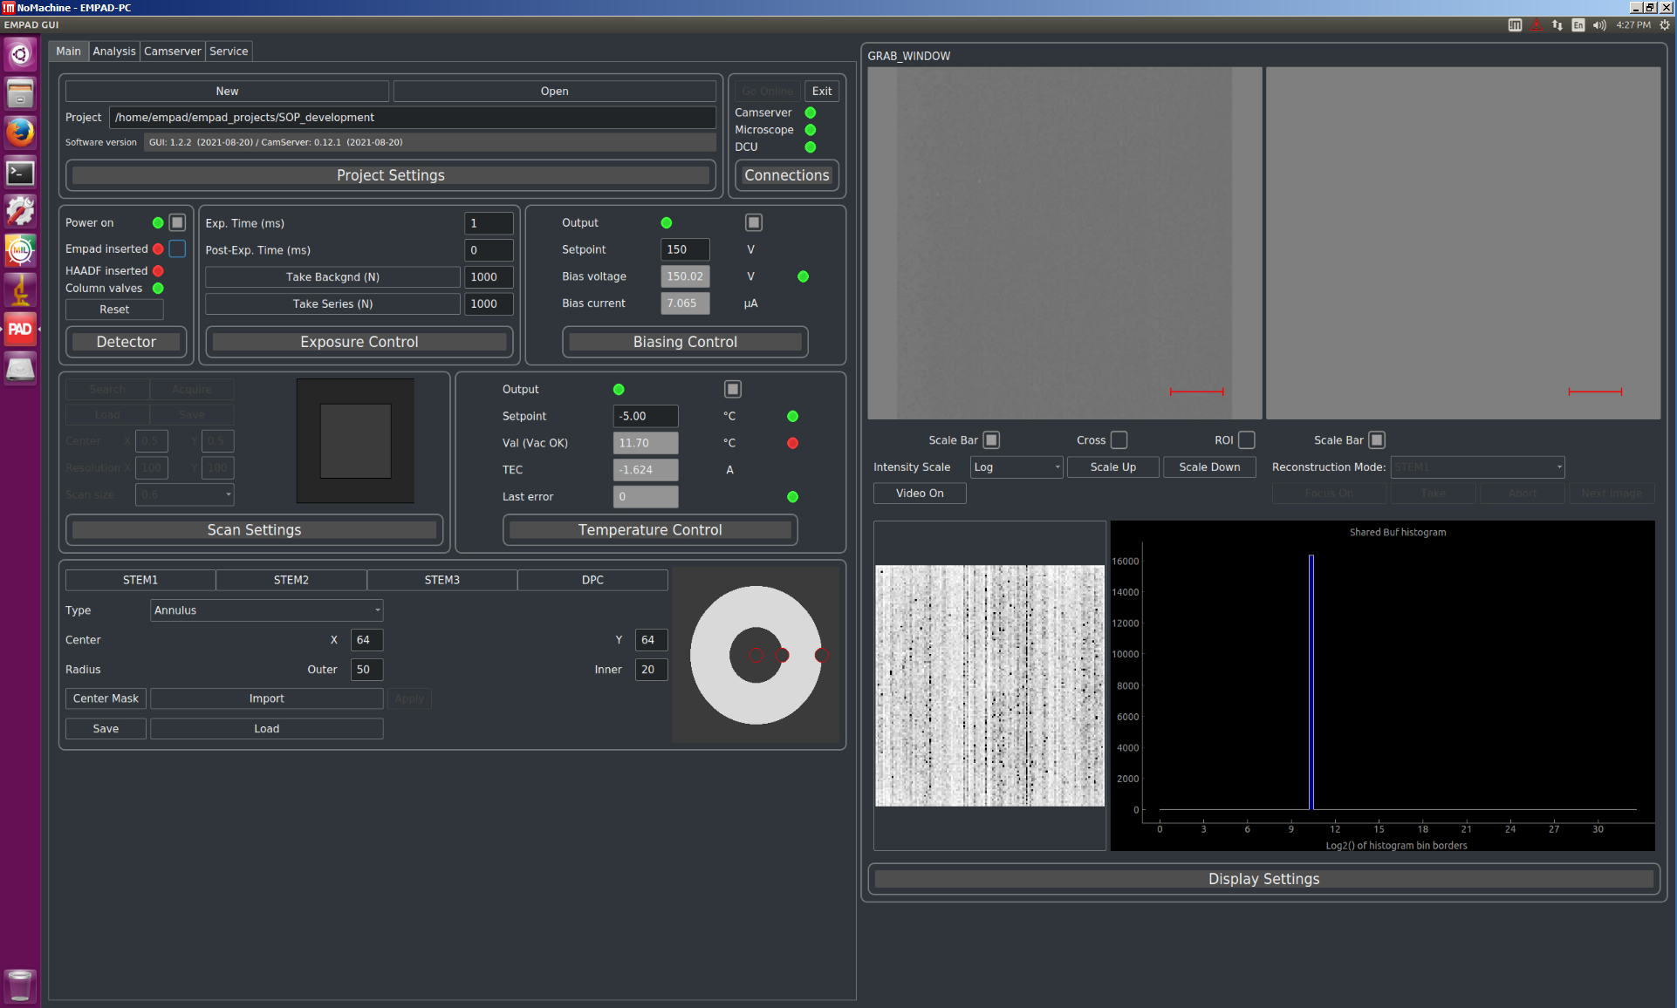

- Background collection

  - Above “Detector”, verify “EMPAD inserted” is deselected; in Velox acquisition, blank the beam; no signal will reach the EMPAD.

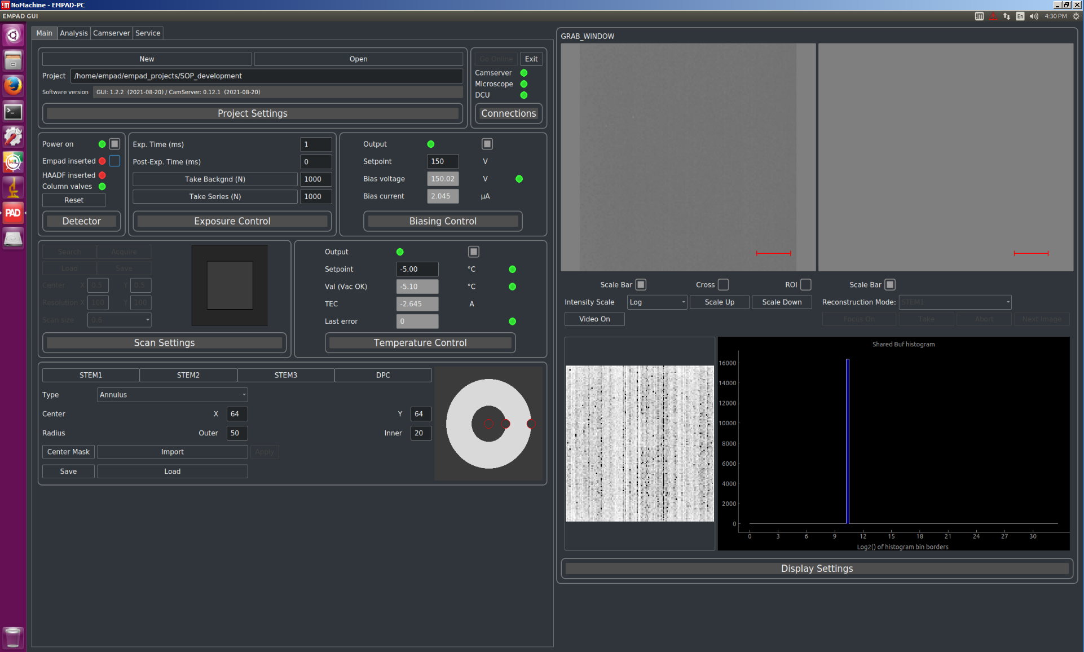

  - Above “Exposure Control”, set “Exp. Time (ms)” = 1, Post Exp. Time (ms) = 0, and “Take Backgnd (N)” = 1000; select “Take Backgnd (N)” to acquire the background.

- Centering CBED patterns on the EMPAD

  - In Velox acquisition, stop scanning and verify that the beam position marker is centered (not shown; described elsewhere).

  - In the EMPAD GUI above “Detector”, select “EMPAD inserted” to insert the EMPAD into the beam path.

  - In the EMPAD GUI under “GRAB_WINDOW”, select “Video On” to view the live CBED pattern.

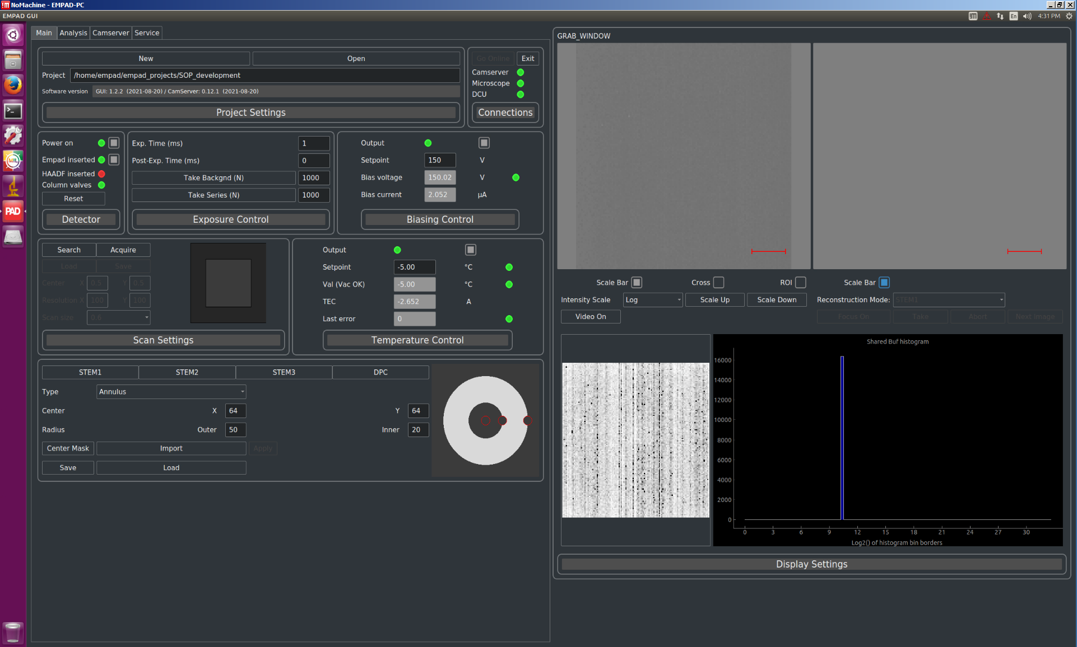

  - The CBED pattern should now be evident under “GRAB WINDOW”.

    - Select “Cross” to mark the center of the window.

    - Adjust the “Intensity Scale” as appropriate to increase visibility (this has no effect on the CBED patterns in the final acquired 4D-STEM dataset).

    - In Microscope Control, use “Diffraction Alignment” to center the CBED pattern in the window (not shown; described elsewhere).

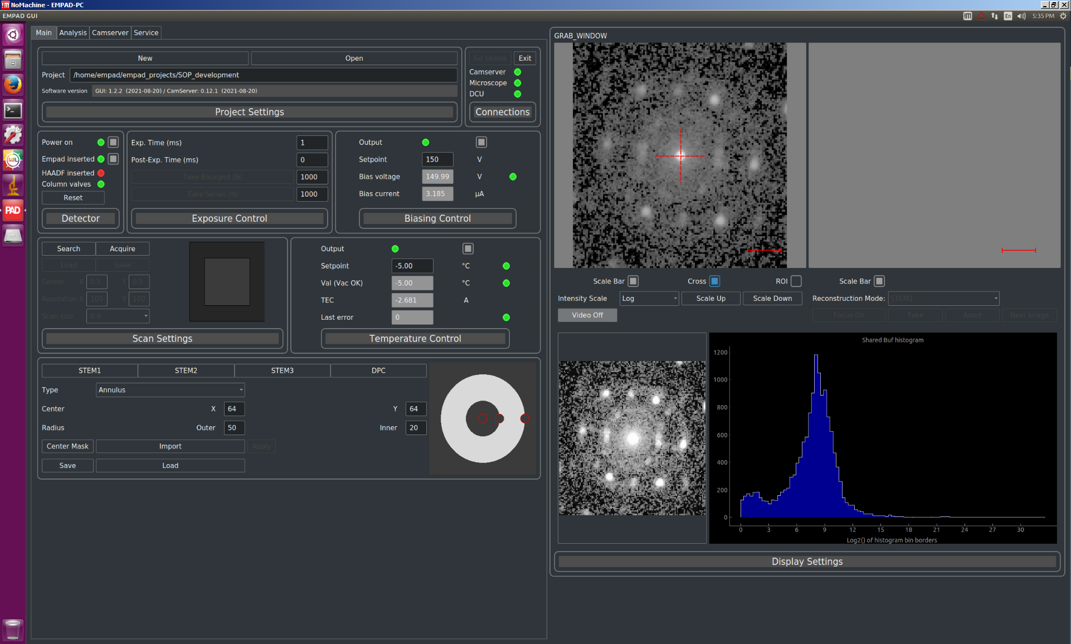

  - When finished, change the setting on the scan input control box from Velox (INT scan) to EMPAD (EDX scan).

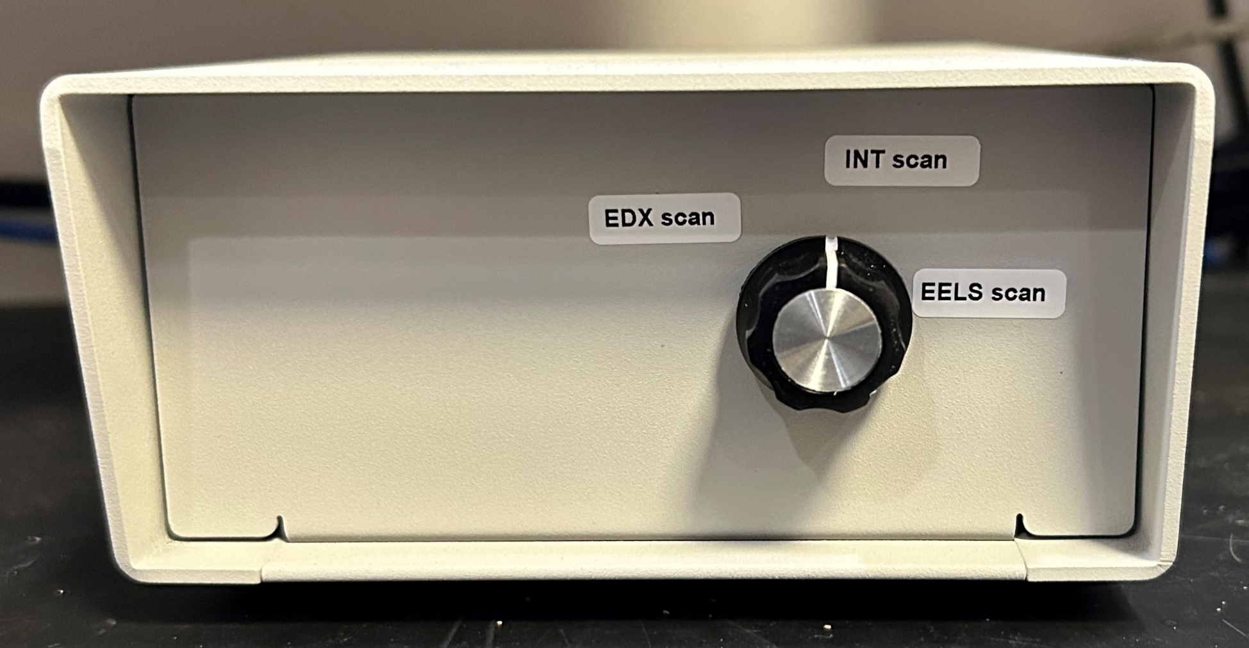

  - NOTE: when viewed on the EMPAD the CBED patterns will be flipped upside down compared to when viewed on the FluCam.
- Search scan settings

  - The “Search” scan setting is generally used for quickly visualizing the area to be scanned at low resolution.

  - Above “Scan Settings”, select “Search” to start scanning the area.

    - It is recommended to set “Scan size” = 1, which corresponds to the full square area.

    - It is recommended to set “Center” to X = 0.5 and Y = 0.5; this intuitively places the center position in the center of the area.

    - “Resolution” defines the resolution of the scanned area; both X and Y may be up to 512; e.g., if X = Y = 128, the scanned area will be the full square area with dimensions of 128×128; if X = 128 and Y = 64; the scanned area will be the full FOV in the X direction, but only half the FOV in the Y direction and centered vertically in the full square ROI. X = Y = 128 is recommended for quickly scanning the full area (~16 s/frame)

  - Under “GRAB_WINDOW”, a reconstructed STEM image based on the “STEM1” virtual detector will be evident.

  - If any of the settings are changed, select “Focus Off” to stop scanning and then “Focus On” to restart scanning with the new settings.

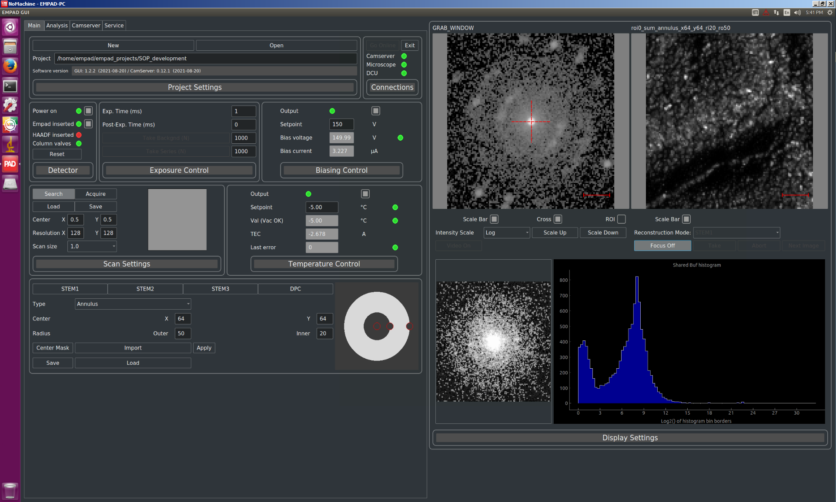

- Virtual STEM detector settings

  - NOTE: virtual detector settings have no impact on the CBED patterns in the final acquired 4D-STEM dataset; the reconstructed STEM image is simply used for quick visualization of the scanned area.

  - Under “GRAB_WINDOW”, verify a CBED pattern is not actively being acquired and scanning is stopped; “Video On” and “Focus On” should be indicated.

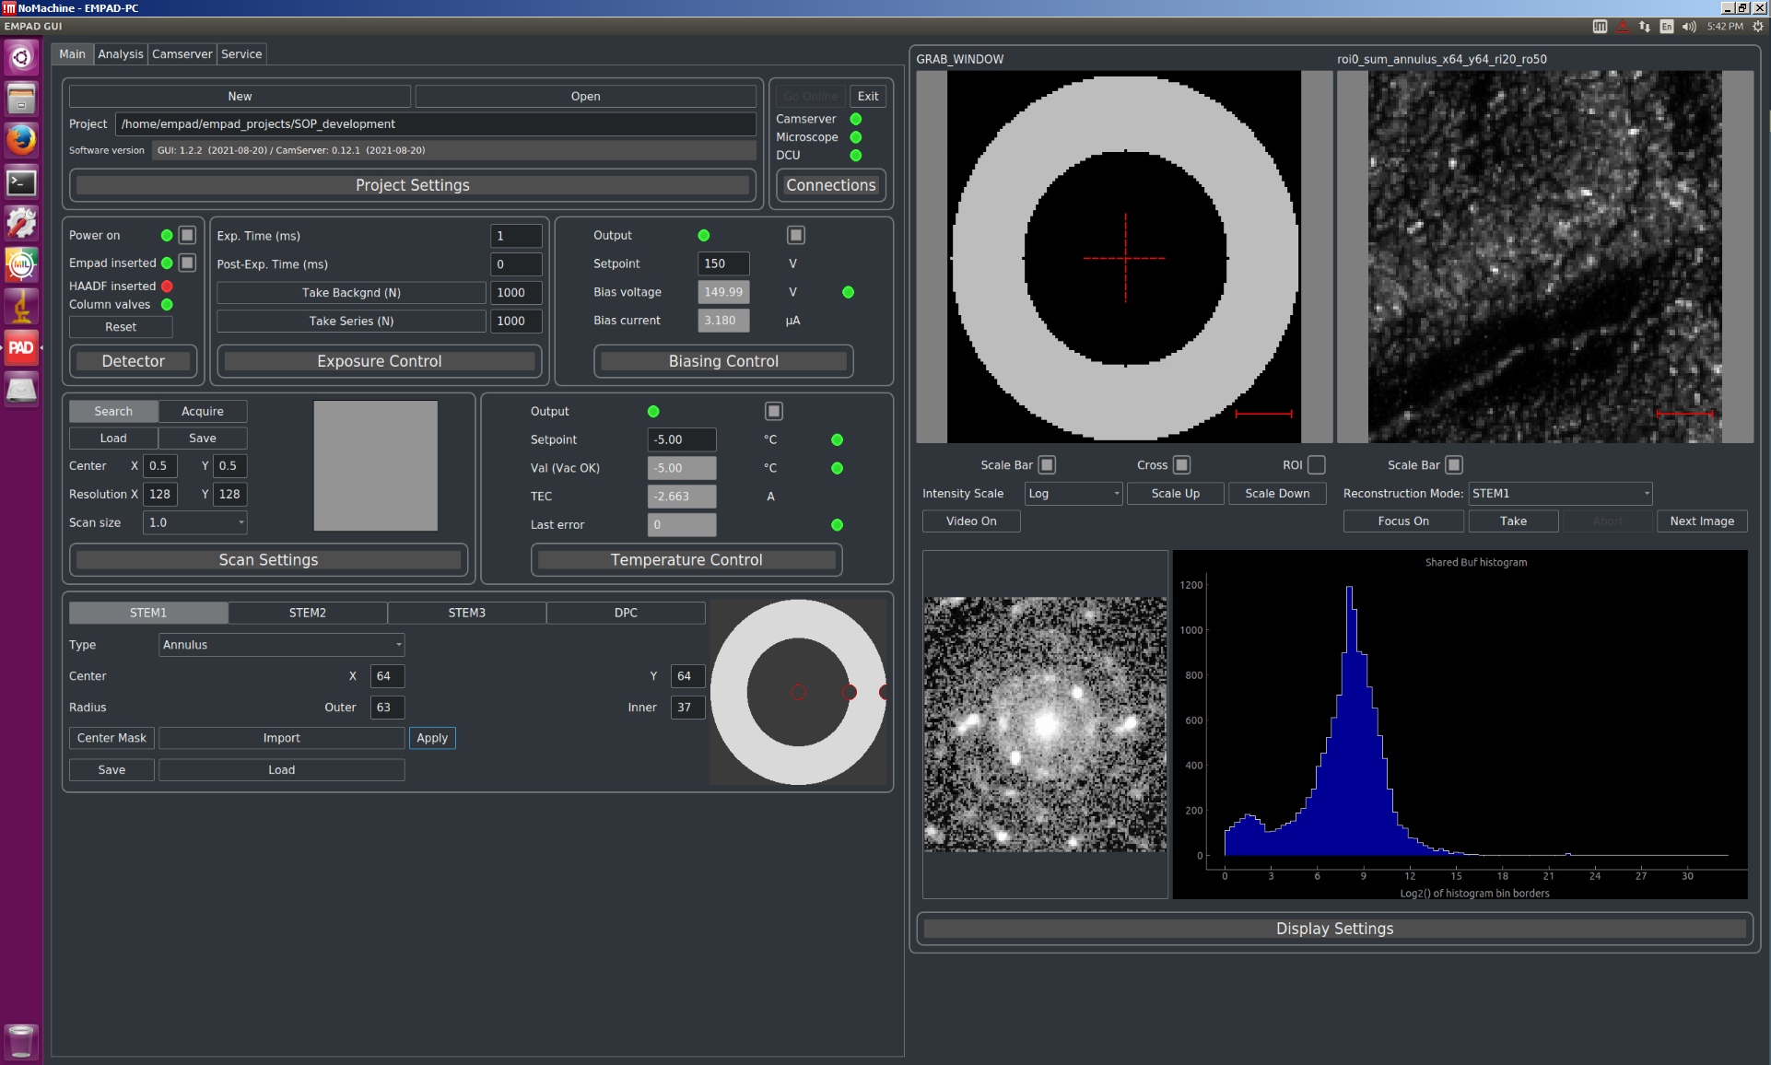

  - Select the “STEM1” virtual STEM detector and adjust the parameters (center, radii, etc.) as desired; when finished, select “Apply”.

  - Under “GRAB_WINDOW”, select “Focus On” to start acquiring a STEM image with the adjusted virtual detector parameters.

- Fine tuning (as needed)

  - Due to the relatively long (minimum) dwell time of 1 ms per pixel used by the EMPAD, it tends to be difficult to accurately optimize focus/stigmation, scan rotation, magnification, and positioning of the specimen.

  - If any of these need to be adjusted, it is best to do this using the live HAADF image in Velox Acquisition.

    - If the EMPAD is inserted, under “Detectors”, deselect “EMPAD inserted” to retract it; otherwise, the EMPAD blocks the beam path to the HAADF detector.

    - Change the setting on the scan input control box from EMPAD (EDX scan) to Velox (INT scan).

    - Make all necessary adjustments using the live HAADF image in Velox (not shown; described elsewhere).

  - Once adjustments are complete, switch the scan input control box from Velox (INT scan) back to EMPAD (EDX scan) and reinsert the EMPAD into the beam path as described previously.

- Acquiring a 4D-STEM dataset

  - Under “GRAB_WINDOW”, verify a CBED pattern is being actively viewed and scanning is currently stopped; “Video Off” and “Focus On” should be indicated.

  - Above “Scan Settings”, select “Acquire” and set the scan settings as described previously.

    - NOTE: due to the information limit associated with digitized data, there is essentially no effective benefit in acquiring a dataset with pixel size smaller than approximately ½ the probe size.

    - The pixel size of the dataset can be calculated by checking the measured FOV in Velox and dividing by the number of pixels in the X direction; e.g., for FOV ~ 1 μm and X = 512 pixels, Δx ~ 2 nm/pixel.

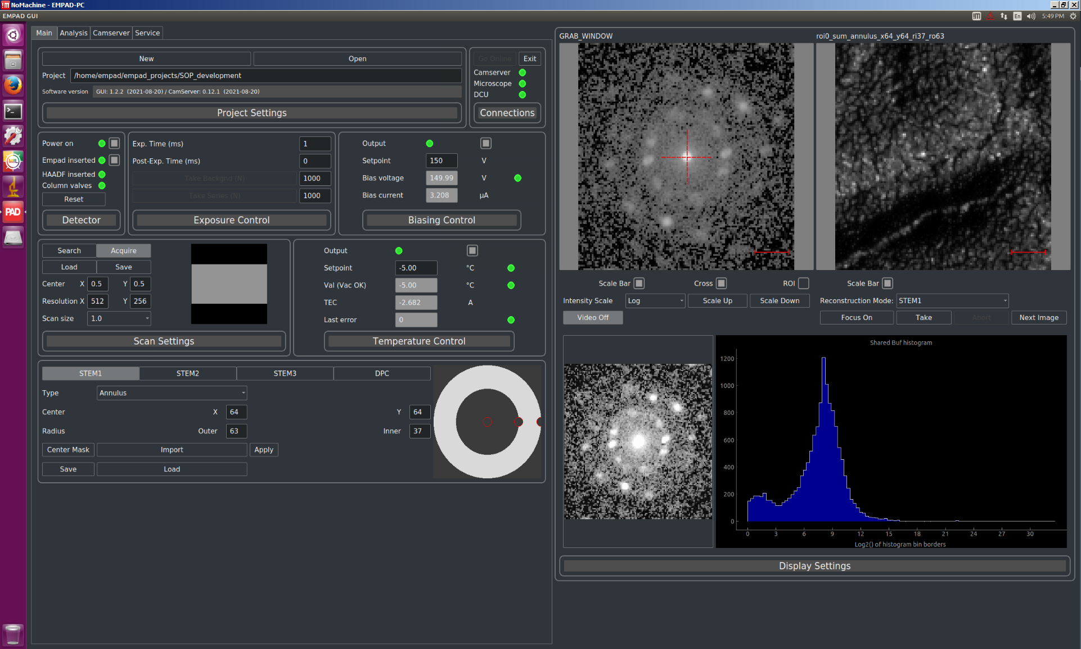

  - If desired, under “GRAB_WINDOW”, select “Focus On” to live STEM image (preview) with the specified scan settings (not shown); select “Focus Off” when finished.

  - Under “GRAB_WINDOW”, select “Take” to acquire the 4D-STEM dataset.

  - Under “GRAB_WINDOW”, a reconstructed STEM image based on the “Acquire” scan settings and “STEM1” virtual detector will be generated.

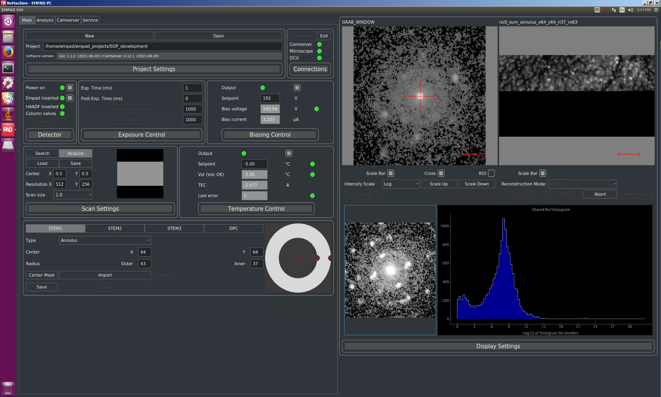

  - When the acquisition is complete, a dialogue box will appear asking for a name for the acquisition.

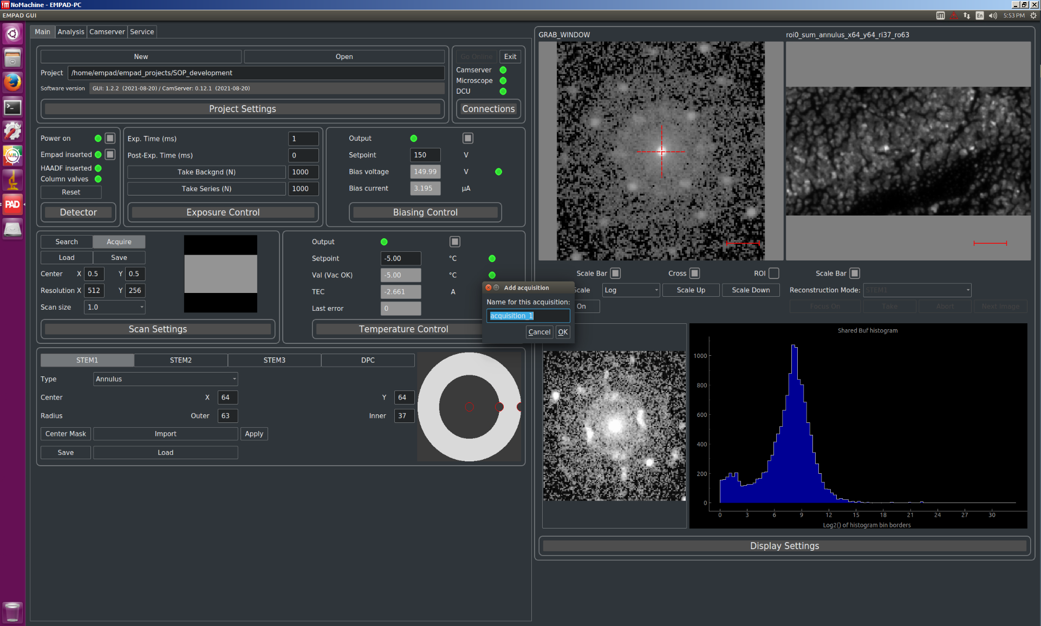

- Finishing with the EMPAD

  - Above “Detector”, deselect “EMPAD inserted” to retract the EMPAD and “Power on” to power down the EMPAD (cooling will stop automatically).

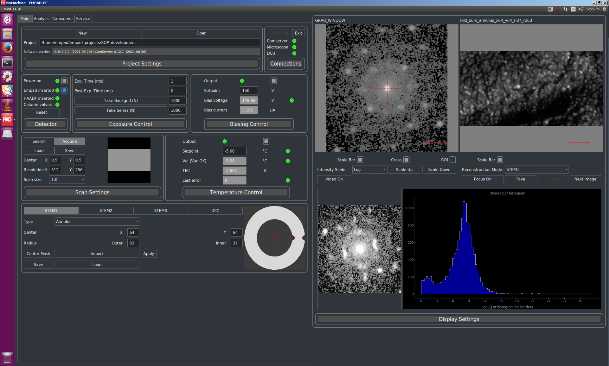

  - Above “Connections”, select “Exit” to exit the EMPAD GUI.

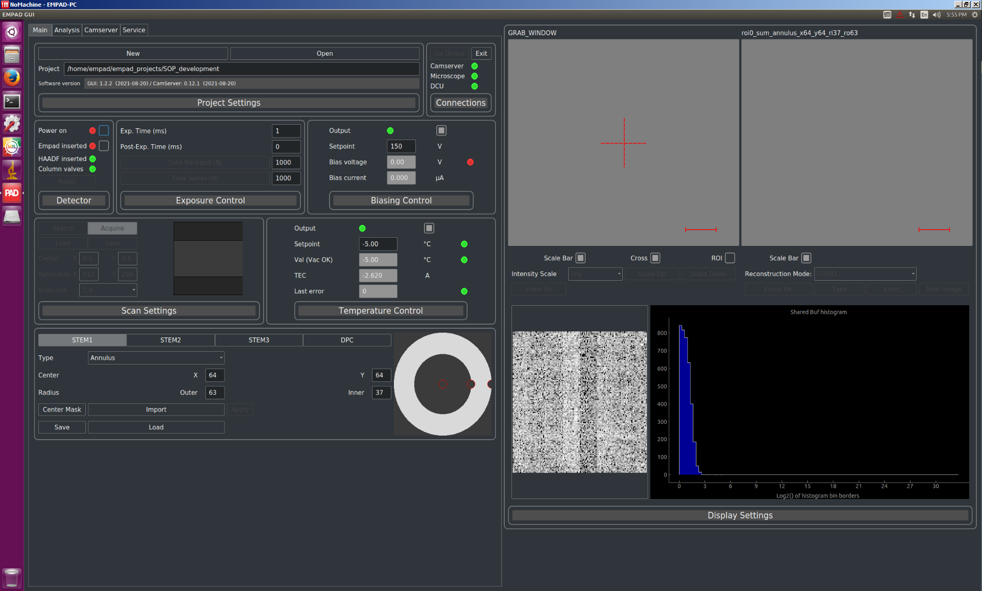

- Locating and transferring datasets

  - On the EMPAD PC taskbar, select “Files”; in the “Home” window, select “empad_projects”.

a screenshot of the EMPAD PC desktop 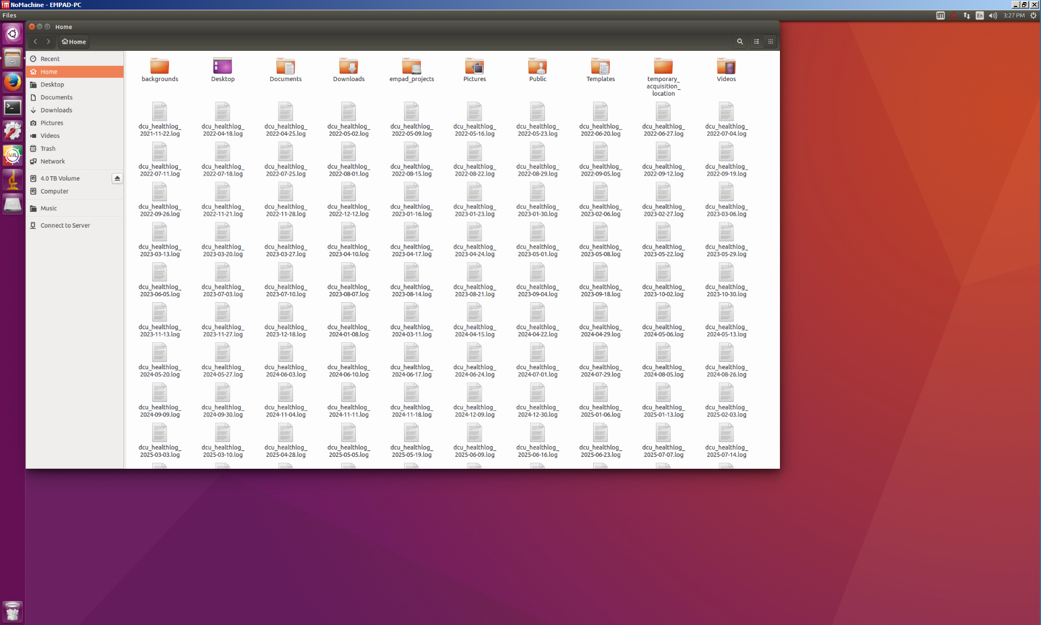

  - In the “empad_projects” window, select the project folder created when the EMPAD GUI was initially started.

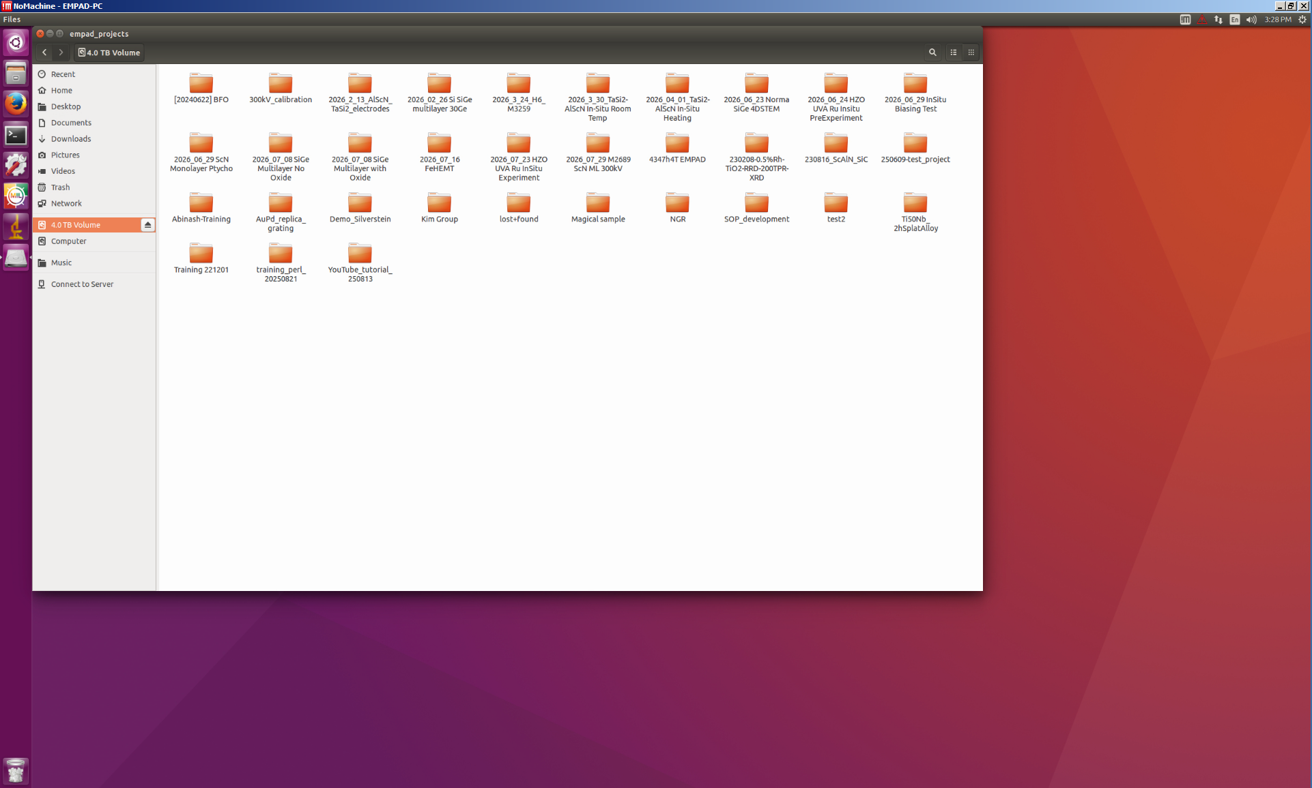

  - The window will now have the project folder name; a folder containing the data for each acquired dataset (as named) will be shown.

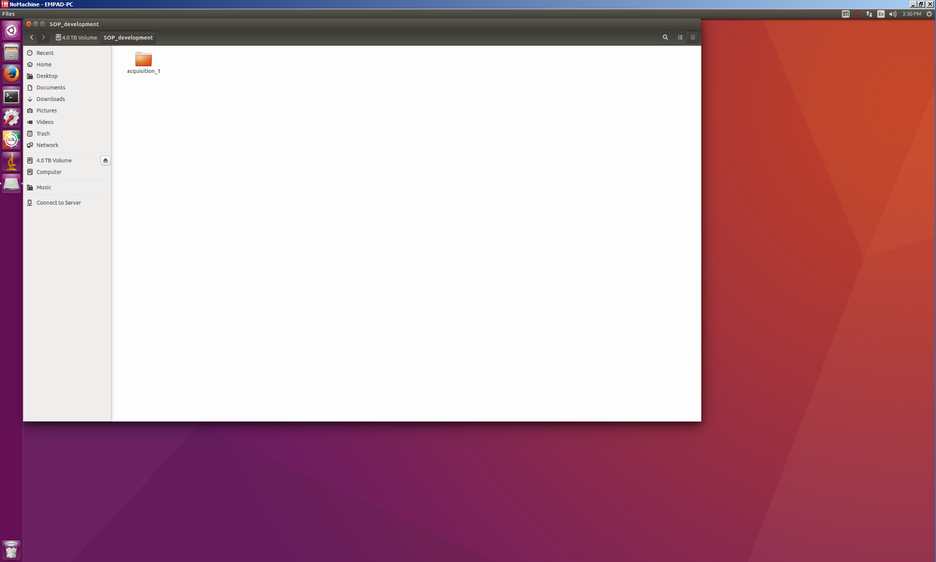

  - Datasets may be transferred off the EMPAD PC using USB (preferably, 3.0) devices; keep in mind that 4D-STEM datasets are often very large with a full 512×512 dataset being over 17 Gb in size.

