
Tencor Alphastep AS500 Profilometer
Standard Operating Procedure
Rev. 2026-01
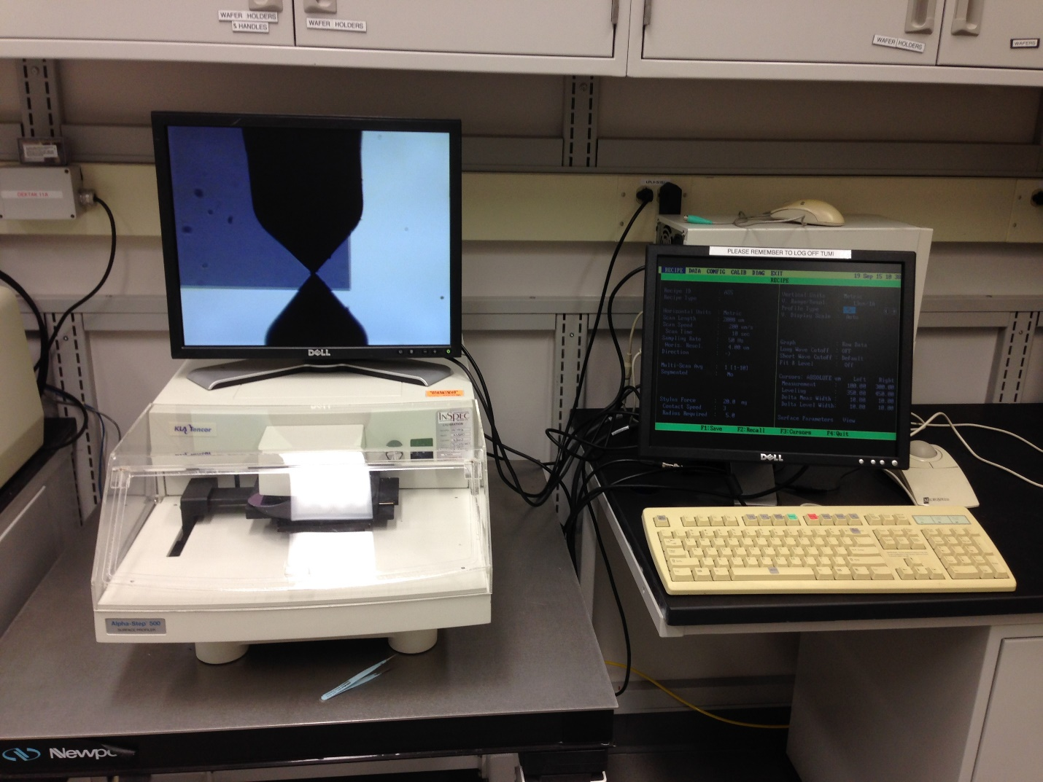

Contents
Description: 2
Safety 2
Equipment Restrictions 2
Specifications: 2
Operation 3
Loading a Sample 3
Parameter Settings 6
Profiling from a scan recipe 7
Leveling the Stage (from the Tencor Manual) 8

Description:

The ALPHA-STEP® 500 is a stylus-based surface profiler. The system provides complete and detailed two-dimensional analysis of surface topography on avariety of surfaces up to 300um in height. It accurately measures surface characteristics such as step height, roughness, and etch depth on a wide variety of substrates. Applications-specific recipes easily programmed to provide automatic leveling, scaling, and measurement analysis–eliminating errors due to operator interpretation and sample positioning. Stylus force–adjustable between 1 and 100 mg–can be tailored for specific surface conditions.

Safety
Moving Components – The User should be aware at all times of the moving components associated with this tool.

Equipment Restrictions
Do not load samples taller than 15mm.
Samples step heights must not be greater than 300um or serious damage to the stylus tip will result.

Specifications:
Vertical resolution 1A with 10A repeatability
Scan length maximum – left to right 10mm, right to left 2mm
Horizontal resolution up to 0.01um (depends on scan speed and sample rate)
Up to 5000 data points per scan
Stylus radius 5 µm (yellow ring)
Ranges and resolutions:13 µm at 1 A, 300 µm at 25 A
Zoom optics with magnification up to 210x
Max sample dimensions: 150 mm wide, 15 mm thick
Scan Types: continuous, segmented, or multi-scan averaged up to 10 times

Operation

Loading a Sample
    - Verify both video monitors are on. The monitor on top of the tool is for viewing the sample position in the camera.
    - Press F5. Press and hold the up arrow ↑ to raise the stylus head (i.e. lower the sample table) until the table stops. The Z position (elevator position) should read <200um.
    - Turn the x and y-axis adjustment knobs (located lower left side of machine) to move the stage to front/center position.
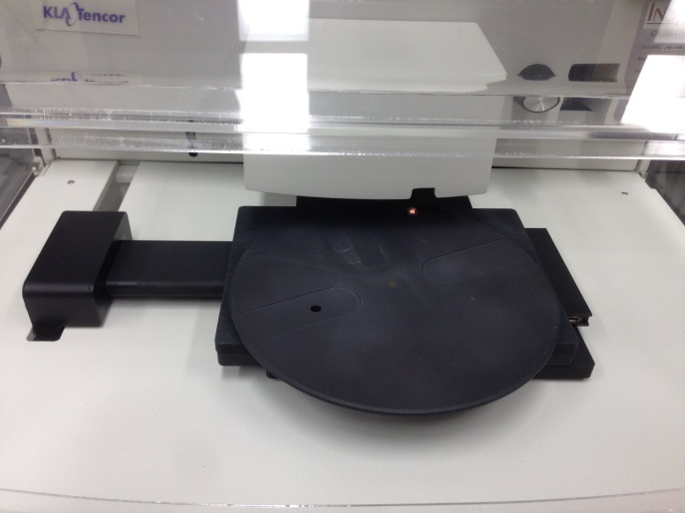
    - Open the acrylic air flow protection door. Place your sample on the center of the table and move the stage backward until your wafer is under the stylus. See the pic below for the stylus location and landing point located just behind the camera light spot (see below). Move the measurement area of your sample to the landing point using the X/Y knobs.
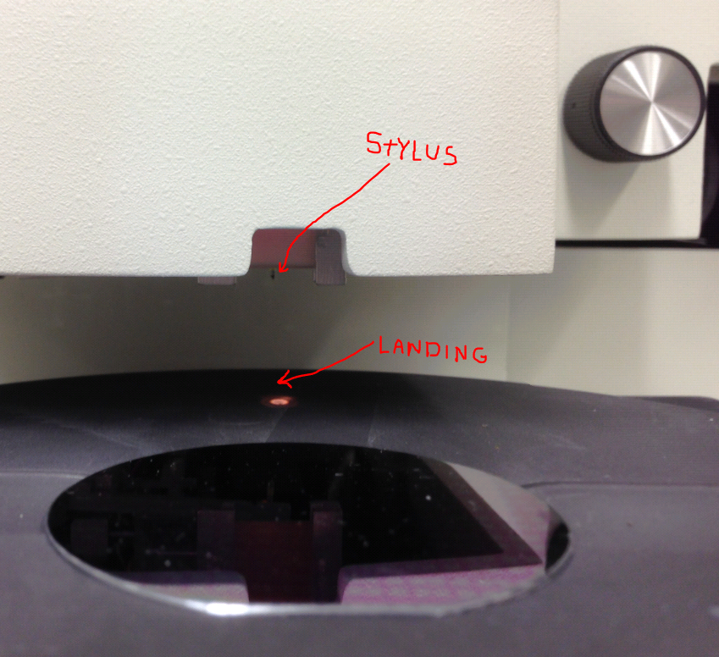
    - Press and hold the down arrow key to move the stage up until the stylus stops on the wafer surface. Press the down arrow again and verify the Z position on the screen is the same when “nulled” the 2nd time. This will guarantee the stage is really in contact with the sample.
    - Tap the up arrow key once (don’t hold down) to lift the stylus up (never move the wafer while the stylus is on the wafer surface). You should see the stylus raised up OFF the sample and out (or barely visible at the top of the camera screen) of camera view.
    - Turn X and Y knobs to move to just left (or right depending on scan direction setting) the feature to be measured.
CAUTION: Stylus should be retracted before moving the stage!
    - Turn the Zoom knob change magnification of the video image if needed.
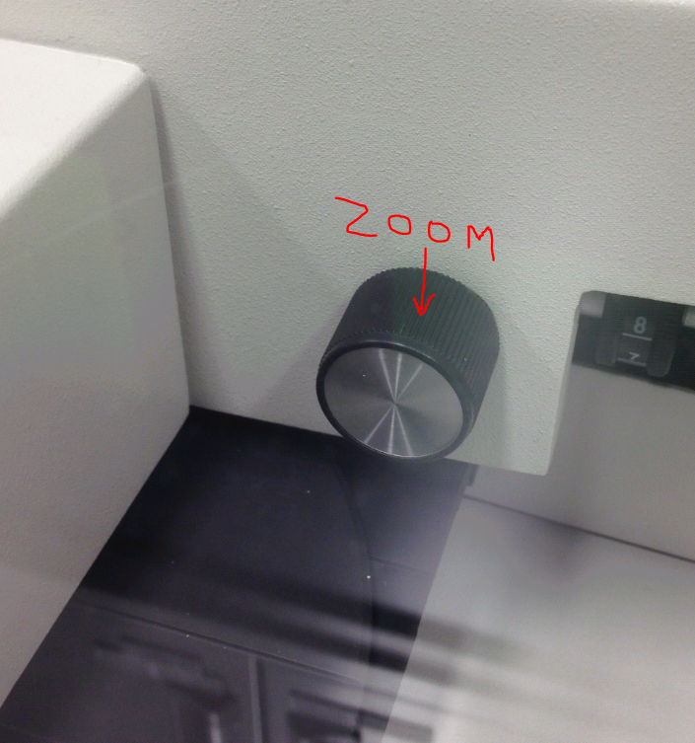
    - You may scan the sample immediately by editing the scan parameters or you can create and save a recipe tailored to your samples. If you would like to use your recipe see section 1.2.
    - Press the Escape key. On the menu bar, use right or left arrow keys to select Recipe and press Enter to View/Modify recipe parameters.

Parameter Settings
Parameter | Range or Description | Typical Value for most step measurements
Scan Length | 1-5000um | 500um
Scan Speed | 2-200um | 50um
Sampling Rate | 50-200 Hz | 50
Direction |  | ->
Multi-scan average | 1 to 10 | 1
Segmented |  | no
Stylus Force | staff adjustable only | 20
Contact Speed | 1 to 6 | 3
Radius Required | 5um radius tip is installed on the NRF tool | parameter does not need to be entered and not part of calculation
V. Range/Resolution | 13um, 300um | 13um
Profile Type | only available for 300um range
V. Display Scale | Manual or Auto | Auto
Graph | see Tencor manual | raw data
long wave cutoff | see Tencor manual | off
short wave cutoff | see Tencor manual | default
Fit and Level | see Tencor manual | off
Cursors: Absolute um
Measurement | measurement cursor positions | 100, 300
Leveling | leveling cursor positions | 10, 100
Delta Meas Width | changes the measure cursor from single point to average of data within cursor width | 50, 50
Delta Level Width | changes the leveling cursor from single point to average of data within cursor width | 50, 50

    - Press F8 “Start” to start scan Start (F8) key to start the scan (don't touch the tool or table during the measurement!). You can press STOP (F9) key to abort a scan at any time. When the scan is completed, the stylus lifts up and the Data screen is displayed with the profile plotted in dimensional coordinates.
    - Leveling the scan trace: Wait until the "Rehoming after scan" is done. Press LEVEL (F10) key if the trace is not horizontal. The leveling cursors L (left) and R (right) will appear, the activated cursor appears red. Move red cursor to the desired position with the arrow keys. Press spacebar to activate the other cursor and position it. You can press the spacebar twice quickly to activate L and R simultaneously. Press LEVEL to level the trace. (Press backspace + LEVEL to return to the previous trace if necessary.)
    - Analyzing the scan: Move L and R cursors to the desired positions. Reading the data in the summary box: Height - Vertical distance between trace intersections of cursors (in Delta Average mode, the vertical distance between the average values of height within the two delta width regions). Width - Horizontal distance between the cursors.
    - To unload the sample: Press Z key. Lower stage using up arrow key. Move stage forward and unload wafer. Switch off monitors. Log off the Tumi

Profiling from a scan recipe
    - Press Escape key.
    - On the menu bar, use right or left arrow keys to select Recipe and down or up arrow keys to select Catalog, press Enter.
    - Use down or up keys to select desired recipe and press Enter.
    - Writing and editing a recipe: To edit an existing recipe, press the up or down keys to select one line and to change values press the right or left arrow keys. Some fields have fixed values other fields you can type in the value from the numeric keyboard.
    - Saving recipes: Don't change an existing recipe! If you would like to create your own recipe, open an existing recipe, make changes, press [F1:Save], type your own recipe name, and press Enter.

Leveling the Stage (from the Tencor Manual)
