
FEI Helios Nanolab 600i dual FIB/SEM
  - Basic Standard Operating Procedure Rev. 2026-01
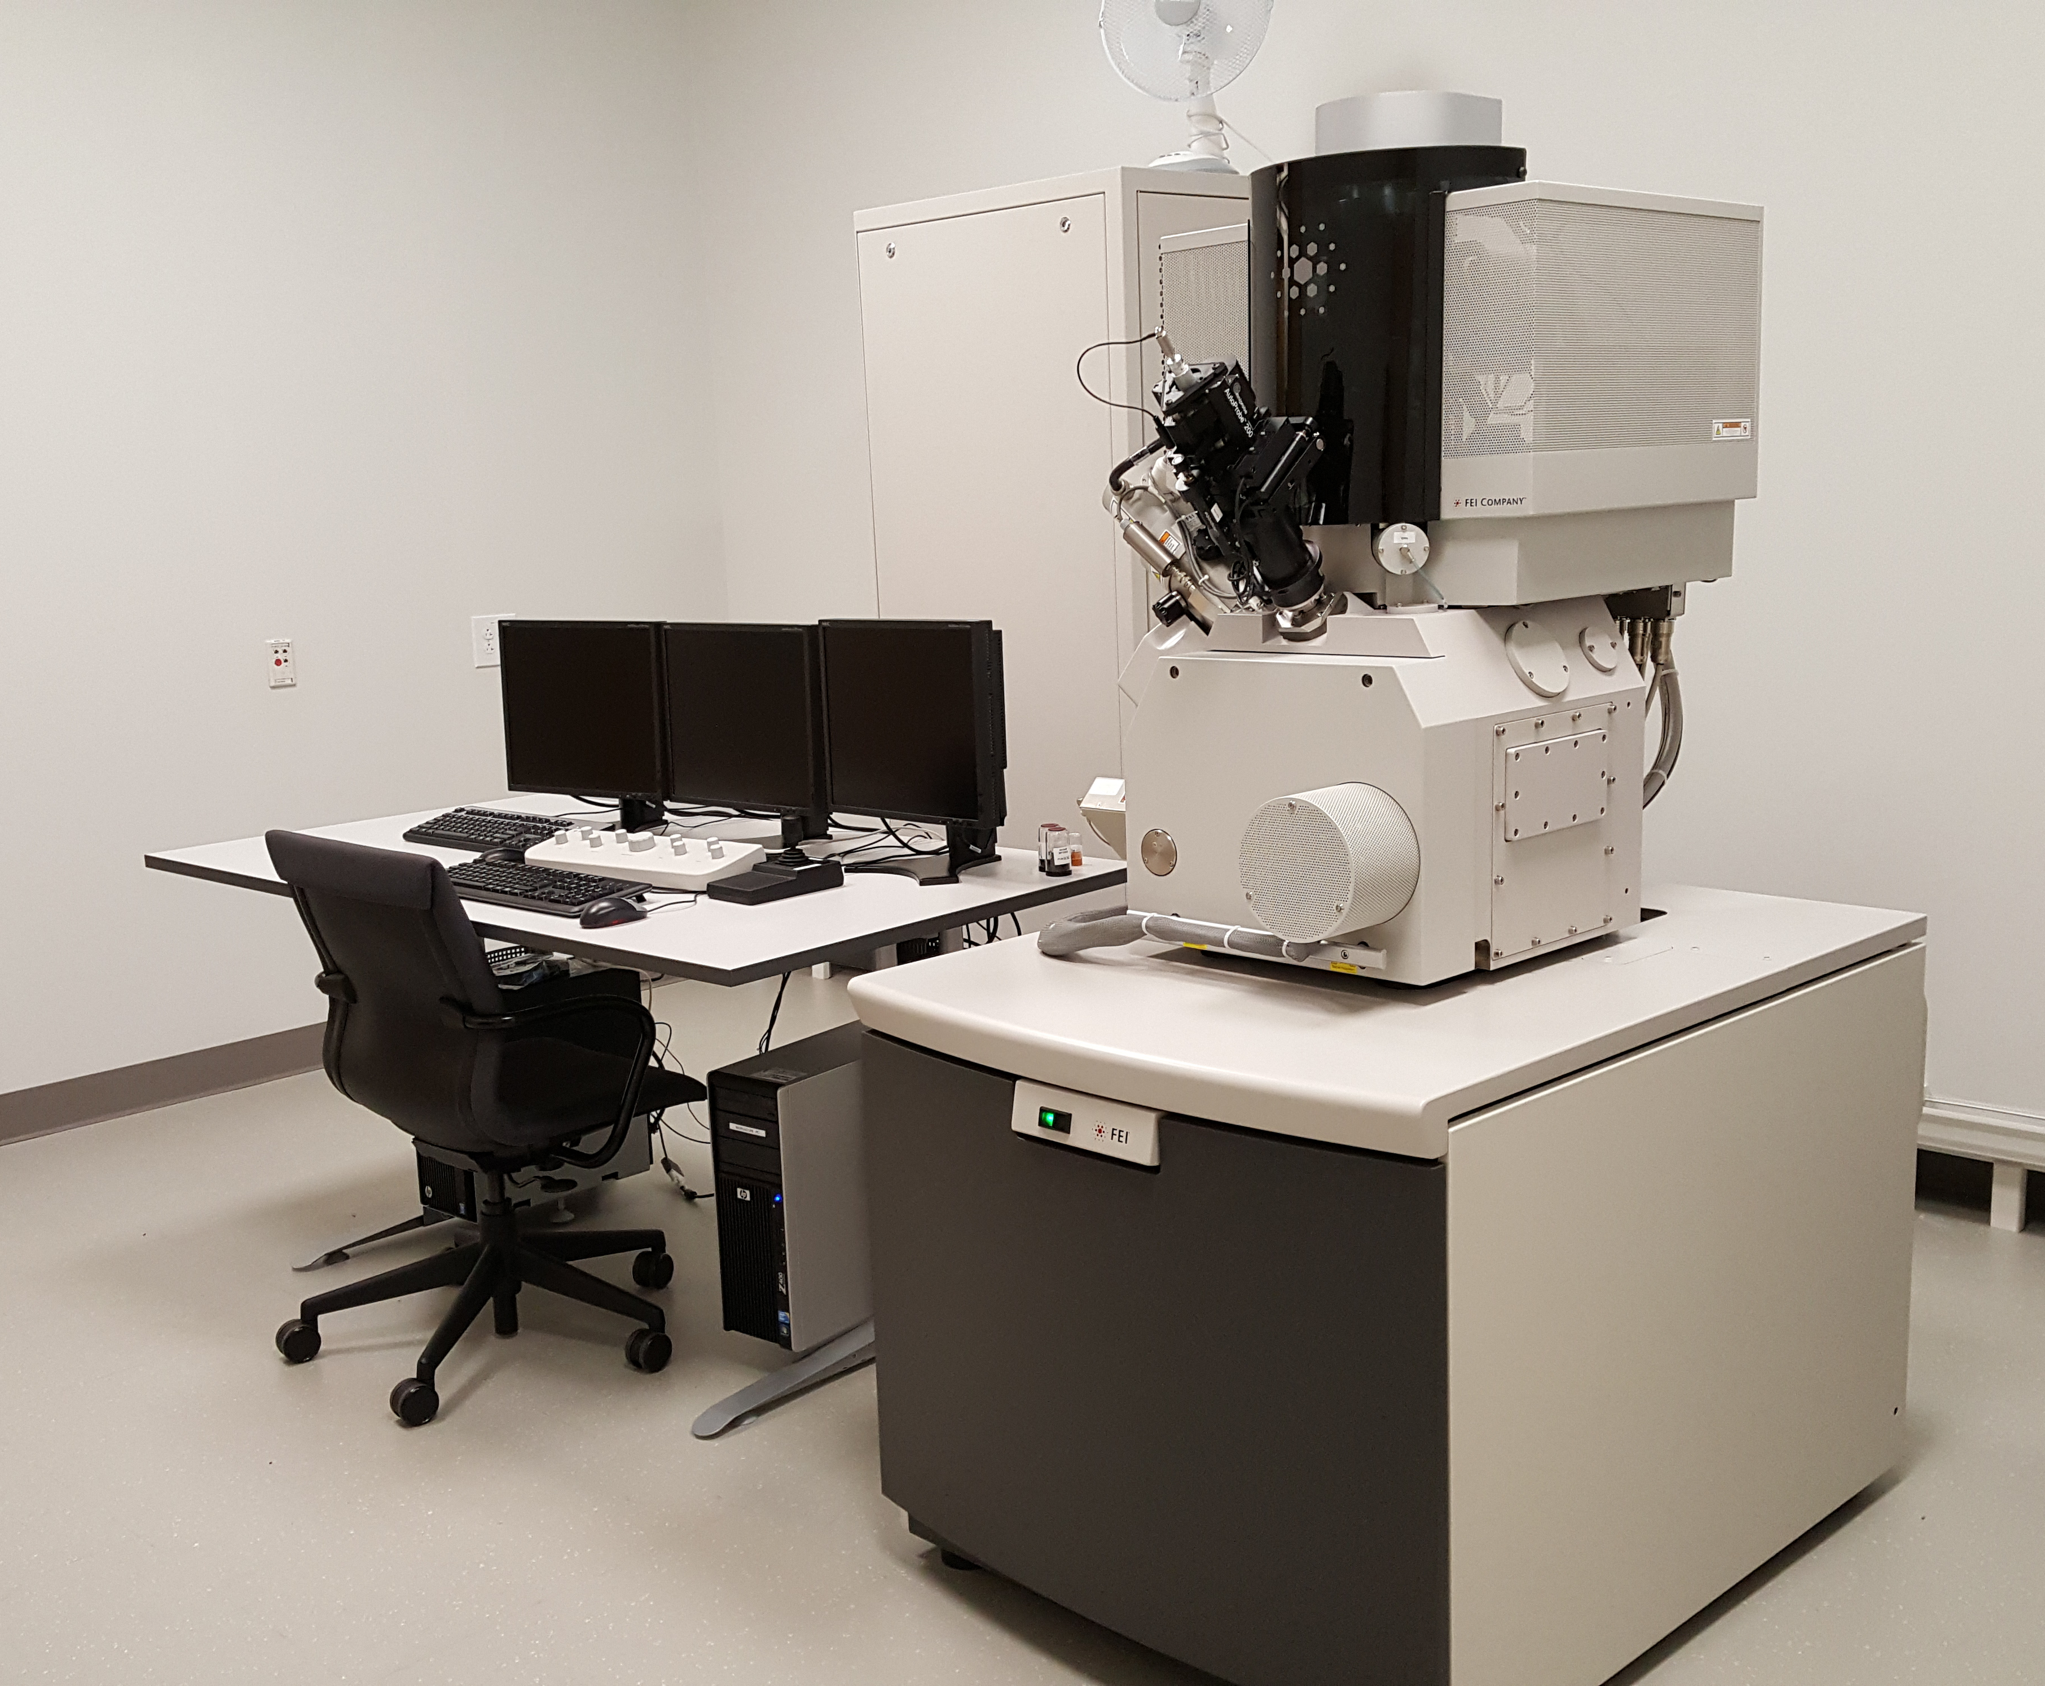

  - Application
The FEI Helios Nanolab 600i is a state-of-the-art dual focused ion beam/scanning electron microscope (FIB/SEM) combining a FIB column with a Ga⁺ liquid metal ion source and ultra-high resolution field emission gun SEM column in one instrument. This document covers basic operation of the instrument; please see separate SOP documents on the NRF instrument page regarding other applications.

  - NRF Contact
Nicholas G. Rudawski

Table of Contents

1. Safety information 3
2. Prerequisites 3
3. Preliminary sample preparation 3
4. Sample mounting 4
5. The xT Microscope Control software environment 5
6. UMB loading 6
7. During evacuation 7
8. Turning on the beams 10
9. Live imaging, snapshots, and photos 10
10. Finding a region of interest, linking Z to the working distance (WD) 12
11. Setting eucentric height 13
12. SEM alignment 15
13. FIB alignment 18
14. Linking the beams 21
15. Electron beam induced deposition (EBID) of Pt 22
16. Ion beam induced deposition (IBID) of Pt 24
17. Milling 27
18. Using the Omniprobe 29
19. Live imaging while FIB patterning 32
20. Finishing the session 33

- Safety information

  - Please use caution when opening and closing the chamber door for possible pinch points.

  - Please ensure that all parts of the universal mounting base are properly secured to prevent parts from falling down the opening to the chamber turbo pump.

  - When loading and unloading the stage, please keep hands away from the area under the pole pieces to minimize exposure to radiation from non-removable radioactive contamination on the pole pieces.

- Prerequisites

  - Successful completion of the FIB/SEM Prerequisite Training online course through elearning.

    - NRF staff may consider waving this requirement for a user with prior extensive (and documented) hands-on experience operating dual FIB/SEM instrumentation.

- Preliminary sample preparation

  - If a specimen is electrically insulating, it should be coated ex situ with a thin, non-porous, conductive layer; otherwise, it will not be possible to perform stable imaging or patterning. Thermally evaporated C works well for this application as does electron beam physical vapor deposited Cr or Si. Sputtered versions of these films may also work but sputtering may cause damage to the surface of specimen. Evaporated or sputtered Au, AuPd, or Ir are not recommended as conductive coatings as these may deposit with a porous microstructure and are known to become porous with FIB exposure.

- Sample mounting

  - Samples should be mounted on standard SEM pin stubs (Ted Pella product #16111 or #16144) using C tape, C sticky tabs, or well-dried conductive paint (best option). When mounted on one of these stubs, the footprint of a specimen should fit basically within the area of the stub with the specimen thickness not exceeding 7 mm. If for some reason a specimen cannot fit within these mounting guidelines, please ask NRF staff for assistance in determining alternative mounting approaches before attempting to load the specimen.

  - NOTE: the ideal specimen geometry for greatest stability during analysis is one with a large footprint and small thickness, e.g., a piece of a semiconductor wafer.

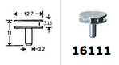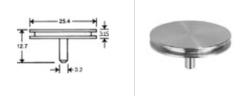
- The xT Microscope Control software environment

  - Log on to the TUMI system (this is required to supply power to the monitors)

  - The xT software consists of four imaging quads labeled 1 – 4, a control module running vertically along the right, and a toolbar and pull-down menu at the top (shown schematically below)

  - The default “beam” for each quad is as shown subsequently; selecting a quad will cause the data bar to turn blue and activates the controls for that specific quad:

    - Quad 1 = SEM (E-beam)

    - Quad 2 = FIB (I-beam)

    - Quad 3 = typically inactive

    - Quad 4 = live CCD camera image from inside of the chamber

  - Selecting the different tabs along the top of the control module will change the module.

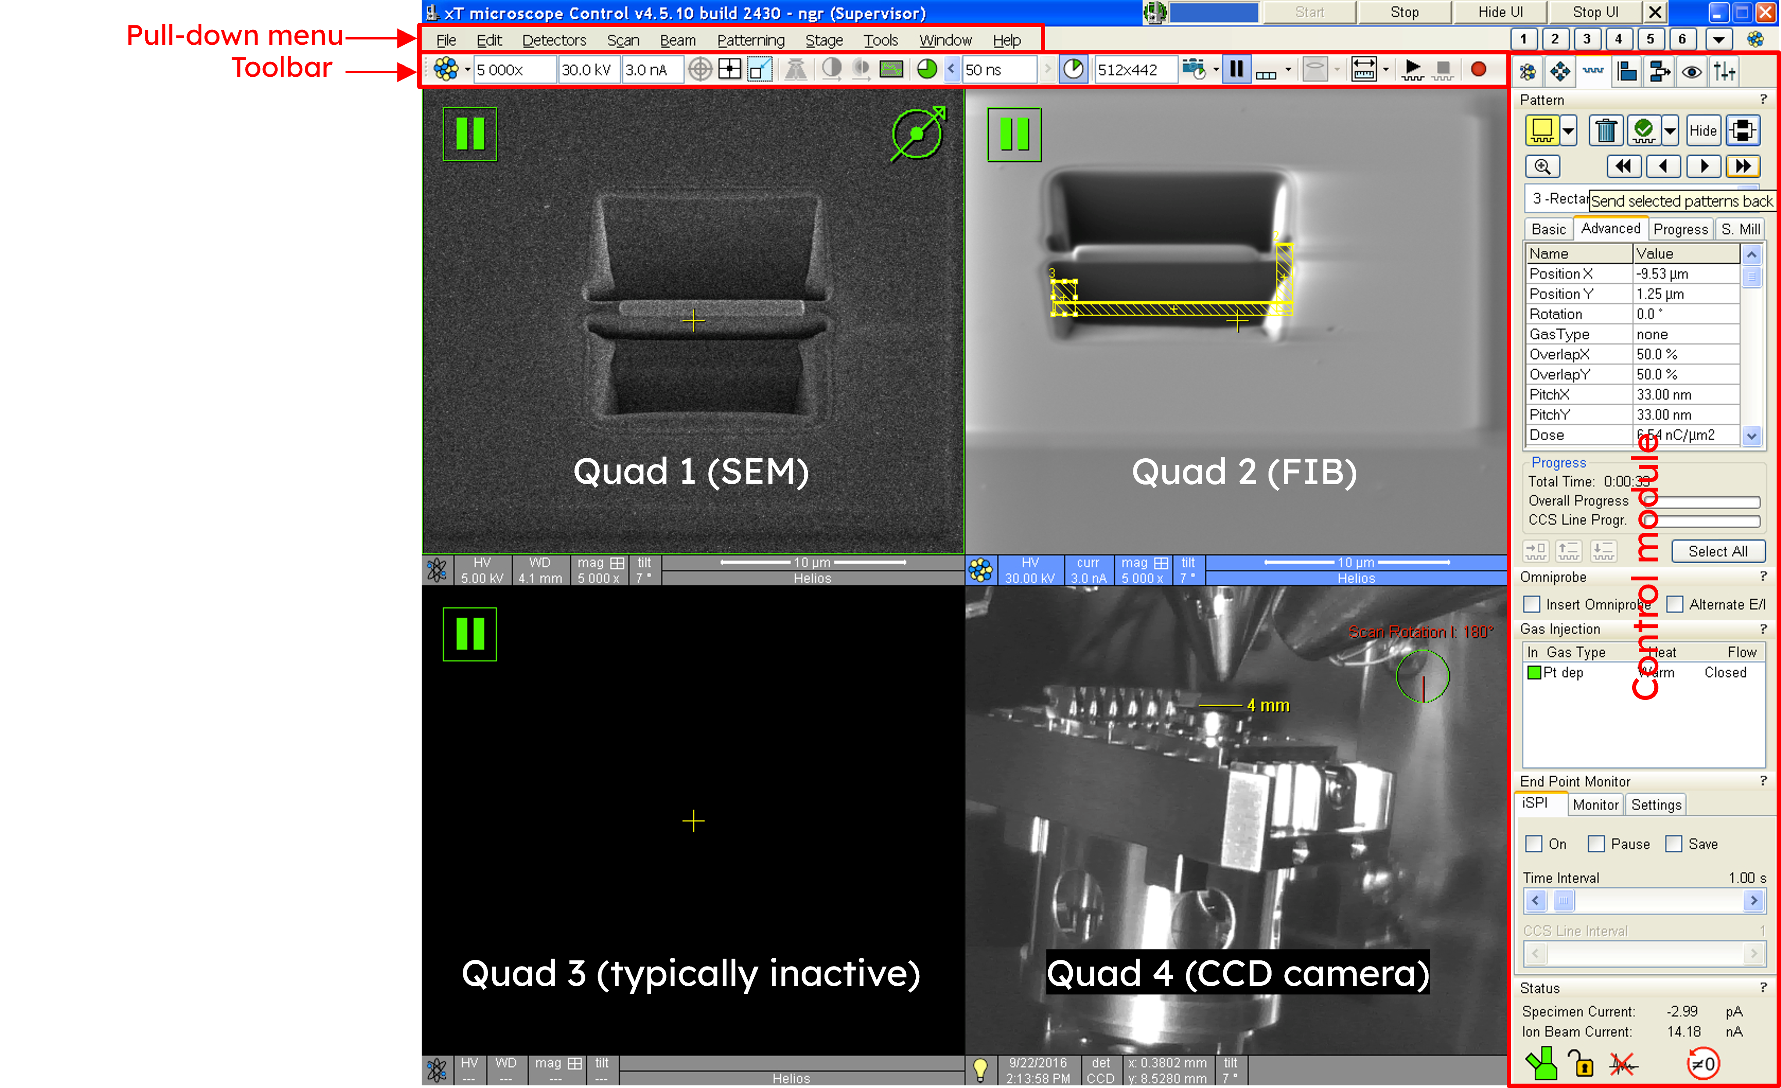
- UMB loading

  - Enter the beam control module . Under “Vacuum”, select “Vent” to start venting the chamber (about 5 min to complete); when venting is complete, gently open the chamber door.

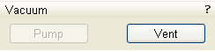

  - The instrument stage is equipped with a universal mounting base (UMB). Gloves must be worn when handling the UMB or any of its components. The UMB can hold 1 or 2 modules, which are secured in place using clamping bars. A stub module will accept 3 standard ½” diameter pin stubs, while a TEM row holder module will accept one S/TEM row holder (which itself can hold up to 6 S/TEM grids).

  - Modules should be placed onto the UMB such that the pins on the modules fall into the fifth set of slots from either end of the UMB and then secured with clamping bars (facing right side up). Be sure to snuggly (but not excessively) tighten the clamping bars.

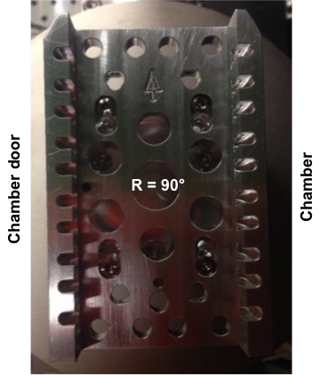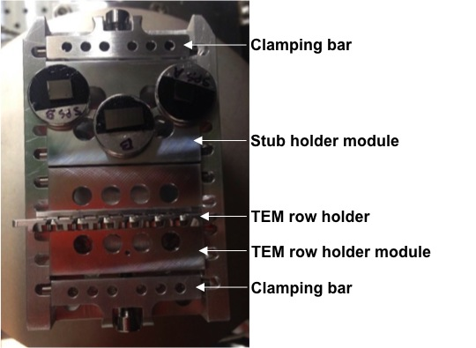

  - Once all modules are loaded onto the UMB and clamped into place, close the chamber door (make sure it is flush with the edge of the chamber) and select “Pump”; apply firm pressure to the chamber door during the initial stage of evacuation to ensure a good seal.

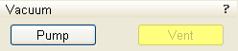
- During evacuation

  - Enter the navigator module . Under “Stage”, select the “Coordinates” tab and double click on the stored “Home” stage position to drive the stage to directly under the SEM column.

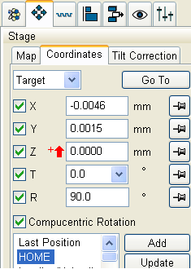

  - Activate the FIB quad and enter the beam control module. Under “Column”, check the progress bar. If the progress bar is green, the ion source is on, and no further action is needed.

  - If the FIB source is not already on, go to “System” and select “Wake Up” to turn on the FIB source (about 2 – 3 min to complete), again, the progress bar will be green once the source is on.

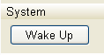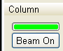

  - Enter the beam control module . Under “Magnification”, check “Couple Magnifications”; to force equal SEM and FIB horizontal field widths.

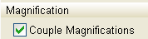
  - Activate the FIB quad and then enter the beam control module . Under “Rotation”, set “Scan Rotation” to 180°; this rotates the FIB image 180° relative to the SEM image and preserves the top-down orientation of the FIB image when the stage is tilted.

Applying the 180° scan rotation to the FIB image is a matter of personal preference but is recommended for new users; as a user becomes more experienced, he/she may decide to forgo doing this.

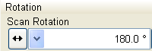

  - Activate the SEM quad. Select “Stage” from the pull-down menu and then “Zero Beam Shift” to reset the beam shift for the SEM. Activate the FIB quad and repeat to reset the beam shift for the FIB.

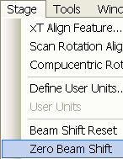

  - Check “Status” at the bottom of the currently activated control module to determine if suitable vacuum has been reached to proceed. The chamber icon will change from orange to green when ready.

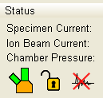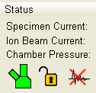

  - If Pt deposition is needed during the session, the Pt GIS needs to be warmed. Enter the patterning module. Under “Gas Injection” double click “Cold” to start heating the Pt GIS. When the Pt heating is complete (about 2 min), “Heat” will read “Warm”.

    - NOTE: Pt GIS warming cannot take place until suitable chamber vacuum is reached.

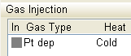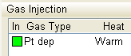

- Turning on the beams

  - Activate the SEM quad and then enter the beam control module . Under “Column”, select “Beam On” (the color will change from white to yellow). Activate the FIB quad and repeat to turn on the FIB.

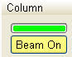

  - Along the left side of the toolbar is the beam voltage and current for the beam currently activated. Clicking on either of these numbers pulls up a list of possible options for each parameter.

- Live imaging, snapshots, and photos

  - If a live image is not actively being acquired for a selected imaging quad, will appear in the upper left corner of the quad. To start live imaging, activate the quad and select from the toolbar; to stop the live image, select from the toolbar.

  - If the live image appears faint or otherwise difficult to see, contrast and brightness on the manual user interface (MUI) can be manually adjusted until this is satisfactory, or this process can be done automatically by selecting auto contrast/brightness from the toolbar. It will usually be necessary to adjust contrast and brightness every time a beam setting (voltage and/or current) or the field of view is changed.

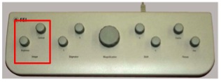

  - The dwell time used to acquire a live image can be adjusted using from the toolbar; the response of the image will be faster using shorter dwell times, but at the expense of a poorer signal to noise ratio.

    - NOTE: a dwell time = 300 ns is recommended for most live imaging.

  - “Snapshot” (low quality, low-resolution) and “photo” (high quality, high-resolution) images of the area being imaged can be acquired by selecting or from the toolbar, respectively. Once a snapshot or photo is complete, the live image will stop; in the case of a photo, a dialogue box will appear asking where to save the image.

  - Any saving of images or data from the Microscope PC must be done on the Support PC using the “Shared Data” drive. Navigate to the desktop of the Microscope PC, select “Shared Data”, and create a folder for storing data; this same folder can be accessed from the Support PC to allow for copying of data to external storage devices.

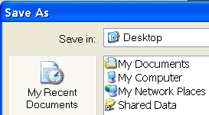

- Finding a region of interest, linking Z to the working distance (WD)

  - Activate the SEM quad and start live SEM imaging. Use the “Magnification” knob on the MUI to reduce the magnification to as low as possible, which will make it easier to navigate around. To move the stage, either double left click on a position in the image to center than position in the image or use the joystick.

  - Once a general region of interest is located, increase the magnification to see greater detail and focus the live SEM image as precisely as possible using the fine “Focus” knob on the MUI.

  - Once focused, select “Link Z to FWD” 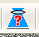from the toolbar to link the Z stage position with the WD.

- Setting eucentric height

  - Verify that the live SEM image is well focused, and Z is linked to the FWD. Failure to do so before proceeding may lead to a collision between the specimen and internal instrument components.

  - Enter the navigation module . Under the “Coordinates” tab, enter 4 mm for Z; the stage will move to WD ~ 4 mm but will probably be out of focus; refocus the image and select from the toolbar to update the WD.

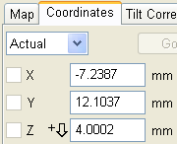

  - Set the image magnification to 1000× and center a recognizable feature in the image by moving the stage (double clicking on the image or using the joystick).

  - Go back to the “Coordinates” tab and set T = 52° to tilt the stage.

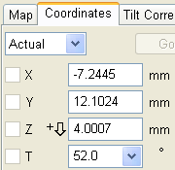

  - Go to the “Stage Z” control and use the sliding bar to shift the image up or down to bring the feature of interest back to the center of the image.

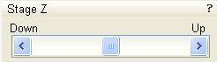

  - Go back to the “Coordinates” tab and return the stage tilt to T = 0° and center the feature of interest in the image using a mouse double click or the joystick; then refocus the image and select to update the WD again (it should still be close to 4 mm).

  - Repeat the previous four steps for an additional iteration; if this was done correctly, the feature of interest should barely shift during the second iteration and the WD should be close to 4 mm.

  - Eucentric height is now set for this location; however, if any large stage moves are performed (moving between specimens, for example), eucentric height will need to be reset at the new location.

- SEM alignment

  - Make sure the SEM quad is activated, the region of interest is at eucentric height, and a live SEM image is being acquired.

  - Find a feature of interest; on the MUI, use the “Magnification” knob to set the magnification to ~10000×, then use the fine “Focus” knob to focus the image as precisely as possible.

  - From the toolbar, select “Direct Adjustments” and then select the “Beam” tab in the “Direct Adjustments” window.

  - Select “Crossover” to and use the “Source Tilt” crosshairs to move the bright spot so it is centered on the center cross; select “Crossover” when finished to return to image mode.

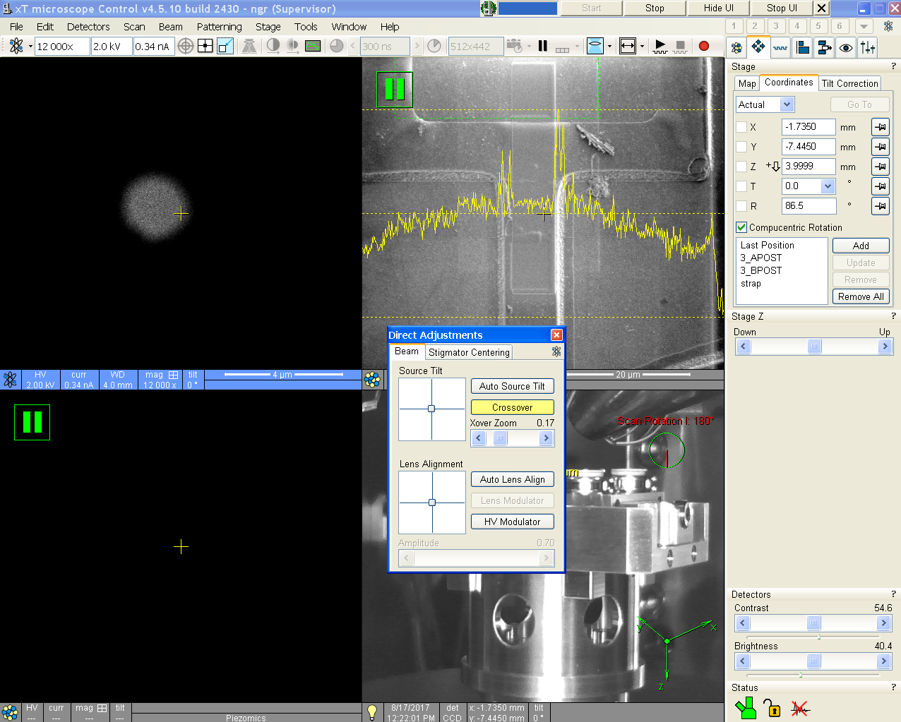

  - Leave the “Direct Adjustments” window open and select “Lens Modulator” to start modulating the final (objective) lens; the image should start going in and out of focus and/or begin shifting.

  - Use the “Lens Alignment” crosshairs to minimize any shifting of the image while it goes in and out of focus; deselect “Lens Modulator” when finished.

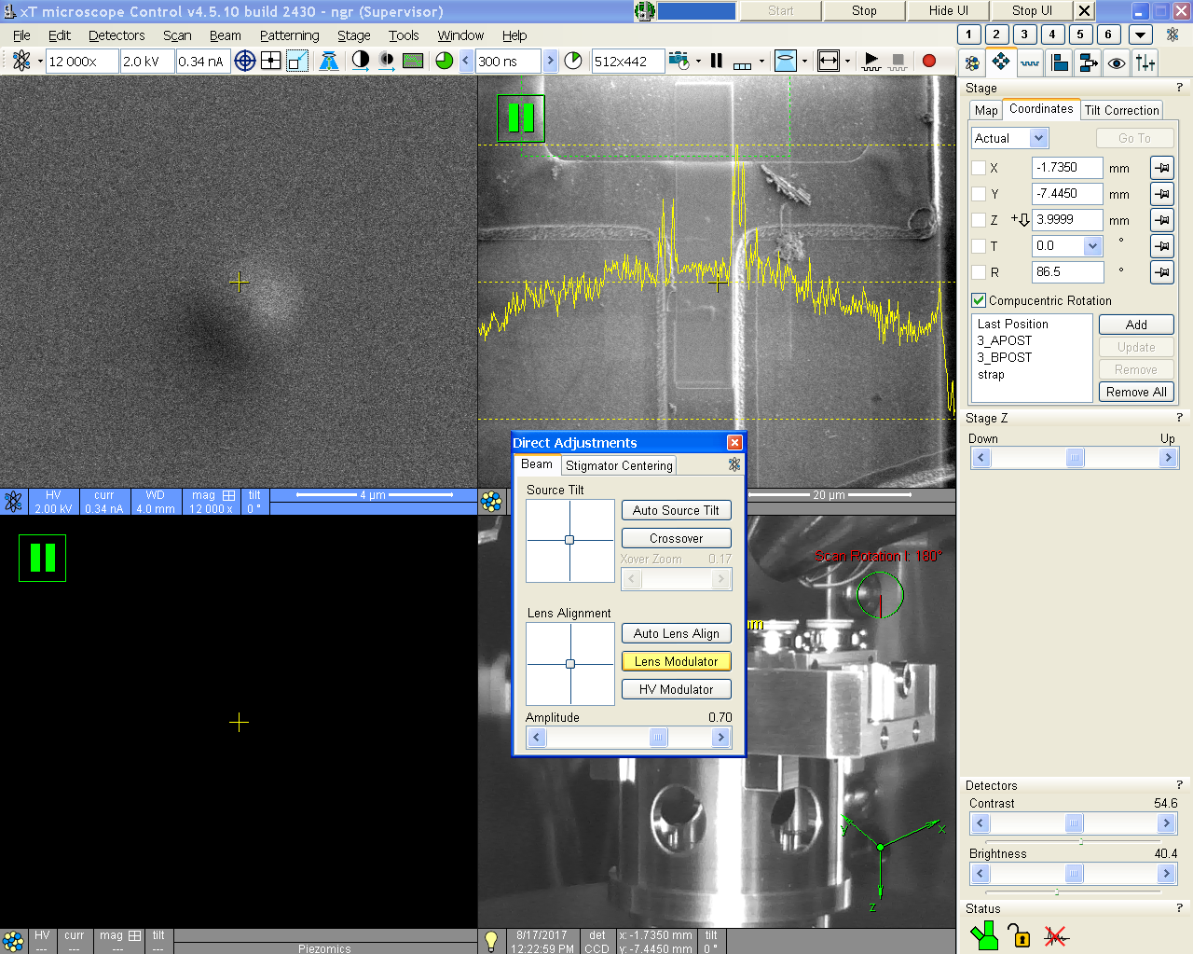

  - Use the (fine) “Focus” knob on the MUI to focus the SEM image as best as possible; then adjust the “Stigmator” knobs on the MUI to obtain the sharpest SEM image possible (iteratively refocus and readjust the stigmators until the best possible image is obtained).

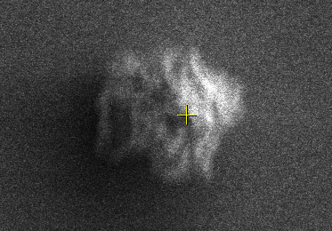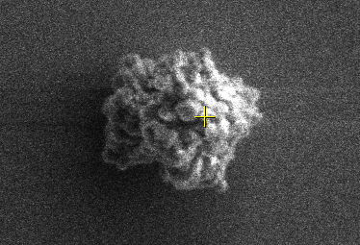

  - NOTE: SEM alignment is highly sensitive to the chosen beam settings; if the voltage and/or current is/are changed, alignment will need to be performed again to optimize the SEM image.

- FIB alignment

  - If eucentric height was properly set, the FIB alignment should not need any adjustment at the 30 kV voltage setting. However, if the FIB image appears clearly out of focus and/or astigmatic, start live FIB imaging and use the (fine) “Focus” and “Stigmator” MUI knobs to obtain the sharpest image possible.

It is advisable to do this using the “reduced area” scanning window on a region in the image that may be damaged/sacrificed by FIB exposure without consequence.

Mo in-situ lift-out grids work well for this purpose.

  - When patterning at FIB voltages ≤ 8 kV, the quad alignment (analogous to lens alignment for SEM) may be adjusted to obtain the best possible results. Start acquiring a live FIB image; use the “Magnification” knob to set the magnification to ~5000 × and select “Direct Adjustments” to open the “Direct Adjustments” window.

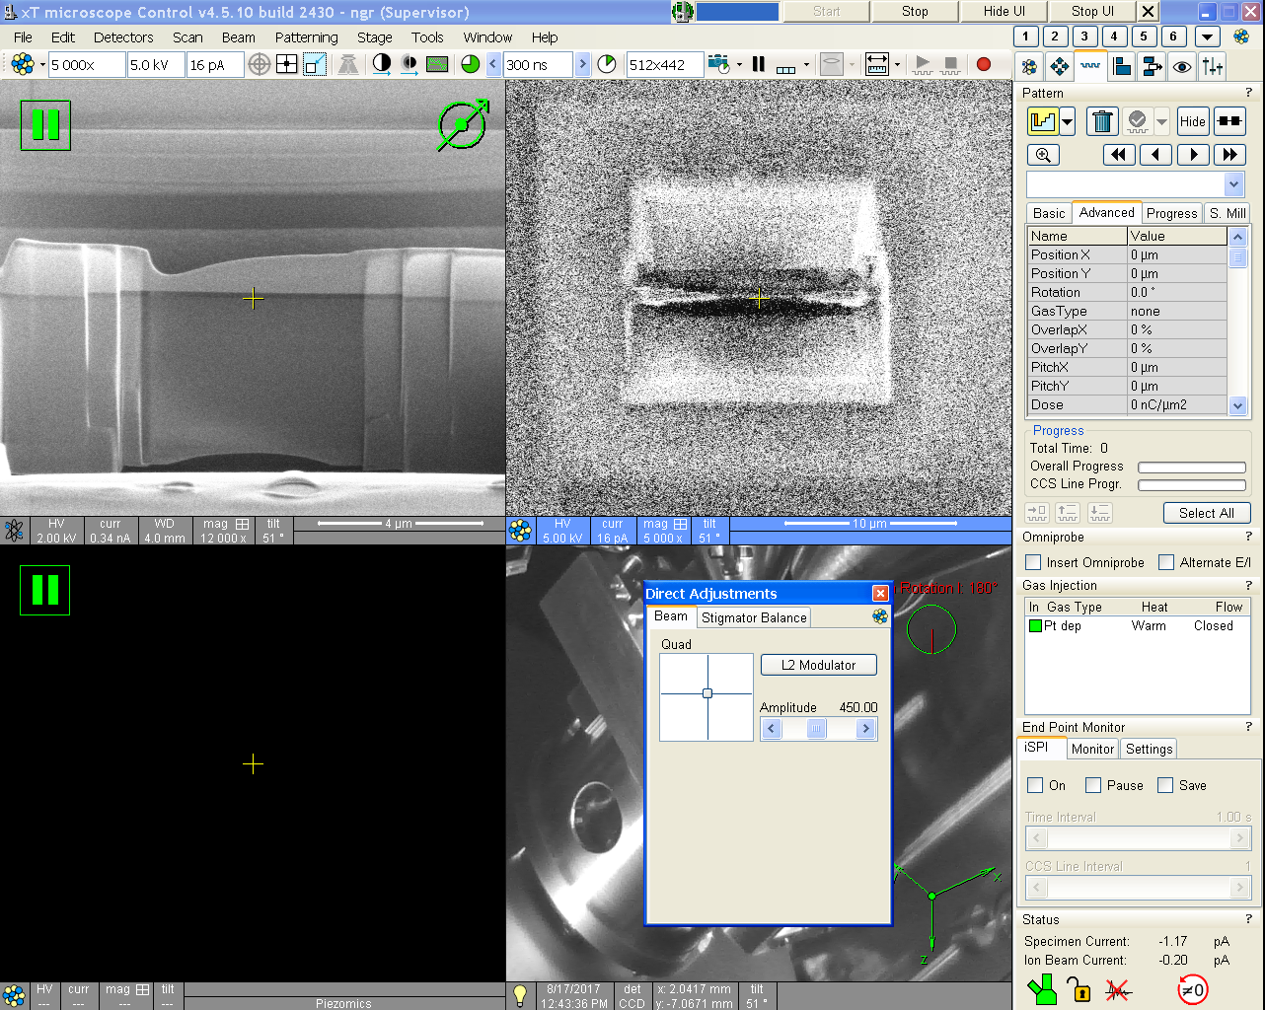

  - In the “Direct Adjustments” window, select the “Beam” tab and then “L2 Modulator” to start modulating the final lens (L2); the image should start going in and out of focus and/or shifting.

  - Use the “Quad” crosshairs to minimize any shifting of the FIB image while going in and out of focus; deselect “L2 Modulator” when finished.

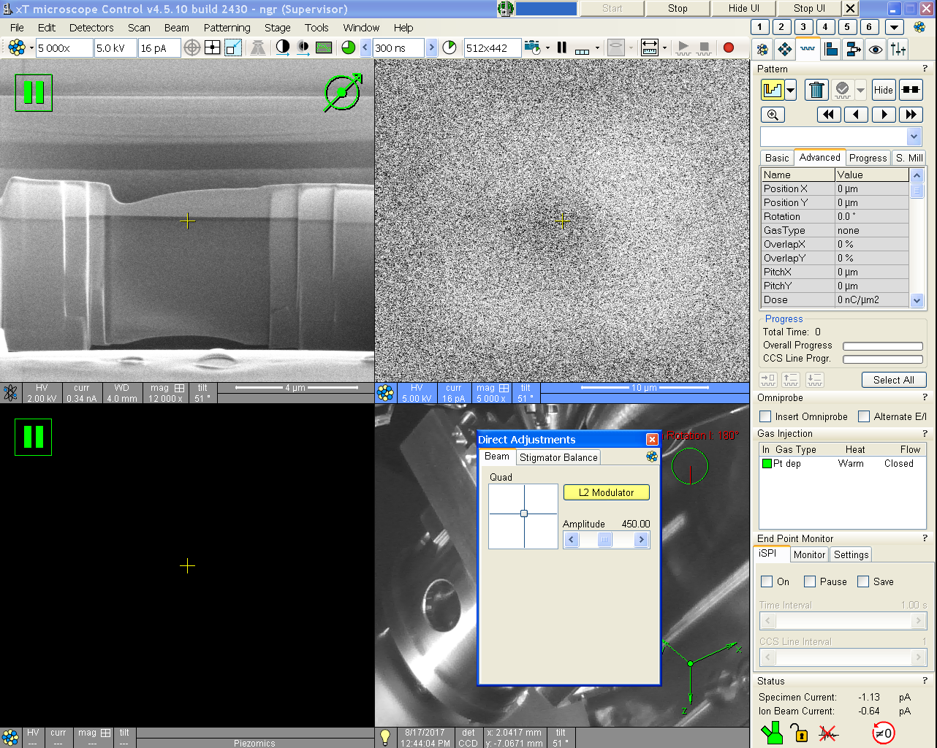

  - Use the (fine) “Focus” knob on the MUI to focus the FIB image as best as possible; then adjust the “Stigmator” knobs on the MUI to obtain the sharpest FIB image possible (iteratively refocus and readjust the stigmators until the best possible image is obtained).

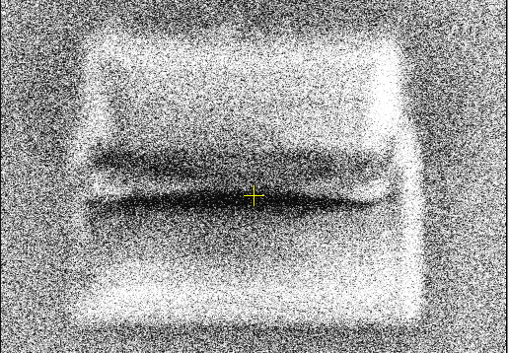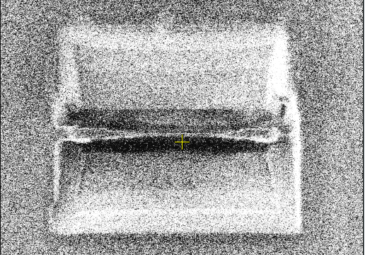

  - NOTE: FIB alignment is highly sensitive to the chosen beam settings; if the voltage and/or current is/are changed, alignment will need to be performed again to optimize the FIB image.
- Linking the beams

  - The area of interest must be at eucentric height before attempting to link the beams.

  - Set the magnification to 1000× and center a feature of interest in the SEM image by moving the stage (again, this should be in the near vicinity of the point where eucentric height was established).

  - Activate the FIB quad, set the beam voltage and current to 30 kV and 10 pA, and start live imaging.

    - NOTE: once an area is exposed to the FIB, the surface can be damaged/altered; if the surface of the specimen needs to be preserved, it therefore must be sufficiently protected before FIB exposure occurs.

  - Use the “Shift” knobs on the MUI (do not move the stage) to center the same feature of interest from the SEM image in the FIB image.

NOTE: if the FIB scan rotation was set = 180° the FIB image will be rotated 180° relative to the SEM image.

  - The link state of the beams will change with the stage tilt. In other words, if the stage is tilted from T = 52 to T = 0°, the beams will need to be linked again (though the adjustment shouldn’t be extremely large). Likewise, the link state of the beams may also change if the beam settings are adjusted, particularly as the FIB voltage is reduced (though again, the adjustment to correct this shouldn’t be extremely large).

- Electron beam induced deposition (EBID) of Pt

  - The region of interest for Pt EBID must be at eucentric height; Pt EBID is usually performed for the purpose of initial, damage-free protective strap deposition and should be performed at stage tilt T = 0°

  - A SEM beam voltage of 2 kV (to enchance the secondary electron yield) with several nA of current is recommended for Pt EBID. Activate the SEM quad and acquire a snapshot of the region.

    - Again, note that if changing the SEM settings, the SEM will need to be realigned as described previously.

  - Enter the patterning module; under “Gas Injection”, verify the “Heat” field is reading “Warm”. Under “In”, check the green box to insert the Pt GIS and take another snapshot.

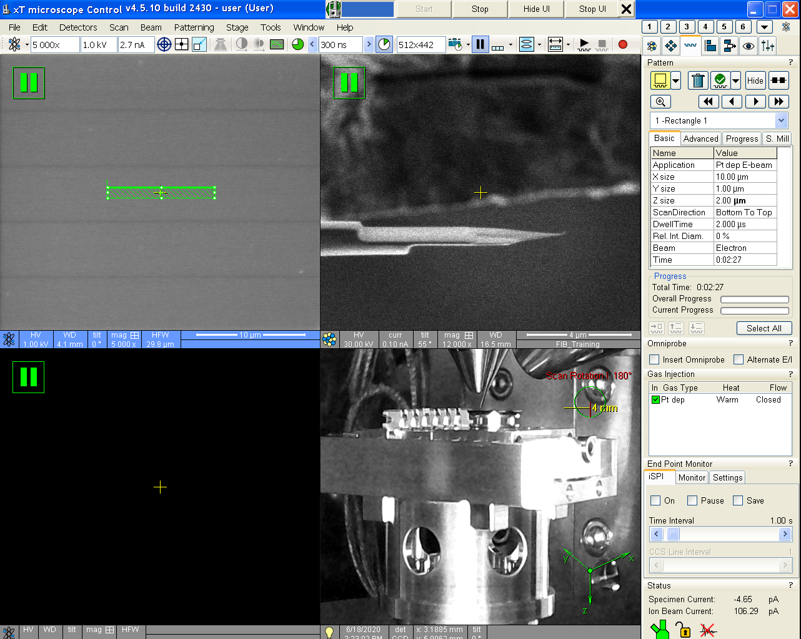

  - Enter the patterning module; under “Pattern”, select the rectangle pattern and click and drag on the SEM quad. In the “Basic” tab, set “Application” = “Pt SEM 2 kV” (the pattern should turn green) and specify the pattern dimensions.

  - Select “Start Patterning” from the toolbar to start the Pt EBID.

  - Once the Pt EBID is complete, return to the “Gas Injection” panel and under “In” uncheck the green box to retract the Pt GIS.

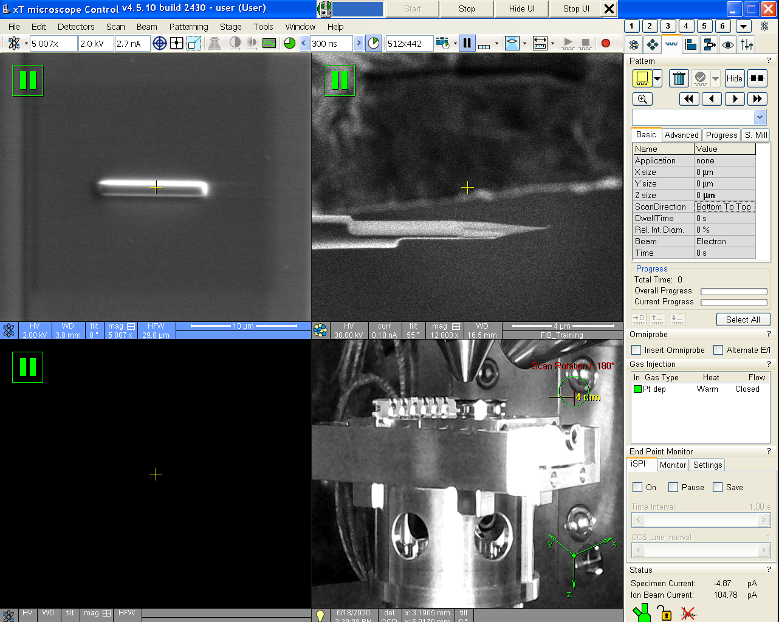
- Ion beam induced deposition (IBID) of Pt

  - The region of interest for Pt IBID must be at eucentric height; Pt IBID may be performed for protective strap deposition (often on top of Pt EBID) or to weld two surfaces together (e.g., lamella to grid); stage tilt T = 52° and T = 0° will typically be used for these two applications, respectively.

  - A 30 kV FIB voltage is optimal for Pt IBID on this instrument; the beam current for the deposition should be selected such that a current density of ~5 pA/µm² is targeted.

E.g., if the area for Pt IBID is 15 µm², 15 µm² × 5 pA/ µm² = 75 pA; the two closest available FIB currents to 75 pA are 50 and 100 pA.

If there are two potential FIB currents to use for deposition, it is generally best to use the smaller option; therefore, continuing with the previous example, select 50 instead of 100 pA.

  - Enter the patterning module; under “Gas Injection”, verify the “Heat” field is reading “Warm”. Under “In”, check the green box to insert the Pt GIS and take another snapshot.

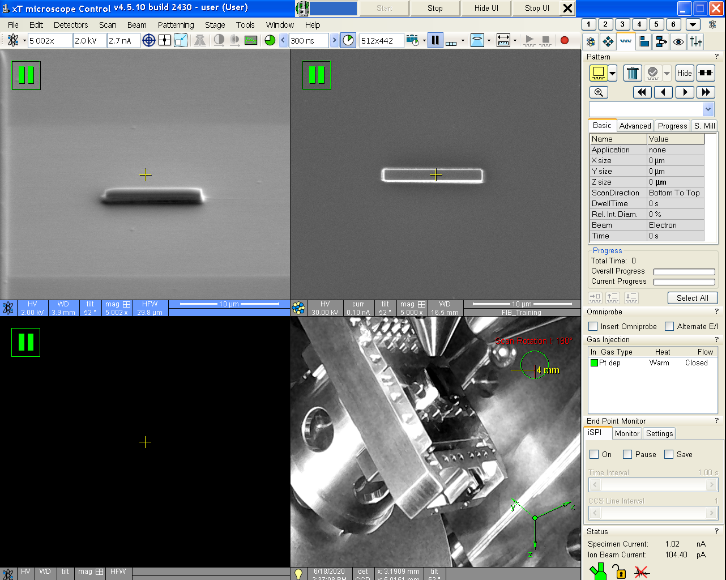

  - Enter the patterning module; under “Pattern”, select the rectangle pattern and click and drag on the FIB quad. In the “Basic” tab, set “Application” = “Pt FIB” (the pattern should turn green) and specify the pattern dimensions.

  - Select “Start Patterning” from the toolbar to start the Pt IBID.

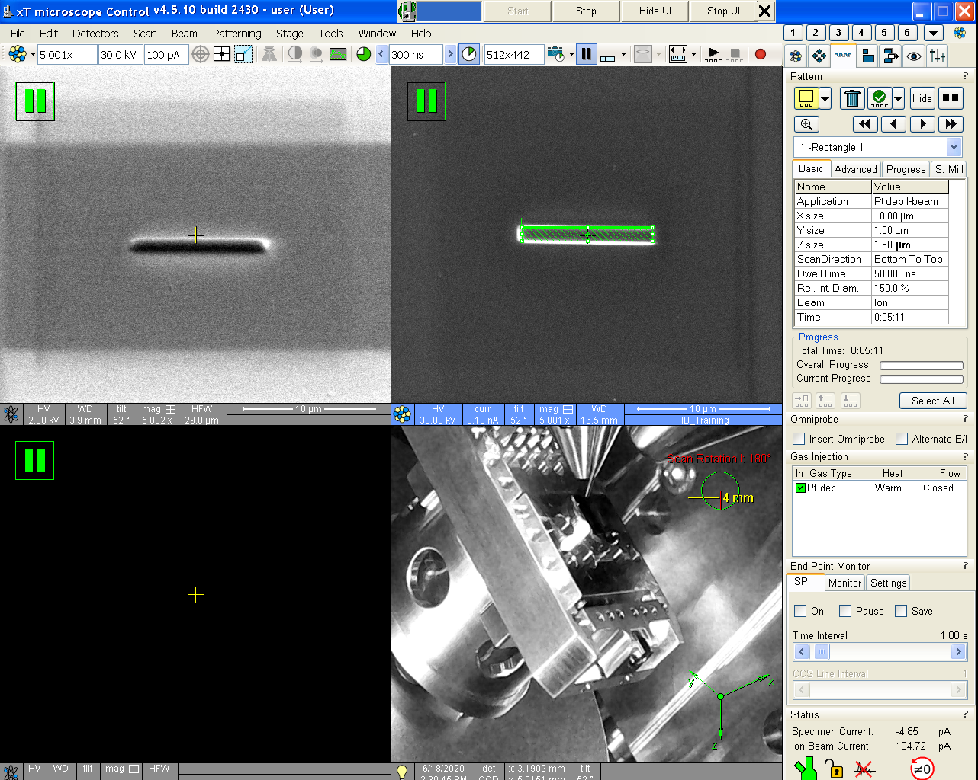

  - Once the Pt IBID is complete, return to the “Gas Injection” panel and under “In” uncheck the green box to retract the Pt GIS.

  - Under “Gas Injection”, check the green box under “In” to insert the Pt GIS; a dialogue box will pop up asking you to confirm this. Then take one more snapshot image ; if any shifting of the image occurred, move the pattern as needed.

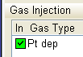

  - Select from the toolbar to start the pattern.

  - Once the pattern is complete, retract the Pt GIS by unchecking the green box under “In”. NOTE: if the Omniprobe is inserted at the same time as the Pt GIS, the Omniprobe should be moved clear (and freed, if necessary) of any nearby surfaces/objects before attempting to retract the Pt GIS. Otherwise, this could result in rupturing of a Pt weld between a specimen and grid or between a specimen and the Omniprobe.

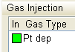

- Milling

  - The region of interest where milling is to be performed must be at eucentric height with the beams linked before attempting milling or milling may not work as expected.

  - Enter the patterning module 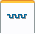. Under “Pattern”, there are several different options available. The most used during specimen preparation are the rectangle , regular cross-section , and cleaning cross-section patterns. Once a pattern type is selected, click and drag on the FIB quad to produce a pattern.

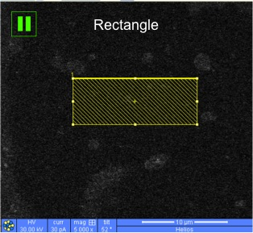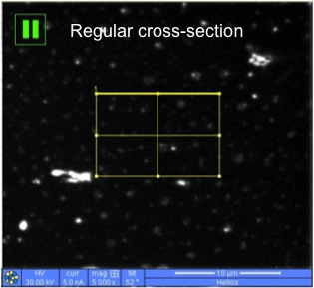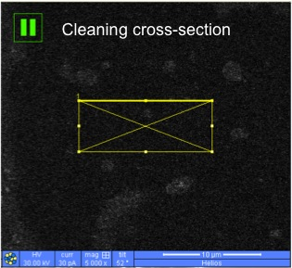

  - In the “Basic” tab next to “Application”, select “Si” (the pattern should turn yellow). If specific dimensions are needed for the pattern, those can also be entered under the “Basic” tab. If the rotation of the pattern needs to be adjusted (relevant for regular and cleaning cross-sections), this can be done in the “Advanced” tab under “Rotation”.

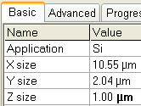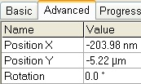

  - If more than one pattern was drawn, the order of execution can be changed under “Pattern” by selecting  for parallel execution or 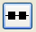 for serial execution. If serial execution is selected, the patterns will be executed in order of being drawn.

  - Once all patterns have been drawn and positioned as needed, take a snapshot FIB image ; if any shifting of the image occurred, move the pattern(s) as needed. When ready, select from the toolbar to start milling; if the pattern needs to be stopped prior to completion, select from the toolbar.

  - To erase a pattern from the image, simply select it in the FIB quad and then select .

- Using the Omniprobe

  - The region of interest must be at eucentric height with stage tilt T ~ 0° before attempting to insert the Omniprobe; otherwise, the Omniprobe will likely crash when inserted.

  - Enter the patterning module . Under “Omniprobe”, check “Insert Omniprobe”.

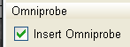

  - The Omniprobe inserts into the “Park” position, which is well above and away from the region of interest. In Autoprobe (left monitor) under “Location Storage”, select “Eucentric High” and then “GOTO”; this automatically moves the Omniprobe to the middle of the SEM image and ~300 µm above the specimen surface. The “GOTO” button will change to “MOVING” during movement and then return to “GOTO” when finished.

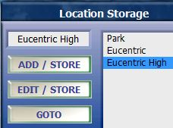

  - Use “Probe Controls” to bring the Omniprobe down to the specimen surface; clicking on the button in the middle of the arrows will change the control from “XY” to “Z” and vice versa. The Omniprobe speed can be adjusted under “Velocity”; generally speaking, the speed should be reduced as the Omniprobe gets closer to the specimen surface to allow for more precise positioning.

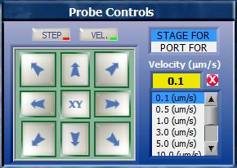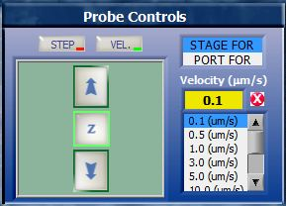

  - In the SEM (FIB) image with scan rotation = 0° (180°), the Omniprobe movement directions in the XY (Z) panel will correspond to same directions in the respective images (see below).

    - It is usually best to use the live SEM image when adjusting the XY Omniprobe position.

    - It is usually best to use the live FIB image when adjusting the Z Omniprobe position.

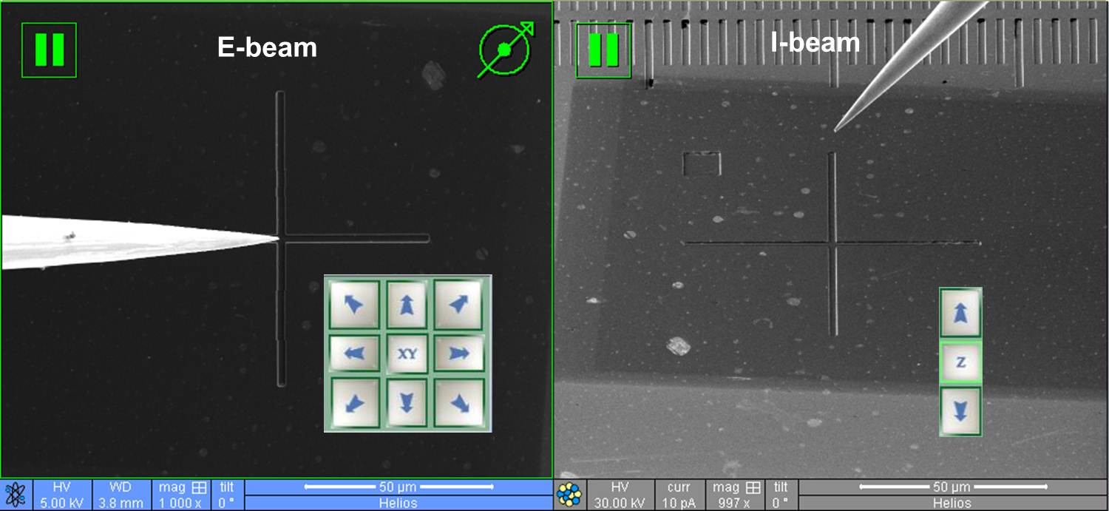
  - When finished using the Omniprobe, enter the navigation module ; use the “Stage Z” control to lower the stage so the Omniprobe is at least several µm clear of anything (grid, specimen surface, etc.).

  - In “Autoprobe”, go to “Location Storage”, select “Park”, and then “GOTO” to move the Omniprobe to the park position. Under “Current Positions”, the X, Y, and Z values will be like what is shown below once park position has been reached. the “Stage Z” control and use the sliding bar to shift the image up or down to bring the feature of interest back to the center of the image.

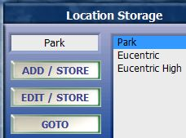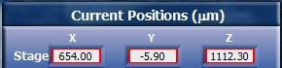

  - When the Omniprobe is finally in “Park” position, enter the patterning module and under “Omniprobe”, uncheck “Insert Omniprobe” to retract the Omniprobe.

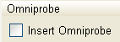
- Live imaging while FIB patterning

  - The SEM can be used to live image patterning being performed by the FIB. After starting a pattern , simply activate the SEM quad and select from the toolbar to start acquiring a live SEM image during patterning; manually adjust contrast and brightness on the MUI to make the SEM image more easily viewable. Also note that the live SEM image will be less noisy the higher the ratio of SEM current to FIB current.

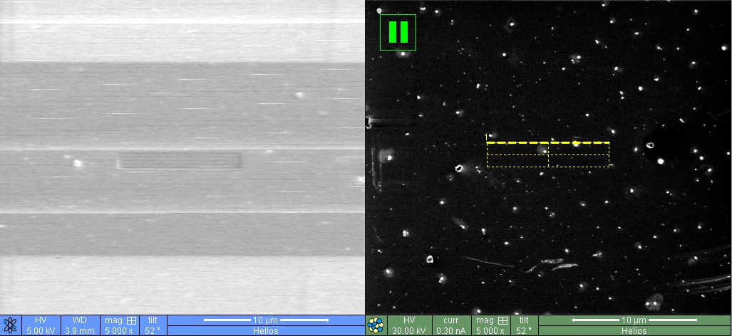

  - It is also possible to observe a live FIB signal from the regions that are being patterned (but not the whole FIB image). After starting a pattern , activate the FIB quad and select ; a live signal from the regions being actively patterned will appear. If the patterned area is large enough, it may be possible to observe an actual image of the region. Again, contrast and brightness using the MUI may need to be adjusted so this can be observed.

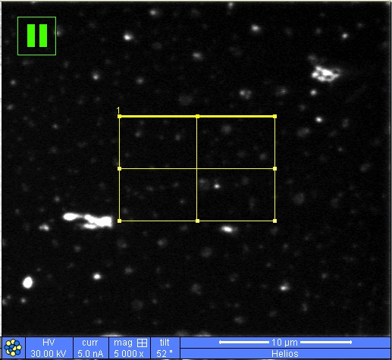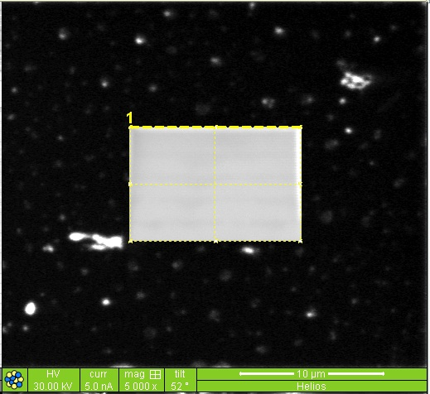
- Finishing the session

  - Activate the SEM quad and enter the beam control module . Under “Column”, select “Beam On” to turn off the beam (the color will change from yellow back to white). Active the FIB quad and repeat to turn off the FIB.

  - If the next user is physically present in the facility at the time the session is ending, the ion source may be left on for the next user; otherwise, it should be put to sleep to help maximize its lifetime (see next step).

  - If the ion source needs to be put to sleep at the end of the session (which should be done if the next user is not physically present in the facility), activate the FIB quad and remain in the beam control module. Under “System”, select “Sleep” to turn off the ion source. Under “Column”, the progress bar should turn white (a few seconds to complete).

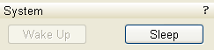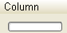

  - Enter the navigator module . Under “Stage”, select the “Coordinates” tab and double click on the stored “Loading/Unloading” stage position to drive the stage accordingly.

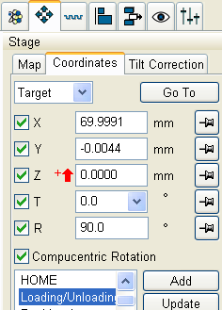

  - If the Pt GIS was used, enter the patterning module . Under “Gas Injection” double click “Warm” to turn off heating of the Pt GIS .

  - Once the stage finishes driving to the loading/unloading position (verify using the live CCD camera image), the chamber may be vented as described previously.

  - Once the chamber is vented, remove the modules from the UMB (please be careful not to lose any items down the opening to the turbo pump), the chamber may be pumped down as described previously.

