
CAMECA SXFive FE EPMA

Standard Operating Procedure Rev. 2026-01

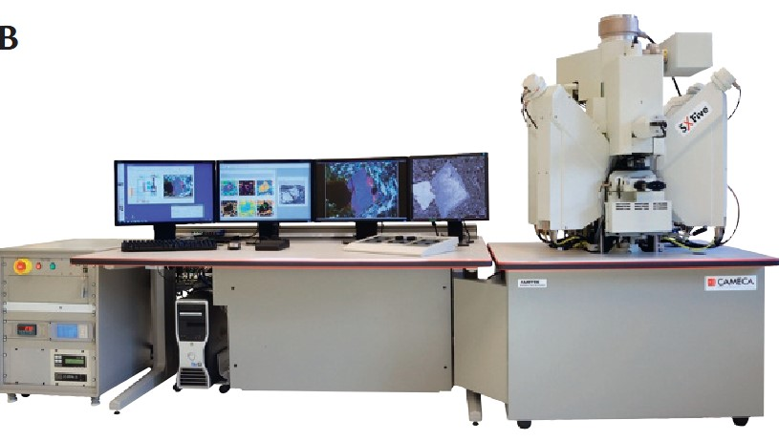

  - Application
Field Emission Electron Probe Micro Analyzer for Quantitative Analysis and X-Ray Mapping with Sub-Micron Spatial Resolution. The SXFiveFE provides:
- Field emission source and SEM with 6nm resolution @ 25-30keV.
- Automation capabilities for-long term unattended analysis.
- Quantitative analysis at submicron scale.
- High quality minor and trace element analysis.
- Mapping at high spatial resolution.
- High precision WDS spectrometers for high reproducibility.
- Detection limits down to 100ppm (0.01%)

  - NRF Contact
  - Kristy Shepker, Andres Trucco

Table of Contents
1. Safety information 3
2. Prerequisites for use 3
3. Pre-Operation 3
4. Peak Sight Software Overview 4
4.2. SX Control 5
4.3. Setting and Acquisitions 6
4.4. SX Results 7
5. EPMA Sample Exchange 8
5.1. Sample In: 8
5.2. Sample Out: 11
5.3. Instrument Standby Mode 12
6. EPMA Crystal Exchange and Spectrometer Verification 12
7. Calibrations 14
8. Quantification 16

- Safety information
DANGER! Do not remove the covers of the instrument. Do not modify the instrument.
    - High Voltage - High Voltage is used throughout the system. System maintenance may only be performed by NRF Staff. Do not remove any tool covers or defeat any interlock on this system.
    - Do no walk behind the instrument.
    - Gloves must be used when handling samples and sample holders.

- Prerequisites for use
- User of the RSC facilities.
- Up-to-date hazardous waste training.
- Instrument training by staff.
- User will be responsible for lost or damaged equipment due to negligence. Negligence means not following the SOP, not asking staff for assistance, intentionally damaging items, etc.

- Pre-Operation
  - Tool Reservations may be made via the NRF Reservation Page.
  - Change gloves. WARNING No solvents or liquids are allowed near the machine, change your gloves before operation!! Must wear gloves while handling samples and sample holders to reduce in chamber contamination.
  - Log into the TUMI computer to enable the instrument.

- Peak Sight Software Overview
Peak Sight is a suite of module tools that can be accessed via the SX-AppBar. SX-AppBar is anchored to the left of the main screen. The AppBar is divided into five modules: Control, Analysis, Position, Data and Utilities.
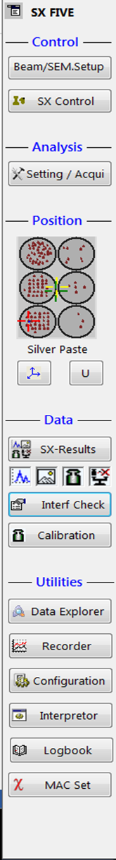
    - SX Control has all the instrument control settings. It allows access to vacuum conditions, operate gate valves, sample introduction and removal, tune beam conditions, electron microscope set up and imaging, optical camera set up, and select parameters for the WDS spectrometers.
    - Settings and Acquisitions program. Allows to define and edit settings, analyses, and batch files used for the acquisition of WDS spectra, electron and X-ray profiles images, quantitative calibrations and quantitative sample analyses. Settings files, contain information about the configuration of the instrument, such as beam energy and X-ray measurement parameters. Acquisition files contain a list of sample locations where measurements are performed. Acquisition files can be combined into a chained list or batch file for unattended operation.
    - Position module displays an overview of the installed sample holder, with live sample and beam locations. It allows us to change the installed holder and access more detailed sample information, is accessible within the SX-Control menu in the Stage/Roller tab (link). It is possible to move to an approximate stage position by double-clicking on the desired location in the Position pictogram on the SX-AppBar. The exact XYZ coordinates after the move will be shown in the Stage/Roller tab (link) and within the optical image display (link).
    - SX-Results program allows us to display and process all types of acquired data. This interface is used for visualization and processing of WDS qualitative and quantitative spectra, images, X-ray intensity, calibrations and quantitative analyses.
    - Interference Check is a program for evaluating potential X-ray overlaps, given a list of analyzed and present elements, measured at a certain beam energy.
    - Calibration(link) button opens a display of the X-ray intensity calibration database.

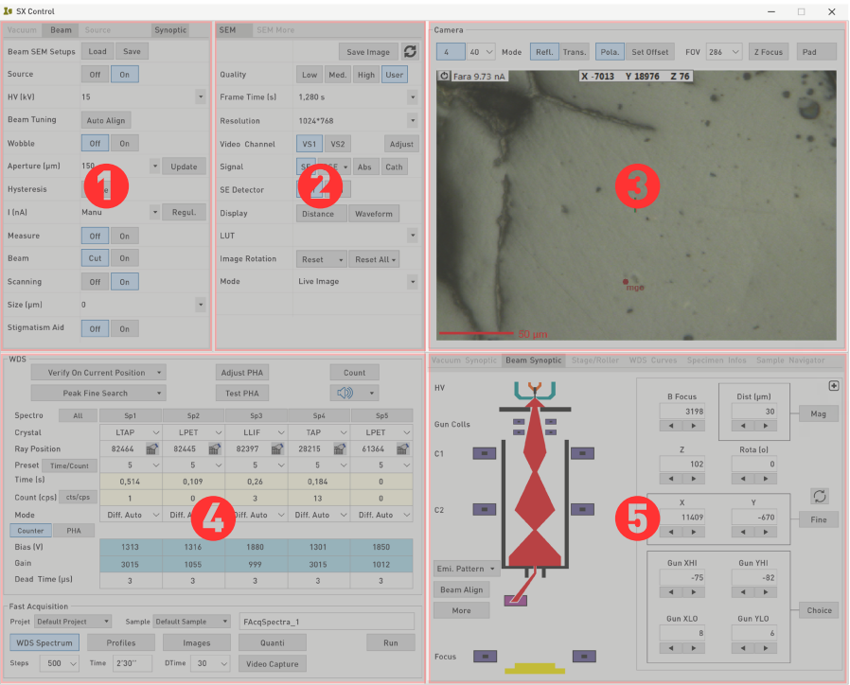
  - SX Control

Four dedicated panels are always available:
1. Upper left panel: Vacuum/Beam (link)
2. Upper center panel: Scanning Electron Microscopy (SEM) (link)
3. Upper right panel: Camera or Real Time Monitor (RTM) (link)
4. Lower left panel: Wavelength Dispersive Spectroscopy (WDS) (link)
5. Lower right panel: Displays various information, such as Vacuum, Beam Synoptic, Stage/ Roller, Specimen Info, WDS Curves and Sample Navigator program by selecting any of the dedicated tabs.
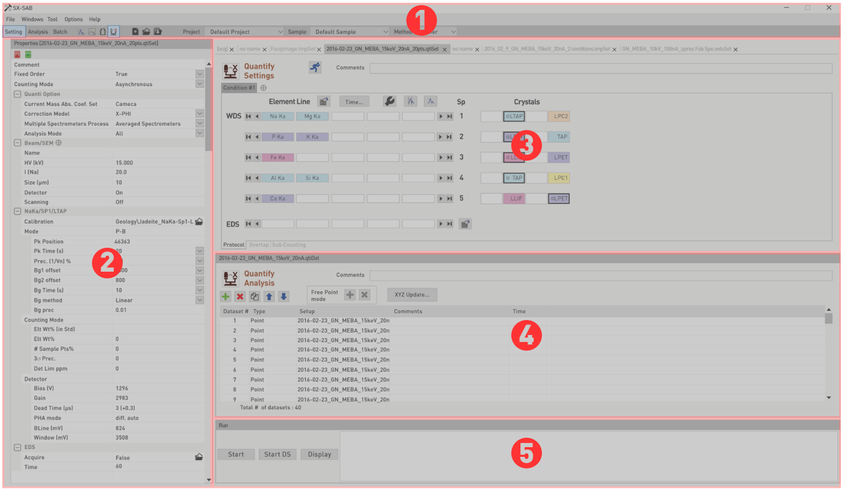
  - Setting and Acquisitions

The SX-SAB window is divided into five parts as follows:
1. Menu, shortcuts, and project bar
2. Properties
3. Setting
4. Analysis or Batch
5. Run and machine status

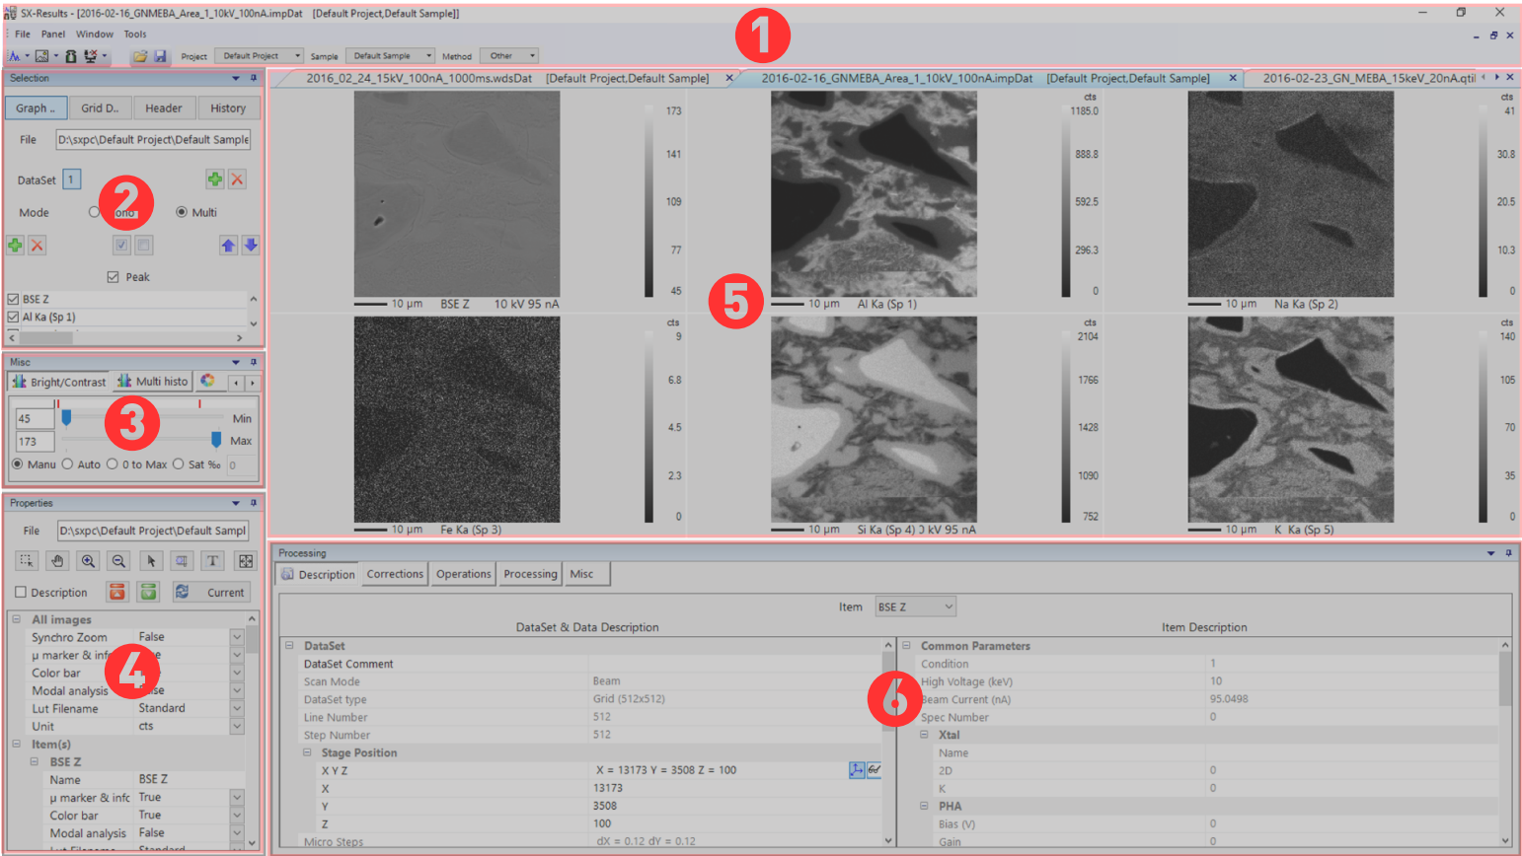
  - SX Results

SX-Results window is divided into six parts as follows:
1. Menu, shortcuts, and project bar
2. Data selection
3. Miscellaneous tools
4. Properties
5. Result viewer
6. Processing tools

- EPMA Sample Exchange
Disclaimer:
Failure to follow these steps will cause severe damage to vacuum systems, windows and field emitter and will be considered negligence from the user.
Note: You must wear gloves before handling samples and any sample holder.
On Sx Control select Vacuum tab to access Sample Exchange In/Out.
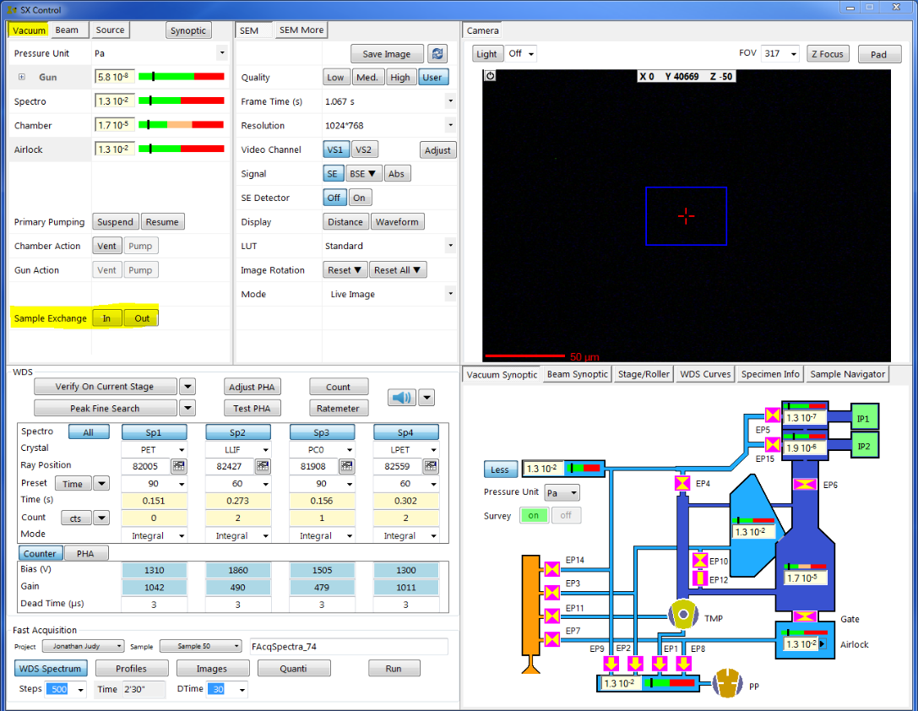

  - Sample In:
Ensure Airlock is vented. If not, go to Vacuum Synoptic, right click over Airlock diagram and select Vent Airlock.
Warning! (Gate valve should be closed before venting Airlock, black lever down position)
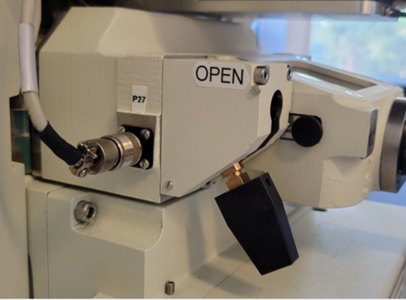
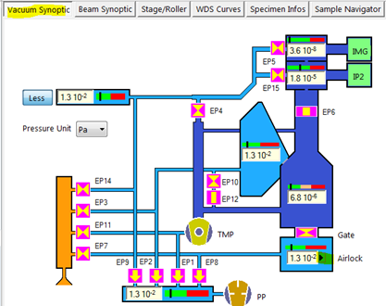

    - Open the Airlock chamber and insert the cassette into the holder and push until it clicks. Close the Airlock.
Warning: Unused set screws in the sample holder will fall down into the stage. Make sure they are removed before loading.
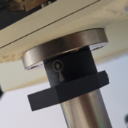
    - Spin the collar to the “In” position. Arrow pointing in.

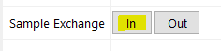
    - Press Sample Exchange In on the Vacuum Tab.
A window will appear asking if the airlock is ready to be pumped (closed). Press OK.

The system will pump down the airlock and prompt the window below when ready.

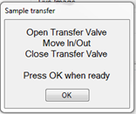
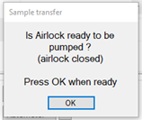
Do not press OK until you follow the steps below :
- Wait for Airlock Vacuum to reach 1.3E-2Pa.
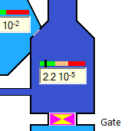
- Open gate valve (press in and up).
- Insert sample by pushing in black lever with both hands then remove back.
- Close gate valve. (Turn right and down)
- Wait for the vacuum chamber to reach 1E-4Pa. (In the meantime, proceed to 5.1.4)
- Press Ok on the sample exchange window.
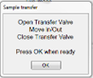

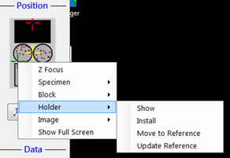
    - After the sample is inserted, make sure appropriate holder is installed and add your new blocks (1”piece) by right clicking over the Position window. To install a new block select: Block / Install over your block location and give it a name then press New Block.

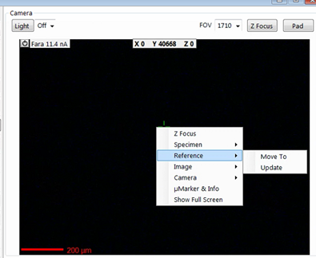
    - Hover over the optical image window, right click and press reference / move to.

    - Align the cross arrow with the optical screen and ensure image is in focus. Right click and select: Reference / Update
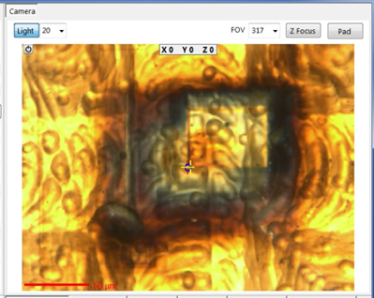

  - Sample Out:
If you are finished with the instrument, Cut the beam, turn off camera Light and set Scanning Off. Set current to C2 = 3800 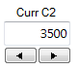.

    - Select Vacuum Synoptic 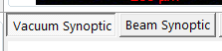, to display vacuum values.
    - Go to the Vacuum tab, select Sample exchange Out. (This will move the sample to the unload position and pump down the airlock).
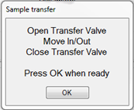
    - The Window below will appear.

    - Open the Gate Valve. (Push in and Up)
    - Move the black collar so the arrow is pointing out.
    - Insert the arm into the chamber until it stops.
    - Retract the arm. (The cassette with your samples should be visible in the Airlock)
    - Close the Gate Valve.( Turn right and down) (Wait for main chamber vacuum reach 1.4E-4Pa or below )
    - Press OK on the Load/Unload window. (The Airlock will automatically vent wait 30s before opening.)
    - If you are done with the system, remove your sample and set screws from the cassette, place the cassette back into the Airlock and close it. Hover over the airlock with the mouse, right click and select: Pump Airlock.
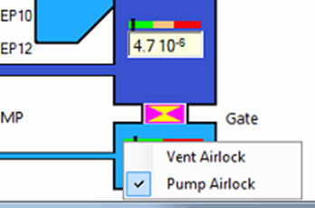
Warning: Make sure Airlock door is closed
before proceeding. Remove any set screws used
to hold your samples. Set screws left in the cassette
will fall inside chamber jamming the stage and
causing expensive repairs.

  - Instrument Standby Mode
    - Make sure C2 is set to 3800 and optical microscope light is turned off.

- EPMA Crystal Exchange and Spectrometer Verification
It is imperative that when you start using the instrument or change a crystal this procedure is performed.

    - On SX Control, WDS section, select the appropriate crystals from the drop-down tab for each Spectrometer.
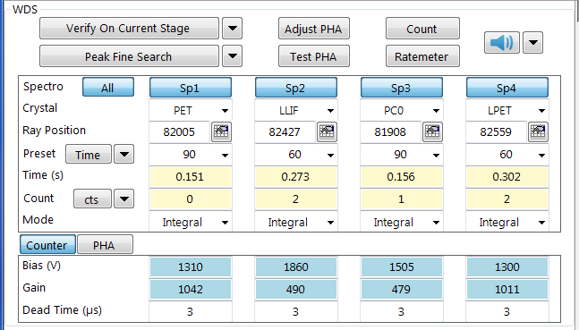
    - Using the Position tool on the SX FIVE bar, click on the icon. Make sure the HO6 holder is installed and in the chamber with all the standards. Refer to sample Exchange SOP.
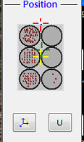

    - Select Block GEOMK 2 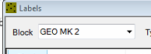 then double click on Andradite.
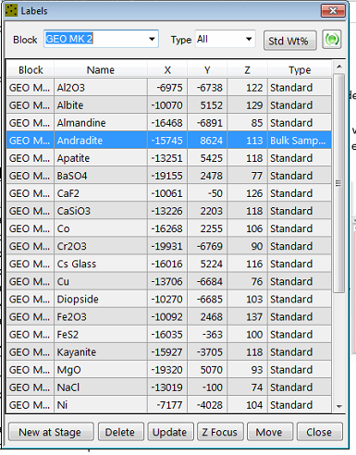
    - The stage will move to Andradite on the GEO MK 2 Standards Block.
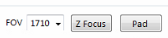
    - Turn On Camera Light. Focus on the surface of the sample by selecting Z Focus on the Camera window. This will auto focus the image.

    - Drive to a clean area on Andradite and press on the Labels window to refresh standard’s location.
    - Set C2 to 2050. Under Beam Tuning, Press Fine Align (wait for it to complete). Adjust C2 to get 20nA of current. Measure must be On and beam Cut to read current measurements.
WARNING: Standards a sensitive to beam current. Use 20nA or below when measuring/imaging standards. Failure to do this will cause damage to the standards.

    - Turn scanning On and Beam On. Focus the SEM image on the surface of Andradite using Fine Focus on the control consol.
    - Turn scanning back Off and Beam Cut set the beam to 20um in size to avoid damaging the standard.
    - On the WDS Window select all four spectrometers and press . You will see the spectrometers move and Spectrum readings appear on SX Control / WDS Curves.
    - Once Verification routine ends, press. Wait for procedure to finish then press.

Crystals are now verified and Peak Height Adjustment (PHA) calibrated.

Note: If crystals are changed any time during your session, this procedure will have to be performed again on the spectrometer containing the flipped crystal.
- Calibrations
    - Allocate your elements to the proper spectrometers and crystals. Make sure you have identified the necessary standards and have calculated the background offsets. This can be done using an Excel sheet and a WDS scan of your sample using all spectrometers to identify offsets for the backgrounds.
    - Load the holder with the calibration standards in the chamber. Refer to: Sample Exchange SOP.
    - Make sure spectrometers are verified. Refer to: Crystal Exchange Spectrometer Verification SOP.
    - Set the proper aperture and set current to 10nA, for sensitive standards, 20nA for all other standards.
Warning: Sensitive standards will be damaged if measured with current larger than 10nA. Refer to the standards list to identify sensitive ones.

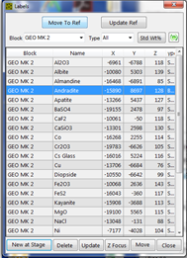
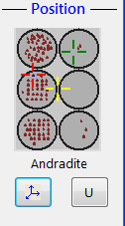
    - Under the Position module, open the Position list 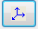and drive to the desired standard location. Focus 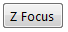 on the surface with the optical image using the smallest field of view 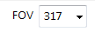 and the location on the position list. (This is important for background measurements done during calibrations.)

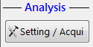
    - Using the SEM image, focus on the surface of the sample.

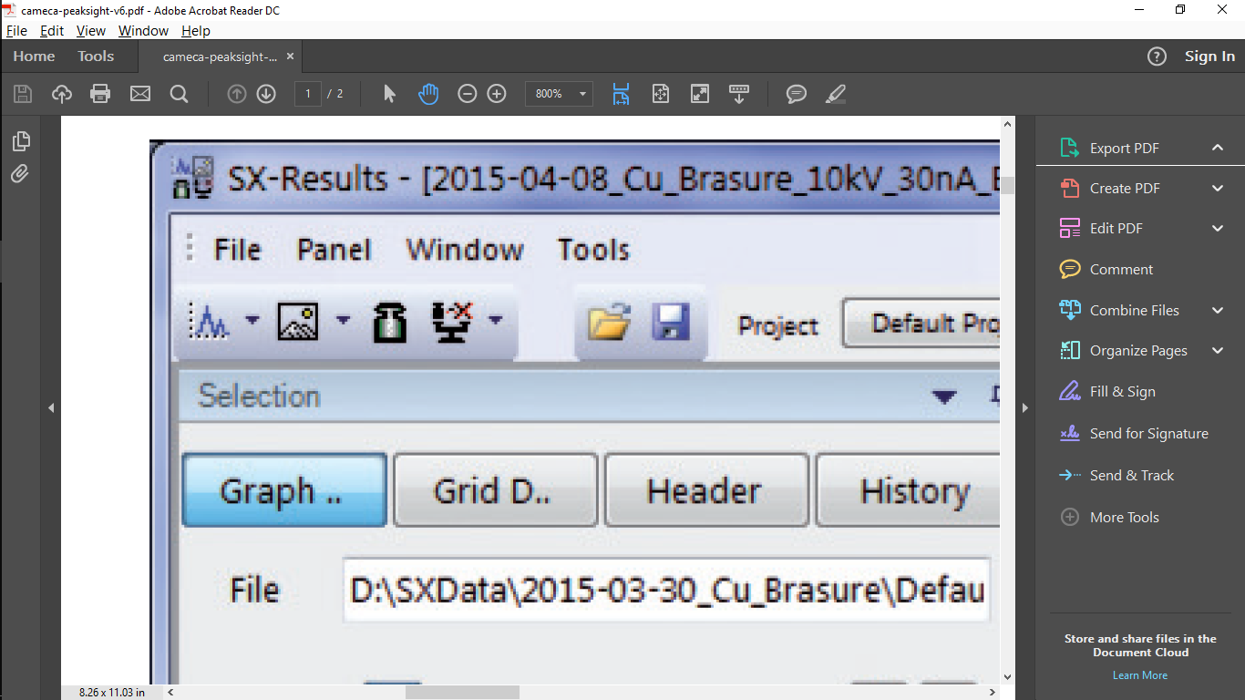
    - Open Setting / Acquisition module , select Settings then Calibration and New . A Calibrate Settings file will open.
Note: You can only select one element at the time. For each element you will generate a new calibration settings file.
    - Open the periodic table on the desired spectrometer and click on the element to be calibrated. Adjust the Pk Time(s), Bg1 offset and Bg2 offset. At the bottom, double click on the standard file icon and select the desired standard from the pop-up list.
    - Press the Acquire Now button (running men). This will save the Settings file and create and link the setting file to a new Analysis file.
    - On the analysis file press the + button to add point locations to be measured on the standard. You can double click on the optical image to go to a new location and add to the list. Pick at least 4 different locations on clean areas of the standard. You should use the SEM image to pick point locations as the optical image may drift.
    - After points are selected, set the beam diameter to 10 to 20um. Cut the beam and turn scanning off. Verify the beam current is at or below 20nA before running.

    - Press Start. This will prompt saving the calibration file. Do not change the name. If the same file already exists, press Append File.
    - The software will announce the end of the calibration. Check the standard deviation and make sure it is below 5%.
    - For the next element to calibrate, go back to step 7.1.5 and repeat process.

- Quantification
    - Go to Settings and Acquisitions Settings Quanti button New
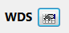
    - Select elements with the WDS button.
    - Select calibration for each element (choose the latest date for needed setup)
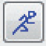
    - Change Quanti Option Analysis Mode to “By stoichiometry” (optional)
    - Click the Acquire button -----------
    - Accept interference warnings.
    - Name and save this set-up file.
    - Right click Data Type on the left menu to select acquisition type (Point/Map/Line)
    - Select points.
- 1st point will be current position by default.

    - Drive to point and focus
- Read location
- Add comments to point (optional)
- Drive to a new area and Click Green + to add new point.

    - Set Focus frequency and Beam measure frequency for each data set or use Common settings to override all dataset selections.
    - Ensure your setup name is loaded beside your points.
    - Check that your beam parameters are set correctly, beam size and current.
    - Click Start to begin acquisition. (Make sure you select all data sets or single data set)
    - Name and save your file.

