
FEI Talos F200i S/TEM
  - Basic TEM mode standard operating procedure Rev. 2026-01
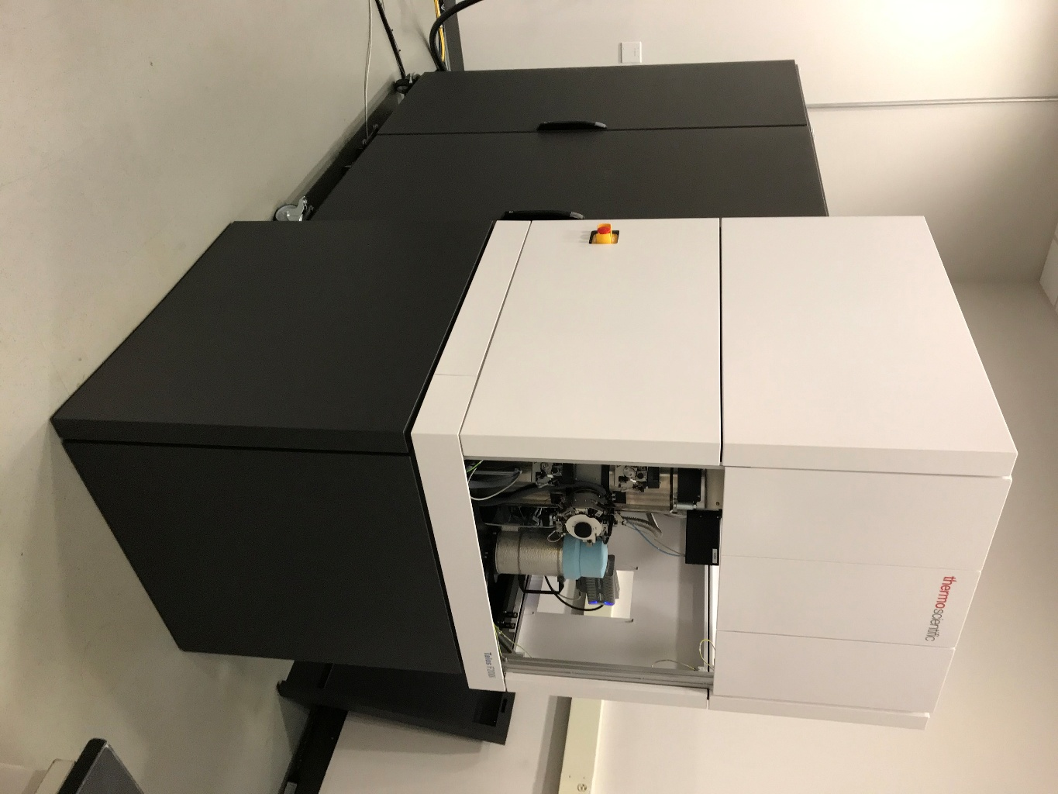

  - Application
The FEI Talos F200i S/TEM is a state-of-the-art non-corrected field emission gun scanning/transmission electron microscope capable of providing micro- to sub nm-scale structural, morphological, and chemical information. This document covers operation of the instrument for conventional (TEM) mode imaging, performing EDS surveys in TEM mode, and using the FluCam to collect SAED patterns. Please see separate SOP documents on the NRF instrument page regarding other applications.

  - NRF Contact
Nicholas G. Rudawski
Table of Contents

1. Safety information 3
2. Prerequisites 3
3. High tension settings 4
4. Filling the cold trap dewar 5
5. Removing the single-tilt holder from the column 5
6. Grid loading 6
7. Loading an alignment file 9
8. Gun alignments 10
9. Spot size 11
10. Finding a region of interest 12
11. Setting eucentric height (coarse) 13
12. C2 aperture alignment 14
13. Condenser astigmatism correction 16
14. Beam tilt pivot points; fine-tuning eucentric height 17
15. Rotation centering 19
16. Specimen orientation adjustment (single crystals or isolated grains) 20
17. Objective aperture selection and centering 23
18. Imaging in Velox; correcting objective astigmatism 25
19. Magnification changes 29
20. Using Mh mode 30
21. Finishing with the Ceta camera 31
22. FluCam selected area diffraction 32
23. EDS in TEM mode 40
24. Grid exchanges; finishing the session 49
25. Cryo cycling (if needed) 53

- Safety information

  - Due to stipulations of the instrument service contract as well as contamination concerns, analysis of radioactive and/or biological specimens with this instrument is strictly prohibited.

  - Please use caution when inserting the holder into the airlock for a possible pinch point between the holder base and the airlock cover plate.

- Prerequisites

  - Successful completion of the S/TEM Prerequisite Training online course through elearning.

    - NRF staff may consider waiving this requirement for a user with prior extensive (and documented) hands-on experience operating S/TEMs.

- High tension settings

  - The default high tension (HT) = 200 kV is sufficient for analyzing most inorganic non-biological materials and specimens, but the instrument may also be operated at HT = 80 kV.

    - NOTE: the instrument was set to HT = 200 kV for this entire document.

  - If considering operation at HT = 80 kV, please discuss this beforehand with NRF staff to determine if this may be an appropriate option.

  - To set HT = 80 kV, select the “Vacuum/HT” tab, and then the “High Tension” control panel.

    - Select 80 kV from the pull-down list; DO NOT select any other values as the system is not configured for use at any other HT settings.

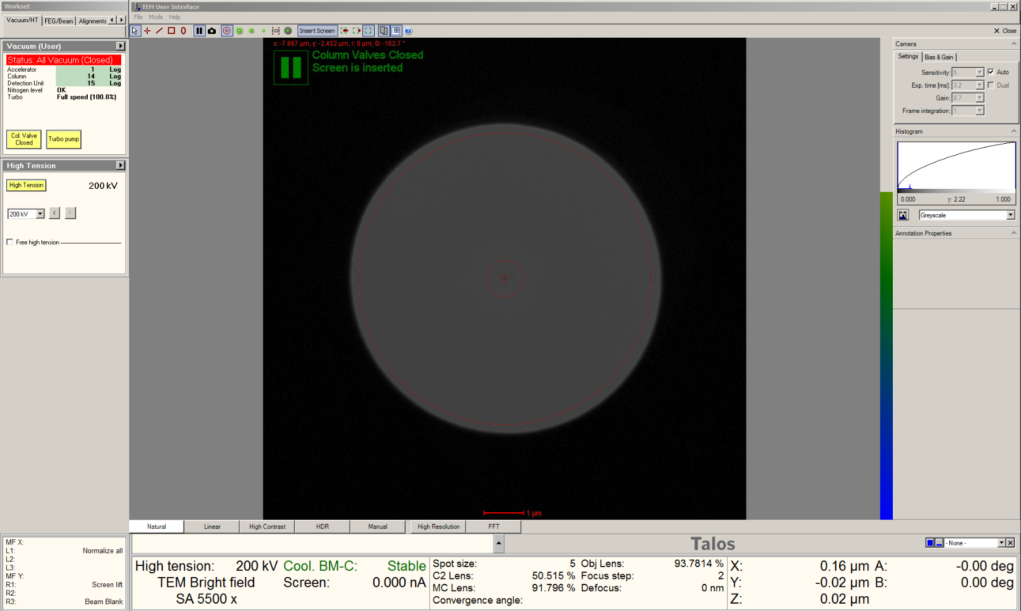

- Filling the cold trap dewar

  - The first user of the day will need to fill the cold trap dewar with liquid N₂ before using the instrument; use of the cold trap helps to reduce sample contamination during imaging and improve the column vacuum (though it does not cause any actual sample cooling).

  - Guide the Cu braid cold fingers into the dewar and then position the cold trap dewar on the stand in the enclosure.

  - Fill the cold trap with liquid N₂; after ~5 min, top off the cold trap with more liquid N₂.

  - Cover the top of the cold trap with the Styrofoam cap.

  - After filling the cold trap, it may be >15 min before the column vacuum reaches the highest level, but the system may be used immediately if the vacuum level is acceptable (described subsequently).

  - If the cold trap was already in place and filled during a previous session that day, it is recommended to top it off before starting the session.

- Removing the single-tilt holder from the column

  - Gloves must always be worn when handling the holders; this is to reduce the introduction of hydrocarbon contamination into the column.

  - The single-tilt holder is to be left inserted into the column when the instrument is not actively in use to help keep the airlock and column clean.

  - Pull the holder straight out until it stops.

  - Rotate the holder clockwise ~150° until it stops.

  - Pull the holder straight out of the airlock (there will be some resistance).
- Grid loading

  - In Microscope Control, select the Vacuum/HT tab and then the “Vacuum” control panel; verify the column vacuum is acceptable (green) before proceeding.

  - Load a grid into the desired holder; if using the double-tilt holder, use extreme caution when screwing/unscrewing the Be hex ring into/out of the basket; do not overtighten and/or apply excessive downward force as this may damage the sapphire screws (indicated by arrows) securing the basket in place (costing ~$3000 to fix).

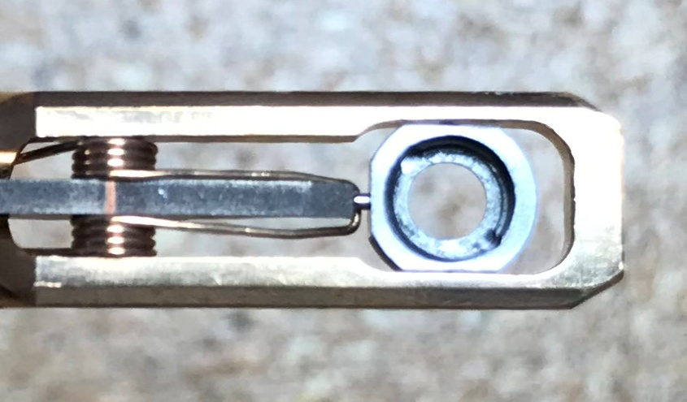

  - Please also be aware that the Be anti-twist washer and hex ring for the double-tilt holder are small, delicate parts and may easily be lost or damaged if mishandled and/or not properly secured in the double tilt-holder (costing ~$1000 and ~$3200 to replace, respectively).

  - Please also be aware that it is critical that the grid, anti-twist washer, and hex ring (as appropriate) is/are properly secured into the selected holder before insertion of the holder into the column; should any of these pieces fall out of the holder upon insertion into the column, this may cause a blockage of the beam path inside the microscope rendering it unusable and requiring a service call to split the column open to retrieve the parts (which is not covered by the service contract).

  - One should (if permissible) plasma clean the holder and grid before inserting into the column; cleaning for 2 – 4 min is usually effective for most Omniprobe grids with non-carbonaceous lamella specimens.

  - Please note that while plasma cleaning is usually very effective at mitigating hydrocarbon contamination, its effectiveness is not perfect, and some may still occur during analysis (particularly if no cleaning was performed prior to insertion). The NRF is not responsible for hydrocarbon contamination to specimens occurring during S/TEM analysis.

  - Line up the triggering pin on the shaft of the holder with the line at ~5 o’clock on the airlock opening; push the holder into the airlock until it firmly stops; if the pin was properly aligned, the holder should insert up to the tape mark indicated on the shaft.

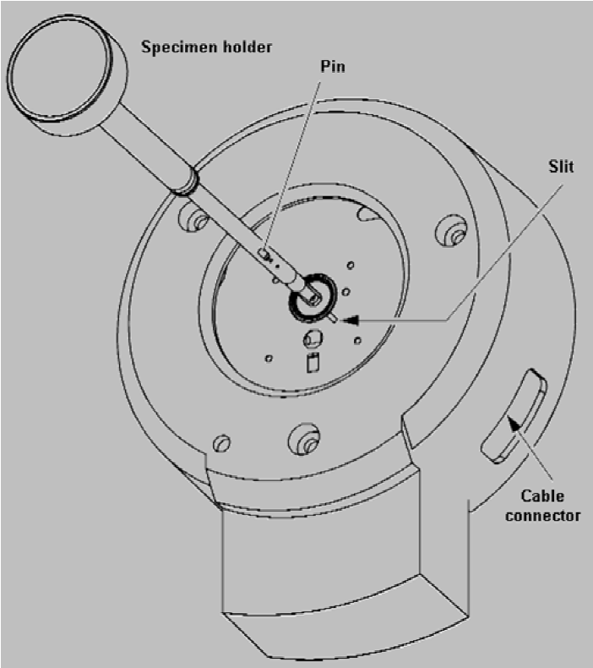

  - The red LED on the airlock will turn on; if the turbo pump is running at full speed, the airlock valve will open and airlock evacuation will begin (otherwise, the valve will open once the turbo pump is at full speed; this will take ~2 min).
  - In Microscope Control, select the holder being used in the bottom information panel; if using the double tilt holder, plug in the cable connection on the outside of the airlock and confirm this in Microscope Control.

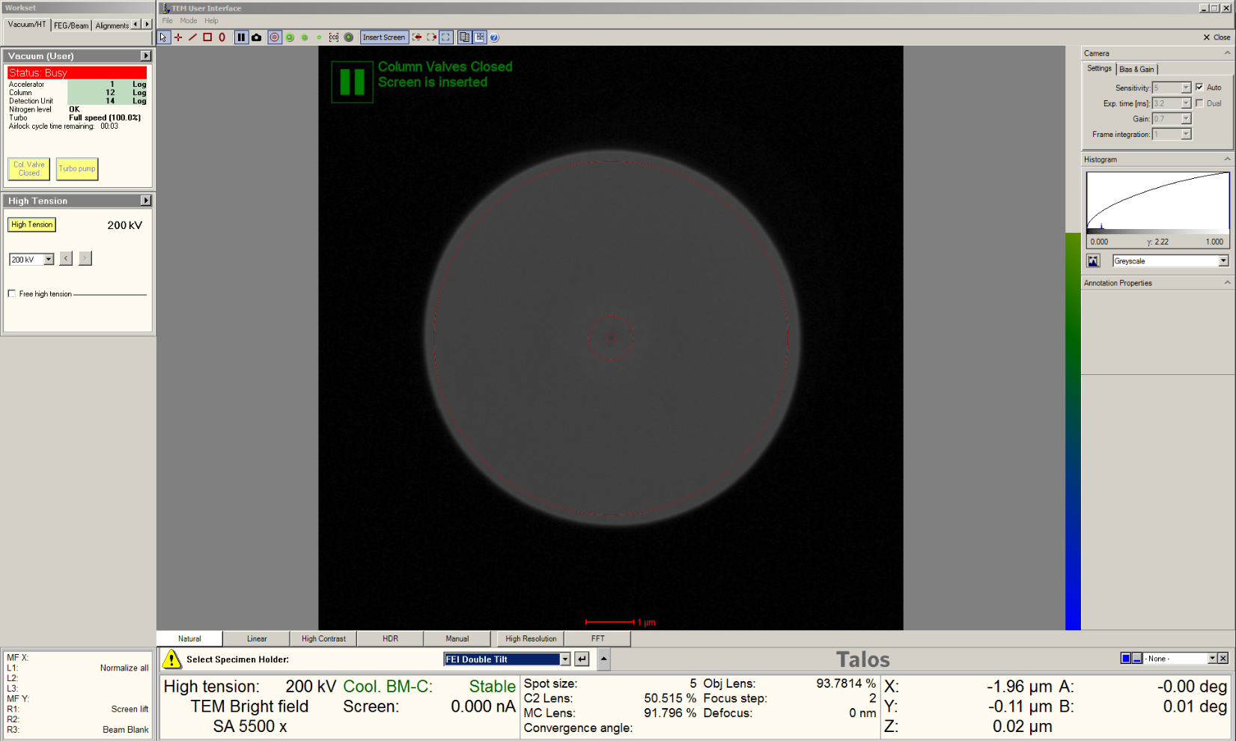

  - When evacuation is complete (~2 min), listen for the airlock valve to close and the red LED will turn off; if it appears that evacuation did not complete as expected, do not proceed further; contact RSC staff for advisement to prevent a possible vacuum crash. Next, slowly rotate the holder counterclockwise ~150° until a firm stop is felt; then maintain tension on the holder as the vacuum slowly pulls it all the way into the column (to prevent a collision and maintain the column vacuum).

  - Check the “Vacuum” control panel and verify that the “Column” vacuum is still acceptable (green); it may be higher than the initial value after insertion of the holder, but this is otherwise not of any concern (not shown).

- Loading an alignment file

  - Select the “Alignments” tab and then the “Alignments” control panel; select the flap-out arrow and then the “File” tab.

    - For operation at HT = 200 kV, select “200kV_NRF” and then “Apply” (shown here).

    - For operation at HT = 80 kV, select “80kV_NRF” and then “Apply”.

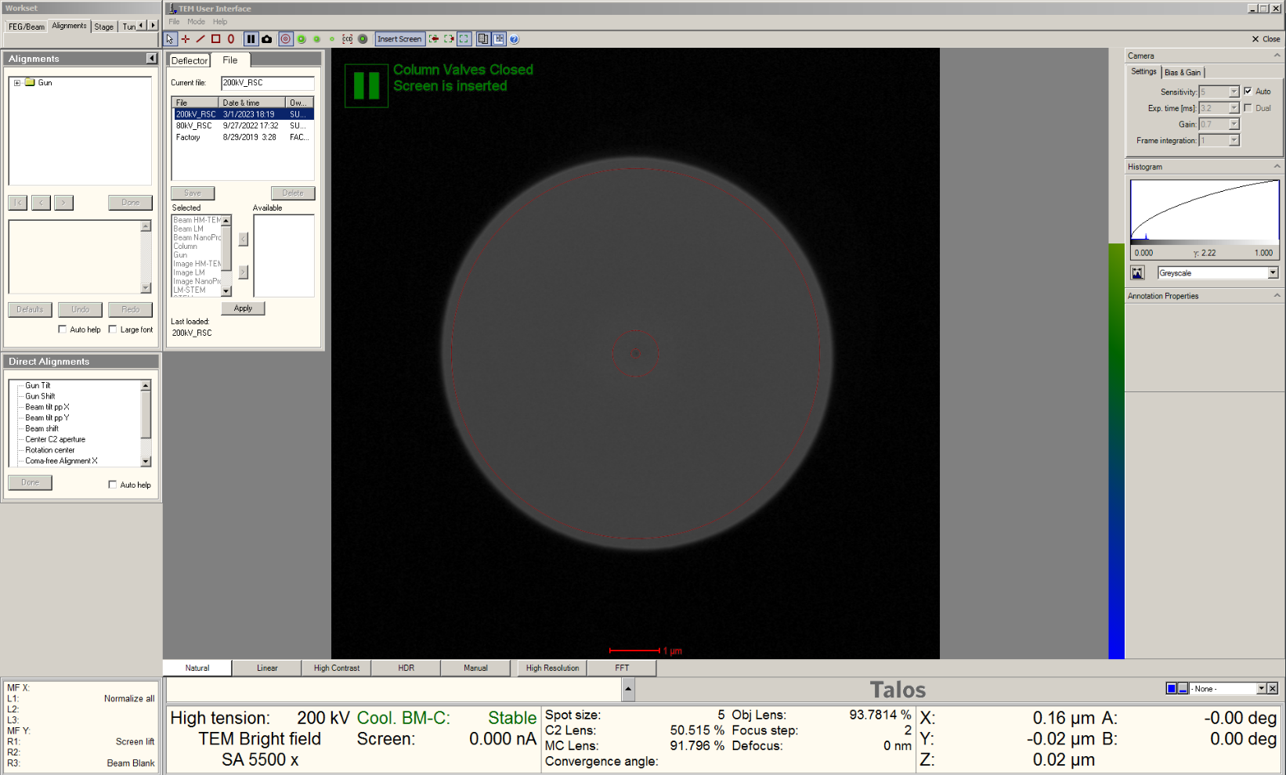
- Gun alignments

  - In Microscope Control, select the “FEG/Beam” tab and then the “FEG Registers” control panel.

    - For TEM mode operation at 200 kV, select “200kV_uP” from the list of registers and then “Set” to apply the gun alignments (shown here).

    - For TEM mode operation at 80 kV, select “80kV_uP” from the list of registers and then “Set” to apply the gun alignments.

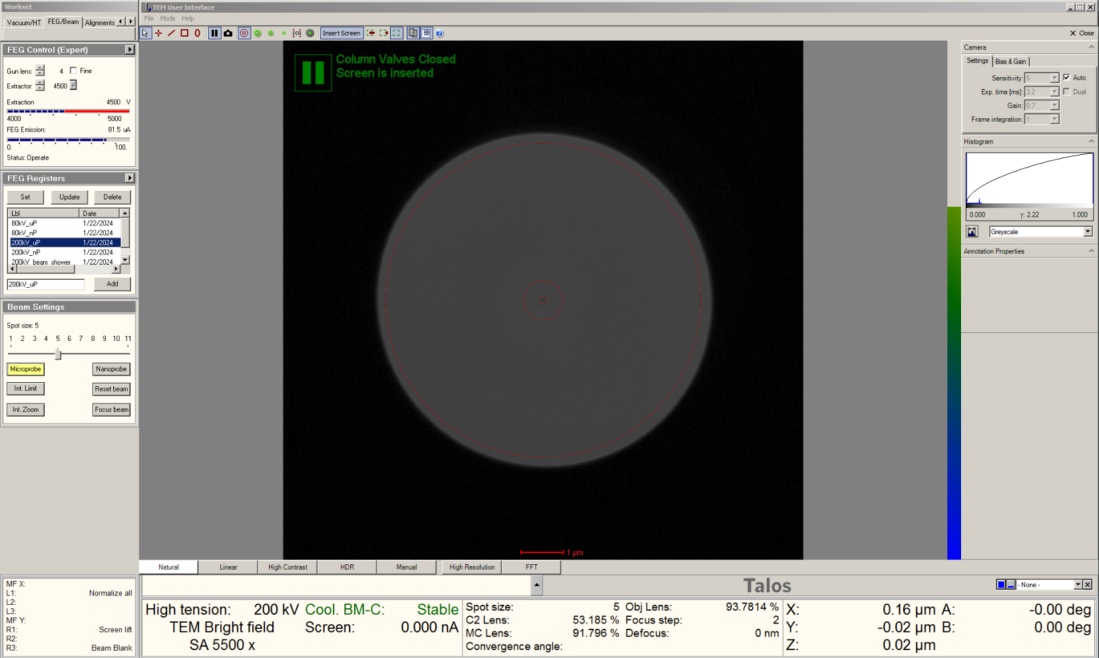
- Spot size

  - Remain in the “FEG/Beam” tab and select the “Beam Settings” control panel.

    - Select the spot size to be used for imaging.

  - Spot size = 4 is the recommended starting point for obtaining sufficient beam current while keeping beam-induced damage to acceptable levels for inorganic, non-biological samples. However, this is not a guarantee that beam-induced damage will be avoided/minimized. It is the responsibility of the operator to recognize if the imaging conditions are damaging the specimen to the point adversely affecting the results and to adjust the imaging conditions accordingly (if possible). The RSC is not responsible for any beam-induced damage to specimens.

  - If the sample is thick, spot size = 2 or 3 may be used to increase the beam current (noting the increased risk of beam-induced damage).

  - Spot size = 2 is the lowest value that may be safely used for general TEM mode imaging; using spot size = 1 results in a very high beam current that may damage the Ceta camera.

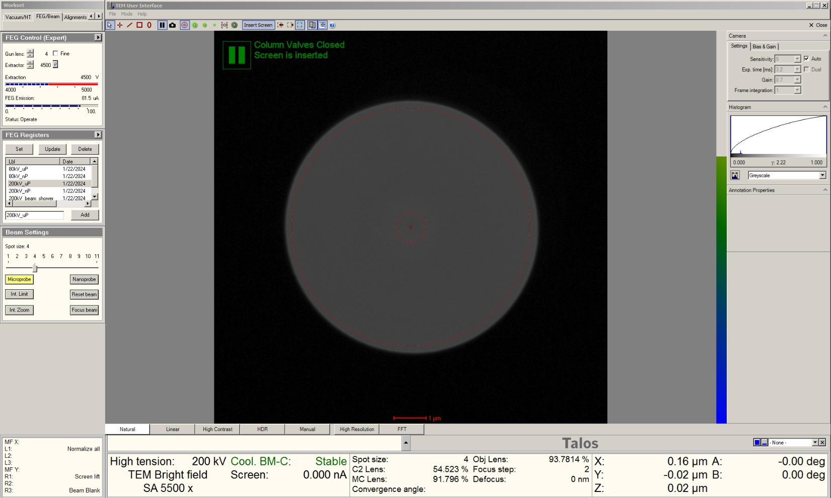

- Finding a region of interest

  - In Microscope Control, select the “Vacuum/HT” tab and then the “Vacuum” control panel; select “Col. Valves Closed” to open the column valves; the button will turn gray, the turbo pump will turn off, and status will read “Status: All Vacuum (Opened)”.

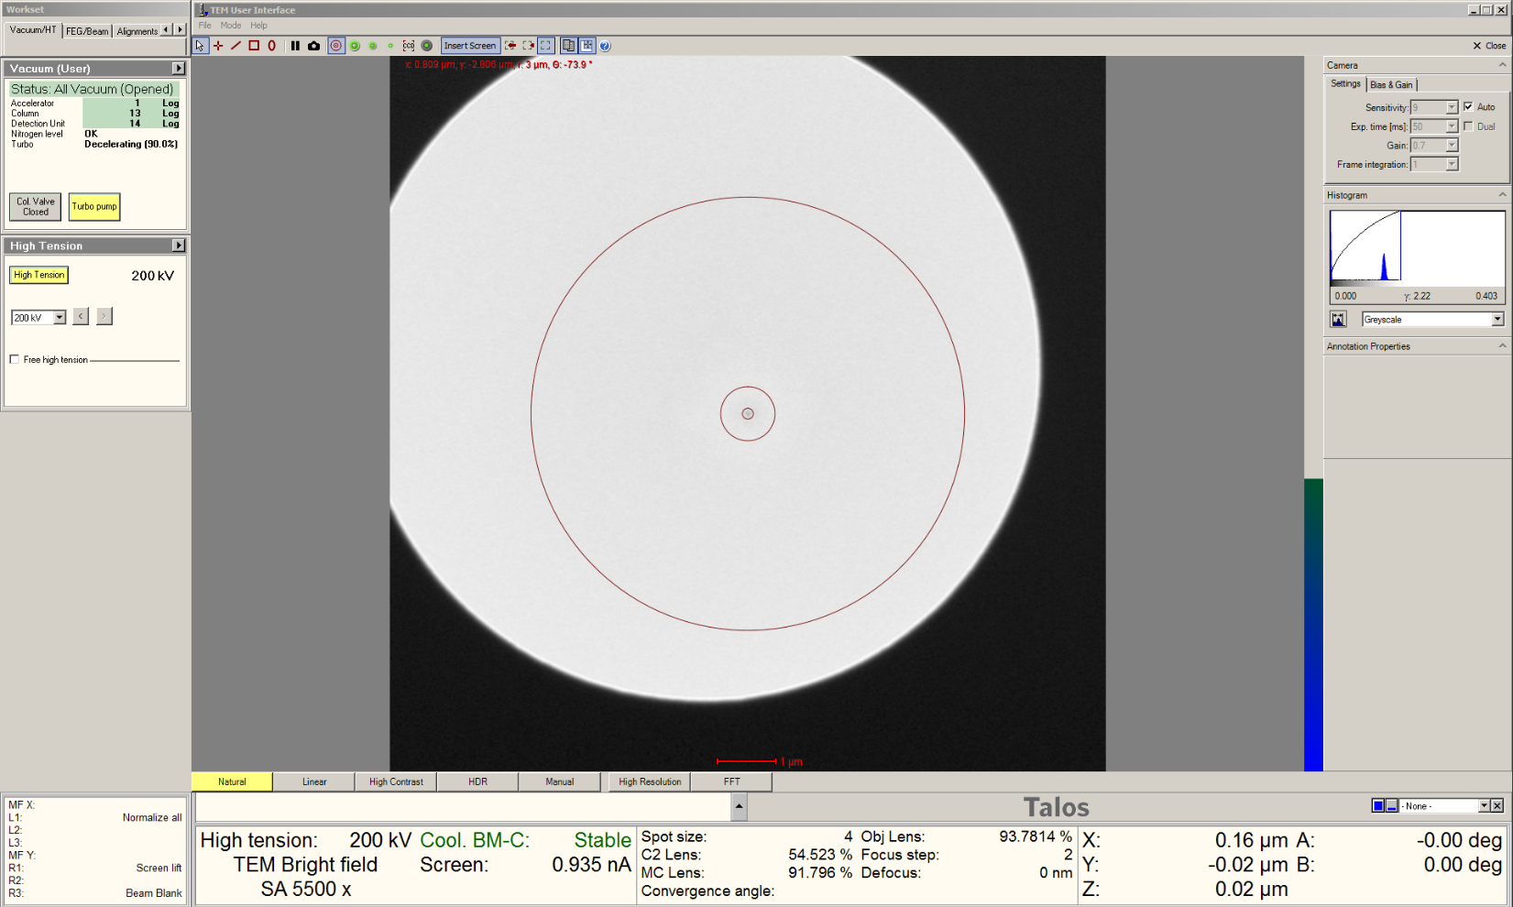

  - Adjust the “Magnification” knob (R control pad) until the microscope is in “LM” mode as verified in the information panel; adjust the “Intensity” knob (L control pad) to expand/contract the beam and the beam shift trackball (L control pad) to reposition the beam as needed.

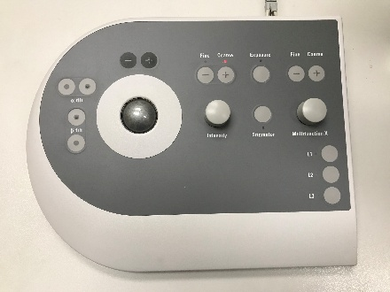
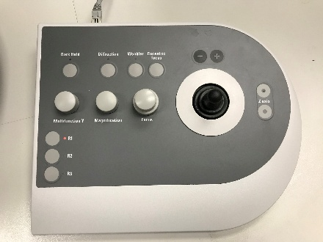
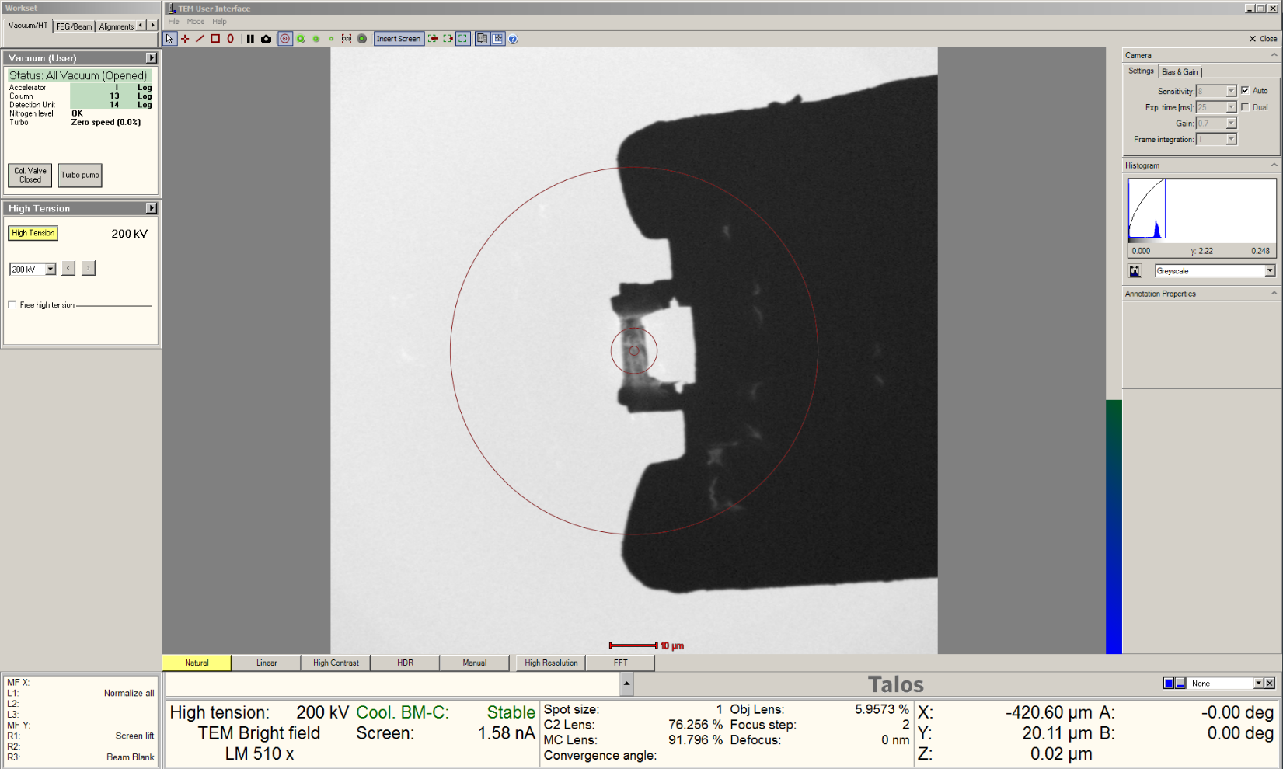

  - Use the joystick (R control pad) to move the stage until a region of interest (ROI) is found and centered on the FluCam, and then adjust the “Magnification” knob until the microscope is in “SA” mode with indicated magnification = 14000×

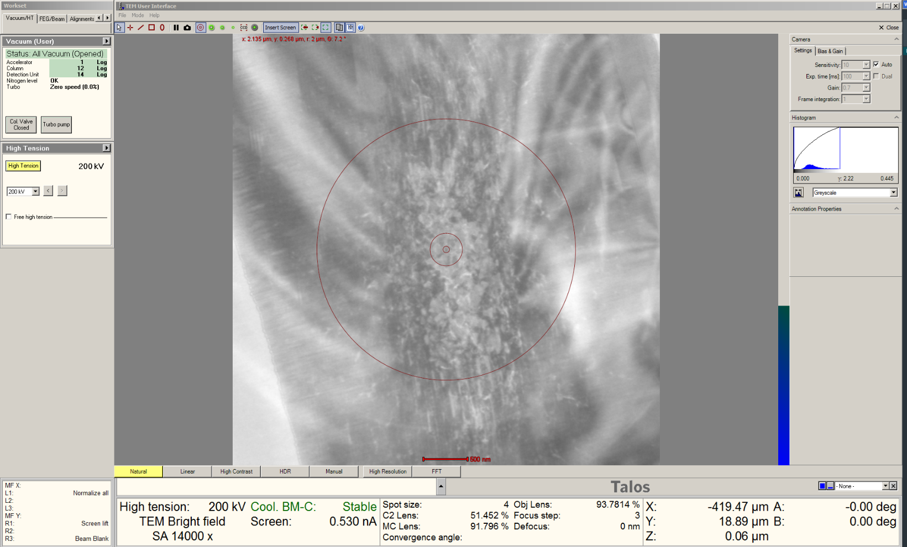

- Setting eucentric height (coarse)

  - Press the “Eucentric focus” button (R control pad); use the “Z axis” buttons (R control pad) to adjust the sample height until the specimen is in focus (minimum contrast).

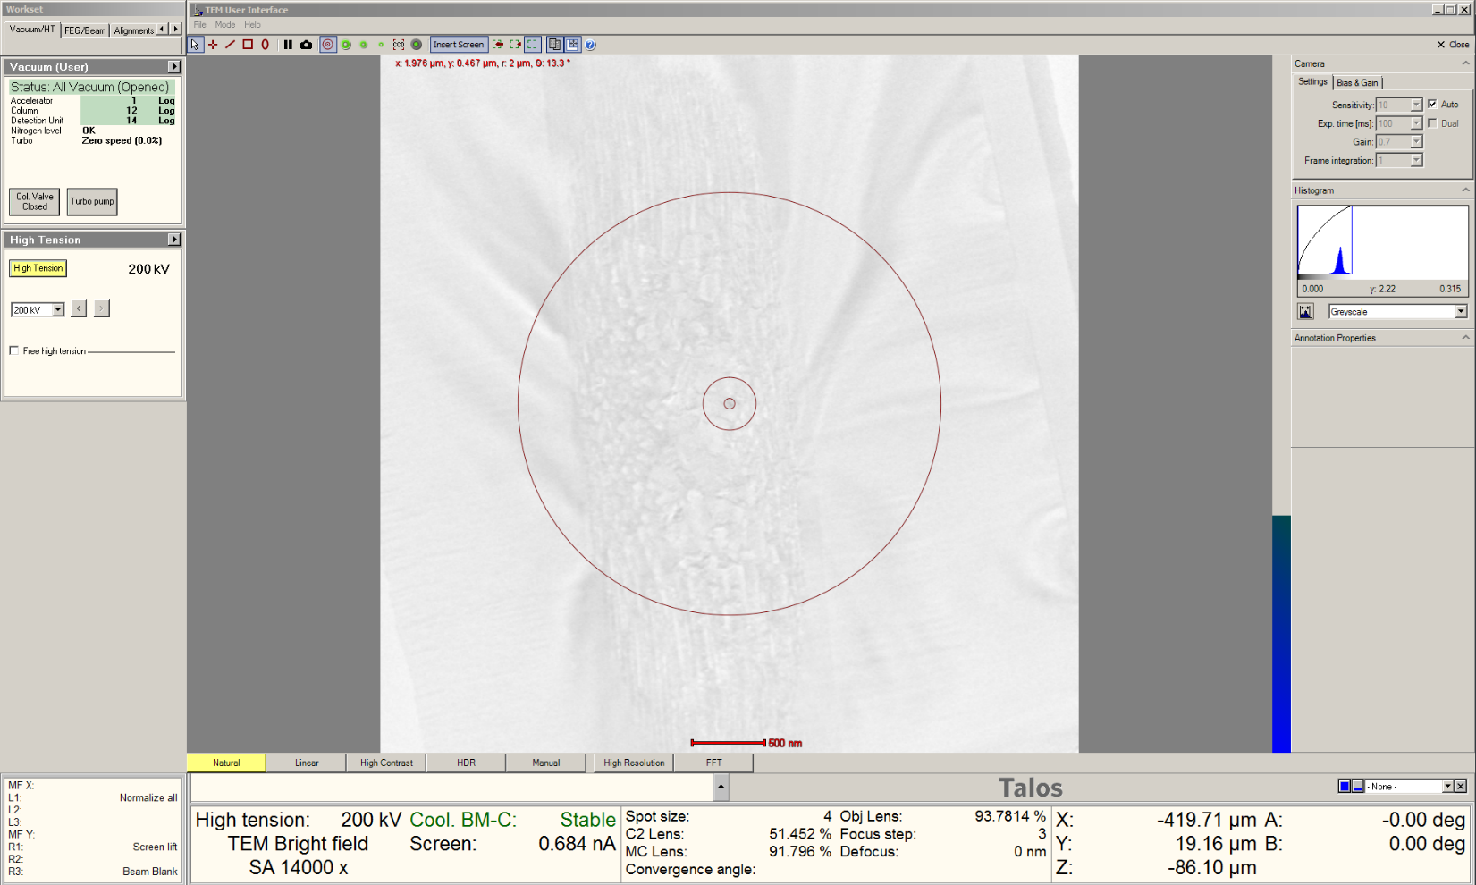

- C2 aperture alignment

  - Leave the indicated magnification to 14000×. Select the “Tune” tab and navigate to the “Apertures” control panel; select the desired C2 aperture from the pull-down list and then select “Adjust” (button will turn yellow).

    - The 70 µm C2 aperture is recommended for most conventional imaging (BF and HR) applications.

  - Use the “Intensity” knob to bring the beam to crossover and then use the beam shift trackball to center the beam on the FluCam (not shown).

  - Turn the “Intensity” knob clockwise to expand the beam from crossover so the diameter is approximately the same size as the 40 mm FluCam circle (indicated by arrow).

    - If the C2 aperture is misaligned, the beam will no longer be centered; DO NOT re-center the beam with the beam shift trackball at this point.

  - Use the “Multifunction” knobs (L+R control pads) to re-center the beam on the FluCam by moving the C2 aperture (if needed).

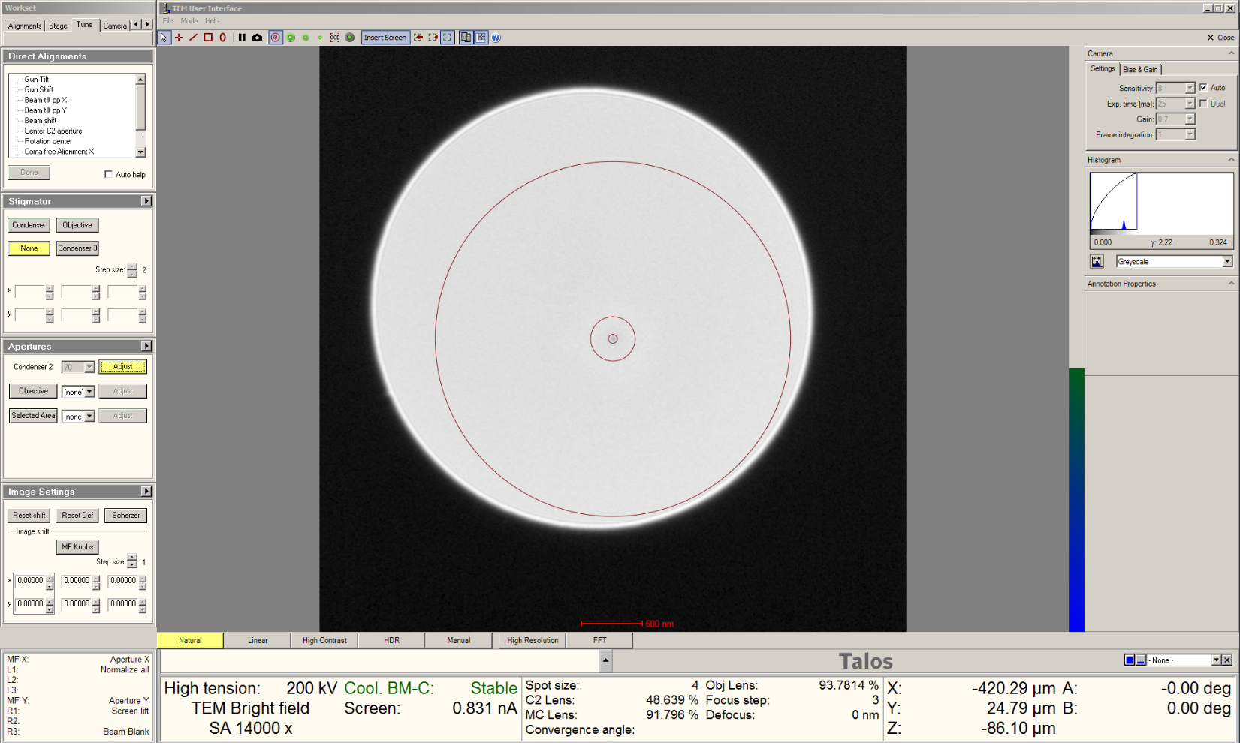

  - Repeat the previous three steps until the beam expands evenly (usually 2 iterations are sufficient).

  - Select “Adjust” in the “Apertures” control panel when finished (button will turn gray).
- Condenser astigmatism correction

  - Use the joystick to temporarily move the specimen out of the way so the middle of the field of view is only vacuum (if possible).

  - Use the “Magnification” knob to set the indicated magnification = 245 k×.

  - Use the “Intensity” knob to expand the beam clockwise from crossover so it is slightly larger than the 40 mm FluCam circle; use the trackball to center the beam.

  - In Microscope Control, select the “Tune” tab and then the “Stigmator” control panel; select “Condenser” (the button will turn yellow) and then use the “Multifunction” knobs (L+R controls pads) to make the beam round.

  - Select “None” when finished.

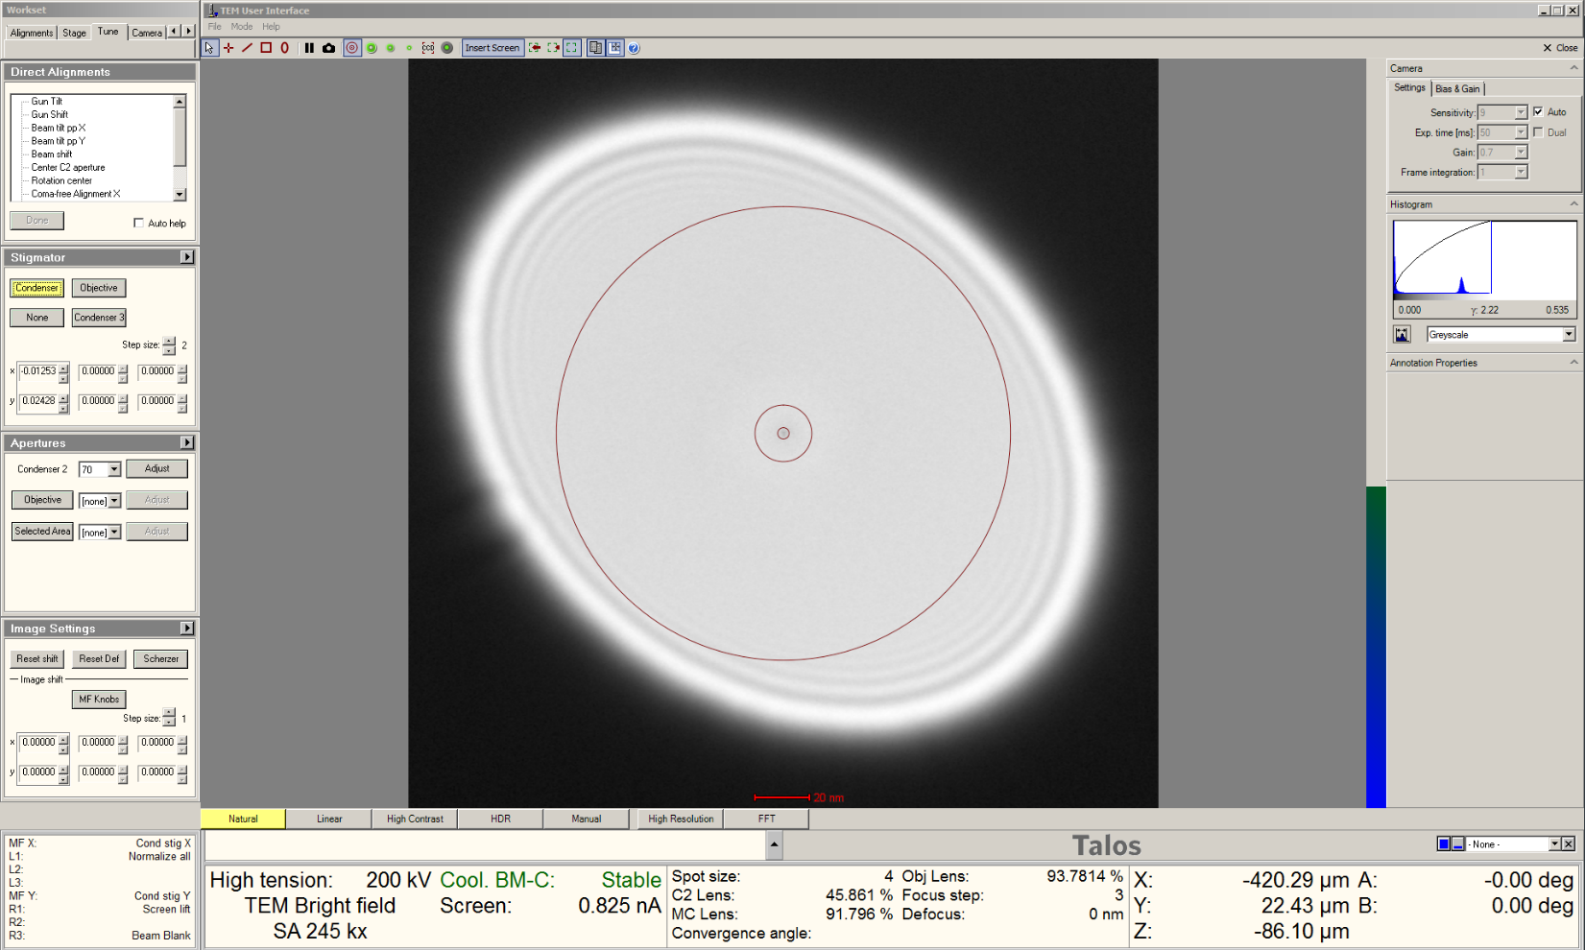
- Beam tilt pivot points; fine-tuning eucentric height

  - Use the joystick to center the ROI on the FluCam.

  - Leave the indicated magnification = 245 k×.

  - Use the “Intensity” knob to expand the beam clockwise from crossover so it is slightly larger than the 40 mm FluCam circle; then use the trackball to center the beam.

  - In Microscope Control, select the “Tune” tab and then the “Direct Alignments” control panel.

  - Select “Beam tilt pp X” and then use the “Multifunction” knobs to eliminate separation of the beam.

  - Select “Done” when finished.

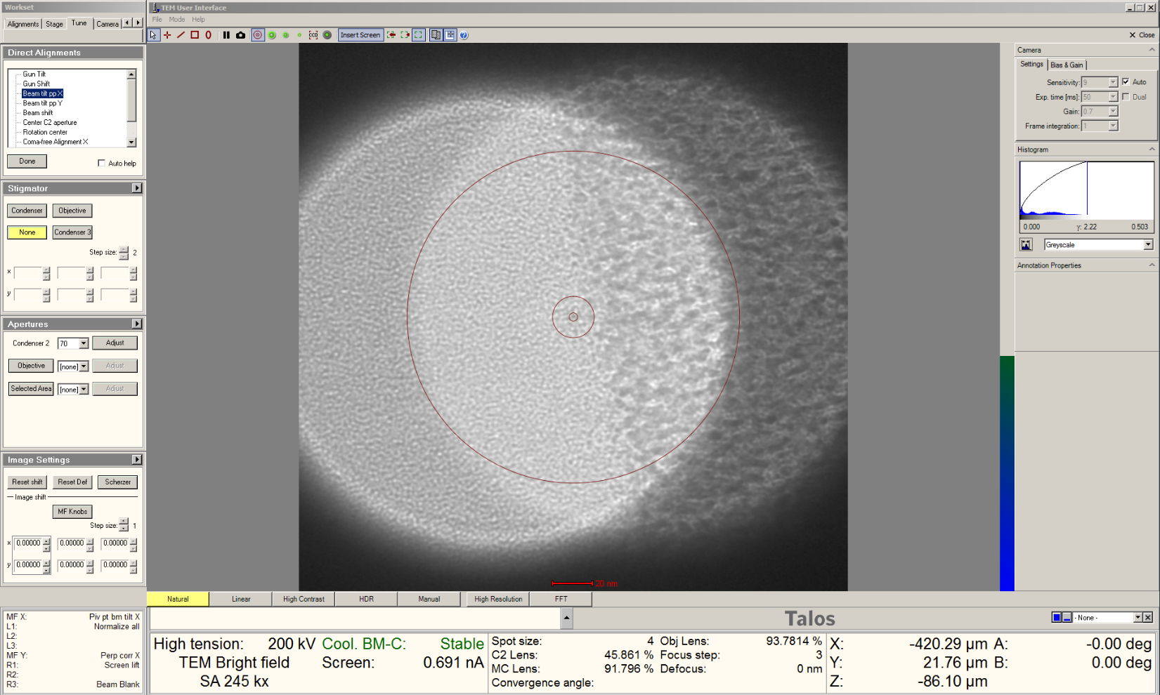
  - Next, select “Beam tilt pp Y” and then use the “Multifunction” knobs to eliminate separation of the beam; DO NOT press “Done” yet.

  - Once the beam is stationary, use the “Z axis” buttons to eliminate any separation of the image of the specimen.

  - Select “Done” when finished.

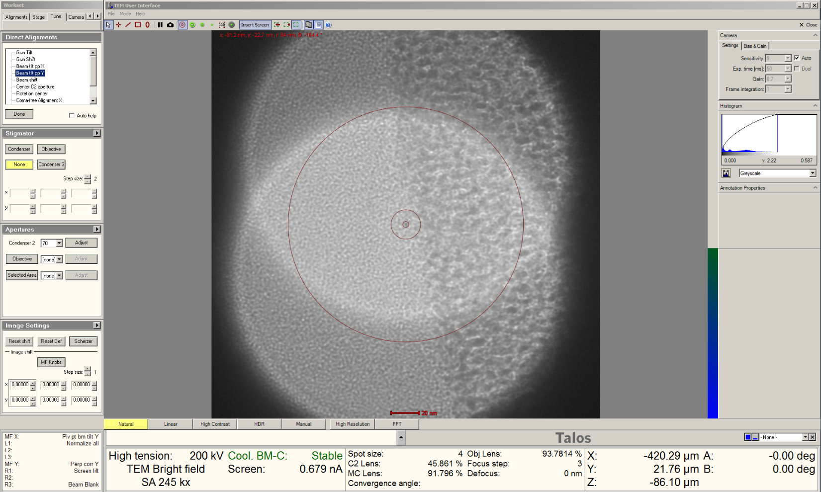
- Rotation centering

  - Leave the indicated magnification at 245 k× and recenter the beam with the trackball.

  - Use the “Intensity” knob to bring the beam to crossover and then center it on the FluCam using the beam shift trackball; turn the “Intensity” knob clockwise to expand the beam from crossover so it is slightly larger than the field of view (no edges of the beam are viewable on the FluCam).

  - Use the joystick to center a distinct, two-dimensional feature on the FluCam.

    - The grains from a protective Pt layer deposited via dual beam FIB/SEM work well for this.

  - Select the “Tune” tab and navigate to the “Direct Alignments” control panel.

  - Select “Rotation center” (the image will start going in and out of focus); use the “Multifunction” knobs to minimize movement of the image.

  - Select “Done” when finished.

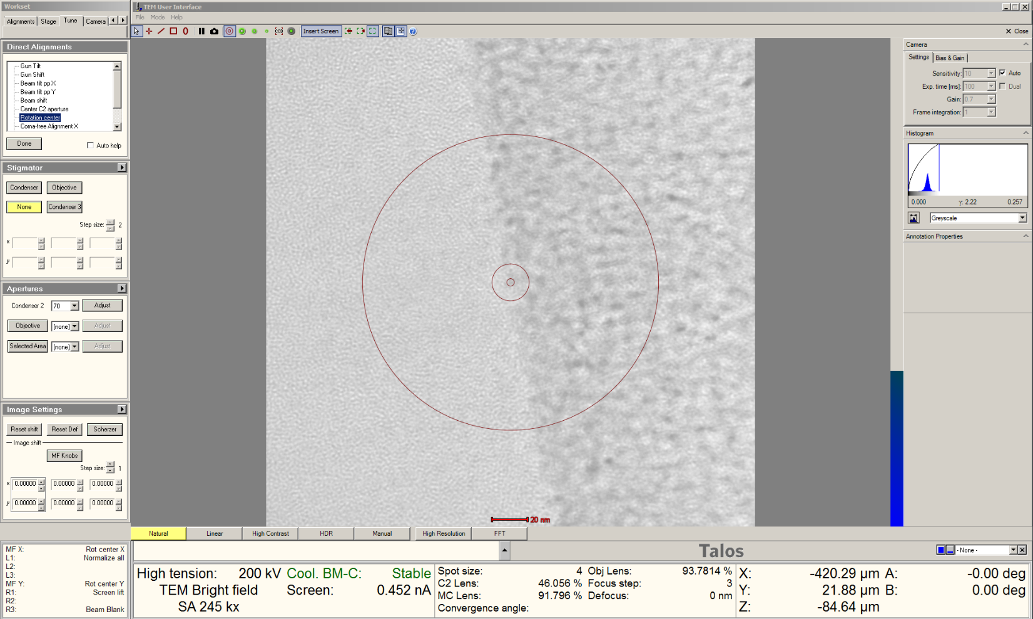
- Specimen orientation adjustment (single crystals or isolated grains)

  - Set the indicated magnification as needed, then use the joystick to ROI on the FluCam; adjust the beam so it evenly illuminates the ROI for zone axis alignment (not shown).

    - NOTE: the entire area illuminated by the beam will contribute to the observed diffraction pattern.

  - Select “Diffraction” (R control pad) to enter diffraction mode.

  - Set the indicated camera length by using the “Magnification” knob; 300 – 800 mm is recommended for observing diffraction patterns.

    - It is also usually best to use the “HDR” FluCam setting for viewing unstopped DPs.

  - If needed, the direct beam may be centered on the FluCam using the “Multifunction” knobs.

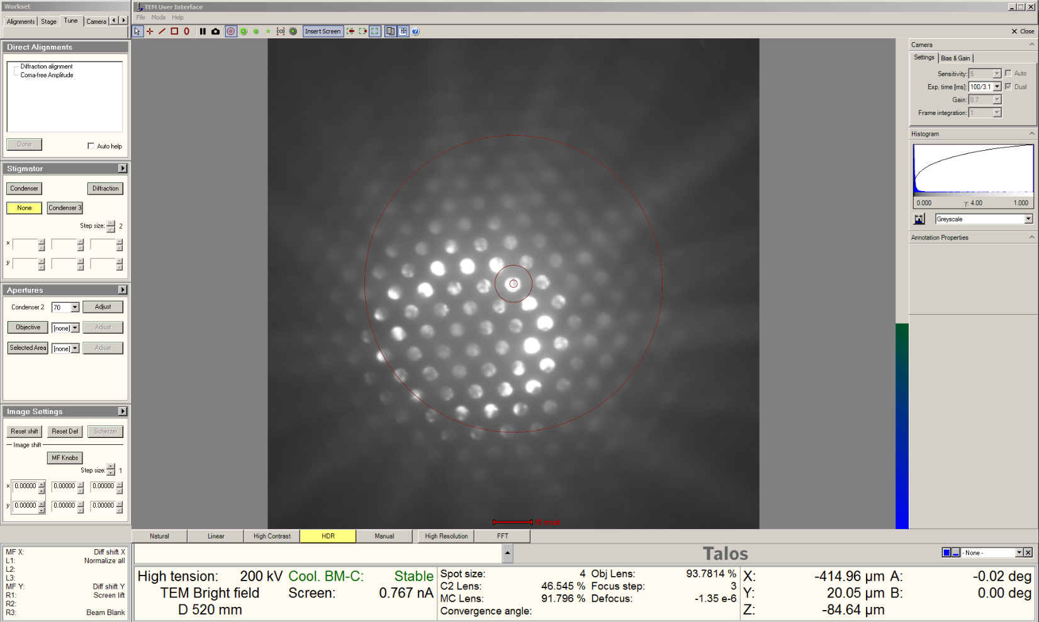
  - Use the α and β tilt buttons (R control pad) to orient the sample as desired based on the appearance of the DP.

    - If the DP suddenly disappears during tilting, the specimen is probably no longer under the beam.

    - Press the “Diffraction” button to return to imaging mode and then recenter the ROI.

    - Press the “Diffraction” button again to return to diffraction mode and resume adjusting the specimen orientation.

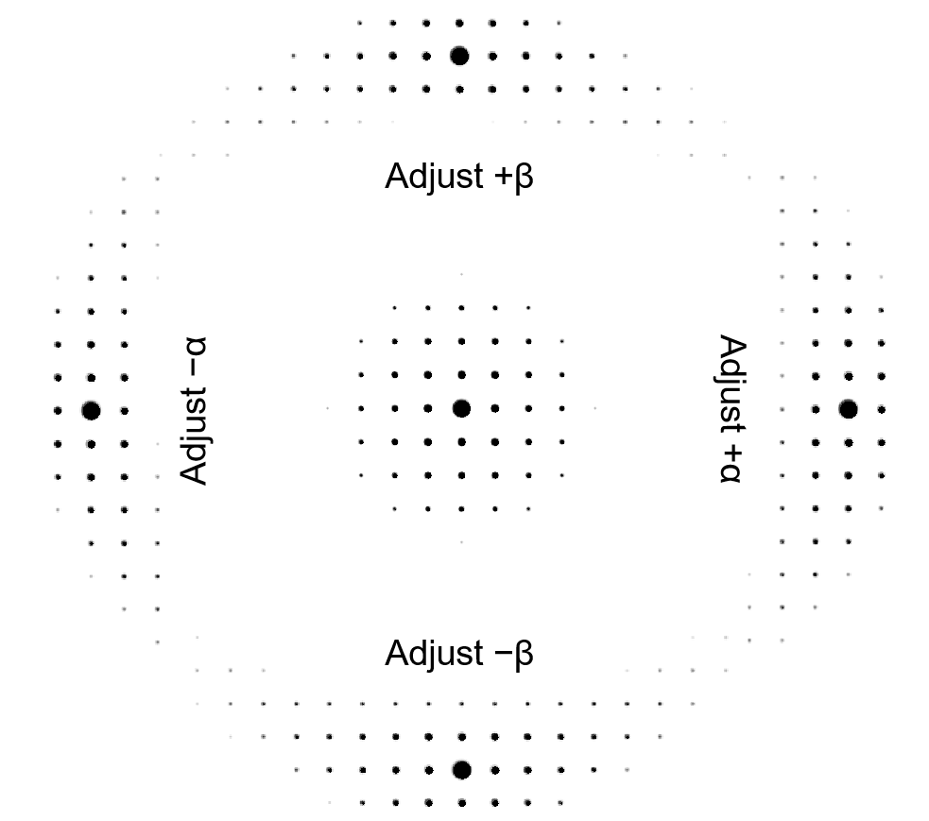

Above: zone axis tilt map when the indicated camera length ≥98 mm
  - When finished tilting, press the “Diffraction” button to return to imaging mode; re-center the ROI on the FluCam, if necessary.

    - The image will probably be out of focus (shown below), refocus using the “Z axis” buttons.

    - After tilting, DO NOT refocus the image with the “Focus” knob.

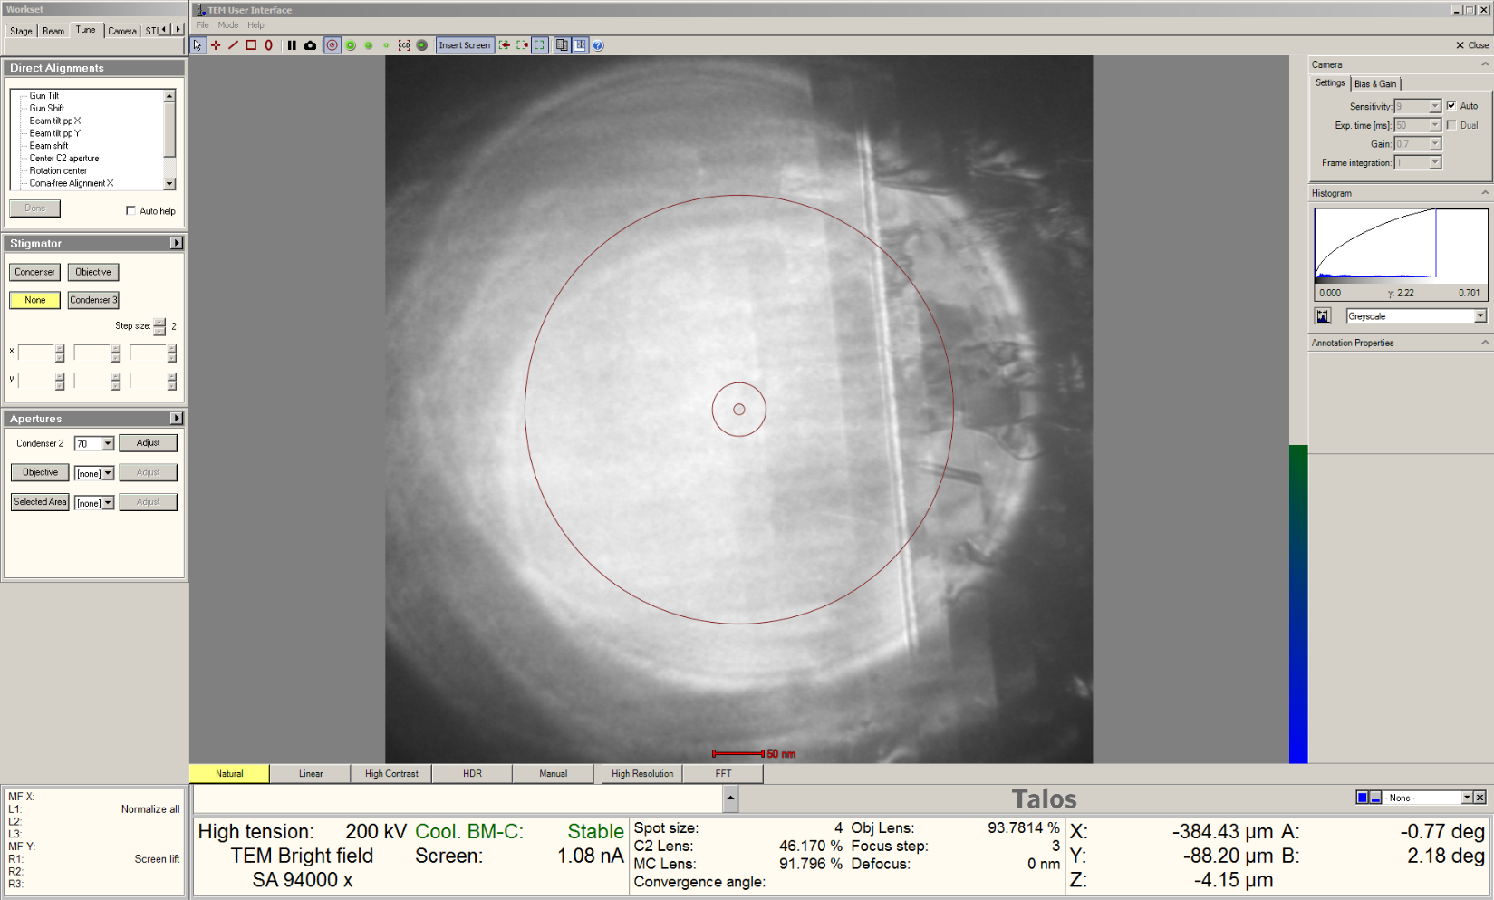

  - Return to diffraction mode and verify the specimen orientation is as expected at the ROI.

    - If the orientation is still not as desired, then continue tilting, recentering the ROI, and refocusing the image with the “Z axis” buttons iteratively until the desired orientation is obtained.

  - Remember, ultimately the ROI should be both aligned to the zone axis and in focus at the “Eucentric focus” setting.

- Objective aperture selection and centering

  - Select “Diffraction” to enter diffraction mode; select the “Tune” tab and navigate to the “Apertures” control panel.

    - For 200 kV HR-TEM imaging, select the 70 µm aperture.

    - For 80 kV HR-TEM imaging, select the 100 µm aperture.

    - For 200 or 80 kV BF-TEM imaging, select the 10 µm aperture.

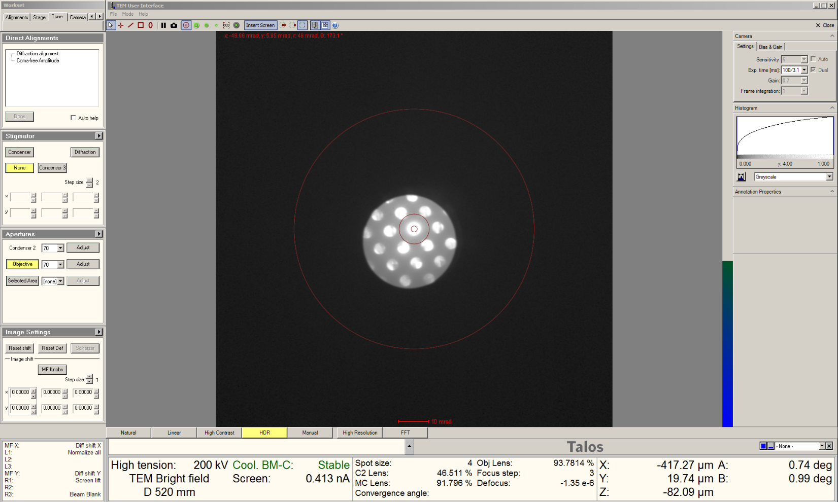

  - Select “Adjust” (button will turn yellow); use the “Multifunction” knobs to center the objective aperture around the direct beam.

  - Select “Adjust” when finished (button will turn gray); then select the “Diffraction” button to return to imaging mode.

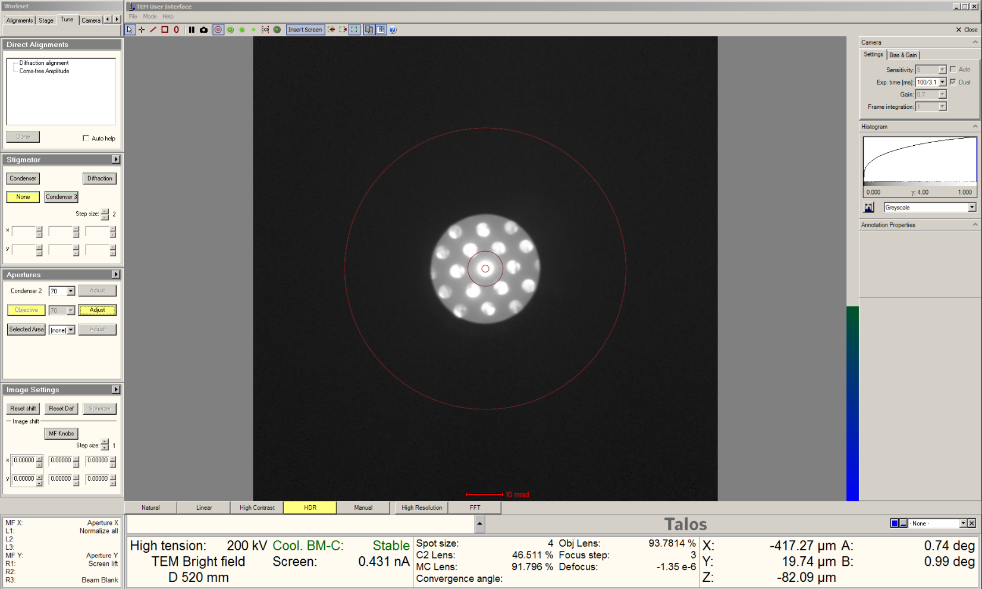

- Imaging in Velox; correcting objective astigmatism

  - Set the indicated magnification as needed, then center and expand the beam clockwise from crossover until it extends just beyond the FluCam viewable area.

  - The focus of the image may be slightly different due to the insertion of the objective aperture; use the “Z axis” buttons to focus the image (minimum contrast) as best as possible.

  - NOTE: correction of objective lens astigmatism should only be attempted if the indicated magnification is ≥100 k×.

    - Unless the instrument is grossly out of sorts, the effect of objective astigmatism at lower magnifications will be negligible.

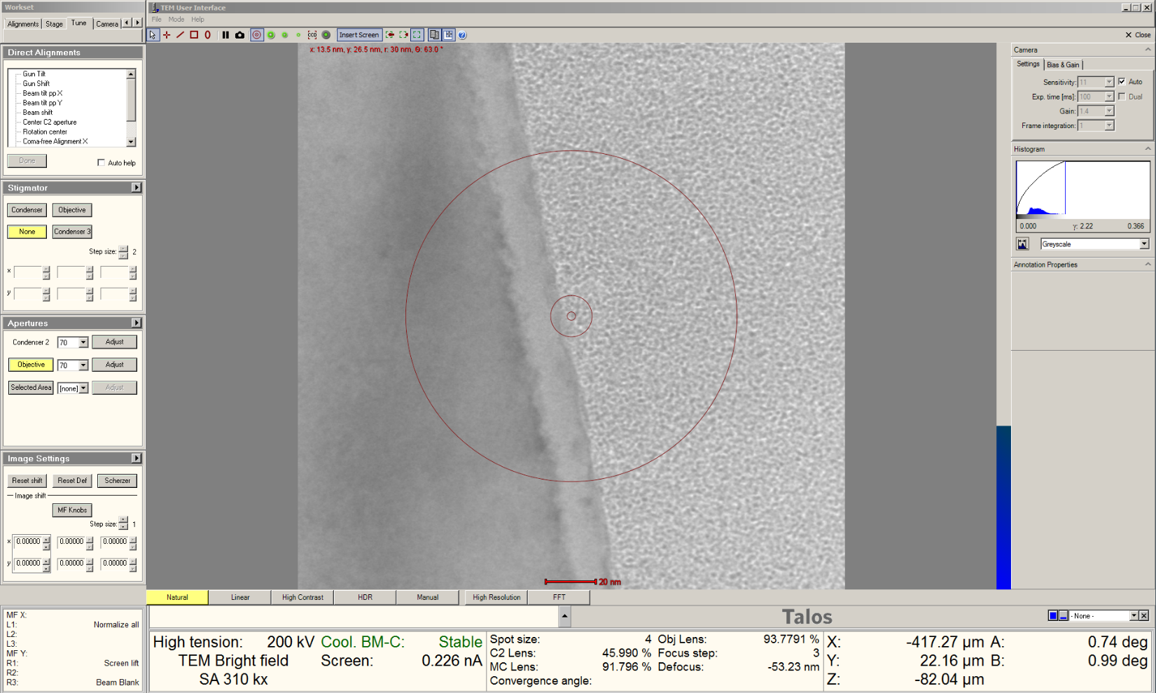

  - Maximize Velox Acquisition imaging software on the second monitor

  - Please DO NOT change any of the default settings in Velox without consulting NRF staff first.

    - If any settings in Velox are changed, the user is expected to return these to the original settings before leaving the instrument.

  - In the Velox Acquisition toolbar, select “Camera View” to start acquiring a live image (1024×1024 resolution with 200 ms exposure time).

    - Navigate to the “Detector Layout” side panel and select “Main Screen” to retract the viewing screen.

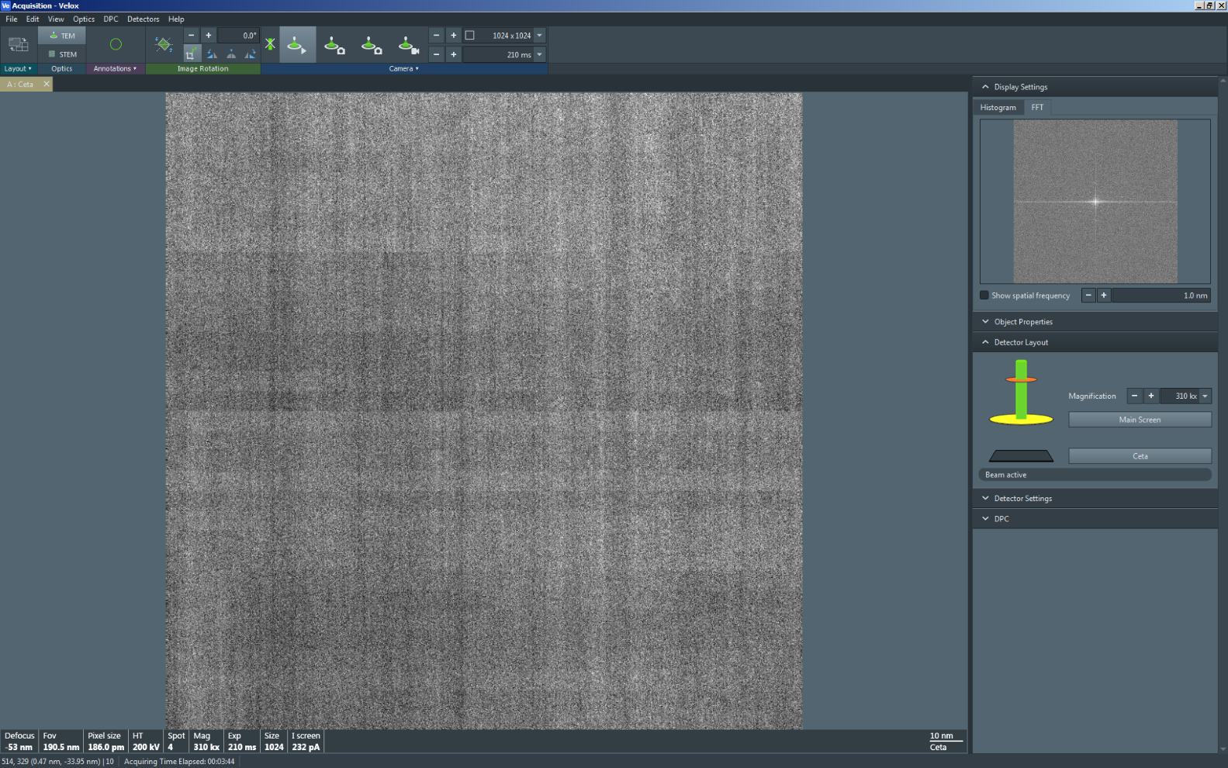

  - The image focus may change after inserting an objective aperture. If so, refocus the image as precisely as possible using only the “Z axis” buttons.

  - Navigate to the “Display Settings” side panel and select the “FFT” tab.

    - Use the “Focus” knob to obtain an under-focused image with 1 or 2 diffuse rings evident in the FFT (assuming part of the image area is amorphous).

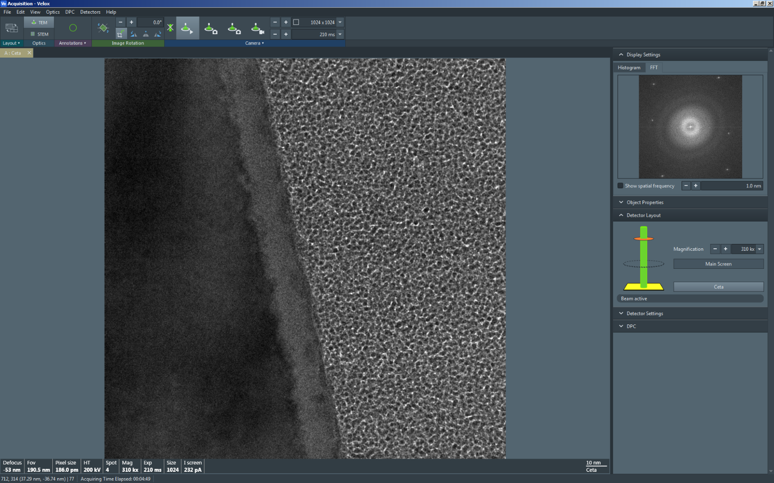

  - NOTE: the image focal state can be determined by observing how the diffuse rings in the FFT expand as the “Focus” knob is adjusted.

    - If the rings expand as the “Focus” knob is turned clockwise, the image is under-focused.

    - If the rings expand as the “Focus” knob is turned counterclockwise, the image is over-focused.
  - In Microscope Control, select the “Tune” tab and navigate to the “Stigmator” control panel.

    - Select “Objective”; use the “Multifunction” knobs to make the FFT rings round.

    - Select “None” when finished.

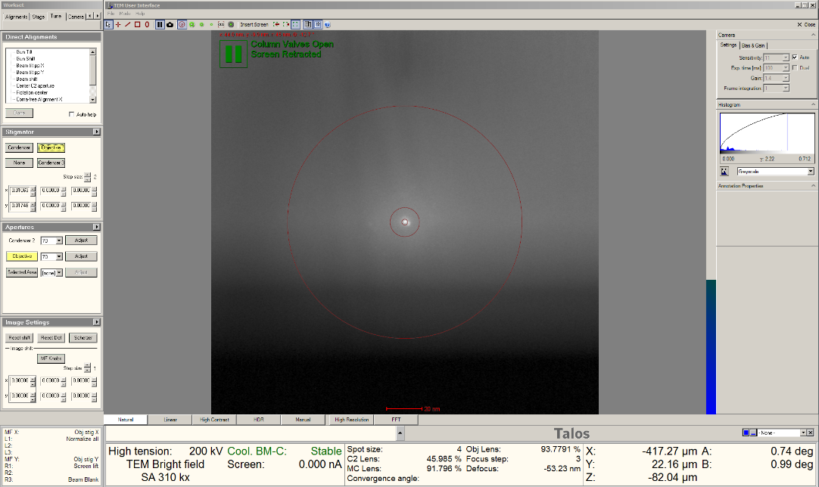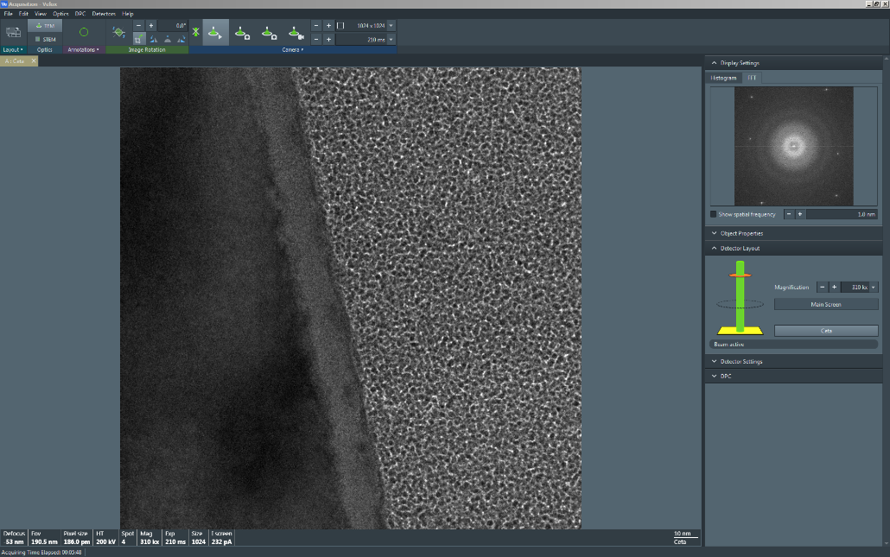

  - Use the “Focus” knob to obtain a slight under-focus condition.

  - In the Velox Acquisition toolbar, select “Acquire Camera Image” to take the final high-quality image (2048×2048 resolution with 1 s exposure time); this will populate in Velox Processing.

    - The live image in Velox Acquisition will restart automatically.

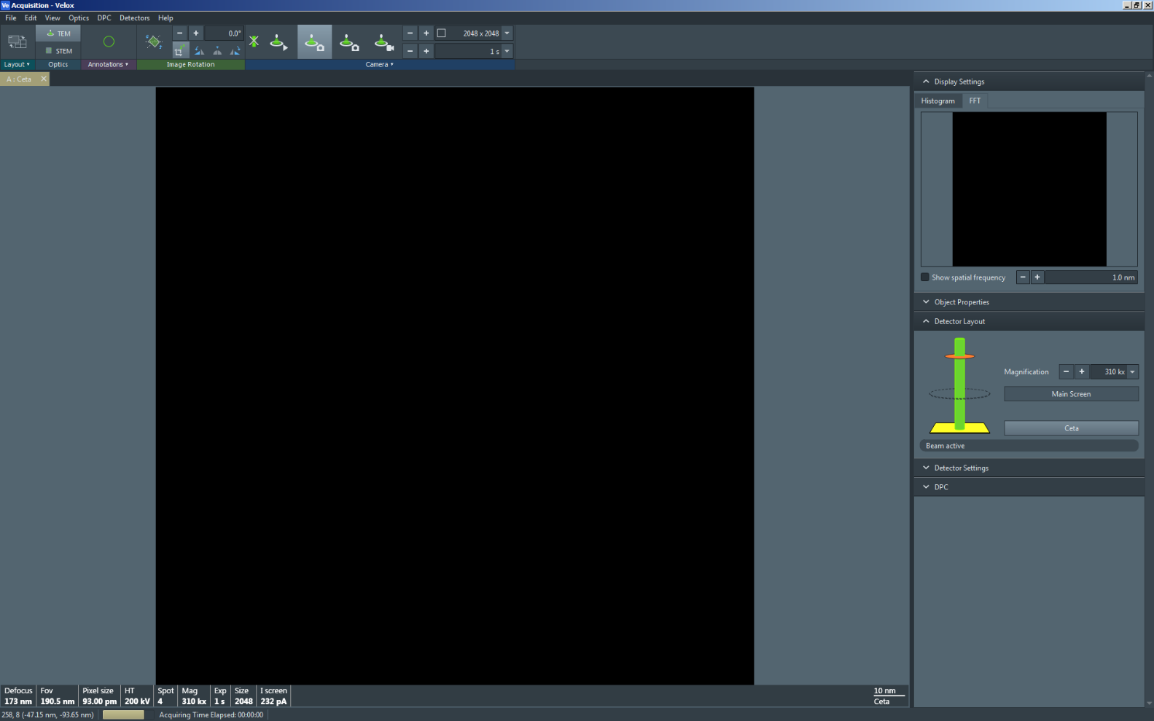
- Magnification changes

  - DO NOT adjust the “Magnification” knob, beam shift trackball, or “Intensity” knob while viewing a live image in Velox Acquisition; otherwise, permanent damage to the Ceta camera can occur due to overexposure, and the cost of repair will not be covered by the service contract.

  - In Velox Acquisition, navigate to the “Detector Layout” side panel and select “Main Screen” to reinsert the viewing screen.

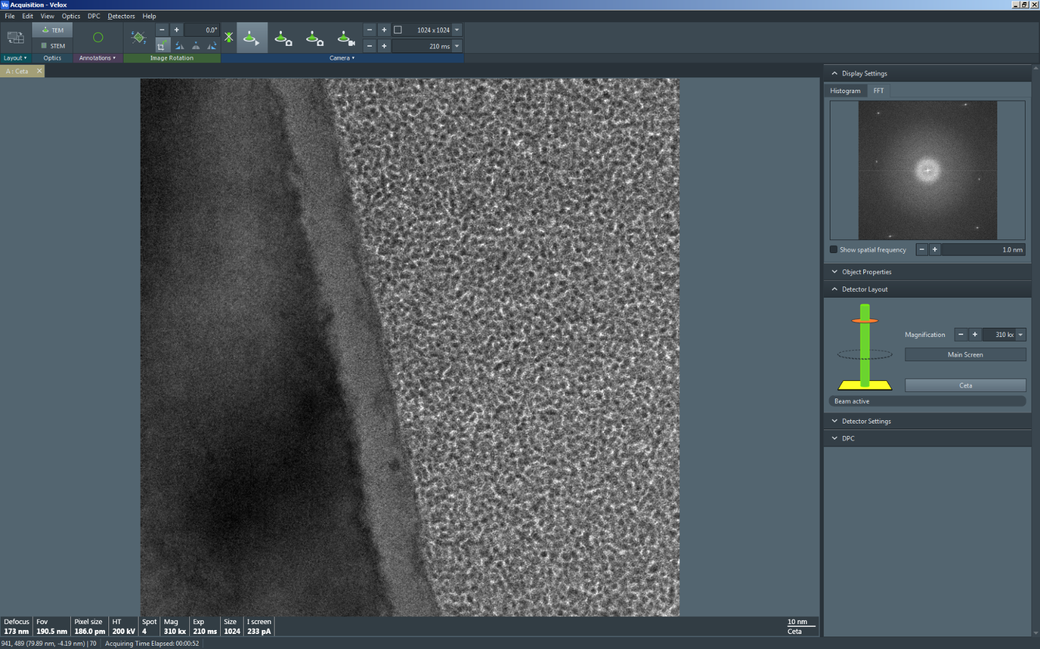

  - Adjust the “Magnification” knob as needed.

  - Use the beam shift trackball and “Intensity” knob and to center and expand the beam clockwise from crossover until it extends just beyond the FluCam viewable area.

  - Retract the viewing screen and the image can now be collected using Velox Acquisition as described previously.

  - NOTE: additional correction of objective astigmatism may be necessary as the indicated magnification is increased as the presence of objective astigmatism is more noticeable when this occurs.
- Using Mh mode

  - The highest indicated magnification possible in SA mode is 630k×; if the indicated magnification is adjusted higher than this, the instrument will switch into “Mh” mode (magnification range = 650 k× to 1.05 M×).

  - Press the “Eucentric focus” button; use the “Z axis” buttons to focus the image as best as possible (minimum contrast).

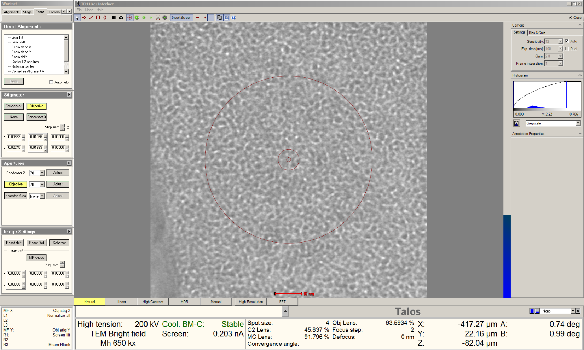

  - Realign the beam tilt pivot points (step 14); the beam may shift outside the FluCam viewable area while doing these alignments; if so, simply reposition it during the alignment with the trackball.

  - Use the “Intensity” knob to expand the beam clockwise from crossover so it is slightly larger than the viewable area on the FluCam; then use the trackball to center the beam.

  - Resume live imaging in Velox; focus and stigmate as described previously.

  - When switching from Mh back to SA mode, press the “Eucentric focus” button and then refocus the image using the “Z axis” buttons.

  - Realign the beam tilt pivot points (step 12).

  - Resume imaging in SA mode as per usual.
- Finishing with the Ceta camera

  - The Ceta camera should only be left inserted while it is actively in use; when it is time to exchange grids or to finish up the session, the camera should be retracted.

  - In Velox Acquisition, select the “Detector Layout” side panel.

    - Select “Main Screen” to reinsert the viewing screen.

    - Select “Ceta” to retract the camera (the live view will automatically stop).

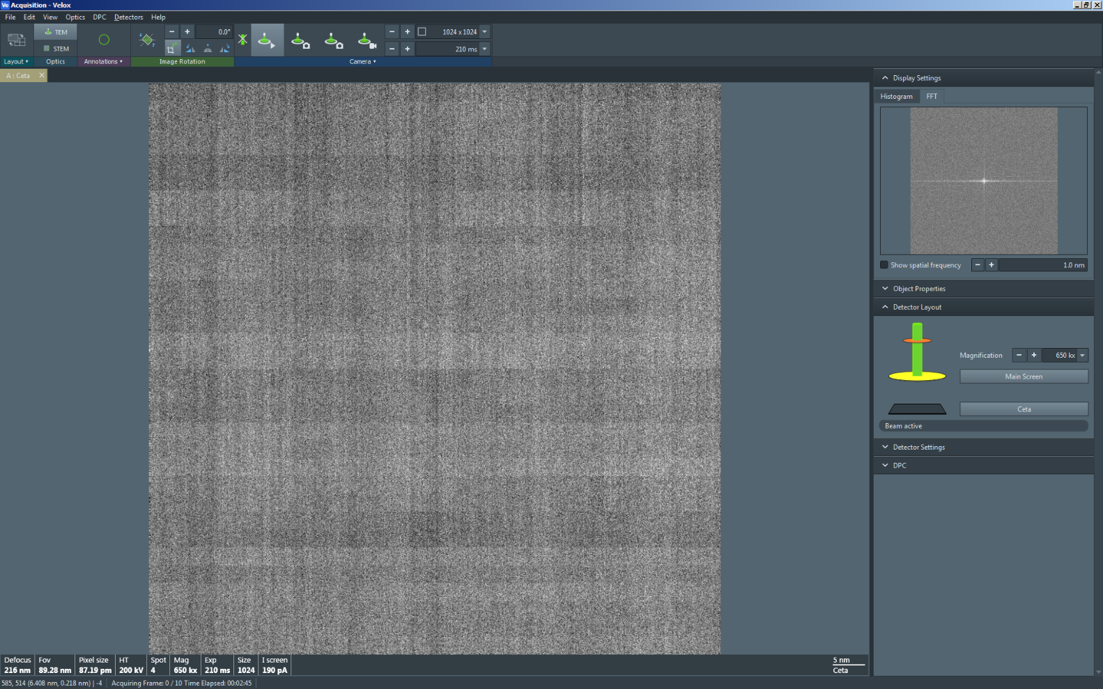
- FluCam selected area diffraction

  - Acquiring diffraction patterns with the Ceta camera is not covered in basic training; please submit a service request for “advanced training” if wanting this additional training.

    - DO NOT attempt to record diffraction patterns with the Ceta camera without being trained to safely do this; otherwise, permanent damage to the Ceta camera can occur due to overexposure, and the cost of repair will not be covered by the service contract.

  - Verify the instrument is in “SA” mode before proceeding; selected area diffraction may only be performed in this imaging mode.

  - Select the “Diffraction” button to enter diffraction mode and use the “Magnification” knob to set the camera length as desired.

  - Select the “Tune” tab and then navigate to the “Apertures” control panel; select and insert any objective aperture.

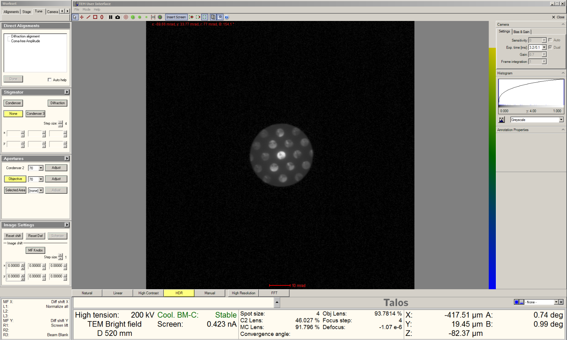
  - Use the “Intensity” knob to focus the spots on the diffraction pattern as sharply as possible.

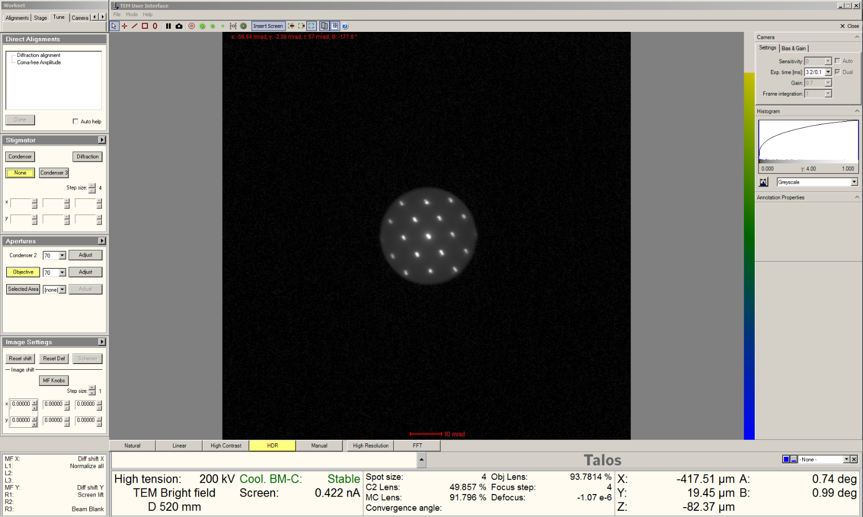

  - Select the “Tune” tab and navigate to the “Stigmator” control panel.

    - Select “Diffraction” and use the “Multifunction” knobs to make the spots round.

    - Select “None” when finished.

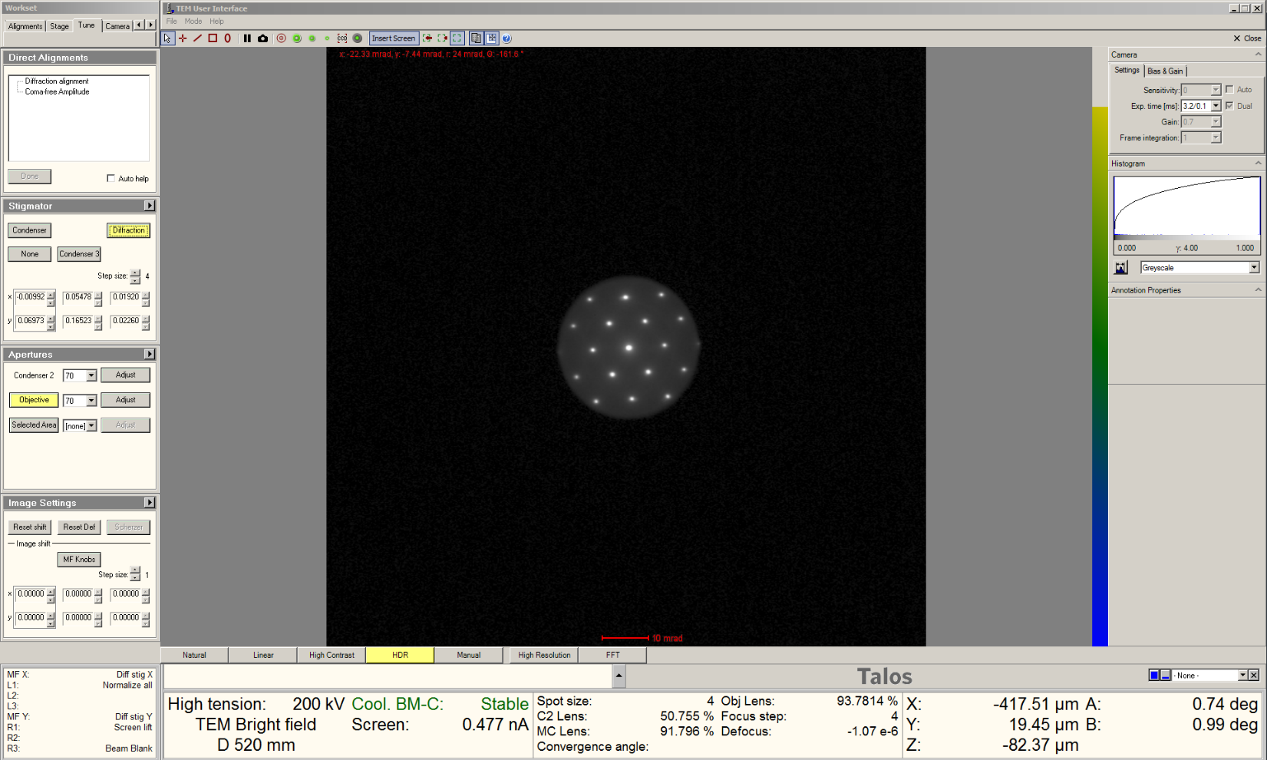

  - Use the “Focus” knob to focus the edge of the objective aperture (arrow).

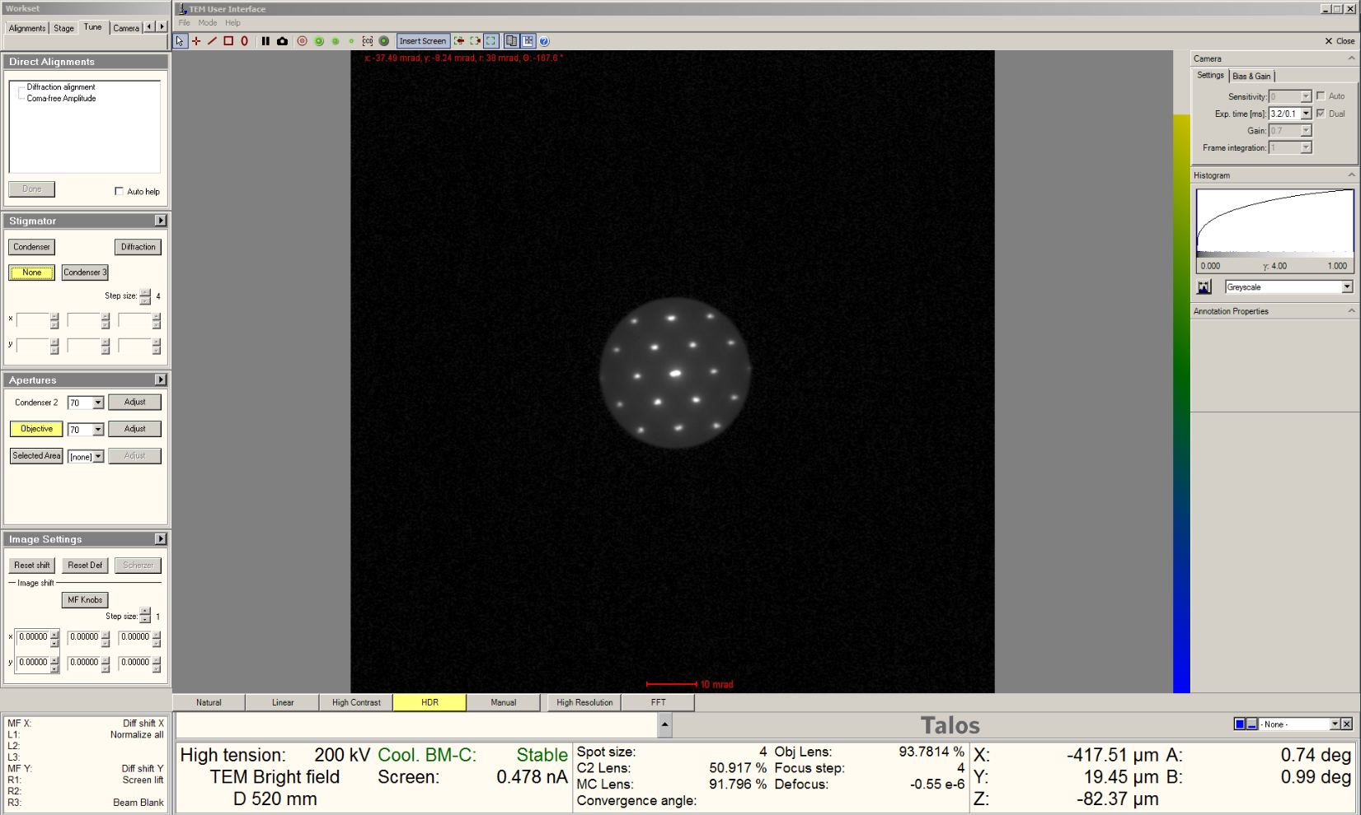

  - Use the “Intensity” knob to focus the spots again; the incident beam is now parallel; DO NOT make any further adjustments to the “Intensity” knob.

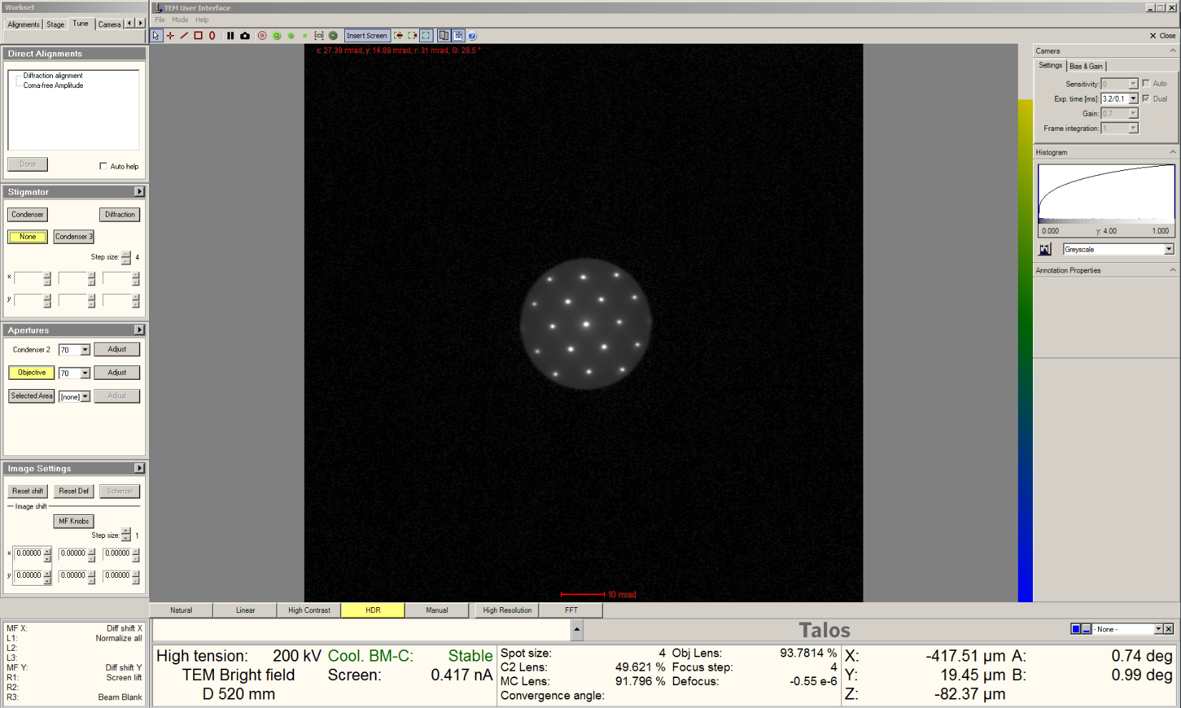
  - Remaining in the “Tune” tab, navigate to the “Apertures” control panel and select “Objective” to retract the objective aperture.

  - Select the “Diffraction” button to return to TEM mode.

    - DO NOT adjust the “Intensity” knob upon returning to TEM mode.

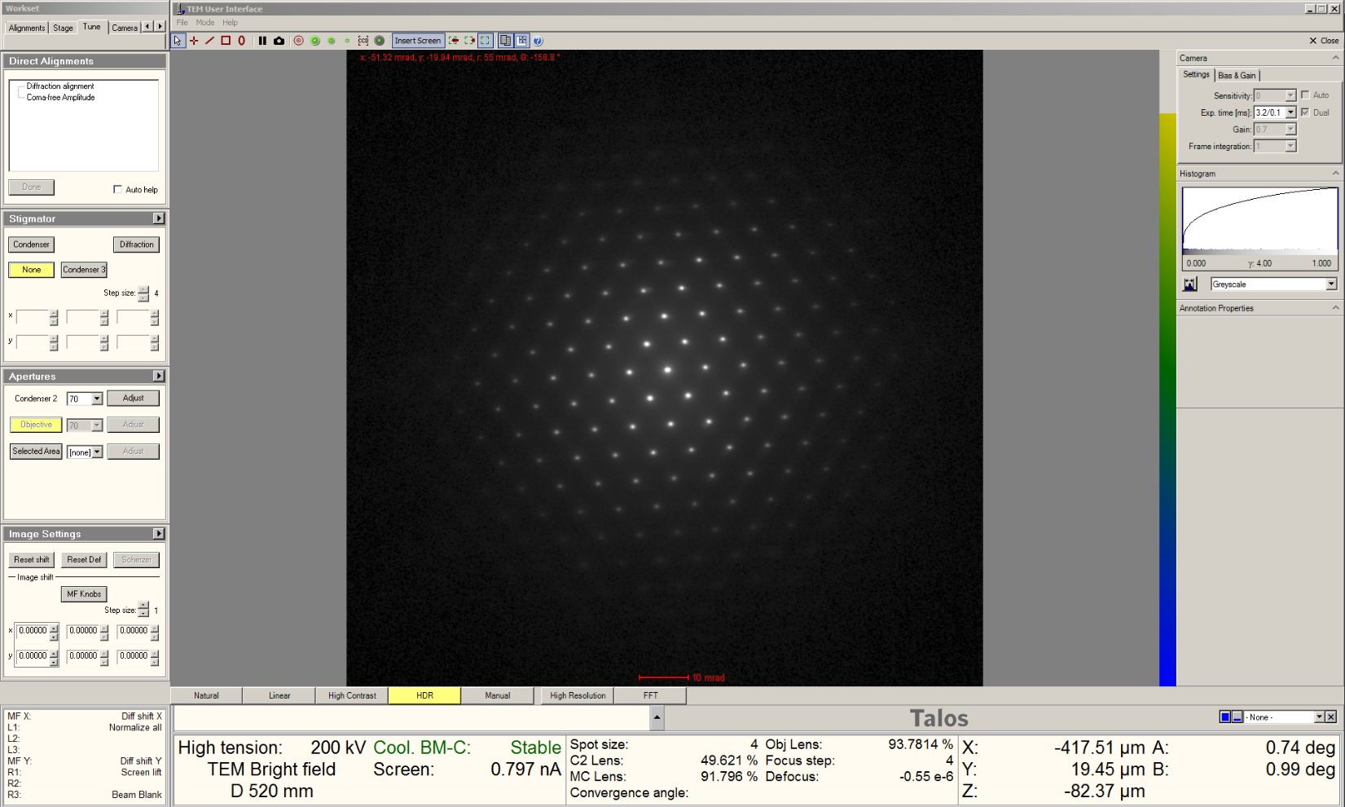
  - Use the “Magnification” knob to set the indicated magnification ≤ SA 28500×; if needed, reposition the beam with the beam shift trackball, but DO NOT adjust the “Intensity” knob.

  - Use the joystick to center the ROI on the FluCam.

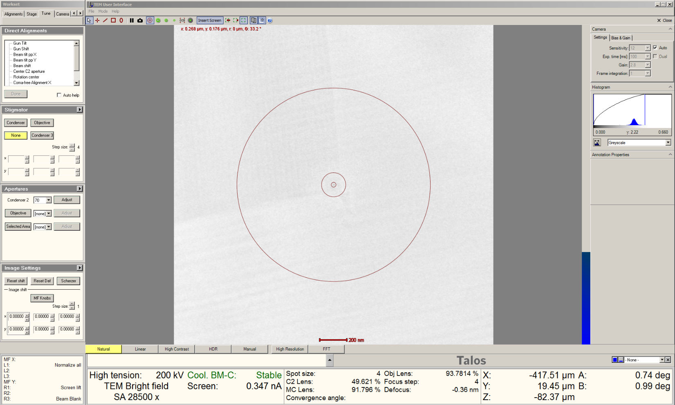

  - In the “Tune” tab, navigate to the “Apertures” control panel and select the desired selected area aperture; select “Adjust”.

  - Use the “Multifunction” knobs to center the aperture on the FluCam (and the ROI); select “Adjust” again when finished.

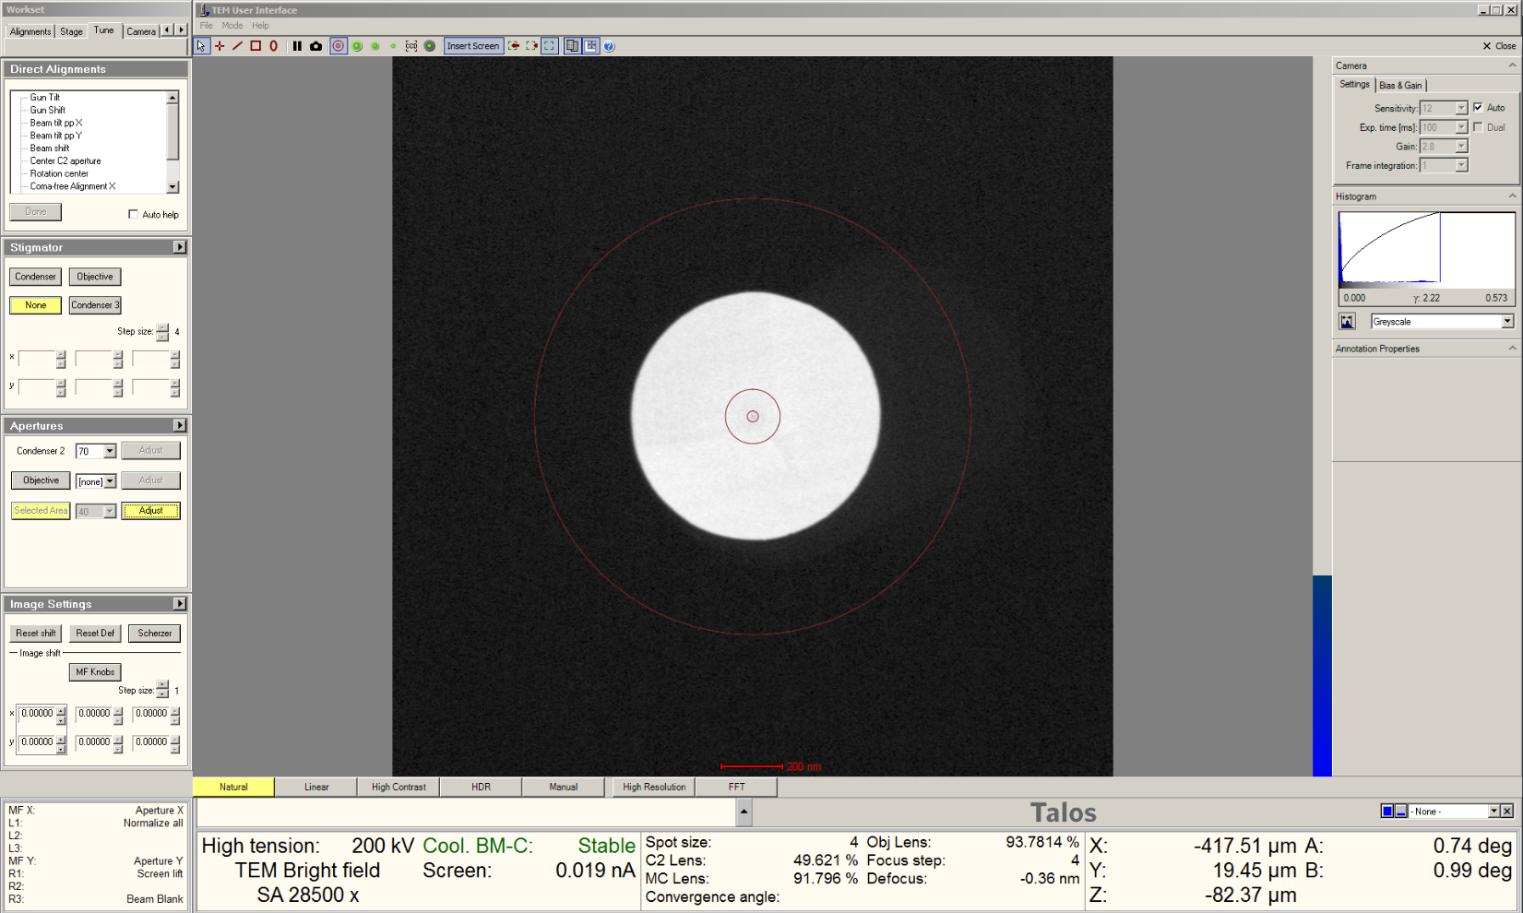
  - “Select the “Diffraction” button to enter diffraction mode.

  - Use the “Multifunction” knobs to center the direct beam on the FluCam.

  - Fully or partially insert the beam stop using the shortcuts from the FluCam toolbar.

    - If the partial insert option was selected (shown below), the direct beam will still be unblocked; use the “Multifunction” knobs to shift the pattern until the direct beam is under the tip of the beam stop.

  - Once the direct beam is blocked, switch the FluCam view mode to “Natural” to establish a starting point for optimizing the exposure time.

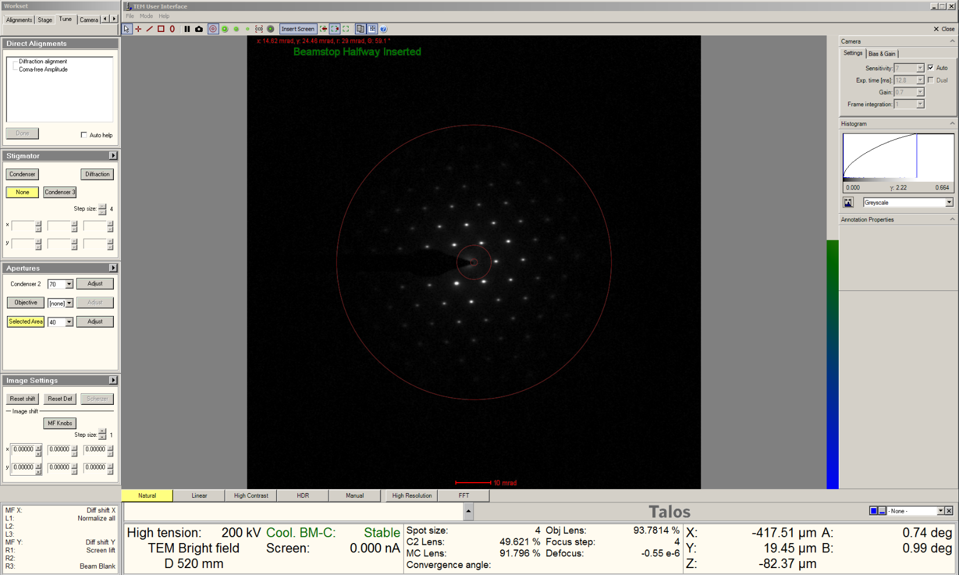
  - Switch the FluCam view mode to “Manual”; in the “Camera” panel near the upper-right corner of the FluCam image, select the “Settings” tab and then adjust the exposure time as needed.

  - When the pattern is satisfactory, select the “snapshot” shortcut from the FluCam toolbar to acquire an image of the pattern and send it to TIA.

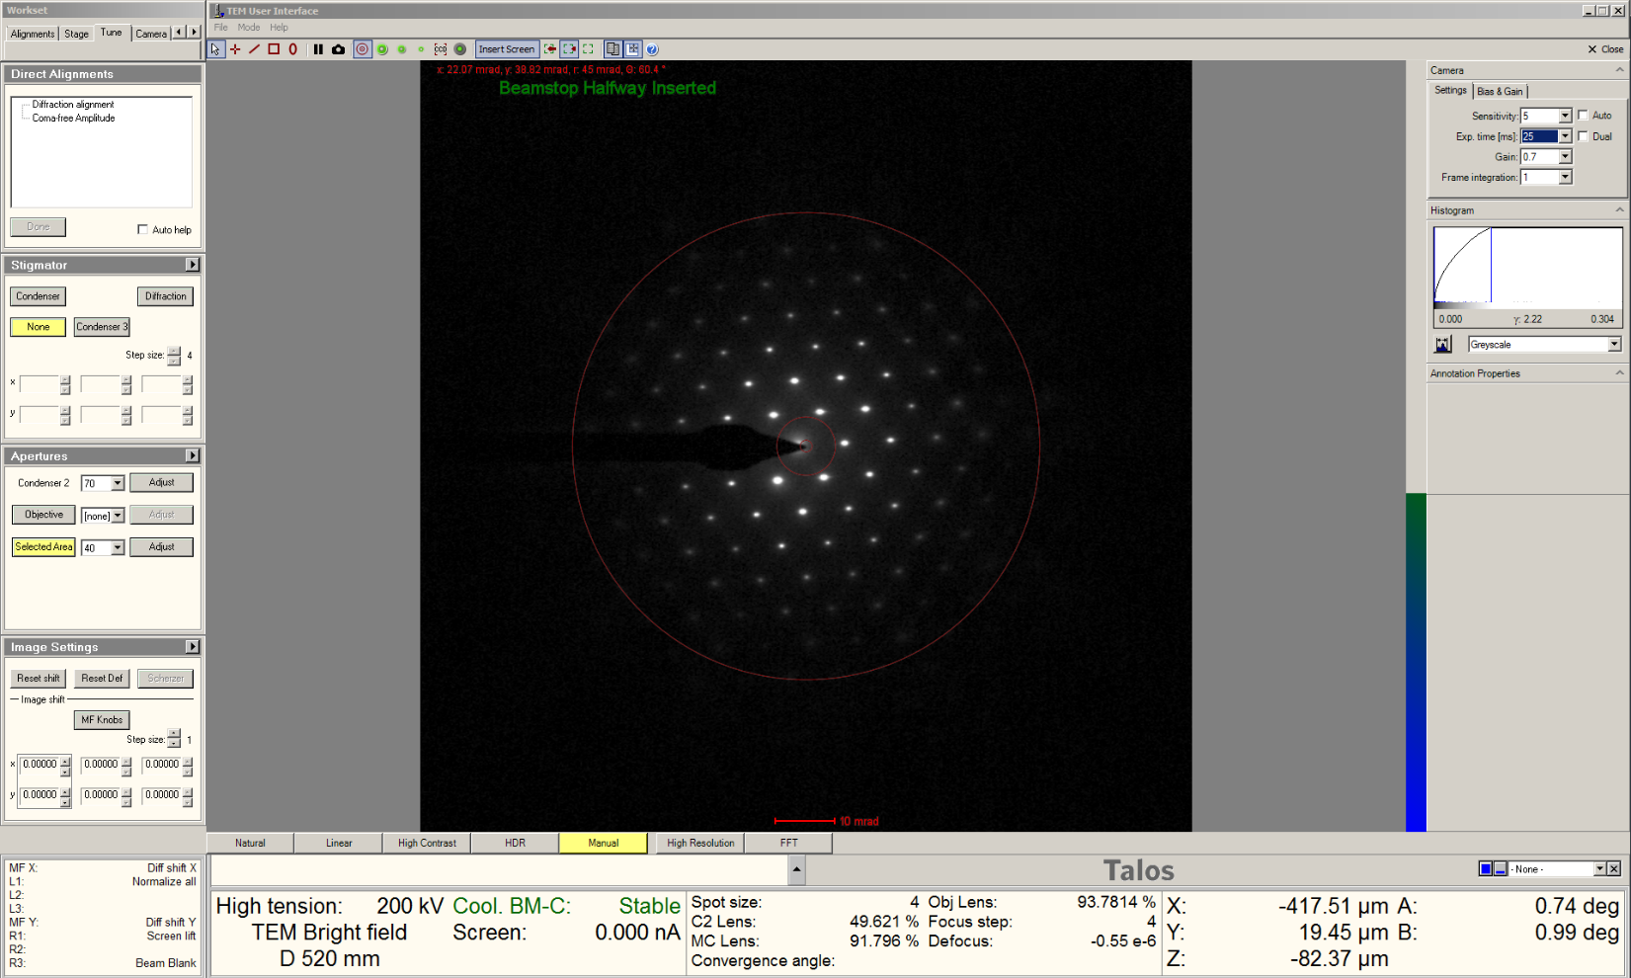
  - When finished acquiring selected area diffraction patterns, select the “Diffraction” button to return to TEM mode.

  - Retract the beam stop using the shortcut from the FluCam toolbar.

  - Select the “Tune” tab and navigate to the “Apertures” control panel.

    - Select “Selected Area” to retract the selected area aperture (button will turn gray).

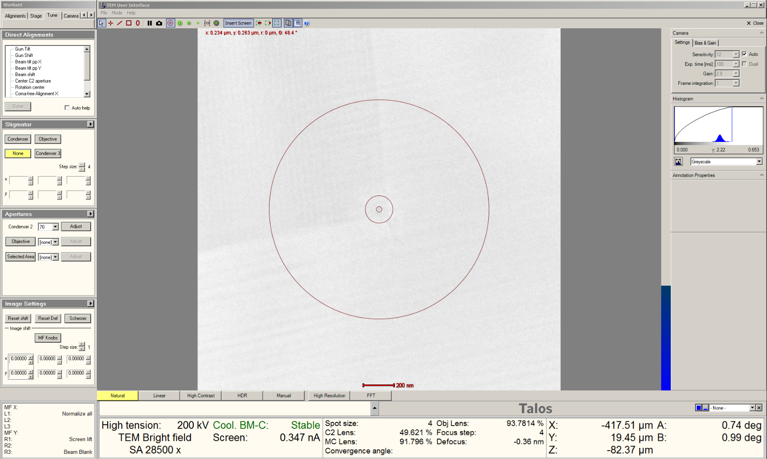

  - Rotation calibration (applies for operation at any HT)

    - If the diffraction pattern was acquired with an indicated camera length ≥98 mm, no rotation is needed to obtain proper alignment with the SA mode image.

    - If the pattern was acquired with an indicated camera length <98 mm, the pattern must be rotated 180° to obtain proper alignment with the SA mode image.

  - DP scale bar calibration (applies for any indicated camera length)

    - For 200 kV operation, multiply measured distances in the DPs (reciprocal length units) by a factor of 1.08.

    - For 80 kV operation, multiply measured distances in the DPs (reciprocal length units) by a factor of 1.18.
- EDS in TEM mode

  - EDS can be performed while in TEM mode to obtain a general survey of the area illuminated by the beam; however, spatially resolved EDS can only be performed in STEM mode (see separate STEM-EDS SOP).

  - Verify the objective and SA apertures are both retracted to prevent EDS detector overload and avoid unwanted system X-ray signals (not shown).

  - If desired, the spot size may be decreased to increase the beam current and increase the number of X-rays generated (not shown).

  - If using the single tilt holder (not used here) the α tilt must be ≥15° to allow enough line of sight between the specimen and the EDS detector; if α ≥ 15° is already satisfied no further adjustment is needed; otherwise, proceed to the next step.

  - In Microscope Control, select the “Stage” tab and navigate to the Stage² control panel.

  - Select the flap-out arrow and then the “Control” tab; under “Alpha toggle, input 15°and select “Set Alpha”; verify α = 15° in the bottom information panel (not done here).

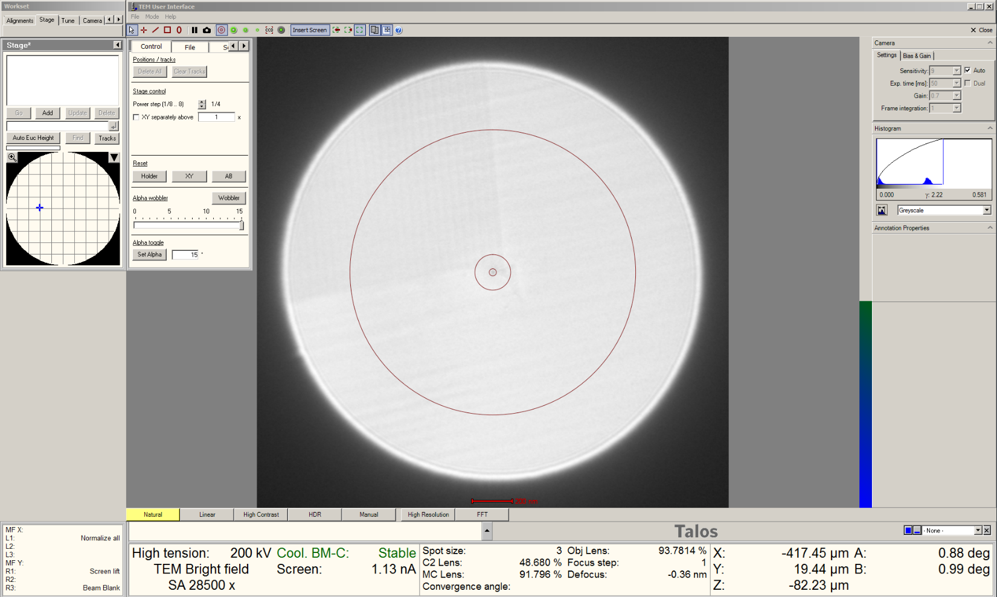

  - Navigate to an ROI on the sample and illuminate as desired using the beam shift track ball and “Intensity” knob; the beam may be as small or as large as desired provided it does not illuminate anything too thick to be electron transparent.

  - Maximize the ESPRIT 2 software on the second monitor.

  - Select “Spectra” from the options list on the left side; select “clear” near the lower right corner to clear any spectra still present in the window.

  - Navigate to the “Project” configurator; select the “I/O” icon and then select “New” to open a new project.

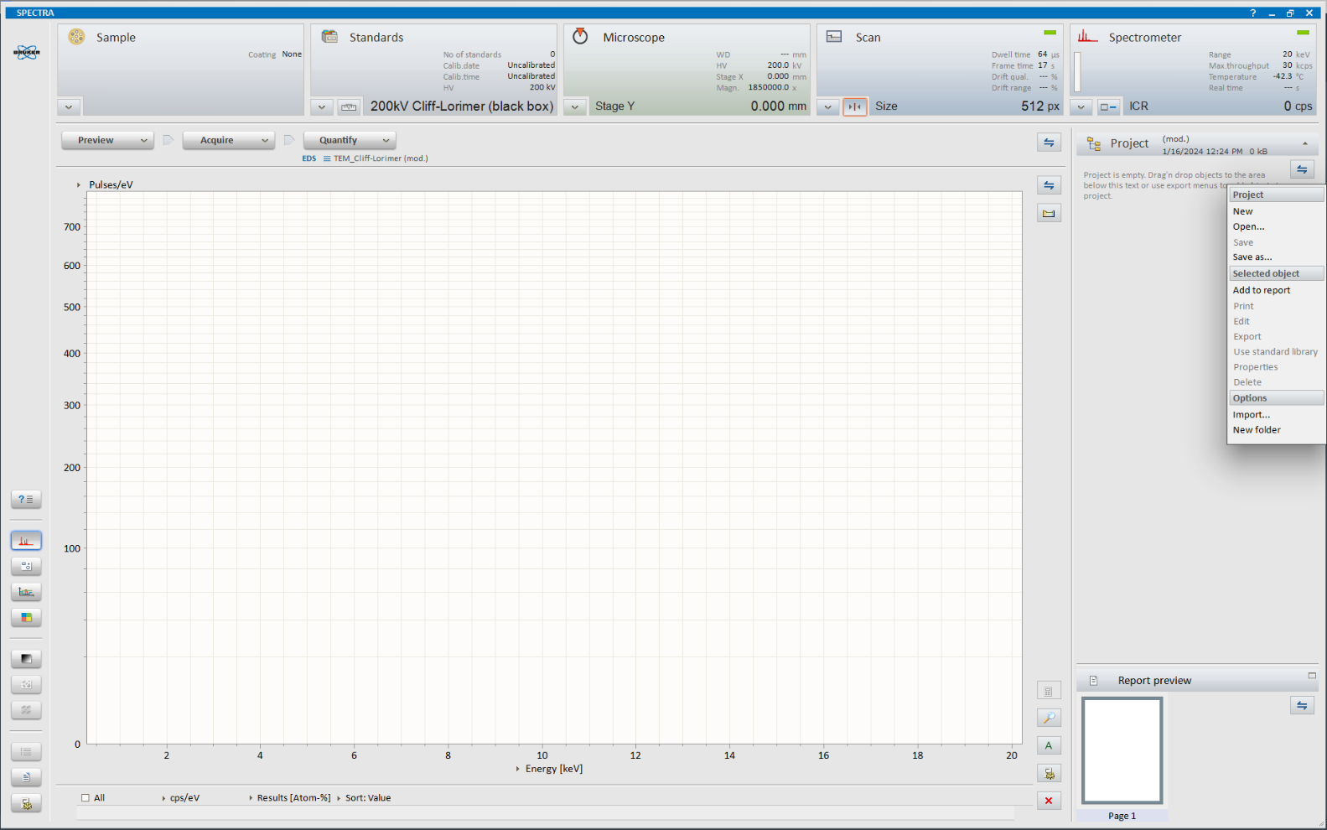

  - Navigate to the “Spectrometer” configurator and then select the detector position icon.

  - in the “DETECTOR POSITION” window, select “OK” to insert the detector (a few seconds to complete).

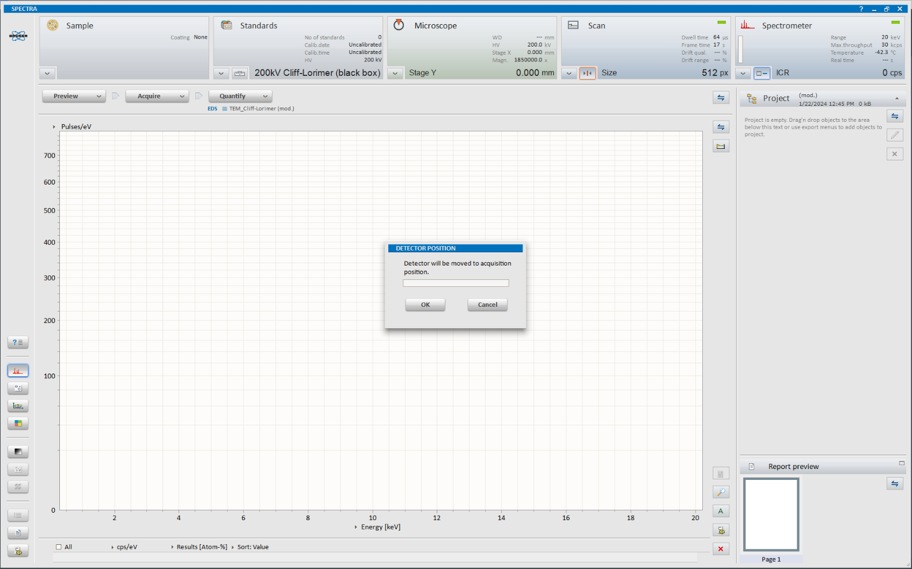
  - Remain in the “Spectrometer” configurator; select the downward-pointing arrow.

  - In the “EDS DETECTOR CONFIGURATION” window, select a value for “Maximum Energy” (20 keV is usually sufficient); and select “Close”.

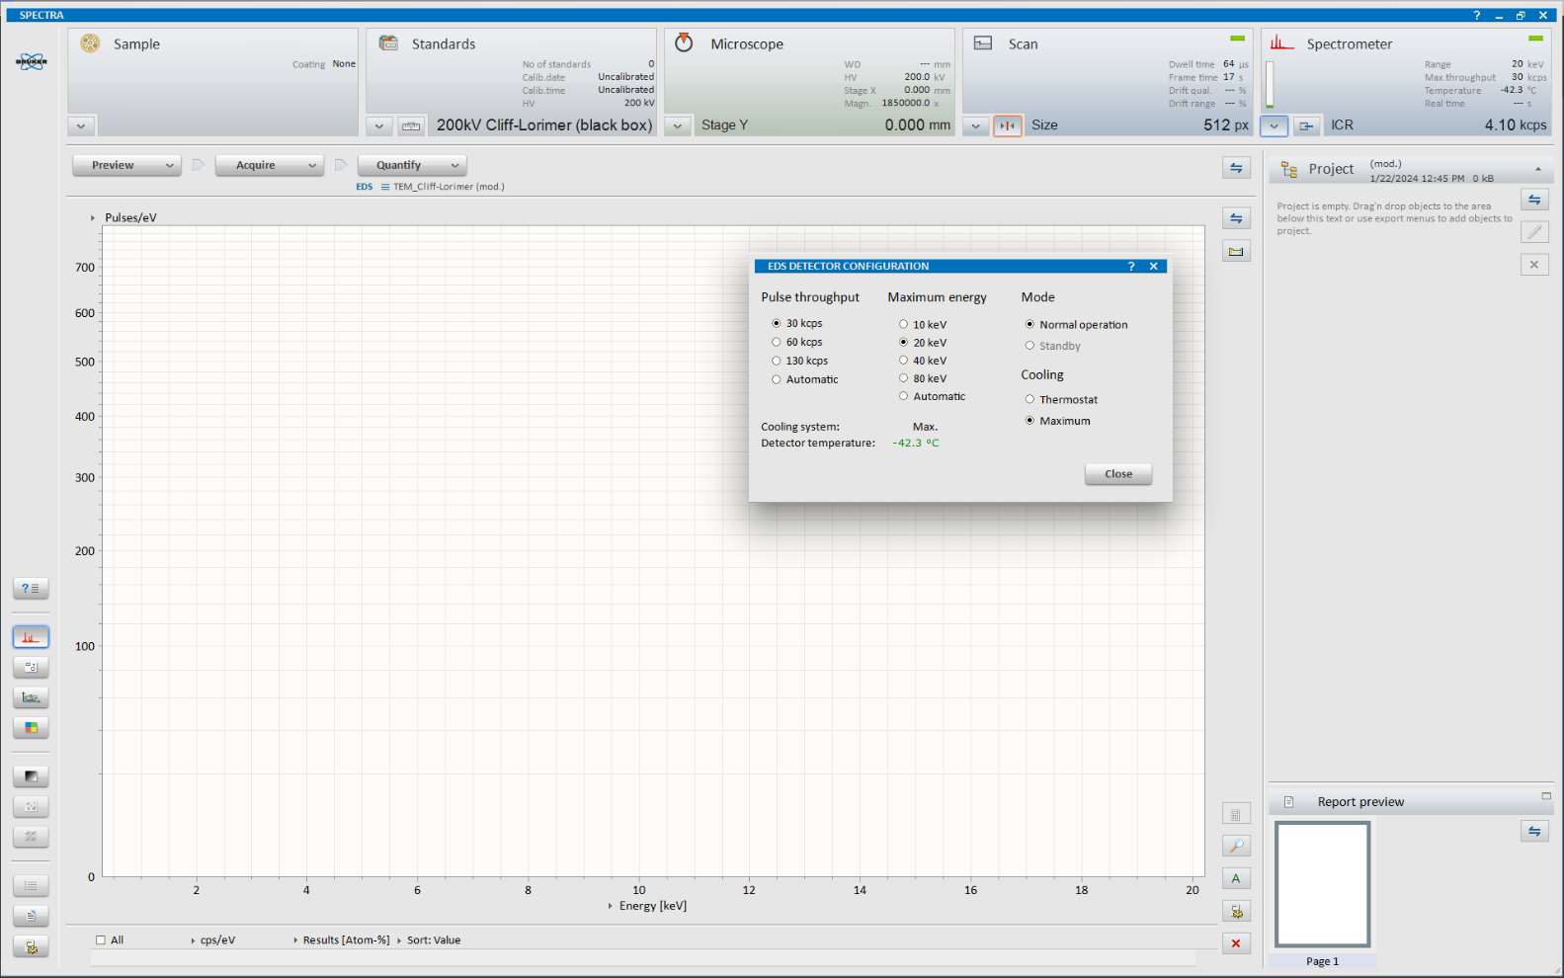

  - Navigate to the “Sample” configurator; select the down pointing arrow.

  - In the “SAMPLE PROPERTIES” window, under “Name”, input the name of the specimen and select “OK”.

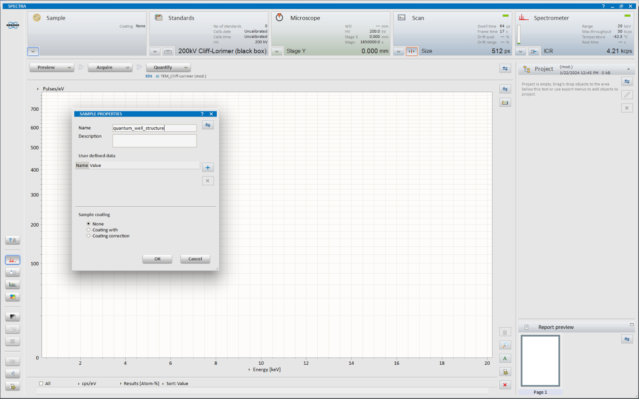
  - In the “Acquire” button, select the down-pointing arrow.

  - Under “Acquisition parameters”, select “Manual”; under “Spectrum numbering” input “Spectrum number” = 1 and check “Automatic numbering”; under “Auto save” check “Add to project”.

  - Select “Acquire” to start acquiring the spectrum.

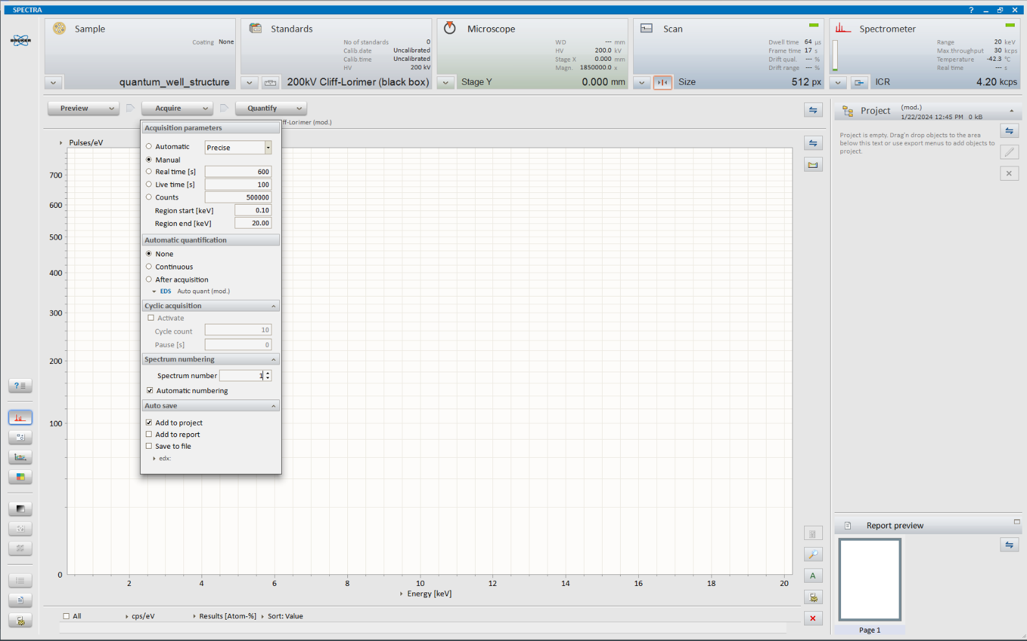

  - Select the periodic table icon near the upper right corner of the spectrum; in the open window, select the “Table of elements” tab and select the elements for identification in the spectrum.

  - When the spectrum is sufficient, select “Acquire” to stop the acquisition and save the spectrum.

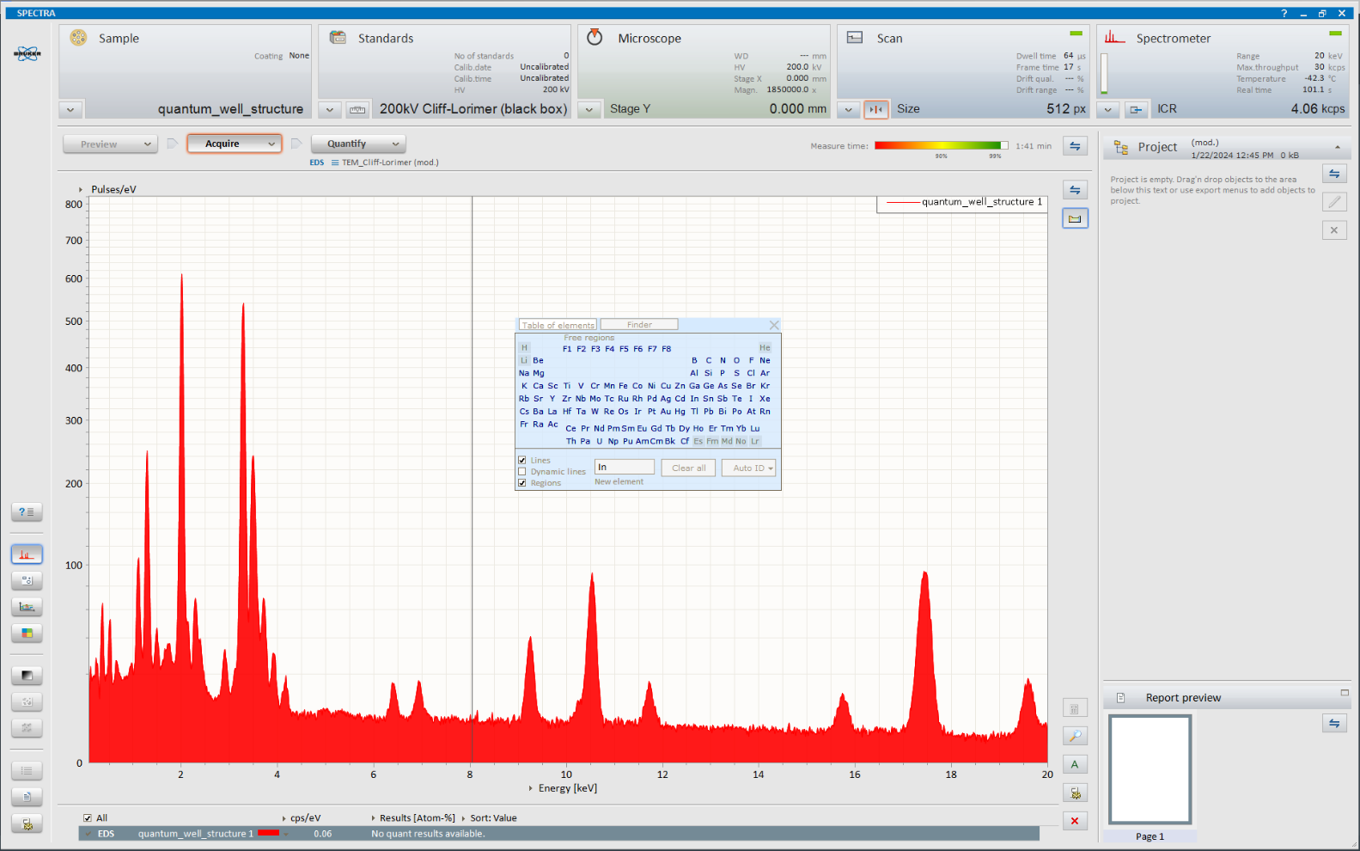
  - Acquired spectra may be added to the window by clicking and dragging from the “project” panel to the spectrum window; alternatively; spectra may be removed from the window by selecting “clear” near the lower right corner.

  - Select the “I/O” icon at the upper right corner of the spectrum window to save the open spectra in the window as either as raw data or as an image.

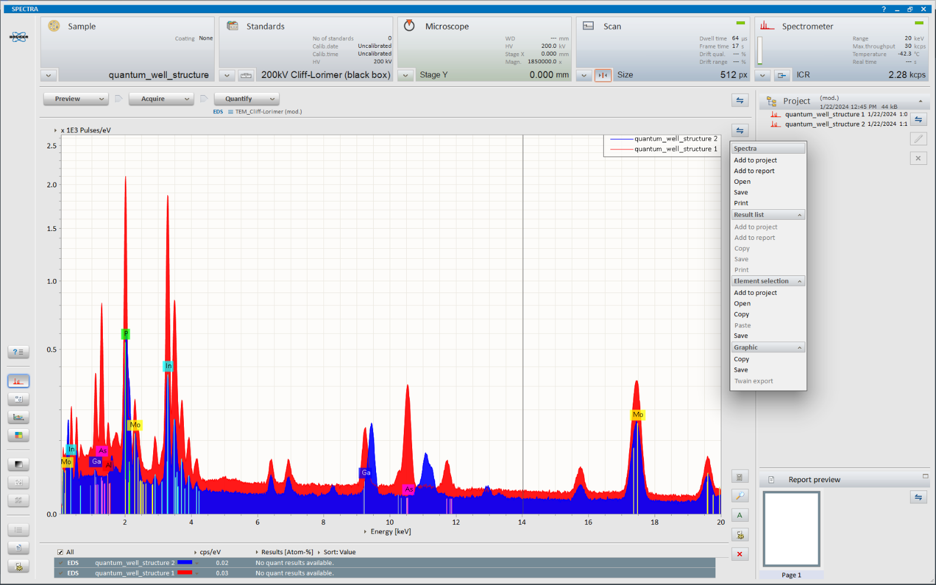

  - When finished performing EDS, navigate to the “Spectrometer” configurator and then select the detector position icon

  - In the “DETECTOR POSITION” window, select “OK” to retract the detector.

    - DO NOT leave the EDS detector inserted when not actively in use.

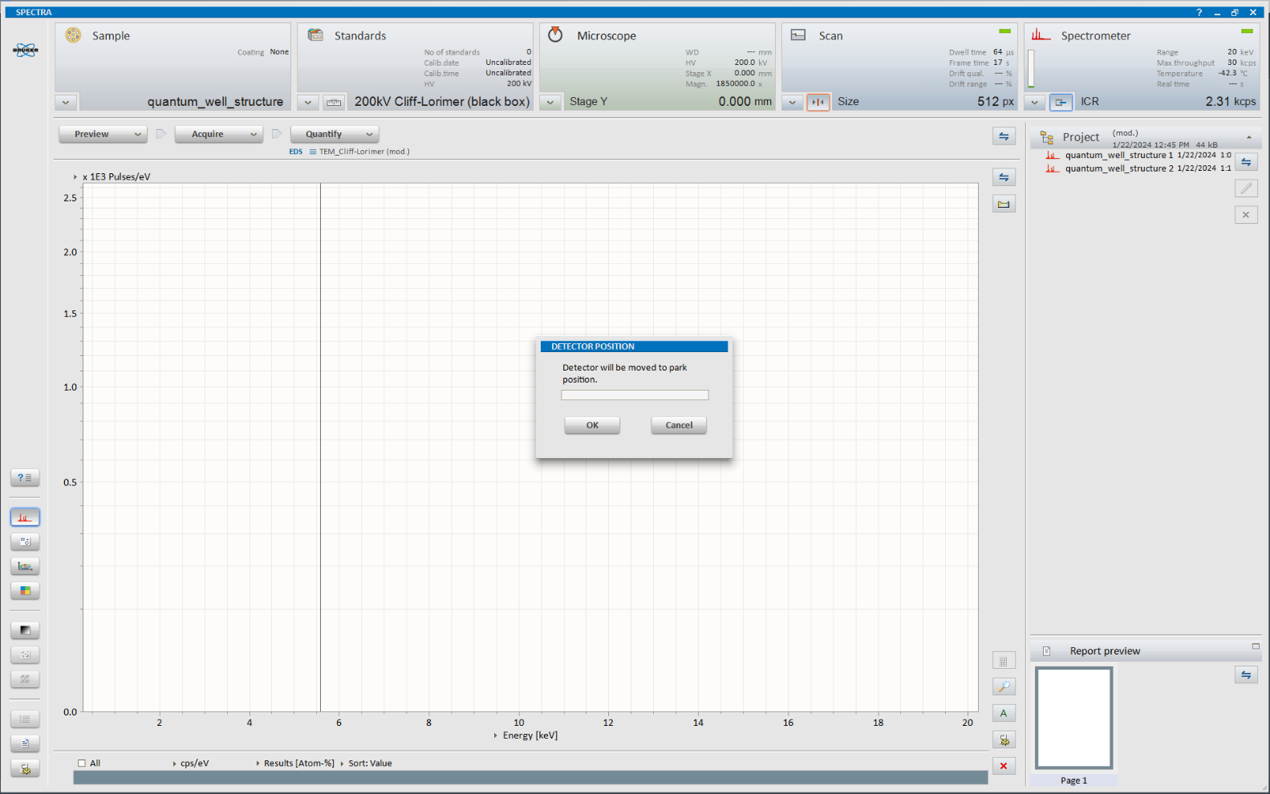
  - If using the single-tilt holder (not used here), return to Microscope Control and select the “Stage” tab.

  - Navigate to the “Stage²” control panel; select the flap-out arrow and then the “Control” tab.

  - Under “Alpha toggle”, input 0° and select “Set Alpha”.

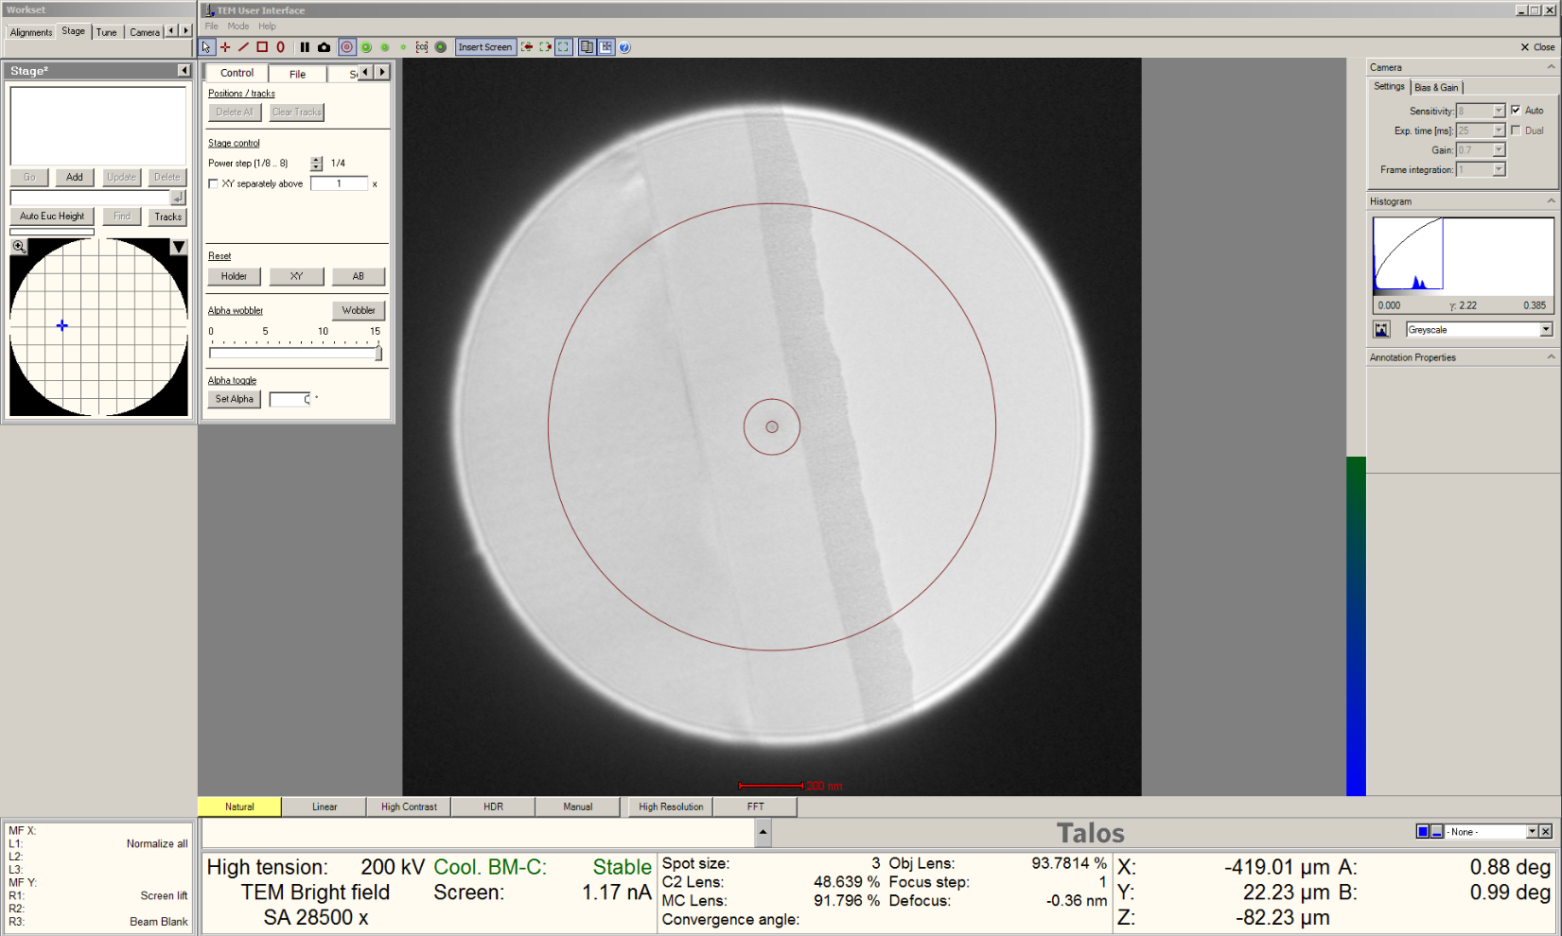
- Grid exchanges; finishing the session

  - When finished with the current grid, return to Microscope Control and place the instrument in SA mode as verified in the bottom information panel.

  - Select the “Vacuum/HT” tab and navigate to the “Vacuum” control panel.

    - select “Col. Valves Closed” to close the column valves; (the button will turn yellow), and status will now read “Status: All Vacuum (Closed)”.

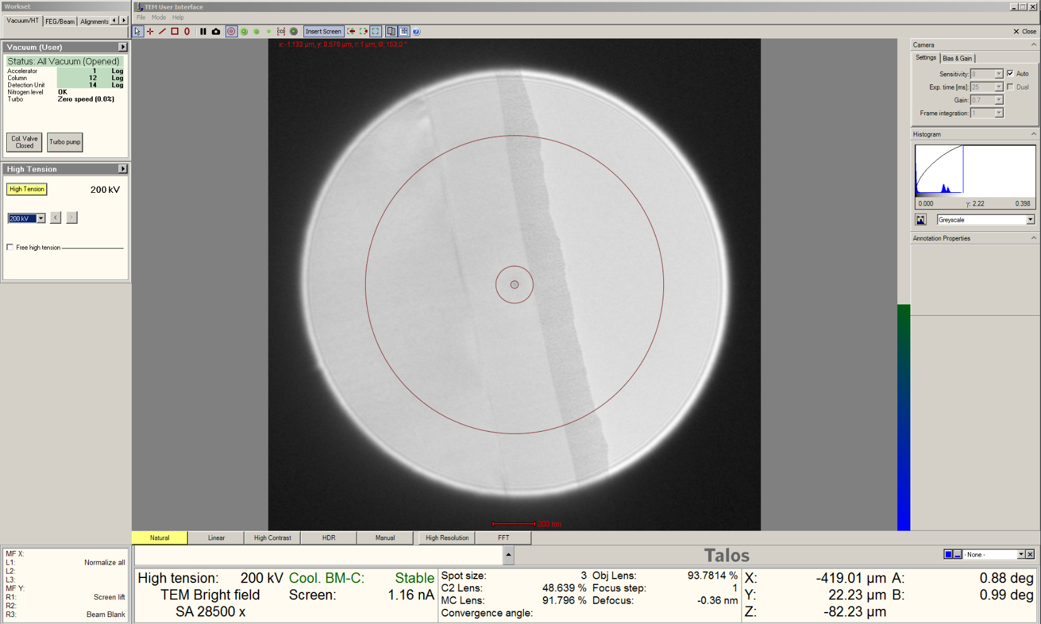

  - Select the “Tune” tab and navigate to the “Apertures” control panel; verify both the objective and SA apertures are retracted.

    - This is crucial to prevent microscope and/or holder damage during stage homing and holder retraction.

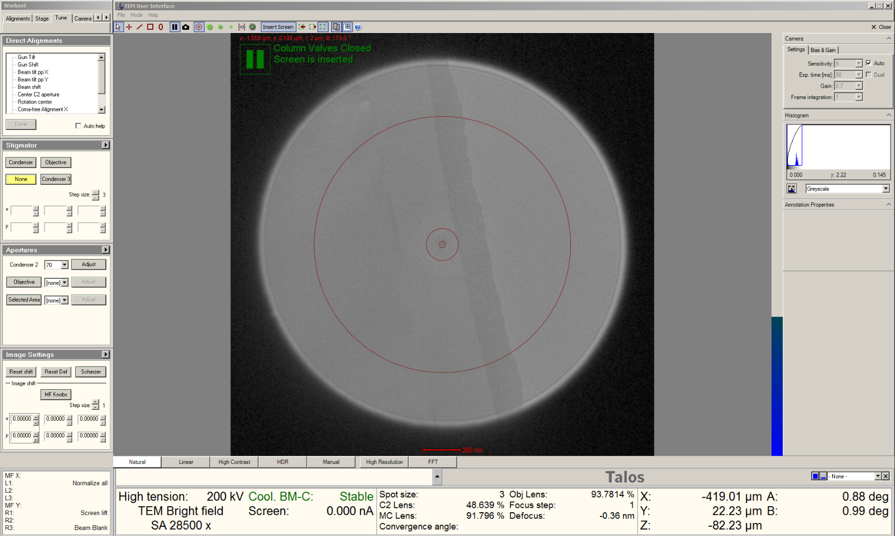

  - In Microscope Control, select the “Stage” tab and navigate to the “Stage²” control panel.

    - Select the flap-out arrow to expand the panel, then the “Control” tab.

    - Select “Holder” to home the stage; verify that X, Y, and Z positions and α and β tilt values are all ~0 before proceeding.

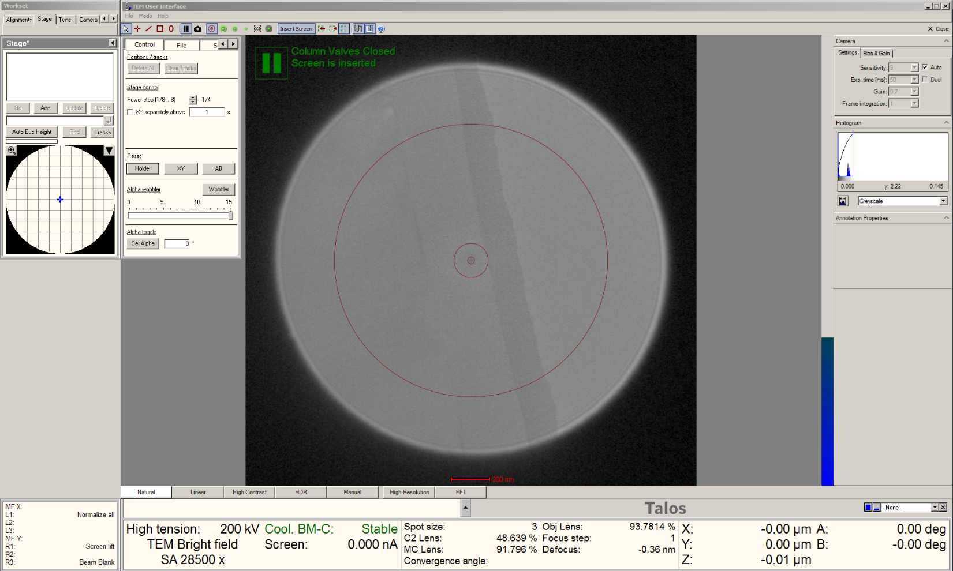
  - If using the double-tilt holder, disconnect the β tilt control.

  - Remove the holder from the column as described previously.

  - Remove the grid from the specimen holder.

  - If another grid is to be imaged, load it into the holder (cleaning it as appropriate), and load the holder back into the column.

  - When imaging a new grid in the same session, it is not necessary to reload the main alignment file.

  - The “200kV_uP” gun alignment does not need to be reloaded unless it was changed prior to unloading the previous grid.

  - “Spot size” must be reset after a grid exchange.

  - Eucentric height must be reset after a grid exchange.

  - It is best practice to perform (or at the very least check) all other alignments again after a grid exchange; particularly if wanting to obtain the best performance from the instrument.

  - If finishing the session, load the single tilt holder back into the column; if the double-tilt holder was used, insert it back into the plasma cleaner and place it back under vacuum and turn off (but do not vent) the plasma cleaner.
- Cryo cycling (if needed)

  - Cryo cycling the instrument is necessary at the end of each day or after the session if the instrument is being used outside of normal business hours; during normal business hours, NRF staff will usually take care of this, but may also request the last user of the day to perform this task.

  - Verify that the single tilt holder is inserted into the column; this must be done before initiating the cryo cycle.

  - Completely remove the cold trap dewar from the enclosure, placing it on the floor or the worktable; if there this any LN₂ remaining in the cold trap dewar, it may be poured back into a storage dewar.

  - A warning message will appear in Microscope Control indicating the LN2 level is nearly empty; this is normal.

  - In Microscope Control, select the “Vacuum/HT” tab and navigate to the “Vacuum” control panel, select the flap-out arrow to expand the panel, and then select the “Cryo” tab; select “Cryo Cycle” and then the green check button (not shown) to initiate the cryo cycle.

    - DO NOT adjust any of the cryo cycle settings unless specifically instructed by NRF staff to do so.

