
FEI Themis Z S/TEM
  - Monochromated STEM Mode Standard Operating Procedure Rev. 2026-01
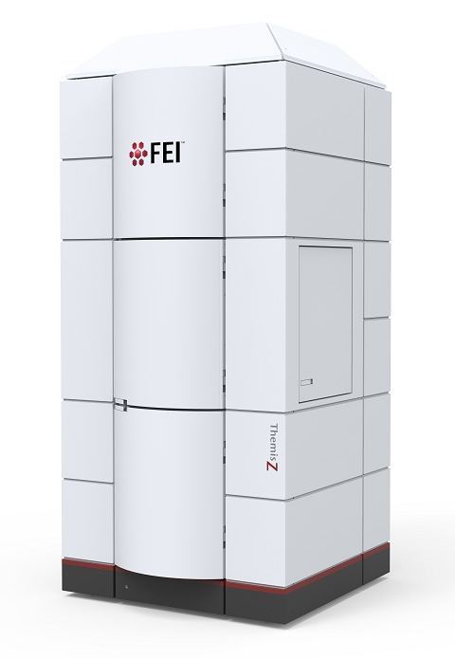
  - Application
The FEI Themis Z S/TEM is a state-of-the-art C_{s} probe-corrected field emission gun scanning/transmission electron microscope capable of providing micro- to pico-scale structural, morphological, magnetic, and chemical information. This document covers operation of the instrument in monochromated STEM mode. Please see separate SOP documents on the NRF instrument page regarding other applications.

  - NRF Contact
Nicholas G. Rudawski

Table of Contents

1. Safety information 3
2. Prerequisites 3
3. General remarks about monochromation 3
4. Before exciting the monochromator 3
5. Monochromator excitation 5
6. Monochromator tuning 9
7. Monochromator spot number selection 13
8. C3 aperture centering 15
9. Centering the dispersed beam 19
10. C1 (energy-filtering) aperture centering 20
11. Coarse A1 and B2 correction 22
12. STEM imaging 22
13. Additional monochromator adjustments 22
14. Considerations for STEM-EELS 24
15. Finishing 25

- Safety information

  - Due to stipulations of the instrument service contract as well as contamination concerns, analysis of radioactive and/or biological specimens with this instrument is strictly prohibited.

- Prerequisites

  - Extensive familiarity with use of the Microscope Control user interface software.

  - Proficient in independent operation of the FEI Themis Z S/TEM for TEM and STEM imaging.

  - Proficient in independent operation of the Gatan GIF Continuum ER energy filter for STEM-EELS analysis.

  - NOTE: as per the prerequisites, many associated details and images that could otherwise be included here are omitted for purposes of clarity (“…as per usual”).

- General remarks about monochromation

  - Monochromation reduces the energy spread of the electrons leaving the gun. At 60 kV, this will improve both STEM probe size (via reduction of chromatic aberration) as well as EELS resolution. However, at 200 kV (or higher), this will basically only improve EELS resolution.

    - The example shown here was performed at 200 kV.

- Before exciting the monochromator

  - It is best to be located over vacuum when exciting/tuning the monochromator and tuning the EELS spectrometer. If using a support film grid with particulates, it is recommended to store two stage positions: 1) where the final analysis is to be performed and 2) an open hole/cut where no support film is present. Once monochromator tuning and/or EELS tuning is/are complete, the stage may then be directly moved to the analysis location.

  - Find a region of interest, perform monochromator centering, and bring the region of interest to eucentric height (not shown, described elsewhere).

  - If intending on performing EELS, GIF tuning should be performed in EFTEM mode before energizing and exciting the monochromator (not shown, described elsewhere).
- Monochromator excitation

  - Maximize Sherpa and select the “OptiMono” application; activate “Details” (if not already activated) so the different steps may be observed.

  - Select “Presets” to set the instrument to appropriate settings (SA 2550×, spot size = 1, C3 lens off, largest C1, C2, and C3 apertures) for exciting (and tuning) the monochromator.

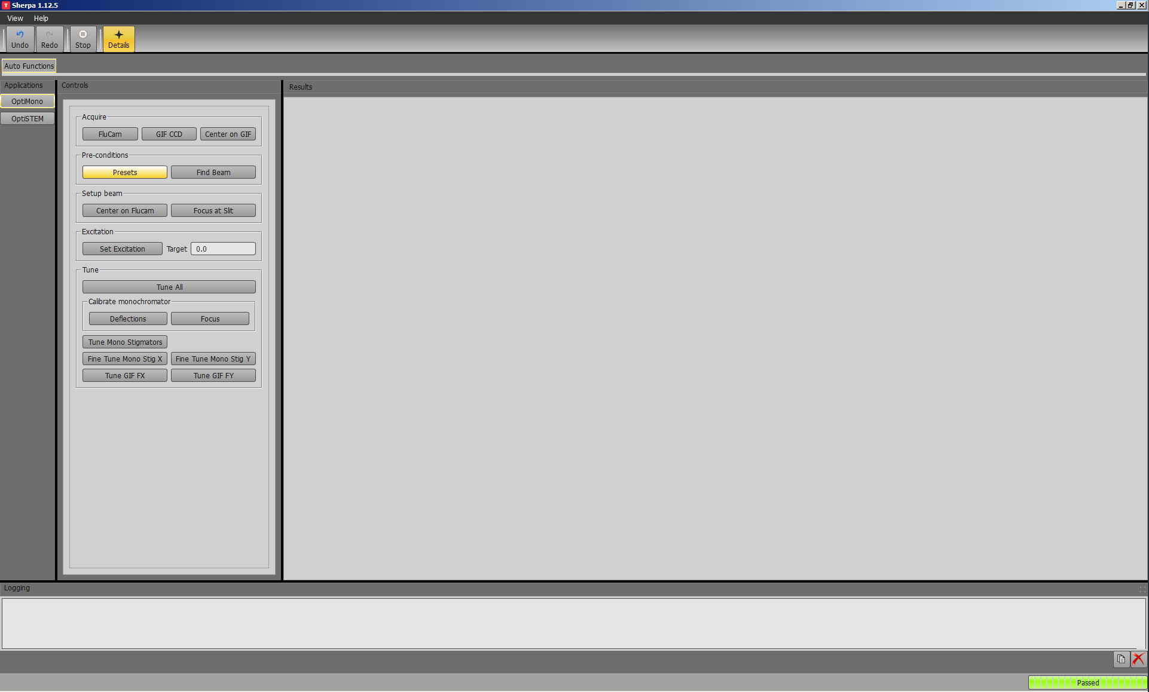

  - Select “Find Beam” to automatically locate the beam.

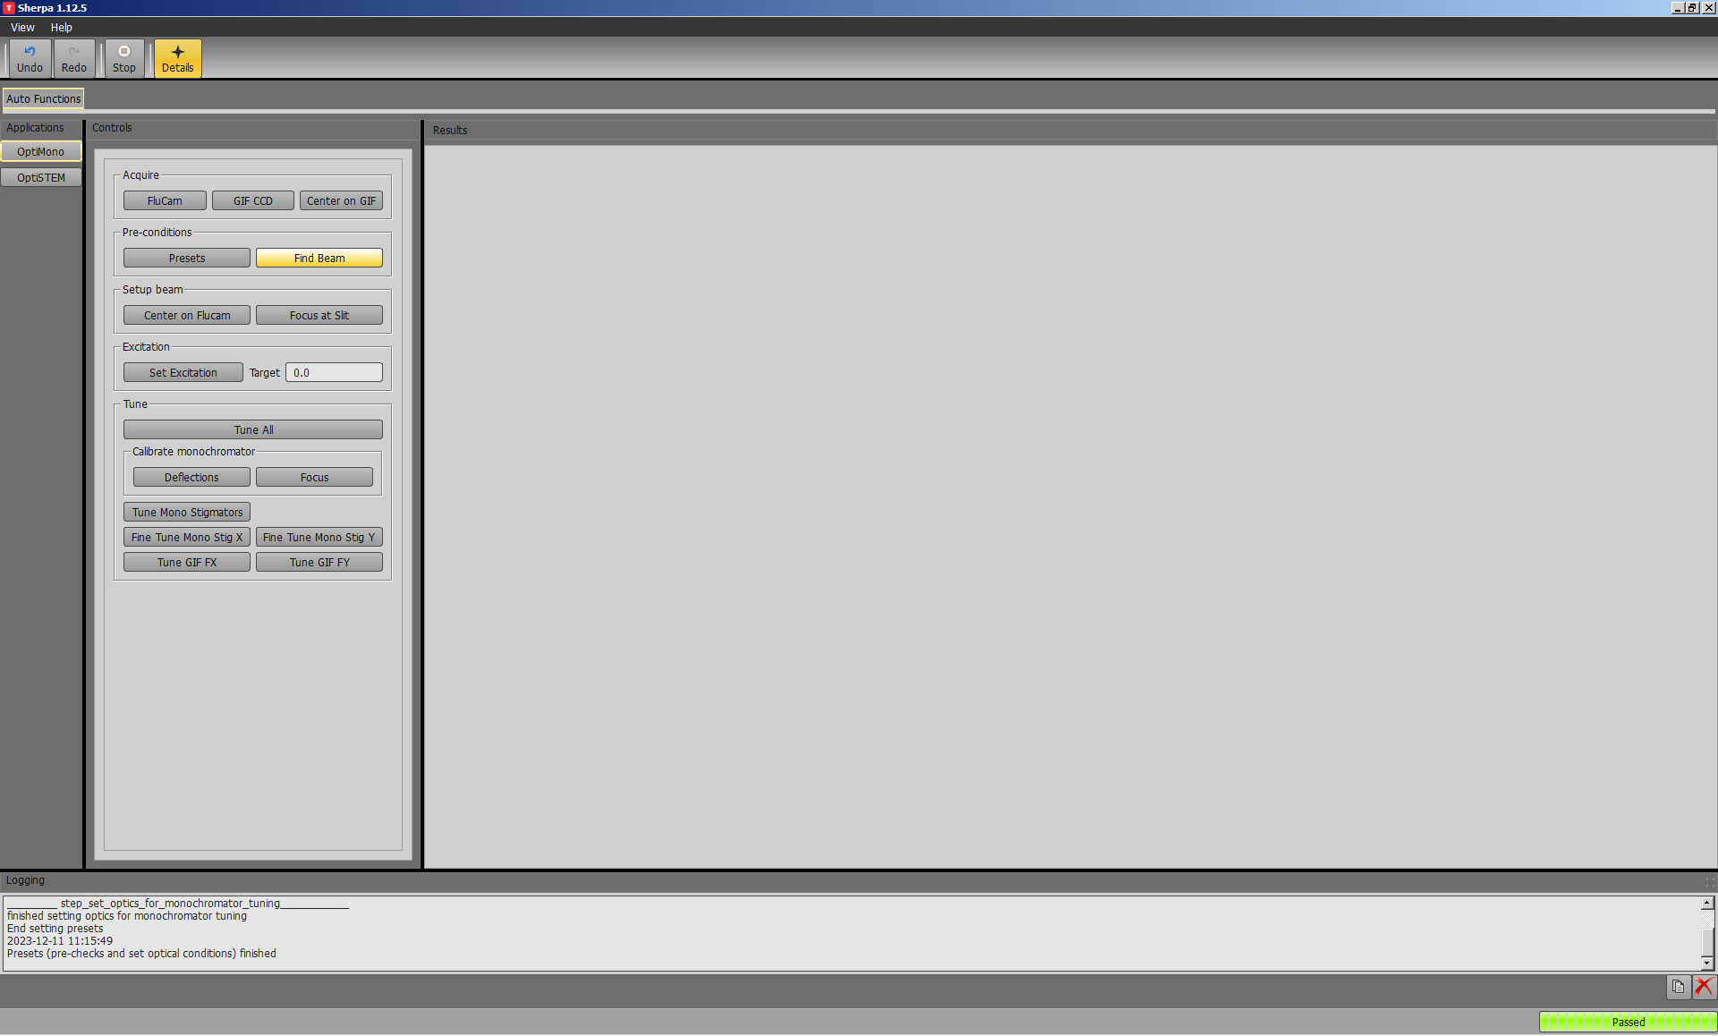

  - Select “Center on Flucam” to automatically center the beam (via maximizing screen current).

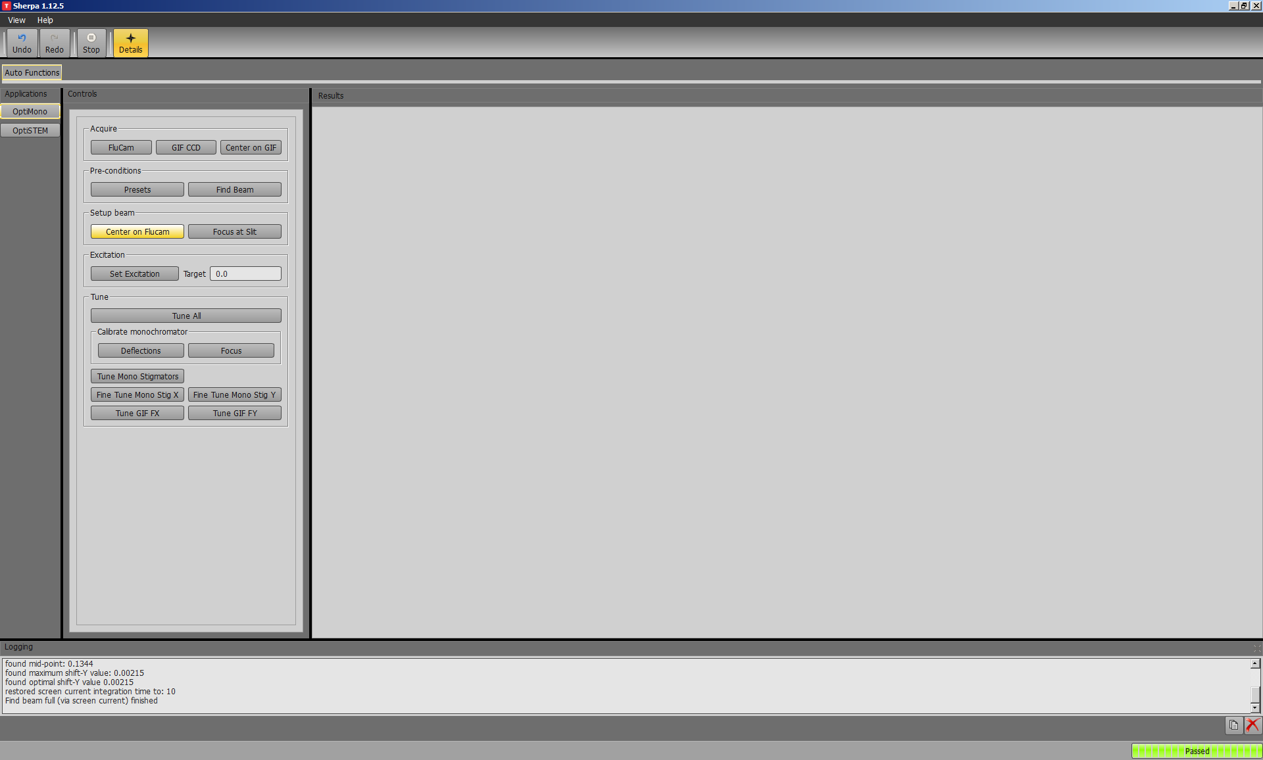

  - Select “Focus at slit” to automatically focus the C2 lens on the energy filtering slit (C1 aperture).

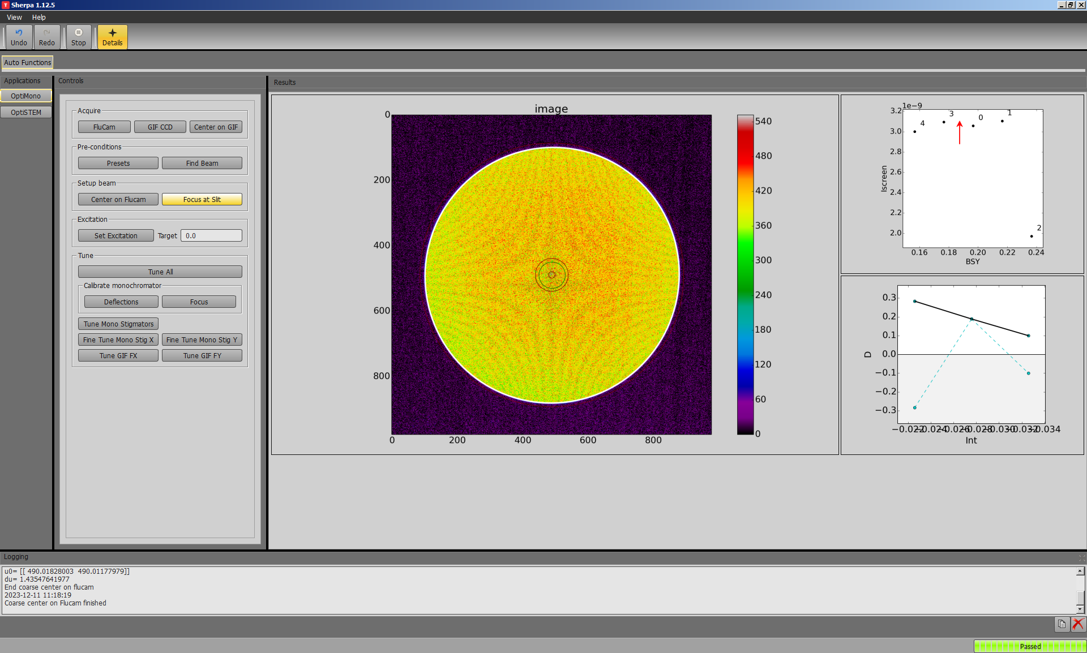
  - Input the desired value for “Target” and select “Set Excitation”; the system will automatically recenter the beam as the excitation is ramped up to the target value.

    - NOTE: larger excitations will improve energy resolution, but at the expense of reduced beam current; excitation = 1.2 is recommended for obtaining the highest possible energy resolution.

    - Once excitation is complete, it is recommended to allow at least 1 h for the monochromator to stabilize.

    - Afterwards, the beam will likely be off the Flucam; either manually adjust the monochromator shifts (not shown) or remain in Sherpa and select “Center on Flucam” to recenter the beam (previously shown).

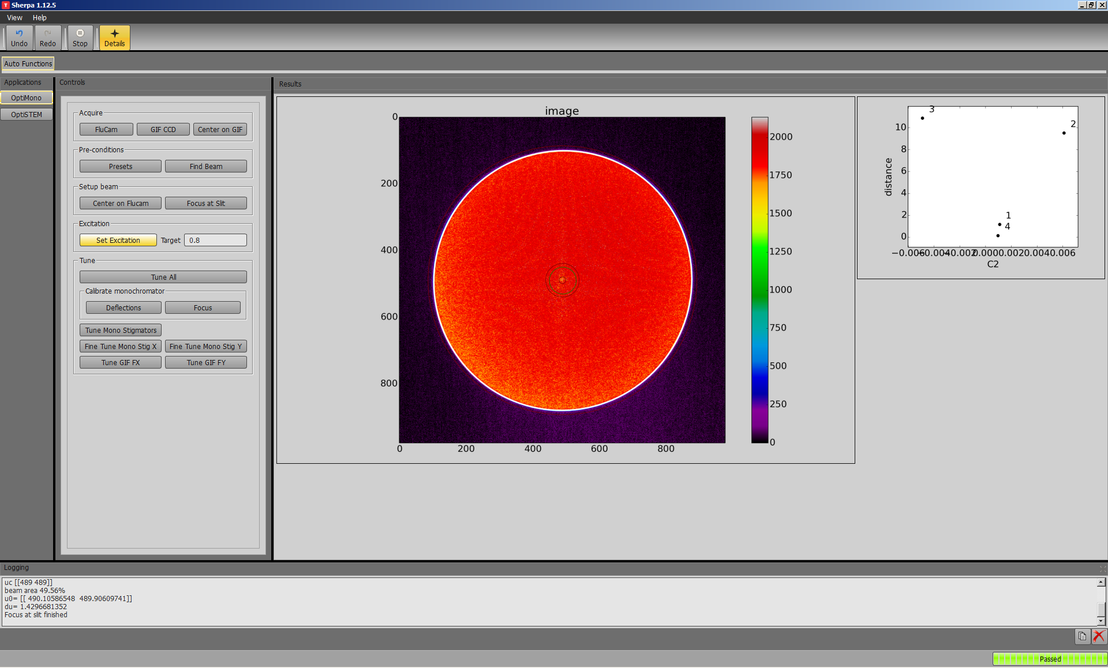
- Monochromator tuning

  - Select “Deflections” to calibrate the different monochromator deflectors; this helps to ensure the beam stays centered as the different deflectors are adjusted.

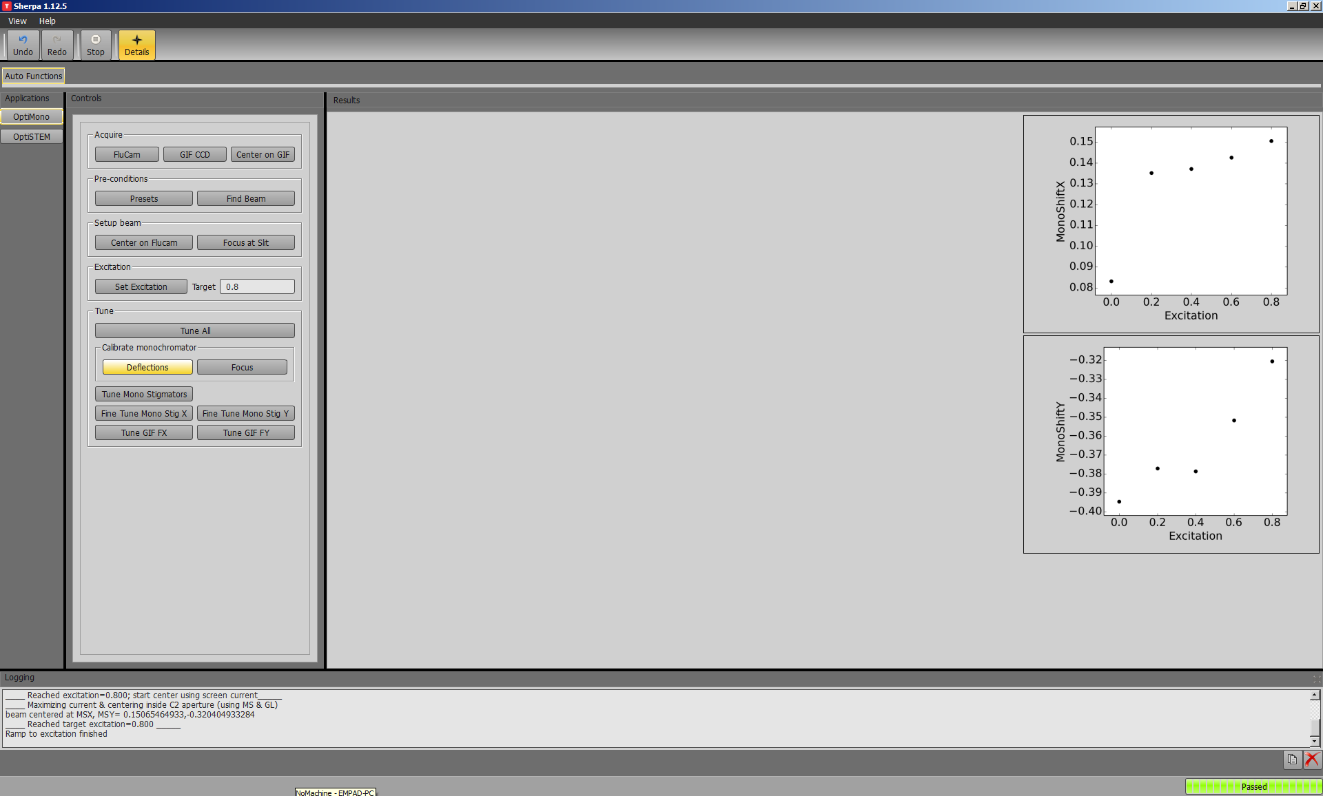

  - Select “Focus” to calibrate the optimal focus for different values of mono stigmator X; this helps to keep the beam focused while optimizing mono stigmator X.

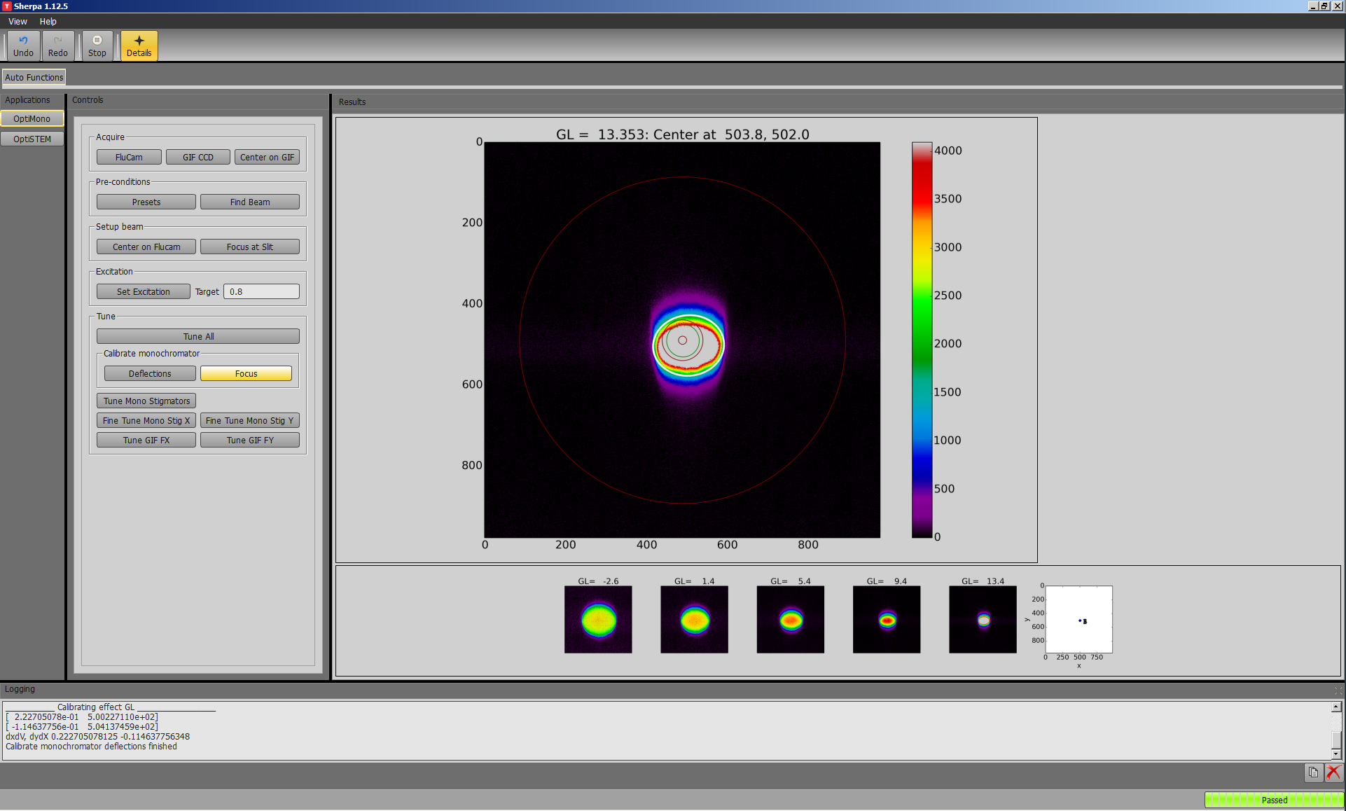
  - Select “Tune Mono Stigmators” to coarsely correct both X and Y monochromator astigmatism.

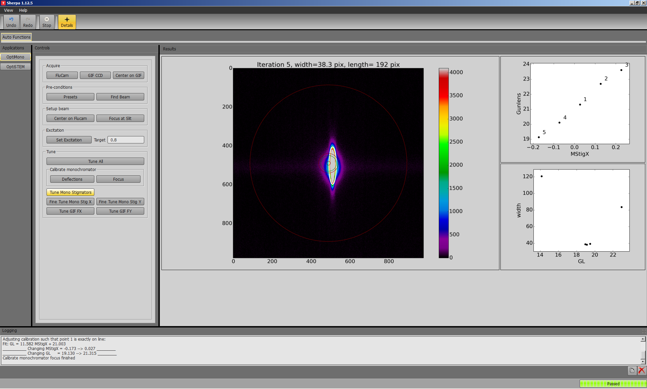

  - Select “Fine Tune Mono Stig Y” to finely correct Y monochromator astigmatism.

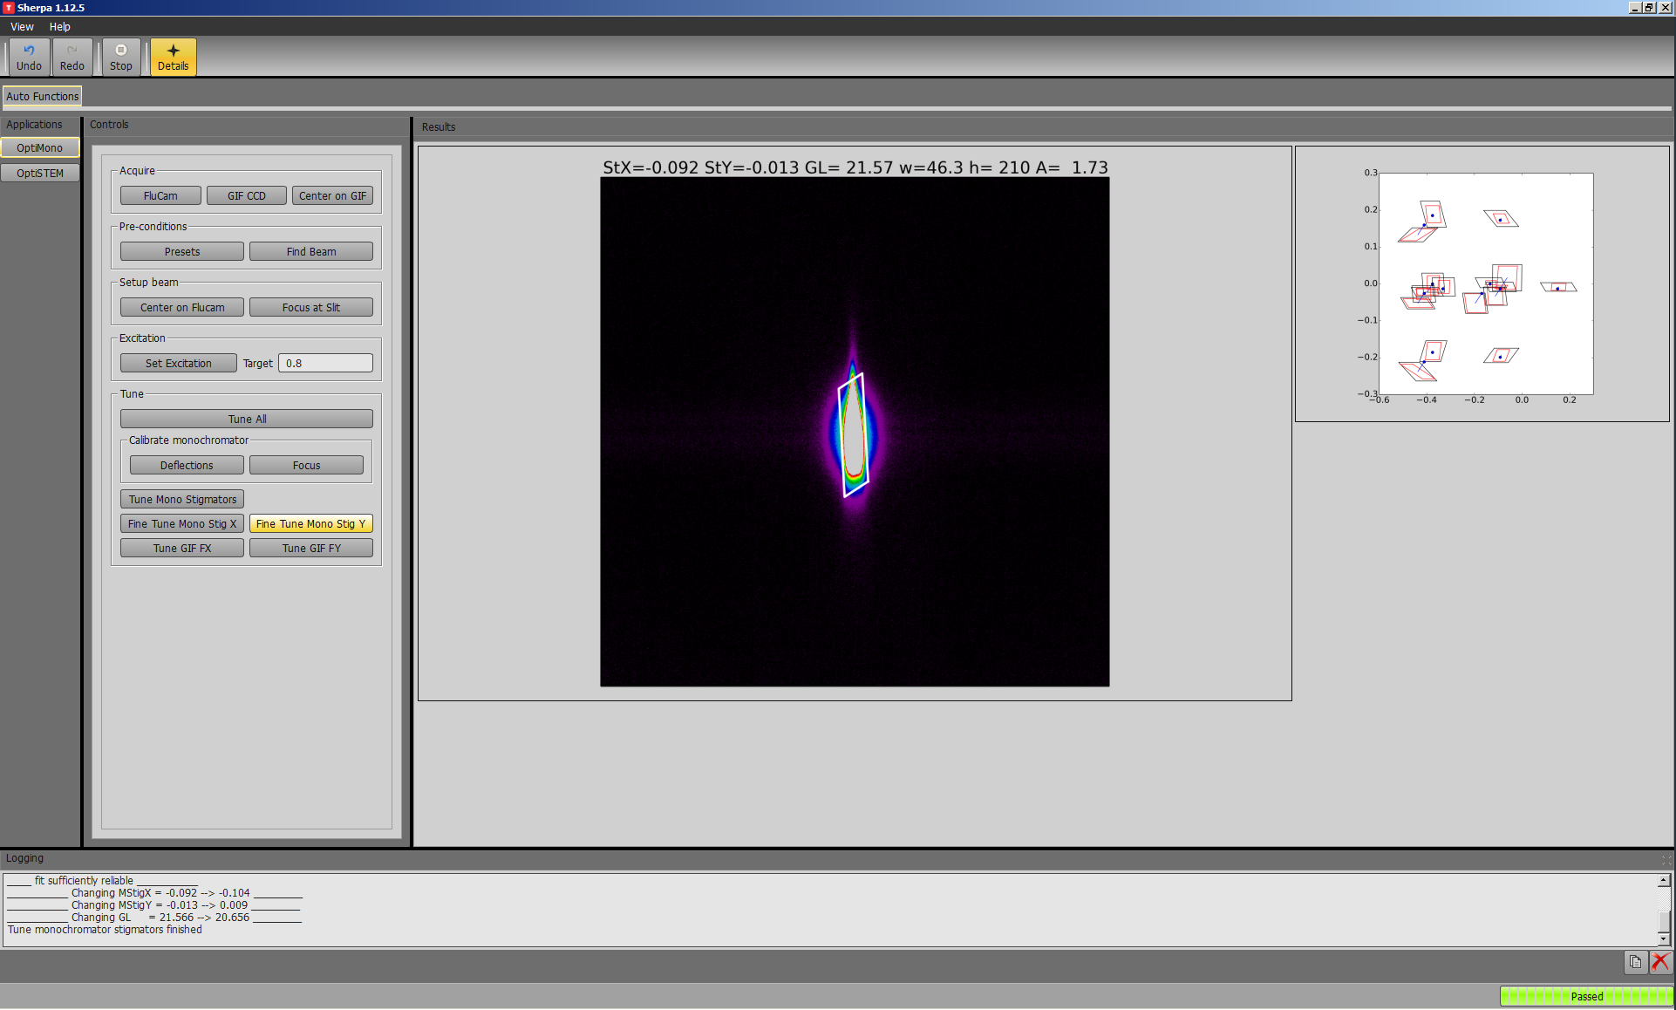
  - Fine correction of the X monochromator astigmatism must be performed manually; return to Microscope Control and un-pause the Flucam to resume live imaging.

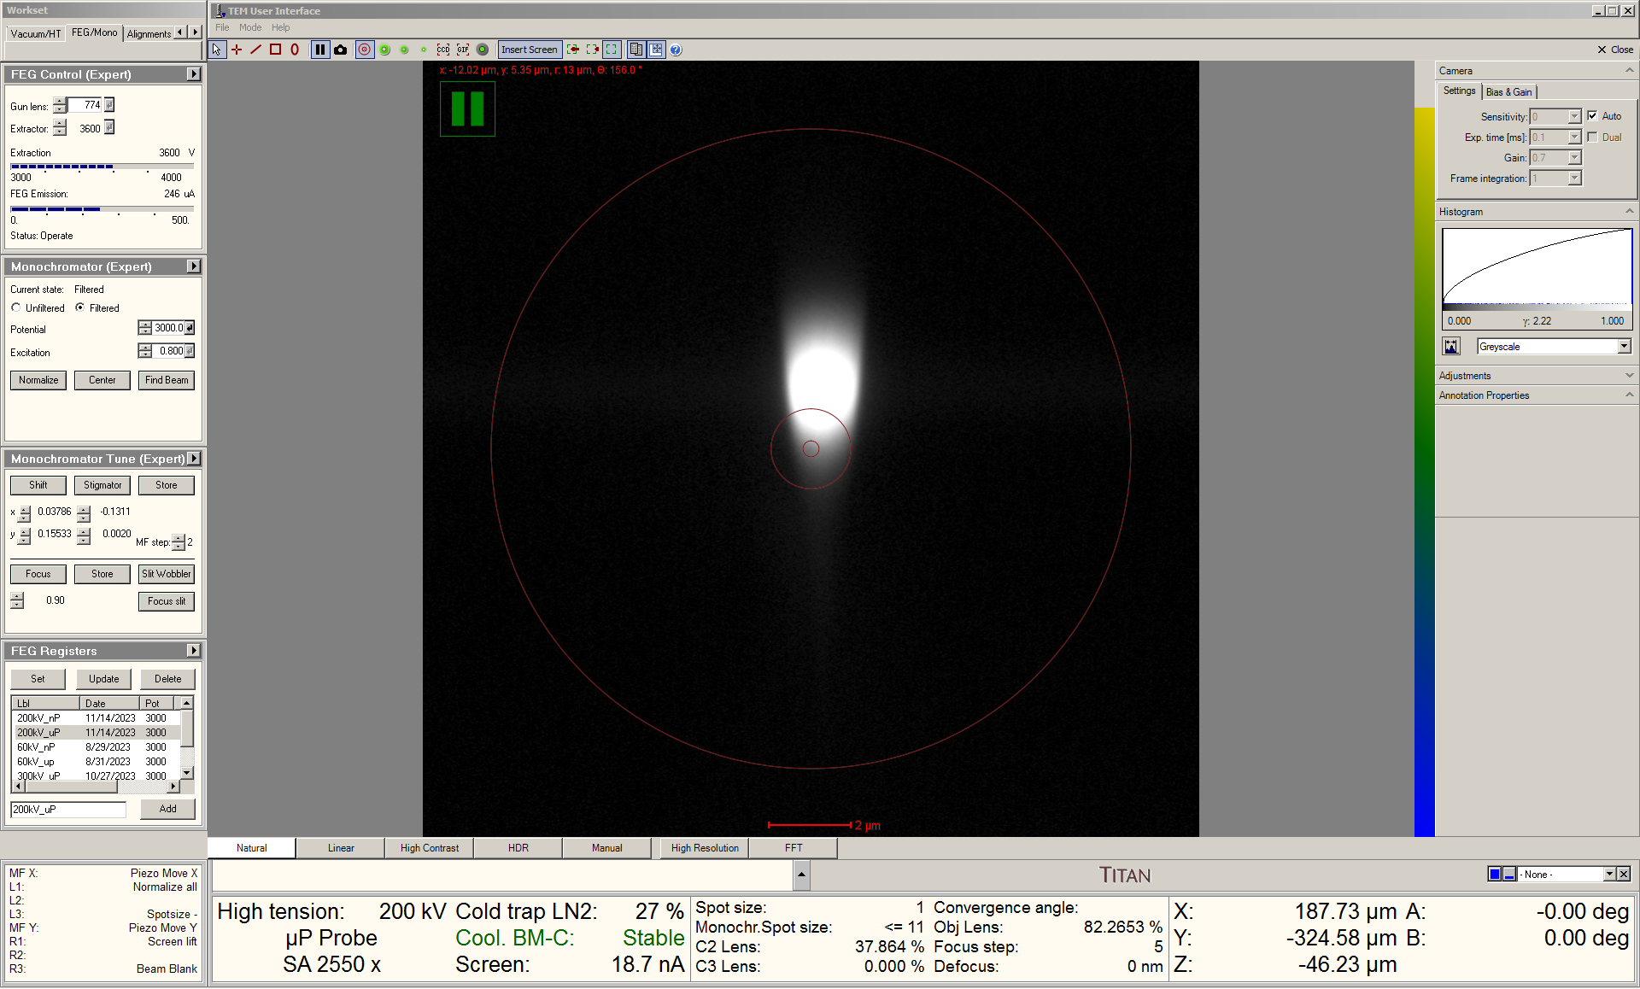

  - Select to the “FEG/Mono” tab and navigate to the “Monochromator Tune” panel; activate “Stigmator” and “Focus”. Monochromator astigmatism will present as asymmetry in the dispersed beam between under (left) and overfocus (right) conditions.

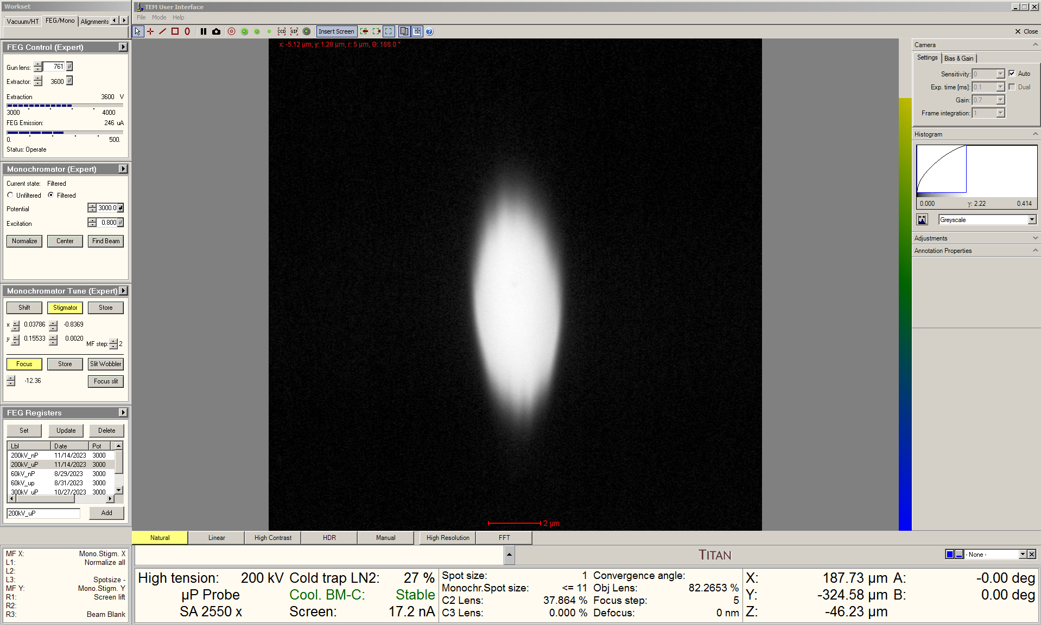
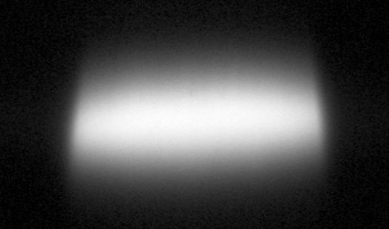
  - Adjust the X “Multifunction” knob (mono stigmator X) so the dispersed beam is symmetric between under (left) and overfocus (right) conditions.

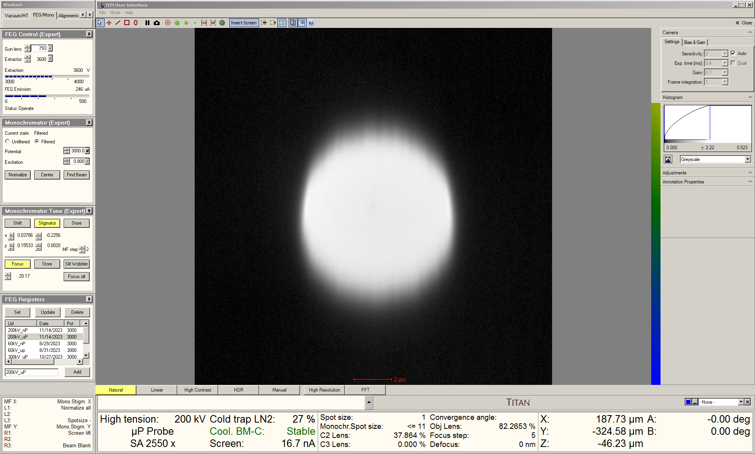
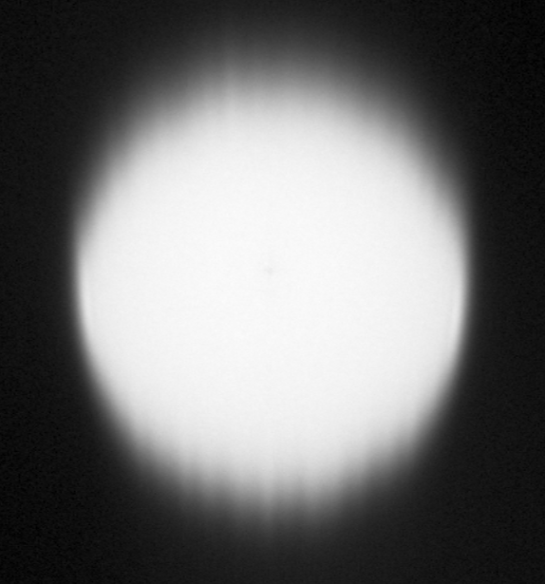

  - Use the “Intensity” knob to focus the dispersed beam as tightly as possible along the non-dispersive (horizontal) direction; In the “Monochromator Tune” panel, select “Store” to set this as the optimal monochromator focus.

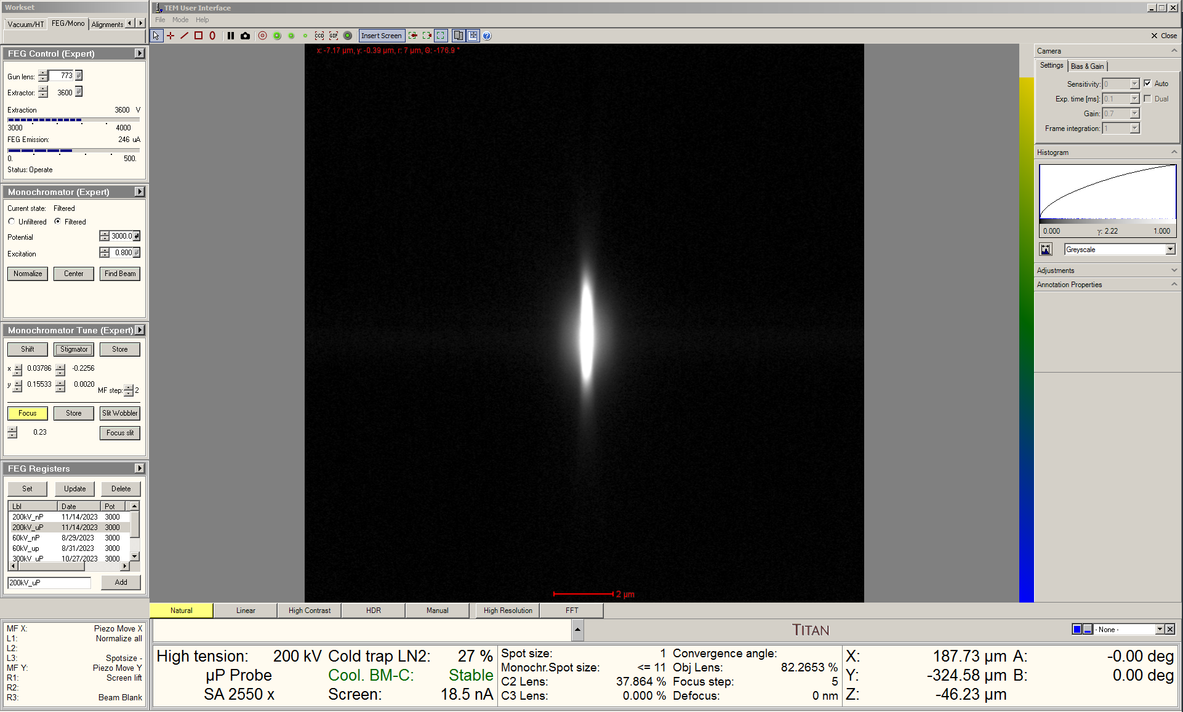
- Monochromator spot number selection

  - Select the “STEM” tab and navigate to the “STEM Imaging” panel; select “STEM” to enter STEM mode, press “Eucentric focus”, set the indicated magnification ≥ 1.3 M×, and center the beam in the image (not shown)

  - Overfocus the monochromator to spread the dispersed beam out (described previously); it will be refocused later when centering the dispersed beam.

  - Navigate to the “STEM AutoTuning” panel; select the flap-out arrow to expand the panel and select “Reset” (not shown).

  - Select the “Beam/Tune” tab and navigate to the “Beam Settings” panel; select “Probe” to switch the system into 3 condenser mode and the panel will automatically expand. In the expanded panel, select the desired “Monochromator spot number”.

    - Monochromator spot number = 12 or 13 is recommended for performing core-loss edge EELS analysis.

    - Monochromator spot number = 15 or 16 is recommended for atomic-resolution STEM imaging.

    - NOTE: when using monochromated spot numbers, it is no longer possible to arbitrarily specify a probe semi-angle of convergence; this will now be defined by the C3 aperture.

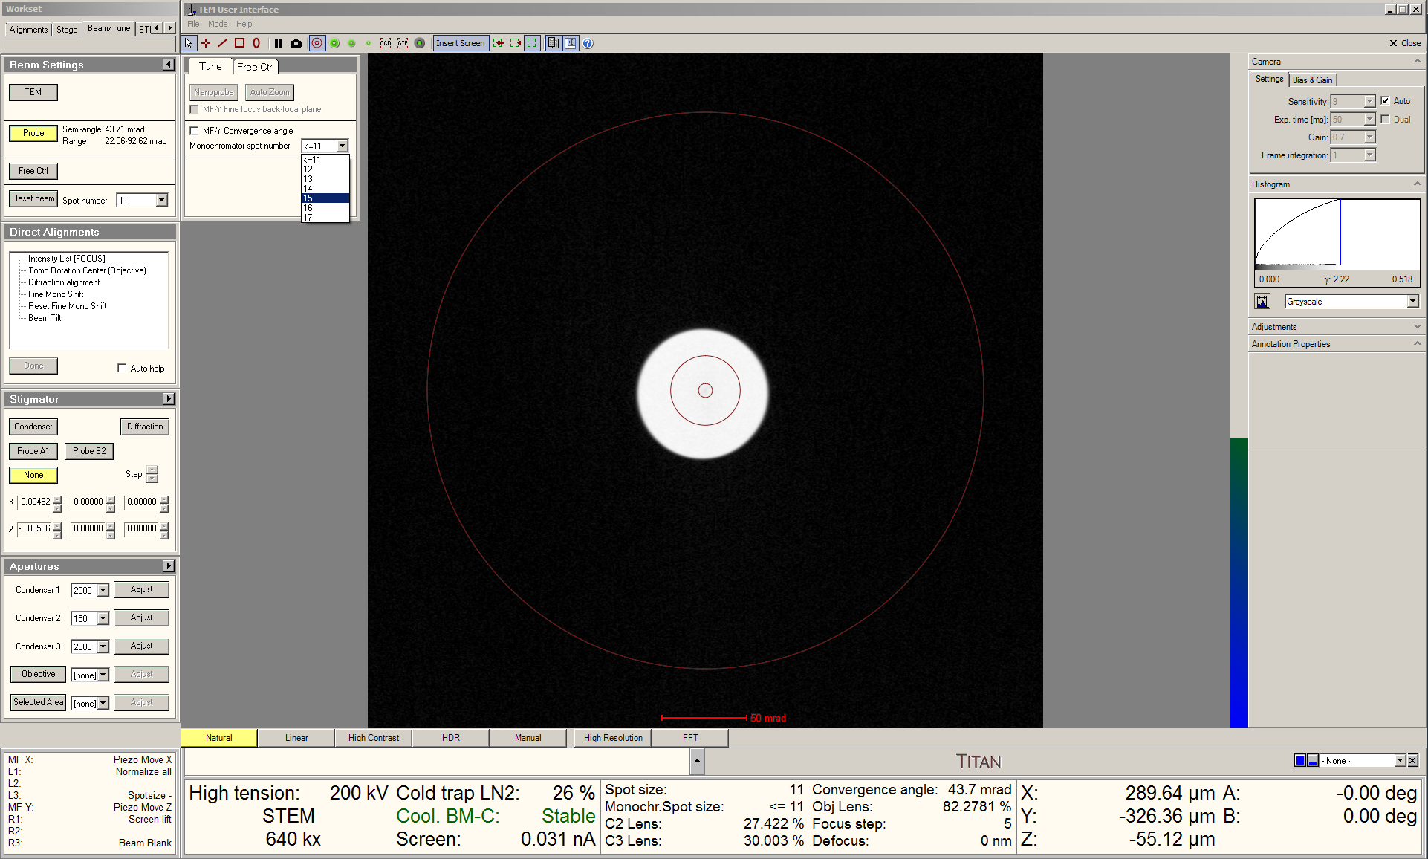
- C3 aperture centering

  - Remain in the “Beam/Tune” tab and navigate to the “Apertures” panel; select and insert the 30 µm C3 aperture and select “Adjust”.

    - Selecting this C3 aperture will result in a probe semi-angle of convergence = 21 mrad (200 kV).

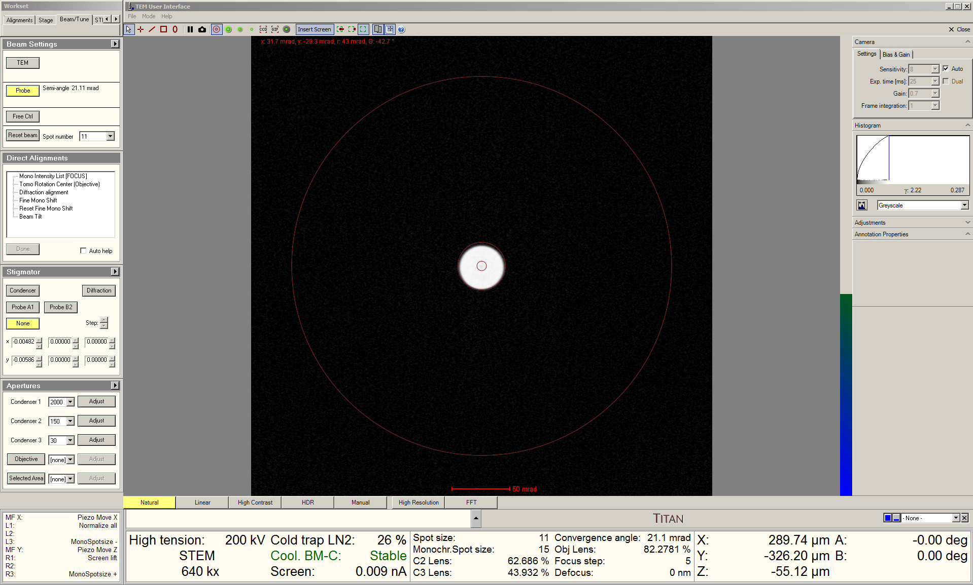
  - On the right-hand panel, select “Diffraction” to observe an image of the probe; set the indicated magnification = SA 230 k× or higher (not shown).

  - In the “Direct Alignments” panel, select “Mono Intensity List [FOCUS]” to couple the C3 lens to the “Focus” knob.

  - Use the “Multifunction” knobs to center the C3 aperture while using the “Focus” knob (coupled to the C3 lens) to expand/contract the beam and “UserBeamShift” in S-CORR to shift/recenter the beam as needed (described elsewhere).

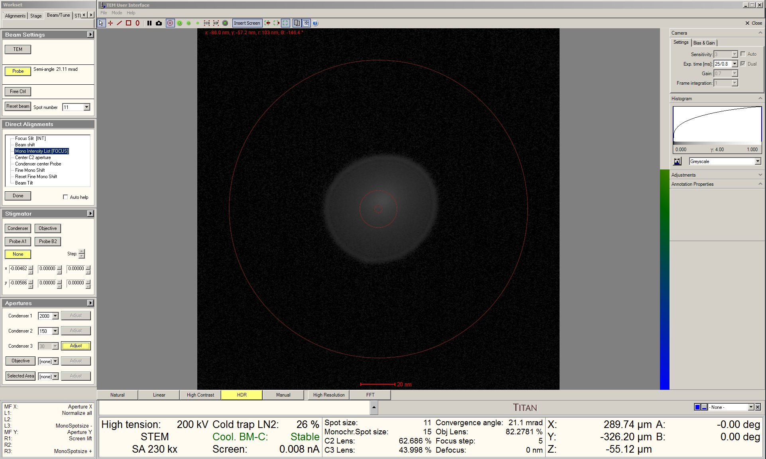

  - Use the “Focus” knob (still coupled to C3) to focus the probe until a sharp, caustic spot is produced inside a diffuse halo; return to the “Direct Alignments” panel and select “Done” to save this C3 setting for “Eucentric focus”.

    - The “Focus” knob will then return to being coupled to the objective lens.

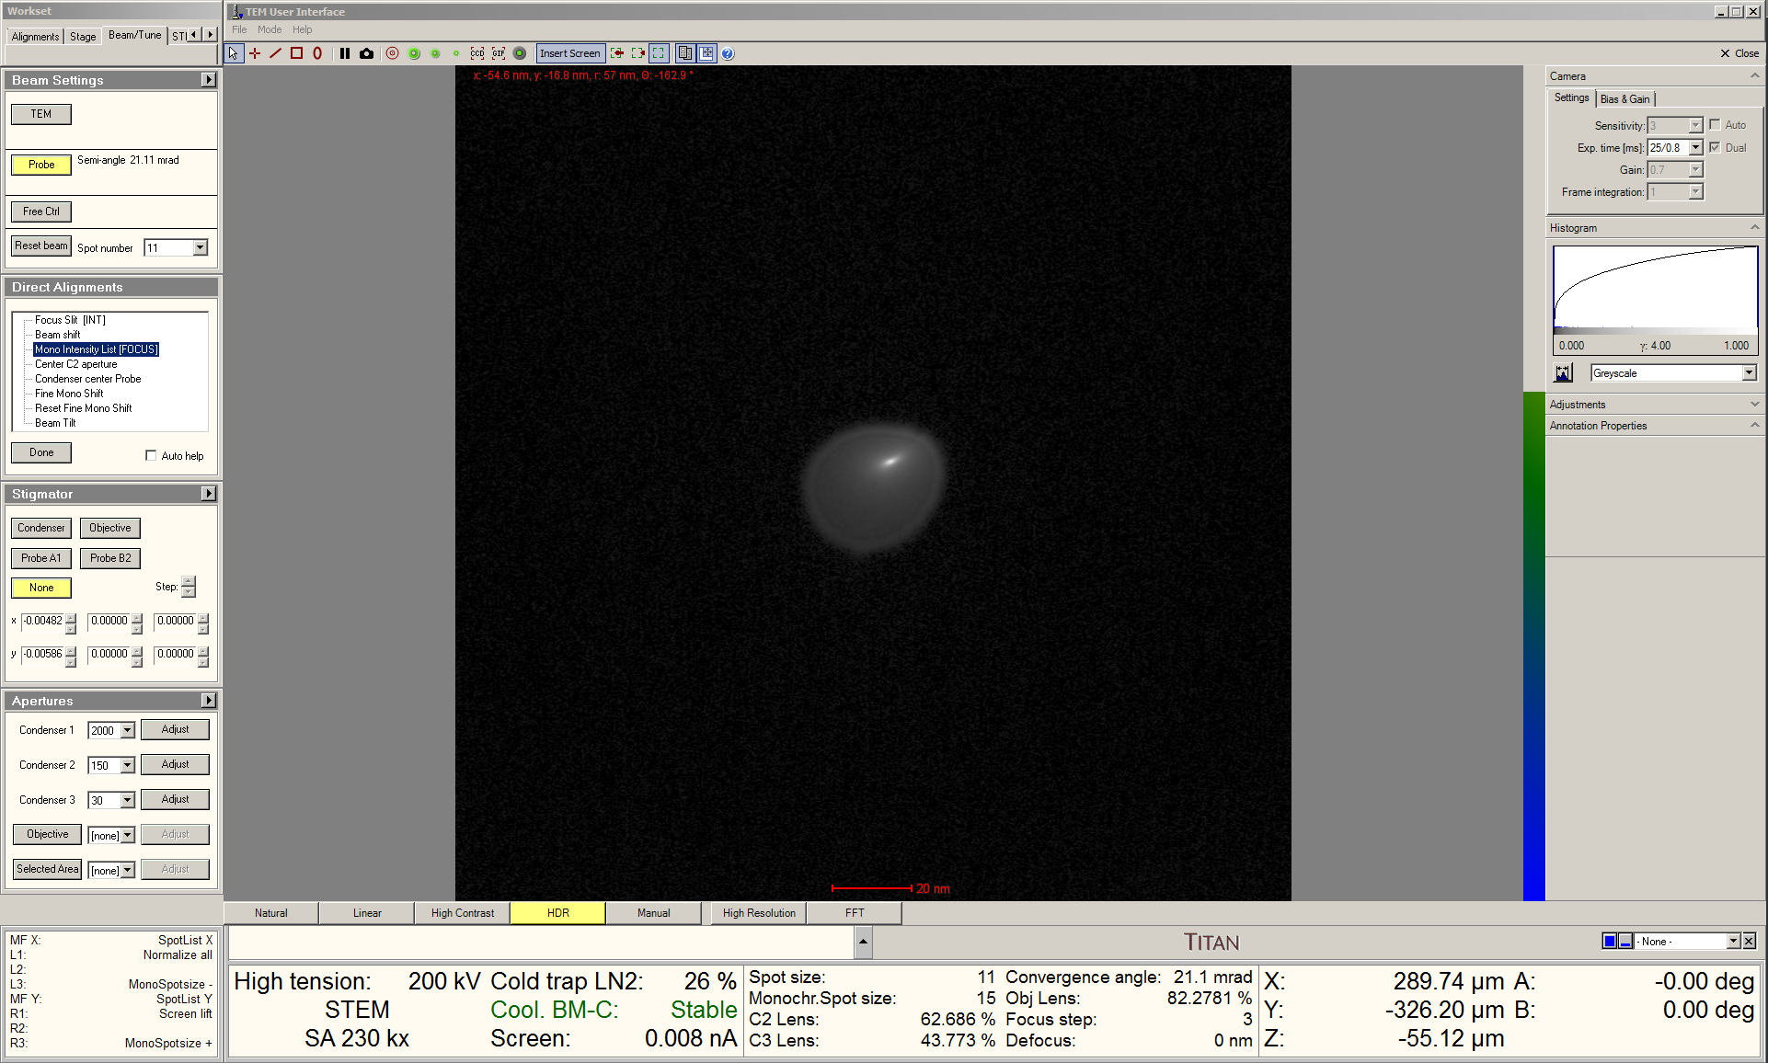

  - Optimize beam tilt by viewing the live STEM image and adjusting “Beam Tilt” in S-CORR (as described elsewhere).

  - On the right-hand panel, select “Diffraction” to view the Ronchigram again; set the indicated camera length = 115 mm (not shown); this is a suitable camera length for performing HAADF-STEM imaging and all subsequent alignment steps.

  - Precisely center the direct disk on the Flucam using “Diffraction alignment” (not shown).

    - NOTE: this is important as this will define the correct position for the C3 aperture, which also defines the correct position for the dispersed beam and C1 aperture.

  - Navigate to the “Apertures” panel and insert the 2000 µm C3 aperture (it does not need to be centered).

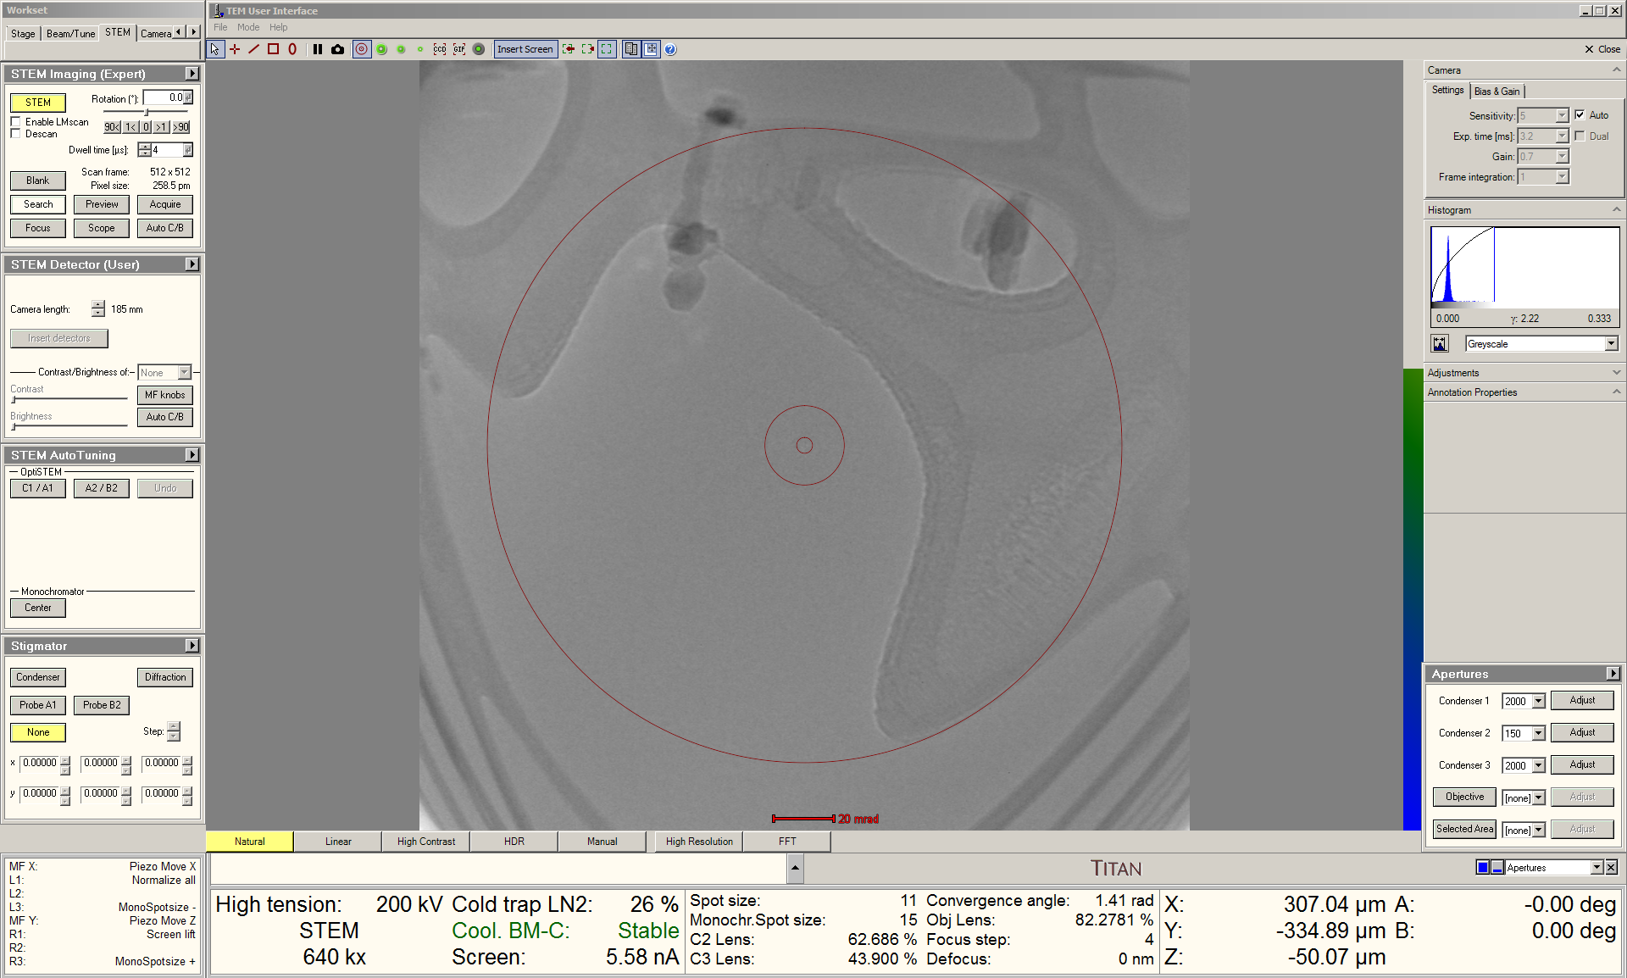

  - Move stage X and Y to center a suitable region for correcting A1 and B2 (e.g., amorphous C, electron beam-induced deposited Pt, etc.) on the Flucam; adjust stage Z to obtain a “blow-up” condition.

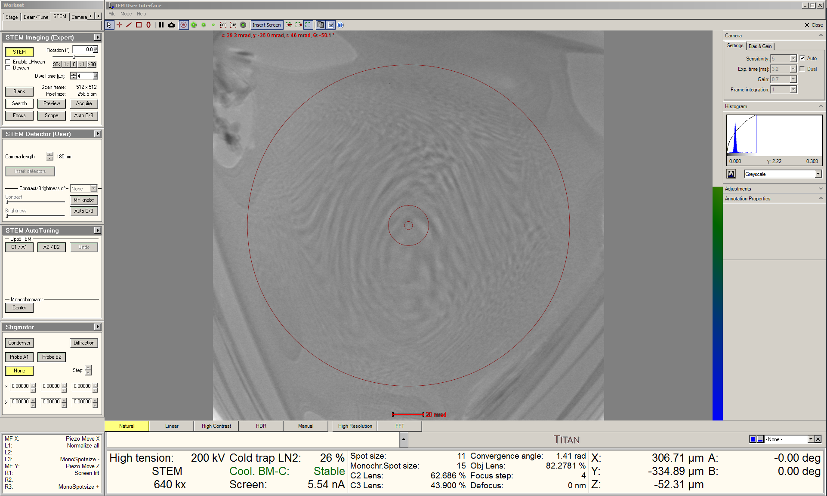

- Centering the dispersed beam

  - Navigate to the “Monochromator Tune” panel and select “Focus”; use the “Intensity” knob to set the monochromator focus = 0.0.

    - NOTE: this will produce an image of the dispersed beam that appears out of focus on the Flucam; this is normal.

  - Remain in the “Monochromator Tune” panel and select “Shift”; use the “Multifunction” knobs to center the dispersed beam on the Flucam.

    - Switching the Flucam display from “Grayscale” to “Temperature” may help with this but is not otherwise necessary.

    - The measured screen current should be maximized when the dispersed beam is properly centered.

    - If centered properly, the most intense (zero-loss) part of the dispersed beam should coincide with the center of the FluCam (where the C3 aperture was also centered)

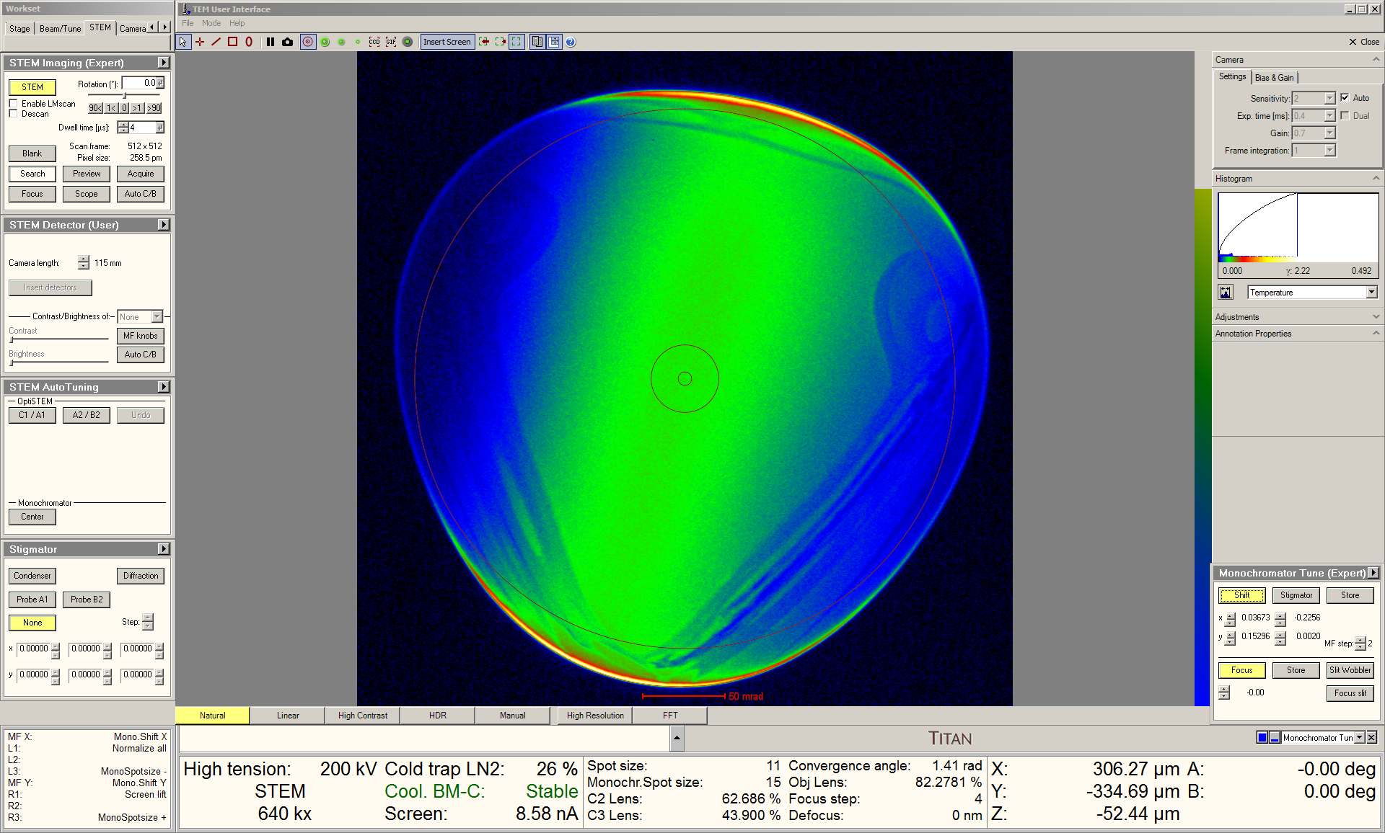
- C1 (energy-filtering) aperture centering

  - Navigate to the “Apertures” panel, insert the desired C1 aperture (slit, hole, wedge, etc.), and select “Adjust”.

    - NOTE: energy resolution will improve as the aperture size decreases, but at the expense of reduced beam current.

    - NOTE: apertures are recommended over slits and wedges to produce the roundest probes.

    - The edges of the C1 aperture will appear out of focus; once again, this is normal.

  - Use the “Multifunction” knobs to center the C1 aperture on the Flucam.

    - Again, the edges of the C1 aperture will appear blurry, but it should still be possible to accurately center the aperture visually.

    - Also, similarly to proper centering of the dispersed beam, the screen current should be maximized when the C1 aperture is centered.

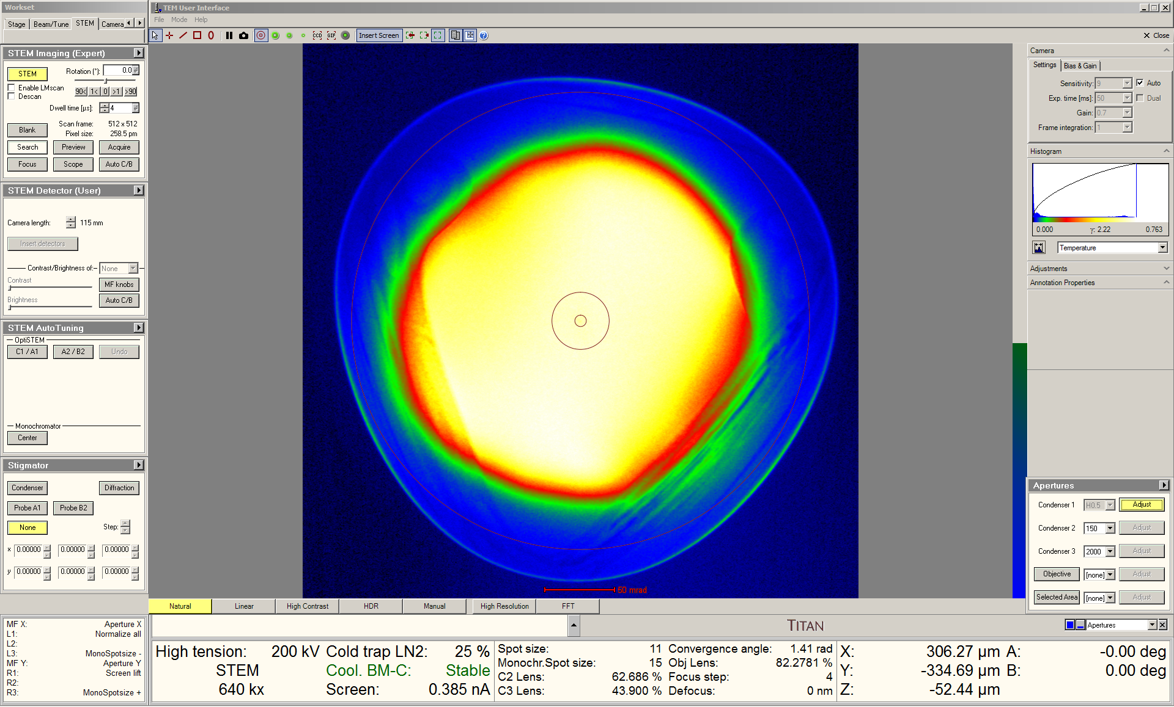

  - After centering the dispersed beam and C1 aperture, re-insert and re-center the 30 µm C3 aperture on the Flucam (not shown); the dispersed beam and C1 aperture are now coincident with the C3 aperture.
- Coarse A1 and B2 correction

  - When performing monochromated STEM, it is easier to correct A1 and B2 with the 30 μm C3 aperture inserted instead of retracted.

  - If needed, move stage X and Y to an appropriate area and then adjust stage Z to obtain a “blow-up” condition in the Ronchigram.

  - Correct A1 and B2 as best as possible using “AT_A1” and “AT_B2” in S-CORR (described elsewhere).

    - Finer correction of A1, A2, and B2 may be performed later during STEM imaging.

- STEM imaging

  - STEM imaging may now be performed as per usual; as is the case with unfiltered STEM imaging, focus the image as best as possible using stage Z and perform any finer focusing by using the “Focus” knob (described elsewhere).

  - Navigate to the “Stigmator” panel, select “Condenser”, and use the “Multifunction” knobs to finely correct A1 as needed (described elsewhere).

  - STEM autotuning to automatically correct C1, A1, A2, and B2 may be performed as needed (described elsewhere).

- Additional monochromator adjustments

  - Once centered, the C1 aperture should remain stable and not need any additional adjustment during the session. However, even with sufficient time to stabilize, the dispersed beam will still drift and require periodic re-centering.

  - If using a low monochromator spot size, re-centering can be accomplished without changing the C3 aperture. However, if using a high monochromator spot size, it will be best to temporarily re-insert the 2000 µm C3 aperture (shown here).

  - Before inserting the largest C3 aperture, precisely center the direct disk on the FluCam using “Diffraction alignment”; then insert the 2000 µm C3 aperture (not shown).

  - Navigate to the “Monochromator Tune” panel, select “Shift”, and use the “Multifunction” knobs to maximize the screen current (described previously).
  - If needed, finer shifting of the dispersed beam may be accomplished by navigating to the “Direct Adjustments” panel, selecting “Fine Mono Shift” and using the “Multifunction” knobs.

    - NOTE: use of “Fine Mono Shift” should be kept as minimal as possible; otherwise, excessive use will result in loss of beam current.

    - NOTE: if “Fine Mono Shift” is used, it must be reset when finished using the monochromator.

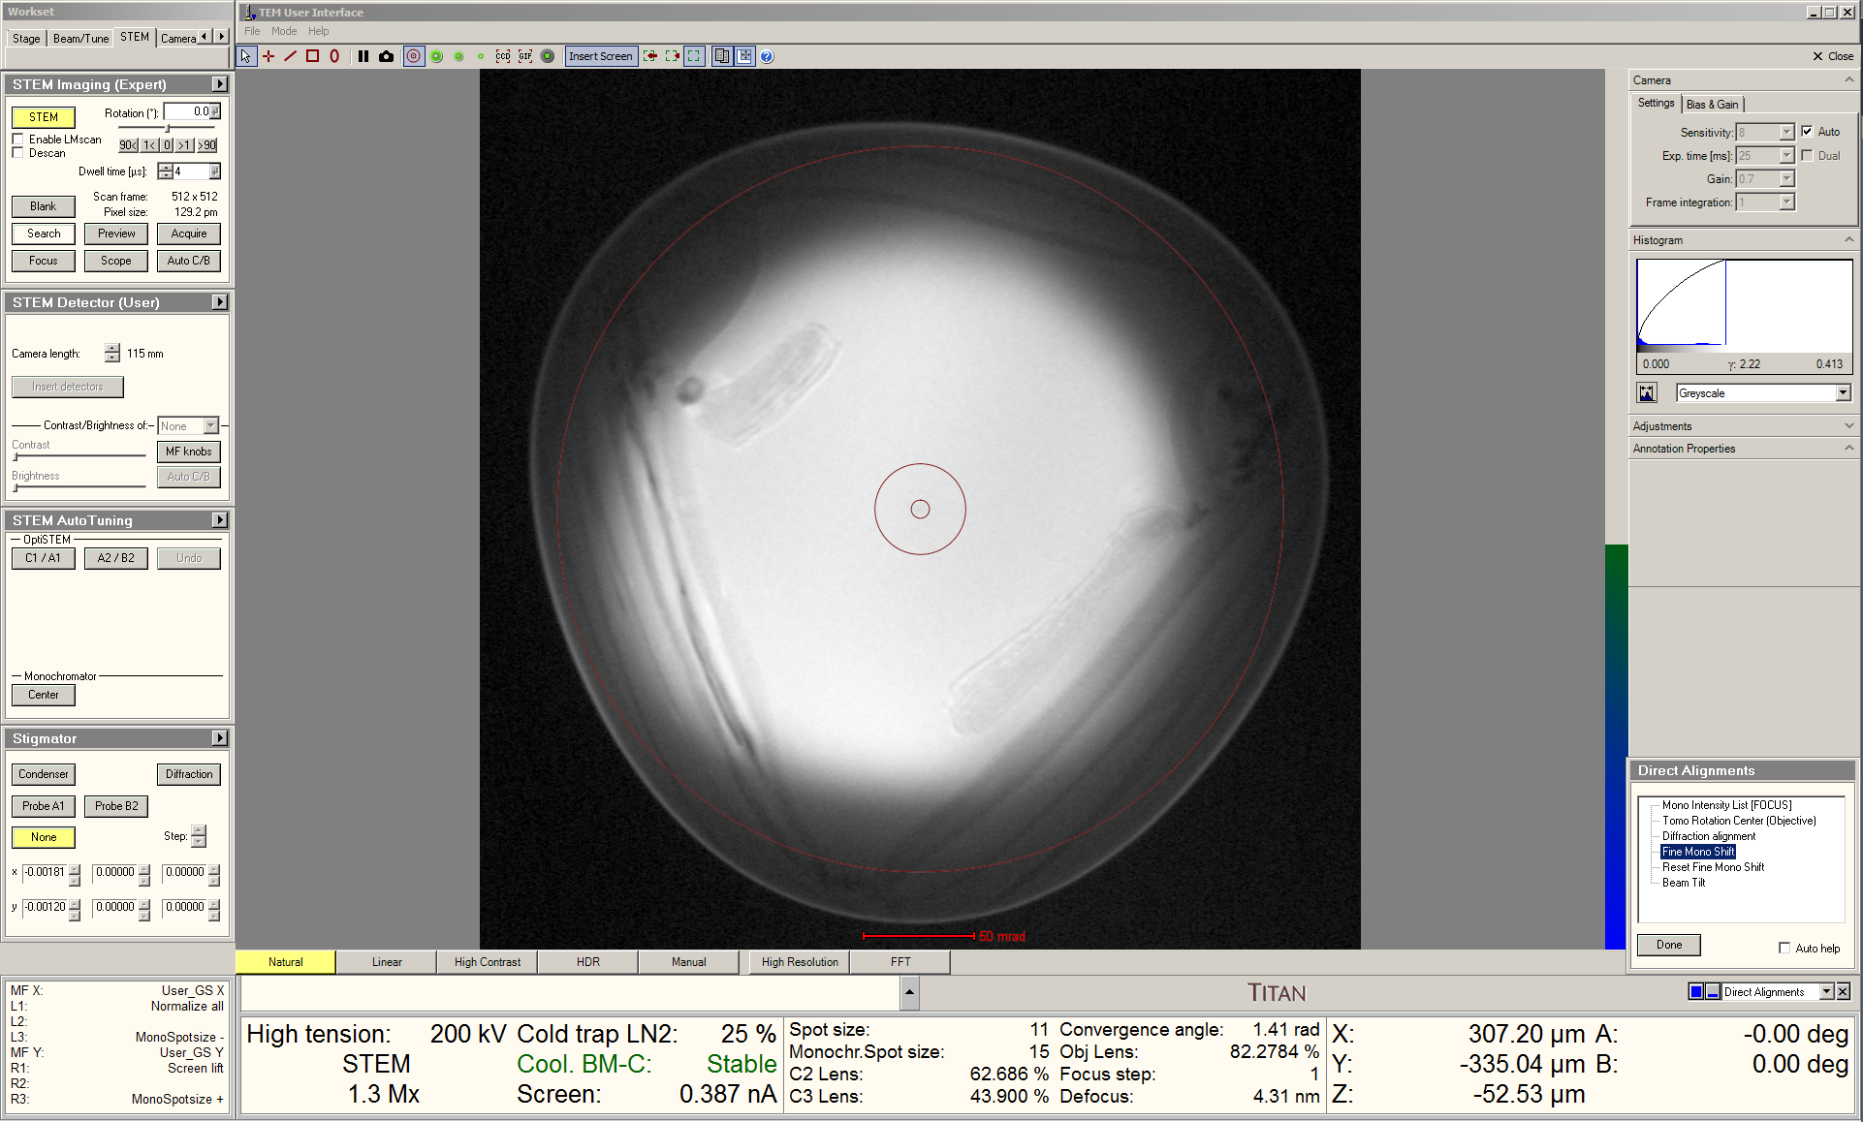

- Considerations for STEM-EELS

  - When switching to EFSTEM mode for the purpose of performing monochromated STEM-EELS, there may be a shift in the dispersed beam resulting from the normalization process.

  - To address this, navigate to the “Monochromator Tune” panel, select “Shift”, and use the “Multifunction” knobs to maximize the screen current (described previously).

  - As described previously, if finer control of the monochromator shift is needed, navigate to the “Direct Alignments” panel, select “Fine Mono Shift”, and use the “Multifunction” knobs to maximize the screen current; again, noting that excessive use of this adjustment will lower the beam current.
- Finishing

  - If the projection system is still in EFSTEM mode, switch it back to normal mode (not shown).

  - If “Fine Mono Shift” was used, navigate to the “Direct Adjustments” panel, select “Reset Fine Mono Shift”, and then “Done”.

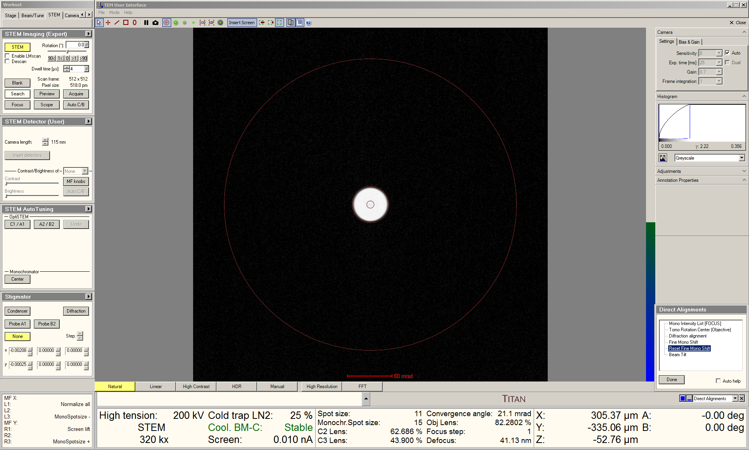

  - Switch from STEM mode back to TEM mode (not shown).

  - Navigate to the “Apertures” panel; re-insert the 2000 µm C1 aperture and the 2000 µm C3 aperture (not shown).
  - Return to Sherpa; set “Target” = 0 and select “Set Excitation”; the system will automatically recenter the beam as the excitation is ramped down.

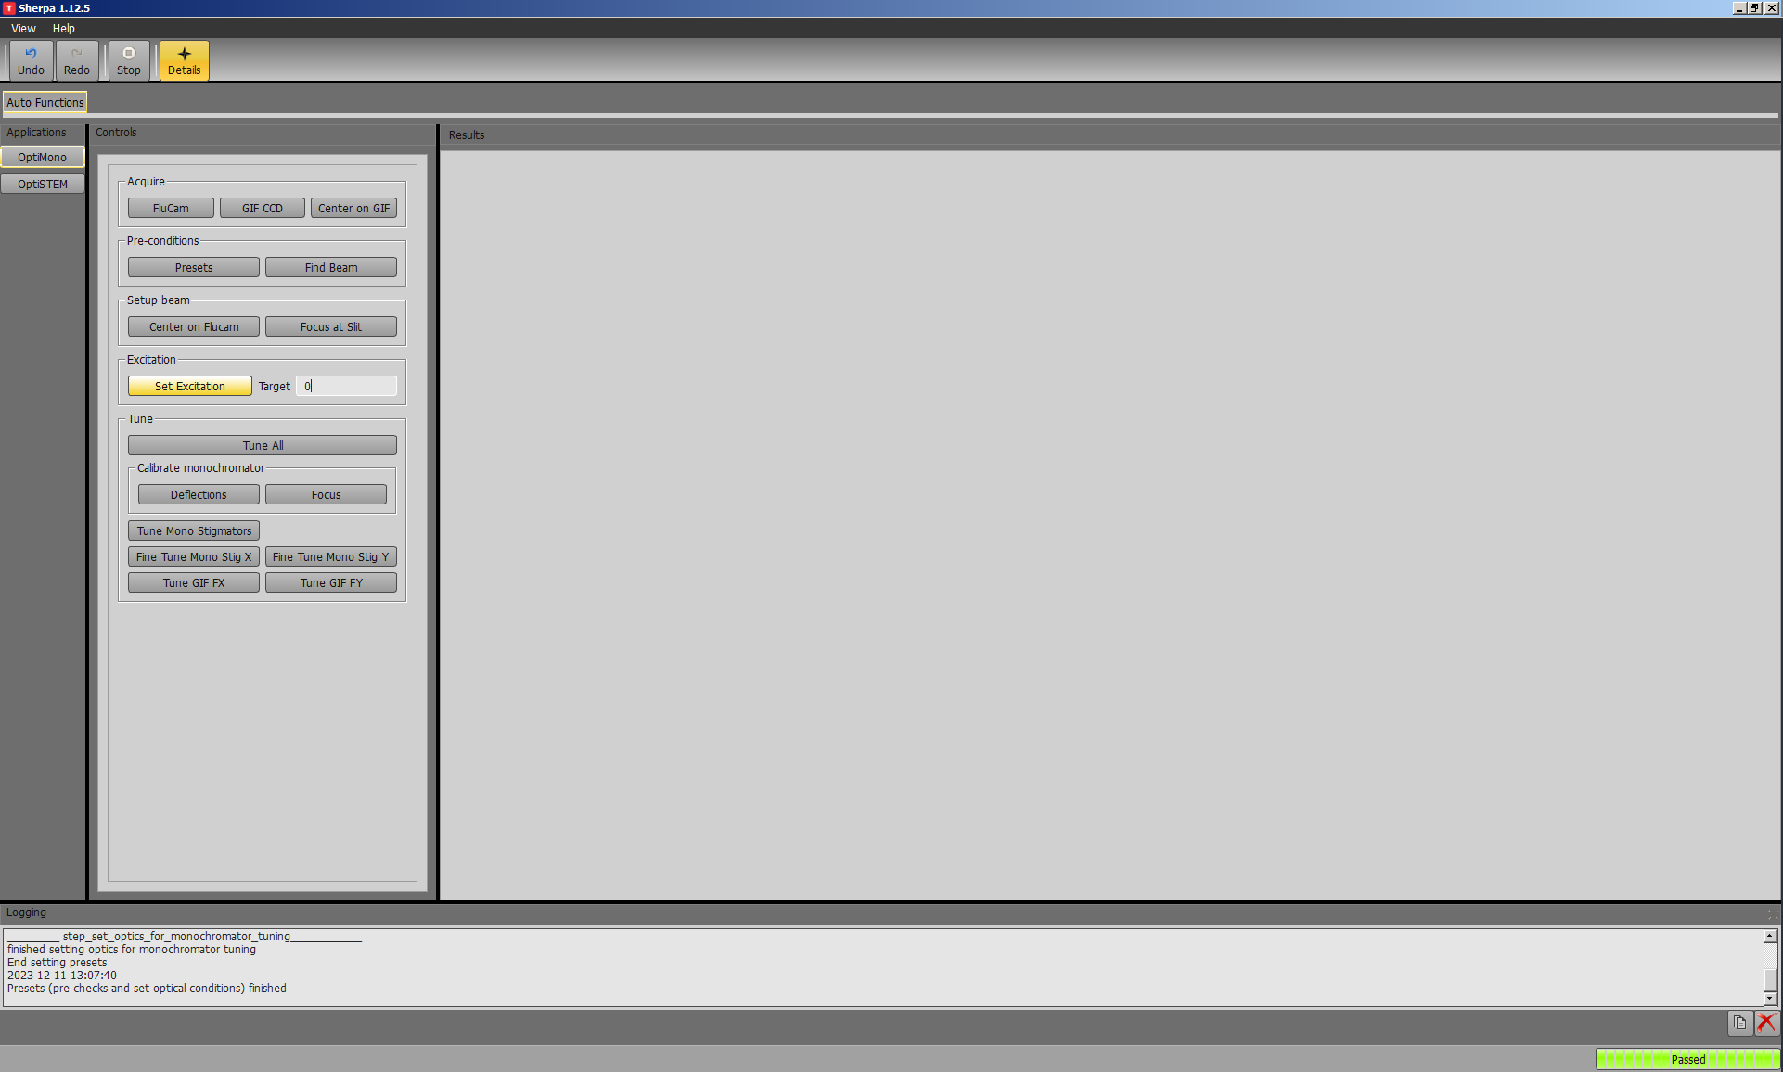

  - Return to Microscope Control; navigate to the “Monochromator Tune” panel, select “Stigmator”, and use the “Multifunction” knobs to make the non-dispersed beam round.

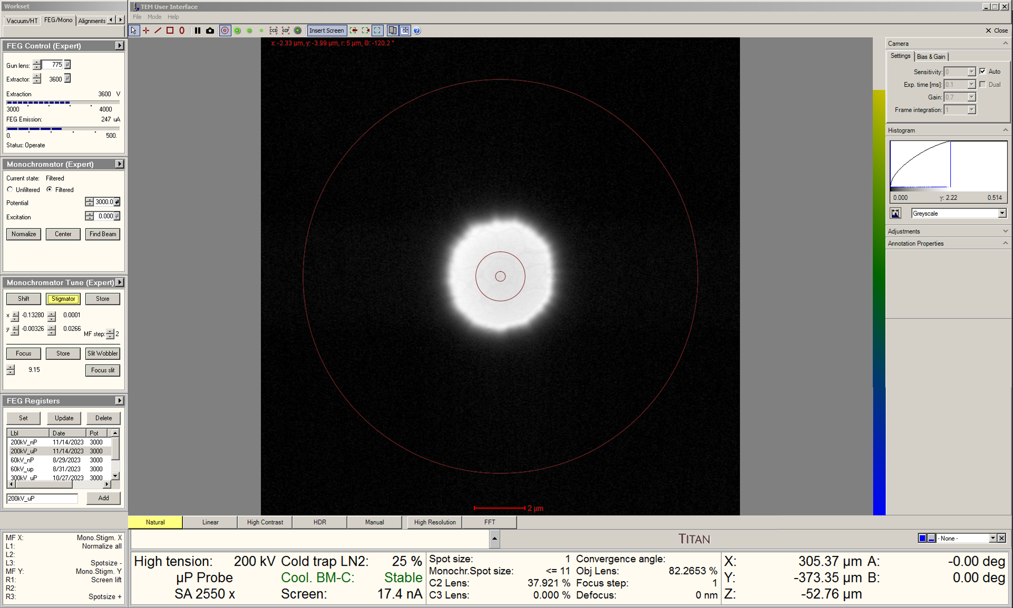
  - Remaining in the “FEG/Mono” tab, navigate to the “Monochromator” panel and set the state to “Unfiltered”.

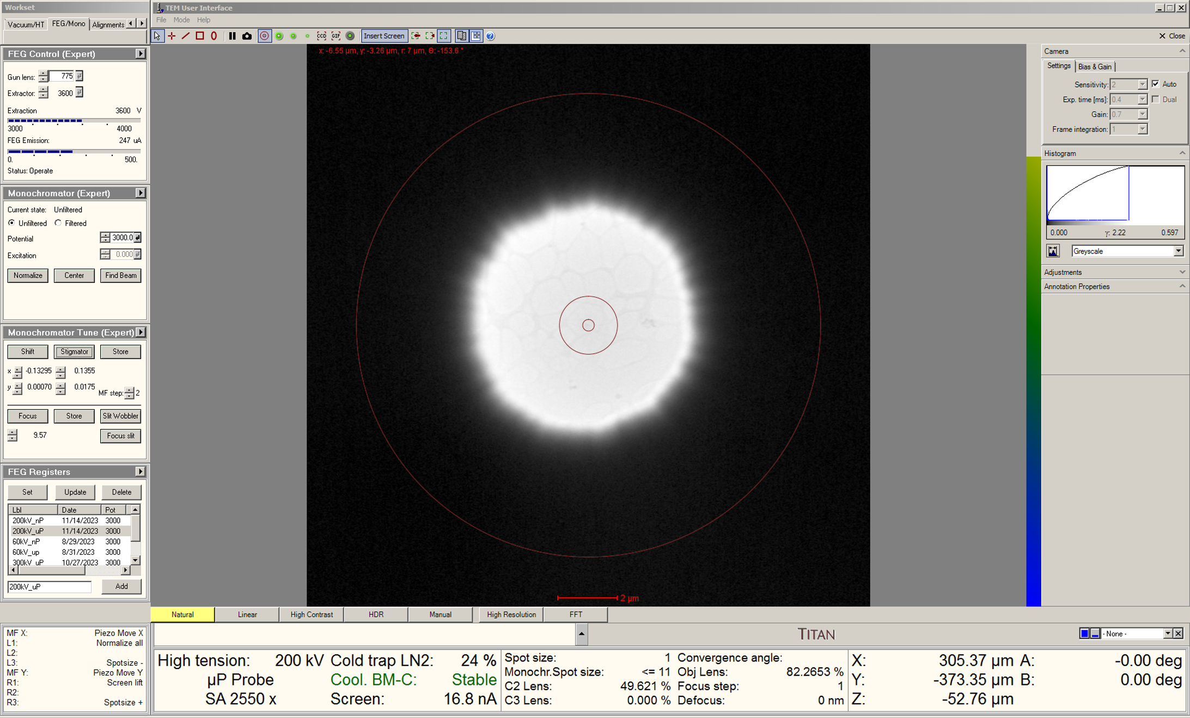

  - If necessary, turn the C3 lens back on (not shown).

  - Again, due to the change in excitation, it may take 1 – 2 h for the monochromator drift to fully stabilize.

