
FEI Themis Z S/TEM
  - TEM Mode Standard Operating Procedure Rev. 2026-01
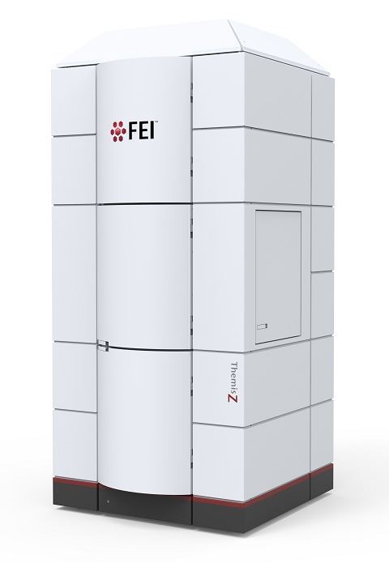
  - Application
The FEI Themis Z S/TEM is a state-of-the-art C_{s} probe-corrected field emission gun scanning/transmission electron microscope capable of providing micro- to pico-scale structural, morphological, magnetic, and chemical information. This document covers operation of the instrument for conventional (TEM) mode imaging only. Please see separate SOP documents on the NRF instrument page regarding other applications.

  - NRF Contact
Nicholas G. Rudawski

Table of Contents

1. Safety information 3
2. Prerequisites 3
3. Instrument voltage 3
4. Specimen loading/unloading 4
5. Base alignments and spot size settings 5
6. Finding an ROI, monochromator focus/shift, setting eucentric height 6
7. C2 aperture alignment 11
8. Condenser astigmatism correction 12
9. Condenser centering (C2/C3 centering) 13
10. Condenser deflector balancing 14
11. Rotation centering 14
12. Using the piezo-enhanced stage 15
13. Zone axis alignment (when relevant) 19
14. Objective aperture centering 21
15. Image acquisition using Velox 22
16. Finishing the session 24

- Safety information

  - Due to stipulations of the instrument service contract as well as contamination concerns, analysis of radioactive and/or biological specimens with this instrument is strictly prohibited.

  - Please use caution when stepping onto and down from the floor riser in front of the door to the instrument enclosure.

  - Please use caution when opening and closing the enclosure door for possible pinch points.

  - Please use caution when inserting the holder into the airlock for a possible pinch point between the holder base and the airlock cover plate.

- Prerequisites

  - Extensive familiarity with use of the Microscope Control user interface software and Velox imaging software.

  - Proficient in independent operation of the FEI Talos F200i S/TEM for high-quality HR-TEM imaging.

  - NOTE: as per the prerequisites, many associated details and images that could otherwise be included here are omitted for purposes of clarity (“…as per usual”).

- Instrument voltage

  - The default voltage setting is 200 kV with an information limit of <100 pm for HR-TEM imaging. If wanting to operate the instrument at a different voltage (60 or 300 kV), please contact staff in advance for assistance.
- Specimen loading/unloading

  - A special high visibility low background “soft-loc” double tilt holder is optimized for use with the Themis Z. Use extreme caution when loading/unloading the basket; do not apply excessive downward force as this may damage the sapphire screws (indicated by arrows) holding the basket in place.

    - This repair costs ~$3000 and takes ~2 weeks to complete.

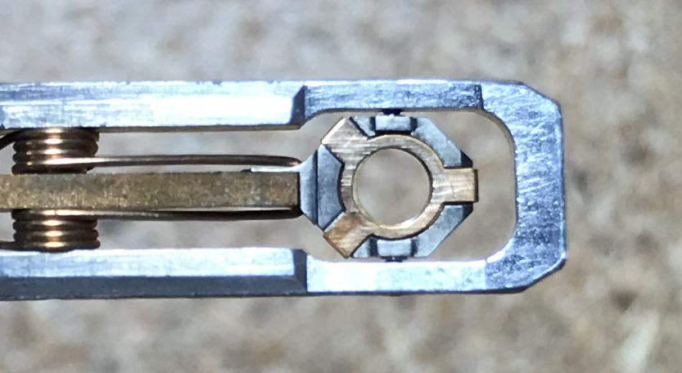

  - Holder loading/unloading into/out of the column is identical to as described for the Talos with the notable exception that a metal plug, rather than a holder, is stored in the column when the system is not actively in use.

    - Be sure to close the enclosure door once the holder is inserted and close the microscope room door upon leaving.

  - Please also be aware that it is critical that the grid, spacer, and three-pronged clip (as appropriate) is/are properly secured into the holder basket before insertion of the holder into the column; should any of these pieces fall out of the holder basket upon insertion into the column, this may cause a blockage of the beam path inside the microscope rendering it unusable.

    - This will require a service call to split the column open to retrieve the parts and clear the blockage (which will not be covered by the service contract).

- Base alignments and spot size settings

  - It is usually not necessary to load an alignment file at the start of the session; the appropriate alignment file should already be loaded and will be updated regularly by NRF staff (this includes probe corrector tuning).

    - The only exceptions to this may be: 1) if the instrument is found completely out of sorts and 2) after a reboot of the system. Please contact NRF staff if you think loading an alignment file may be necessary.

  - Select the “Beam/Tune” tab and navigate to the “Beam Settings” control panel.

    - Set “Spot number” = 4 as per usual.

    - This is the recommended spot number for general TEM work and should be effective for everything from microscale bright-field imaging to angstrom-resolution lattice imaging.

    - NOTE: every incremental decrease (increase) in spot number results in a beam current increase (decrease) of a factor of ~2 (½), all other factors being equal.
- Finding an ROI, monochromator focus/shift, setting eucentric height

  - Open the column valves as per usual.

  - Adjust the indicated magnification, expand/contract the beam, and recenter/shift the beam as per usual.

    - NOTE: the TEM magnification modes in order of increasing magnification are LM < SA < Mh (there is no “M” mode).

  - Move the stage until an ROI is found and centered on the FluCam; set the indicated magnification = 17000×.

  - If possible, move the stage to retract the specimen from the FOV so the beam is over vacuum only.

    - Otherwise, ensure the entire FOV is transmissive to the beam.

  - Expand the beam from crossover by turning the “Intensity” knob clockwise so it is slightly larger than the 40 mm circle on the FluCam; center the beam with the beam shift trackball.

    - Similarly to TEM mode operation on the Talos, the beam should always be expanded from crossover by turning the “Intensity” knob clockwise.

    - The beam may look strange at this point; if so, this is likely due to misaligned monochromator shift, which will be subsequently addressed.

  - Select the “FEG/Mono” tab and navigate to the “Monochromator Tune” control panel; note the value for “Focus” (gun lens).

    - “Focus” = –40 (negative) should be used for TEM mode operation; this reduces source brightness but yields higher beam current.

    - Select “Focus”; while keeping “Focus” < 0, use the “Intensity” knob (coupled to the gun lens) to converge the beam until the edge is visible inside the shadow of the C2 aperture.

    - NOTE: if the initial value of “Focus” > 0, the beam must go through crossover to obtain “Focus” < 0.

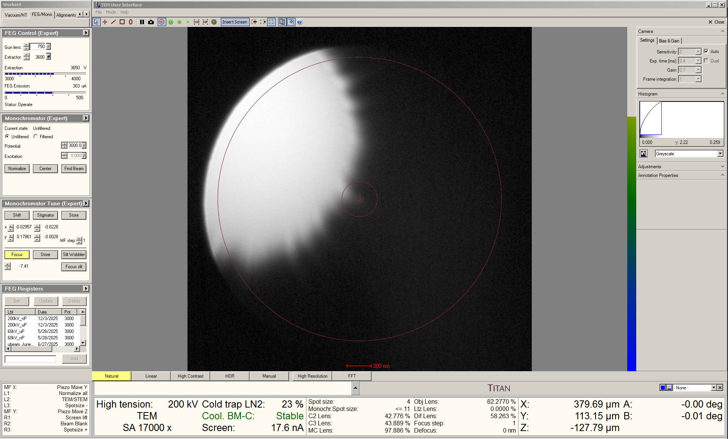

    - Select “Shift”; use the “MF” knobs to accurately center the beam inside the shadow of the C2 aperture.

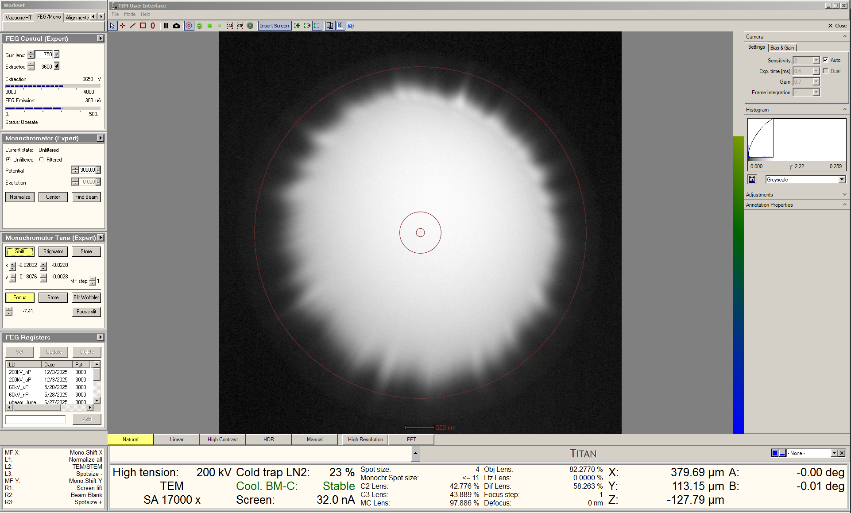

    - Adjust the “Intensity” knob to defocus the beam and obtain “Focus” = –40 (negative).

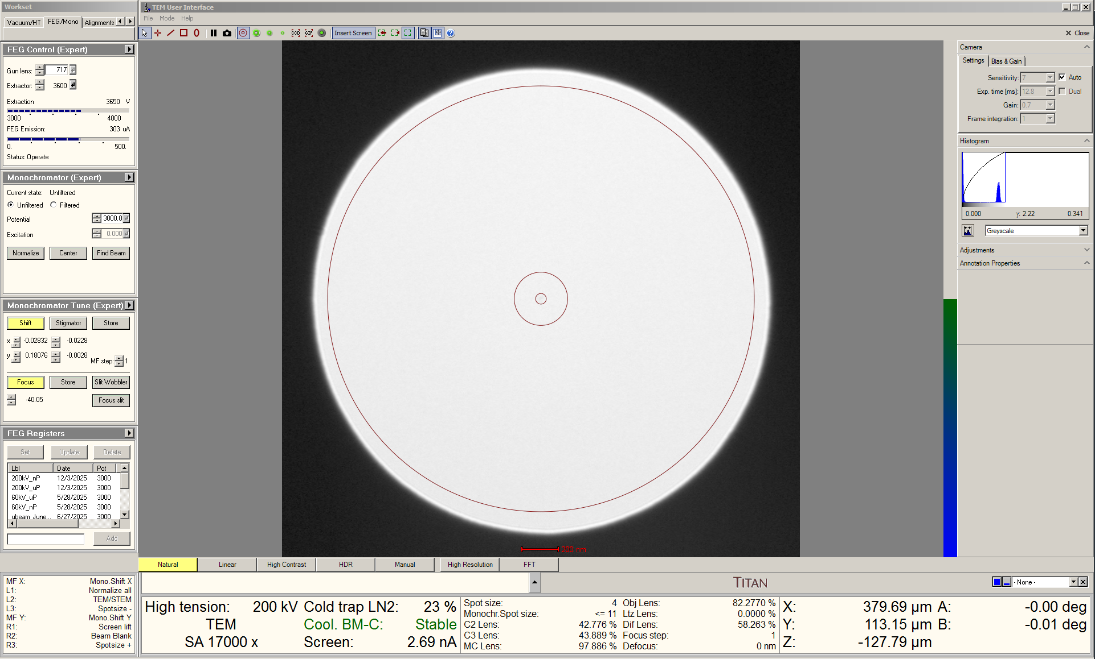
    - Deselect “Focus” and “Shift”.

    - The monochromator shift will be stable for many hours and should not need to be adjusted again while performing TEM imaging.

  - If no beam can be found while manually adjusting the monochromator focus, the monochromator shift has likely severely drifted. In this case, an automated function to find the beam can be used.

    - Navigate to the “Monochromator” control panel and select “Find Beam”.

    - NOTE: the indicated magnification, spot size, and C2 aperture may automatically change while the routine is running. After the beam is found, the user will need to return to the initial settings.

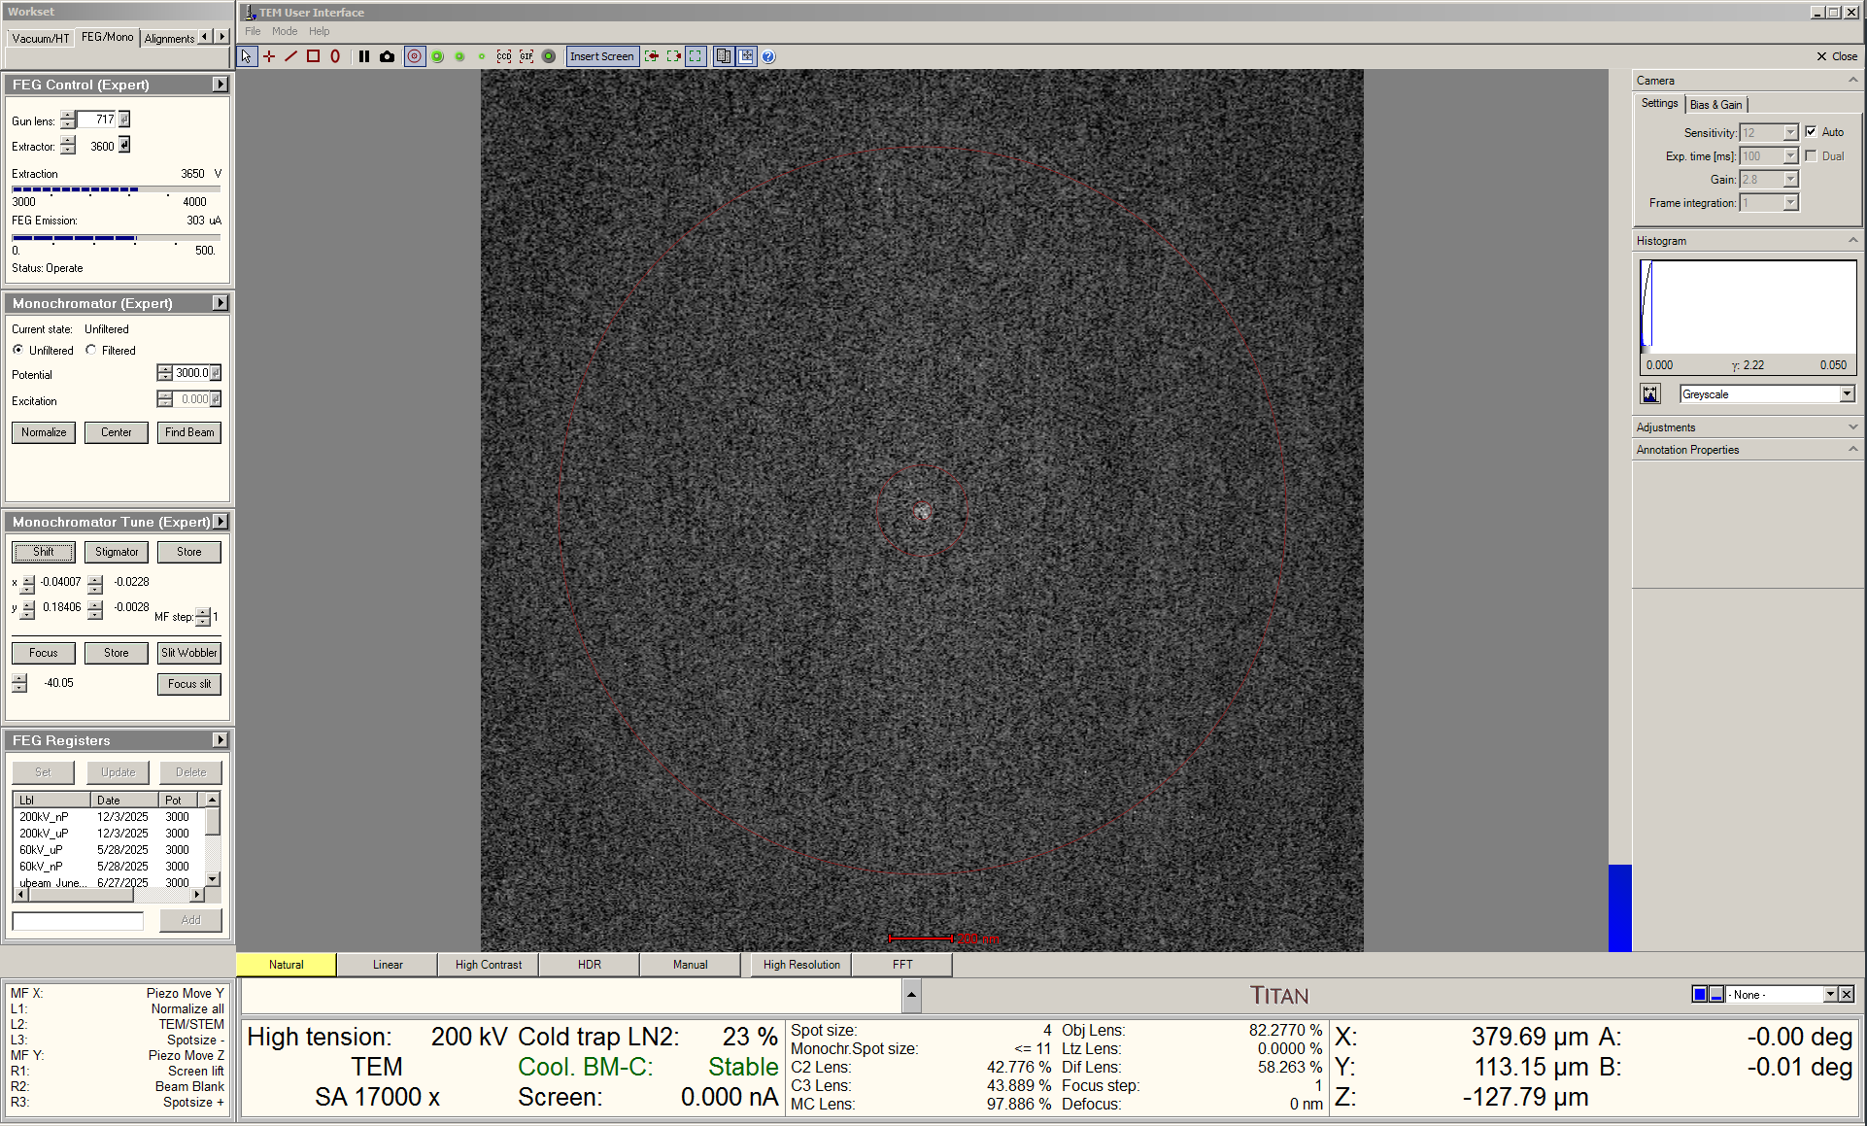

    - Once the beam is found, the monochromator focus and shift should be manually adjusted as per step 5.6.

  - Once the monochromator focus and shift are properly adjusted, move the sample back under the beam and set eucentric height as per usual.
- C2 aperture alignment

  - Leave the indicated magnification = 17000×.

  - Verify the 70 µm C2 aperture is inserted; if not, insert it as per usual.

  - Select the “Beam/Tune” tab and navigate to the “Beam Settings” control panel; select “Free Ctrl” and then the flap-out arrow in the upper right corner.

    - In the flap-out panel, select the “Free Ctrl” tab and select the “C3” radio button to turn the C3 lens off.

    - Center the C2 aperture as per usual.

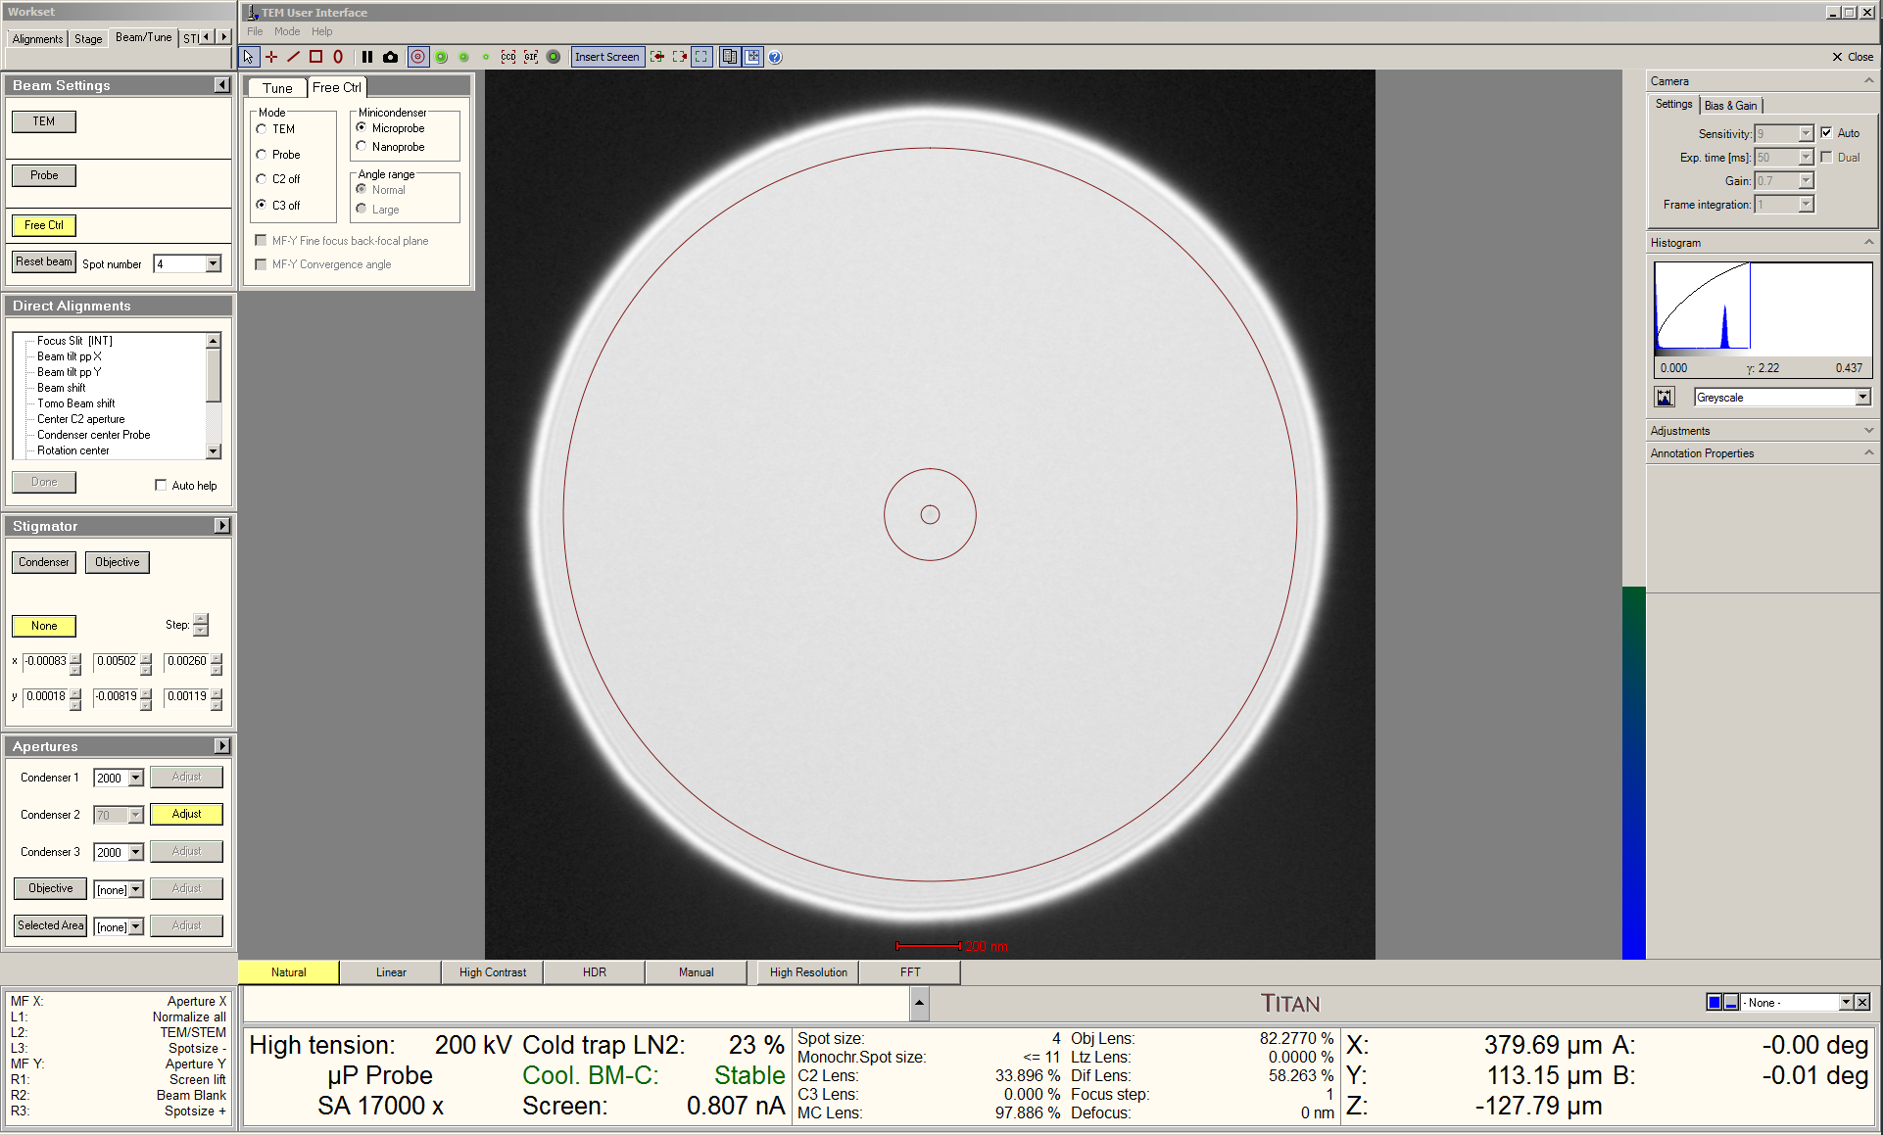
    - Select “TEM” in the “Beam Settings” control panel to turn the C3 lens back on; this is the standard lens configuration for TEM imaging.

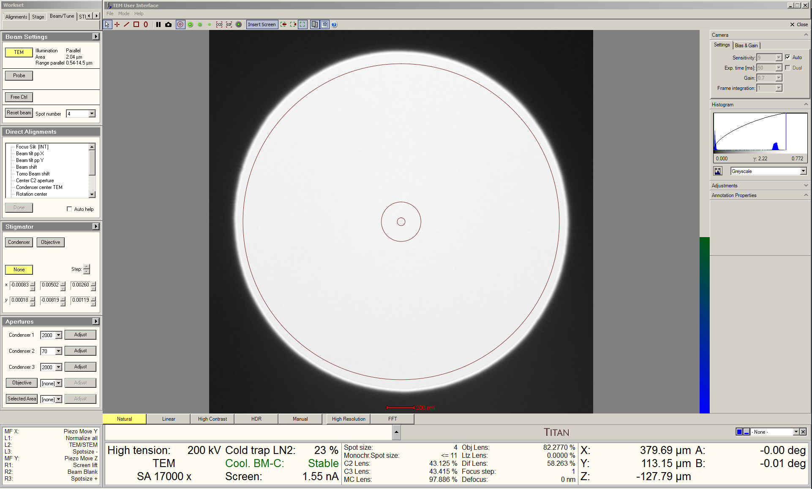

  - Once again, remember that the beam should always be expanded from crossover by turning the “Intensity” knob clockwise.

- Condenser astigmatism correction

  - Leave the indicated magnification = 17000×; expand the beam to just larger than the 40 mm circle on the FluCam and center it as per usual.

  - Activate the condenser stigmators and make the beam circular as per usual.

    - NOTE: do not make any additional adjustments to the condenser stigmators as this can impact subsequent condenser centering.

    - The beam may appear slightly astigmatic near crossover and at very high magnifications, but this will not have any noticeable impact on TEM imaging.
- Condenser centering (C2/C3 centering)

  - Leave the indicated magnification = 17000×; expand the beam to the size of the 40 mm circle on the FluCam and center it as per usual.

  - Select the “Tune” tab and navigate to the “Direct Alignments” control panel.

    - Select “Condenser center TEM”; the beam will start expanding/contracting.

    - Adjust the “Intensity” knob to set the limit of contraction to approximately the 4 mm circle; adjust the “Focus” ring to set the limit of expansion to approximately the 40 mm circle.

    - Use the beam shift trackball to shift the beam so the point of contraction is centered on the FluCam.

    - Adjust the “MF” knobs so the beam expands and contracts concentrically.

    - NOTE: the point of contraction will shift while performing this alignment; periodically use the beam shift trackball to shift the beam to recenter the point of contraction on the FluCam.

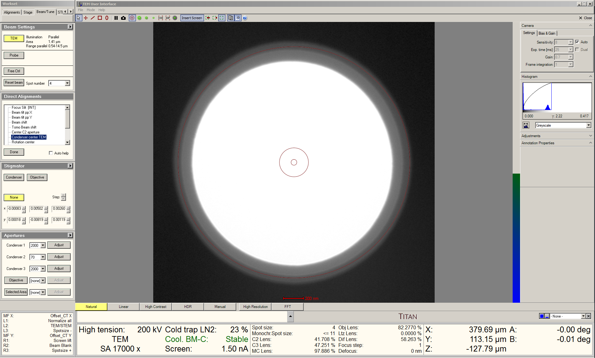
- Condenser deflector balancing

  - Set the indicated magnification as needed; to effectively observe lattice fringes, indicated magnifications ≥115 k× are needed.

  - Expand the beam to just larger than the 40 mm circle on the FluCam and center it as per usual.

  - Focus the image as precisely as possible using only stage Z.

  - Perform the “Beam tilt pp X” direct alignment as per usual.

  - Perform the “Beam tilt pp Y” direct alignment as per usual.

  - Reactivate the beam tilt pivot point alignment resulting in the greatest image separation; minimize the separation of the image with stage Z.

- Rotation centering

  - Recenter the beam and then continue to expand it so it is just outside the viewable area of the FluCam as per usual.

    - NOTE: if any fringes near the beam edge are still visible, continue expanding the beam until these are outside the viewable area.

  - Perform the “Rotation center” direct alignment as per usual.
- Using the piezo-enhanced stage

  - When performing HR-TEM imaging in SA or Mh mode, the stage piezo controller enables positioning of the specimen with < nm precision in three dimensions.

    - The piezo controller can move ±1200 nm in X and Y.

    - The piezo controller can move ±600 nm in Z, which allows precise focusing without adjustment of the OBJ lens.

  - If nothing else is being actively controlled by the “MF” knobs, these should default to control “Piezo Move X” and “Piezo Move Y”.

    - Simply use the “MF” knobs to use the piezo controller to position the specimen in X and Y as needed.

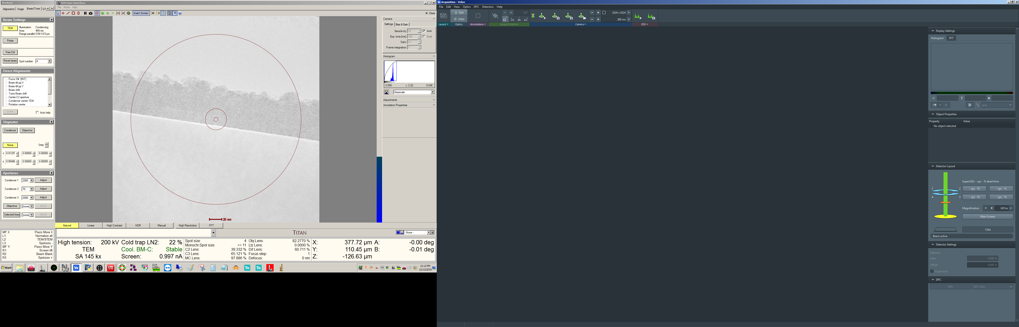
  - If the “MF” knobs are not set to operate the piezo controller, navigate to the bottom left information panel, find the “MF X:” line, right click on the right side of the line, and select “Piezo Move X”.

    - The “MF Y:” line should automatically set to “Piezo Move Y”; if not, activate this similarly to as described in the previous step.

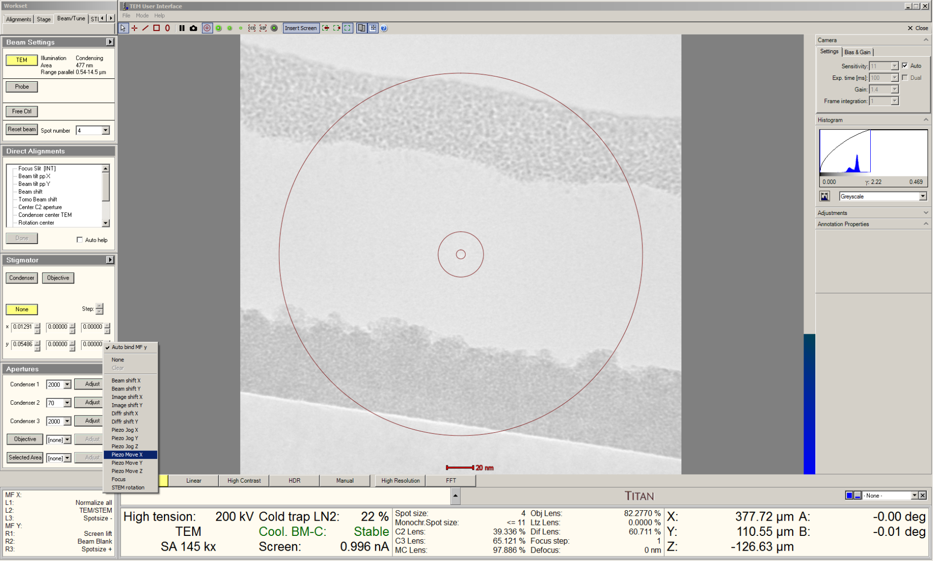

  - Only 2 of 3 axes can be activated simultaneously. To activate “Piezo Move Z”, right click on the right side of either “MF” line and select “Piezo Move Z”; the setting for the other “MF” line should remain the same.

    - NOTE: the strength of the adjustment for the Z axis of the piezo controller is controlled by the “Focus step” setting.

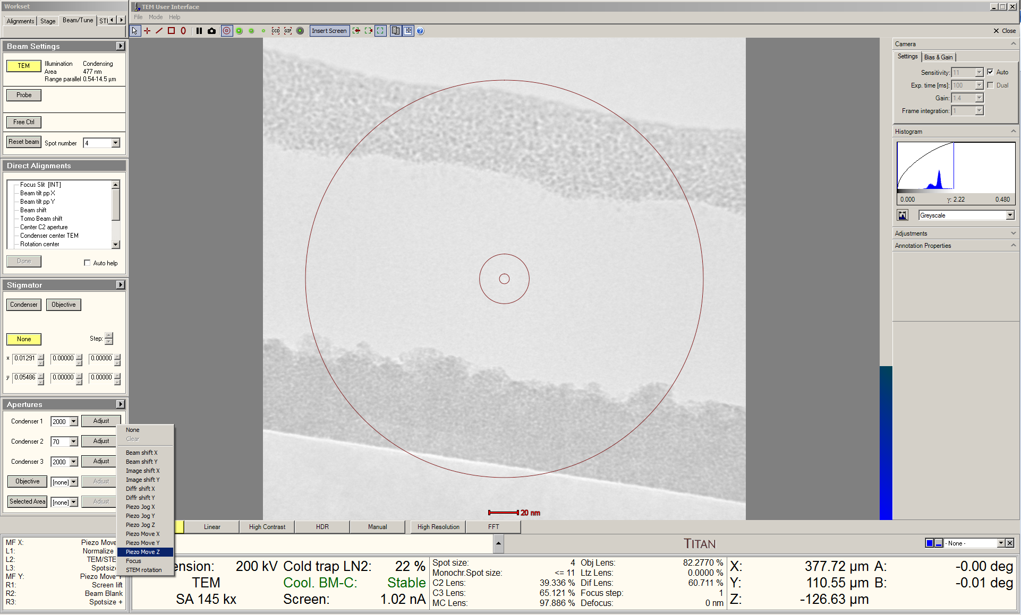
  - If the limit of one of the piezo controller axes is approached, a warning message will appear and the axis in question should be reset. Select the “Stage” tab and navigate to the “Stage Piezo” control panel.

    - Select “Reset” next to the axis in question.

    - The mechanical stage will compensate for this, and the specimen should remain nominally stationary.

    - DO NOT disable (stop) the piezo controller; this ensures stable, drift-free performance when use of the piezo controller is needed.

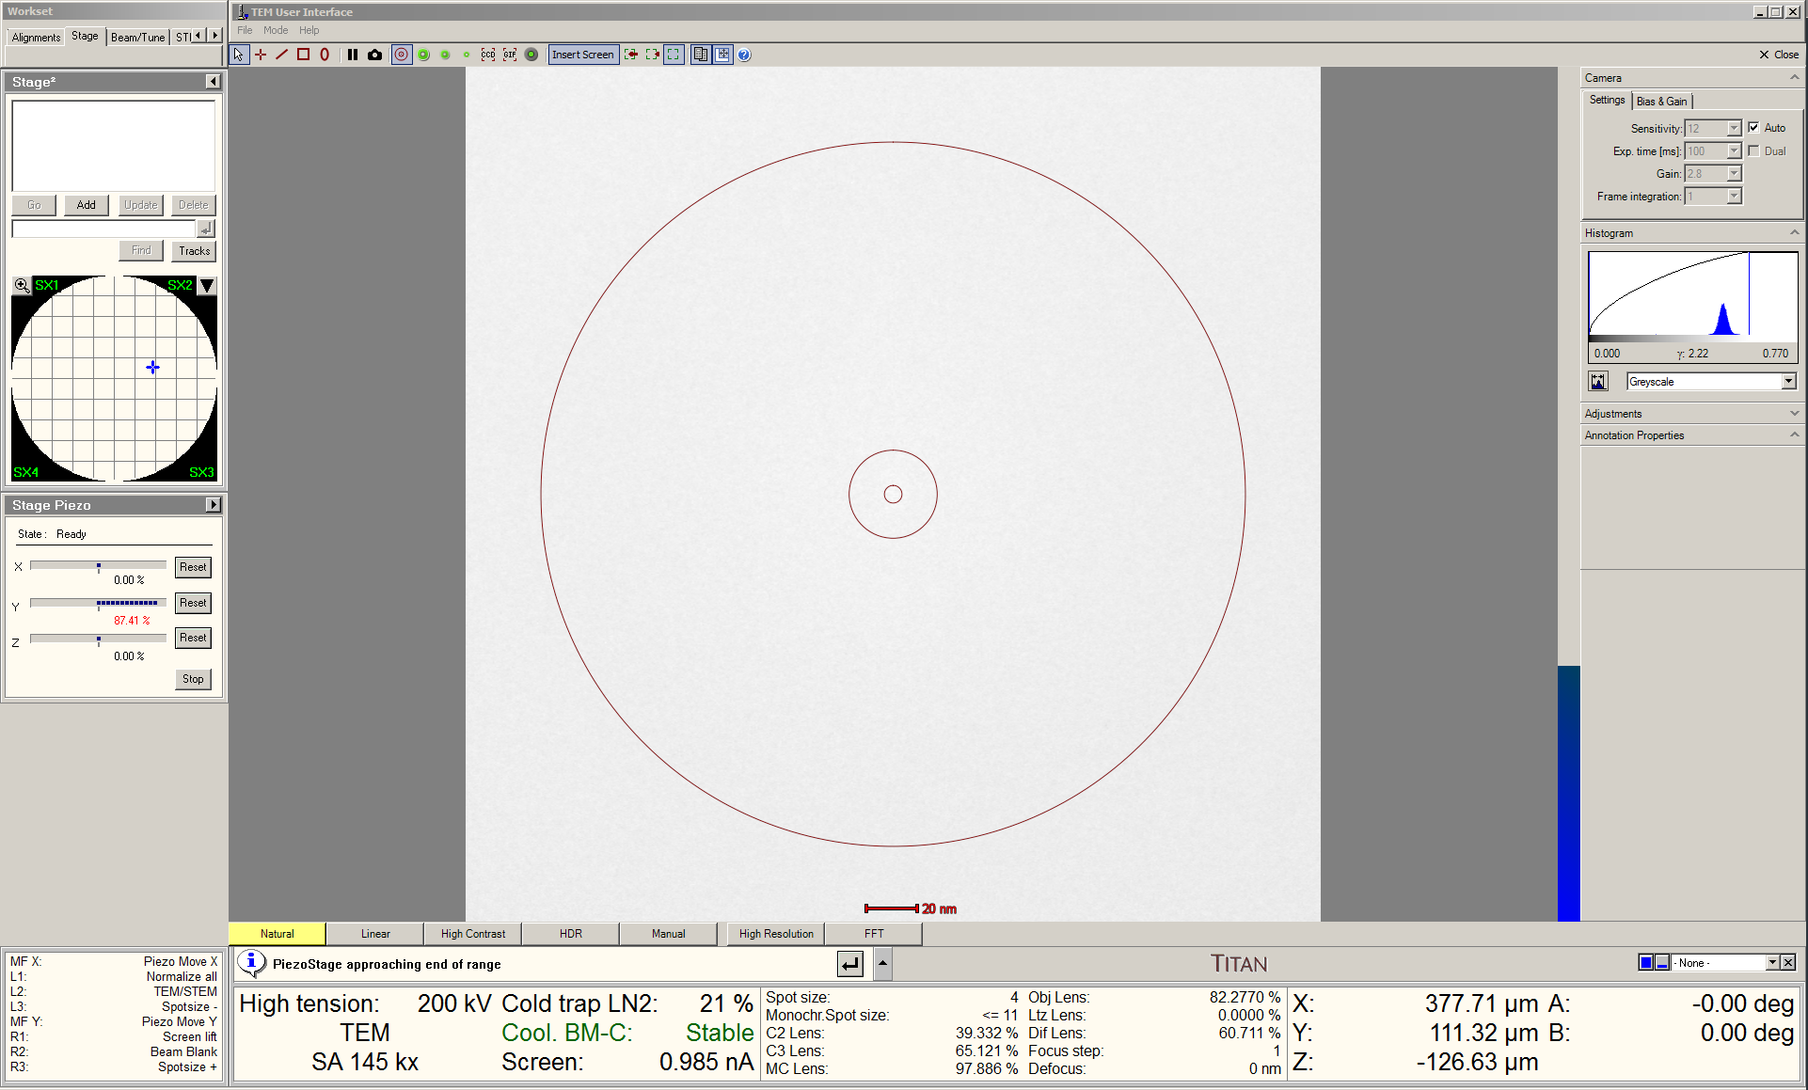

  - After resetting, resume normal use of the piezo controller again (as needed).
- Zone axis alignment (when relevant)

  - Center the ROI on the FluCam and adjust the beam as appropriate.

  - Enter diffraction mode and set the indicated camera length as per usual.

    - An indicated camera length L = 460 mm will usually suffice for performing zone axis alignment.

  - Tilt the stage to orient the sample toward the zone axis via the zone axis tilt map shown below (valid for any camera length).

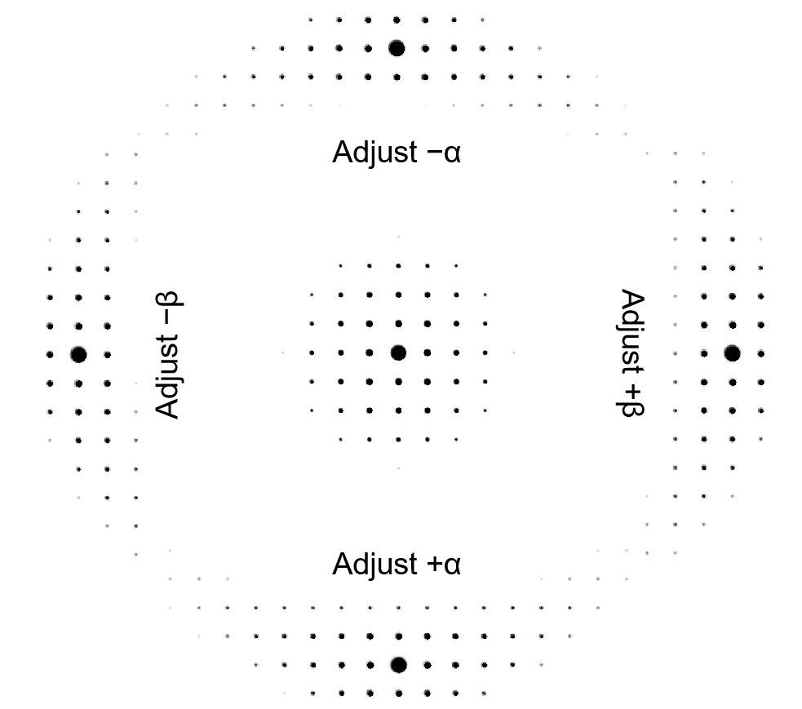

  - Return to imaging mode.

  - The ROI may move when the stage is tilted (particularly if the β tilt is adjusted); find and recenter the ROI on the FluCam.

  - Refocus the image as accurately as possible using only stage Z.

  - Return to diffraction mode and verify the specimen orientation is as desired at the ROI.

    - If the orientation is still not as desired, then repeat the previous steps iteratively until the desired orientation is obtained.
- Objective aperture centering

  - Enter diffraction mode and select the camera length as needed.

    - Again, L = 460 mm should suffice for this.

  - Select, insert, and center an appropriate objective aperture as per usual.

    - The 40 or 50 µm objective apertures are recommended for high-resolution (lattice) imaging at 200 kV.

    - The 10 µm objective aperture is recommended for low magnification bright-field imaging.

  - Return to imaging mode.

  - Center the beam and then continue to expand it so the beam is just outside the viewable area of the FluCam as per usual.

    - If any fringes near the beam edge are still visible in the viewable area (these may be faint), continue expanding the beam until these are no longer observed.

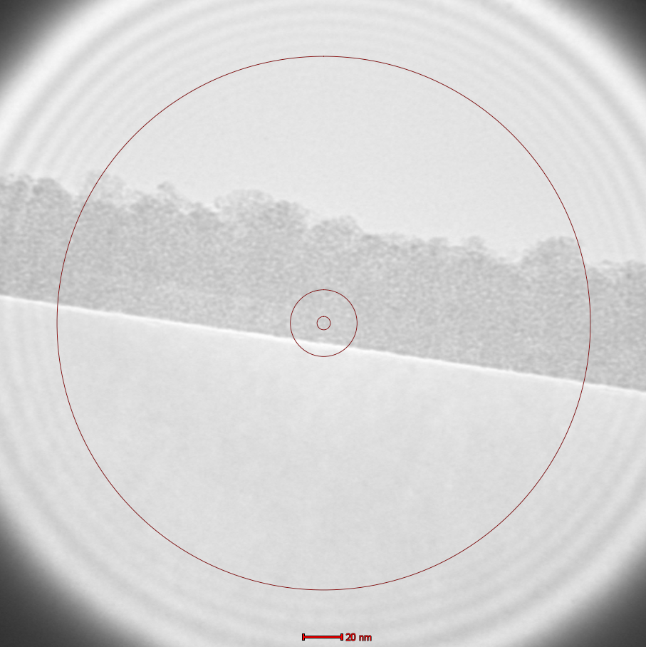

Left image: beam not expanded enough; fringes near beam edge observed in viewable area. Right image: beam expanded properly; no fringes near beam edge observed in viewable area
- Image acquisition using Velox

  - Correction of objective lens astigmatism should only be attempted if the indicated magnification is ≥115 k×; do not attempt otherwise.

  - Retract the main screen and start acquiring a live image in Velox as per usual.

  - While observing the FFT of the live image activate the objective stigmators and correct objective astigmatism as per usual.

    - NOTE: all or part of the image must be amorphous or partially amorphous for this to work effectively.

  - Optimize image focus using the “Focus” knob and/or “Piezo Move Z” and acquire the final image.

  - Changing magnifications

    - Reinsert the viewing screen and adjust the magnification as per usual.

    - Recenter and resize the beam as per usual.

    - Resume live imaging in Velox; correct objective astigmatism and refocus (will likely be necessary when increasing magnifications).

  - Switching from SA (380 k× maximum) to Mh (460 k× minimum) mode:

    - Press “Eucentric Focus”.

    - Retract the objective aperture.

    - Focus the image as precisely as possible using stage Z.

    - Balance the beam tilt pivot points; align the rotation center.

    - Enter diffraction mode and reinsert/center the objective aperture.

    - Return to imaging mode; recenter and resize the beam as per usual.

    - Resume live imaging in Velox; correct objective astigmatism and focus as per usual.

  - When finished imaging with the Ceta camera, reinsert the viewing screen and retract the Ceta camera as per usual.
- Finishing the session

  - Verify the Ceta camera is retracted.

  - Verify the SA and objective apertures are retracted.

  - Place the instrument in SA mode (do not leave in LM, Mh, or diffraction mode).

  - Close the column valves.

  - Reset the stage and verify all coordinates are returned to ~0.

    - If needed, reset each axis of the piezo controller (described earlier).

    - Again, DO NOT disable (stop) the piezo controller.

  - Retract the holder and insert the metal plug into the airlock.

    - NOTE: for proper insertion, the flat edge of the outer cylinder must be oriented vertically at 3 o’clock as shown below.

