
FEI Themis Z S/TEM
  - STEM Mode Standard Operating Procedure Rev. 2026-01
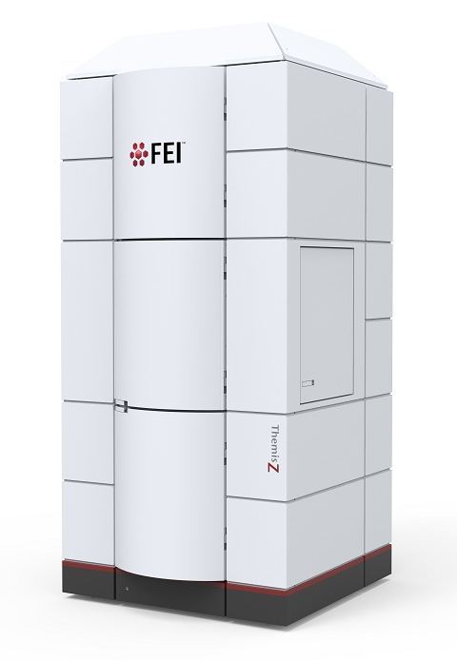
  - Application
The FEI Themis Z S/TEM is a state-of-the-art C_{s} probe-corrected field emission gun scanning/transmission electron microscope capable of providing micro- to pico-scale structural, morphological, magnetic, and chemical information. This document covers operation of the instrument for scanning (STEM) mode imaging only. Please see separate SOP documents on the NRF instrument page regarding other applications.

  - NRF Contact
Nicholas G. Rudawski

Table of Contents

1. Safety 3
2. Pre-requisites 3
3. Voltage settings 3
4. Alignments in TEM mode 4
5. Entering STEM mode 5
6. Setting “Eucentric focus” 8
7. Optimizing beam tilt 11
8. Correcting B2 and A1 using the Ronchigram 14
9. HAADF imaging using Velox 19
10. OptiSTEM using Sherpa (as needed) 21
11. ABF imaging 24
12. Current adjustments 26
13. Finishing in STEM mode 27

- Safety

  - Due to stipulations of the instrument service contract as well as contamination concerns, analysis of radioactive and/or biological specimens with this instrument is strictly prohibited.

- Pre-requisites

  - Extensive familiarity with use of the Microscope Control user interface software and Velox imaging software.

  - Proficient in independent operation of the FEI Themis Z S/TEM for TEM imaging.

  - NOTE: as per the prerequisites, many associated details and images that could otherwise be included here are omitted for purposes of clarity (“…as per usual”).

- Voltage settings

  - The default voltage setting is 200 kV and will provide up to < 80 pm STEM resolution. If wanting to operate the instrument at a different voltage (60 or 300 kV), please contact staff in advance for assistance.

  - As per the TEM mode operation SOP, it should not be necessary to load an alignment file at the start of the session.

- Alignments in TEM mode

  - Navigate to the specimen as per usual; then, retract it from the FOV (if possible).

  - Perform monochromator centering but set the monochromator focus = +40 (positive).

    - This increases source brightness, which is beneficial for STEM imaging.

  - With the C3 lens off, insert and center the 70 µm C2 aperture.

    - On this instrument, if the C2 aperture is properly aligned in TEM mode, it will be properly aligned in STEM mode.

  - Turn the C3 lens back on.

  - Move the specimen back into the FOV and bring it to eucentric height.

  - If needed, enter diffraction mode and tilt the stage to crystallographically align the area of interest and then re-establish eucentric height.

    - Finer adjustments to the crystallographic alignment can be performed in STEM mode.

  - Verify the objective and SA apertures are both retracted.

  - If possible, retract the specimen from the FOV (again); this will facilitate the initial steps of STEM mode alignment as described subsequently.

- Entering STEM mode

  - In Microscope Control, navigate to the “STEM” tab and enter STEM mode as per usual.

  - Upon entering STEM mode, the “MF-Y” knob should default to control “Piezo Move Z”; if not, activate it as per usual.

  - Set the indicated camera length as per usual; an indicated camera length L = 115 mm will suffice for both HAADF-STEM imaging as well as all subsequent alignment steps.

  - Set the indicated magnification ≥ 1M× as per usual.

  - Remain in the STEM tab and navigate to the “STEM AutoTuning” control panel.

    - Select the flap-out arrow and select “Reset” in the flap-out panel.

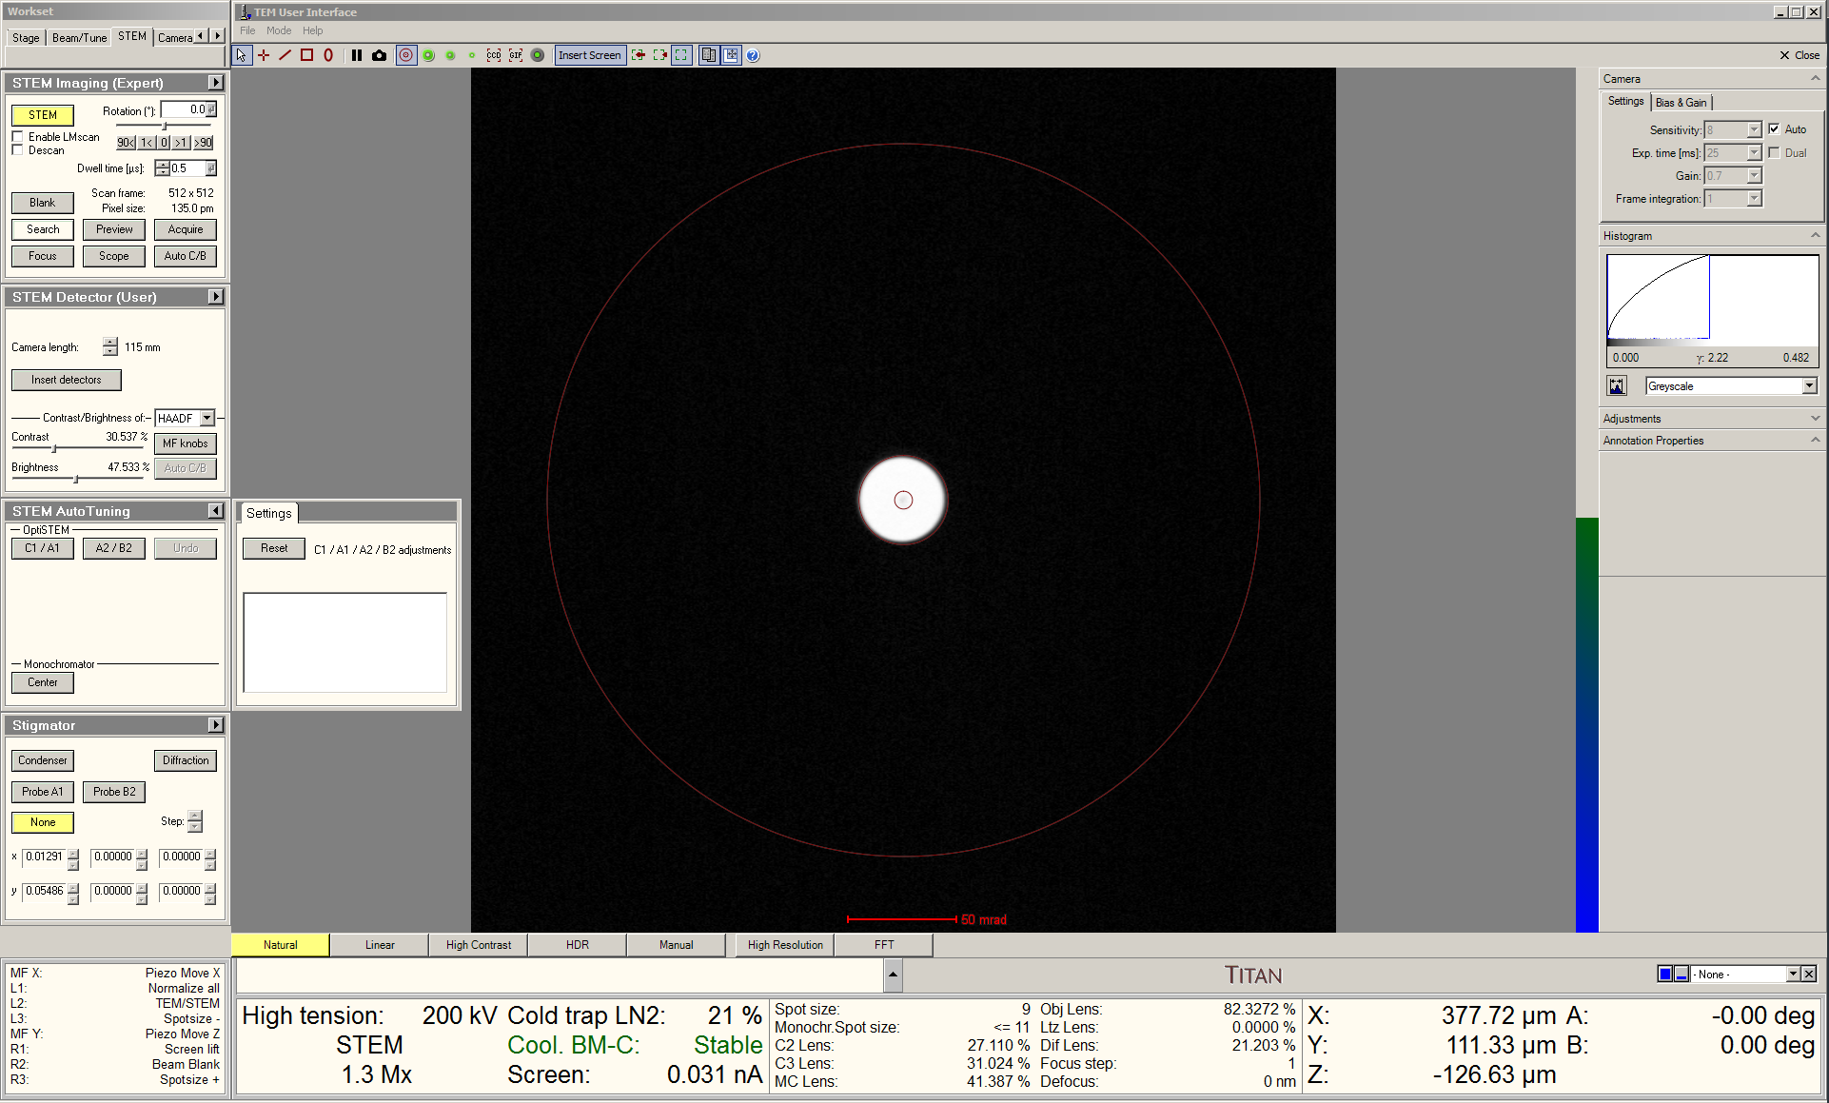

  - In Velox Acquisition, select “HAADF” from the toolbar to start live STEM imaging.

    - Right click on the beam position marker and select “Center beam”.

    - After verifying the beam position marker is centered in the STEM image, select “HAADF” from the toolbar again to stop live STEM imaging and retract the HAADF detector.
  - Select the “Beam/Tune” tab and navigate to the “Beam Settings” control panel.

    - Set “Spot number” = 9 or 10 to obtain the best STEM resolution.

    - Set “Spot number” = 5 or 6 for performing STEM-EELS.

    - Select the flap-out arrow and then the “Tune” tab.

    - Check “MF-Y Convergence angle” and use the “Multifunction Y” knob to set the semi-angle of convergence; semi-angle = 22 mrad is recommended for optimal STEM resolution.

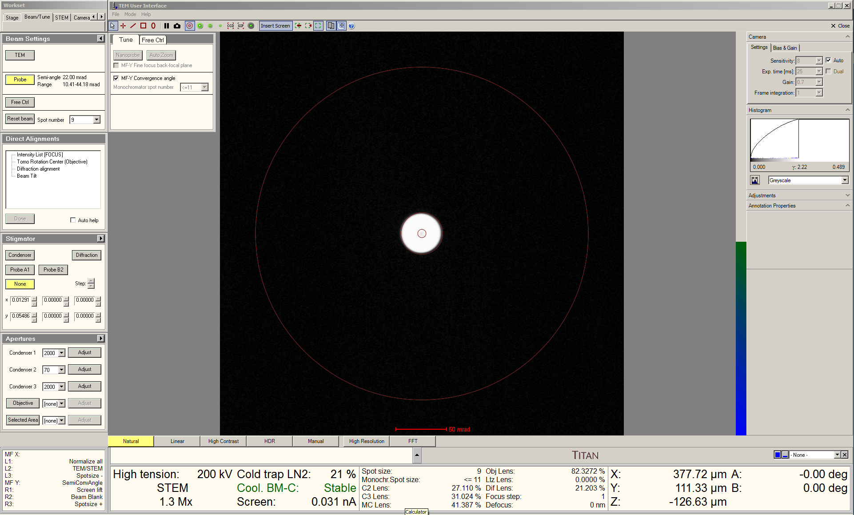

    - Uncheck “MF-Y Convergence angle” when finished.

    - With monochromator focus = +40, spot numbers 9 and 10 should produce probe currents of ~25 and ~13 pA, which are sufficient for < 80 pm STEM resolution at 200 kV.

    - With monochromator focus = +40, spot numbers 5 and 6 should produce probe currents of ~450 and ~225 pA, which are suitable for STEM-EELS with < 0.2 nm resolution.

- Setting “Eucentric focus”

  - Select “Diffraction” on the RH control panel to exit diffraction mode and enter image mode; an image of the probe will now be visible on the FluCam.

  - Set the indicated magnification ≥ SA 230 k×.

  - In S-CORR, select the “State Of Correction” tab and then the “Manual Correction” tab.

    - Select “User Beam Shift” with Bit Multiplier = 3

    - Use the keyboard ↕↔ arrow keys to center the beam.

    - With “Diffraction” off, shift the beam as needed during alignment but using only the “User Beam Shift” function in S-CORR.

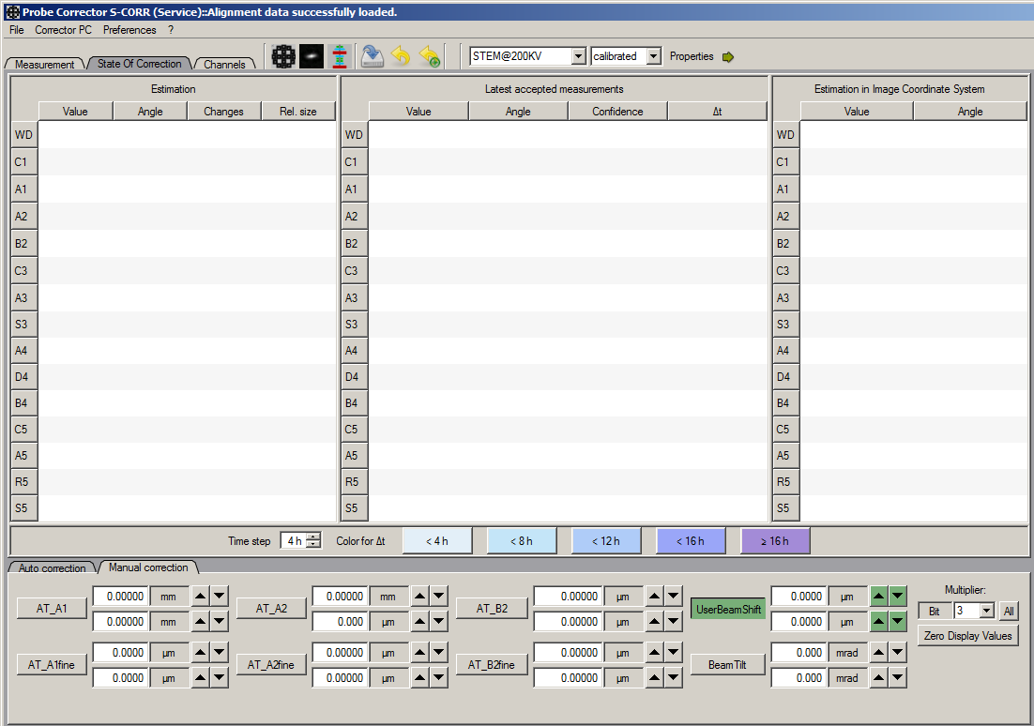
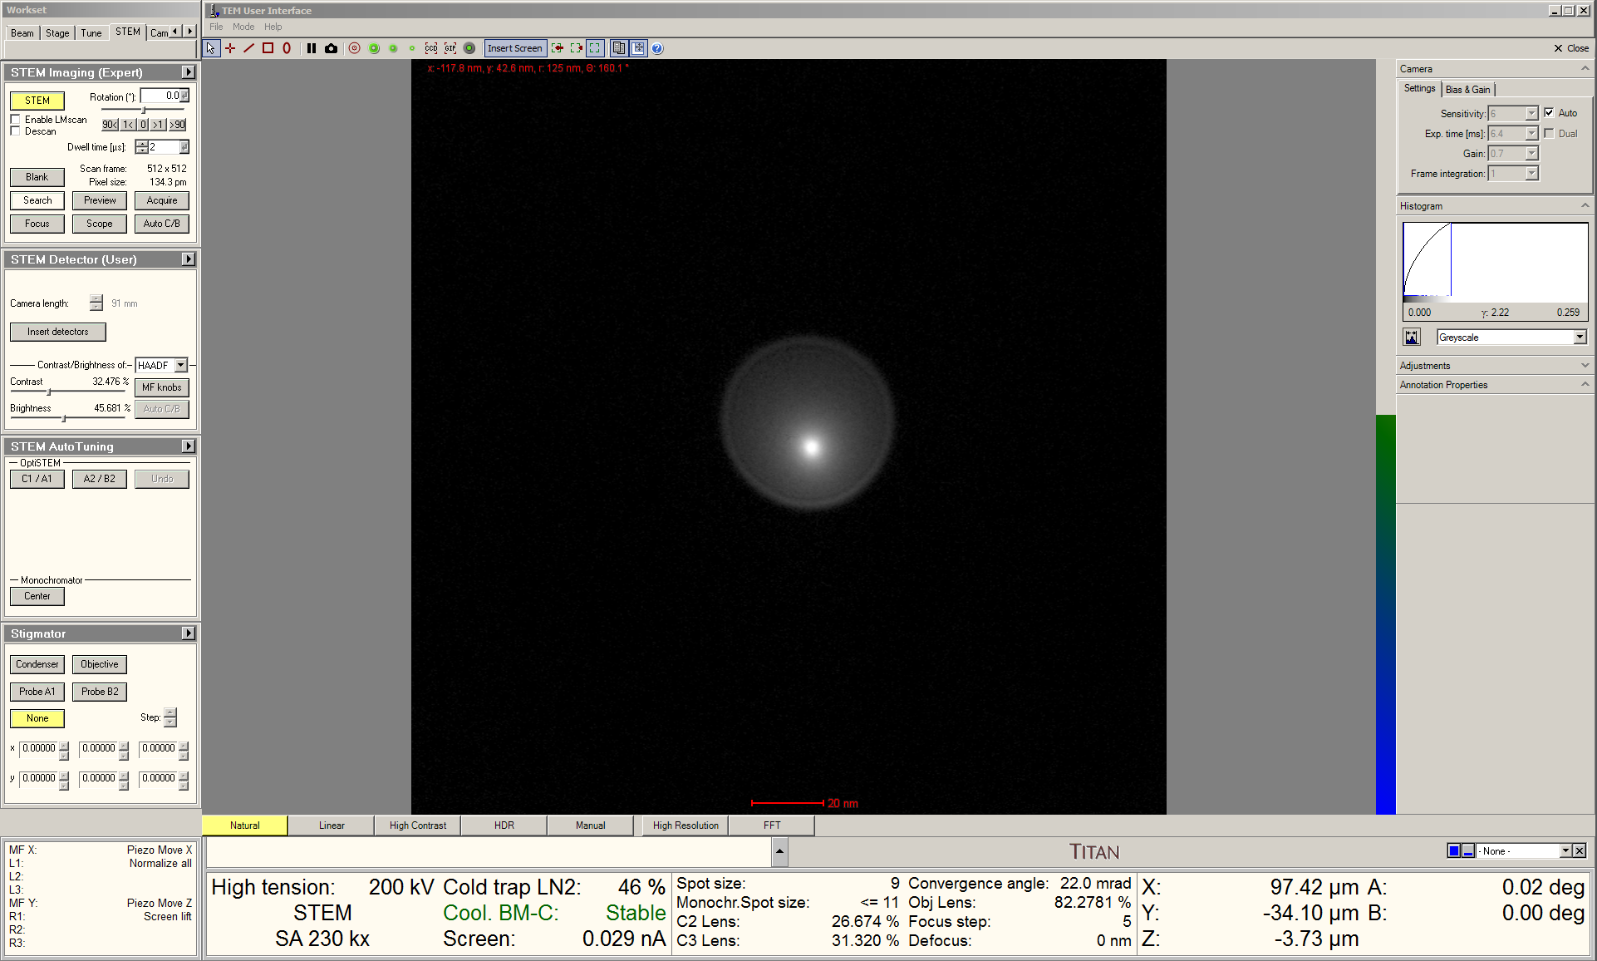

  - In S-CORR, select the “State Of Correction” tab and then the “Manual Correction” tab.

  - Select “AT_A1” (coarse 2-fold astigmatism) with “Bit Multiplier” = 0.

  - Use the keyboard ↕↔ arrow keys to correct 2-fold astigmatism (A1) as best as possible.

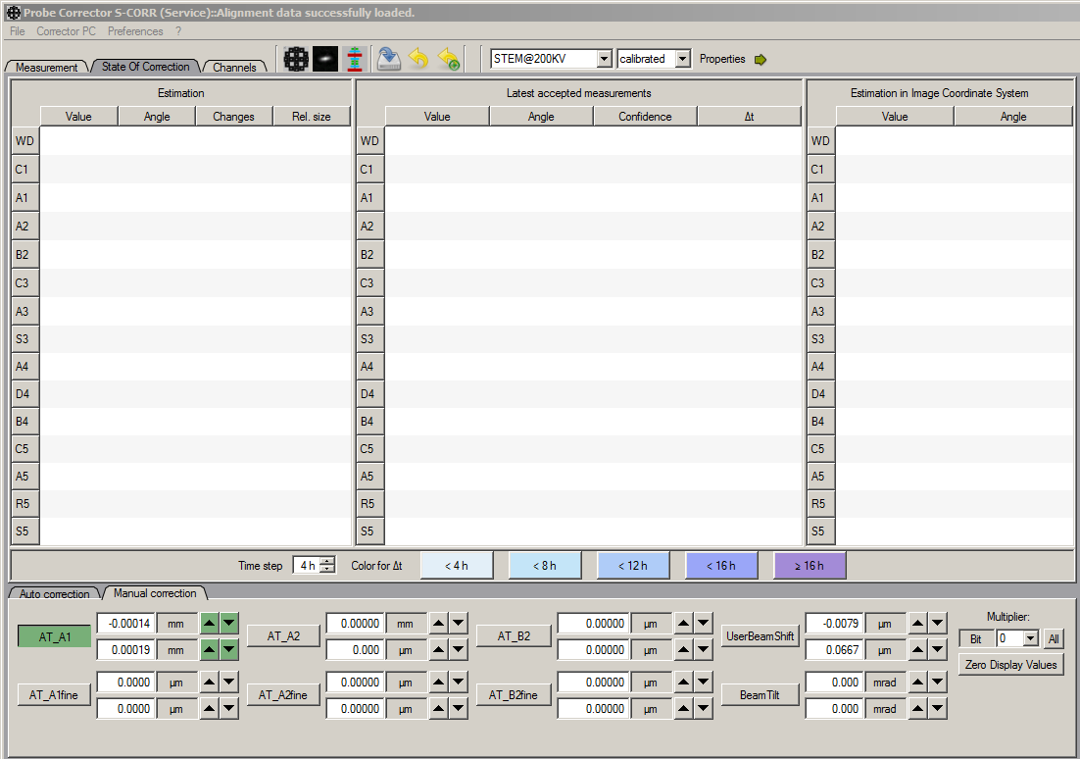
a screenshot of microscope control user interface software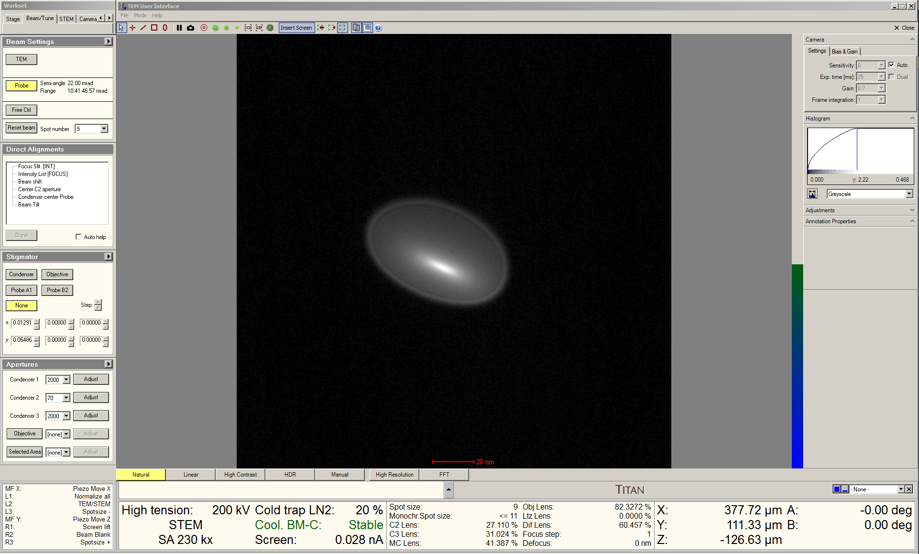
  - Remain in the “Beam/Tune” tab and navigate to the “Direct Alignments” control panel.

  - Select “Intensity List [FOCUS]”.

  - Use the “Focus” knob (coupled to C3) to focus the probe.

    - Setting the FluCam to “Natural” mode and then manually increasing the histogram white level can aid with this; the mode will then switch to “Manual”.

    - Proper focus is a small, bright (caustic) spot surrounded by a diffuse halo (shown below).

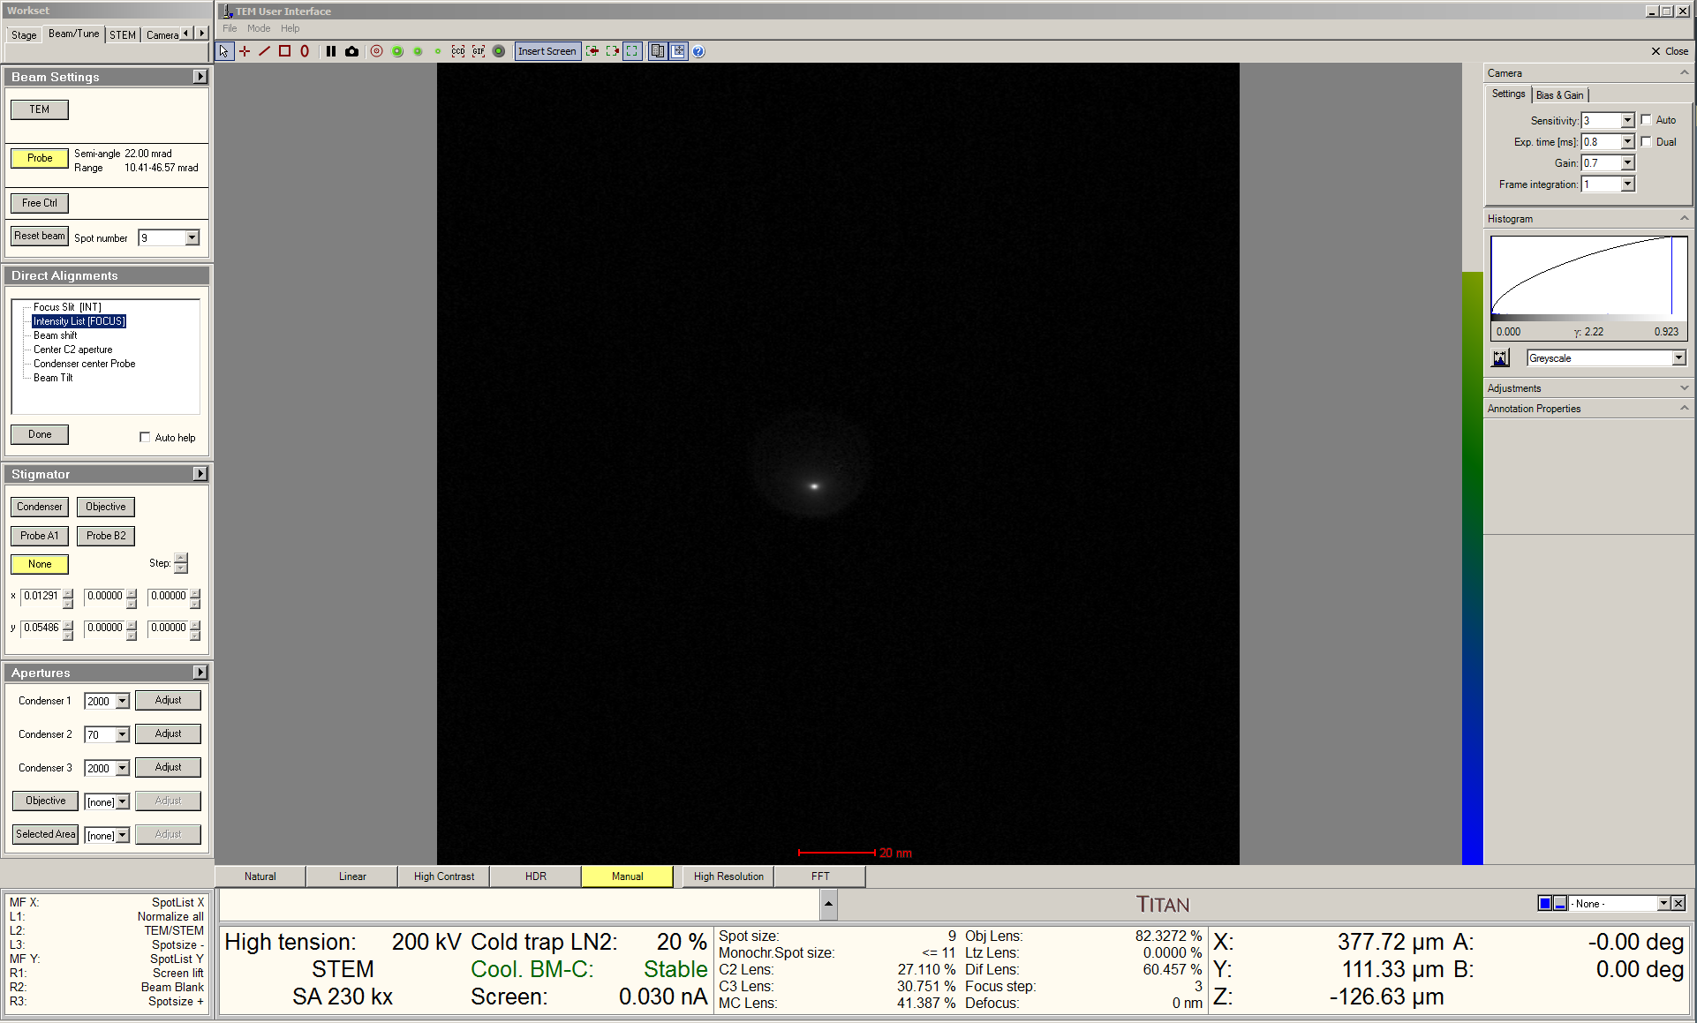

  - Select “Done” when finished; this setting for the C3 lens is now stored for “Eucentric focus” for the chosen spot number.

  - At this point, the caustic spot may not be centered inside the diffuse halo, seemingly indicating the beam tilt needs to be adjusted; however, DO NOT adjust the beam tilt at this point; the correct way to optimize beam tilt is described in the next section.
- Optimizing beam tilt

  - Select “Diffraction” on the RH control panel to exit image mode and enter diffraction mode; a CBED pattern should be evident on the FluCam.

  - Start live STEM imaging in Velox; navigate over to the specimen and find a feature that is two-dimensional in nature; set the indicated magnification = 225 k× and precisely center the feature in the live STEM image.

  - Focus the live STEM image using only stage Z (recall “Piezo Move Z”) as accurately as possible; move the feature back to the middle of the image (if necessary).

  - Select “Reduced Area” and set the dwell time = 1 μs; adjust the size of the window so it is approximately square and approximately 1/4 the width of the full frame and then center it.

    - NOTE: right-click on the STEM image and select “center cross” to identify the center of the image.

  - In Microscope Control, select the “Tune” tab and navigate to the “Direct Alignments” control panel; select “Beam Tilt” to start wobbling the OBJ lens.

    - Adjust the “Focus” ring to change the strength of the wobble.

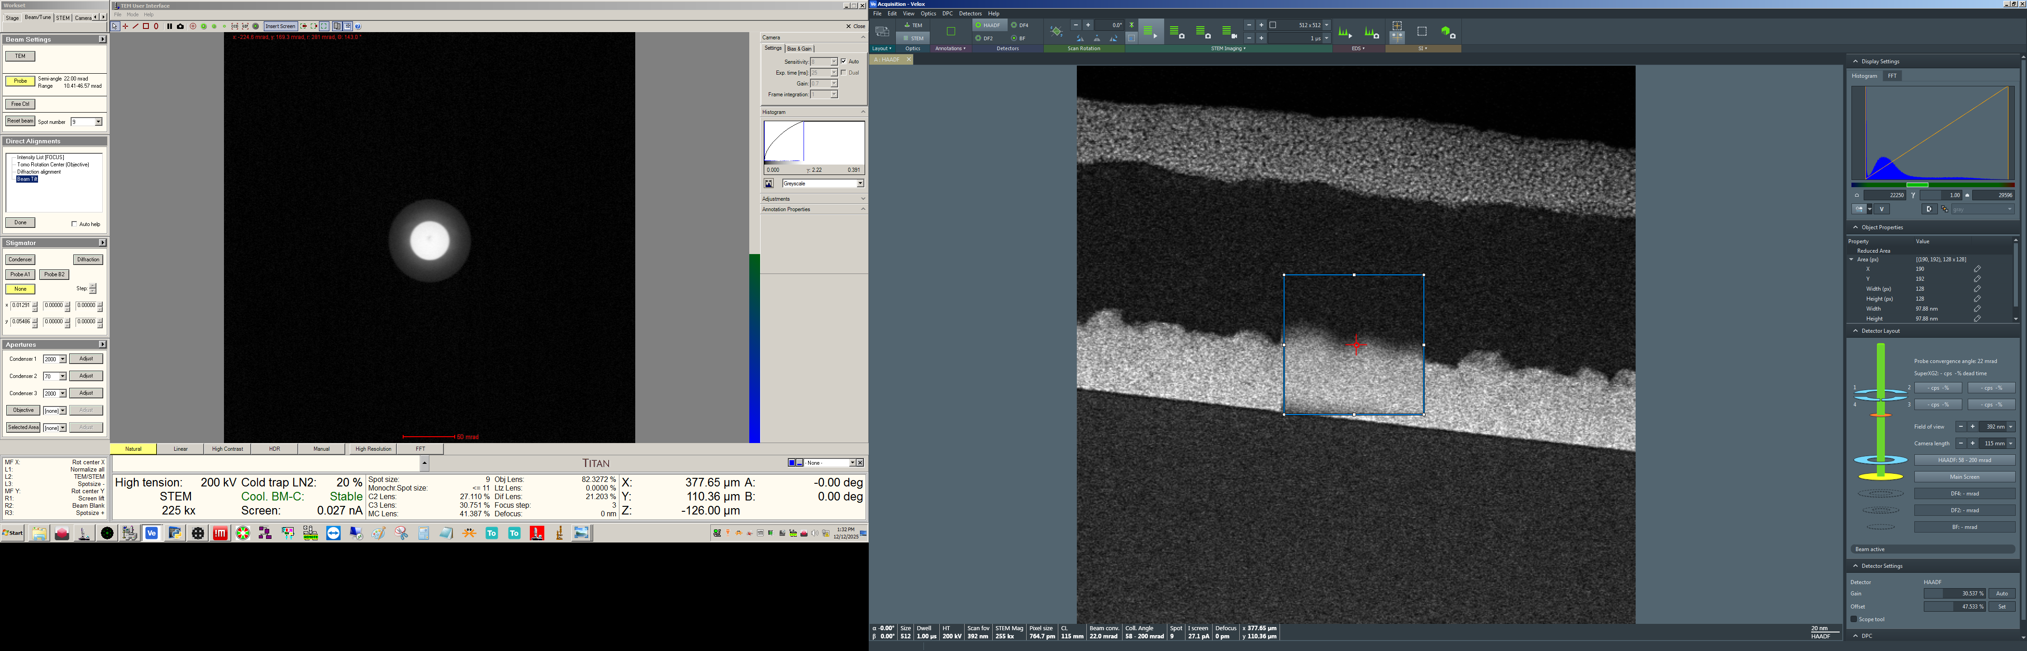

  - In S-CORR, select the “State Of Correction” tab and then the “Manual Correction” tab.

  - Select “Beam Tilt” with “Bit Multiplier” = 3.

  - Use the keyboard ↕↔ arrow keys to eliminate shifting the live STEM image.

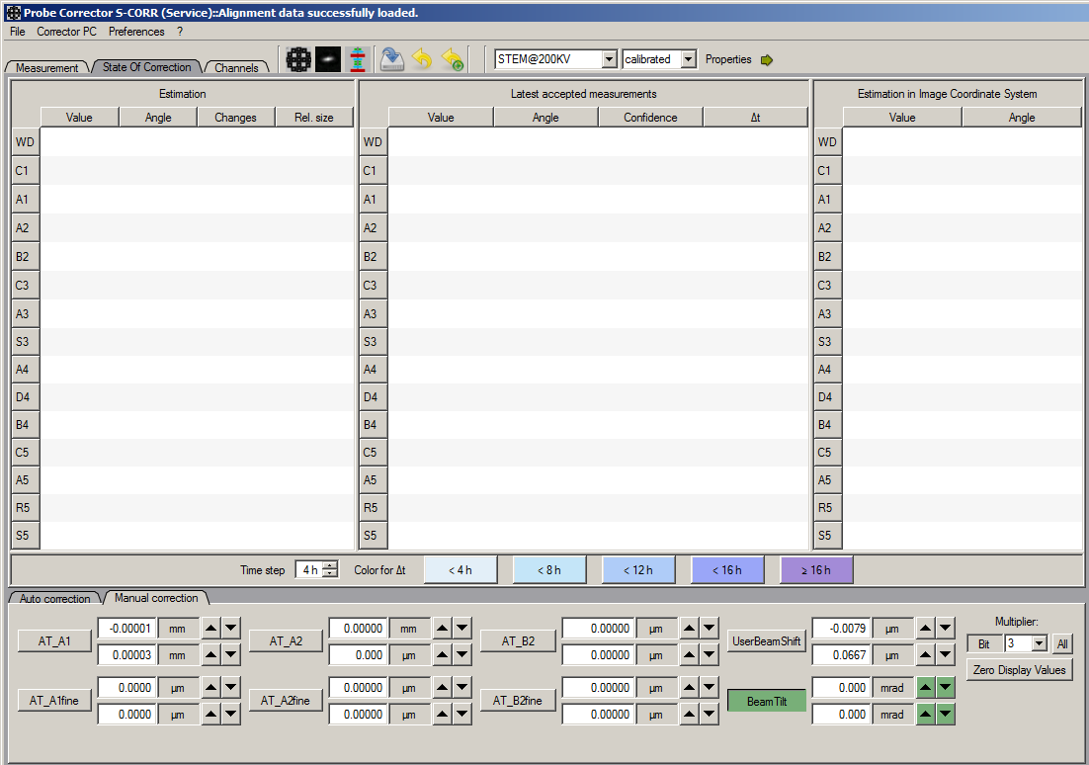

  - In Microscope Control, select the “Tune” tab, navigate to the “Direct Alignments” control panel, and select “Done”.

  - The STEM image may be out of focus now; if so, press “Eucentric Focus” to perform normalization and the image should be in focus again.
- Correcting B2 and A1 using the Ronchigram

  - While live STEM imaging, center an amorphous or partially amorphous region of the specimen in the image and set the indicated magnification ≥ 1 M× and stop scanning.

    - The beam position in Velox should still be at the center of the image.

    - A Ronchigram should now be evident on the FluCam.

    - Retract the HAADF detector.

    - Switch the FluCam to “High Resolution” mode to magnify the Ronchigram for easier visibility without changing the indicated camera length.

  - Return to Microscope Control, select the “Beam/Tune” tab, and navigate to the “Direct Alignments” control panel.

    - Use the “Diffraction Shift” direct alignment to precisely center the Ronchigram on the FluCam.

    - This is important as this will serve as the reference position when the C2 aperture is subsequently changed.

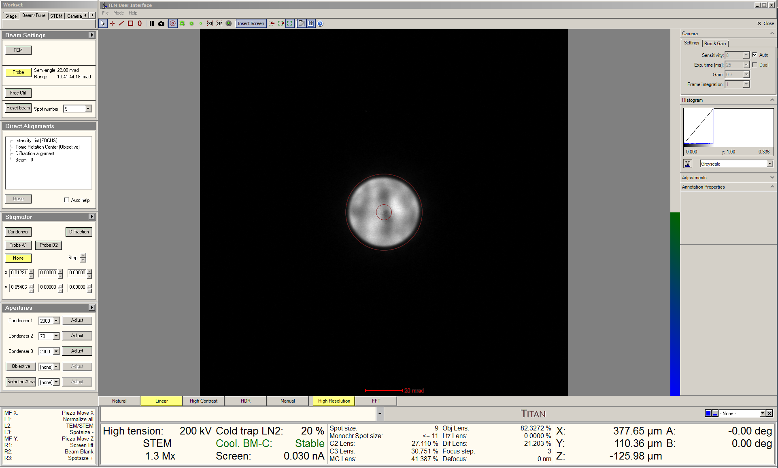

  - Insert the 150 µm C2 aperture and precisely center it on the FluCam as per usual.
  - Adjust stage Z to obtain a “blow up” condition for the Ronchigram.

  - In Microscope Control, select the “Beam/Tune” tab, and navigate to the “Stigmator” control panel.

    - Select “Probe B2”; the OBJ will start wobbling and the Ronchigram will start pulsing in and out of the “blow-up” condition.

    - DO NOT adjust the “MF” knobs.

    - Adjust the “Focus” ring counterclockwise to reduce the magnitude of the OBJ wobble as needed.

  - In S-CORR, select the “State Of Correction” tab and then the “Manual Correction” tab.

    - Select “AT_B2” with Bit Multiplier = 9.

    - Use the keyboard ↕↔ arrow keys to correct axial coma (B2); i.e., eliminate any up and down and/or side-to-side sweeping as the Ronchigram goes through the “blow-up” condition.

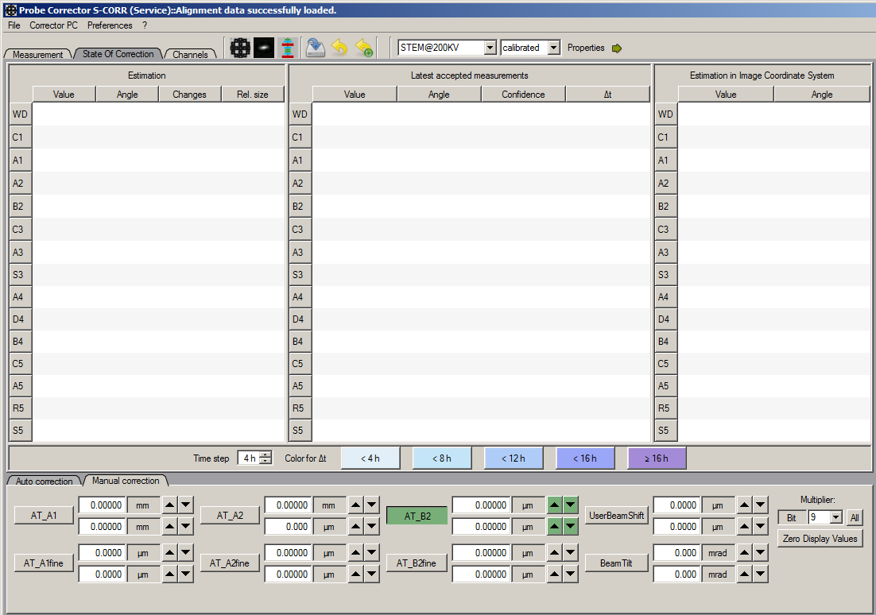
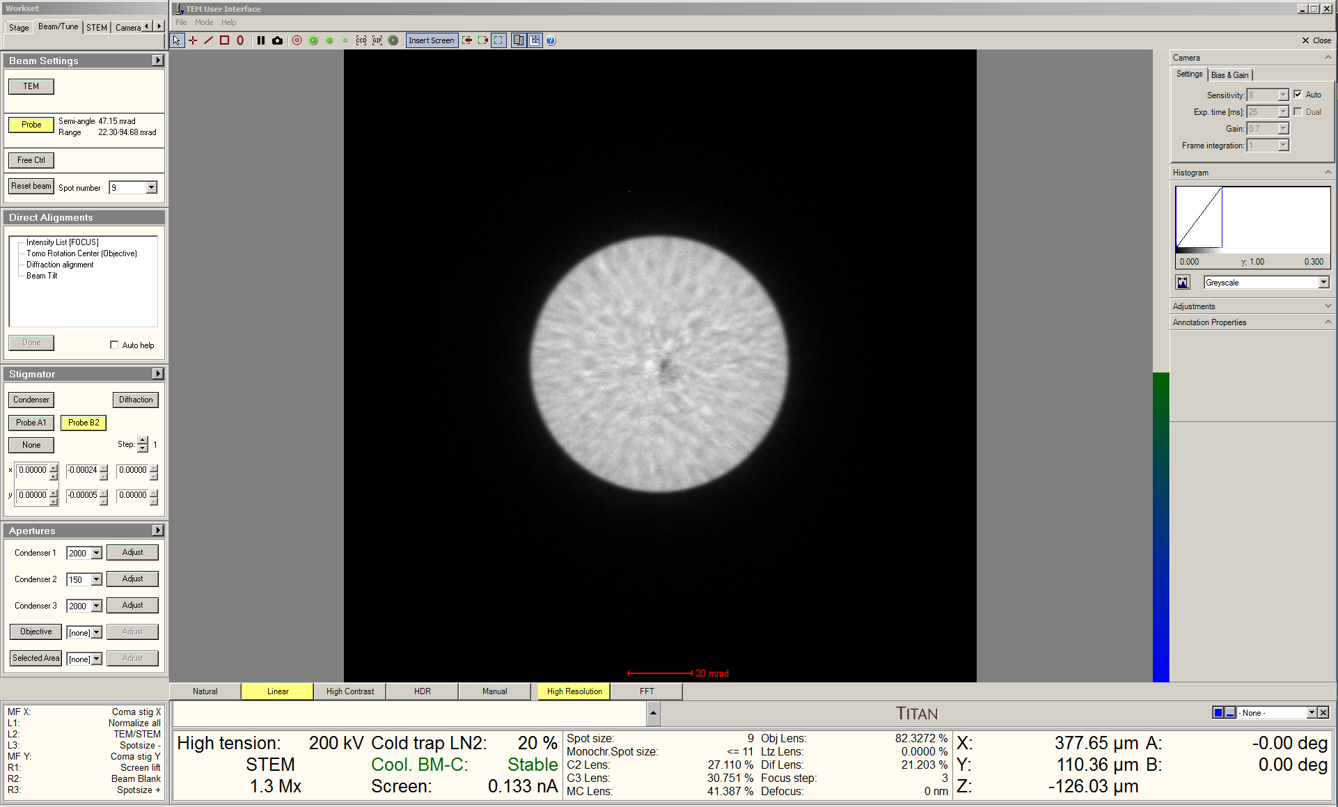

    - When finished correcting B2, return to Microscope Control, select the “Beam/Tune” tab, navigate to the “Stigmator” control panel, and select “None” to stop the OBJ wobble.
  - Remain In S-CORR, select the “State Of Correction” tab and then the “Manual Correction” tab.

    - Select “AT_A1” with Bit Multiplier = 0.

    - Use the keyboard ↕↔ arrow keys to correct A1 as accurately as possible; as this was already corrected by viewing the probe image, the adjustment needed here may be minimal.

    - As needed, adjust stage Z to obtain the “blow-up” condition.

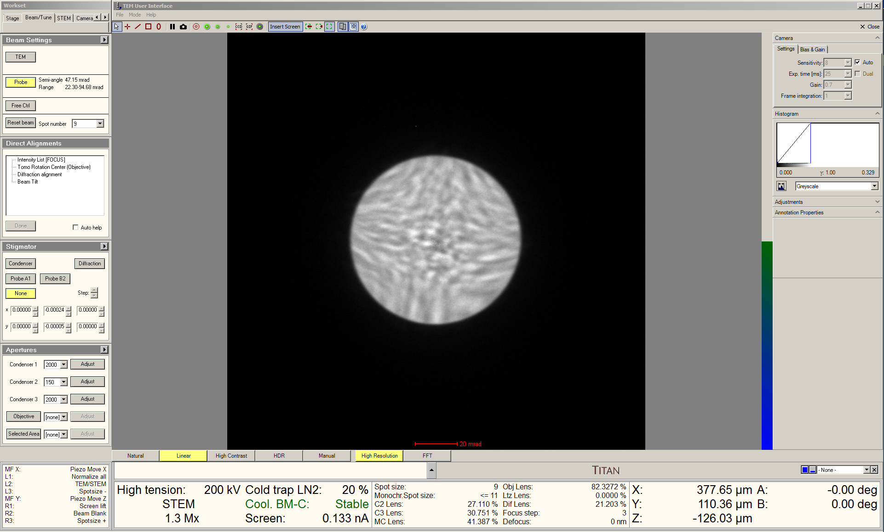
  - If B2 and A1 are properly corrected, the Ronchigram should show 6-fold symmetry at the outer edges with a “featureless” region in the middle (solid green circle).

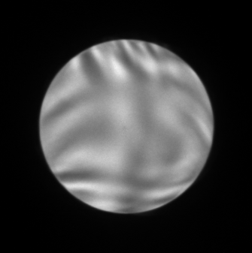
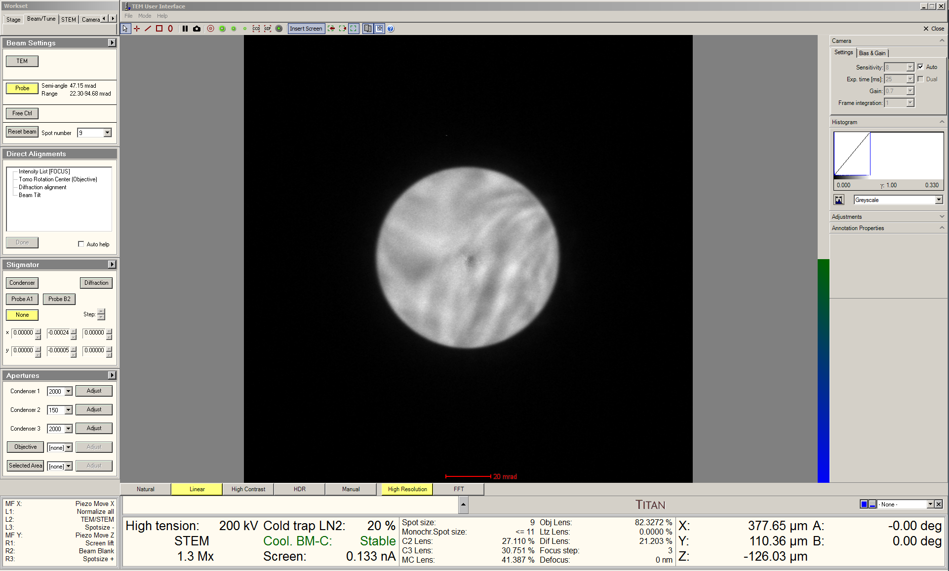

  - Re-insert and precisely center the 70 µm C2 aperture on the FluCam as per usual.

  - Insert the HAADF detector and use the “Diffraction Shift” direct alignment to center the Ronchigram inside the inner rim of the HAADF detector as per usual.
- HAADF imaging using Velox

  - Deviations from the “Eucentric focus” OBJ setting should be kept as small as possible to ensure optimal performance; thus, the majority of focusing should be accomplished via the adjustment of stage Z.

    - If the OBJ lens deviation becomes excessive, simply press “Eucentric focus” and refocus the image with stage Z.

    - This may also result in a slightly shift in the CBED pattern; simply recenter with “Diffraction alignment” as needed.

    - This may also introduce a small amount of A1; which can be corrected as described subsequently.

  - In Velox, start acquiring a live HAADF-STEM image and adjust the dwell time as per usual.

  - Adjust the detector “Gain” and “Offset” as needed to make optimal use of the detector dynamic range as per usual.

  - Adjust the STEM image rotation as per usual.

  - Focus the image as per usual; remember, the piezo controller may be used to perform atomic-level resolution focusing using “Piezo Move Z”.

  - If desired, fine correction of A1 may be performed manually while viewing the live STEM image using the “Condenser” stigmators as per usual.

    - Alternatively, A1 may be corrected more precisely using STEM AutoTuning as will be subsequently discussed in the next section.
  - If needed, tilt the stage to crystallographically align the specimen as desired using the zone axis tilt map shown below.

    - Remember to accurately refocus the image after tilting by only adjusting stage Z.

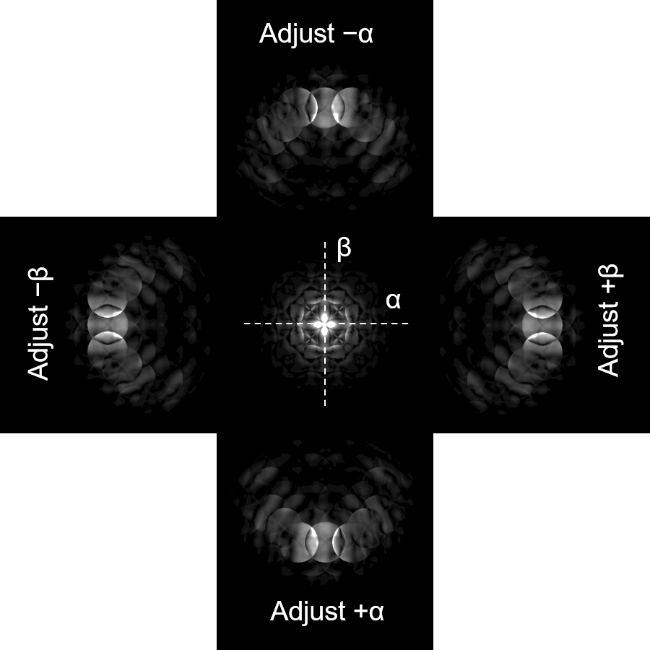

- OptiSTEM using Sherpa (as needed)

  - Specimen drift and contamination must be minimal for OptiSTEM to work properly.

  - OptiSTEM may be performed to correct defocus (C1), A1, A2 (three-fold astigmatism) and B2.

    - Correcting C1 and A1 (first-order aberrations) is equally effective on both single crystals and polycrystalline specimens.

    - Correcting A2 and B2 (second-order aberrations) is usually only effective on single crystal samples aligned to a major crystallographic zone axis.

  - Set the indicated magnification high enough such that at least 3 unique pairs of spots are present in the FFT (i.e., > 1M×).

  - Focus the image (again, remember “Piezo Move Z”) and adjust detector gain/offset to make optimal use of the detector dynamic range.

  - Freeze the scan (but do not blank the beam).

  - In Sherpa, navigate to “Auto Functions” and verify “OptiSTEM” is selected and “Details” is activated in the toolbar.

    - Under “Tune”, select “C1/A1” to correct first-order aberrations C1 and A1; this should only take a few seconds.

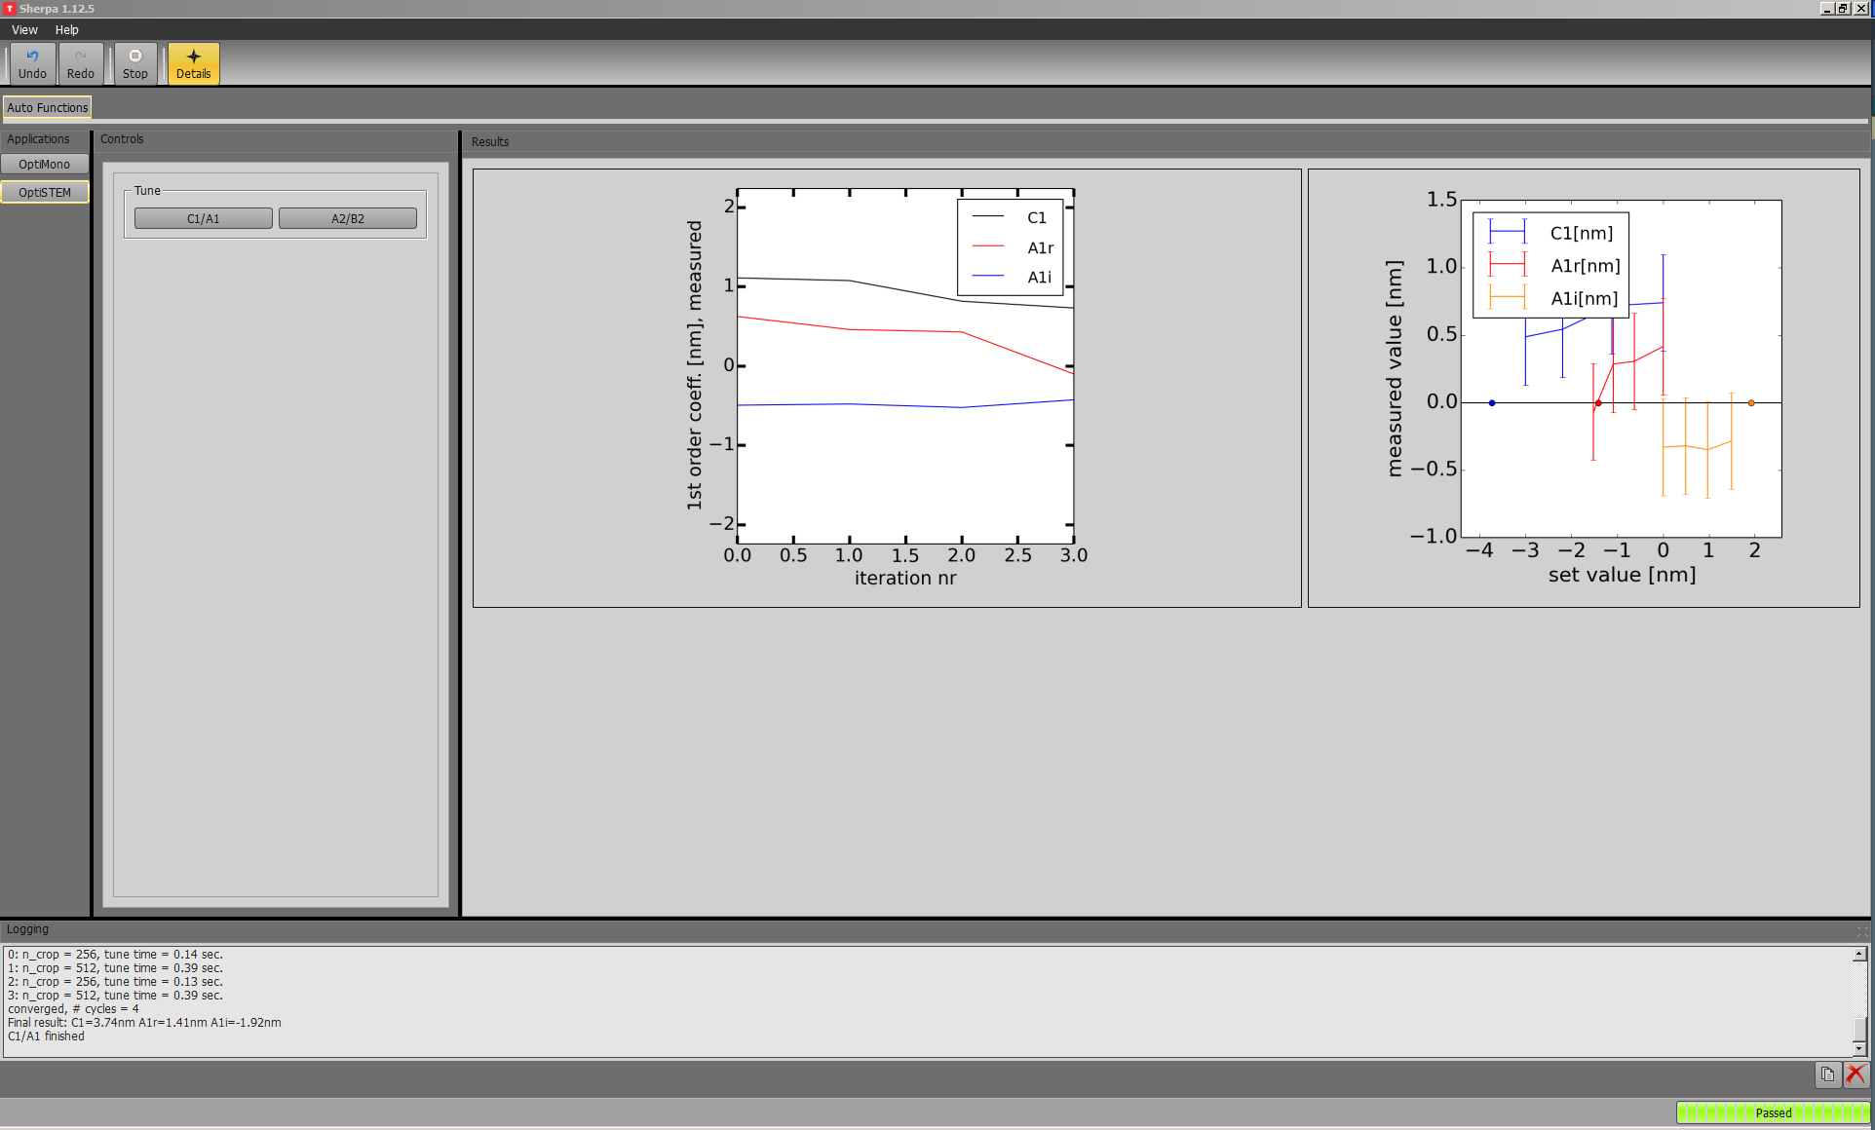

    - Under “Tune”, select “A2/B2” to correct first order aberrations C1 and A1 as well as second order aberrations A2 and B2; this may take a few minutes.

    - NOTE: if “A2/B2” tuning is working properly, the tuning plots for the real and imaginary components of A2 and B2 should all exhibit approximately symmetric upside-down parabolas.

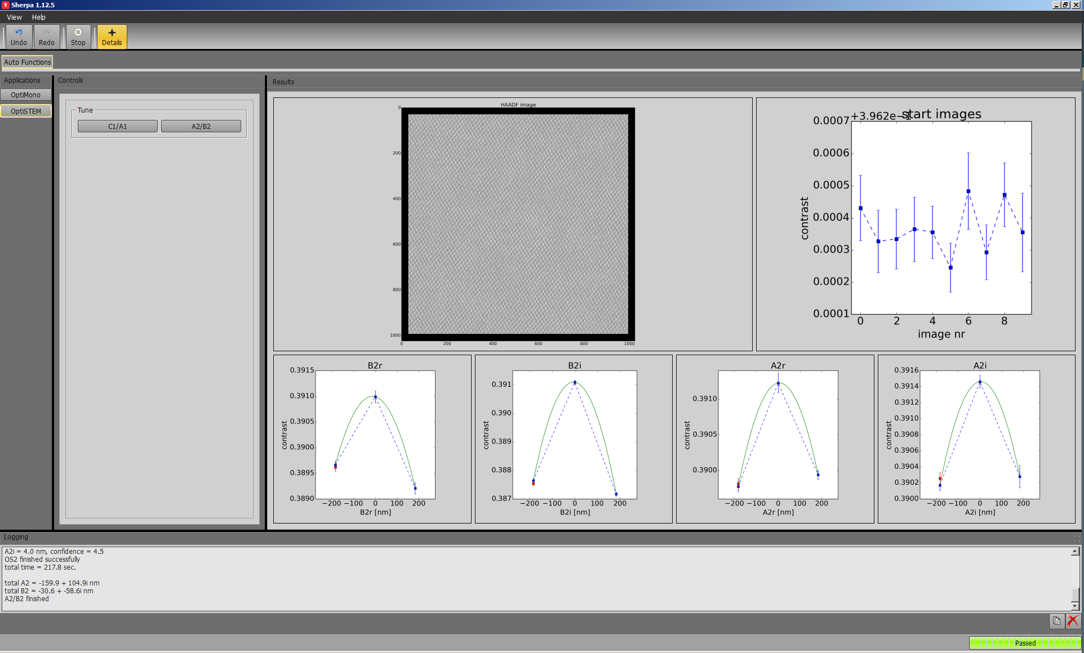

  - C1 and A1 typically exhibit stability over a few minutes (or in the case of C1, until the sample is moved) and thus C1/A1 correction may be performed as needed.

    - Remember, focus should be first optimized by adjusting stage Z to ensure any changes to the OBJ lens are minimal.

    - Alternatively, A1 may be manually corrected using the “Condenser” stigmators as per usual.

  - A2 and B2 typically exhibit stability over a few hours. Should A2/B2 correction succeed, this should not need correcting again for the remainder of the session.

    - If A2/B2 correction fails, the system will revert to the initial settings; in this case, the magnification can be reduced and A2/B2 correction attempted again (though it may still fail).

    - If B2 was manually corrected reasonably well, < 90 pm resolution should still be possible even without successful OptiSTEM A2/B2 correction.
- ABF imaging

  - Full alignment using a HAADF image should be performed as described previously before attempting to set up an ABF image.

  - Zone axis alignment, if needed, needs to be performed using a HAADF imaging condition before attempting to set up an ABF image.

  - If desired, OptiSTEM using a HAADF image should be performed before attempting to set up an ABF image.

  - Retract the specimen from the FOV, set the indicated magnification to ≥ 1 M×, and freeze the live STEM image; the beam will now be over vacuum; do not blank the beam.

  - Set the indicated camera length L = 580 mm and retract the HAADF detector as per usual.

  - Activate the HAADF detector markings from the FluCam toolbar.

  - Use the “Diffraction Alignment” direct alignment to precisely center the direct disk relative to the indicated position of the inner rim of the HAADF detector (indicated by arrows).

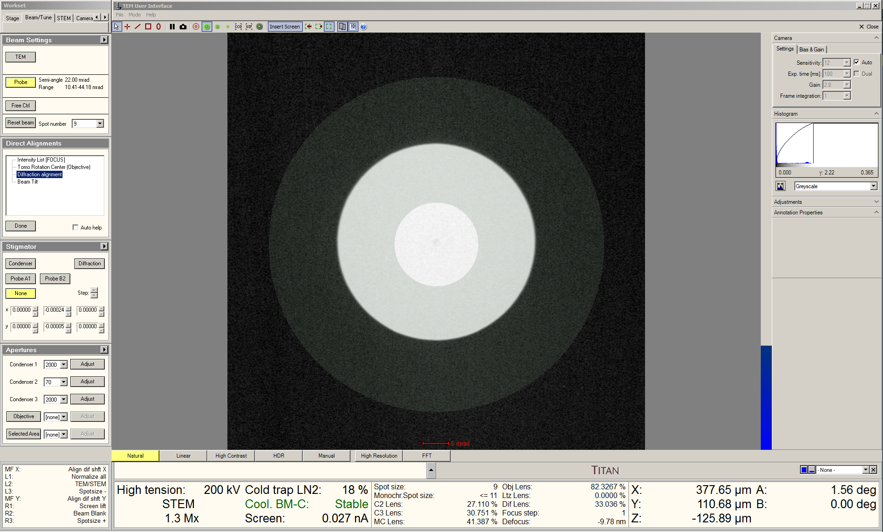
  - Select and insert the 60 µm objective aperture and precisely center it relative to the HAADF detector marking (only a slightly cutoff direct disk should be left).

    - This step is critical; if the objective aperture is not precisely centered on the direct disk, ABF imaging will not work properly.

    - Use of the 60 µm assumes a semi-angle of convergence ≤ 24 mrad; if the value is larger than this, the 70 µm objective aperture should be used instead.

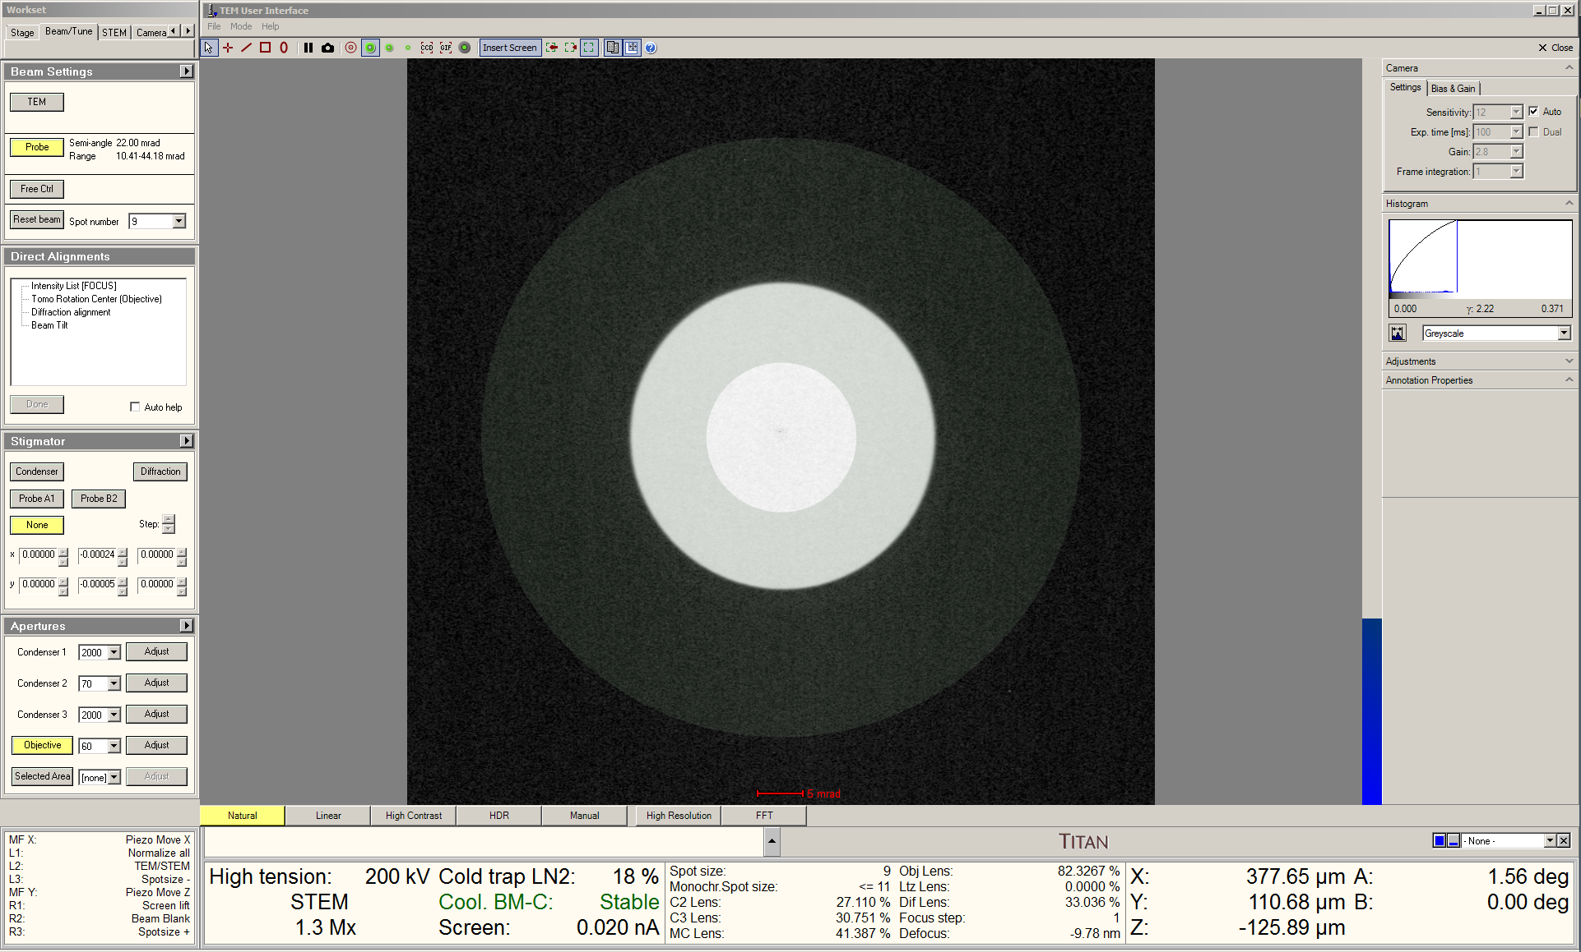

  - Re-insert the HAADF detector and resume STEM imaging in Velox as per usual.

  - Due to increased signal on the HAADF detector when ABF imaging, readjust the detector “Gain” and “Offset” accordingly.

  - Finely focus the image, adjust the “Condenser” stigmators, and acquire STEM images as per usual.

    - Attempting OptiSTEM is not recommended while ABF imaging.
- Current adjustments

  - The probe current can be quickly altered by adjusting the monochromator focus without changing any other optical settings and thus eliminating the need for extensive instrument realignment.

  - In Velox, start acquiring a live HAADF-STEM image; adjust the magnification so vacuum (or a weakly scattering area of the specimen) is visible in the image.

  - Freeze the scan (but do not blank the beam); position the beam over vacuum (or a weakly scattering area of the specimen) and note the measured screen current in the first Microscope Control info panel.

  - Select the “FEG/Beam” tab and navigate to the “Monochromator Tune” control panel.

    - Select “Focus”.

    - Adjust the “Intensity” knob to set the probe current as desired, while making sure to maintain positive monochromator focus.

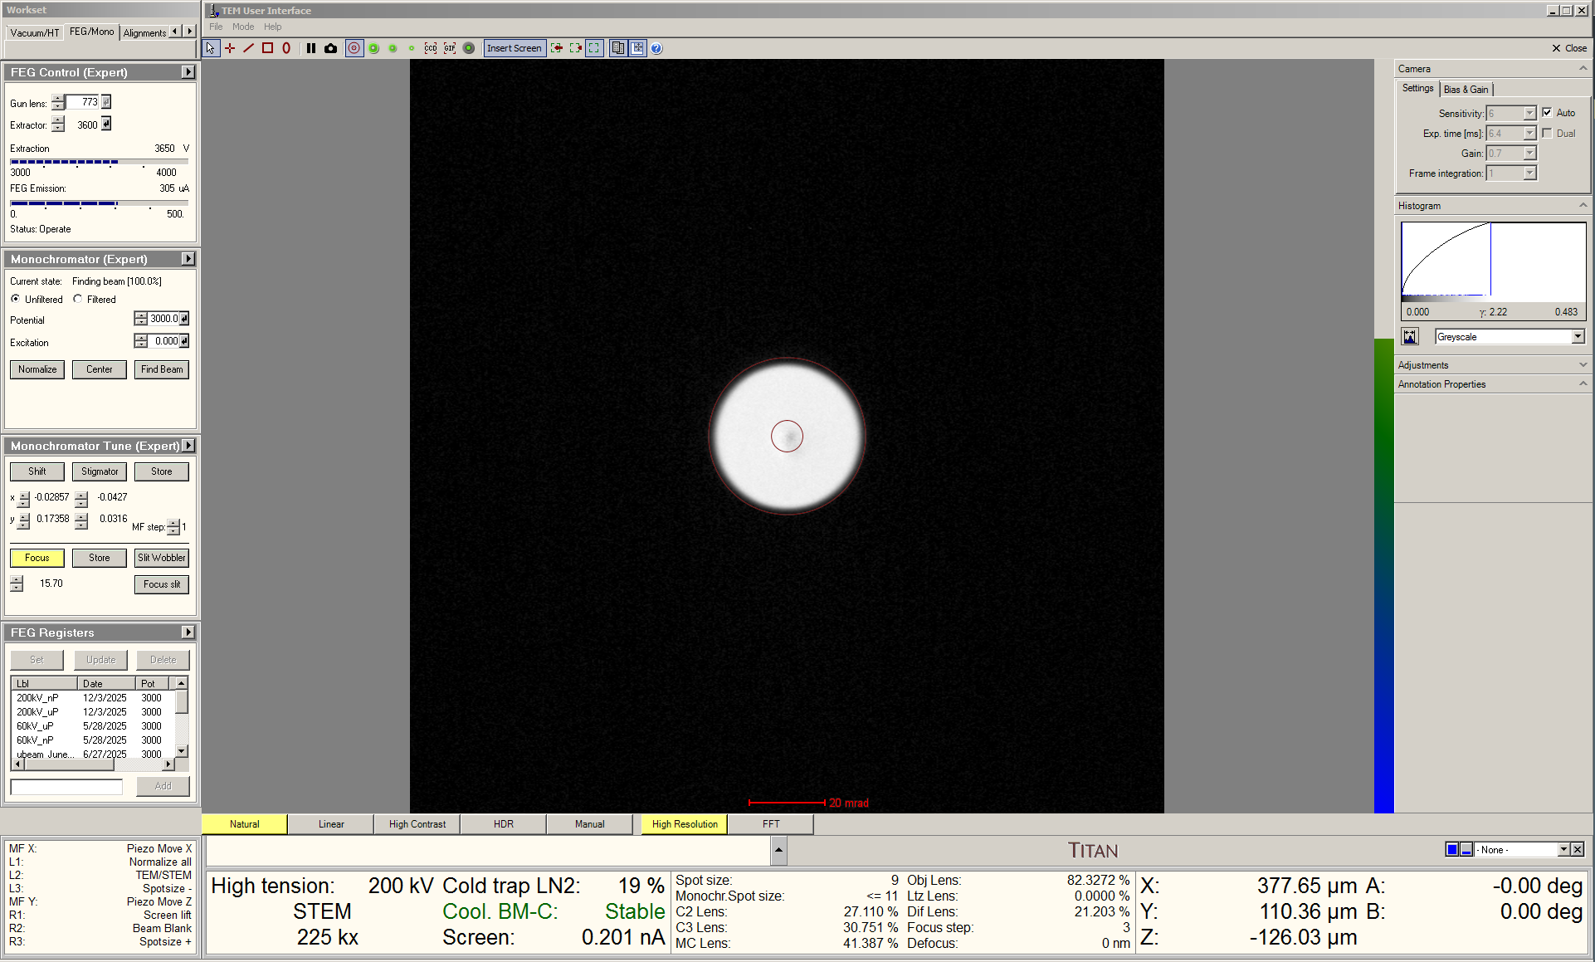

    - Deselect “Focus” when finished.

    - NOTE: after the monochromator focus is changed, a small adjustment using stage Z or the “Focus” knob may be needed to refocus the image.

- Finishing in STEM mode

  - In Velox, verify the beam is not being blanked and the scan rotation is returned to 0° (if needed) and then return to TEM mode as per usual.

  - If ABF imaging was performed, retract the objective aperture as per usual.

  - If TEM imaging is to be performed, the full TEM alignment procedure should be performed as described elsewhere.
=
    - Remember, the optimal monochromator focus = –40 (negative) for TEM imaging.

  - If no TEM imaging is to be performed, simply finish the session as per usual (close column valves, reset stage, reset piezo controller, remove holder, insert metal plug into airlock, etc.).

