
Tescan Mira3 SEM
  - EBSD Standard Operating Procedure Rev. 2026-01
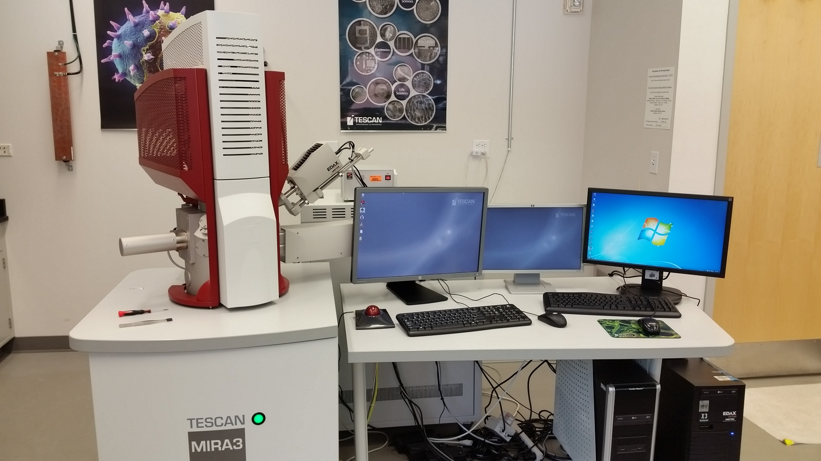

  - Application
The Tescan Mira3 SEM is a state-of-the-art field emission gun scanning electron microscope capable of providing mm- to nm-scale structural, morphological, and chemical information. This document covers operation of the instrument for performing electron backscattered diffraction only. Please see separate SOP documents on the NRF instrument page regarding other applications.

  - NRF Contact
Nicholas G. Rudawski

Table of Contents

1. Safety information 3
2. Prerequisites 3
3. Sample mounting, preparation, and constraints 3
4. Specimen loading 4
5. Beam and detector settings for EBSD 5
6. Setting specimen tilt and magnification 6
7. Starting TEAM and setting up your project file 8
8. Inserting the EBSD camera 10
9. EBSD camera settings 11
10. Imaging and tuning the indexing 15
11. Performing EBSD in “Point Analysis” mode 19
12. Performing EBSD in “Mapping” mode 21
13. Changing analysis areas on the same specimen 23
14. Changing samples; manipulating project content 24
15. Finishing the session 27

- Safety information

  - Due to stipulations of the instrument service contract as well as contamination concerns, analysis of radioactive specimens with this instrument is strictly prohibited.

  - Please use caution when opening and closing the chamber door for possible pinch points.

  - Please use caution when inserting the EBSD camera to avoid a possible collision with the specimen.

  - Please use caution when moving the stage while the EBSD camera is inserted to avoid a collision with the EBSD camera.

- Prerequisites

  - Completion of base training and proficiency in independent operation of the Tescan Mira3 for general SEM imaging (including familiarity with and use of the MiraTC user interface software).

  - Familiarity with and understanding of the basic and fundamental aspects of EBSD including the basic operating principles of EBSD as well as basic analysis and interpretation of EBSD-related data.

- Sample mounting, preparation, and constraints

  - EBSD specimens must be 15 mm or less in thickness with a flat, damage-free, smooth surface and have a footprint that fits basically within the area of standard SEM pin stubs (Ted Pella #16111, diameter ~13 mm or Ted Pella #16144, diameter ~25 mm).

    - Ideally, the thickness to footprint ratio of the specimen should be kept as small as possible (subject to the above constraints) as this will increase specimen stability.

  - It is preferable to mount specimens using conductive paint instead of carbon tape to limit specimen drift; if using conductive paint, ensure it is thoroughly dried before loading the sample into the chamber. If the sample is non-conductive, it should be given a light C coat (few nm) after being mounted on a stub to ensure a path to ground is produced.

- Specimen loading

  - Specimens should be loaded in the “7” position of the carousel; additionally, if the specimen is ~3 mm or less in thickness, insert a 12 mm stub extender (Ted Pella #15318) and then load your specimen on top of the stub extender.

    - Note: the stub extender is required for specimens of this thickness; otherwise, it will not be possible to attain the necessary stage tilt and working distance for performing EBSD).

    - When attempting EBSD, DO NOT load specimens in any other carousel position besides “7”.

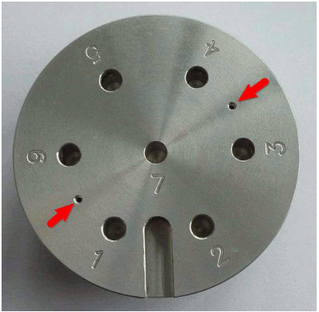

- Beam and detector settings for EBSD

  - In principle, the spatial resolution of EBSD improves as the beam voltage and probe size (controlled by beam voltage and intensity) are both lowered. However, the signal to noise ratio in the EBSD patterns also decreases as the beam voltage and current are lowered, which makes indexing of the patterns more difficult. If unsure about the microstructure of the specimen, a beam voltage of 20 kV with a beam intensity of 15 – 20 are recommended starting beam conditions. If unsure as to what beam settings to use for EBSD, please consult with NRF staff for recommendations.

  - The only detector on the SEM that may be used when performing EBSD is the ETD (erroneously called “SE”) detector; do not insert the BSE detector if intending on performing EBSD or a collision between the sample and BSE detector may occur. There is a forward scattered detector (FSD) on the EBSD camera that can also be used when performing EBSD as will be described later.

  - Once appropriate beam settings have been selected, find a region of interest on the specimen (ideally, away from the specimen edges); then focus the image and set WD = 20 mm in the “Stage Control” panel (this is the optimal WD for performing EBSD).

  - Perform the basic SEM alignment: auto gun centering, beam centering, and astigmatism correction.

- Setting specimen tilt and magnification

  - Verify that the BSE detector is retracted using the “Chamber View” panel before attempting any tilting of the stage; otherwise, a collision with the BSE detector could result.

  - Use the stage to center a recognizable feature in the live image. In the “Stage Control” panel, make sure “Keep view field” is checked; this keeps the feature roughly centered in the image and at (approximately) the same WD after tilting.

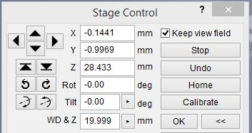

  - Using the “Stage Control” panel, tilt the stage to –70° (negative 70°) in 10° increments; after each increment, perform auto contrast/brightness, re-center the feature in the image, refocus on the feature, and set WD = 20 mm in the “Stage Control” panel. When finished tilting, the “Chamber View” panel should look like what is shown below.

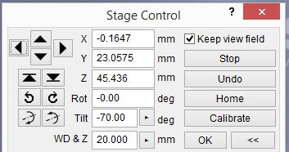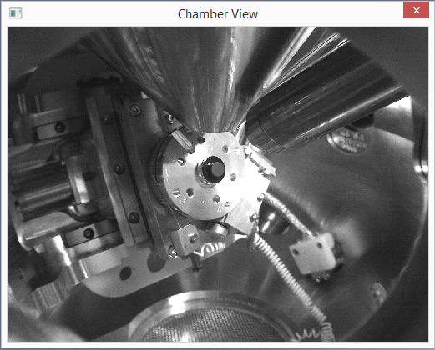

  - In the “Geometric Transformations” panel, enter –70° in “Dynamic focus” (be sure to hit the “Enter” key) and then finely focus the feature of interest (which again should be at the center of the image). Then set the scan speed to 4 or higher (the scan speed must be slow for dynamic focus to work); the entire surface of the specimen will now be in focus.

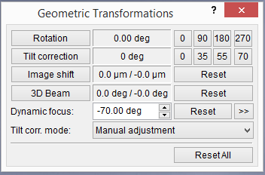

  - Set the magnification as needed. Any magnification can be used, but it should ideally be high enough such that if reduced by 50%, no specimen edges will be present in the image. As a general recommendation, a magnification of 500 – 1000× will usually be sufficient for a specimen with an average grain size of a few 10s of μm.

    - This corresponds to a field of view (horizontal field width) of ~ 1 mm to several hundred μm.
- Starting TEAM and setting up your project file

  - You must be logged on to MiraTC before starting TEAM or TEAM will not function properly; DO NOT attempt to open TEAM without being logged on to MiraTC.

  - Open EDAX TEAM software. A splash screen will pop up as the hardware is initialized (listen for the motor on the EBSD camera to turn on).

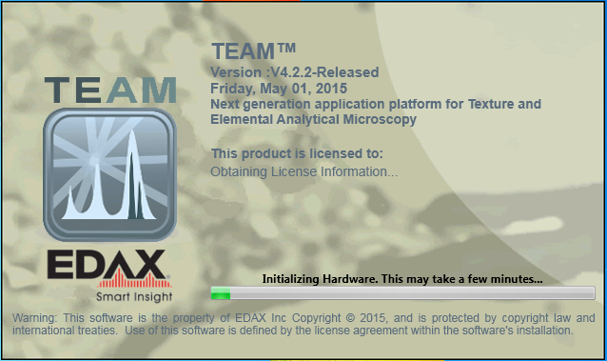

  - Enter your username into the “Log In” dialogue box and then select EBSD; then enter your password and select “Log In”.

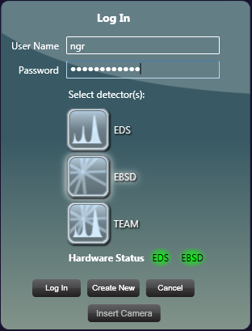

  - In the “Project” dialogue box, go to “Create” and select “Project” to create a new blank project; this will bring up the “Create Project” dialogue box, where you can name the project and specimen.

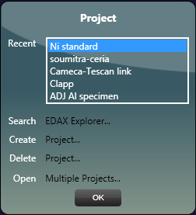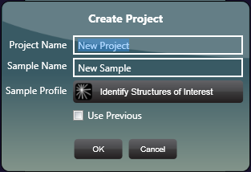

  - In the same “Create Project” dialogue box, select “Identify Structures of Interest”; you can search for the phases present in your sample based the elements expected to be present and then add these to the “EBSD Active Phase List”. You must add at least one phase to the list or the EBSD patterns cannot be indexed. Select “OK” when finished, and then select “OK” again in the “Create Project” dialogue box.

    - NOTE: when performing EBSD, it is generally best to keep the number of candidate phases as small as possible, i.e., if it is known that the material only has one phase, then only select that phase.

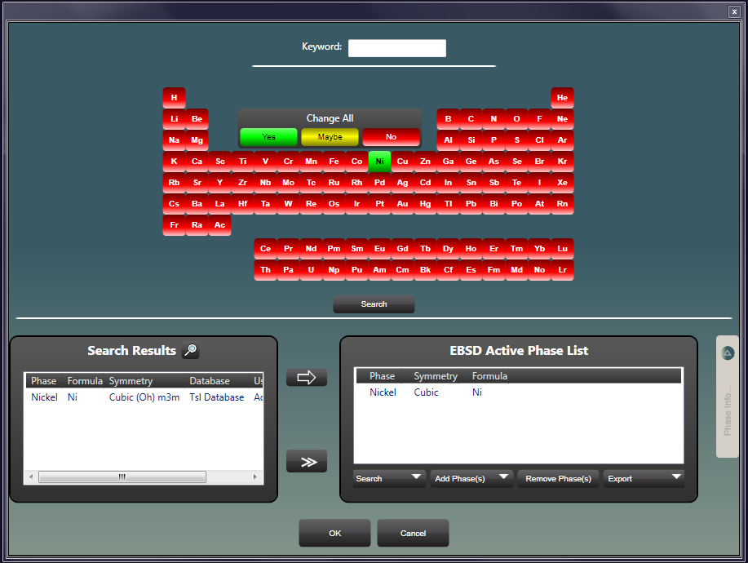

- Inserting the EBSD camera

  - The stage tilt must be set to –70° (negative 70°) and the image in focus at WD = 20 mm prior to insertion of the EBSD camera. Insertion of the camera under any other conditions may cause a collision of the camera with the specimen or stage.

    - NOTE: there is no interlock preventing insertion of the EBSD camera under inappropriate conditions.

  - Expand the “Advanced Properties” tab (right side of the window) and select “Camera Position”; select “Insert” to insert the camera (listen for the motor to start).

    - Be sure to monitor the insertion process in the “Chamber View” panel and be prepared to select “Stop” if any collision appears imminent. The “Chamber View” panel should look like below after insertion is complete.

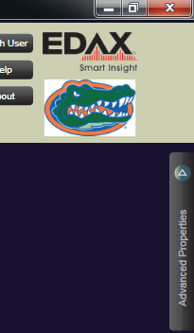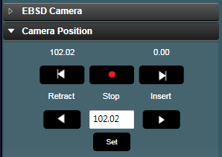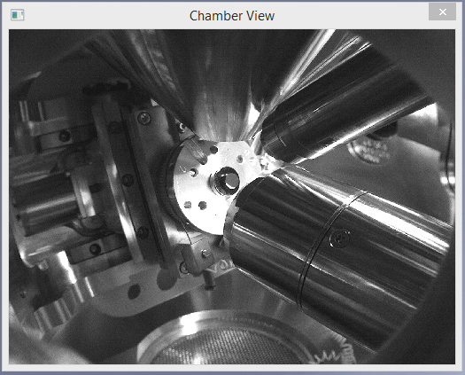

- EBSD camera settings

  - Turn off the CCD camera in MiraTC; otherwise, it will interfere with proper operation of the EBSD camera.

  - In TEAM, expand the “Advanced Properties” tab and select “EBSD Camera”; for a given “Binning” setting, the “Gain” and “Exposure” settings need to be adjusted to obtain a pattern intensity of 0.8 – 0.9.

    - Increasing “Binning” reduces the pixel resolution of the pattern; this reduces detail in the patterns but generally allows for faster mapping.

    - Increasing “Gain” increases the pattern intensity without affecting the camera speed, but at the expense of adding noise to the EBSD patterns.

    - Increasing “Exposure” increases the signal in the patterns, making indexing more effective, but reduces the speed at which patterns can be acquired.

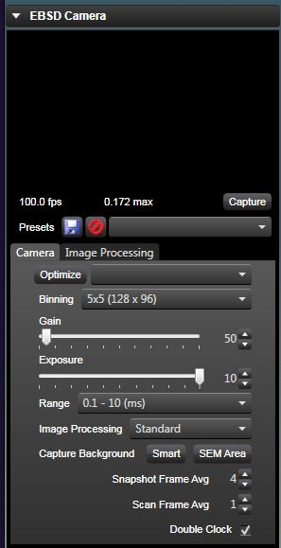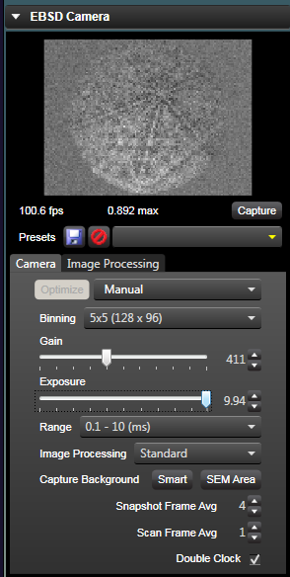

  - The default “Binning” is 5×5. If the binning is increased, the “Exposure” can be reduced to bring the pattern intensity back within the optimal range. As a result, the camera speed will increase, but the patterns will have less detail. However, if the specimen quality is good, this is usually not detrimental to the indexing.

    - For point analysis: 1×1 or 2×2 is recommended as only a few patterns will be collected.

    - For mapping: if the specimen quality is good and produces clear EBSD patterns, 8×8 is recommended as this will allow mapping to be performed faster (and will take up less storage if the patterns are saved for later processing).

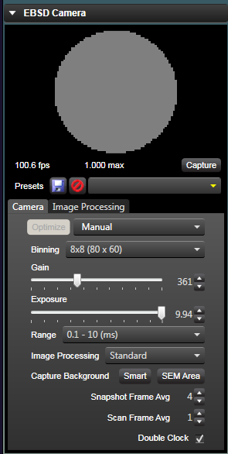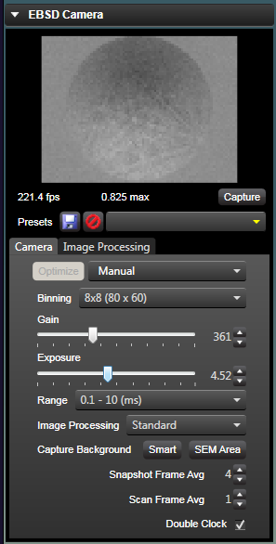

  - Once an appropriate binning has been selected, “Gain” and “Exposure” can be further adjusted. Generally, with higher beam voltages (≥ 20 kV) and high-quality specimens, higher “Gain” and shorter “Exposure” can be used when performing mapping (again, to reduce the time it takes to produce the map). However, If performing point analysis, it is best to opt for lower “Gain” and longer “Exposure” as only a few patterns will be collected anyways and speed is not a concern.

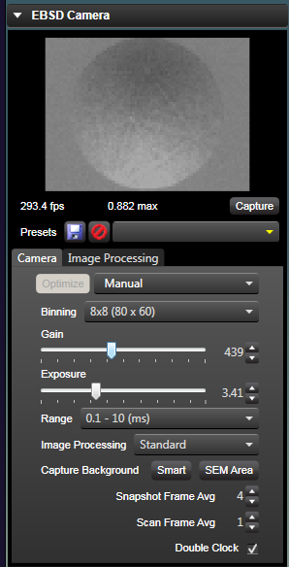

  - In MiraTC, increase the scanning speed to maximum value.

  - In TEAM under “Image Processing”, select “Enhanced”; then, next to “Capture Background”, select “SEM Area” to capture the background (the EBSD pattern should now look featureless if there is sufficient variation in the EBSD pattern over the FOV).

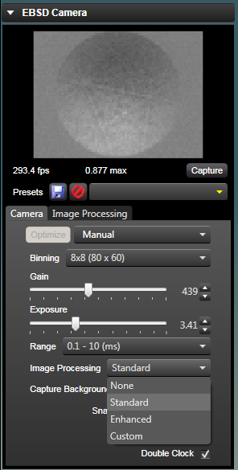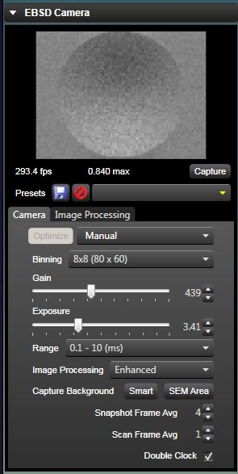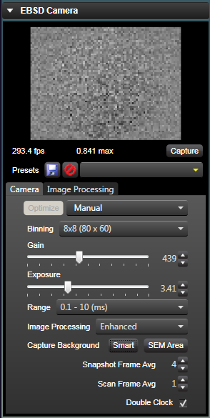

  - In MiraTC, decrease the scanning speed back to the previous setting (4 or higher); the camera is now ready to collect and index EBSD patterns.

- Imaging and tuning the indexing

  - In TEAM, expand the “Advanced Properties” tab, select “Image Area”; and verify that “Tilt Correction” is enabled.

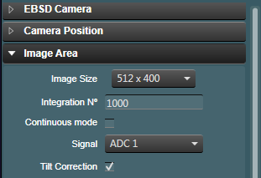

  - In TEAM, select “Survey” from the top menu bar to enter survey mode. Then hover over “Image Area” to see the options for “Matrix Size” (image resolution) and “Signal”. Selecting the “ACD 1” signal (default) will use the ETD on the SEM to form the image while selecting the “FSD” signal will use the FSD on the EBSD camera to form the image. When ready, select “Image Area” to collect an image.

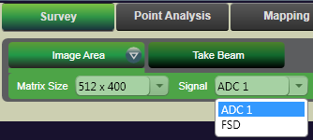

FSD
SE
  - A small green circle will appear in the center of the acquired image, which corresponds to the position of the beam. Now click, hold, and drag on the image and you will see the live EBSD pattern under “EBSD Camera” change as you move the cursor. Find a location near the center of the image that produces a clear EBSD pattern; then, release the mouse and a “Pattern” window will pop up showing the indexed solution for the pattern.

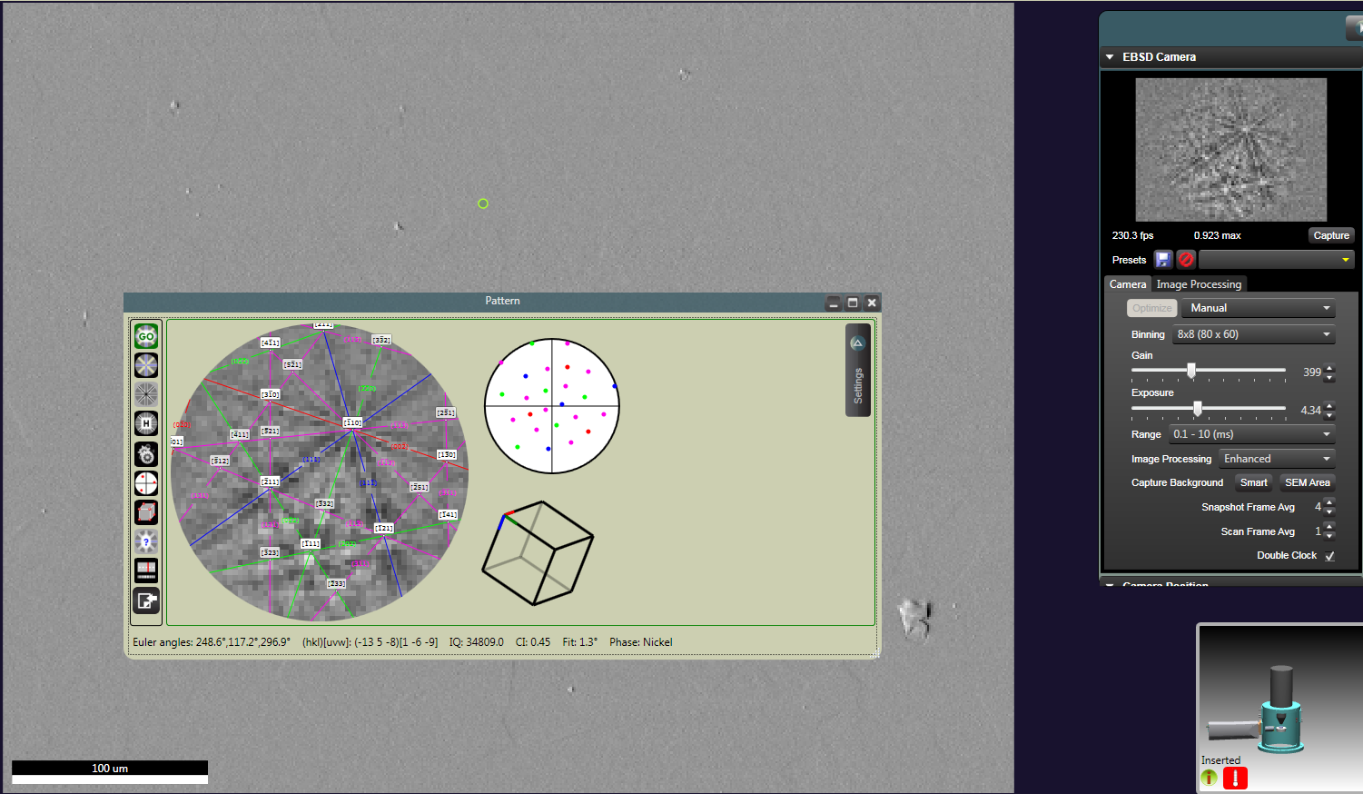

  - In the “Pattern” window, expand the “Settings” tab (right side of the window) and then select “Hough”. Select the pull-down menu next to “Mask” and select the appropriate Hough mask for the beam voltage.

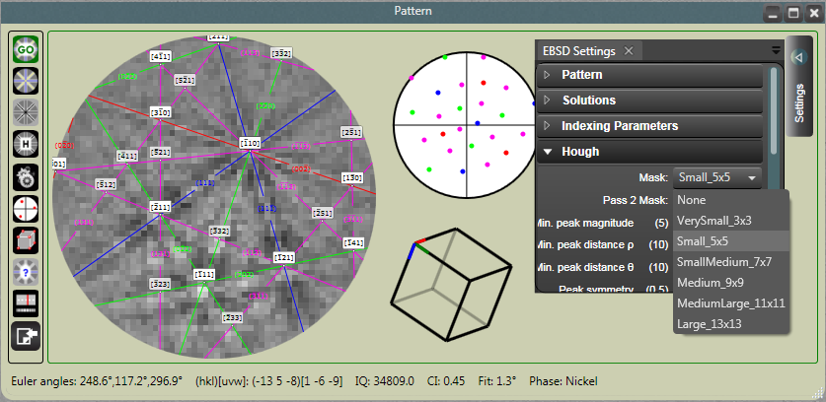

Beam voltage (kV) | Hough Mask
10 | MediumLarge_11×11
15 | Medium_9×9
20 | Medium_9×9
25 | SmallMedium_7×7
30 | Small_5×5
  - If the Hough mask setting was changed, select “Go” to re-index the pattern and then “tune” to tune the solution. The indexed bands in the solution should coincide well with the actual bands in the pattern.

    - NOTE: if the solution does not fit the pattern well, there is likely a problem with the phase list and/or the indexing parameters (or the pattern may not be of sufficient quality).

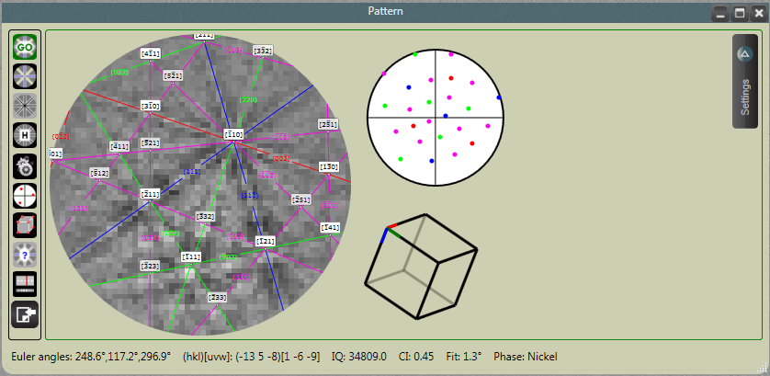

  - Once all tuning is complete, select the disk icon to save the pattern (and, more importantly, the tuning) to the project.

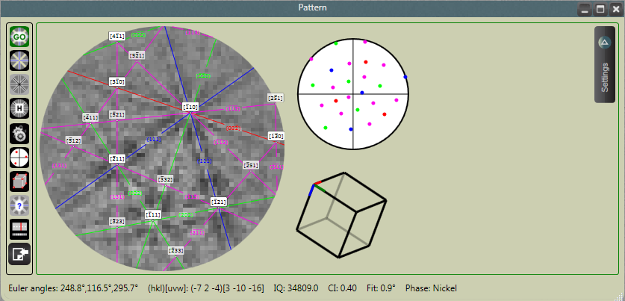

- Performing EBSD in “Point Analysis” mode

  - Select “Point Analysis” from the top menu bar; the image you acquired in survey mode will appear, so you don’t need to acquire another image; hover over the “Collect Data” button; under “Point Mode”, you can select options to analyze single or multiple points.

  - If the “Single” option is selected, just click on the image where you want to analyze to start. If the “Multiple” option is selected, click on all the points on the image you want to analyze and then select the “Collect Data” button to start the analysis. As each point is analyzed, the “Pattern” window will pop up and show the acquired pattern and the indexed solution.

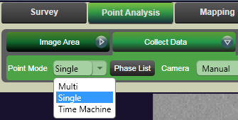

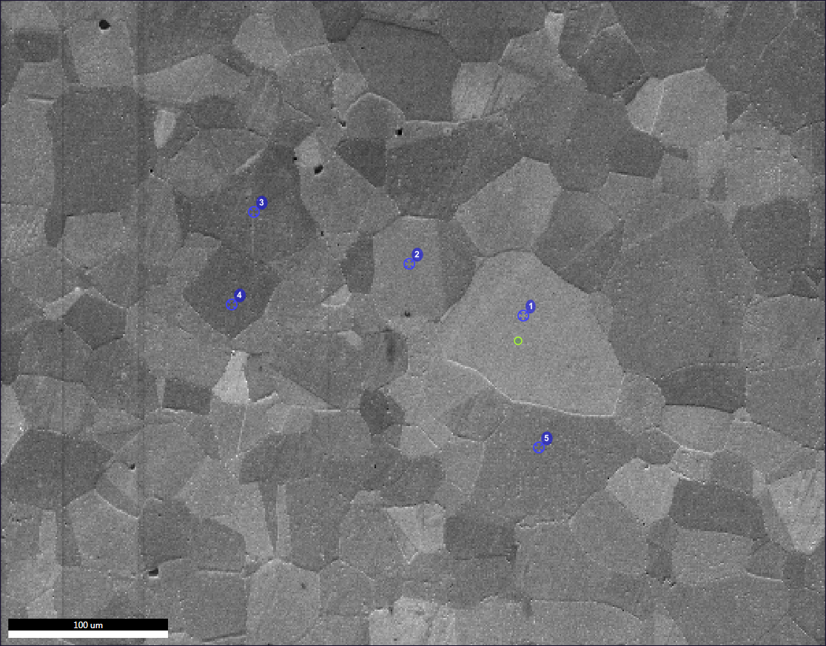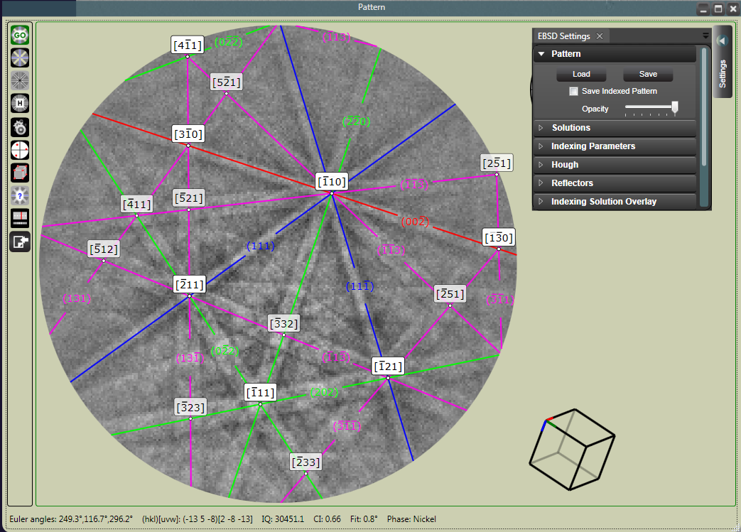

  - To recall a saved pattern, expand the “Project Content” tab and select the area of interest; the reference image will appear with all analysis points superimposed. Then select from the list of spots to show only that spot on the SEM image along with the associated EBSD pattern. To save the SEM image with the superimposed spot location to your designated folder, select the “Folder” button at the upper left side of the image. Keep in mind the EBSD pattern will not be saved when doing this (see next step).

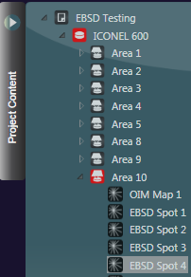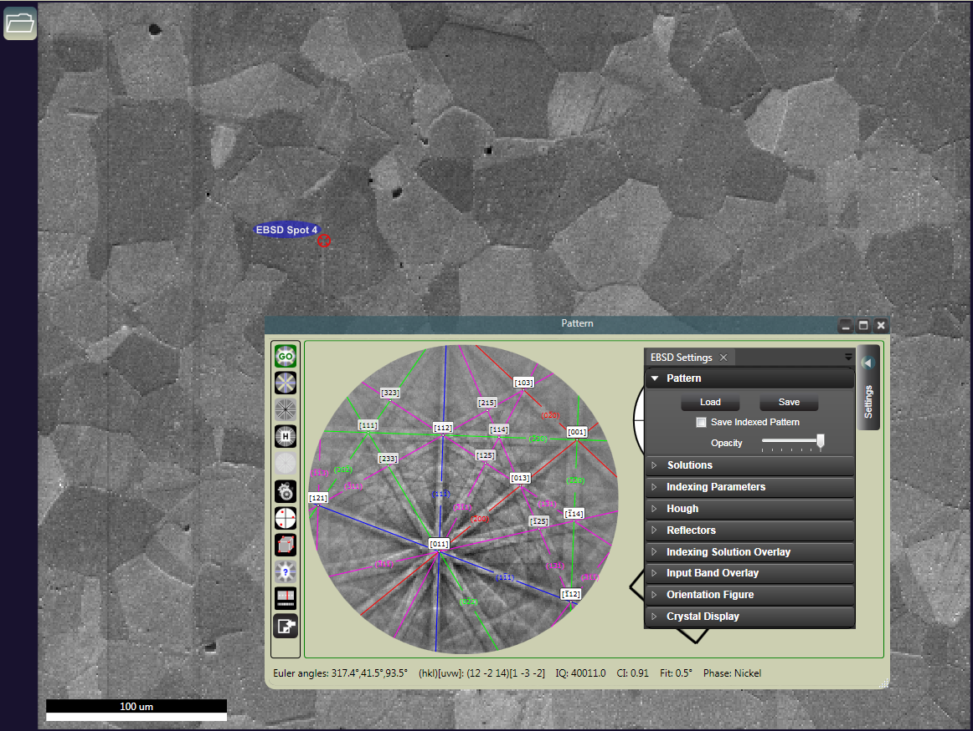

  - To save the EBSD pattern, go to the “Pattern” window and expand the “Settings” tab; under “Pattern”, you can elect to have the solution overlay saved by checking “Save Indexed Pattern”. Select “Save” to save the pattern.

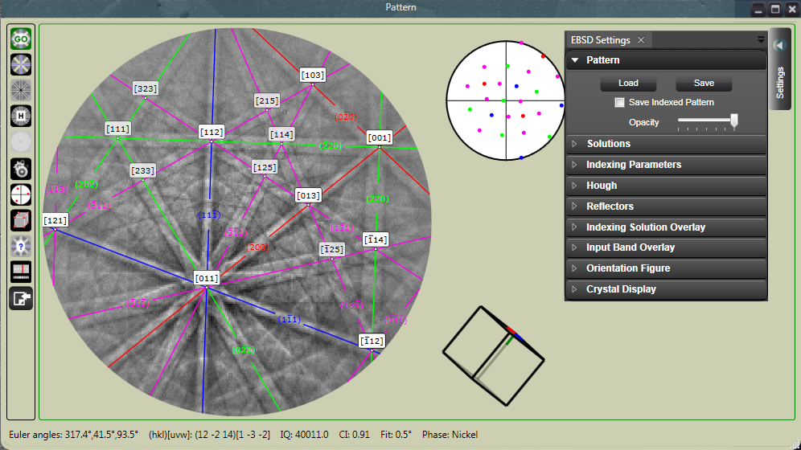

- Performing EBSD in “Mapping” mode

  - Select “Mapping: from the top menu bar; the image you acquired in survey mode will appear, so you don’t need to acquire another image. Hover over the “Collect Map” button and then select an option for map resolution. As the resolution increases, more points will be mapped (as indicated in the lower right corner of the green defining box), so the time required to perform mapping will increase. Once a map resolution is selected, select “Collect Map” to start mapping

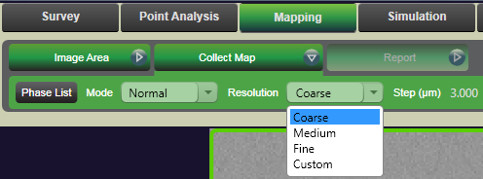

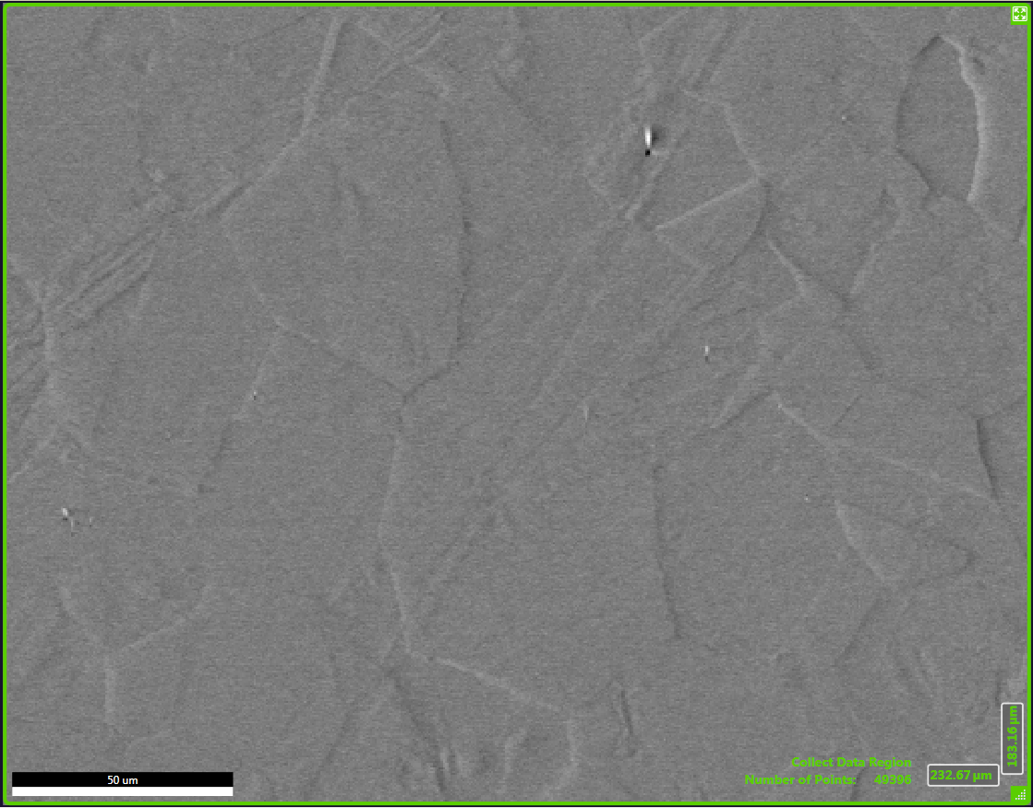

  - A live crystal orientation (inverse pole figure) map representing the crystal planes parallel to the surface overlaid on a pattern quality map will be generated. To view the live EBSD pattern and indexed unit cell, select the EBSD pattern and unit cell icons from the compass.

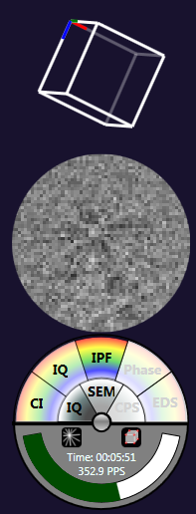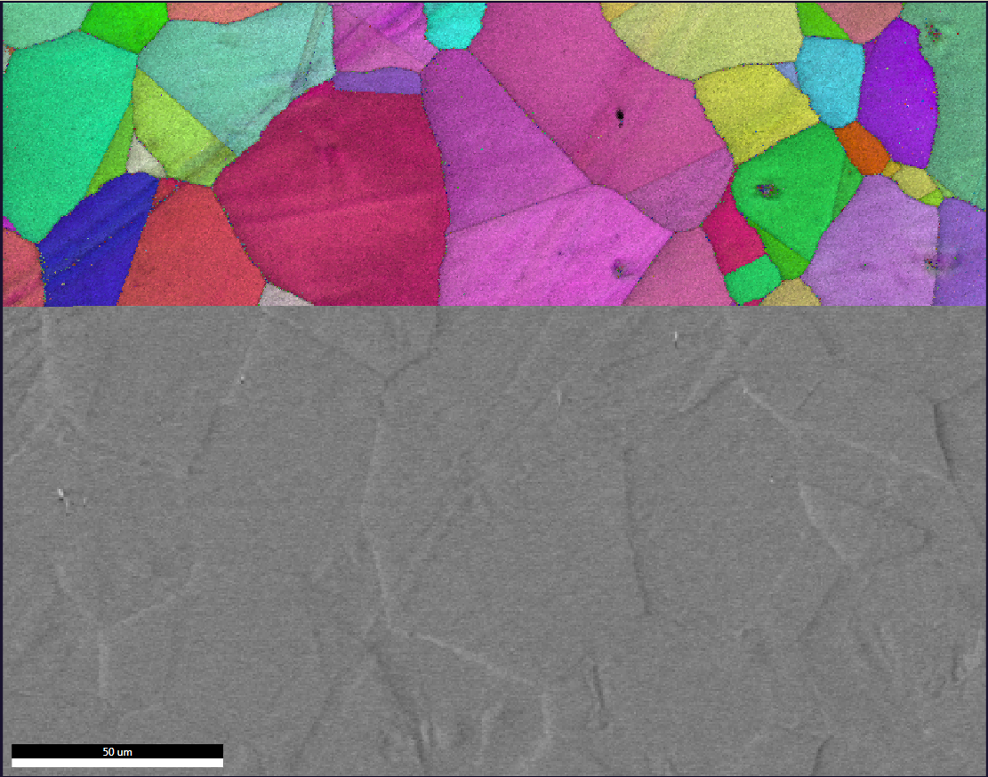
  - When the map is finished, the “Scan Complete” window will pop up giving a synopsis of the mapping results. Select “OK” to close the window and then select “Finish” to save the map.

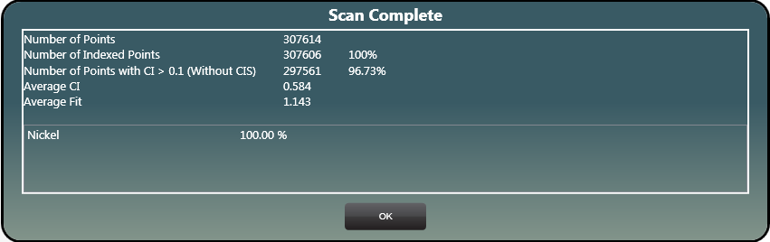

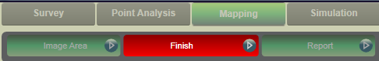

  - Further processing, analysis, and saving of map data (IPF maps, grain maps, grain boundary maps, etc.) should be done using OIM Analysis. To export the data to OIM Analysis, select the area of interest and then the map of interest from the project tree; then select “Review Data” from the top menu bar; hover over “Report” and select “Send to OIMA” to export the data to OIM Analysis. OIM Analysis will immediately open with the imported data set.

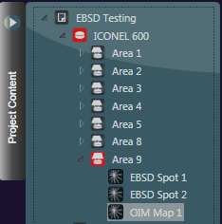

- Changing analysis areas on the same specimen

  - In the live SEM image, you can move either directly to the left or right and still reasonably maintain WD = 20 mm without any possible risk of collision with the camera. After moving, you should finely refocus the center of the image. Do not attempt any other types of stage movements with the camera inserted.

- Changing samples; manipulating project content

  - If you want to change specimens and add another sample to the project, first retract the EBSD camera and unload the current specimen as described in the next step (DO NOT close TEAM or MiraTC). Then, load the new sample, set the correct stage tilt and working distance, and reinsert the EBSD camera.

  - If keeping the beam settings the same between specimens, the SEM alignment will still be ballpark accurate when the new sample is loaded and brought to WD = 20 mm but performing centering and correcting astigmatism is still recommended.

    - If the beam voltage and/or intensity are changed for analyzing a new sample, the complete SEM alignment should be repeated.

  - From the expanded “Project Content” tab, select “Sample” and follow the instructions to create a new sample and follow the instructions to create a new sample. If the material(s) is (are) the same as the previous sample, you can check “Inherit structures from active”. Otherwise, from the expanded “Project Content’ tab, select “Profile” and follow the instructions to add new phases.

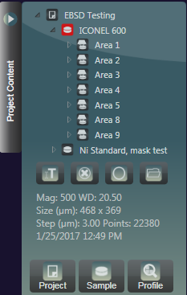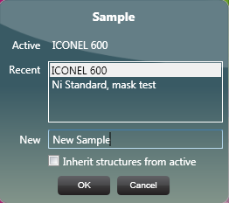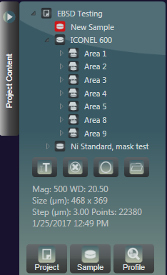

  - Every time a new sample is loaded and/or beam conditions are changed, it is necessary to reconfigure the EBSD camera (binning, exposure, gain, background capture) and tuning of the EBSD pattern indexing.
  - Expand the “Project Content” tab (upper left side of window); expand the current sample to see a list of all the imaged areas with associated results. Then expand each area to see a list of all the data (EBSD spots and OIM maps) associated with that area.

  - Double clicking on an area will bring up the SEM image collected for that area. If any point analysis was done on that area, the analysis points will also be shown on the image. To save the image (with overlaid points) to your designated folder, hover over the image and select the “folder” button (top left side of the image).

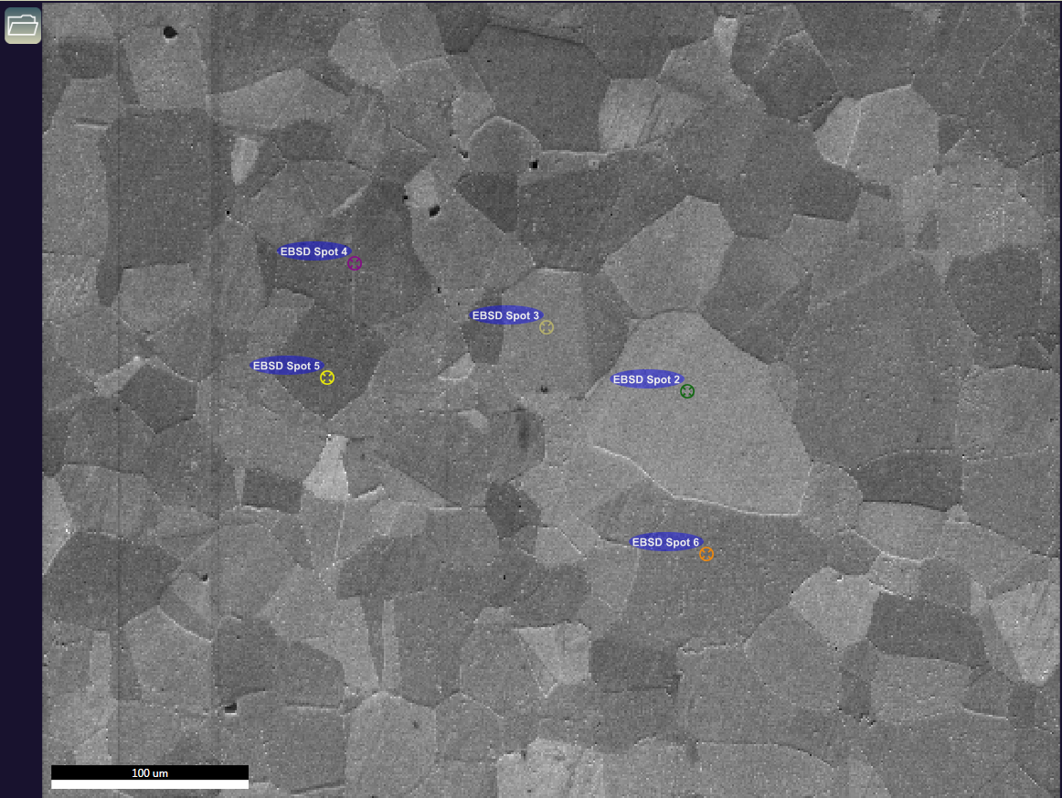

  - Any sample, area, EBSD spot, or OIM map can be renamed or deleted from the project by selecting the item and then selecting the “Edit” or “Delete” buttons, respectively.

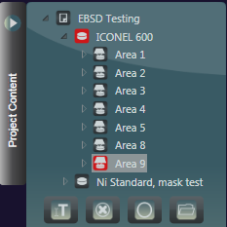
- Finishing the session

  - In MiraTC, turn the CCD camera back on.

  - Expand the “Advanced Properties” tab and then “Camera Position”; select “Retract” to retract the camera (you should hear the motor start). The “Chamber View” panel should look like below after retraction is complete (and you should hear the motor stop, too).

  - In the “Stage Control” panel, tilt the stage back to 0° (this does not need to be done incrementally). In the “Geometric Transformations” panel, select “Reset” to turn off dynamic focusing.

  - Close the TEAM software (all data is saved automatically).

  - Turn off the beam, calibrate the stage, vent the chamber, remove the specimen (and stub extender, if applicable), pump the chamber back down, and log off MiraTC.

