
EDAX Octane Pro (10 mm squared active area) SDD EDS

Standard Operating Procedure Rev. 2026-01

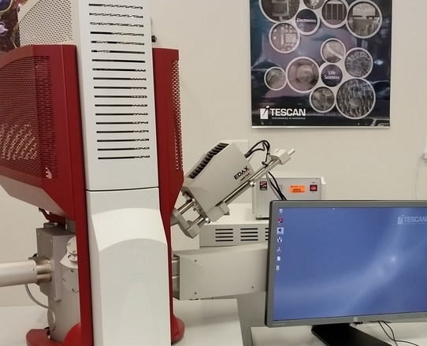

  - Application

Energy-dispersive X-ray spectroscopy (EDS, EDX, EDXS or XEDS), sometimes called energy dispersive X-ray analysis (EDXA or EDAX) or energy dispersive X-ray microanalysis (EDXMA), is an analytical technique used for the elemental analysis or chemical characterization of a sample.

  - NRF Contact
  - Andres Trucco

Table of Contents
1. Safety information 3
2. Prerequisites for use 3
3. Sample mounting, preparation, and constraints 3
4. Specimen loading 3
5. Beam and detector settings for EDS 4
6. Starting TEAM and setting up your project file 5
7. Cooling the detector 7
8. “Spectrum Only” mode; adjusting detector settings 8
9. “Point Analysis” mode 9
10. “Mapping” mode 11
11. “Line Scan” mode 17
12. Using drift correction (if needed) 21
13. Changing analysis areas 22
14. Changing samples; manipulating project content 22
15. Finishing the session 23

- Safety information
    - Detector is already inserted in the chamber. Caution must be taken when tilting the sample at 15mm working distance.
    - Detector Cooling ON/OFF - Before venting chamber make sure detector cooling is off to prevent condensation. See SOP for details.

- Prerequisites for use
- User of the RSC facilities.
- Prior training on the TescanSEM by staff.
- User will be responsible for lost or damaged equipment due to negligence. Negligence means not following the SOP, not asking staff for assistance, intentionally damaging items, etc.
- This procedure assumes the user is already familiar with basic operation of the SEM and the Mira TC interface.

- Sample mounting, preparation, and constraints
    - Specimens for EDS should be mounted on standard 3 mm-thick SEM pin stubs (Ted Pella #16111, diameter ~13 mm or Ted Pella #16144, diameter~25 mm). Ideally, the thickness to footprint ratio of the specimen should be kept as small as possible (subject to the above constraints) as this will increase specimen stability. Ideally, the specimens should be flat to prevent shadowing effects, but rough specimens can still be used (at least for qualitative purposes).
    - All specimens should be mounted on the aforementioned standard SEM stubs using conductive tape; it is also permissible to use carbon paint, but this should be avoided if possible. If your sample is non-conductive, it should begiven a light C coat (few nm) after being mounted on a stub to ensure a path to ground is produced.
- Specimen loading
    - Log on to MiraTC, vent the chamber, and open the chamber door.
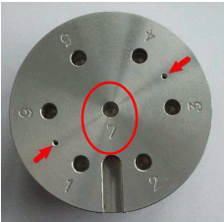
    - Specimens should be loaded in the “7” position of the carousel; if you will only be performing EDS, it is not necessary to use any type of stub extender.

    - Close the chamber door and evacuate the chamber.
- Beam and detector settings for EDS
    - The beam voltage for EDS should be selected based on the elements of interest and the spatial resolution needed; ask for a recommendation if you are unsure what beam voltage to use. The beam intensity should be set to a value of 15 – 20 to generate a high current probe to produce sufficient counts for EDS.
    - The SE or BSE detector may be used when performing EDS. Simply set the desired detector in MiraTC in the “SEM Detectors & Mixers” panel and the corresponding signal will be acquired in the software used for EDS.
    - Once appropriate beam and detector settings have been selected, find a region of interest on the specimen (ideally, away from the specimen edges); then focus the image and set WD = 15 mm in the “Stage Control” panel (this is the optimal WD for performing EDS).

    - Perform the basic SEM alignment: auto gun centering, beam centering, and astigmatism correction. When finished, set the magnification as needed and then turn off the CCD camera (otherwise, the EDS detector will not function properly).

- Starting TEAM and setting up your project file

    - You must be logged on to MiraTC before starting TEAM or TEAM will not function properly; do not attempt to open TEAM without being logged on to MiraTC.
    - Look at the back of the EDS detector; the green LED on the Ethernet port will be flashing if the detector is properly communicating with the TEAM computer; if this LED is not flashing, an Ethernet adapter on the TEAM computer must be reset.
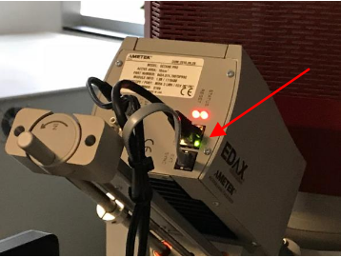

    - If it has been determined that the EDS detector is not properly communicating with the TEAM computer, open “Device Manager” and expand “Network Adapters”; then disable and enable “Intel Gigabit CT Desktop Adapter #2”

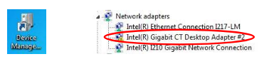

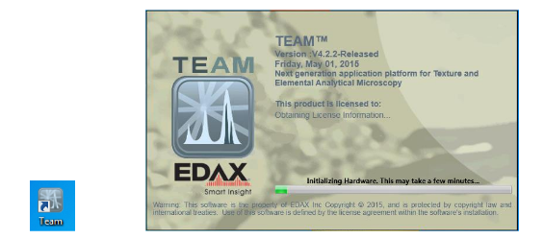
    - Open the TEAM software. A splash screen will pop up as the hardware is initialized (listen for the motor on the EBSD camera to turn on).

    - Enter your username into the “Log In” dialogue box and then select EDS; then enter in your password and select “Log In”.

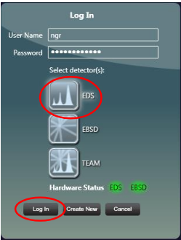

    - In the “Project” dialogue box, go to “Create” and select “Project” to create a new blank project; this will bring up the “Create Project” dialogue box, where you can name the project and specimen.
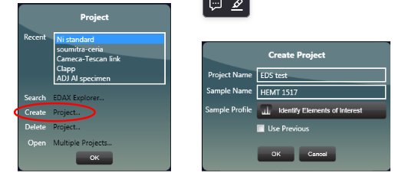

- Cooling the detector
    - Expand the “Advanced Properties” tab (upper right corner of the TEAM window); then select “EDS detectors”; then “Octane Pro”, and finally “Det 1 – Detector Status”. Select “Cooling Off” to start cooling the detector. The button will be green and read “Cooling On” when cooling is complete.
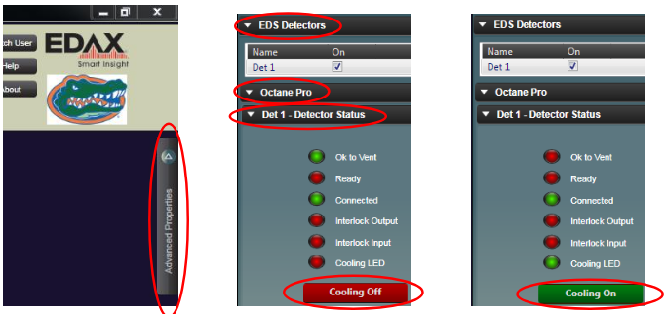

- “Spectrum Only” mode; adjusting detector settings
    - Make sure a live image is actively being acquired from the area of interest in MiraTC.
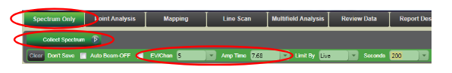
    - In TEAM, select “Spectrum Only” from the top menu bar. Then hover over “Collect Spectrum” to see the options for detector settings and set “EV/Chan” = 5 and “Amp Time” = 7.68; these settings will give the best energy resolution for the detector and will not need to be adjusted again during the session.

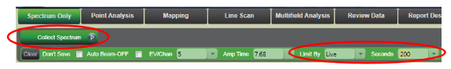
    - Continue hovering over “Collect Spectrum”; make sure set “Limit By” = Live, and then input a desired time; then select “Collect Spectrum” to start acquiring a spectrum (acquisition will stop automatically when finished).

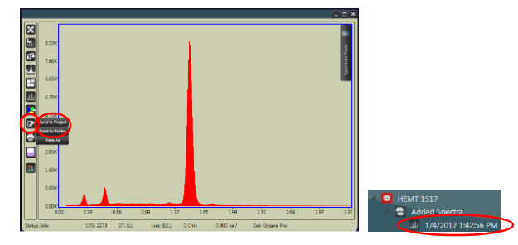
    - To save the spectrum to your project, select the disk icon and then “Send to Project” (the spectrum will appear under “Added Spectra”); to save copies of the spectrum (both image and excel versions) to your designated folder, select the disk icon and then “Send to Folder” along the left side of the spectrum window.

- “Point Analysis” mode
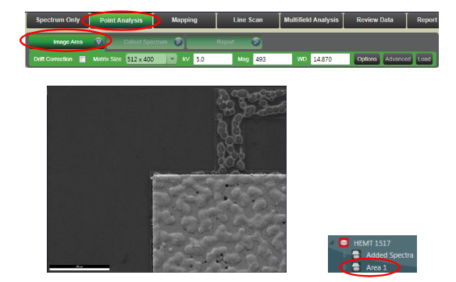
    - Select “Point Analysis” from the top menu bar and then “Image Area” to acquire an image and generate an analysis area in the project tree.

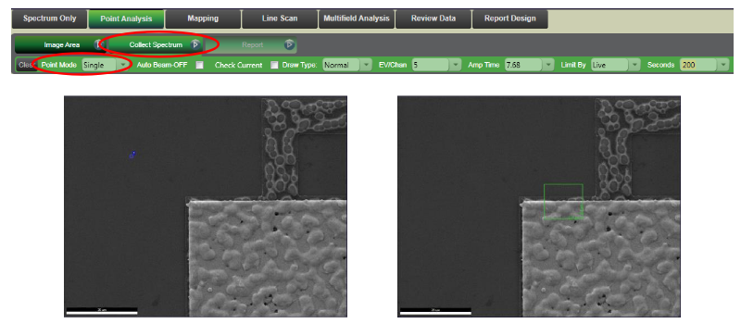
    - Hover over “Collect Spectrum” (the same settings used for “Spectrum Only” mode will automatically load); under “Point Mode”, you can select options to analyze single or multiple points. If the “Single” option is selected, just click on the image (or click and drag to define a rectangular region) and analysis will start automatically (the spectrum will save to the project automatically once complete)

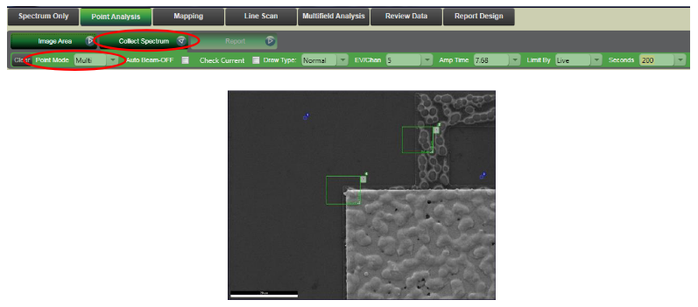
    - If the “Multi” option is selected, click on all the points on the image (or click and drag to define rectangular regions) you want to analyze and then select “Collect Spectrum” to start the analysis. A spectrum will be collected from each selected point/region in the order of being drawn and will be automatically saved to the project once complete.

    - Double clicking on the area in the project tree used for point analysis will pull up the reference SEM image used for point analysis with all spots/regions used for analysis indicated. To save this image to your designated folder, hover over the image and select the folder button (top left side of the image); the spots/regions used for point analysis will be saved on the image.
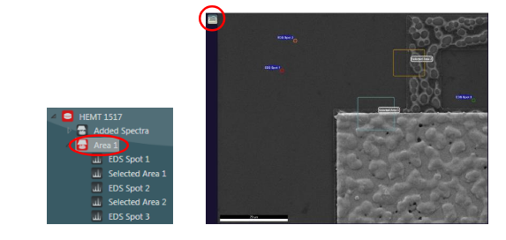

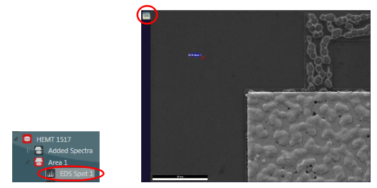
    - To show the spectrum from an individual spot/region, simply double click on the spot/region in the project tree; the SEM image will now only show this analysis spot/region (again, use the folder button if you want to save the image). Copies of the spectrum (both image and excel versions), can be saved as described previously.

- “Mapping” mode
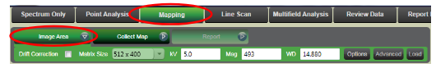
    - Select “Mapping” from the top menu bar; the image acquired for the currently activated analysis area (if you just performed point analysis, for example) will appear. If you wish to move to a different area on the specimen and/or change magnification for mapping, do so and then select “Image Area” to acquire a new image and generate a new analysis area in the project. If you wish to map on the same analysis area just used, you do not need to do this as the mapping data will be saved to this analysis area.

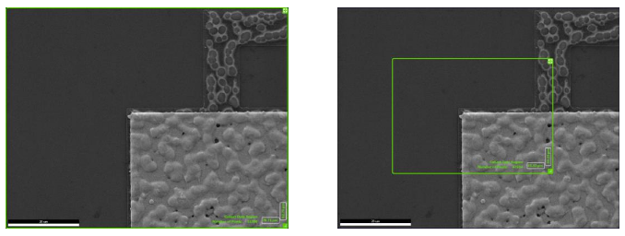
    - Mapping can be performed over all or part of the imaged area. The default setting is to collect a map over the whole area (shown at left); to adjust this area, click and drag the corners of the green defining box and move it as desired (shown at right).

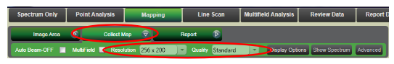
    - Hover over “Collect Map” and select desired options for “Resolution” and “Quality” (“256×200” and “Standard” are usually sufficient). Select “Collect Map” to start mapping; the system will auto identify the elements present in the region and then begin mapping.

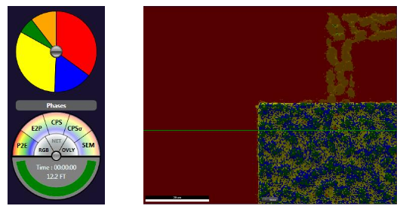
    - A live phase map will be produced as the beam is scanned across the image area; the system will assign a unique color to each pixel in the image it considers to be of a particular phase (composition).

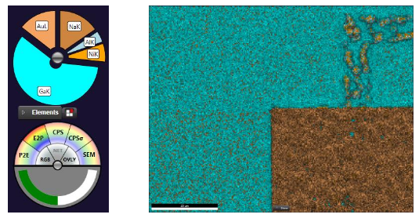
    - To change to a composite map of the individual elements, select “E2P” from the compass (lower left corner of the window).

    - To add/remove elements for mapping, first make sure “E2P” is selected from the compass and then select “Modify element list” (above the compass). You can then add or remove elements using the interactive periodic table. Additionally, by expanding the “ZAF/Peak Selection” tab on the right side of the periodic table, you can also choose which peaks you want to use to map for each element (Kα versus Lα, etc.).
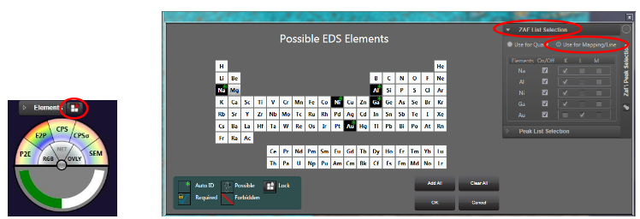

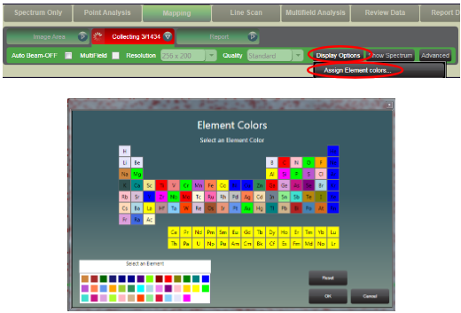
    - To change the color of a particular element being mapped (while mapping), select “Display Options” and then “Assign Element Colors”. Then select the element of interest from the periodic table and assign the desired color to it. Keep in mind that this will be color assigned for this element for all other maps or line scans in the project (unless the assigned color is changed again).

    - If you wish to turn off specific elements in the composite map, simply click once on the expanded section of the pie chart corresponding to the element (if you want to add it back after turning it off, just double click on the section again).
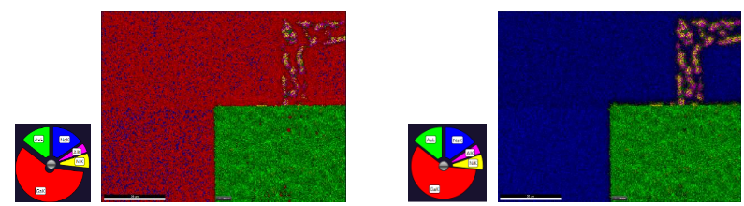

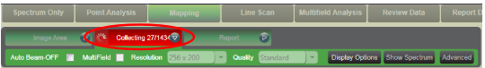
    - Mapping will run for the amount of time automatically determined by the system or can be stopped manually prior to completion by selecting “Collecting”.

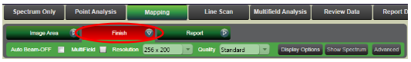
    - Once mapping has completed (or has been stopped manually), select “Finish” to save the map.

    - Double clicking on the area in the project tree used for mapping will pull up the reference SEM image used for mapping. To save this image to your designated folder, hover over the image and select the folder icon (top left corner of the image).
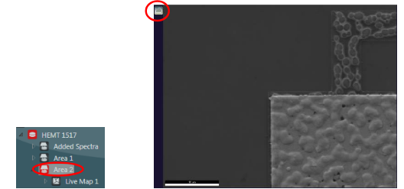

    - Double clicking on the map in the project tree will pull up the mapping data for this area, where you can then view the phase map, composite element map, and individual element maps. Once a map has been selected, hover over the map and select the folder icon (top left corner of the image) to save the map to your designated folder.
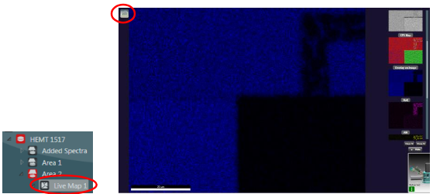

    - A sum spectrum from the whole analysis area will also come up, which can be saved as described previously. Additionally, by clicking and dragging on any map to create an area, the portion of the sum spectrum isolated from this area will be shown (which can, again, be saved as previously described); the selected area on the image will be indicated. If you want to save the image with the selected area indicated, this must be done via screen capture, rather than by using the folder icon.
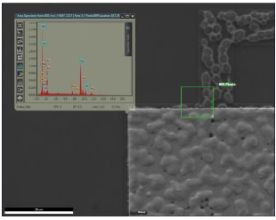

    - The as-collected maps measure intensity without any background subtraction (Phase Map) for the selected elements. However, it is possible to re-plot the maps as intensity with background subtraction (Net Intensity), atomic/weight % (ZAF), and/or with more/fewer elements. Double click on the map in the project; then hover over “Rebuild EDS Map” and select the desired type of map under “Map Type”; select “Rebuild EDS Map” to rebuild the maps using the selected map type; you will be prompted to add/remove any elements you choose before starting. Once the rebuilt map set is complete, it will now show up in the project under the original map (the data can be saved similarly as described for the original map).
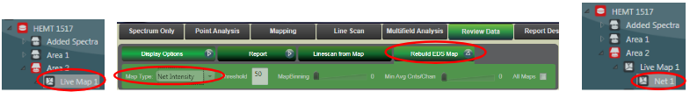

    - If after acquisition or rebuilding of a map you wish to change the assigned element colors, select “Mapping”, hover over “Collect Map”, select “Display options”, and then “Assign Element Colors” (remember, this setting is global for the whole project).
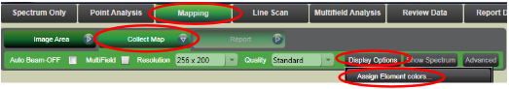

- “Line Scan” mode
    - Select “Line Scan” from the top menu bar; the image acquired for the currently activated analysis area (if you just performed mapping, for example) will appear. If you wish to move to a different area on the specimen and/or change magnification for performing a line scan, do so and then select “Image Area” to acquire a new image and generate a new analysis area in the project. If you wish to perform a line scan on the same analysis area just used, you do not need to do this as the line scan data will be saved to this analysis area. Click and drag on the image to position the line as desired.

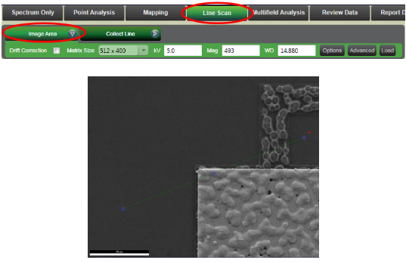

    - Hover over “Collect Line” and select a value for “Resolution” (distance between points on the line. The smaller the value of “Resolution”, the greater the number of points on the line, and the longer the time required to complete the line scan. For “Quality”, the “Standard” setting is usually sufficient.
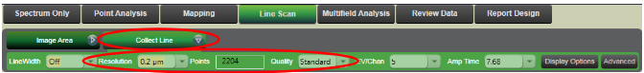

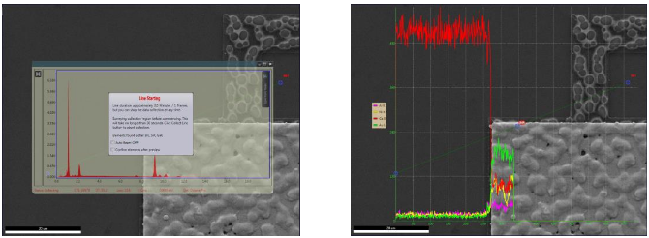
    - Once all settings for the line scan have been determined, select “Collect Line” to start collecting the line scan; the system will first collect a survey spectrum to determine which elements are present and then begin mapping.

    - If you already assigned element colors previously, those same settings will be used for the line scan. If you want to change the color settings while mapping, select “Display Options” and then “Assign Element Colors” as previously described for mapping.
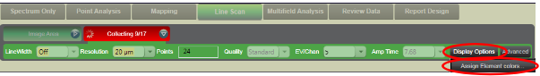

    - When the line scan is complete, select “Finish” to save the line scan.

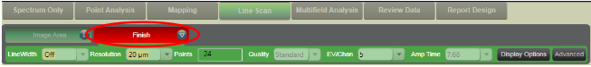

    - Double clicking on the line scan in the project tree will pull up the imaged area with the line scans for each element superimposed and the sum spectrum for the line scan (which can be saved as already described). Hover over the image and select the folder icon (top left corner of the image) to save the image with the superimposed line scans along with an excel file of the map data to your designated folder.

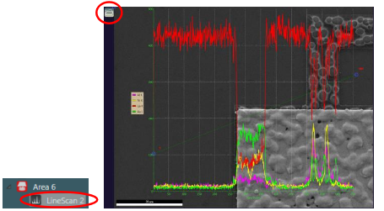

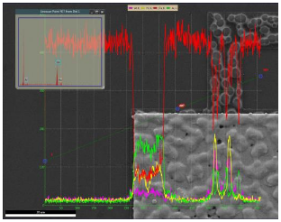
    - Clicking on a point in the line scan will bring up the spectrum for that point (which can be saved as already described); the selected point on the line scan will be indicated in the image. However, if you want to save the image with the superimposed line scans with the selected point indicated, this must be done via screen capture, rather than by using the folder icon.

    - The as-collected line scan plots measured intensity without any background subtraction (ROI) for the automatically identified elements. However, the line scan can be replotted as intensity with background subtraction (Net), atomic %, or weight % or with more/fewer elements. Double click on the line scan in the project; then hover over “Rebuild Line” and select the desired type of line scan under “Data Type”; select “Rebuild Line” to rebuild the line scan using the selected data type; you will be prompted to add/remove any elements you choose. Once the rebuilt line scan is complete, it will now show up in the project under the original line scan (the image with the superimposed lines scans and data can be saved as described for the original line scan).
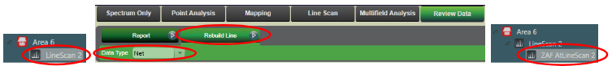

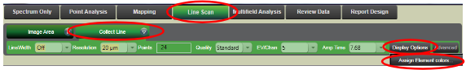
    - If after acquisition or rebuilding of a line scan you wish to change the assigned element colors, select “Line Scan”, hover over “Collect Line”, select “Display options”, and then “Assign Element Colors” (again, this setting is global for the whole project).

- Using drift correction (if needed)
    - After selecting “Mapping” or “Line scan” mode, set your magnification as needed and select “Image Area” to acquire an image.

    - Check the check box next to “Drift Correction”; you will then be prompted to change the magnification to half the value just used to collect the initial image; return to MiraTC and adjust the magnification accordingly.
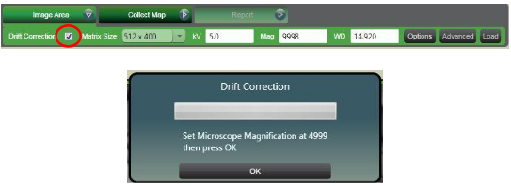

    - Set your mapping or line scan areas and parameters as needed and then start collection of the data as you would for a regular map or line scan
    - Drift correction will be enabled for any additional analysis areas generated when “Image Area” is selected, but you will not be prompted to the change the image magnification in MiraTC again; however, all subsequent images collected in TEAM will show half the field of view displayed in MiraTC.

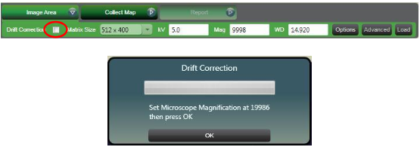
    - To turn off drift correction, hover over “Image Area” and uncheck the check box next to “Drift Correction”; you will be prompted to change the magnification to twice the value indicated in MiraTC; return to MiraTC software and adjust the magnification accordingly and then select “OK”. A new analysis area will be added to the project tree and an image will be acquired in TEAM (and will now have the same field of view displayed in MiraTC).

- Changing analysis areas
    - If EDS is to be performed on a different area on the specimen, the new area should be brought to WD = 15 mm as described previously.
- Changing samples; manipulating project content
    - If you want to change samples, first warm the EDS detector and unload the current specimen as described in the next step (you do not need to close TEAM or MiraTC). Then, load the new sample, bring it to the correct working distance, adjust the SEM alignment (if needed) and re-cool the detector.
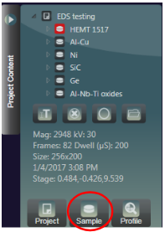
    - From the expanded “Project Content” tab, select “Sample” and follow the instructions to create a new sample.

    - Generally speaking, if you keep the beam voltage and intensity the same between specimens, the SEM alignment will still be reasonably accurate when the new sample is loaded and brought to WD = 15 mm (though it doesn’t hurt to check it again anyways). That being said, if the beam voltage and/or intensity are changed for analyzing a new sample, the complete SEM alignment should be repeated.
    - Any sample, area, spectrum, spot, map, or line scan can be renamed or deleted from the project by selecting the item and then selecting “Edit” or “Delete” buttons, respectively.
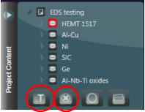

- Finishing the session
    - Turn the CCD camera back on in MiraTC.
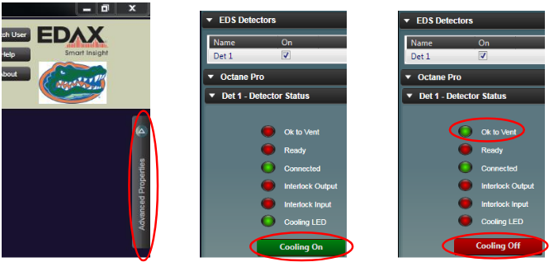
    - In TEAM, expand the “Advanced Properties” tab (upper right corner of the window); then select “EDS detectors”; “Octane Pro”, and “Det 1 – Detector Status”. Select “Cooling On” to stop cooling the detector. The button will turn red and read “Cooling Off” and “Ok to Vent” will turn green when cooling is off. Do not vent the SEM unless “Ok to Vent” is green.

    - Close the TEAM software (all data is saved automatically).
    - Turn off the beam, calibrate the stage, vent the chamber, remove the specimen, pump the chamber back down, and log off MiraTC (do not go into Standby mode).

END

