

ST-270D Spin Dryer

Standard Operating Procedure Rev. 2026-01

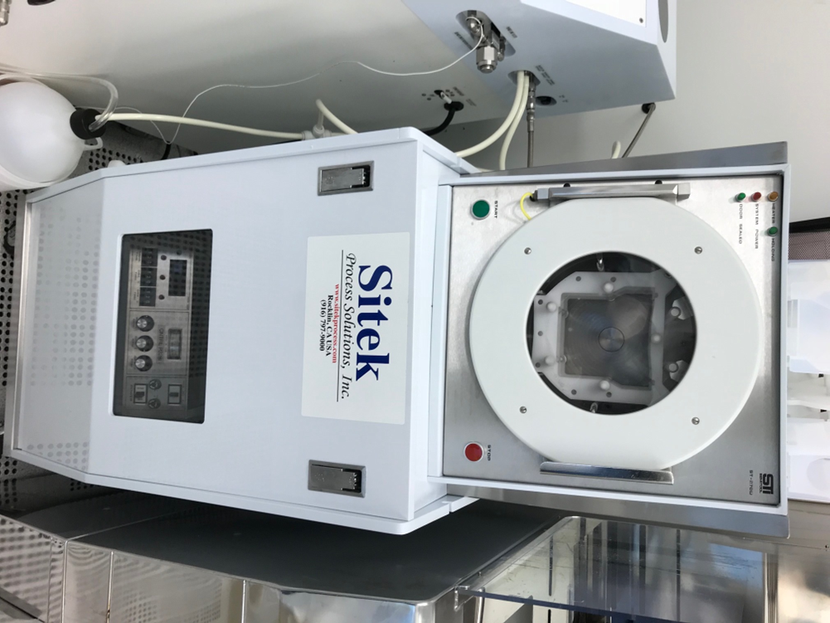

  - Application

The ST-270D is designed for drying wafers without leaving water spots using cassettes. It has an automated program that will perform a quick DI water rinse and then dry the wafer(s) using heated nitrogen while spinning at high rpm. It is capable of handling 2 inch, 3 inch, 4inch and 6 inch wafers as well as pieces.
  - NRF Contact

David Hays
Table of Contents
1. Safety information 3
2. Prerequisites for use 3
3. Sample Restrictions 4
4. Start Up 4
5. Tool Operation 4
6. Ending The Session 6

- Safety information
- Moving components – The tool has rotating parts at very high rpm’s. Never attempt to open the door while the rotor is still in motion.
- Prerequisites for use
- User of the RSC facilities.
- Up-to-date hazardous waste training.
- Training by staff.
- User will be responsible for lost or damaged equipment due to negligence. Negligence means not following the SOP, not asking staff for assistance, intentionally damaging items, etc.

- Sample Restrictions
    - The tool can only dry round substrates of 2”, 3”, 4” and 6”. Do not attempt to dry pieces or masks.
    - Use only the designated cassettes. Other cassettes may fit, but could cause the system to be unbalanced and lead to wafer breakage or damage to the tool.
    - Do not use this equipment as a rinser! It is a dryer only, and all substrates must be properly rinsed with DI water before loading. All loaded samples must be clean and free of chemicals.
- Start Up
    - Log in to TUMI
- Tool Operation
    - Login using TUMI system to activate tool and start billing period.
    - Open the door and place the proper rotor insert (2”, 3”, or 4”) for your substrate diameter in the slot.
    - There are labels stamped on the front of the inserts and the label must face the door.
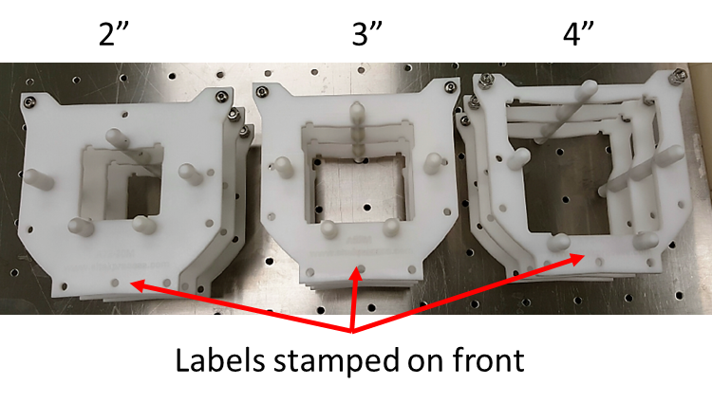

    - When your wafers have finished rinsing, place the cassette in the opening of the insert with the H-bar to the back.
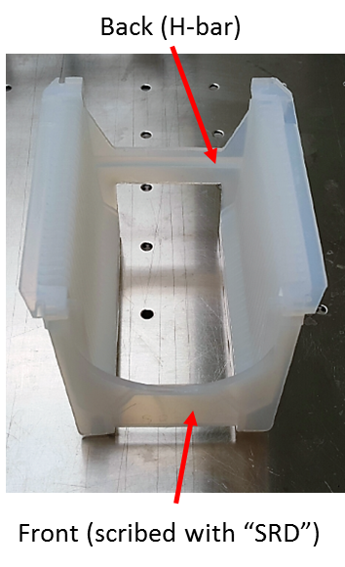

CAUTION  CAUTION
Only use the designated (marked) cassettes!

    - Close the door
    - Press the green, start button to begin the process

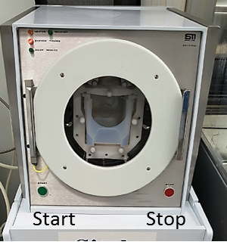

    - If you hear anything unusual; wafers breaking, unbalanced rotor, knocking, etc….press the stop button and contact staff.
    - When the process is finished, the rotor “should” go back to the upright position, the N2 will turn off and the door will unlock.
    - Open the door and remove the cassette. If rotor did not stop in upright position, simply rotate by hand and then remove the cassette.
    - Close the door
    - Place cassette back on top of the dryer
    - Log off the TUMI system
- Ending The Session
    - Log off TUMI

