\

Kurt Lesker CMS-18 Multi Target Sputter Deposition

Standard Operating Procedure

Rev. 2026-01

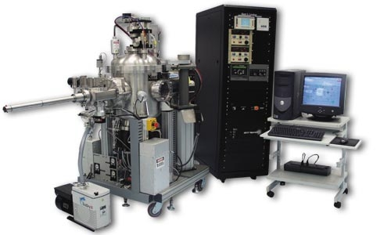

Contents
Kurt Lesker CMS-18 Multi Target Sputter Deposition 1
Standard Operating Procedure 1
Rev. 2026-01 1
Safety 2
Quality Control and Calibrations 2
Sputter Rates 2
Test Sample Procedure to Measure Thickness: 2
Film Quality 3
Heater Box Temperature 4
Operation 4
Pre-Operation 4
Sample Load 4
Sample Pre-Treatments 12
Sample Clean with Argon or O2 12
Sample Clean with Oxygen Plasma 12
Sputter Types and Materials 12
Running a Deposition 15
Sample Unload 19

Safety

High Voltage - High Voltage Radio Frequency and High Voltage DC is used throughout the system. System maintenance may only be performed NRF Staff. Do not remove any tool covers or defeat any interlock on this system.
Moving Components - The User should be aware at all times of the moving components associated with this tool. For instance, the turret unit does rotate and does present a potential hazard. The User must exert caution at all times such that a limb, finger, or article of clothing does not become trapped or entangled (or worse, violently detached) when components of the machine are in motion.
Heat – The sample platen is heated and should never be touched.

Quality Control and Calibrations

Sputter Rates

The Sputter rates contained in the spreadsheet located on the sputter tool computer were accurate at the time of calibration and should only be used as an estimate. Rate calibrations are not performed on a periodic schedule. Due to the complexity of the sputter process, these rates may change slightly over time. If you need a very specific film thickness you must run a test deposition on a specific gun.

Test Sample Procedure to Measure Thickness:

Load clean polished silicon or a clean glass slide for the test. Run recipe long enough to obtain a film thickness of at least 1000 angstroms (thicker is better). Do not cover your sample with a shadow mask or tape. Dip a swab into a bottle of AZ1512 and touch a small area of photoresist onto the test sample. You don’t want the PR to be too thick or it will be hard to bake. Bake the sample for 3 mins. at 112C for wet etch and 10 mins for plasma etch. Small bottles of photoresist are located on the bottom shelf of the Litho Bay chrome rack. Etch the film using the appropriate wet chemistry or plasma etch. Remove the photoresist using acetone after etch and measure the film etch step using the Stylus Profiler. Once you have the calibrated rate, email the results to NRF Staff. You may request that your target be loaded into the same sputter gun in the future for consistency.

Available Sputter Materials – Partial List. Contact Staff before purchasing new materials. We may already have it….
Ag | Ni | InO/ZnO | W2B
Al / 2% Si | Pd | ITO | Y2O3
 | Pt | Ru
Au | Ti | Si undoped | ZnO
Bi2O3 | W | SIO2 | ZnO / 2%Al203
Cr | Al | Ta | Zr
Cu | Hf | TaN | ZrB2
Ge | HfO | TiB2 | ZrN
Ir | In2O3 | TiN
Mo | InGaZnO | TiO2

Film Quality

For ultra-sensitive oxide targets such as Indium Zinc Oxide, InGaZnO, the main chamber base pressure must be <5.0e -7 Torr. This is also true for reactive oxide recipes. The best way to achieve this is to request that the target be loaded at the end of the day and reserve the tool for the next morning. This can be done via email to Staff in most cases.

Heater Box Temperature

The temperature of the heater box is controlled by 2 thermocouple sensors located several inches from the sample holder. There is a substantial temperature offset between the system readout and actual sample temperature. Please check the calibration curves posted and consult with the process engineers for elevated temperature processes.

Operation

Pre-Operation

  - Please read and observe reservation requirements on the RSC Kurt Lesker Sputter equipment page.
  - When NRF Staff changes the sputter targets, a note regarding loaded targets will appear in the logoff notes. To see the note, go to the sputter equipment page and click on “Status Log”. The sputter materials loaded will be listed in order guns 1-4. The time stamp of the note will also give you an idea of when the chamber pump down started.
  - Before logging onto the tool, check that the ion gauge is not on. It’s a quartz tube located at the rear of the sputter chamber. It’s very bright when it is on and indicates the chamber is still pumping down to the base pressure of 2e-6 Torr. Wait until the filament is off before logging onto the Tumi.
  - Log onto the tool via the Tumi.
  - Log onto the tool using your name and password.
  - On the machine, use the Deposition screen (click the Deposition tab along the top of the screen) to verify that the targets you need are listed and match the Staff logoff notes. If not, log off the TUMI with a comment/email to Staff stating the problem and Call NRF Staff.

Sample Load

  - Log into the tool using your login name and password.
  - Verify that the target you need is loaded into the machine. Click the “Deposition” tab at the top of the screen. The target name is shown for each source. If your target is not loaded, contact Staff and log off the tool.
  - The base pressure is checked to be <2e-6 Torr during each pumpdown from atmosphere.
  - If you would like to check the actual Process Chamber base pressure before you start. Click on the Vacuum Screen Tab. Run the “PC Pump” recipe on the right side of screen. The pump down routine will run and at the end turn on the ion gauge. The pressure will be displayed under “IG Pressure” shown below. The gauge will turn off if the pressure is better than 2E-6….i.e. should only be on for a short period if everything is good.
  - Click “LL Vent” on the right side of the screen.
  - The Recipe Monitor window will open and the “LL Vent” recipe will execute. When done, you will see the message in green below. You may now open the load lock door.
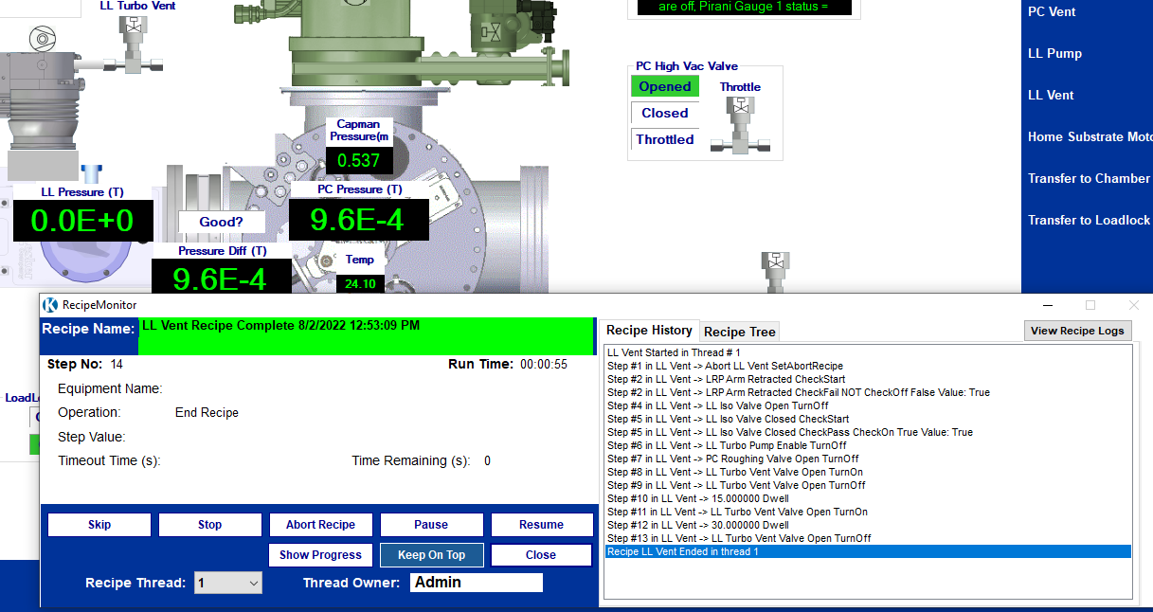

  - Secure your sample to the 6 inch sample holder. Use the screws and clips provided. Caution: The sample may not extend past the height of the lip of the holder or 6mm total (this includes the sample and clip height). Note: The ONLY tape that may be used in this system is 3M High-temp Polyimide Kapton Tape. If you absolutely have to use glue, the only types that are allowed are Varian Torr Seal or Kurt J. Lesker KL-325K.
  - Place the support ring around the sample holder as shown below.
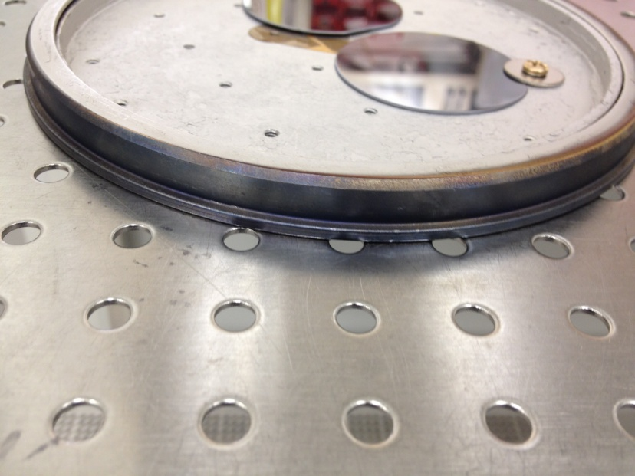
  - Using your right hand, load the sample holder “face” or “sample” down onto the load fork (see pic below) and shut the load lock door.
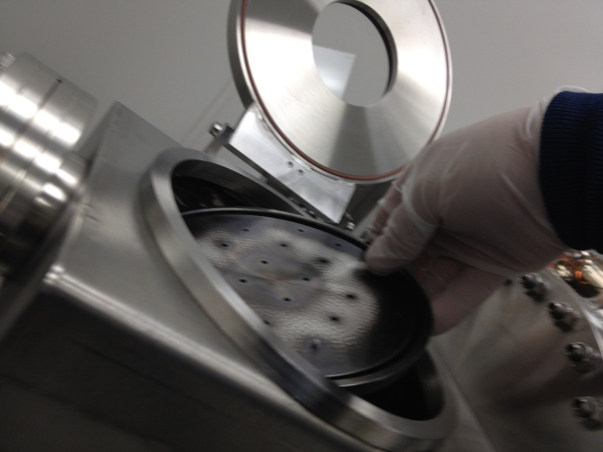
  - Click “LL Pump” on the right side of the screen. The LL Pump recipe will execute and display “LL Pump Recipe Complete” in green in the Recipe Monitor window when the tool is ready for the next step.

  - Refer to the following drawing for terminology during this procedure.
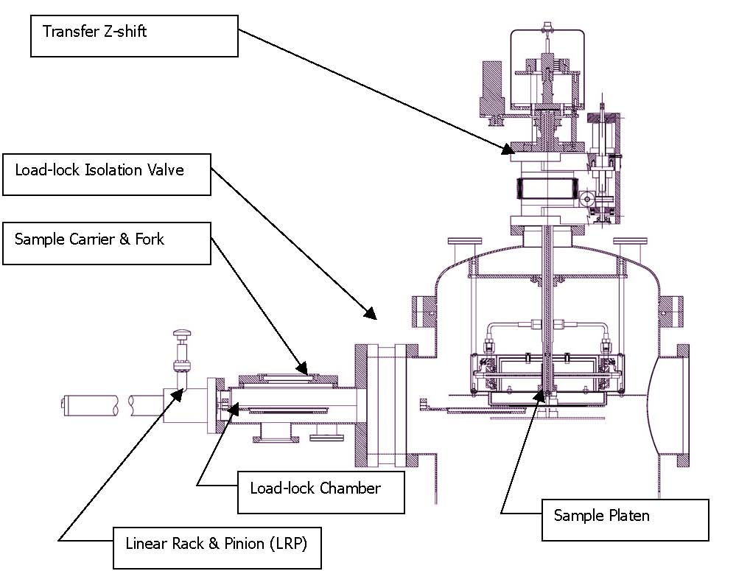
  - Click “Transfer to Chamber” on the right side of the screen. The recipe will pause with message “User Set Z Axis to Full down Position”
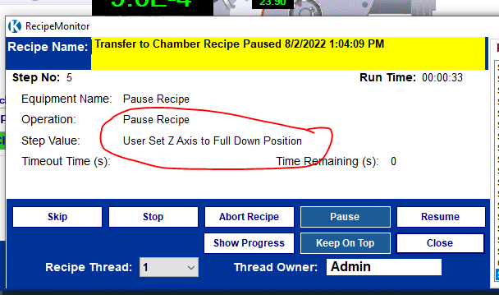
  - When “Pause – User Confirm Z-Shift Position” appears in the “Step” field, verify that the platen is all the way down. See red arrow in pic below. Normally it is already in this position from the last user.

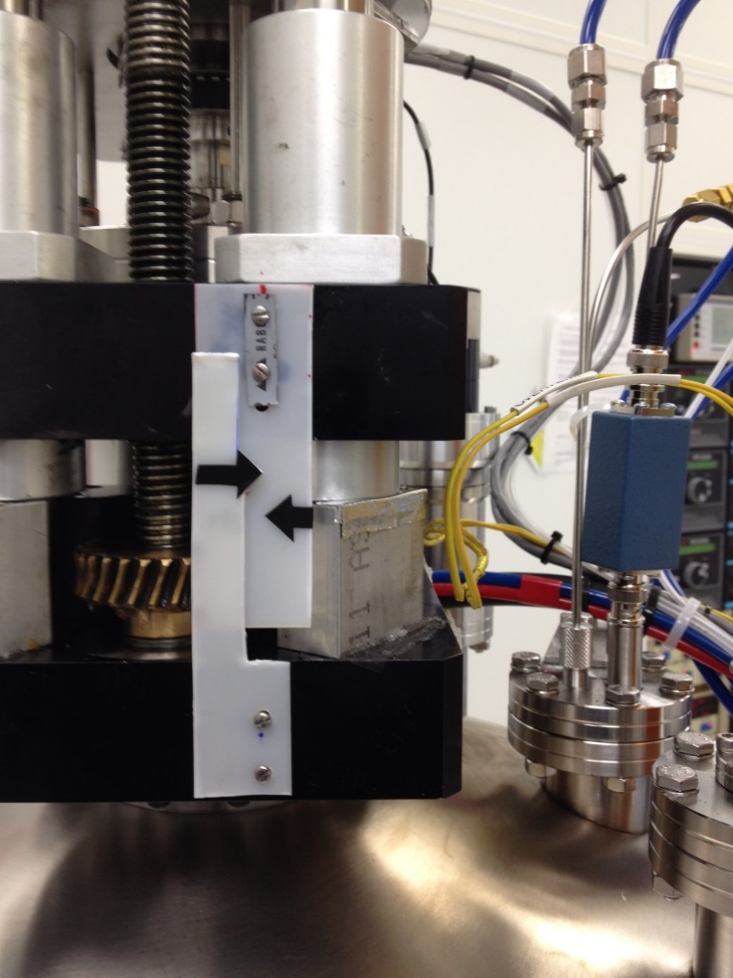
The bushing is all the way down against the block.

  - If not all the way down, rotate the Transfer Z shift manual knob (see pic below) clockwise until the sample platen is lowered completely. Stop when you feel resistance, i.e. do not force it!
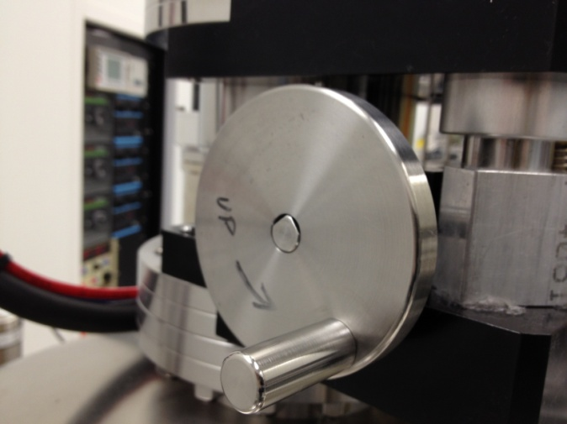

  - Click the “Resume”, see below.
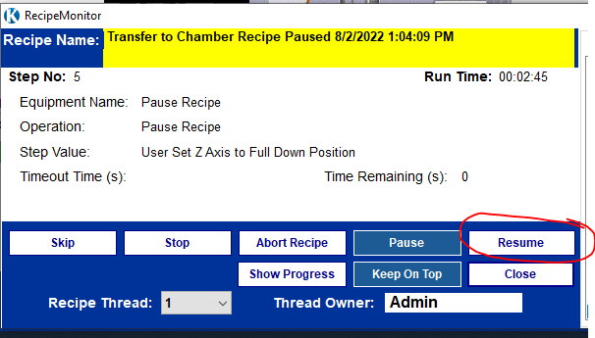
  - The load lock/dep chamber isolation valve will then open. The recipe will pause with the following message. 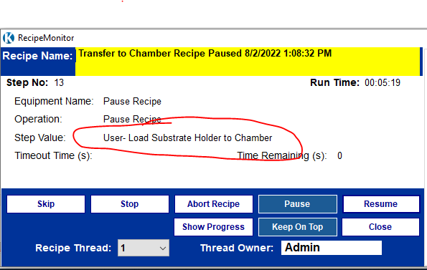

  - Rotate the LOAD ARM Load Arm knob until the sample is inserted completely into the process chamber and bumps into the sample holder. It will meet a mechanical stop.
  - Raise the sample platen slowly by turning the Transfer Z-Shift knob until the 2 black arrows on the plastic indicator are aligned. See pic below.
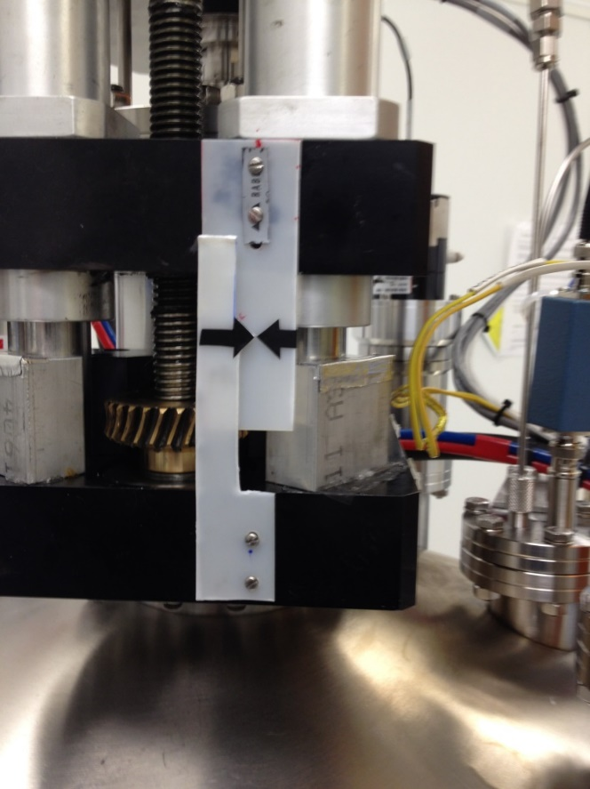
DO NOT RAISE THE PLATEN UP HIGHER THAN THIS WITH THE LOAD ARM INSIDE THE CHAMBER.

  - Return the LOAD ARM to home position. If you hear any badness (like the sample holder falling off the load arm) call NRF Staff. Using the flashlight mounted on the control rack, verify that your sample is centered on the platen holder ring. If it is not, stop and contact NRF Staff. If OK, click the “Resume” button again.
  - Verify the load arm is all the way back home. “Lrp EOT” should be green.
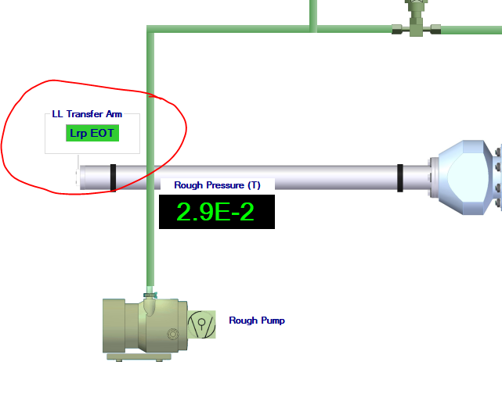

  - Raise the sample platen completely to the top (deposition position) by turning the Transfer Z-Shift knob anti-clockwise. See below. Stop when you feel resistance, i.e. do not force it!

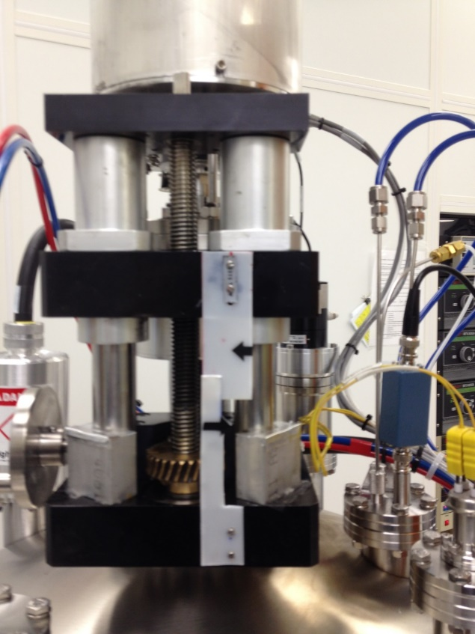

  - Click “Resume” when done.

Sample Pre-Treatments

Sample Clean with Argon or O2

    - If you wish, you can remove a surface layer of your sample before deposition.
    - The amount of material removed will depend on the material type and you must use at your own risk.
    - A 30 second treatment should be plenty to clean the surface.
    - Before deposition run the recipe called “Argon_Clean”.

Sample Clean with Oxygen Plasma

    - If you wish, you can clean the surface layer of your sample before deposition.
    - A 30 second O2 plasma should be plenty to clean the surface.
    - Before deposition run the recipe called “O2_Clean”.
    - Note: This recipe will turn on the ion gauge at the end and wait for the base pressure to return to <2e-6. Be patient, it may take 10-15 minutes.

Sputter Types and Materials

There are 3 different sputter recipe types based on the type of material being sputtered:
- Standard Recipes – standard argon sputter at 5mTorr partial pressure. The 4 standard recipes for all metals are named as shown below. 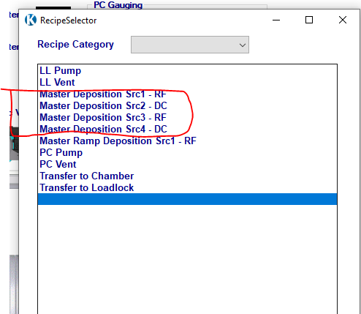
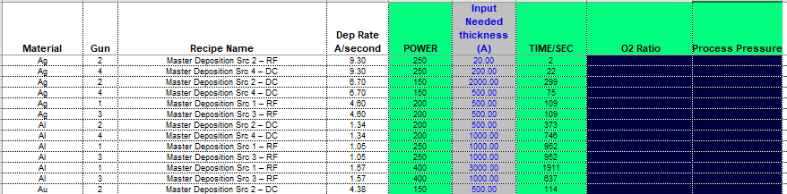

- Insulating Target Materials Recipes – argon sputter (sometimes includes other gases) of insulating materials. Usually done in RF guns 1 or 3. Insulating materials have poor thermal conductivity and crack easily. Because of this, magnetron power must be increased and decreased slowly to prevent target damage. These recipes typically take approximately 4 minutes to ramp power both up and down. Please allow an additional 15 mins for your sputter reservation. These targets require special care. The power and deposition times (the green colored columns below) will be entered using the “KL_Sputter” Excel worksheet, shown below. Take great care to enter the correct power from the spreadsheet or the target may be destroyed. Insulators shown below.
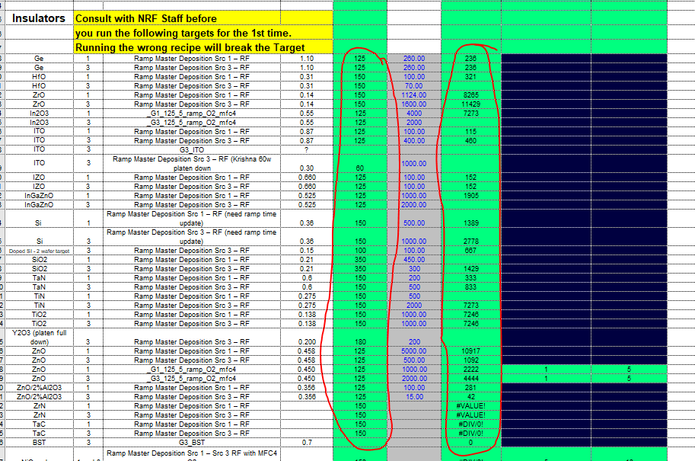

- Reactive Recipes – reactive gases are added to the chamber to reactively create films. Example: O2 is added to chamber while sputtering Chromium to create Chromium Oxide. .
- Reactive sputter reservations - see the tool web page on the web site for reservation instructions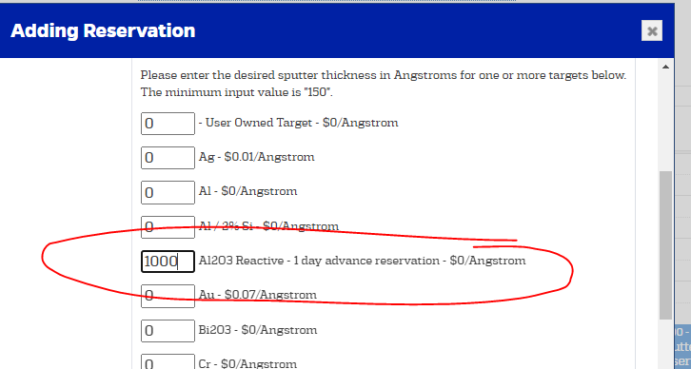

Running a Deposition

    - Open the “KL_Recipes_xxxxx” workbook on the sputter tool desktop.
    - Find the “Material” in column A you are sputtering.
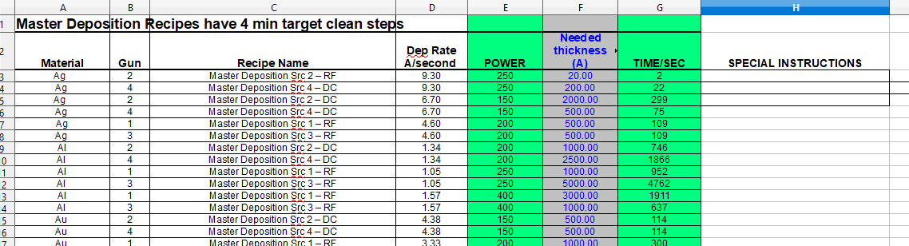

    - Determine which Source gun has the material you are sputtering. See below.

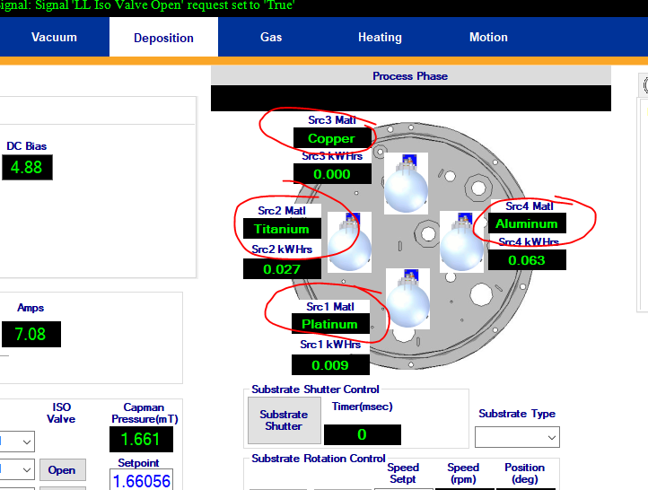
    - In the spreadsheet enter the thickness in Angstroms you need and enter the value into the spreadsheet column F.
    - Write down the Power column E (green) and Time/Sec column G for the material, you will need to enter these 2 values.
    - If you are running a “Reactive” process you will also need to input the “O2 Ratio” and the “Process Pressure” from the spreadsheet for the material you are depositing.
    - Click “Run Recipe” on the right hand side of the KJL software screen. Select the recipe (see column C of the spreadsheet). Select the recipe and click “Run Recipe”.

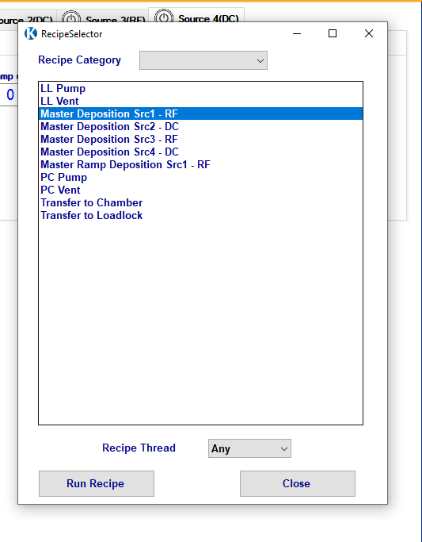
    - The next window will appear. Enter the Power and time in seconds in the far right value fields. Red circles below. If you are running a “Reactive” or “Ramp Recipe” recipe you may also be prompted to enter the “O2 Ratio” and the “Process Pressure”. Refer to the KL_Recipes” Excel worksheet shown above for the values to be entered. If it asks for a value that does not exist in the spreadsheet, call Staff immediately for assistance.
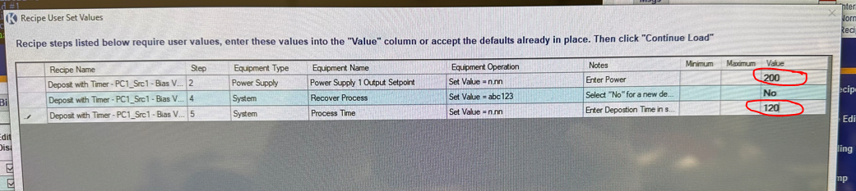

    - Click “Continue Load”. The recipe will execute.
    - The tool has no way of knowing if the mechanical shutters are opened or closed. For this reason, you must physically check.
    - Observe the recipe while it runs. When it has ignited plasma for the appropriate magnetron source(s) and the shutter is indicated as open on the computer screen, open the viewport window and check that the shutter for the gun you need is actually open. The pic below shows Source 1 shutter open and the shutters for Sources 2,3,4 are close as an example. 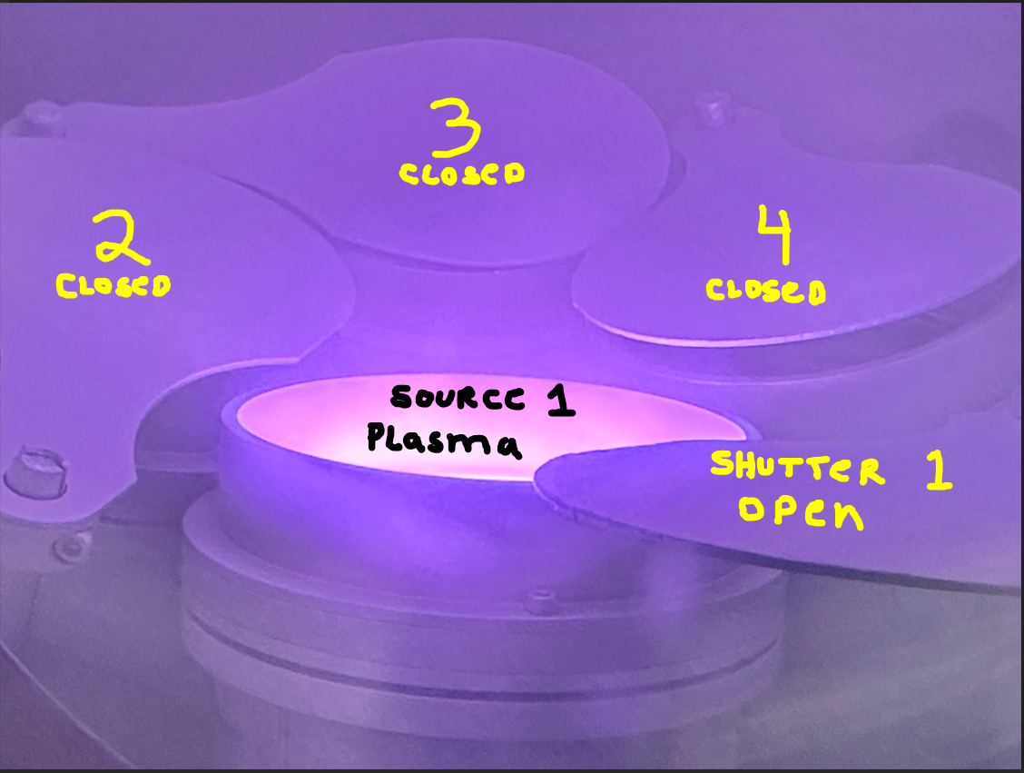
    - If the shutter is closed, press abort in the recipe window and call Staff for help.
    - When the deposition process starts, the “Substrate Shutter will open. The icon will turn blue. 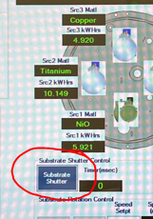
    - Check that the substrate shutter is open. It’s located directly below the sample holder. See below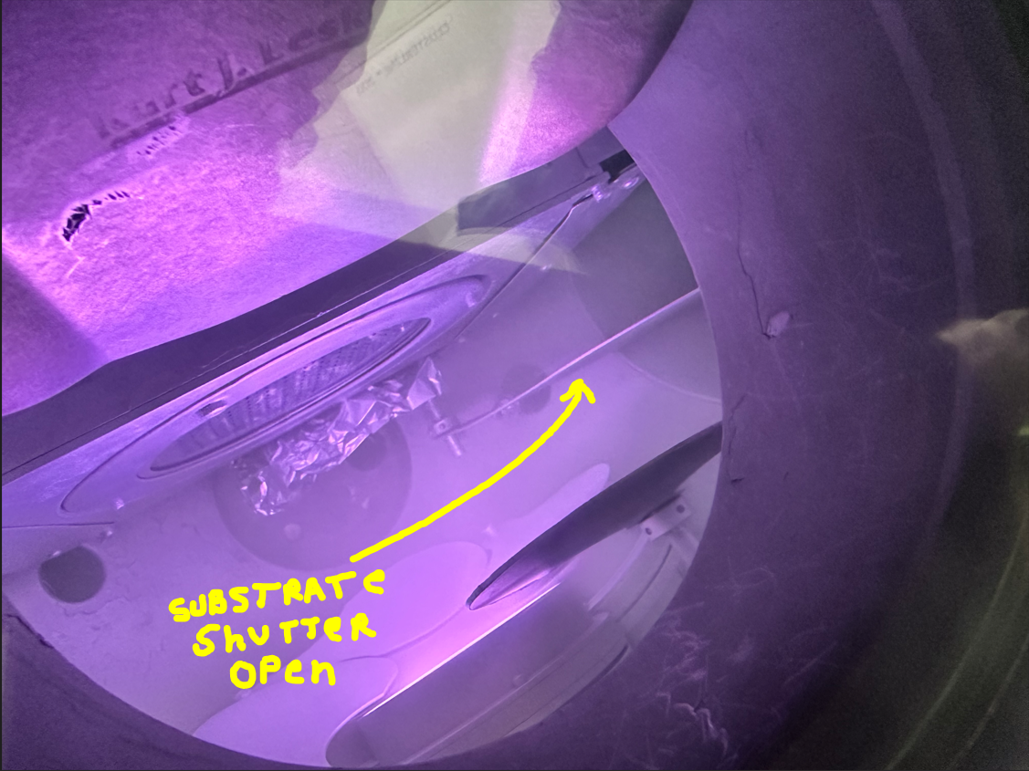
    - You can monitor the process time on the deposition screen, see below. “Process Time SP” is the deposition time you entered. “Process Time” is the actual elapsed time processed. This number will be used to recover the deposition if the recipe aborts during the deposition. Process time starts when the Substrate Shutter opens.
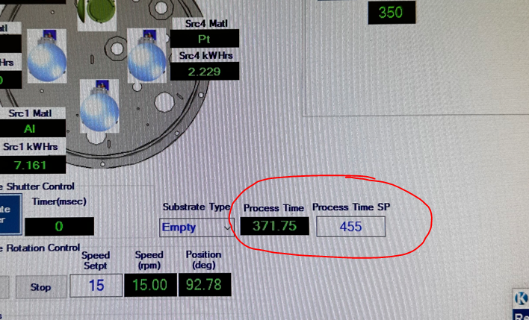
    - If plasma is lost during deposition and the recipe aborts, contact RSC Staff. The “Process Time” widow will stop the counter and display the deposition time elapsed up to the abort process. Once the problem is resolved, the remaining sputter time can be recovered automatically by doing the following. Run the recipe again with the same power and time entries as entered initially. Double click on the “no” value for the recovery step shown below and select “yes”. Press “continue load”.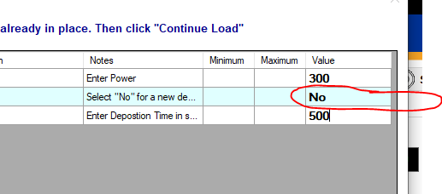
    - When the recipe runs the 2nd time, the “Process Time” on the deposition screen will continue to count down the deposition time remaining i.e. continue the deposition where it left off. It will start counting again when the substrate shutter opens.
    - NOTE: Reactive Recipes Only - The recipe will check that the base pressure of the process chamber is <5e-7 Torr. You may need to wait for pressure to come down. If pressure is not reached within 15 mins, it will abort the recipe and notify you to “contact NRF Staff
    - It is always a good idea to verify plasma is on by looking through the view port window during deposition. The shutter handle is to the right of the window. Rotate the handle to look in the window.

Sample Unload

  - Click “Transfer to Loadlock” button. When “User set Z axis to arrow to arrow position” appears in the “Step Value” field, rotate the Transfer Z shift manual knob clockwise until the 2 black arrows on the plastic indicator line up. See below.
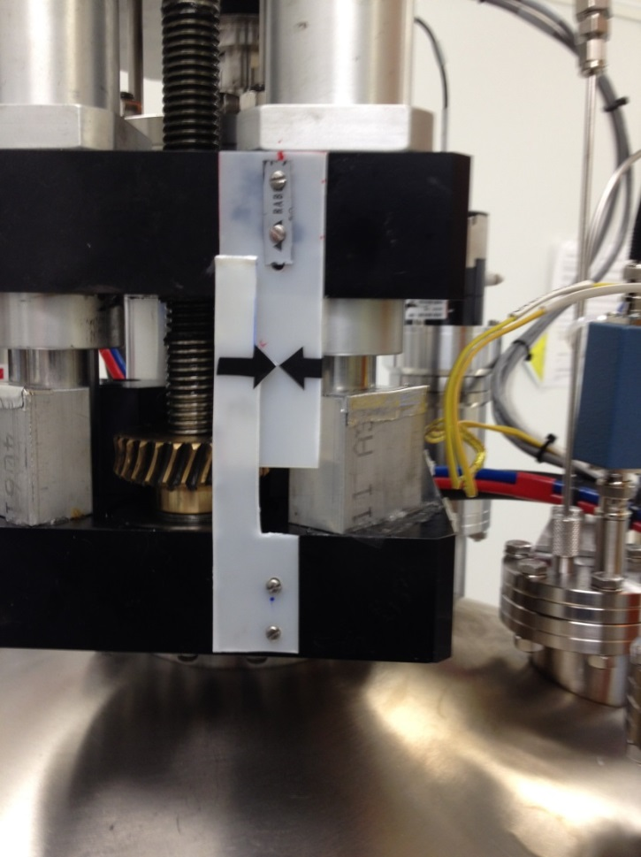
  - Click Resume. The load lock/dep chamber isolation valve will then open. When done the recipe will prompt “User-Unload substrate from chamber”. Rotate the LOAD ARM Load Arm knob until the arm is completely inside the process chamber and you feel it bump against the sample holder. Leave the arm in that position.
  - Lower the sample platen slowly by turning the Transfer Z-Shift knob clockwise until the platen stops turning (don’t force it). It should be all the way down as shown below.
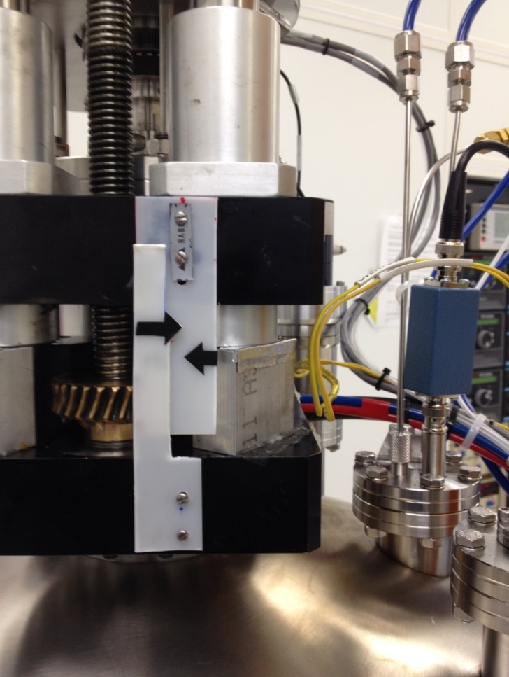
  - Return the LOAD ARM to home position. If you hear anything unusual (like the sample holder falling) call NRF Staff. If the sample makes it back to the loadlock, click the “Resume” button again.
  - Vent the loadlock by pressing the “LL Vent” button. You may open the LL door and remove your sample when the LL vent sequence is done.
  - Pump the load lock back down by pressing “LL Pump”.

