
SSI Solaris 150 RTA

Standard Operating Procedure Rev. 2026-01

  - Application

The Solaris 150 RTA is a rapid thermal annealing system capable of handling sample sizes up to 100mm (4” diameter) or smaller. The system can anneal in N₂ and Forming gas (N₂ with 4%H₂) up to a maximum temperature of 1100°C. Process time is limited to 60 seconds.
The system is reserved for conventional semiconductors, dielectrics and metals. See the acceptable materials list at the end of the SOP.

  - NRF Contact
  - Andres Trucco

Table of Contents
1. Safety information 3
2. Prerequisites for use 3
3. Pre-Operation 3
4. Hardware overview. 4
5. User Interface 4
6. Operation 5
7. Shut Down 10
8. Acceptable Materials List 11

- Safety information
DANGER! Do not remove the covers of the instrument. Do not modify the instrument.
    - HOT Components - The User must observe caution when loading/unloading samples from the sample stage or graphite susceptor. Samples are very hot when immediately removed from the process chamber. Sufficient cooling time must be allowed prior to sample handling.
    - Chilled Water Leaks – Due to chamber designs, we have had instances where chilled water has leaked out of the system. In the event of a leak, press EMO button and turn chiller off, toggle switch on the chillers front panel. Immediately contact NRF staff.
- Prerequisites for use
- User of the RSC facilities.
- Up-to-date hazardous waste training.
- Training by staff.
- User will be responsible for lost or damaged equipment due to negligence. Negligence means not following the SOP, not asking staff for assistance, intentionally damaging items, etc.
- Pre-Operation
    - Tool Reservations may be made via the NRF Reservation Page. http://nimet.ufl.edu/servicecenter/resources/default.asp
    - Change gloves. WARNING No solvents or liquids are allowed near the machine, change your gloves before operation!!
    - Log into the tool by using the TUMI computer in this room (NRF 122).

- Hardware overview.
The Solaris RTA consists of the following components: computer, main oven unit, chiller, gas sources, and oxygen sensor. See the image below for system layout.

Figure 1. System layout.

- User Interface
The Solaris RTA operation is controlled through the software interface. The appropriate screens and functions will be addressed through the Operation portion of this SOP.

- Operation

    - Log into the Solaris RTA through the TUMI computer located in room 122. The TUMI computer is located in the back right corner of the room. This will enable the computer monitor and the chiller for the RTA.

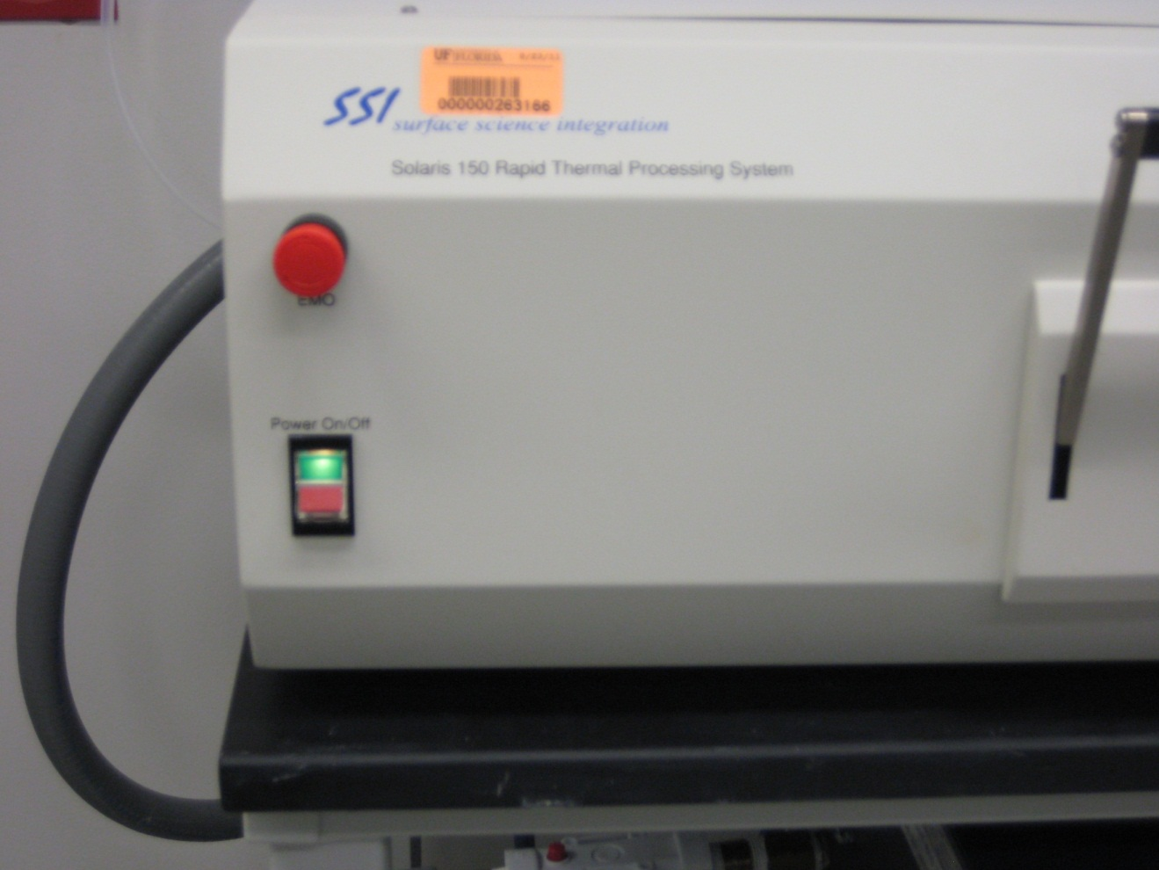
    - Power on the main power on the oven unit.

Figure 2. Main oven power switch and EMO button.

Do not use the EMO as a power on and power off button. The EMO is the Emergency Manual Off button and should only be used to turn off the equipment in an emergency.

    - To load the sample, slowly lower the door handle with both hands and gently pull the sample door open. The quartz sample tray will withdraw with the door. The control thermocouple (TC) is located under the small Si disc on the sample tray. The sample tray is loosely attached to the door.
NOTE: The sample or 100mm Si carrier must be placed over the TC for accurate processing.

For small samples – load small samples onto a Si carrier wafer (100mm). A Si carrier wafer with a second Si wafer as a lid can be used with transparent samples or samples requiring a group V overpressure for annealing.

For large samples –place the wafer sample on the 3 support pins and TC. (Refer to figure 4)
Gently slide the door closed. Pay close attention to the side to side clearance of the sample tray and the RTA chamber. Raise the door handle to lock the door.

CAUTION  CAUTION

THE SAMPLE TRAY IS VERY FRAGILE, USE CAUTION WHEN
OPENING AND CLOSING THE TRAY DOOR.

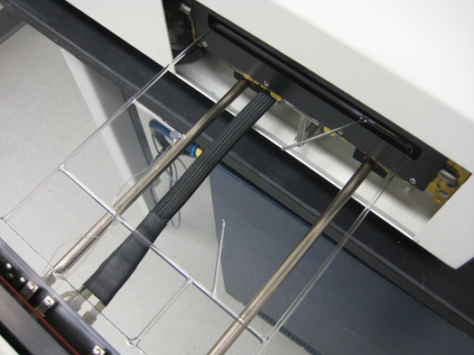


Figure 4. Image of quartz sample tray with support pins and TC exposed (red circles).

    - Turn on the process gas. The N₂ is already on and available. Forming gas is in the gas cylinder located to the left of the system. Open the main tank valve, the regulator should already be set to 10psi. Please confirm the process gas pressure (high and low side of regulator) before continuing. If you have any questions, please consult with staff.
Oxygen can be available by selecting Oxygen on the pneumatic switch over the gas bottles on the left wall. Open the main tank valve and secondary valve. The output pressure should be set at 10psi. On this setting, the Honey Well oxygen sensor will not read the O2 content in the chamber.

The gas selecting manifold is designed so Oxygen cannot be run simultaneously with forming gas.

    - Start Solaris 3.8 software. The main oven unit must be powered on before the Solaris software is launched. Failure to do so in the prescribed order will lead to a communication error.
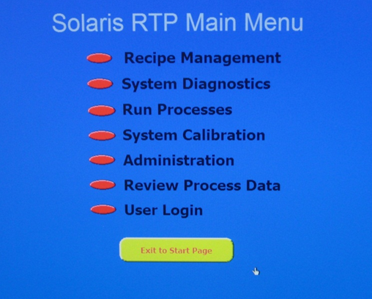
Once the Solaris software is running select “Start RTP Process”. The next screen (see below) will become visible.

The menus that should be used by the user are Recipe Management and Run Process. All other menus are for NRF Staff and should not be accessed by users.

Recipe management – in this screen, the user may create or edit recipes for their processing. Many of the basic recipes are already available, these may be edited and saved under different names.

The recipes are created as steps following a process flow. Each step can be edited for ramp rate, gas flow, hold time, etc. Steps can be added or inserted, depending on the type of processing required. The image of the Recipe Management screen is shown in Figure 5.

NOTE: the default purge gas is N₂ and will be flowing at 3.0 SLPM when the Run Process menu is opened.

It is highly recommended that the user edit an existing basic recipe and refer to NRF staff regarding the limits of the thermal process. Process time is limited to 5 min. Exceeding this time will cause the heaters to trip.

Recipes are selected through a drop down list. When prompt for a password, click [OK]. Password is not required.

Some basic recipes are:
300C_N2_60sec 400C_N2_60sec 500C_N2_60sec
600C_N2_60sec 700C_N2_60sec 800C_N2_60sec
900C_N2_60sec 1000C_N2_60sec
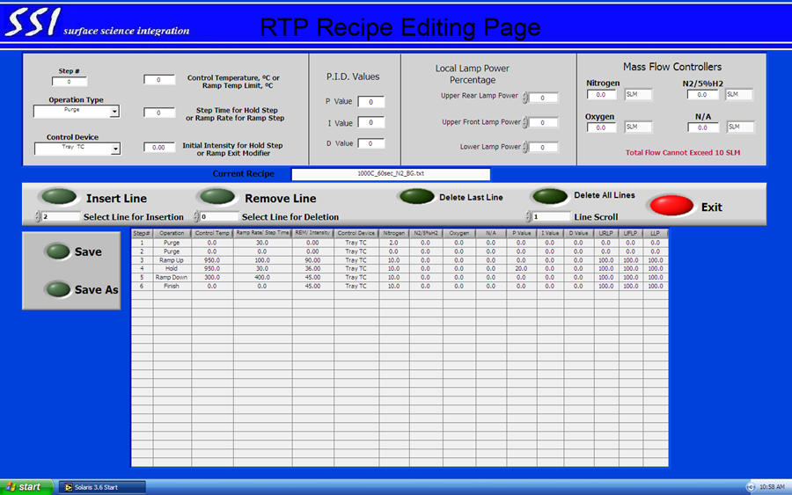

Figure 5. Screen for Recipe Management.

Once the recipe has been edited, it can be saved with a different file name. The save command will return the user to the RTP Process menus.

    - Next select the “Run Process” menu. In this menu, the user can select the process recipe and track the process flow with the graphic tool that follows the RTA process. Figure 6.

- Select the process recipe from the drop down list. Leave the calibration file set to “factory calibration”. The recipe cannot be edited from this page.
- Set the Overtemp Setpoint to 20°C above the recipe maximum temperature. This will prevent a possible temperature run away to protect the RTA system and the user’s sample. Power Limit = 100%, Power Limit Time = 3.0, Purge MFC = 3.0.
- Leave Learn Mode off. This will prevent the software to from automatically adjust the recipe ramp and hold parameters.
- Leave the TC type set to Tray TC. This will read the temperature of the susceptor or the sample wafer as the process temperature.
- When ready, click the Start button on the menu. The user will be prompt to enter a sample name and user name, simply click the START PROCESS button and skip these fields. This will begin the RTA process. Recipe progress can be monitored on the graphical display as well as the table under the display.

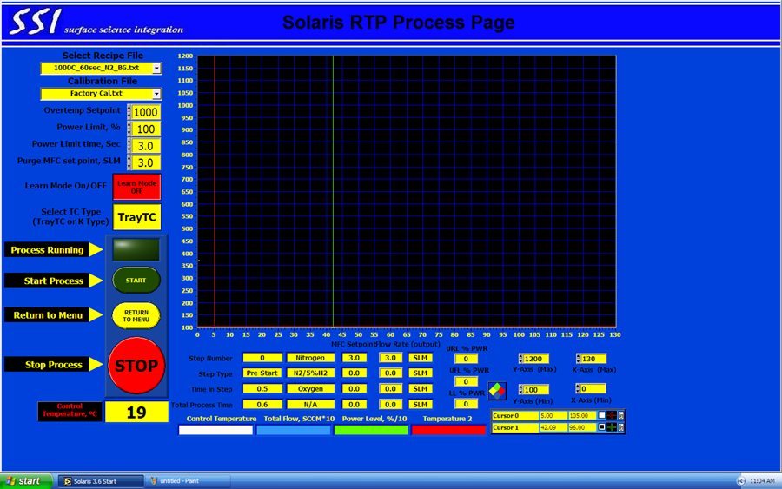

Figure 6. Screen for Run Process menu.

Monitor the oxygen sensor readout which monitors the output gas of the RTA system. The lowest recorded oxygen concentration is 0.8%. Typically a 60 second pre purge is sufficient to achieve this limit. If the oxygen has not reached 0.8% before the temperature ramp step, stop the process with the STOP button. The purge time may need to be increased or there may be an issue with the system.

- When the process is complete, select Next Wafer. The Run Process Menu page will remain until the user clicks the Return to Main Menu button. It is generally a good practice to remain on the Run Process Menu page to monitor the sample temperature.

    - Unloading sample – When the sample is cool enough, it can be removed from the system. Lower the door handle and gently pull the door open. Carefully remove the sample or susceptor from the right side of the tray. This will prevent possible damage to the TC or TC wires. Close the tray carefully when sample removal is complete.
    - It is highly recommended to run an oxygen chamber clean anneal using the supplied Si wafer carrier before your samples are run. This will eliminate any potential contamination inflicted by previous users. The recipe runs oxygen at 1000C for 30s. Contact NRF staff for recommended recipe name.

CAUTION  CAUTION

THE SAMPLE AND WAFER HOLDER MAY BE VERY HOT (OVER 100°C).
USE CAUTION TO NOT TOUCH THE SAMPLE TRAY OR SUSCEPTOR.

CAUTION 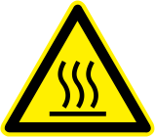 CAUTION

- Shut Down
    - Exit the Solaris software and return back to the main Windows desktop.
    - Turn the main oven power off. (figure 2)
    - Close any process gas cylinders by closing the main tank valve. The compressed air and N₂ should remain on.
    - Log off the Solaris RTA system via the TUMI, record any comments. The Chiller will continue to run for an additional 10 minutes after logging off. This is to ensure proper cooling of the RTA oven.

- Acceptable Materials List
Semiconductors:

Si
Ge
Ga(Al,In)As
Ga(Al,In)P
Ga(Al,In)N
Ga(Al,In)Sb
Zn(Mg)O
SiC

Dielectrics:

SiO₂
Si₃N₄
Sc₂O₃
Mg(Ca)O
Al₂O₃
HfO₂
TiN
TiO₂

Metals:

Ti
Al
Pt
Au
Ni
Pd
Ir
Boride containing alloys
Nitride containing alloys

