

Dektak XT

Standard Operating Procedure Rev. 2026-01

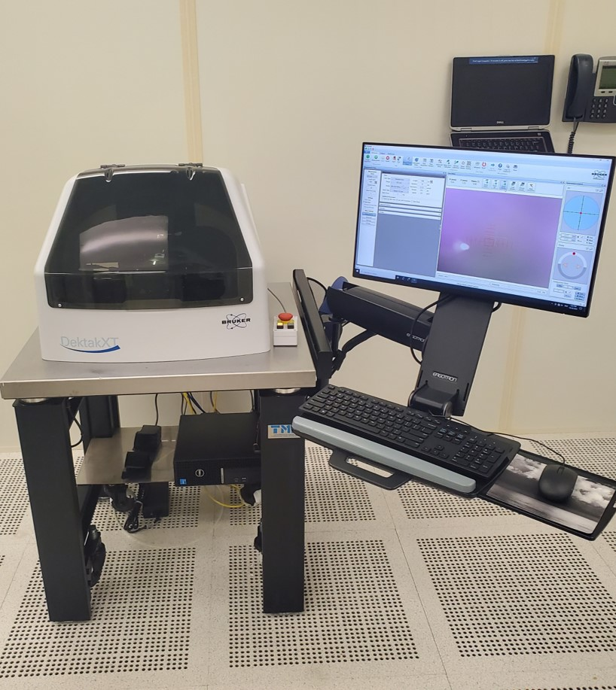

  - Application

The DektakXT system takes measurements by moving a diamond-tipped stylus over the sample surface according to a user-programmed scan length, speed, and stylus force. It can be used to measure step heights, surface roughness, waviness and stress. Vertical resolution is 1Å max, using the 6.55µm range and the stylus force can be varied from 1mg to 15mg. The Dektak XT can accommodate wafers up to 200mm and features a motorized X-Y stage with 3D mapping capability.

  - NRF Contact

David Hays

Table of Contents
1. Safety information 3
2. Prerequisites for use 3
3. Launch Software 4
3.1. Start Up 4
4. Sample Handling 4
4.1. Sample Loading And Positioning 4
5. Measuring A Surface 5
5.1. Set Scan Parameters And Start Measurement 5
6. Data Analysis 7
7. Saving Data 9
8. Unloading or Exchanging Sample 9
9. Ending The Session 10

- Safety information
- Moving Components – The optical profiler is equipped with a motorized stage that can create pinch points – areas where a person’s fingers can get caught or crushed. Do not move the stage with your hands near it.

  - If you feel that the tool is operating in an unusual of unsafe manner, then press the ‘Cancel’ button in the top ribbon.
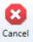
  - If this does not stop the behavior, then hit the red Emergency Off Switch located next to the tool enclosure.
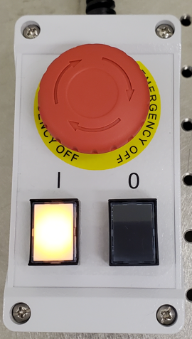
- Prerequisites for use
- User of the RSC facilities.
- Up-to-date hazardous waste training.
- Training by staff.
- User will be responsible for lost or damaged equipment due to negligence. Negligence means not following the SOP, not asking staff for assistance, intentionally damaging items, etc.
  - No measurement of step heights higher than 1mm. Measuring step heights taller than 1mm could damage the stylus. The cost of a new stylus is approximately $800 and you may be accountable.
  - Warning: Always raise the stylus to exchange another sample or unload any sample. There is a high risk of impacting the stylus and breaking it. If you break the tip due to negligence of not following this SOP, you can be charged for a new stylus. The cost is approximately $800.00

- Launch Software
  - Start Up
    - Log on TUMI
    - Start the Vision 64 software by double-clicking the icon

    - The software will launch and click ‘initialize’ on the pop-up windows asking to reset the stage XY and rotation.
- Sample Handling
  - Sample Loading And Positioning
    - The stage is normally covered with a 4” wafer with the unpolished, bottom side up. This is for stylus protection when measuring small pieces and do not remove it unless you are measuring a large sample

    - Click on the Unload sample button to bring the stage out to the load position.
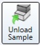
    - Place your sample on the center of the stage and click on the Load sample button. This will bring the stage back to the home position.
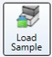
    - Click on the Tower down button to lower the stylus. Make sure that the stylus will land on your sample before lowering!
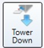

    - Adjust the light intensity and zoom to properly view the sample by using the intensity and zoom sliders at the bottom of the live video window.
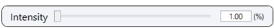

    - The XY position of the stage can be changed by left click grabbing the red dot in the XY window and dragging it in the direction you want to move. The speed is controlled by how far you pull from the center, and also from the slow/med/fast buttons. You can also double-click a feature in the camera view, and it will move to that location.

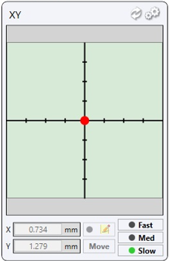

    - Stage rotation can be changed by left click grabbing the red dot in the Theta window and dragging it in the direction you want it to move. Speed is controlled by the slow/med/fast buttons. Clicking on the yellow triangles will move in that direction in
1-degree increments.

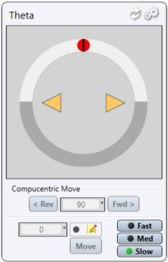
- Measuring A Surface
  - Set Scan Parameters And Start Measurement
    - Click on the Measurement Setup button 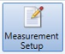on the top instrument ribbon, and then click the Measurement button in the measurement setup window to expand the option window.

    - You will now see the measurement window shown below and you can edit your scan parameters through drop-down menus or text fields.

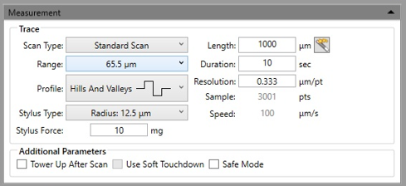

    - Scan Type- Only Standard Scan and Map Scan may be selected. Specialized training is needed for map scanning. Contact NRF staff if map scan is needed.

    - Range- The available vertical resolution depends upon the range selected. Select a range that best matches your topography.

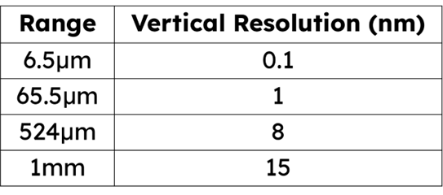

    - Stylus Type- allows you to specify which stylus type is used in your system. Our system is fixed at 12.5µm radius.

    - Stylus Force- You can set the stylus force from 1 mg to 15 mg force.

    - Profile- This setting scales the measurement range according to the profile selected. Three different profiles are available for a variety of sample surface characteristics.
Valleys: Provides 90% of the measurement range below the zero horizontal grid line. Used primarily for measuring etch depths.
Hills and Valleys: Provides 50% of the measurement range above the zero horizontal grid line and 50 percent below. Used in most applications, especially if the surface characteristics of the sample are not well known, or if the sample is out of level.
Hills: Provides 90% of the measurement range above the horizontal grid line. Used primarily for measuring step heights.

    - Scan Length- Scan lengths from 50 μm to 55,000 μm (55 mm) for non-stitched measurements. Contact NRF staff if you need scans greater than 55mm.

    - Scan Duration- Displays the amount of time it takes to complete a given scan. Scan duration, in conjunction with scan length, determines the horizontal resolution of a scan. Therefore, scan speed is directly related to the horizontal resolution.

    - Scan Resolution- Enter the horizontal resolution for the scan length and scan duration. The scan resolution is expressed in um/sample, indicating the horizontal distance between data points.

    - Click on the Single acquisition or Measurement button in the top instrument ribbon to start the scan.
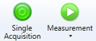

    - After the tip is lowered, if you see that the red stylus reticle does not match the point where the scan originates, then you will need to run the alignment routine. Do this only after setting your scan parameters. To align the reticle, right click in the camera window and select ‘AlignReticle”. This will walk you through the routine.Vertical scanning interferometry (VSI) uses a broadband (normally white) light source. It is effective for measuring objects with rough surfaces, as well as those with adjacent pixel-height differences (steps) greater than 135 nm. Resolution is in the nm range and the maximum height is 10mm.
- Data Analysis
    - When the scan is complete, a data plot window will open as shown below.

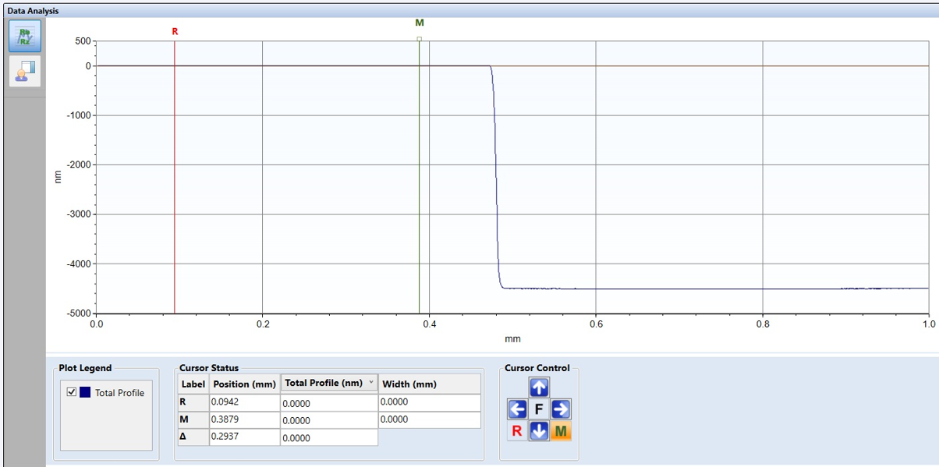

    - If the scan has excessive tilt, then you should level the stage with the knob on the front of the stage. Turning the knob clockwise will move the end of the scan in the up direction.

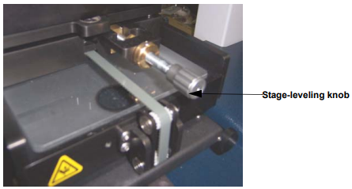

    - The reference (R) cursor and measurement (M) cursor define the portion of the profile trace for leveling or performing analytical functions. You can adjust the bandwidth at each cursor to average the data points within the cursor’s bandwidth. This is useful for leveling and average step height measurements.

    - Position the R and M cursors along the baseline of the step and adjust the bandwidth by clicking it to display small boxes that you can then drag and expand.

    - To level the trace, click the left-right arrows on the Data Leveling button. The profile trace replots and levels with the R and M cursor intercepts at zero. Clicking the actual button will open a dialog box and you select the “Two point linear fit” and then the ‘Calculate” button.
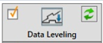

    - Measure the step height by moving the R and M cursors. The measurement is listed in many locations.
- Delta in the cursor status window
- Analytical results window
- Watch list

    - Measuring roughness can be performed in two ways. First move the R and M cursors to the surface you want to measure. Click on the Roughness button and select the roughness values that you wish to include and then click “Calculate”. The values will show up in the Analytical results window. This is a one-time measurement per location.
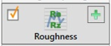

    - The second method is to click on the blue gears on the Watch list and select the roughness values of interest. Close the window and the values will be displayed in the Watch list. These values are constantly updated as you move the R and M cursors.
- Saving Data
    - Click the Save button on the top ribbon and select “Dataset” from the drop-down menu. Create your own folder and save. This will create an ‘OPDX’ extension file that can only be opened in Vision 64.
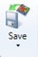

    - To export the scan as a CSV, you can simply right-click on the graph and select “Export CSV”. Create your own folder and save.

    - To just save an image, click on the ‘Copy to clipboard’ button and select the save as bitmap option.

    - Data can be removed by thumb drive.
- Unloading or Exchanging Sample
Warning: Always raise the stylus to exchange another sample or unload any sample. There is a high risk of impacting the stylus and breaking it. If you break the tip due to negligence of not following this SOP, you can be charged for a new stylus. The cost is approximately $800.00

    - Click the Measurement Setup button to have access to the tower options.

    - Click the Tower Home button to raise the stylus. NOT THE TOWER UP BUTTON!
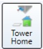

    - Click on the Unload sample button to bring the stage out to the load position and remove your sample carefully.
    - Click on the Load sample button to bring the stage back to the home position.
    - Raise the measurement head about a centimeter above your sample.
- Ending The Session
    - Exit the software

    - Log off TUMI

