
Steag RTA

Standard Operating Procedure
Rev. 2026-01

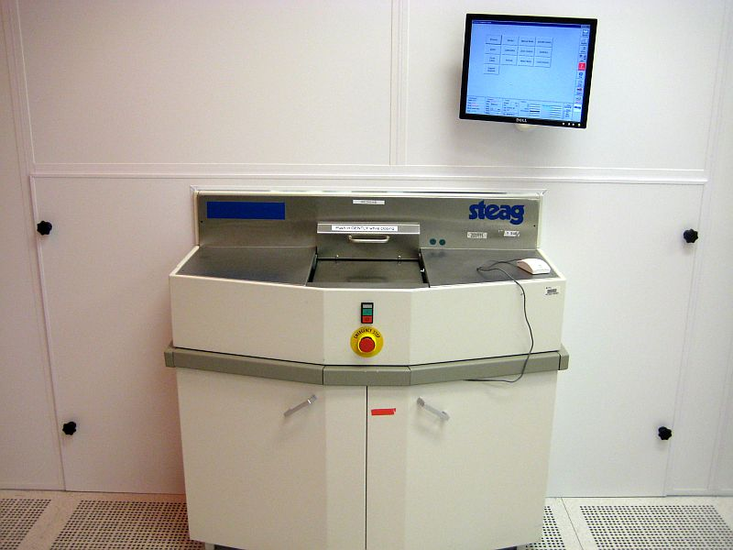

Contents
1
1
Safety 1
Equipment Uses and Restrictions 2
Equipment Specifications: 2
Operation Instructions: 3

Safety
Moving Components – The User should be aware at all times of the moving components associated with this tool. The process chamber reaches temperatures as high as 1050C during processing. Do not abort the process and try to open the chamber door until it has cooled to room temperature. Users are not allowed to adjust any mechanical devices within this machine. If an error or problem occurs, put the system down in the NRF web site with comments and notify NRF Staff. Do not attempt to fix ANY problem. Do not attempt to open the door unless you know the chamber is at room temperature.

Equipment Uses and Restrictions
This tool is for processing thermal processing recipes <5 minutes. Only approved materials may be processed in the RTA system. The risk of cross contamination of materials and of the quartz chamber is very high. Loading the wrong material into the chamber can also cause permanent damage to chamber. You must get approval from NRF Staff before running each sample type. The complete composition of the sample must be documented and emailed to NRF Staff before you may process the sample. It is OK to process exact duplicate samples that have been approved.

Equipment Specifications:

- Atmospheric chamber 100-1050°C
- Process gases include: N2, O2, 4%H2/N2

Operation Instructions:

  - Log onto the Steag RTA via the TUMI system.
  - Click the “Engineer” icon on the right side of the screen. 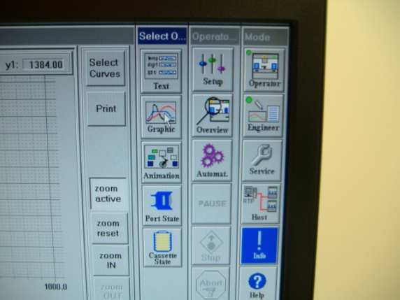
  - Enter the login name and password and click “log on”. The login and password are both the letter “a”.
  - The system must be preheated before you actually run your sample.
  - On the Process Engineering screen click “Batch”, followed by “Load Recipe”.
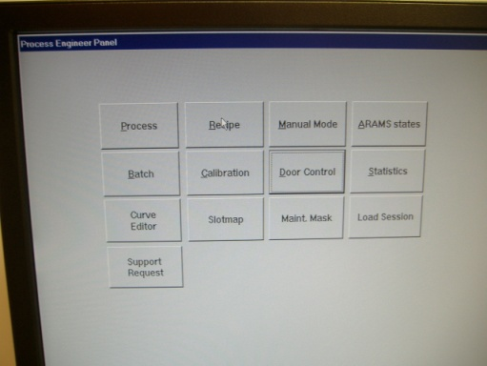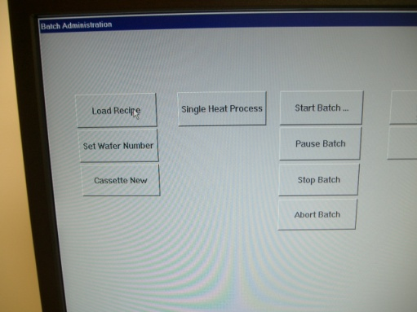
  - Select process named “Preheat200” and click “OK
  - Click “Single Heat Process” and answer “yes”. If an error occurs during the process, contact NRF Staff. DO NOT try to fix anything yourself. When the process temperature reached <40C you may about the recipe by pressing the “abort” button.
  - To watch the process graphics during the run, click the “Operator” Icon in the upper right corner, then “Graphics”.
  - When the process is complete and the temperature of the chamber is <40°C, the chamber door may be opened. DO NOT OPEN THE DOOR UNTIL THE CHAMBER IS COOL. This will take 5-10 minutes depending on the recipe temp. The “Actual” temp can be found at the bottom center of the screen. See pic below
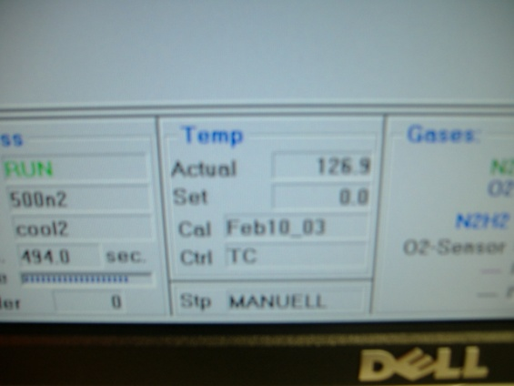
  - If the chamber is cool and less that 40°C, and the recipe is still running, you may abort the recipe by clicking “Abort All” (red stop sign) on the Operator screen. If you do this, the alarm will come on. To acknowledge the alarm, click the red “error” icon and click OK on the error list screen.
  - On the Process Engineering screen click “door control”.
  - Click “open door”. You should hear the door lock open. Carefully and slowly slide open the quartz tray.
  - REMINDER- Every sample type you load into this system must be approved and discussed with NRF Staff. Examples of obvious forbidden materials are photoresist, polymers, polyimide, SU8, lead, iron, cobalt, PZT silicones, just to mention a few. YOU MUST HAVE APPROVAL BEFORE YOU PROCESS.
  - Use clean tweezers to place your sample on top of the 5” wafer as pictured below. DO NOT touch anything inside the chamber, even with your gloved fingers. You may place multiple samples on the wafer. Take extreme care to not move the 2” TC wafer around and do not place your samples on top of the TC wafer. It cost $500. 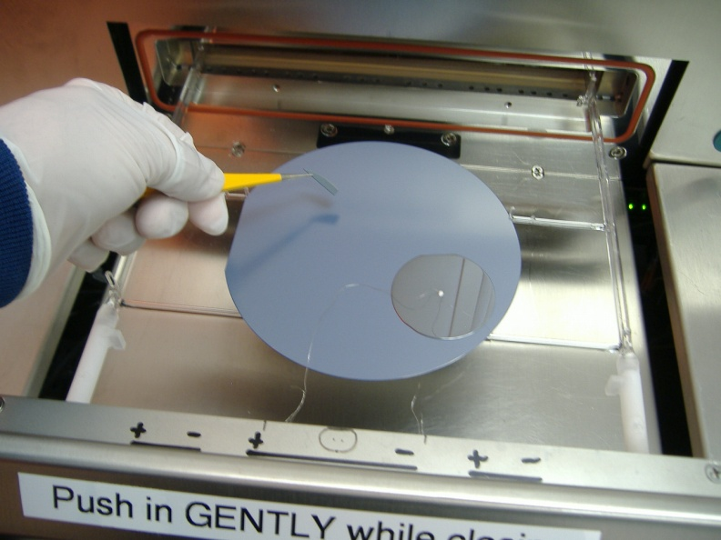
  - If you are loading a 4” wafer, contact NRF Staff and we will show you how to place the wafer.
  - Very carefully slide the chamber tray back into the system. Hold the tray door closed with one hand while pressing the “Close Door” icon. You should hear 2 closing clicks. Verify the door is tightly closed. You should not be able to move the door at all. If you can, call staff and stop procedure.
  - Exit the door control screen and click “Batch”. Click “Load Recipe” if needed and then click “Single Heat Process” and “Yes” to start the process.
  - Click the “Operator” Icon in the upper right corner and then “Graphic” to watch the process.
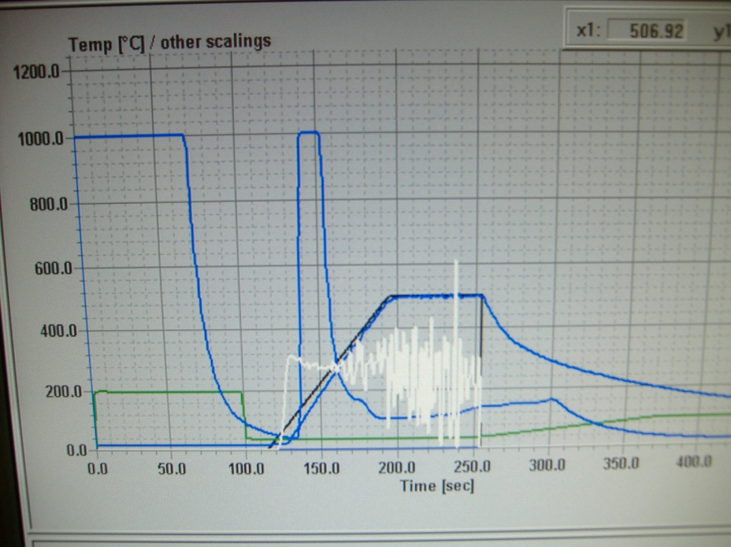

  - The process will take anywhere from 8-15 mins total.
  - Some notes about the process graph….
- The vertical axis is to scale for actual temperature, temp set point and O2 content but not gas flow rate and power output.
- The blue line (starting left)with a value of “1000” is O2 content in PPM.
- The blue line that starts low is the actual temp
- The black line is temperature “setpoint”
- The white line is power output to the halogen lamps i.e. heating power
- The green line is N2 flow. It starts out at 20 SCM (not 200) and then drops to 2 SCM for the heat process. The long flow at the beginning is to remove O2
- If you are running a process with H2N2 or O2, you will need to click the “Select Curves” icon and change which gases are displayed on the graph.
  - You may also click “Text” to see the actual values with the correct scale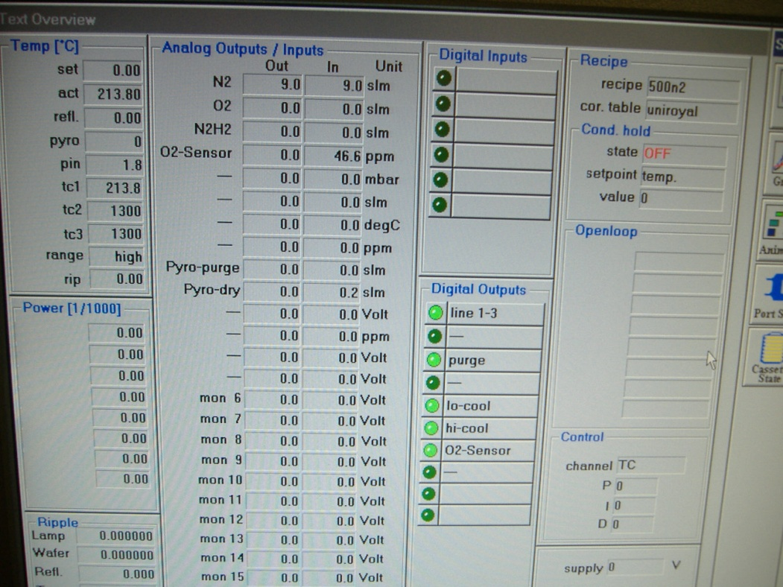
  - When the process is complete and the temperature of the chamber is <40°C, the chamber door may be opened. DO NOT OPEN THE DOOR UNTIL THE CHAMBER IS COOL. This will take 5-10 minutes depending on the recipe temp.
  - If the chamber is cool and less that 40°C, and the recipe is still running, you may abort the recipe by clicking “Abort All” on the Operator screen. If you do this, the alarm will come on. To acknowledge the alarm, click the red “error” icon and click OK on the error list screen.
  - On the Process Engineering screen click “door control”.
  - Click “open door”. You should hear the door lock open. Carefully and slowly slide open the quartz tray.
  - Use clean tweezers to unload your sample
  - Very carefully slide the chamber tray back into the system. Hold the tray door closed with one hand while pressing the “Close Door” icon.
  - Log off of the “Tumi” log computer.

