\

NRF Unaxis ICP/RIE Etch

Standard Operating Procedure

Rev. 2026-01

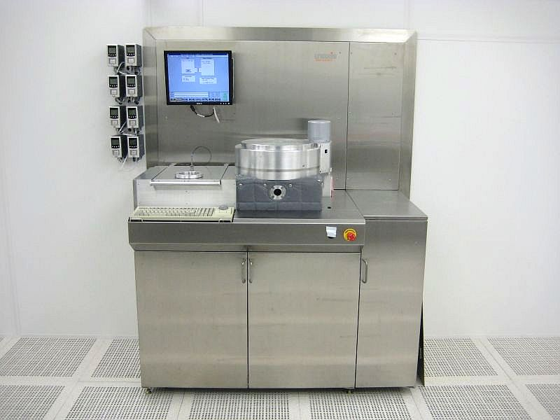

Contents
NRF Unaxis ICP/RIE Etch 1
Standard Operating Procedure 1
Rev. 2026-01 1
Description 2
Safety 2
Restrictions 3
Operation 3
Using the Edge Exclusion Mask 7
Misc. Info 9

Description
Unaxis Shuttlelock Reactive Ion Etcher with Inductively Coupled Plasma Module. Etch Capabilities: SiO2, Si3N4, Al, dielectrics and other commonly used materials. The system is equipped with two 13.56 MHz RF power supplies. A 2KW Inductively Coupled power supply and a 600W RIE power supply. The substrate is Helium cooled. Process Gases Available: Ch1=N2, Ch2=CH4, Ch3=H2 or CHF3, Ch4=Ar, Ch5=SF6, Ch6=O2, Ch7=CL2, Ch8=empty. Only 4” (or 5” with a clamp change) wafers may be loaded into the system. Small samples may be mounted on top of a clean 4” wafer but keep in mind that this will defeat the He cooling capabilities. Process on full 4” wafers for best cooling results.
PHOTORESISTS MAY ONLY BE USED AS A ETCH MASK IN THIS SYSTEM…..I.E. NO PHOTORESIST/POLYMER STRIPPING IS ALLOWED IN THIS SYSTEM. THE UNAXIS 790 RIE IS TO BE USED INSTEAD.

Safety
- Chamber – Do not attempt to vent the process (right) chamber for any reason. Contact NRF Staff for assistance.
- Gas Detection Alarm -The gases supplied to this system are monitored by leak detection sensors in the cleanroom and the service area.
- High Voltage - High Voltage Radio Frequency is used throughout the system. System maintenance may only be performed by Unaxis or NRF Staff. Do not remove any tool covers or defeat any interlock on this system.
- Moving Components - The User must exert caution when opening and closing the loadlock lid. Your fingers after being violently detached by the chamber lid will prevent the system from reaching base pressure.

Restrictions

  - PHOTORESISTS MAY ONLY BE USED AS A ETCH MASK IN THIS SYSTEM…..I.E. NO PHOTORESIST/POLYMER STRIPPING IS ALLOWED IN THIS SYSTEM. THE UNAXIS 790 RIE IS TO BE USED INSTEAD.
  - Only 4” wafers may be loaded in this machine. No photoresists, tapes or adhesives can be within 10mm of the 4” wafer edge…or the wafer will stick to the clamp, possibly breaking your wafer and the wafer clamp. The replacement cost for the ceramic wafer clamp is $7000.00. See section 2.0 for details.
  - If you must load small substrate pieces (i.e. any sample that is not a 4” diameter substrate) on top of the 4” carrier wafer, it must be no closer than 12mm from the edge of the wafer or the ceramic clamp will be broken. The replacement cost for this clamp is $7000.00.

Operation

  - WARNING- The process chamber “Wafer Clamp” can be broken if your sample is not loaded correctly. The replacement cost for the Wafer Clamp if you break it is $7000.00. Failure to follow this SOP may result in Wafer Clamp breakage.
  - Four inch wafers broken in half are never allowed in this tool. If you have an odd sized sample that does not fit per these instructions, consult with staff for a solution. Do not load it and cross your fingers!
  - The tool will only load 4” diameter wafers. Sample pieces will be loaded onto a 4” carrier wafer described below.
  - The Wafer Clamp holds down the entire outer 5mm circumference (including the flat) of a 4” wafer. The outer 10mm of the wafer must not have any Photoresist. It must be removed before loading. Any resist in this area will heat up during the etch process and cause the wafer to stick to the clamp. When this happens the wafer will most likely fall off and break wafer and possibly the Wafer Clamp during wafer unload.

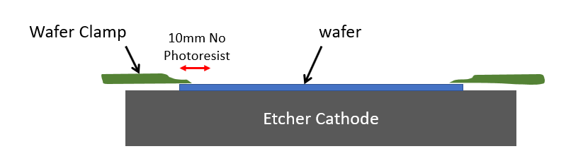

  - Photoresist Removal Options:
- Expose the outside edge after you expose your layer mask i.e. before you develop the wafer. There is a mask in the NRF Litho Bay designed specifically for Unaxis etch. See instructions for how to use the mask Section 3.0 below
- Remove the photoresist using a foam swab and acetone.
  - If you must load small substrate pieces (i.e. any sample that is not a 4” diameter substrate) on top of the 4” carrier wafer, it must be no closer than 12mm from the edge of the wafer or the ceramic clamp will be broken. (see pic below). The replacement cost for this clamp if you break it is $7000.00.

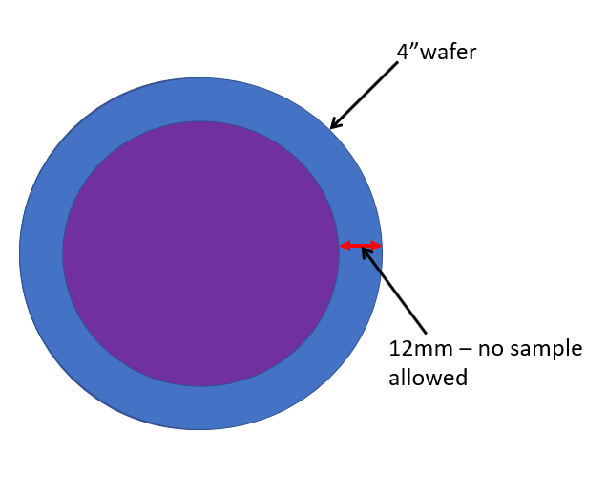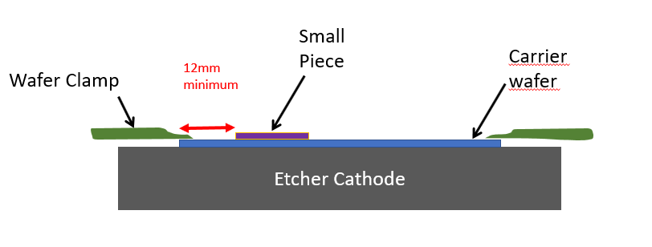

  - The system must be in “Standby” mode for normal processing. If the system is in the “Ready” mode i.e. the “Ready” radio button near the bottom of the screen is highlighted, click the “Standby” radio button to switch modes.

  - Vent the loadlock to load your sample. Click “Service” (top menu), “Maintenance”, “Vent”, “loadlock” and wait for “Atmosphere” to appear in the loadlock status window.

  - Examine your sample. The backside and the outer 5mm of the wafer must be completely free of photoresists, tape, etc. Your wafer will not come back out alive if not. The backside of the wafer must be clean or the He cooling will not work properly.

  - Load your sample on the load arm with the wafer flat in the back. Close the lid and click “Service” (top menu), “Maintenance”, “Pump”, “Loadlock”. Press down on the loadlock for the 1st few seconds while it pumps down. NOTE: If the system does not let you pump down the loadlock it may be that the main chamber is not in the normal pumped down state. The pressure in the main chamber should read 0.0 Torr. You can pump it down (or check that it is pumped down) by clicking “Service” (top menu), “Maintenance”, “Pump”, “Chamber”. You will see the main chamber pressure go down to 0.0 and hear a valve open if it was not already in that state.

  - Load your wafer into the right chamber, click “Service”, “Maintenance”, “Wafer Handling” and on the next screen Wafer Transfer “Load”. Exit out of this screen once the transfer is complete.

  - Click “Service” (top menu), “Manual” to enter the manual process screen.

  - Set the Helium flow to 10 (sccm) lower left of the screen. Turn on the Helium cooling by clicking “Helium - On” (top of screen). Wait 1-2 minutes for the Helium pressure to build up in the cooling gas loop. Check that the Helium Pressure (Torr) reading is >.35. If the pressure is low it may indicate that your sample carrier wafer is contaminated. Unload and check you sample. If you still have issues with He pressure, contact NRF Staff.

  - Set all gas flows to 0.0 in the gas window and enter your desired gas set points. Click the “Gas” On” radio button.

  - Set the desired process pressure in the “Pressure - Chamber (mTorr)” window and click the “Pressure - On” radio button.

  - Set RF1 (RIE) and RF2 (ICP) to desired power.

  - Set the RF process time in the “Run” field. This is the etch time and will start counting when you click “RF On”. Click “RF ON” when ready. When the time has expired, everything will shut off automatically.

  - When the etch is complete, click the “Purge” button at the top of the screen and wait for 3 minutes before unloading your sample from the chamber. This is important as it will help cool the wafer so that it will unload properly and it will purge the chamber.

  - Unload your wafer. Click “Service”, “Maintenance”, “Wafer Handling” and on the next screen, Wafer Transfer “Unload”. Exit out of this screen once the transfer is complete.

  - Vent the loadlock. Click “Service” (top menu), “Maintenance”, “Vent”, “loadlock” and wait for “Atmosphere” to be displayed.

  - When done etching all samples, place a clean dummy wafer back on the load arm. Close the lid and go to “ServiceMaintenancePump Loadlock”. Press down on the loadlock lid for the 1st few seconds while it pumps down.

  - Click "Standby" button ON (bottom left of screen)

  - Click "Process, Batch" This will bring up another window.

  - Click “File, Load” and select O2clean.bch

  - Click “File, Exit”. You must exit before running any process.

  - Click "Ready" button on bottom of screen.

  - Click "Run" on the right bottom of screen. You will see a recipe execution pop up window if done correctly. You can leave the tool. The wafer will load, process and unload automatically.

Using the Edge Exclusion Mask

  - Use the Unaxis Edge exclusion mask located in the Litho Bay near the MA6 to expose the edge. The mask is for positive photoresists.
  - Expose your wafer normally on the MA6. Change the mask to the Edge Exclusion mask and reload your wafer into the MA6.
  - There is a flat alignment mark on the exclusion mask. The mark is 10um wide (see the U shaped white line in the pic below) and can be seen with the 5X alignment objective. Use the left 5X objective for the left end of the wafer flat and the right objective for the right end of the wafer flat. See the pic below. Center the 2 vertical lines to the ends of the flat as shown.
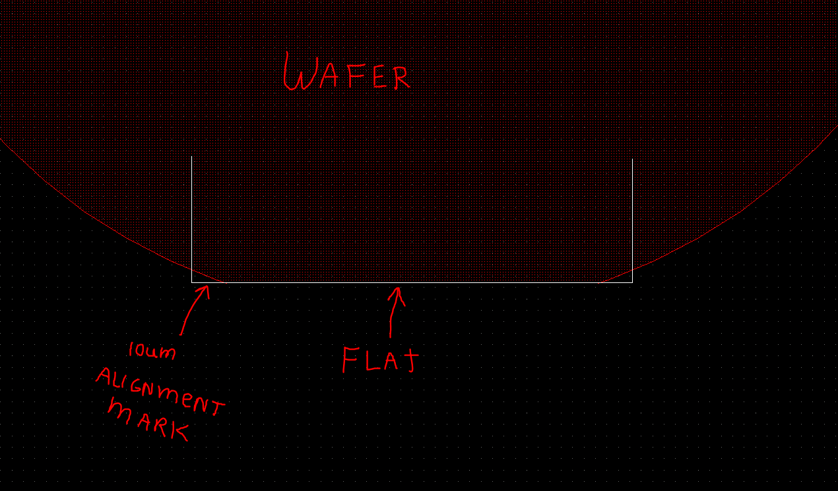

Misc. Info

Unaxis Gas Correction Factors
Channel | Gas | Expected
1 | N2 | 1
2 | CH4 | 0.72
3 | CHF3 | 0.5
3 | H2 | 1.01
4 | Ar | 1.39
5 | SF6 | 0.26
6 | O2 | 0.993
7 | CL2 | 0.86
8 | none

