
Amerimade RCA Wet Bench

Standard Operating Procedure
Rev. 2026-01

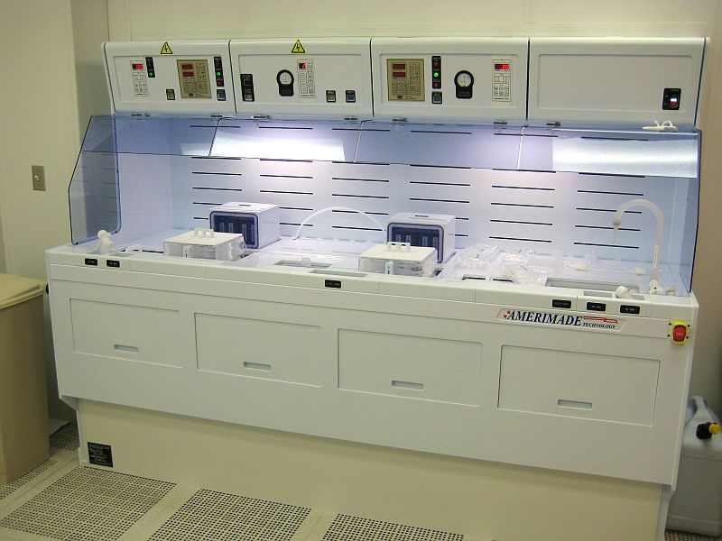

Contents
Bench Features 3
Safety 3
Waste disposal 4
Spills Protocol 5
Chemical Exposure 5
Operation 6
SC1 + HF + SC2 Operation 6
Initial Setup 6
SC1 Organic Clean 9
HF Clean 11
SC2 Metals Clean 11
BOE 6:1 Etch 13
Supplemental Info for NRF Staff 14

Bench Features
Tanks 1, 2 and 4 are dedicated to RCA Process (HF, SC1, SC2) batch/bulk cleans. All SC1/SC2 use of the bench will incur a chemical surcharge. Tank 5 is dedicated to BOE etch. Tank 5 may be used solo (i.e. without performing RCA process) for clean oxide on silicon etch only, see section 7.0. Only clean silicon wafers (pre furnace) or oxide on silicon ONLY wafers may be processed in this bench. No other materials are allowed. STAFF MUST BE NOTIFIED BEFORE EACH USE. WASTE DISPOSAL IS PERFORMED BY STAFF ONLY. See Table 1.0 below for chemicals and tank assignments. No other chemicals are allowed.

Safety
  - Note: This SOP is to be followed in addition to the UF EH&S Lab Safety Policies found at http://www.ehs.ufl.edu/Lab/default.asp
  - This bench may only be used Mon-Fri 8-5. You must notify Staff before EACH use.
  - The safety shower is located across the bay near the JST wet bench. Make sure you know exactly where it is before using this bench.
  - All processes must be reviewed by the researchers PI for safety and compatibility issues which include the review of the Material Safety Data Sheets (MSDSs) for all of the materials used in the process.
  - Any deviation from the procedures written in this SOP must be approved by your PI and a member of Staff, documented and a print out of the new procedure present while working.
  - A copy of this SOP must be present and open during the process run.
  - The following Personal Protection Equipment (PPE) must be worn at all times when working with Acids – NO EXCEPTIONS.
  - Full Face Shield
  - Acid Apron, tied in the back
  - Acid Gloves – 12” or longer
  - Full coverage street shoes i.e. no open toes
  - After donning your gloves, fold the glove back at the wrist to contain drips.
  - When diluting acid, pour acid into water - "Do like you oughta, add acid to water”. Pouring water into acid may cause a very violent reaction.
  - If your samples are in process and you need to walk away from the bench, write your name and date on a piece of paper and place it in front of the tank.
  - The bench deck is not a storage area. All items left will be discarded and future use of the bench will be prohibited.
  - Rinse all tweezers, containers i.e. anything that may have come into contact with acid inside the glove wash compartment or the dump rinser. Rinse your gloves with DI Water before removing PPE.
  - If you intend to re-use your acid apron and face shield (provided it is not contaminated) hang it on one of the hooks provided and attach a name label on the hook. Turn your gloves inside out after removal and dispose. Do not re-use gloves. All contaminated items are to be disposed per section 2.0 Waste Disposal.
Table 1 – Tank Assignments
HF – Hydrofluoric acid 50% - diluted 200:1 | Tank #1
NH4OH – ammonium hydroxide 30% | Tank #2
H2O2 – hydrogen peroxide 30% | Tank #2 and #4
HCL – hydrochloric acid 38% | Tank #4
BOE 6:1 | Tank #5

Waste disposal

  - Read and review the UF Policy (http://www.ehs.ufl.edu/HMM/HWguide.pdf )
  - All process chemicals contained within Tanks 1-5 will be disposed of by Staff ONLY. Contact Staff when chemical disposal is needed.
  - Contaminated consumables: Laboratory wipes, gloves, arm guards, swabs and other disposable materials that have been contaminated with hazardous substances should be set aside for proper disposal after the user is finished processing. There is a small trash can labeled ACTIVE PROCESS TRASH next to the wet bench which is specifically for process contaminated debris. There should be three trash bags (one inside the other) folded over the rim of the can. Once the work area is cleaned and the debris is placed in the can rinse the gloves and tie the inner most bag, squeezing out as much air as possible. Rinse the gloves again and tie the secondary bag and then the third bag in the same fashion. Once the three bags are securely tied the package can be transferred to the normal trash. Always thoroughly rinse gloves with DI water before removing then inside out and disposal in the normal trash. Similarly, aprons are to be removed so that they are inside out before disposal.
  - Broken glass lab ware is to be handled and disposed by staff. All sharp process materials (broken wafers, pipettes, slides, etc) are to be disposed on in the proper container; NOT in the normal trash cans. Sharp objects in the normal trash can compromise the safety of users and cleaning staff.

Spills Protocol

  - Minor spills / droplets on the wipes on the bench top may be cleaned after the process during clean up. Notify Staff of spills larger than > 10 ml.
  - ANY spill out side of the wet bench top must be cleaned by NRF staff. Evacuate the processing area and call for clean up, staff will notify users when cleanup is complete.

Chemical Exposure

  - It is the policy of the NRF that hazardous and or toxic substances will not be used without a safety back-up person present to give emergency aid. This person can give aid and or contact emergency response personnel should the user become incapacitated. Should hazardous chemical exposure happen; response time is critical.
  - All direct contact of user’s skin to hazardous materials will be reported to the facility staff as soon as is permissible. Severely exposed individuals should be placed under the safety shower with no delay and clothing removed. Rinse for at least 15 minutes. If there was no initial exposure to the eyes, the eye protection should be removed last. In the event of splash exposure to the eyes, the injured person should be helped to the eyewash station and the eyes be rinsed while holding the eyes open for five minutes while emergency aid summoned.

Operation

SC1 + HF + SC2 Operation

Initial Setup

    - Do not start this process after 4PM.
    - On the Tumi computer, log onto “Amerimade Bench HF/BOE” and “Amerimade Bench SC1/SC2”. You must log onto both to enable the SC1/SC2 tank heaters.
    - NOTE : SC1 and SC2 filled tank may be used up to 2 times by spiking the tank with H2O2. If you need SC1 and SC2 clean 2 times within the same week, the tanks do not need to be emptied after the first use. It may be used twice before dumping. Contact Staff for instructions
    - Rinse tanks 1, 2 and 4 using the DI water gun and siphon out using the aspirator.
    - Open the QDR (quick dump rinser) tank lid and leave it open during this entire procedure.
    - Open the HF Tank #1 lid. If it is full, then filling the tank will not be needed and you can skip to step 5.1.5
    - If the tank is empty, pour 3000ml of DI water into HF tank #1 using a 1 liter graduated beaker.
    - Pour 50ml of 50% HF into HF tank #1.
    - Add 1950ml of DI water to tank #1. This will provide mixing action for the solution. The final solution strength is 200:1 - H2O:HF.
    - Place the lid on HF tank #1.
    - IMPORTANT - When filling tanks 2 and 4 in the following procedure, the maximum liquid level shall NEVER exceed the red line shown below which is 5mm from the bottom of the Amerimade Lettering printed information label. The Liquid should never be as high as the letters in the label.

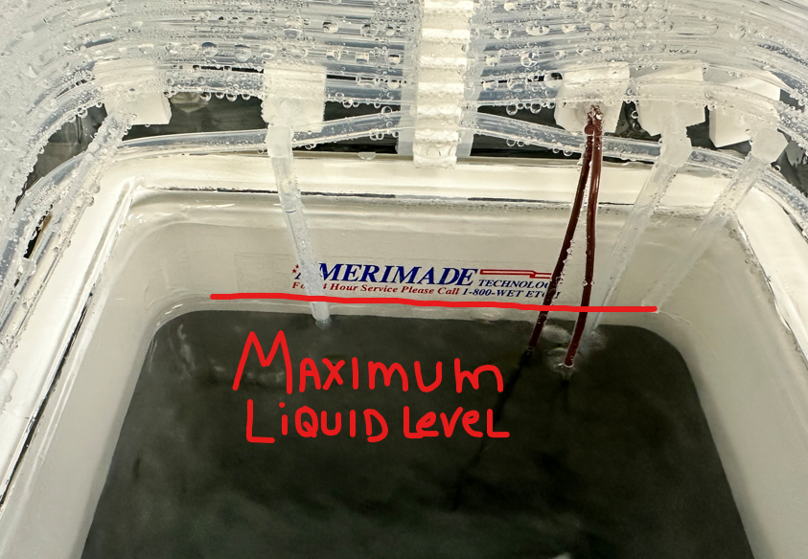

    - If the liquid makes it to this level and you are still not done with the pouring instructions, STOP and immediately contact staff for help. Do not continue adding liquid to attempt to trip the L Level sensor.
    - Triple rinse a 1 Liter glass beaker using the DI water gun. Hold over the Quick Dump Rinser while rinsing.
    - Pour 6000 ml of DI water into SC1 tank #2 using a 1 liter graduated beaker. Use the DI water gun to fill.
    - Pour 1000 ml of Ammonium hydroxide into SC1 tank #2.
    - Triple rinse the graduated beaker inside the quick dump rinse tank using the DI water gun.
    - Pour 7800 ml of DI water in SC2 tank #4 using a 1 liter graduated beaker.
    - Pour 100 ml of Hydrochloric acid in SC2 tank #4.
    - Triple rinse the graduated beaker inside the quick dump rinse tank using the DI water gun.
    - Add 1000ml of Hydrogen peroxide to tank 2.
    - Add 100ml of Hydrogen peroxide to tank 4.
    - The “L Level” light on the Bath Controllers should be “off” now, indicating that the heater is enabled and the fluid level is adequate. Contact Staff at this point if the low level lights are still “ON” for either tank and stop procedure. Do not add liquid.
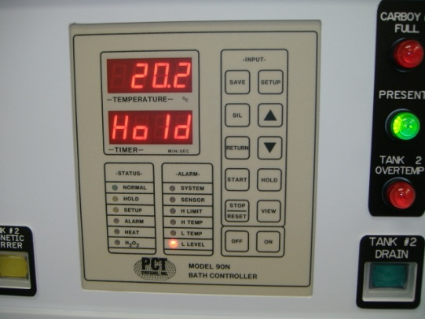
Bath Controller with low level light “on”.

    - Verify the “Hydroseal Left” and “Hydroseal Right” are ON and flowing 10GPH. Contact NRF Staff immediately if it does not turn on.
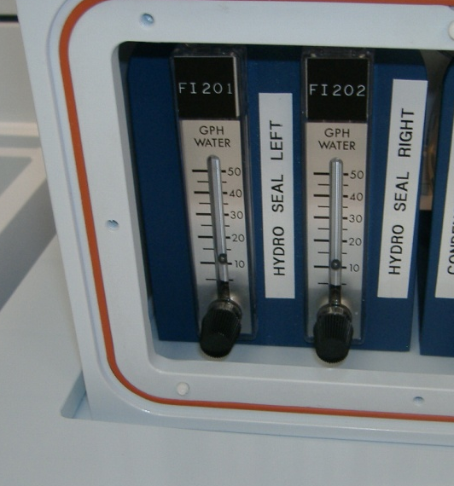

    - Press the “view” button on tank 2 and 4 controllers to verify setpoint is 75°C. If it is not, press “setup” once and change the PS parameter to 75 and press “save”. Press “return” to exit.
    - Press the “hold” buttons on Bath Controllers for tanks 2 and 4 to start heating.
    - Place the lids back on tanks 2 and 4.
    - Rinse your gloves thoroughly using the glove rinse box. Do not allow the water spray up near the glove cuffs. The rinse box water is activated by pressing your finger against the pressure sensor, located inside the box on the left side. Dry your hands using a clean wipe. Don’t use the N2 gun. Wait for the tanks to get up to 75°C.

SC1 Organic Clean

    - NOTE : SC1 filled tank may be used up to 2 times by spiking the tank with H2O2. If you need SC1 clean 2 times within the same week, the tanks do not need to be emptied after the first use. It may be used twice before dumping. Contact Staff for instructions
    - Press the “setup” button on the bath controller once to display “CS” and set the countdown time to 10m minutes using the up/dwn buttons. Press the “return” button to exit setup.
    - Attach the Fluoroware handle to the ends of the cassette H bar as shown in the picture below. Make sure it is secure. When lifting the cassette via the handle only hold onto the upper horizontal bar, not the lower bar. Your gloves shall never go into the liquid.
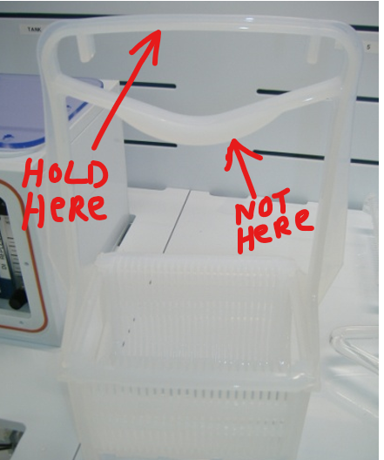

    - Load your sample into tank #2 and press the “start” button.
    - When the sample in tank 2 is done, lift out of the bath using the cassette handle (grasp only the very top bar of the handle) and lightly shake off excess liquid. Wait until the cassette is not dripping.
    - Place samples in the filled dump rinse tank (tank 3). Press the start button on the dump rinser controller. The QDR will cycle 3 times. Press stop/reset when done to silence the alarm. Rinse the top of the cassette handle with the DI water spray gun while it is inside the dump rinser.
    - Replace the lid for tank #2.
    - Rinse your gloves thoroughly using the glove rinse box. Do not allow the water spray up near the glove cuffs. The rinse box water is activated by pressing your finger against the pressure sensor, located inside the box on the left side. Dry your hands using a clean wipe. Don’t use the N2 gun.
    - If you are done using tank #2, turn off the heater by depressing the “hold” button on the controller.
    - Press “open” on the QDR controller so the water will drain out of the tank.
    - Notify Staff by email when you are done using the bench so the chemical may be dumped. If you will need to use the bench again within the next week, let Staff know that also.

HF Clean

    - Verify the lids for tanks 2 and 4 are in place.
    - Place the samples in HF tank #1. The oxide removal rate for 20:1 HF is approximately 90A/min. Oxide is removed when the wafers are hydrophobic, and the liquid does not adhere to the Si surface when lifted out of the bath. Native oxide takes about 10 seconds for removal.
    - When the sample in tank 1 is done, lift out of the bath using the cassette handle and lightly shake off excess liquid. Wait until the cassette is not dripping. Do not move the samples over the top of tank 2 when transferring to the QDR tank. Move samples around the back of tank 2 (i.e.over the top of the water box) if possible so HF doesn’t drip around or into tank #2.
    - Place samples in the filled dump rinse tank (tank 3). Press the start button on the dump rinser controller. The QDR will cycle 3 times. Press stop/reset when done to silence the alarm. Rinse the top of the cassette handle with the DI water spray gun while it is inside the dump rinser.
    - Rinse your gloves thoroughly using the glove rinse box. Do not allow the water spray up near the glove cuffs. The rinse box water is activated by pressing your finger against the pressure sensor, located inside the box on the left side. Dry your hands using a clean wipe. Don’t use the N2 gun.
    - Press “open” on the QDR controller so the water will drain out of the tank.
    - Notify Staff by email when you are done using the bench so the chemical may be dumped. If you will need to use the bench again within the next week, let Staff know that also.

SC2 Metals Clean

    - Note: if the bath you are using was not poured today, contact NRF Staff for spiking instruction.
    - Press the “setup” button on the bath controller once to display “CS” and set the countdown time to 10m minutes using the up/dwn buttons. Press the “return” button to exit setup.
    - Attach the Fluoroware handle to the ends of the cassette H bar as shown in the picture below. Make sure it is secure. When lifting the cassette via the handle only hold onto the upper horizontal bar, not the lower bar. Your gloves shall never go into the liquid.

    - Load your sample into tank #4 and press the “start” button.
    - When the sample in tank 4 is done, lift out of the bath using the cassette handle (grasp only the very top bar of the handle) and lightly shake off excess liquid.
    - Place samples in the filled dump rinse tank (tank 3). Press the start button on the dump rinser controller. The QDR will cycle 3 times. Press stop/reset when done to silence the alarm. Rinse the top of the cassette handle with the DI water spray gun while it is inside the dump rinser.
    - Replace the lid for tank #4.
    - Rinse your gloves thoroughly using the glove rinse box. Do not allow the water spray up near the glove cuffs. The rinse box water is activated by pressing your finger against the pressure sensor, located inside the box on the left side. Dry your hands using a clean wipe. Don’t use the N2 gun.
    - When the QDR is done, move your sample carrier over to the open sink on the far right side of the bench. Use the Sitek Spin Rinse Dryer to rinse and dry the wafers. You will need to arrange training with staff to use it dryer. Alternately, you can and use the N2 gun to dry your samples. To completely dry your samples if N2 gun is used, you will need remove them from the Fluoroware and bake them at 100-120°C oven.
    - If you are done using tank #4, turn off the heater by depressing the “hold” button on the bath controller.
    - Notify Staff when done so that they can empty the chemical tanks.
    - Press “open” on the QDR controller so the water will drain out of the tank.
    - On the Tumi computer, log off “Amerimade Bench HF/BOE” and “Amerimade Bench SC1/SC2”. CHECK THE “POST TO TOOL STATUS” button when logging off the Tumi and log a comment “DONE WITH CHEMICALS” so that NRF Staff will know they can dump your chemicals.

BOE 6:1 Etch

    - On the Tumi computer, log onto “Amerimade Bench HF/BOE”.
    - Tank #5 is permanently dedicated to BOE 6:1 and will normally be filled. This tank is for silicon with oxide only. No other substrates may be etched without consultation and permission from NRF Staff.
    - If the tank is not full or needs to be cleaned, contact NRF Staff. Do not attempt to drain this tank by any method.
    - Place your samples in the appropriate Flouroware wafer holder, no glass allowed. When done etching, do not move the samples over the top of tank 4 when transferring to the QDR tank. Move samples around the back of tank 4 (i.e. over the top of the water box) if possible so BOE doesn’t drip around or into tank #2.
    - Place samples in the filled dump rinse tank (tank 3). Press the start button on the dump rinser controller. The QDR will cycle 3 times. Press stop/reset when done to silence the alarm. Rinse the top of the cassette handle with the DI water spray gun while it is inside the dump rinser.
    - Rinse your gloves thoroughly using the glove rinse box. Do not allow the water spray up near the glove cuffs. The rinse box water is activated by pressing your finger against the pressure sensor, located inside the box on the left side. Dry your hands using a clean wipe. Don’t use the N2 gun.
    - When the QDR is done, move your sample carrier over to the open sink on the far right side of the bench. Use the Sitek Spin Rinse Dryer to rinse and dry the wafers. You will need to arrange training with staff to use it dryer. Alternately, you can and use the N2 gun to dry your samples. To completely dry your samples if N2 gun is used, you will need remove them from the Fluoroware and bake them at 100-120°C oven.
    - Press “open” on the QDR controller so the water will drain out of the tank.
    - Notify Staff if the tank becomes contaminated.
    - Log off the Tumi.

Supplemental Info for NRF Staff

N2 Flow Rates
Heater level =1.0
High High Level =1.0
Glovewash Flow = 2
Headcase Purge =20-25
Hydroseal Flow =10GPH

Note: the tank drain valves for tanks 2 and 4 are disabled once the heaters go higher than C and must be reset before each draining. This will prevent users from attempting to drain the tanks. The HF tank drain air is disabled so that only Staff can drain.

