

Filmetrics F40

Standard Operating Procedure Rev. 2026-01

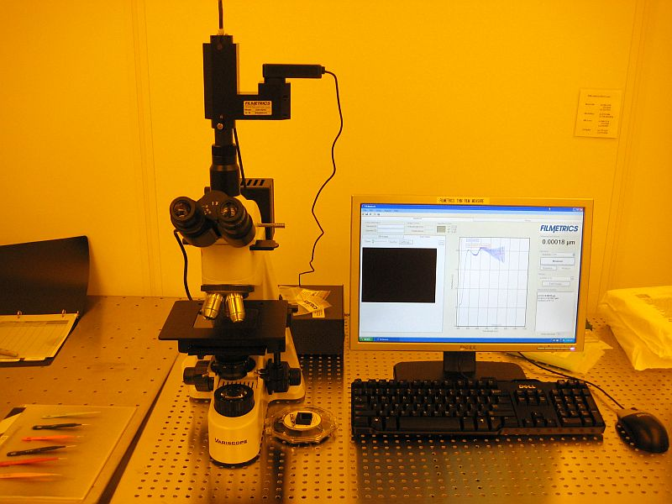

  - Application

The F40 is a reflectometer used to measure the thickness and optical constants of thin, transparent/semi-transparent films. By fitting it to a microscope the tool can have a measurement spot size down to ~10µm. Commonly measured films include, oxides, nitrides, photoresists, polysilicon and optical coatings. Films that cannot be measured include very rough films and metal films.
  - NRF Contact

David Hays

Table of Contents
1. Safety information 3
2. Prerequisites for use 3
3. Operation 4
3.1. Start Up 4
3.2. Sample Loading And Baselining 4
3.3. Scanning The Sample 5
4. Saving And Removing Data 5
5. Ending The Session 5

- Safety information
- None
- Prerequisites for use
- User of the RSC facilities.
- Up-to-date hazardous waste training.
- Training by staff.
- User will be responsible for lost or damaged equipment due to negligence. Negligence means not following the SOP, not asking staff for assistance, intentionally damaging items, etc.
- Operation
  - Start Up
    - Turn on top lamp for microscope to highest setting. The lamp control is the black box to the right of the microscope.
    - Double click the Filmeasure icon to start the software if not already running.
    - Log on (if previous user closed the software)
      - Name = nrfuser
      - Password = nrfuser
    - Click the “Live video” tab
    - Select recipe from pull-down menu. If a recipe needs to be created, contact the NRF staff and one can be made relatively easily if your film is in our database. If a material file does not exist then we will need a sample of your film to create one.
    - Select the objective. Objective versus measurement spot size and thickness range is shown in section below.
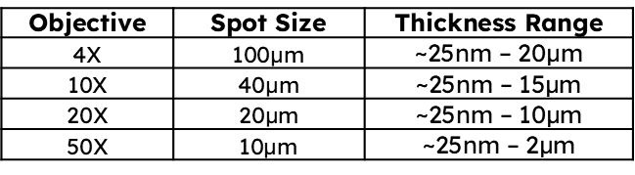
  - Sample Loading And Baselining
    - Place your sample on the stage and focus on the surface. Films without topography can be difficult so close the F-Stop aperture and adjust focus until the edges of the aperture appear sharp.
    - Click the “Baseline” button. A baseline needs to be done when first logging onto the tool, when changing objectives, or after adjusting the light source. Failure to do so will result in larger measurement error.
    - Click the “Acquire sample” button.
    - Remove your sample and place the Silicon reference on the stage and focus.
    - Click the “Acquire reference” button.
    - Remove the Silicon reference and place the 45° Tilt Reference on the stage and place the light source in the middle of the tilted surface.
    - Click the “Acquire background” button.
    - Click the “Finish” button.
  - Scanning The Sample
    - Place your sample back on the stage, focus, and click the “Measure” button.
    - Check that the measurement makes sense and the Goodness Of Fit (GOF) for the model is close to 1.
- Saving And Removing Data
    - You can save a screen shot to file as an image. Click “File” then “Save” screen to file, or you can click on the icon that looks like a screen with a diskette.
    - The measurement spectrum can be saved by clicking on the diskette icon. They can be saved as Filmetrics files or a csv file that can opened in other plotting software.
    - If multiple measurements were made, the measurement history can also be saved. Click on the “History” tab, select any unwanted files from previous users and click the “Delete selected” button. Now, either click “Copy” and then paste it to Excel, or click “Save as” button and save it as a csv file.
    - Use a thumb drive to save to your device.
- Ending The Session
    - Log off TUMI

