
YES Image Reversal and HMDS Oven

Standard Operating Procedure
Rev. 2026-01

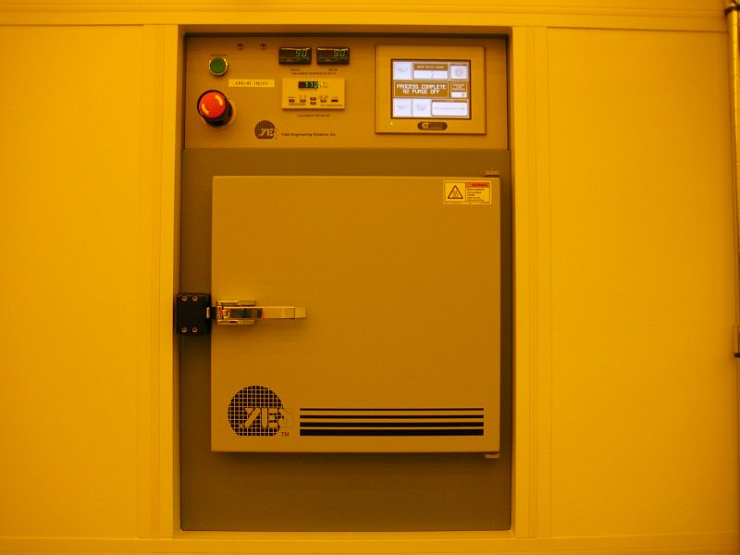

Contents
Safety 2
Controls and Calibrations 2
Processes Description 2
Process Information for Lift Off 3
Operation 4

Safety
- Heat – The inside chamber and inside door will be very hot (up to 150 ºC) and will cause severe burns if touched. Do not touch the sample tray or inside oven walls.
- Gases – Ammonia is used in this equipment. The odor threshold for NH3 is approx 5ppm which is way below the IDLH of 300ppm. The door seals and chamber walls will absorb a small amount of ammonia and you may smell it at very low levels. It should never be irritating. If you smell strong ammonia, immediately evacuate the area and notify NRF Staff.
- Refer to the “NRF Clean Room User Operations Manual” for detailed information about clean room alarms.
- If the system aborts during processing, select and run recipe 10 to return to atmosphere.

Controls and Calibrations

    - The oven temperature is checked once per year. The actual temperature is not critical for process control.

Processes Description

The YES 310-TA Image Reversal/HMDS Oven is capable of several different processes. The basic process descriptions are as follows:

Image reversal of positive tone photoresist. Negative images may be formed with higher resolution, ease of use and superior edge quality provided by positive photoresist. Image reversal provides reentrant sidewall profiles for lift off processes via a single resist application. HMDS adhesion layer formation. The oven cycles from vacuum to 10 Torr with hot N2 refills to remove water followed by a HMDS vapor treatment to form a HMDS monolayer. The Silizanes bond with the silicon and the methyls bond with the photoresist.
Vacuum Bake to 150 ºC. Note: curing photoresists, polyimide, spin-on silicon, PDMS etc. is not allowed in this oven.
Vacuum Bake cycling with hot N2 refills. Note: curing photoresists, polyimide, spin-on silicon, PDMS etc. is not allowed in this oven. Atmospheric hot N2 environment bake. Note: curing photoresists, polyimide, spin-on silicon, PDMS etc. is not allowed in this oven.

Process Information for Lift Off

The main benefits for using image reversal on positive resists instead of negative tone photoresists or an inverted mask are: higher resolution, re-entrant sidewalls so that it’s easier to sputter materials without bridging, smoother sidewall edges.

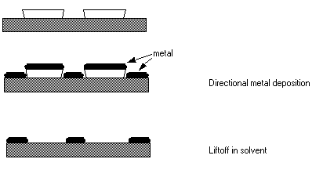

There are three parts to an image reversal process: Image Exposure Dose, Ammonia Exposure, Flood Exposure

Image Exposure Dose- The image exposure dose is the main controlling factor of the edge wall angle. The profile can be tailored by varying the amount of exposure. Underexposure leads to an undercut profile, while overexposure can lead to a rounded profile. In most cases, 70% of the normal dose to size should provide a 15-20° undercut. To determine the amount of undercut, matrix the exposure from 50% to 200% of your normal imaging exposure.

Ammonia Exposure - The main factor in this step is the temperature of the exposure. The objective is to react the exposed resist with the ammonia without damaging the remaining photoactive compound in the resist. Most people run between 75 and 100°C with 90° being the most common and the temperature at the NRF. The length of time of the exposure step is not as critical as the objective to go to completion. Resist films of less than 5 microns should be run at about 45 minutes. Thick films of up to 50 microns have been run successfully using longer exposure times to allow the ammonia to diffuse through the film. If the images fall off the wafer during the develop step, then lengthen the time of the ammonia exposure. Contact NRF Staff if you need to adjust the temp or time parameter.

Flood Exposure - When the wafers have been exposed to ammonia, then the remaining photoactive compound must be exposed. Due to the long bake during the ammonia step, the flood exposure should be 2-3 times the normal imaging exposure. Once again, over-exposure is not an issue, so longer is better. You are trying to expose ALL the remaining photoactive compound. Develop as normal. Due to the length of the bake, the develop step may have to be increased somewhat, but that will depend on your resist process (thickness, soft bake temp, etc) .

The basic process flow for Image Reversal is:

- Clean substrate
- Dehydration bake-adhesion promotion
- Spin on positive tone photoresist
- Standard softbake
- Exposure (dose determines sidewall slope)
- Image Reversal – NH3 exposure
- Flood exposure at 2x to 3x normal expo dose
- develop

Operation

NOTE: This oven will normally be set up to run Image Reversal Process. HMDS mode is used for large batches of samples or if the thermal conductance of your sample is poor such as a thick glass substrate. The HMDS hotplate in the solvent hood is normally used for small numbers of samples. You will need to contact NRF Staff to run in HMDS mode. A sign above the system will indicate which process is presently set. Contact NRF Staff if the process type needs to be changed back to Image Reversal.

  - The YES control display will be off until you log onto the tool using the TUMI login system notebook at the end of bay.
  - Verify that the sign above the YES Oven indicates “Image Reversal” mode is set.
  - Verify that the oven is idle before proceeding and the temperature is correct for your process. The screen will display “reset state” (or “process complete” if it just completed a sample) as shown below when idle.
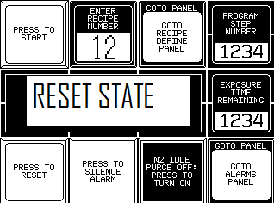
Figure 1.0

  - Press “Press to Reset” icon.
  - Press “ENTER RECIPE NUMBER” and select recipe (2 for Image Reversal). See table below for recipe #’s.

Recipe # | Description
1 | HMDS
2 | Image Reversal
3 | Vacuum Bake with N2 flow
4 | Vacuum Bake

  - Open the door and place your sample horizontally on the sample tray in the center of the oven. Take care not to touch anything and use tweezers
  - Close and latch the door. Depress “PRESS TO START”. The image reversal process takes approx 1 hour 20 minutes.
  - If the system errors during processing, press “RESET” and select and run recipe 10. This recipe will return the chamber to atmosphere after performing some pump/vent cycles. Note: the system will always alarm if you select the wrong recipe for the mode it is set for i.e. if you run the HMDS recipe with system in image reversal mode.
  - When done, the yellow light status light will illuminate and “process complete” will be displayed on screen.
  - Press the reset button and remove your sample.
  - Log out of the TUMI log system.

