
NRF Lithography Processes

Standard Operating Procedure
Rev. 2026-01

Contents
HMDS Adhesion Promotion and Dehydration Bake 2
AZ9260 / EVG620 or Suss MA6 Process Recommendations 3
AZ1512 (or S1813) and Suss MA6 Process Recommendations 7
AZnLOF 2020/2035 Processing 9
K6008 / EVG620 / Suss MA6 Process Recommendations 12
LOR 3A Processing 15
LOR 3A with AZ1512 (OR S1813). (For this example I used 0.5µm LOR3A) 16
LOR 3A with AZ9260. (For this example I used 1µm LOR3A) 17
Liftoff Process for AZ1512 Image Reversal – MA6 and Heidelberg 19
Photoresist Baking 20
Hotplate Operation 8 21
Tekvac 4” Wafer Hotplate 21
CEE Hotplate 22
Wenesco Hotplate - LOR 23
Softbake 24
Oven Softbake 25
Hardbake 26
Photoresist Removal 28
Type 1 PR Strip 28
Type 2 PR Strip 28
Type 3 PR Strip 29
Type 4 PR Strip 29
Type 5 Plasma Bulk PR Strip 29
Flood Expose Procedure 30
Reduced Energy Exposure for Better Dose Control 30

HMDS Adhesion Promotion and Dehydration Bake

  - HMDS adhesion treatment is recommended for most samples.
  - Surface preparation is very important for proper photoresist adhesion. If you are reworking a sample (i.e. stripping photoresist and starting over) it is especially important to clean and dry the substrate properly. See section 7.0 Photoresist Removal for tips.
  - NOTE: the following procedure applies to substrates with relatively high thermal conductivity i.e. crystalline silicon, but is not recommended for thermally insulating substrates such as glass thicker than a standard glass slide. YES Oven HMDS treatment is recommended for thick samples. See the “YES Oven SOP” for instructions.
  - During the HMDS process, the sample will be heated from 90-130°C to drive off water. Then HMDS vapor exposure will form a hydrophobic surface monolayer that will aid in photoresist adhesion. It will also help to prevent developer from leaching under the photoresist substrate interface during develop.

HMDS Hotplate Operation Instructions.
-the HMDS hotplate is located inside (far right side) Stainless Amerimade bench at the end of the Litho Bay
- Open hotplate lid and place sample on the hotplate surface.
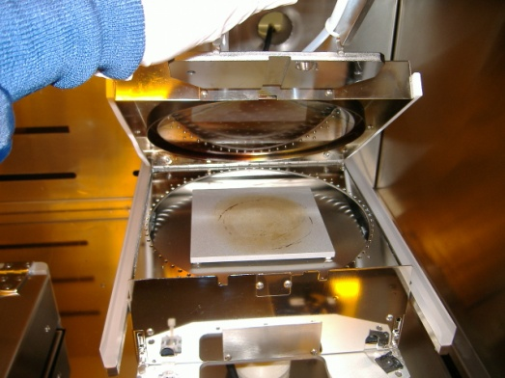
HMDS Hotplate
- Wait 3 minutes to drive off moisture.
- Depress the manual HMDS vapor actuator (black mushroom button) in front of the hotplate.
- Hold the button down by hand for 30 seconds.
- Release the button and wait 1 minutes.
- Remove your sample and place it on the cold plate at least 20 seconds to bring sample back to room temp.
  - If you have more than 10 wafers that require HMDS treatment, it is faster and easier to use the YES Oven in HMDS mode for adhesion. The YES HMDS process takes about 30 minutes for a full cassette of wafers. See the “YES Oven SOP” for instructions.

AZ9260 / EVG620 or Suss MA6 Process Recommendations

  - Perform HMDS bake. See section 1.0
  - Apply photoresist on the Laurell Spinner. Use the chart below to determine the casting spin speed.
  - The recommended procedure for spinning 9260 on 4” wafer is as follows. Smaller substrates can be prepared the same way but use only enough pipetted PR to cover 50-80% of the piece.
  - Prepare an automatic recipe with the following steps.
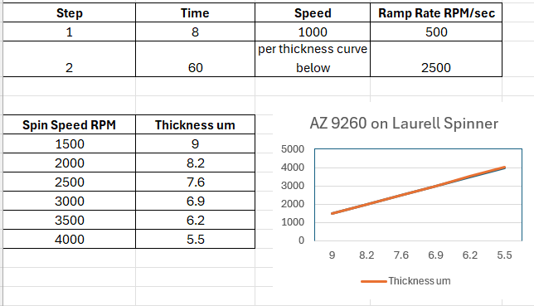

  - Edit the recipe per above suggestion. Switch Laurell to “OFF” using F1 key so that it’s in automated mode.
  - Load the 4” wafer. Load the pipette with =>3ml of AZ9260. Let bubbles rise up out of the tube if present.
  - Dispense 3.0ml onto the center of the 4” wafer (less for smaller pieces). It’s best to not dispense the bubbles out at the end of dispense. Immediately close the lid and press the “Start” button.
  - Refer to AZ9260 PROCESS TABLE below for process times for the following steps.
  - For 4” wafers, bake on the Tekvac Hotplate or the CEE Hotplate per instructions section 7.0. Do Not use the Wenesco Hotplate. For samples other than 4” wafers, bake on the CEE Hotplate.
  - Leave samples in open air in the Litho bay to allow the photoresist to rehydrate. See AZ9260 PROCESS TABLE for times.
  - Expose on the Suss MA6 or EVG620 aligner. The recommended mode for exposures on both aligner tools is “Hard Contact” mode. The exposure time in AZ9260 PROCESS TABLE was determined empirically on bare silicon. The dose for your sample will vary depending on the substrate reflectivity. Doses for SiO2 will need to be increased. Doses for most reflective metals such as aluminum will be similar to silicon.

NOTE: A dose test using various energies is always recommended for a new process/mask/substrate etc… There is a fixture you can use to accomplish this on a single 4” wafer. Ask staff for help.

  - DEVELOP PROCEDURE for consistent results - Mix 3:1 (water;developer) for faster develop times and slightly more dark erosion (less contrast) or 4:1 for slower develop time and more contrast. Use the following rules:
- Rinse graduated cylinders thoroughly before each use.
- USE A 25-50ml GRADUATED CYLINDER (tall thin cylinder) TO MEASURE 400K. Do not use a wide beaker. The ratio of water to developer is very important and develop time will be affected if mixed improperly.
- For all samples, use 20ml of developer to 60 DI water in a 6” round beaker for 3:1.
- Do not re-use developer that has been in open air >15 minutes. Develop speed changes rapidly.
- If you have multiple samples to develop, expose them all and then develop them one after another or together.
  - Refer to AZ9260 Process Table below for suggested develop times. If your sample does not develop all the way you can always put back in developer for a little extra time.
  - Remove your sample from the develop beaker using tweezers and immediately place under running water from the DI water gooseneck on the develop bench. N2 dry.
  - De-scum – To remove residue in normally cleared areas of the pattern. Run sample in Anatech Asher for 1 minute @ 300W, Gas 1-O2@300sccm. Skip this step if your sample is susceptible to RF damage.
  - Hard bake – hard bake is not needed or recommended for AZ9260.
AZ9260 Process Table

 |  | NRF Suggested Process for AZ9260 – Hot Plate Bake -Tekvac or Cee Hotplate
Standard thickness substrate=baresilicon
thickness | bake time @112°C min:sec – Tekvac or CEE Hotplate Vacuum contact Mode |  |  | rehydration delay time @ 50% relative humidity |  |  | Approximate exposure dose - Suss MA6 |  | Approximate exposure dose –  EVG-620 | dev time - diluted AZ 400K 3:1 (DI:400K) | dev time - diluted AZ 400K 4:1 (DI:400K)
um | Min:sec |  |  | min:sec |  |  | mj |  | mj | min:sec | min:sec
6 | 3:00 |  |  | 5:00 |  |  | 140 |  | 140 | 3:30 | 9:00
7 | 3:00 |  |  | 7:00 |  |  | 163 |  | 163 | 4:00 | 9:20
8 | 3:00 |  |  | 8:00 |  |  | 186 |  | 186 | 4:30 | 9:40
9 | 3:00 |  |  | 10:00 |  |  | 209 |  | 209 | 5:00 | 10:00
10 | 3:00 |  |  | 12:00:00 |  |  | 232 |  | 232 | 5:30 | 10:20
11 | 3:00 |  |  | 14:00:00 |  |  | 255 |  | 255 | 6:00 | 10:40
12 | 3:00 |  |  | 16:00:00 |  |  | 278 |  | 278 | 6:30 | 11:00
 |  | If you must use oven bake due to thick substrate (consult with Staff) – use Despatch Oven - 30 minutes@105⁰C. The develop time must be increased for oven baked samples. Refer to the table below.
Develop Times for oven baked samples
thickness | dev time - diluted AZ 400K 3:1 (DI:400K) |  | dev time - diluted AZ 400K 4:1 (DI:400K)
um | min:sec |  | min:sec
6 | 6:00 |  | 14:00
7 | 6:30 |  | 14:30
8 | 7:00 |  | 15:00
9 | 7:30 |  | 15:30
10 | 8:00 |  | 16:00
11 | 8:30 |  | 16:30
12 | 9:00 |  | 17:00

Note: rehydration for 50um film will take 15 hours at 50% relative humidity. The humidity inside the NRF cleanroom is maintained at 50%. Insufficient rehydration may cause some photoresist profile degradation.

2.11 For multiple coats to obtain >10um films: Apply layer 1, softbake @112C for 80 seconds, Apply layer 2, softbake at 112C for 3 mins.

AZ1512 (or S1813) and Suss MA6 Process Recommendations

  - Perform HMDS baking. See section 1.0.
  - Apply photoresist on the Suss Delta 80.
  - For 4” wafers, bake on the Tekvac Hotplate or the CEE Hotplate for 1 min per instructions section 7.0. The Wenesco Hotplate may be used for 4” wafers for 2 mins. For samples other than 4” wafers, bake on the CEE Hotplate.
  - Expose on the Suss MA6 aligner. The dose for your sample is dependent many variables including substrate reflectivity. The dose for SiO2 or films that act antireflective will need to be increased 10-20%. High reflectivity metals such as aluminum should be similar to silicon.
  - The approximate dose for AZ1512 (or S1813) on bare silicon substrate pattern features can be calculated by the following formula:
- (PR Thickness in microns) x (35) = dose in mj.
- Exposure time in seconds = (dose in mj) / (MA6 CH1 365nm Power)
- NOTE: If the smallest critical dimensions for your mask is <3um and the calculated dose is less than 6 seconds, it’s recommended that you increase the exposure time by reducing the energy using the neutral density filter. See section 10 for instructions.
  - Notes about <3um pattern feature sizes……..
- For exposure of features smaller than 3um, you will need to perform an exposure dose matrix. Consult with Staff for advice about performing a dose matrix.
- Features <3um are difficult to make accurately and reproducibly, especially over large surface areas. This is mainly due to the difficulty in making good contact between the mask and the sample. The wafer is not perfectly flat and the mask is not perfectly flat. “Vac” expose mode is best for 4” wafers. Consult with Staff for help and settings of vacuum mode parameters. Mask and wafer must be very clean.
- “Vac” mode may only be used for 4” wafers or (using the small substrate check) 2” wafers and quartered 4” wafers. Consult with staff.
  - Develop for 75 seconds in AZ 300MIF developer. Only use enough fluid to submerge your sample. Please don’t waste developer. For a single 4” wafer, use approximately 60ml in a 6” round breaker. Do not re-use developer more than 10 minutes after it was dispensed. The develop speed changes rapidly. If you have multiple samples to develop, use a little more developer, and expose them all and then develop them one after another in the same develop bath. You can develop up to 5 wafers with 120ml of developer without affecting develop speed.
NOTE: developer speed decreases with time. Do not use developer that has been in open air for more than 10 mins.
  - Remove your sample from the develop beaker using tweezers and immediately place under running water from the DI water gooseneck on the develop bench. N2 dry.
  - De-scum – To remove residue in normally cleared areas of the pattern. Run sample in Tepla or Anatech Asher for 1 minute @ 300W, Gas 1-O2@300sccm. Skip this step if your sample is susceptible to RF damage.
  - If you are wet etching your sample, no hardbake is needed or recommended.
  - If you are Plasma Etching your sample you may require hard bake. Hardbake not usually required silicon etching. Hard bake temperature for AZ1512 (OR S1813) is 125°C. See section 6.4 for hardbake instructions.

AZnLOF 2020/2035 Processing

AZnLOF 2000 series is a negative photoresist designed specifically for liftoff processing. The resist produces and negative (undercut) profile to reduce deposition of material on sidewalls and allow access for solvents to liftoff the film.

  - Perform HMDS baking. See section 1.0

  - Apply photoresist using the Laurell spinner. Double coats may be used to obtain thicker films.

  - For 4” wafers, bake on the Tekvac Hotplate or the CEE Hotplate per instructions section 7.0. Bake 1 min per micron thickness. For samples other than 4” wafers, bake on the CEE Hotplate.
  - See section 7.0 for bake instructions
    - When double coating, bake first film for 1 minute at 112°C, then follow the 1 minute per micron bake after the second coating. But, film may only crosslink up to approximately 3.5um total thickness due to poor light penetration.
CAUTION…Do not let the second coat sit for long on the first layer. The solvent rich second coat will dissolve your first layer and will result in much thinner films than expected.
  - Expose on the Suss MA6 aligner. Use the chart below to determine the dose required.
    - NOTE: If the calculated dose is less than 6 seconds, it’s recommended that you increase the exposure time by reducing the energy using the neutral density filter. See section 10 for instructions. This may apply to thinner diluted nLOF.
Resist Thickness (µm) | Dose (mJ/cm2)
1.5 | 80
2 | 95
3 | 110
4 | 125
5 | 140
6 | 155
7 | 170

- Exposure time in seconds = (dose in mJ/cm2) / (MA6 CH1 365nm Power)
  - A post exposure bake MUST be performed for this resist. Bake at 112°C (or 105°C for more pronounced undercut) for 1 minute Tekvac Hotplate (or Cee Hotplate) for 4” wafers, Cee Hotplate for everything else. Do not bake on the Wenesco hotplate. This bake time does not vary for thickness. See section 7.0 for bake instructions.
  - Develop time for nLOF 2020/2035 (AZ 300MIF developer) can vary depending on the amount of undercut desired. The time should be no less than 2 minutes but can go as long as 3.5 minutes for more undercut.
    - For films between 2 – 3µm thick, a 2 minute develop will produce ~0.5µm undercut. A 3 minute develop will produce ~0.8µm undercut.
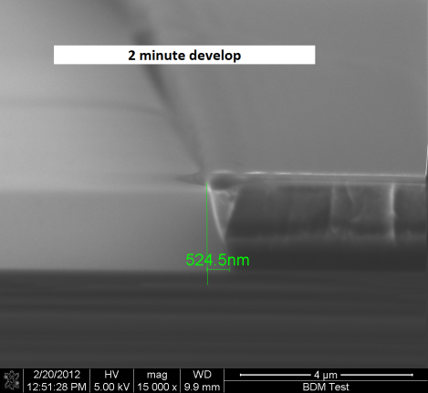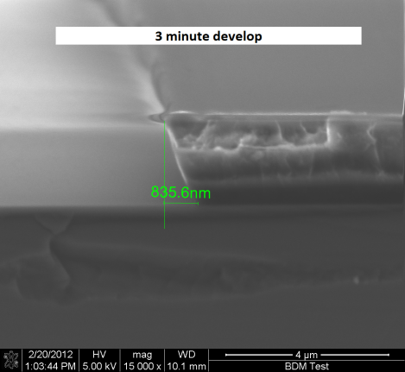
    - Because light can only penetrate ~3µm into this resist, thicker films will not be sufficiently cross linked and undercut will be much larger. Undercut will vary greatly with film thickness so you will need to run test samples and cross-section them to determine your desired undercut. See example below.
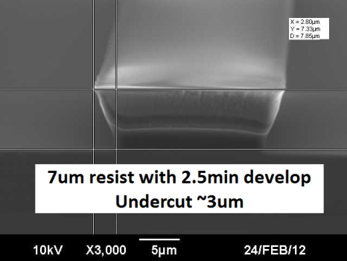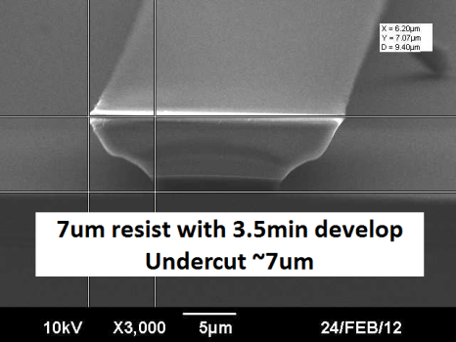
- Note the nearly isotropic undercut after a depth of ~3-4µm, due to lack of cross linking. This is normal for thicker AZ nLOF films so do not try to correct with over-exposing.
    - Only use enough fluid to submerge your sample. Please don’t waste developer. For a single 4” wafer, use approximately 60ml in a 6” round breaker. Do not re-use developer that has been in open air >15 minutes. The develop speed changes rapidly. If you have multiple samples to develop, use a little more developer, and expose them all and then develop them one after another in the same develop bath. You can develop up to 5 wafers with 120ml of developer without affecting the develop speed.
  - Remove your sample from the develop beaker using tweezers and immediately place under running water from the DI water gooseneck on the develop bench. N2 dry.
  - De-scum – To remove residue in normally cleared areas of the pattern. This will greatly increase adhesion of the deposited film. Run sample in Anatech Asher for 1 minute @ 300W, Gas 1-O2@300sccm. . The Tepla asher may also be used at 100W, 300sccm O2, 1 min..
  - Skip this step if your sample is susceptible to RF damage
  - No hard bake is needed for this resist. In fact, never perform a hard bake with this resist because it makes it very difficult to remove.
  - For lift-off or resist removal, only heated TECHNISTRIP MLO07will remove it. Use the heated resist strip, or liftoff bath, in the solvent bench in the wet process bay. Acetone will only crystallize this resist and will not remove it.

K6008 / EVG620 / Suss MA6 Process Recommendations

  - Perform HMDS bake. See section 1.0
  - Refer to K6008 PROCESS TABLE below for process times for the following steps.
  - Coat the sample on the Suss Delta 80 spinner. See Delta 80 SOP for procedure.
  - For 4” wafers, bake on the Tekvac Hotplate or the CEE Hotplate per instructions section 7.0. Do Not use the Wenesco Hotplate. For samples other than 4” wafers, bake on the CEE Hotplate.
  - Expose on the Suss MA6 or EVG620 aligner. The recommended mode for exposures on both aligner tools is “Hard Contact” mode. The exposure time in K6008 PROCESS TABLE was determined empirically on bare silicon. The dose for your sample will vary depending on the substrate reflectivity. Doses for SiO2 will need to be increased. Doses for for most reflective metals such as aluminum will be similar to silicon. NOTE: A dose test using various energies is always recommended for a new process/mask/substrate etc… There is a fixture you can use to accomplish this on a single 4” wafer. Ask staff for help.
  - DEVELOP PROCEDURE
  - Normally for a 4” wafer, the 6” cylindrical glass beaker is used. Measure 50-60ml of AZ 300MIF developer. It can be measured using the hand pump when dispensing. You only need enough developer to cover the top of the sample.
  - Do not re-use developer that has been in open air >10 minutes. Developer speed changes rapidly when exposed to air.
  - If you have multiple samples to develop, expose them all and then develop them one after another or together.
  - Refer to K6008 Process Table below for suggested develop times. If your sample does not develop all the way you can always put back in developer for a little extra time.
  - Remove your sample from the develop beaker using tweezers and immediately place under running water from the DI water gooseneck on the develop bench. N2 dry.
  - De-scum – To remove residue in normally cleared areas of the pattern. Run sample in Anatech Asher for 1 minute @ 300W, Gas 1-O2@300sccm. Skip this step if your sample is susceptible to RF damage.
  - Hard bake – hard bake is not normally needed for K6008.
K6008 Process Table

 |  |  | NRF Suggested Process for K6008 – Hot Plate Bake w/vacuum contact
substrate=baresilicon
thickness - NRF Suss Delta 80 |  | bake time @112°C min:sec -Tekvac or CEE Hotplate Vacuum Mode |  | Approximate exposure dose -NRF Suss MA6 | Approximate exposure dose -NRF EVG 620 | dev time – 300MIF/ minutes
um |  | Min:sec |  | mj | mj | min:sec
4 |  | 3:00 (Plasma Etch Bake 6:00) |  | 105 | 95 | 1.5
5 |  | 3:00 (Plasma Etch Bake 6:00) |  | 120 | 110 | 1.5
6 |  | 3:00 (Plasma Etch Bake 6:00) |  | 135 | 125 | 2
7 |  | 3:00 (Plasma Etch Bake 6:00) |  | 150 | 140 | 2
8 |  | 3:00 (Plasma Etch Bake 6:00) |  | 165 | 155 | 2:30
9 |  | 3:00 (Plasma Etch Bake 6:00) |  | 180 | 165 | 3
10 |  | 3:00 (Plasma Etch Bake 6:00) |  | 195 | 180 | 3
14 |  | 3:30 (Plasma Etch Bake 7:00) |  | 240 | 230 | 3:30
 | Despatch Oven 30 minutes@105⁰C for thick substrates. The develop time must be increased for oven baked samples.

  - For multiple coats: Apply layer 1, softbake @112C for 80 seconds, Apply layer 2, softbake at 112C for 4 mins (or greater). The resist surface should be hard after it cools to room temperature i.e. it should scratch easily and not feel tacky.

LOR 3A Processing

LOR 3A is a PMGI based resist that is intended to be used for bi-layer liftoff purposes. It is designed to be used in conjunction with standard photoresists and is compatible with all positive and negative types we use. The “A” series has a slower dissolution speed and is more controllable when compared to the “B” series. The following is a guide for processing the “A” series only! NOTE: Liftoff processes using LOR are time consuming and complicated when compared to negative photoresist such as AZ2035 or positive PR with “Image Reversal Process”. It is normally needed when you have features that are smaller than 3um. Consult with staff if unsure.

  - HMDS adhesion promote is typically not needed but a 5 minute bake at 80-120°C is recommended. LOR has excellent adhesion on most clean surfaces. If using HMDS follow procedure as outlined in Section 1.
  - Apply LOR 3A using the Laurell spinner litho bay. Double coats may be used to obtain thicker films. The LOR is your liftoff layer and should be ~3X your deposited metal/film thickness.

  - Bake at 190°C for 5 minutes on the back right Wenesco Hotplate, use the vacuum ports during bake. See Section 6 for bake instructions. Consult with staff if unsure what plate to use.
    - When double coating, bake first film for 1 minute at 190°C,
    - then bake for 5 minutes after the second coating.

LOR 3A with AZ1512 (OR S1813). (For this example I used 0.5µm LOR3A)
NOTE: Liftoff processes using LOR + AZ1512 are time consuming and complicated when compared to using negative photoresist such as nLof 2035. Consult with NRF Staff for more information.
    - After LOR application and bake. Apply 2.5µm coating of AZ1512 (OR S1813) using spin/bake/expose conditions from Section 3. Remember, the AZ1512 (OR S1813) is NOT the liftoff layer so thickness does not matter.
    - Develop using AZ300MIF only! Develop time of ~2.5 minutes will clear both layers and result in an undercut of ~0.5µm.
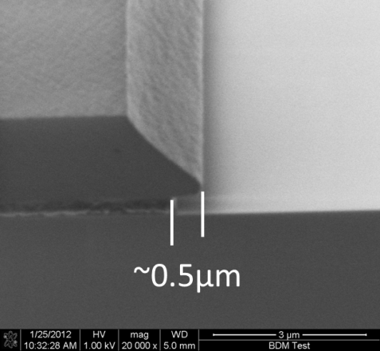
The bulk dissolution rate of LOR 3A is ~170Å/sec (i.e. the LOR area not covered by photoresist). LOR is slightly photosensitive so the rate can increase up to ~200Å/sec for high exposures.
The photoresist undercut rate is ~50Å/s
    - Only use enough fluid to submerge your sample. Please don’t waste developer. For a single 4” wafer, use approximately 60ml in a 6” round breaker. Do not re-use developer that has been in open air >15 minutes. The develop speed changes rapidly. If you have multiple samples to develop, use a little more developer, and expose them all and then develop them one after another in the same develop bath. You can develop up to 5 wafers with 120ml of developer without affecting the develop speed.
    - Remove your sample from the develop beaker using tweezers and immediately place under running water from the DI water gooseneck on the develop bench. N2 dry.
    - De-scum – To remove residue in normally cleared areas of the pattern. This will greatly increase adhesion of the deposited film. Run sample in Anatech Asher for 1 minute @ 300W, Gas 1-O2@300sccm. Skip this step if your sample is susceptible to RF damage.
    - For lift-off or resist removal, only heated TECHNISTRIP MLO07will remove it. Use the heated resist strip, or liftoff bath, in the solvent bench in the wet process bay. Acetone will only crystallize this resist and will not remove it.

LOR 3A with AZ9260. (For this example I used 1µm LOR3A)
    - After LOR application and bake. Apply 6µm coating of AZ9260 using spin/bake/expose conditions from Section 2. Remember, the AZ9260 is NOT the liftoff layer so thickness does not matter.
    - Develop using AZ300MIF only! Develop time of ~7 minutes will clear both layers and result in an undercut of ~1µm.
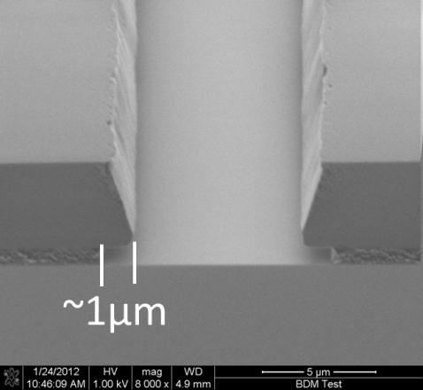
The bulk dissolution rate of LOR 3A is ~170Å/sec (i.e. the LOR area not covered by photoresist). LOR is slightly photosensitive so the rate can increase up to ~200Å/sec for high exposures.
The photoresist undercut rate is ~50Å/s
    - Only use enough fluid to submerge your sample. Please don’t waste developer. For a single 4” wafer, use approximately 60ml in a 6” round breaker. Do not re-use developer that has been in open air >15 minutes. The develop speed changes rapidly. If you have multiple samples to develop, use a little more developer, and expose them all and then develop them one after another in the same develop bath. You can develop up to 5 wafers with 120ml of developer without affecting the develop speed.
    - Remove your sample from the develop beaker using tweezers and immediately place under running water from the DI water gooseneck on the develop bench. N2 dry.
    - De-scum – To remove residue in normally cleared areas of the pattern. This will greatly increase adhesion of the deposited film. Run sample in Anatech Asher for 1 minute @ 300W, Gas 1-O2@300sccm. Skip this step if your sample is susceptible to RF damage.
For lift-off or resist removal, only heated TECHNISTRIP MLO07will remove it. Use the heated resist strip, or liftoff bath, in the solvent bench in the wet process bay. Acetone will only crystallize this resist and will not remove it.

Liftoff Process for AZ1512 Image Reversal – MA6 and Heidelberg

The following procedure has only been tested with metal thickness <3500A + photoresist thickness >1.2um. For patterns with features <3um or for patterns that require high uniformity or reproducible results, the Heidelberg tool is highly recommended. See Staff for advice.

Warning – If using the Mask Aligner, this procedure will require a mask that is the binary opposite of the positive photoresist mask. Metal will remain in the non-exposed or chrome areas of the mask.

NOTE: There are some Advantages to this Process over LOR liftoff process:
- It only requires one photoresist and can be done in the automated Delta 80 spinner.
- The film to be exposed is more uniform since the need to spin one polymer layer (which is always problematic) is eliminated.
- The pattern resolution and uniformity is better due to the above fact.
- Less possibility for User induced problems since there are fewer process steps. Manual LOR spinning in the Laurell Spinner is not needed.
- You don’t have to worry about getting the develop time exactly correct to create undercut. The undercut is created by the inversion or reversal of the feature sidewall slope.
- Metal features down to 1um are possible if the Heidelberg is used. This can also be done using LOR but dose and focus are more critical.
- Expensive LOR chemical not needed.

  - Perform HMDS baking. See section 1.0.
  - Apply photoresist on the Suss Delta 80.
  - For 4” wafers, bake on the Tekvac Hotplate or the CEE Hotplate 1 min per instructions section 7.0. For samples other than 4” wafers, bake on the CEE Hotplate.
  - See section 7.0 for bake instructions
  - For Suss MA6 Exposure
  - Expose on the Suss MA6 aligner per the instructions in section Note: Image reversal requires a higher than normal dose when possible for best results.
  - For Heidelberg Exposure
    - Exposure for image reversal will require a higher than normal dose for proper crosslinking. If you need to obtain exact sizing of deposited features you will need to adjust feature sizes using spot size correction and exposure dose….i.e. run an array of conditions. See Staff for help.
    - For additional info regarding this process, see the power point file “Liftoff - AZ1512 (OR S1813) Image Reversal” on the web site under “Docs” for the MA6 or Heidelberg.
  - Load the sample in YES Oven. Run recipe #2, it takes about 1.5 hours.
  - Flood expose the sample on the Suss MA6 aligner. The total dose should be approximately 3X the normal exposure dose. Set the MA6 mode to “Flood” and just lay the sample on top of the 4” wafer holder. No mask.
  - Develop for 1 minute in AZ400K 1:4 developer (i.e. 1 part 400K:4 parts DI water). Do not re-use developer that has been in open air >10 minutes. The develop speed changes rapidly.
  - Remove your sample from the develop beaker using tweezers and immediately place under running water from the DI water gooseneck on the develop bench. N2 dry.
  - De-scum – To remove residue in normally cleared areas of the pattern. Run sample in Anatech Asher for 1 minute @ 300W, Gas 1-O2@300sccm.
  - Metal should be e-beam evaporated using the PVD system up to 3500A thickness. Sputtered metals may work with this process but have not been tried.

Photoresist Baking

NOTE: Substrates with poor thermal conductivity, (i.e. <50W·m-1·K-1) such as glass, should never be baked on a hotplate. Use the Despatch ovens for all baking. Use the YES Oven for HMDS application. As a general rule, oven bake times are 30 minutes long and 10 degrees lower than the recommended hotplate temperature. If in doubt about your process, ask NRF Staff for help.

NOTE: To obtain the correct thickness for Suss Delta 80 (as described in the recipe name) applied photoresist, you must follow the baking instructions below.

Hotplate Operation 8

Tekvac 4” Wafer Hotplate
This plate is for 4” wafers only. The wafer is baked for a specific time automatically. It may also be used with N2 inert purge though it is not really needed for most photoresists. To change the hotplate temperature set point, press and hold the left * button and press the up/down keys. The temp is normally kept at 112C. If you change it, return it to 112C when done.
  - The plate temperature must be at the setpoint for the pins to move down.
  - Photoresist on the backside of your sample will cause non uniform baking and contaminate the hotplate. Check the backside of your sample for PR or particles. Remove backside PR with acetone a very lightly moistened foam swab.
  - Place your wafer on top of the lift pins with the edge against the 2 white alignment posts as shown below.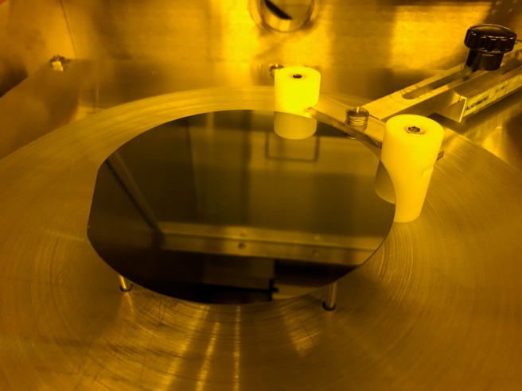
  - Set the timer. The numbers on the dial are 2X the actual time in minutes. For It can be adjusted by turniing the outerside ring. 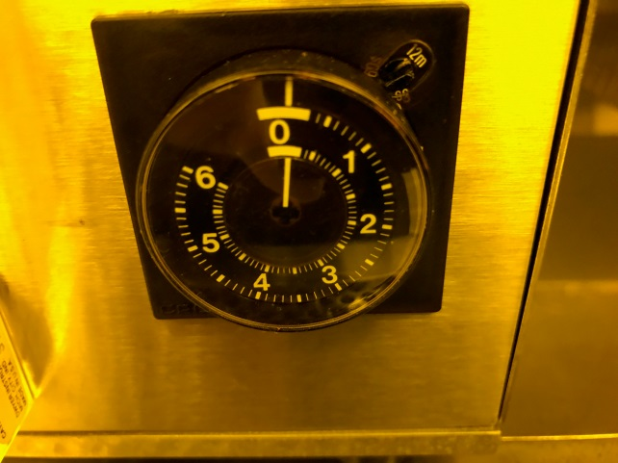
  - If you need to use the N2 inert purge, close the hotplate door and rotate the N2 purge flowmeter knob CCW for a flow rate of 20-25 l/min. Wait 2 mins before starting the bake. Make sure you close the flowmeter when done!
  - To start bake, press the black button above the flowmeter. The lift pins will lower the wafer and vacuum will turn on to hold the wafer tight to the hotplate surface. 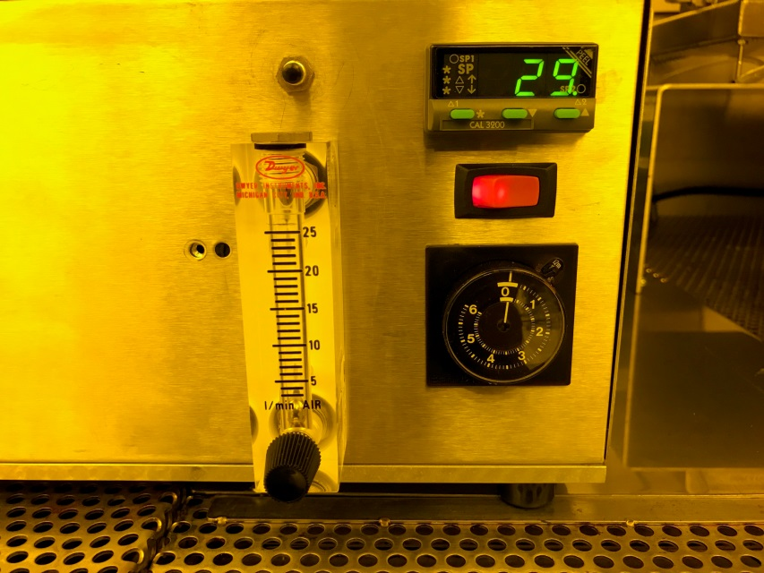
  - The lift pins will raise when the timer is done.

CEE Hotplate

  - Photoresist on the backside of your sample will cause non uniform baking and contaminate the hotplate. Check the backside of your sample for PR or particles. Remove backside PR with acetone a very lightly moistened foam swab.
  - Load vacuum bake recipe name “112VxMIN”where x is the recommended time in mins. When you run the vacuum bake recipe, vacuum is applied to all the small holes on the plate. NOTE: The large holes in the plate are not used. 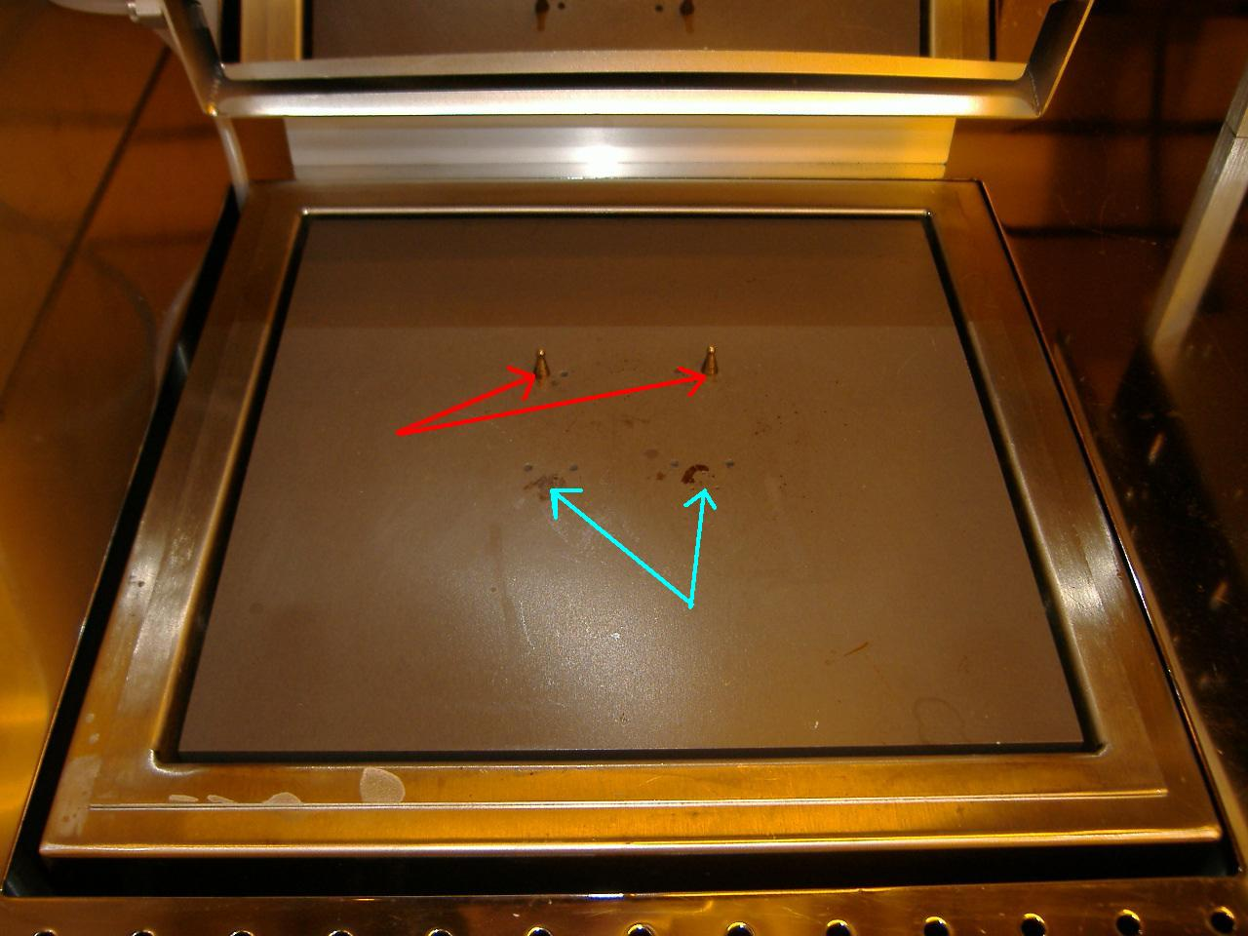
  - Load the recipe and press the start button. After the recipe starts, place your sample directly on the small vacuum holes. Choose the group that will apply the most vacuum holes to your sample.
  - The program will beep when done. Slide the sample to the opening at the edge of the plate and pick up with tweezers. Place it on the cold plate located to the right of the CEE Plate.

Wenesco Hotplate - LOR

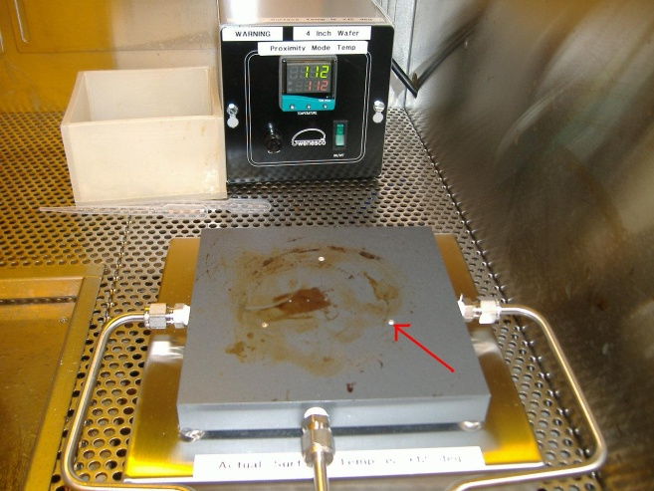
Wenesco Hotplate

  - The set point is normally set to 190C and the bake time is 5 mins. The temp can be changed to 180C if faster undercut is desired.
  - Note: the 3 white ceramic standoff pins for proximity bake are no longer being used and are now recessed in the plate.
  - Place your sample over the 3 small holes located in the center of the plate and turn the vacuum valve(s) ON. The handle is pointed “down” for ON. There is one valve per vacuum hole. The valve positions correspond to the hole positions, left, center and right. 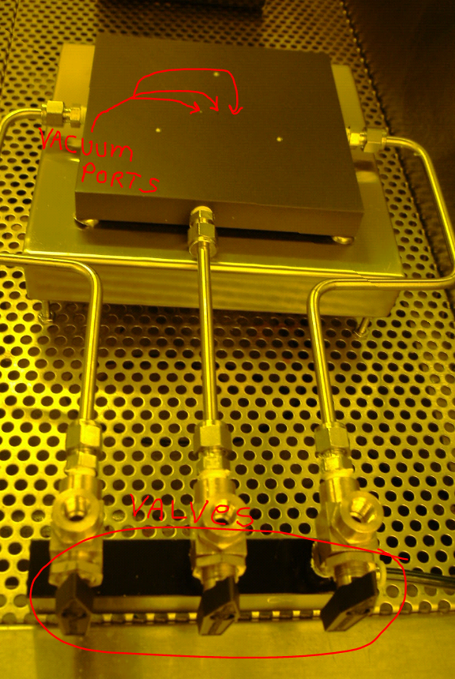
  - Turn the vacuum valves(s) off and remove the sample.

Softbake

Use the following table to determine best hotplate to use.

Softbake Table
Photoresist | Hoplate | Temperature C | Time/mins
AZ1512 | Tekvac HP Bake | 112 | 1
AZ1512 | Wenesco Front HP Bake - 4” wafer only | 112 | 2
AZ1512 | CEE HP | 112 | 1
AZ1512 | Oven Bake | 105 | 30
K6008 | Tekvac HP Bake | 112 | 3
K6008 | CEE HP | 112 | 3
K6008 | Oven Bake | 105 | 30
AZ9260 | Tekvac HP Bake | 112 | 3 (<12um thick)
AZ9260 | CEE HP | 112 | 3 (<12um thick)
AZ9260 | Oven Bake | 105 | 30 mins
AZ nLof 2035 | Tekvac HP Bake | 112 | 1 min per um
AZ nLof 2035 | CEE HP | 112 | 1 min per um
AZ nLof 2035 | Oven Bake | 105 | 30
LOR 3A | Wenesco Back HP Bake (manual vacuum) | 180-190 | 5

Oven Softbake

  - Oven baking takes longer than a hotplate but provides very good uniformity across the sample.
  - The lower Despatch oven in the Litho Bay is normally maintained @ 105°C which is good for both AZ1512 (OR S1813) AZ9260 and K6008 softbake.
  - Develop times for oven baked AZ9260 is longer than hotplate baked. Refer to “AZ9260 Process Table” in section 2 for times. This will most likely also apply to AZ1512 (OR S1813) but the test has not been run yet to determine this.
  - Press the door release button and press in on the door handle for the door to pop open. 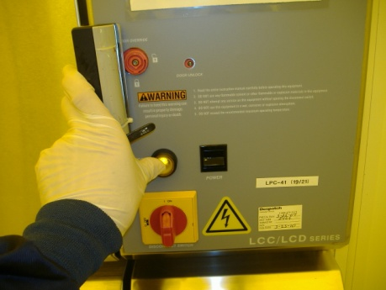
  - Place your sample on the shelf. It it not recommended that you place your sample directly on the metal grate. Use a quartz wafer holder or thick piece of glass.
  - For standard silicon wafer with AZ1512 (OR S1813), 15 minutes will be enough. For thick samples, substrates with poor thermal transfer properties or photoresists thicker than 4um, 30 minutes is recommended.

Hardbake

  - AZ9260 photoresist does not require hardbake.
  - K6008 photoresist does not normally require hardbake.
  - AZ1512 (OR S1813) Hardbake - Pre Plasma Etch – hardbake temp for this resist is 125ºC. Hardbake may not be needed for some plasma etch processes, consult with NRF Staff. You may use any of the following 3 options:
- Option 1 - Use the Cee Hotplate recipe “125V2MIN” for fragments. Use “125P2min” for 4” wafers.

- Option 2 - Use the Despatch Oven at 120 – 125 ºC for 20 minutes. Press and hold the door release button and press in and then pull on the door handle for the door to open.
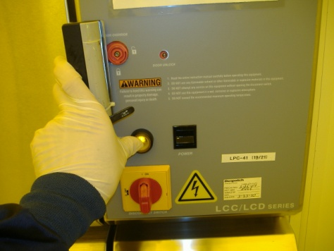
Place your sample on top of the solid top shelf.
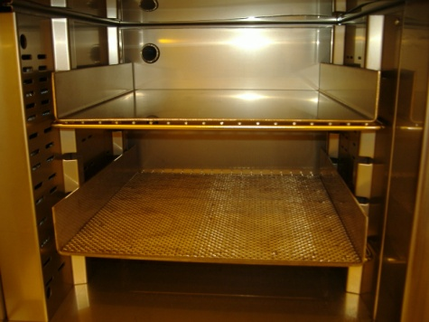

- Option 3 - Use the Wenesco hotplate (for fragment only hardbake). Use the vacuum ports located in the center of the hotplate. Place your sample on top of the 1mm vacuum holes and turn the vacuum valves (shown in the pic below) so that they point down. Vacuum will be applied to your sample. Bake AZ1512 (OR S1813) for 2 mins. Turn the valves back up when don to release the sample.
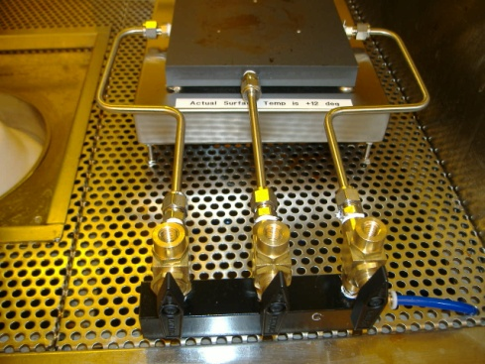

Photoresist Removal

Photoresist may be removed a number of ways. Which method you choose depends on sample composition, prior processing steps and available equipment. There are basically 4 categories that most samples fall under. Determine which category applies to your sample from the 4 Types listed below.

Type 1 - soft bake only <115°C
no metal layer

Type 2 - soft bake only <115°C
with metal layers

Type 3 – hard baking >115°C, implant or plasma etch
no metal layer

Type 4 – hard baked >115°C, plasma etched
with metal layers

Type 5 – Plasma Strip – Oxygen Plasma. For samples that can’t be put in solvents.

Refer to the specific equipment SOP’s for each tool where needed.

Type 1 PR Strip

- Flood Expose- procedure below. This method will not clean the edge or backside of the sample. Use a swab + solvent to clean back and edge.
- O2 Plasma Ash in Anatech for 3 minutes. 600W, 600 sccm O2.
- Optionally instead of ashing, Piranha Strip. Consult with NRF Staff for Piranha procedure.

Type 2 PR Strip

- Soak in TECHNISTRIP MLO07@ 60°C for 5 minutes
- O2 Plasma Ash in Anatech for 3 minutes. 600W, Gas 1-O2@600 sccm

Type 3 PR Strip

- Soak in TECHNISTRIP MLO07@ 60°C for 15 minutes
- O2 Plasma Ash in Anatech for 3 minutes. 600W, Gas 1-O2@600 sccm
- Optionally in place of ashing, heated Piranha Strip. Consult with NRF Staff for Piranha procedure.

Type 4 PR Strip

- Soak in TECHNISTRIP MLO07@ 60°C for 15 minutes
- O2 Plasma Ash in Anatech for 3 minutes. 600W, Gas 1- O2@600 sccm

Type 5 Plasma Bulk PR Strip

- Strip in the Tepla Asher. 500W, 300sccm recipe approximate positive PR etch rates shown below.
- Etch rate is very dependent on temperature. 1um of AZ1512 takes about 10 mins. 6um or AZ9269 takes about 20 mins. Just etch until the PR is gone.

Flood Expose Procedure

- Set the MA6 to “Flood Expose” mode and set the dose to 2X the normal exposure dose.
- Expose the sample without a mask.
- Develop the sample standard processing
- To remove remaining residue, run the sample in the Anatech Barrel Asher for 3 minutes with the following conditions: 600W, 600sccm-O2, 3 minutes.

Reduced Energy Exposure for Better Dose Control

  - When the calculated exposure dose will require less than 6 seconds of exposure, it is recommended to reduce the exposure energy by using the 25% transmission (ND 0.6) neutral density filter.
  - The ND 0.6 filter is located on the chrome rack (black case shown below) next to the MA6 aligner. 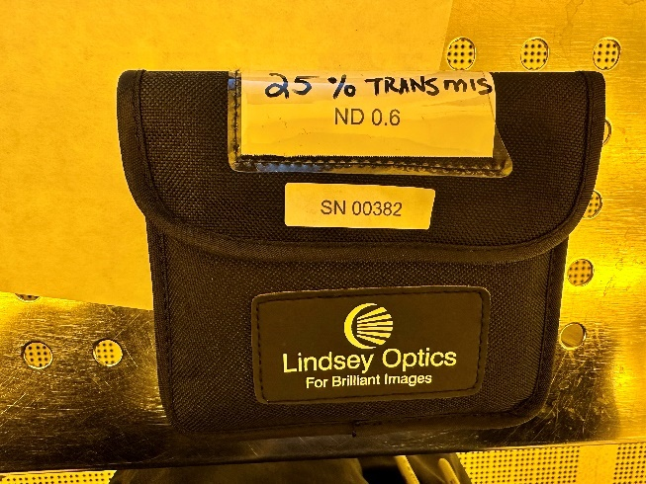
  - Remove the filter but do not touch the glass. Handle it by grasping the outside support ring.
  - After loading the photomask in the MA6 or EVG620, lay the filter over the mask as shown below.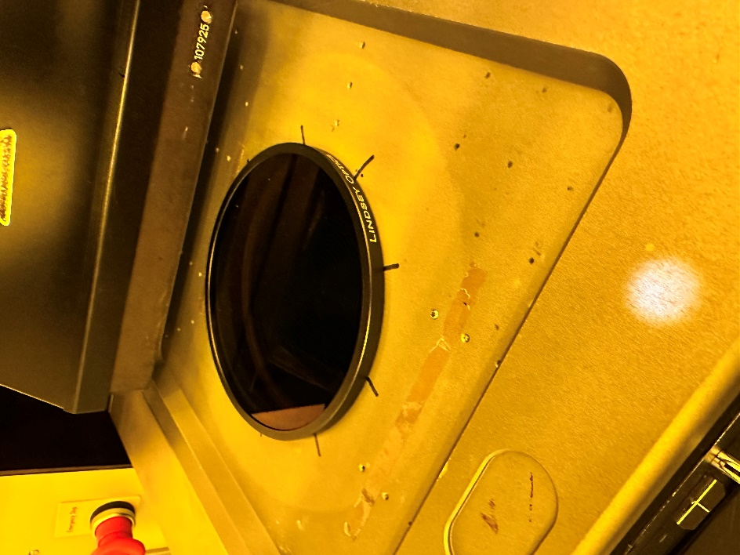
  - Expose the sample with 4X the normal time for the correct dose.
  - Return the filter to the black case when done.

