

Anatech Asher

Standard Operating Procedure Rev. 2026-01

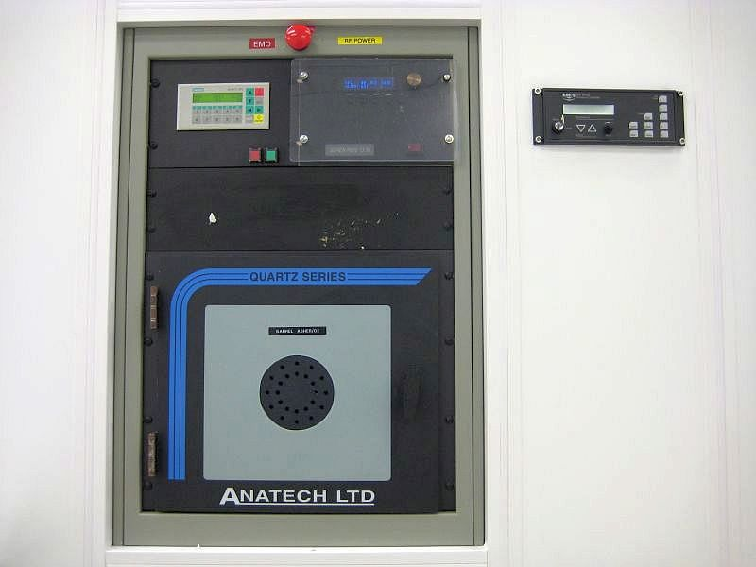

  - Application

Barrel asher that uses an oxygen plasma for stripping photoresist, descum, surface cleaning, and surface treatment. Can process up to 25, four-inch wafers at one time. Max power is 600W.The

  - NRF Contact

David Hays

Table of Contents
1. Safety information 3
2. Prerequisites for use 3
3. Tool Operation 4
3.1. Procedure 4

- Safety information
- High Voltage Radio Frequency is used throughout the system. System maintenance may only be performed by NRF Staff. Do not remove any tool covers or defeat any interlock on this system.
- Prerequisites for use
- User of the RSC facilities.
- Up-to-date hazardous waste training.
- Training by staff.
- User will be responsible for lost or damaged equipment due to negligence. Negligence means not following the SOP, not asking staff for assistance, intentionally damaging items, etc.

- Tool Operation
  - Procedure
    - This asher is a barrel downstream O2 plasma system. It’s best for gentle de-scum operation. If you need to strip photoresist, use the Tepla Asher.
    - Place your sample on the quartz boat. Use a carrier wafer if your sample is too small to fit.
    - Open the door and place the quartz boat inside the chamber. Close the door and twist the latch to lock it.
    - To edit a recipe, press the SHIFT+F3 buttons. Use the left/right arrows to select the desired recipe number. Use the number pad to enter the password “12345” and press the enter button.
    - Press SHIFT+F5
    - Use the left/right arrows to cycle through the settings. Use the number pad to change the value and then press enter.
    - Recipe Parameters for de-scum
      - Number of steps – 1
      - RF Power –200W, 300sccm O2, 1 min
    - For PR strip, Max power is 600W, max gas flow 600sccm. 1um of PR takes about 30 mins.
    - Keep cycling through the steps until you see the message “Do you want to save the changes”. Press SHIFT+F5 to save.
    - Press escape to get back to the main menu.
    - To run the process, Press SHIFT+F1, select your recipe number and then SHIFT+F5
    - When done, the screen will read “venting chamber”, takes about 30 seconds.
    - When the process is complete, remove the quartz boat using the metal holder. CAUTION – The boat can be extremely hot after processing. Always use the metal holder to remove the boat.
    - Logout of TUMI system to deactivate tool and stop billing period.

