

Nikon LV100 Microscope

Standard Operating Procedure Rev. 2026-01

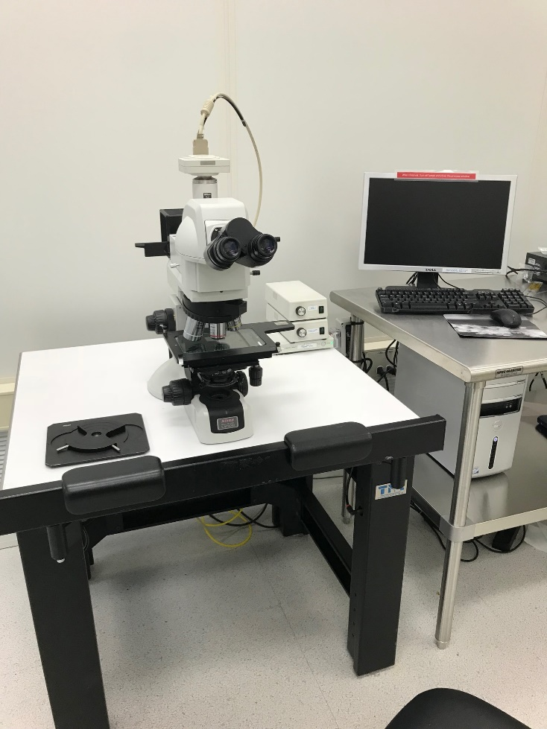

  - Application

The Nikon LV 100 UDM Microscope features both epipscopic and diascopic illumination that can be controlled independently. The light is produced through dual, 50 Watt lamphouses that are capable of producing light that is the equivalent to 100W in other microscopes. It has both bright field and darkfield lighting techniques and is fitted with 5X, 10X, 20X, 50X and 100X objectives with a 1000X total magnification capability. It has a wafer stage with recesses for 2” to 6” diameter wafers with rotation. Images can be captured via the digital 1.3 megapixel camera, and image analysis software allows for measurements and annotation.
  - NRF Contact

David Hays
Table of Contents
1. Safety information 3
2. Prerequisites for use 3
3. Basic Microscope Layout 4
4. Microscope Operation 4
5. Software Operation 5

- Safety information
- None
- Prerequisites for use
- User of the RSC facilities.
- Up-to-date hazardous waste training.
- Training by staff.
- User will be responsible for lost or damaged equipment due to negligence. Negligence means not following the SOP, not asking staff for assistance, intentionally damaging items, etc.
  - Do not attempt to calibrate the instrument.

- Basic Microscope Layout
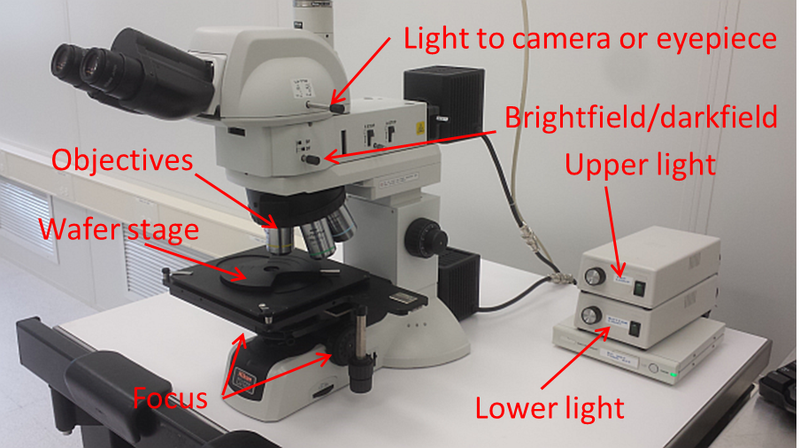

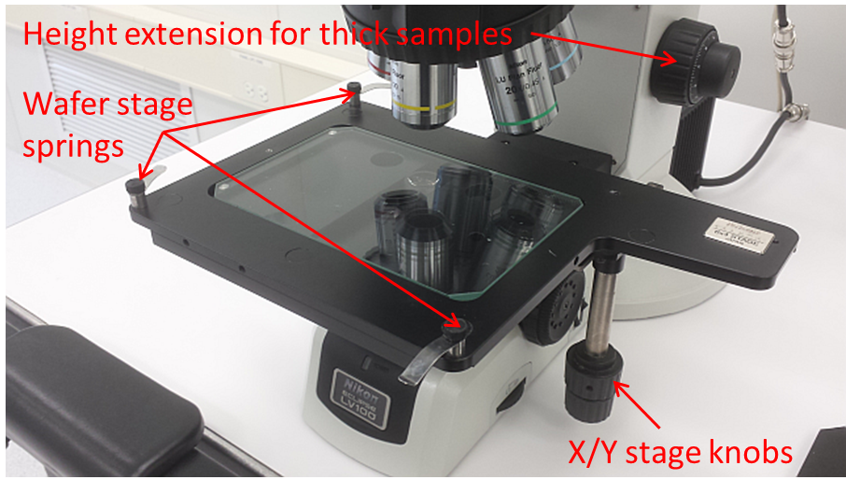
- Microscope Operation
    - Determine the method of illumination, either episcopic (top light) or diascopic (bottom light).
    - For diascopic operation, the wafer stage needs to be removed. Simply rotate the spring clamps off of the stage and lift the stage to remove it.
    - Episcopic operation can be used with or without the wafer stage. To reinstall the stage, place it on the microscope platform and ensure the alignment pins are in the recesses of the platform. Rotate the spring clamps on the wafer stage and tighten.
    - Turn on the proper illuminator to the desired brightness.
    - Focus using the focus control knobs, or the height extension knobs
    - Rotate the objective turret to the desired magnification.
CAUTION: Do not allow the objectives to touch your sample. Be very careful when focusing or changing the objectives!
    - For darkfield operation, pull the brightfield/darkfield knob OUT. This mode is useful for examining defects and particles. You may need to increase the brightness. Please push the knob back in when finished to return it to brightfield mode.
- Software Operation
    - To start the software, double-click the “i-solution lite” icon 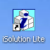. The main menu bar is shown below.
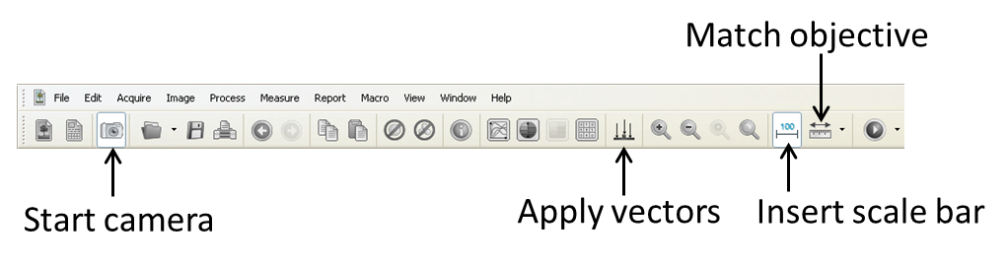
    - Press the “Start camera” icon on the menu bar and another window will open.
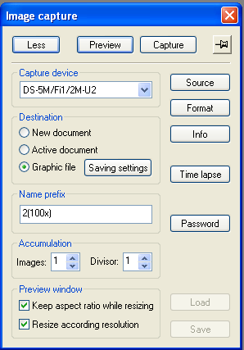
    - Press the “Preview” button to see the live image
    - If the brightness/contrast does not auto gain, then press the “source” button. Go to the “Exposure preset” and select “Brightfield” from the pull-down menu. Also, make sure that both “Vert” and “Horz” have check marks (this keeps the camera and eyepiece orientation the same)
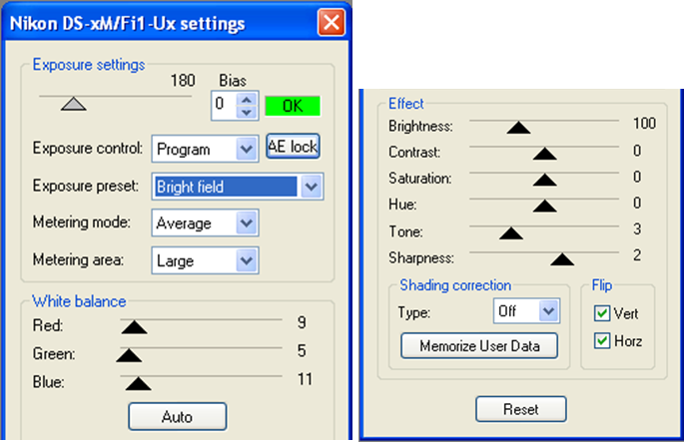
    - To capture an image, press the “Capture” button. The captured image is placed behind the preview so turn the preview off by pressing the “Preview” button again.
    - With the image captured, you can now perform a variety measurements and annotations.
    - To perform a measurement, you need to match the objective you used to take the image. It looks like a ruler (shown below) on the menu bar. Click on it and select the proper objective. The tool list on the left contains the measurement options (line measure, circle by radius, angle, etc).
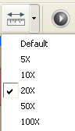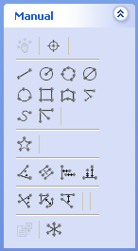
    - To insert a scale bar, press the “Scale bar” icon on the menu. Change the number to resize the scale bar. You can also change the color by going to the color tab.
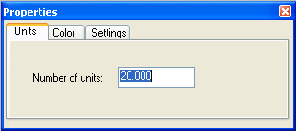
    - To merge the measurements and scale bar with the image, you need to press the “Apply vectors” button on the main menu.
    - To save the image, go to “File” then “Save as” and pic from the various image types and save to your folder in the User_Pictures main folder.
    - When you are finished, ensure that the preview is off. This will turn off the camera.

