
Suss Delta 80 Spinner
Standard Operating Procedure
Rev. 2026-01

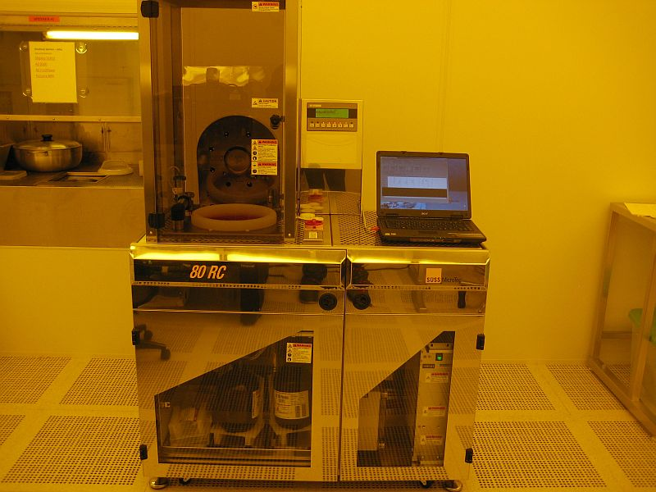

Contents
Safety 2
Quality Control and Calibrations 2
Equipment Uses and Restrictions 2
Equipment Specifications 3
System Preparation 3
Coating 8

Safety
Moving Components – The User should be aware at all times of the moving components associated with this tool. The spin chamber door must be closed at all times while processing your sample. The spin chamber door is interlocked, and tool will not operate with the door open. DO NOT ATTEMPT TO DEFEAT THIS INTERLOCK. Users are not allowed to adjust any mechanical devices within this machine and are prohibited from opening any doors except the spin chamber door. If a error or problem occurs, put the coater down in the NRF web site with comments and notify NRF Staff. Do not attempt to fix the problem.

Quality Control and Calibrations
Photoresist thickness and uniformity checks are currently performed once per year. The repeatability of the system is very good but if you need a specific accuracy of thickness or uniformity you must run dummy samples. Thickness measurements may be made using the Filmetrics F40 located in the Bio/Nano Bay. Staff is available for help and advice. For full processing instructions, see the “NRF Photolithography SOP”. The recipe “named” thickness applies to a bare 4" silicon wafer that has been processed per the “NRF Photolithography SOP”. Be advised that thickness and uniformity will be affected by your sample size, surface tension and topography of the sample.

Equipment Uses and Restrictions
Each spinner in the NRF is dedicated to certain materials.
The Suss Delta 80 is dedicated to AZ1512 and Kemlab K6008 photoresists. These are the ONLY materials you may spin without Staff consent.
This tool only processes substrates that are 75-100mm. Smaller pieces are not allowed.

Equipment Specifications

- Sample sizes: 4”, 3” round or square. Pieces smaller than 3” diameter are not allowed. The Laurell spinner must be used.
- Pump 1 = AZ1512 photoresist
- Pump 2 = Kemlab K6008 photoresist
- Automated Photoresist solvent strip for non-hardbaked and non-etched photoresists
- Maximum RPM Open bowl 4” wafer (Standard Tall Bowl ring = 5000)
- Maximum RPM with Gryset Short bowl ring = 4000
- Max sample size: 4” round or square
- Maximum sample thickness is 4mm.

System Preparation

Note: The Suss Delta 80 System includes the unique capability of
“Inhibited Drying” by spinning the sample inside a solvent rich environment. The benefits are a wider thickness range than normally possible for a given photoresist viscosity. This is accomplished via the “Gryset” head. It’s basically a stainless cup shaped dome that comes down over the sample prior to spinning the sample to the desired thickness. The Gryset head will only be used for:

- thinner than normal AZ1512 photoresist 0.7 - 1.2um thickness
- Two additional thicknesses of K6008 photoresist. 14um and 3.7um

  - Log into the Tumi. The waste bottle full sensor is interlocked through the Tumi system. If the screen shows the error “Waste bottle full or not connected”, just press the return key and the message will disappear.
  - Determine which of the 2 setup modes you will need based on your samples size and shape:

Standard Coating Mode–Tall bowl ring installed (see pic below)
    - all round and square substrates
    - all substrates <15mm

“Gyrset” Mode-Short bowl ring installed (see pic below)
    - AZ1512 when <1.2um thickness is needed
    - K6008 when 3.7um or 14um is needed.

  - Use the table below to select the correct recipe and to determine if you need the tall bowl ring for non-inhibited drying or short ring for Gyset IHD mode. The PW_K6008 recipe can be used for single layer thick resist to improve uniformity if needed.

Recipe Selection Table
Resist Type | Substrate Size | Thickness Range um | Use this recipe | Spin Bowl Ring | Exceptions:
AZ1512 | 75-100mm | 1.2 - 2.0um | 1512_(xx.x) | TALL
AZ1512 | 75-100mm | 0.72 - 1.2um | Gyset_1512_(xx.x) | SHORT
K6008 | 75-100mm | 4.2 - 10um | PW_K6008_(xx.x) | TALL | DON'T use for multiple coats
K6008 | 75-100mm | 4.75 - 10um | K6008_(xx.x) | TALL
K6008 | 75-100mm | 3.7 or 14um | Gyset_K6008_(xx.x) | SHORT
Recipe name letter meanings:
Gyrset=Gyrset Head comes down, P=solvent prewet

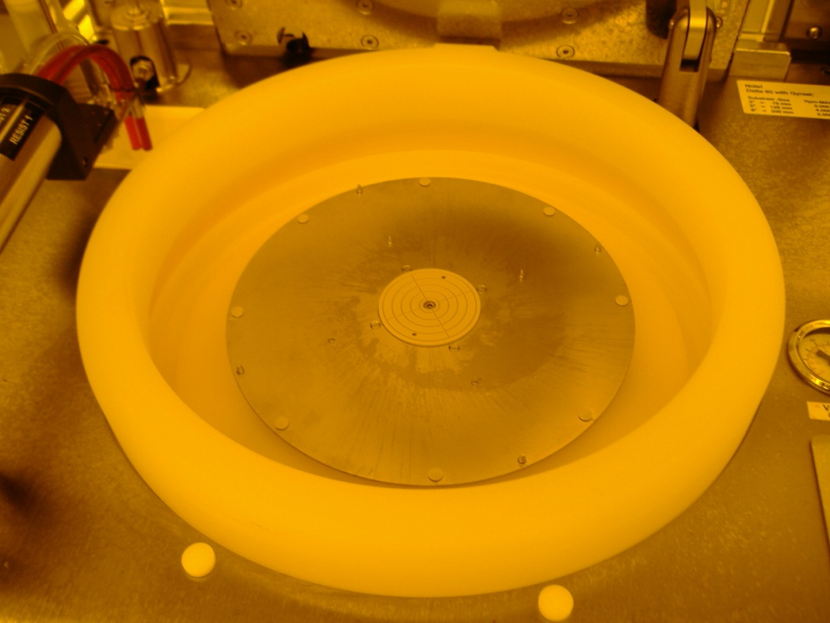
4” wafer centering pins

Chamber deck
Tall spin bowl ring is higher than the chamber deck

Standard Coating Mode

  - The picture above shows the standard bowl setup using the Tall spin bowl ring for standard photoresist thicknesses and will be used most often.

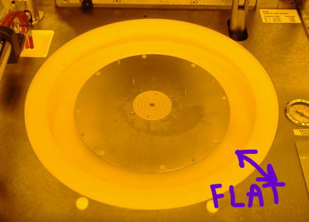

Gyrset mode ring installed, 2 surfaces are flat

  - The bowl setup above is for Gyrset mode. Notice the upper bowl ring is shorter and flush with the main chamber platform short bowl ring. The shorter bowl ring allows the “Gyrset” head to come down during processing.

  - If the ring must be changed for your setup, the ring presently installed must be cleaned by YOU! Place a clean wipe under the ring (just in case it drips) while removing it from the tool. Use the work space in the left side of the wet bench near the Laurell Spinner, not the right side near the hotplates. Clean the ring using a liberal amount of acetone and wipes. When the ring is clean, place it on the white tray on the chrome rack. It should look like this!
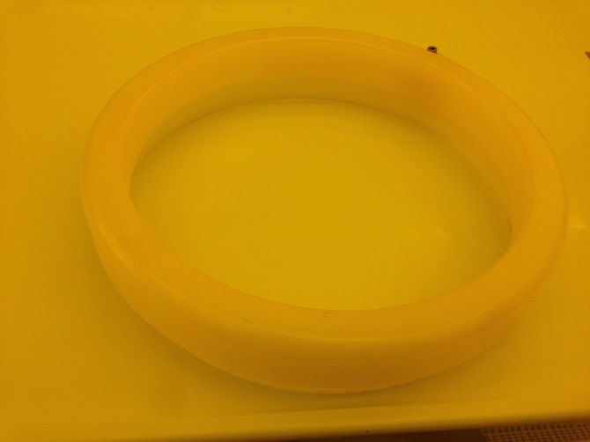

  - A Note about bowl cleanliness: The “bowl clean” recipe will be run at the end of each use. This recipe will leave a significant amount of photoresist on the lower bowl and the lower ring. It will also leave a smaller amount of photoresist on the upper ring, this is OK. See the 2 pics below.
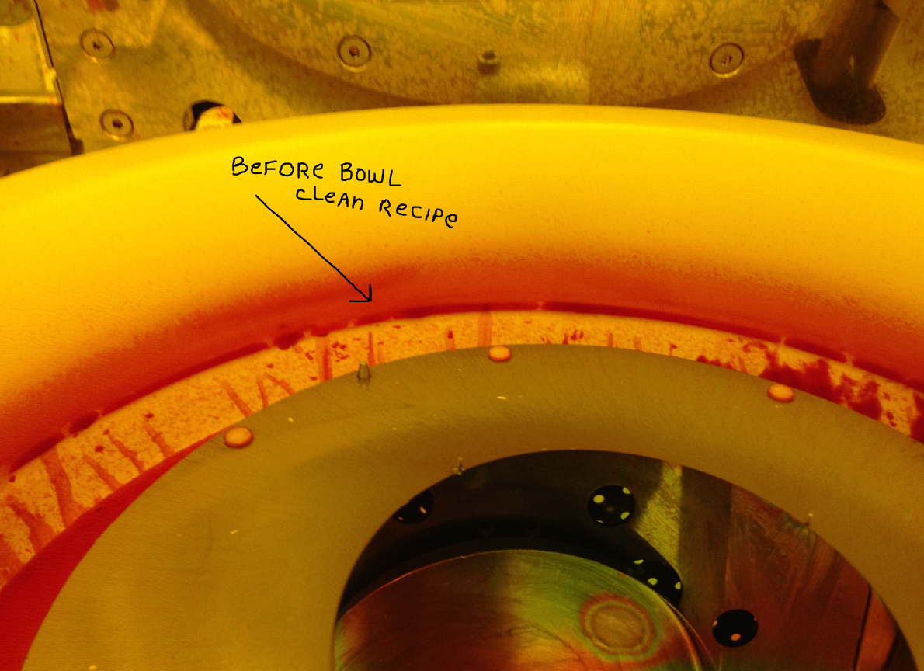
Pre “bowl rinse” recipe
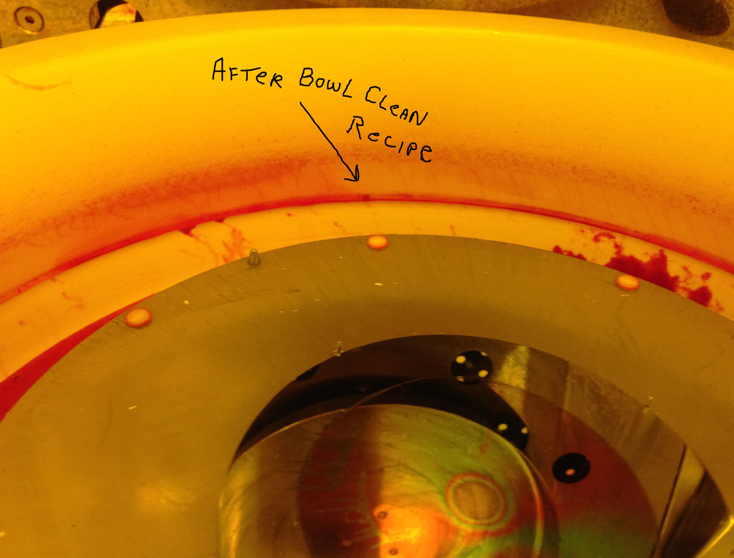
Post “bowl rinse” recipe

  - As you can see the change is not real obvious. Leave the bowl in the system when you are done. Just MAKE SURE you run the “bowl clean” recipe.
  - The Gyrset metal lid will be removed and cleaned periodically by staff. There is no need to clean it.
  - NOTE: some parts of the bowl will always have a photoresist coating. See pic below.
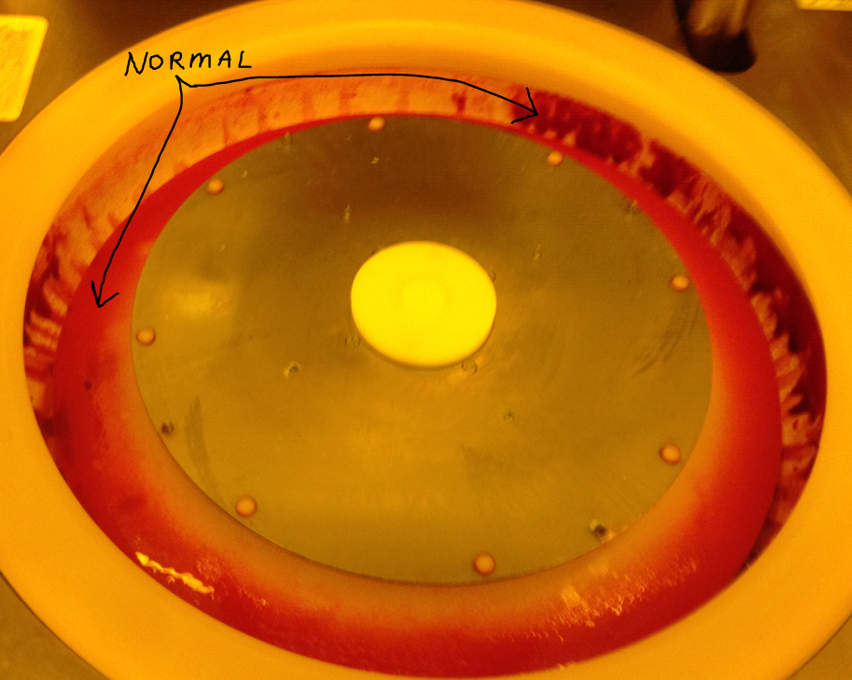

Coating

  - For 3” wafer, center the wafer by eye within the 4” alignment pins. For 4” wafer, just place the wafer directly on the chuck inside the 4” alignment pins. Your sample backside must be very clean and flat. If not, you will either get a vacuum error or the spinner may launch your sample off the vacuum chuck and you will be very disappointed by it.
  - Close the spin chamber door. The system will not run with the door open.
  - Click the “Process” icon on the Delta 80 RC laptop main screen.

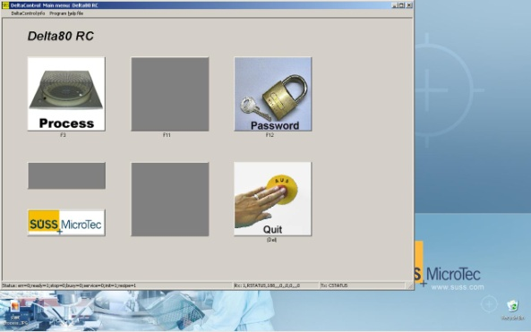

  - Select the recipe “predisp_1512” or “predisp_K6008” depending on what type of resist you will need. The recipe will just clean the resist nozzle. It won’t dispense on your sample. You only need to run this recipe one time during your tool use.
  - Click once on the recipe and click “TRANSMIT” button.
  - Click “START PROCESS” to run the wafer. The final dispense should stream straight out of the nozzle (exactly centered) and the flow should be smooth. If an error shown below do the following.
    - Error 220 Drain not connected, you may not have logged into the Tumi.
    - Error 40 - ignore it. It’s just a warning that the spinner is spinning.
    - Error 170 and 171 - Do not press “ignore”. Stop processing. Contact staff immediately if during normal work hours. If after hours, put sign on tool and email staff. Error 170=resist 1 empty, 171=resist 2 empty.
    - Error 172 - you may press “Ignore” to continue processing and immediately notify RSC Staff by phone or email so that we can add solvent to the tank. Error 172=solvent tank empty.
    - All other errors, contact staff and stop work.
  - Select and transmit the your process recipe per the Table in section 5 above. Press start.
  - When the process is complete the spin motor will rotate to home position and the chuck vacuum will turn off. Do not open the door until this is complete of the system will error. Remove your sample.
  - If the spin coat quality is poor for some reason, you can strip and re-apply photoresist. Select and run the recipe called “Strip_Short” for AZ1512 or “Strip_Long” for K6008 resist. Then just re-run the correct process recipe.
  - Please refer to the “NRF Lithography Processes SOP” for all photoresist baking instructions.
If you ran a 3” wafer, clean the top and bottom of the fragment adapter using wipes and acetone. Moisten a clean wipe with acetone and clean the spin chuck and the metal surface all the way out to the 4” wafer alignment pins. See the following picture.

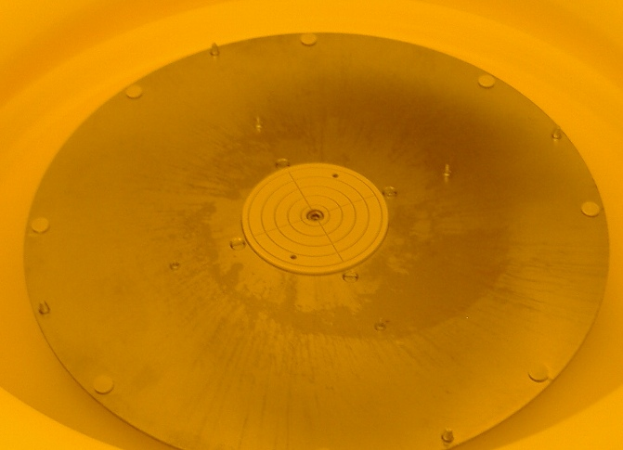
Clean me using a wipe and acetone.
1.22 Load the 4” wafer found on the top of the system . Use the 4” guide pins as reference to center the smaller wafer. Execute the “Clean_Bowl” recipe. Do not run the “Clean_Bowl” recipe with anything but a 4” wafer.

