\
Laurell Spinner

Standard Operating Procedure
Rev. 2026-01

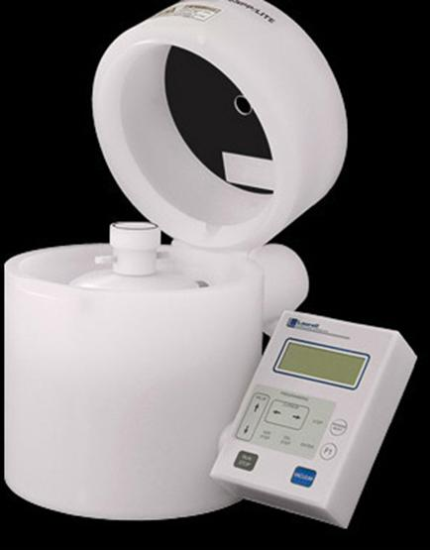

Table of Contents
Equipment Uses and Restrictions 2
Safety 2
Equipment Specifications 2
Operating Instructions: 4
Photoresists Management and Handling 4
Recipe Programming 6
Wafer Coating 2-4” / Static Dispense Only 7
Fragment Coating – Static Dispense Only Allowed 8
Cleaning 11
Thickness Curves 12

Equipment Uses and Restrictions
Each spinner in the NRF is dedicated to certain materials. The list of approved materials for each individual spinner is located near the spinner. These are the ONLY materials you may spin. If you have a new material, contact NRF Staff for review. If approved, it will then be added to the spinner approved materials list.

Safety
- Moving Components – The User should be aware at all times of the moving components associated with this tool. The spinner lid must be closed while processing your sample. The spinner lid is interlocked and will not operate with the lid open. DO NOT ATTEMPT TO DEFEAT THIS INTERLOCK.

Equipment Specifications

Maximum RPM: 6000
Max sample size: 6” diameter

Operating Instructions:

Photoresists Management and Handling

  - AZ1512, AZ9260, AZ nLof2035, LOR-3A are available in small amber bottles separated by bins, see below. The bottles are filled regularly by staff. 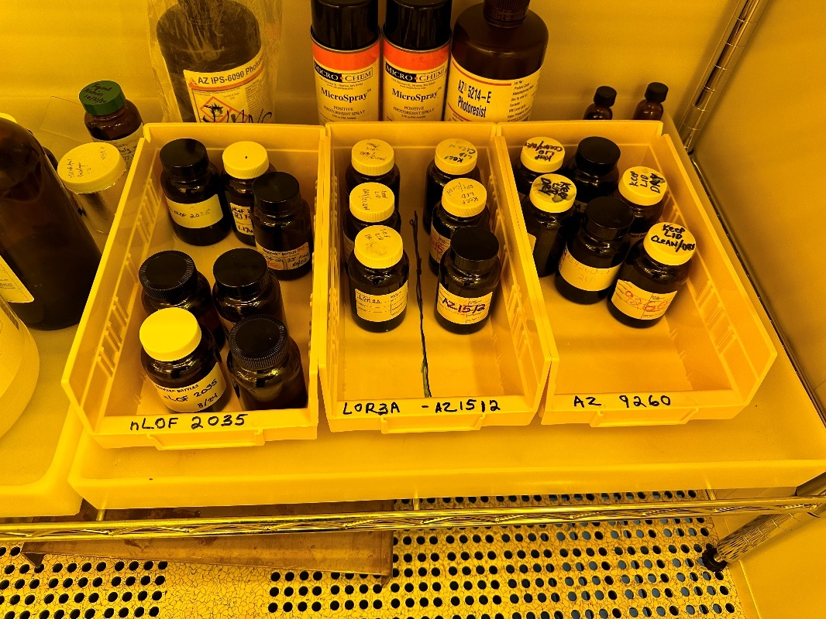
  - These materials dry very quickly when exposed to air. Resist on the inside of lid and on the rim of the bottle dry quickly even though the lid may be closed. Because of this, the lids and rim of the bottle must be kept very clean i.e. resist free. If not, the dried resist particles fall into the resist and end up on your (and other users) samples in the form of particle defects in your lithography pattern. Examples of bad handling are shown below. This mess was created in one month.
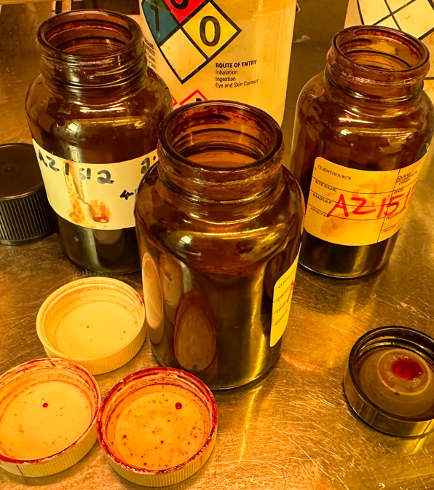
  - When transporting the bottle, do not tip the bottle. Hold it vertical and level.
  - To load you pipette with resist, squeeze the air out of the bulb outside the bottle. Submerge the pipette to the bottom of the bottle and allow the bulb to expand on it’s own to fill with resist. Before dispensing onto your sample wait until all the bubbles have floated to the top of the liquid and there are no air pockets at the bottom.
  - When pipetting thicker resists there will be a lot of resist on the outside of the pipette. To remove this excess resist before dispensing onto your sample, touch the inside area of the bottle below the rim. Not the upper area of the rim. See pics.
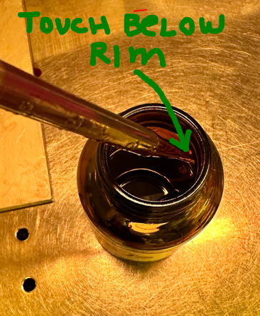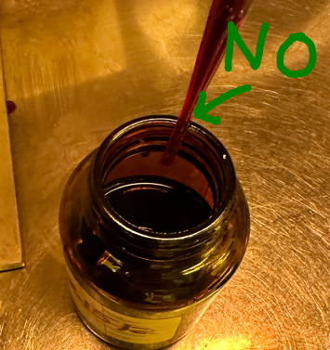

Recipe Programming

  - Place the system in “Programming” mode by pressing the F1 key. PGM will be displayed in the upper left corner of the display. When the value is “OFF” it’s in automatic recipe mode.
  - Select the program letter (A-R) to be modified using the up/down arrow keys. The program letter selection will be indicated in the upper right-hand area of the display.
  - To change step values, use the up/down arrows. To move the edit cursor between fields, use the </> arrows. Press the enter key every time you change values within a step. The must be done for each step. Press enter to save.
  - Use ADD STEP to create new steps and the DEL STEP keys to remove steps.
  - Note: the ACL at the bottom of each step screen stands for acceleration. The left number is a digital value. The right number is the actual ramp or deceleration rate. Change the left number to change the acceleration or deceleration from one step to the next. Deceleration values should not exceed 100 RPM/sec and acceleration should not exceed 10000 RPM/sec.
  - Use the STEP key to step through the program and verify the correctness of all values.

Wafer Coating 2-4” / Static Dispense Only

  - Verify the display reads PGM in the upper left corner, if not depress F1.
  - For 4” wafers, place wafer on the wafer centering tool. Place the wafer on the chuck and depress the vacuum button.
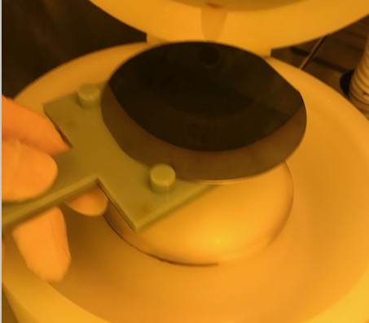
If the pressure reading on the screen is lower than required, the pressure displayed will blink on/off indicating the you have a leak and the recipe will not run. Check the backside of your sample and try cleaning the chuck again (see above). If all else fails, call staff for help.

  - Select any spin recipe letter you like and press edit….

Step 1 time= 2 sec for AZ1512, LOR-3A
Step 1 time= 3 sec for AZnlof 2035
Step 1 time= 6 sec for AZ9260, K6008
Step 1 speed= 1000rpm
Step 1 ramp rate= 550rpm/sec. (5acc value)

Step 2 time= 60 seconds,
Step 2 speed= (per material thickness curve-see section 6, do not go below 1000rpm if using 1000rpm for step 1)
Step 2 ramp rate= 2090rpm/sec (019 acc value)

  - When done editing, press F1 to switch back the automatic mode. The display reads “OFF”
  - The dispense puddle in the following step, should normally cover at least 50% of the wafer diameter. For a 4” wafer use 2-3ml. For 2” wafer, use about 1ml. For AZ9260 use ≥3ml.
  - Using a new pipette, squeeze all the air out of the bulb. Then submerge the tip into the source liquid and allow the bulb to expand filling with liquid. When working with PR, do not allow PR to get on the rim of the bottle or the bottle lid. This will dry and cause contamination of the PR bottle which will reappear as defects on your sample. For thicker materials, there will be excess PR on the outside of the pipette. Remove it by touching the pipette to the lower inside rim of the bottle (not up near the top). Allow any bubbles to rise to the top of the pipette and move any resist gaps at the bottom of the pipette.
  - Open the lid and squeeze the liquid onto the center of the wafer. Don’t squeeze the last bit out of the pipette. Stop before it is all gone to prevent bubbles from being dispensed.
  - Immediately close the lid and press the “Run” button.
  - Press VACUUM to turn off the vacuum and remove the sample.
  - PREWET- If you are having trouble getting the PR to cover the whole sample, solvent prewet can be used to lower the surface tension. Before applying photoresist, spin the sample at 3000rpm and while the sample is spinning, squirt PGMEA (aka AZ EBR) through the hole on the top cover onto the center of the sample for 3-4 seconds and allow it to spin dry at 3000rpm for one minute. Do not do this for PMMA. Only do this for PGMEA based materials such as AZ1512, AZ9260, AZ nLOF2035, K6008 or LOR3A.
  - Proceed to section 3 “Cleaning”.

Fragment Coating – Static Dispense Only Allowed

  - Only Static Dispense is allowed.
  - The proper “Fragment Adapter” must be used, or your sample will be broken. The vacuum o-ring should be approximately 25% to 50% of the smallest width of your sample. The pic below are examples of the correct chuck size for various substrate sizes. 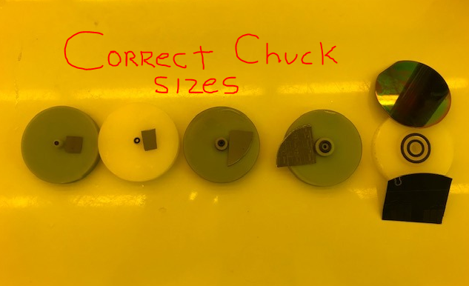
  - Before placing the sample adapter chuck over the main chuck, verify that it is clean. It should not have any dark material inside the vacuum groove or in the vacuum hole. If cleaning is needed, soak the adapter in a beaker of Technistrip MLO07 solvent for 3-4 mins. Look through the vacuum hole (hold up to light). and rinse with DI water. If the vacuum hole is still plugged you may need to use a paper clip to remove the material.
  - Verify that o-ring is in place and place the sample centered on the vacuum surface. Press “Vacuum” to turn on the chuck vacuum. If the pressure reading on the screen is lower than required, the pressure displayed will blink on/off indicating a vacuum leak and the recipe will not run. Check the backside of your sample and try cleaning the chuck again (see above) or change to a different chuck. If all else fails, call staff for help.
  - CAUTION -- DO NOT ALLOW ANY FLUID TO ENTER THE VACUUM CHUCK OR UNDER THE CHUCK ASSEMBLY.
  - Select a spin recipe (A to R) and press edit….

Step 1 time= 60 seconds,
Step 1 speed= (per material thickness curve-see section 6)
Step 1 ramp rate= 2090rpm/sec (019 acc value)

  - Set the operation mode using the F1 key to OFF (not PGM mode)
  - Using a new pipette, squeeze air out of the bulb. Then submerge the tip into the source liquid and allow the bulb to expand filling with liquid. When working with PR, do not allow PR to get on the rim of the bottle or the bottle lid. This will dry and cause contamination of the PR bottle which will reappear as defects on your sample. For thicker materials, there will be excess PR on the outside of the pipette. Remove it by touching the pipette to the lower inside rim of the bottle (not up near the top). Allow any bubbles to rise to the top of the pipette. Remove any gaps in the bottom of the pipette.
  - For square or rectangular pieces smaller than 20mm, cover most of the surface with photoresist allowing surface tension to hold the liquid on top. Immediately Close the lid and press “Run”.

See examples below. The fluid is covering all but the extreme corners of the sample, which is OK.
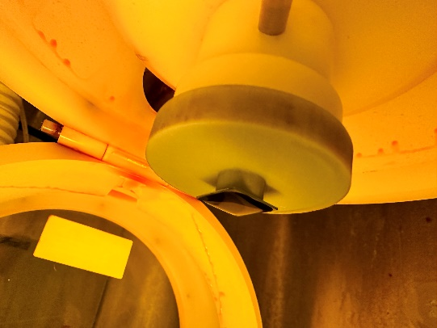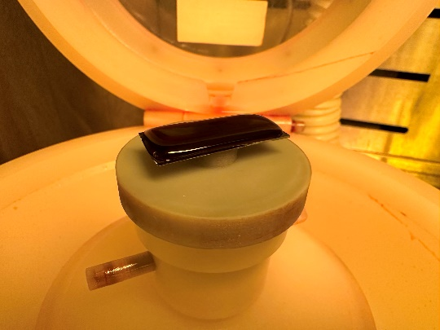

For larger asymmetrical substrates such as glass slides or the one shown below, apply the puddle lengthwise as show below. 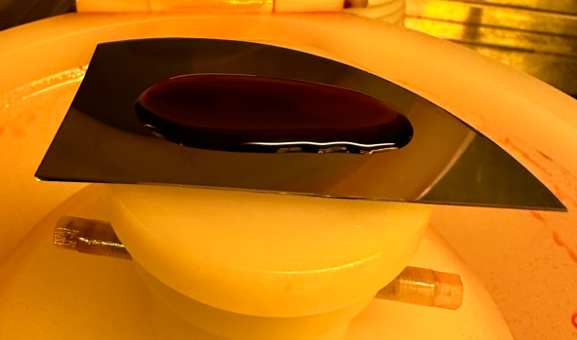

  - PREWET- If you are having trouble getting the PR to cover the whole sample, solvent prewet can be used to lower the surface tension. Before applying photoresist, spin the sample at 3000rpm and while the sample is spinning, squirt PGMEA (aka AZ EBR) through the hole on the top cover onto the center of the sample for 3-4 seconds and allow it to spin dry at 3000rpm for one minute. This may be done for PGMEA based materials such as AZ1512, AZ9260, AZ nLOF2035, K6008 or LOR3A. Do not do this for PMMA.
  - Proceed to section 3 “Cleaning” when done.

Cleaning

  - When cleaning immediately after use (as should always be done), use Isopropanol.
  - If the material is dried in the bowl (i.e. it’s been more than 1 hour since it was dispensed) use Technistrip MLO07 to clean the bowl.
  - Using the lab squirt bottle, apply liberal amounts of Propanol in the areas shown in red in the pic below. 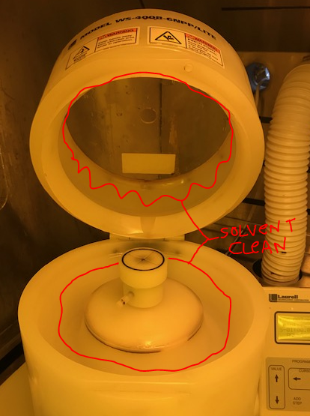
  - Wipe the areas with clean wipes. Apply more solvent and wipe again until the bowl is extremely clean. It should not feel slick when it is clean. Also, there will be no more color changes to the wipe when the bowl is clean.
  - If using Technistrip MLO07 to clean, follow up with a DI soaked clean wipe to remove the Technistrip MLO07.
  - Verify that the vacuum chuck is not contaminated. If it is, clean the surface and contact staff so that we can determine why material is being sucked onto vacuum chuck.
  - Place contaminated wipes in the solvent waste can.
  - FAILURE to clean the bowl properly will cause you to loose privileges on this spinner.

Thickness Curves

AZ1500

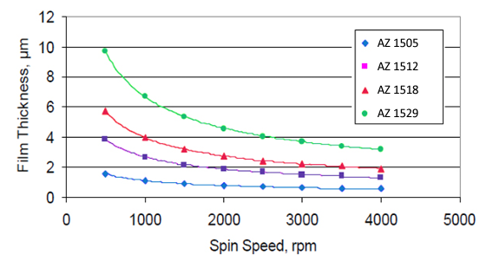

AZ9260

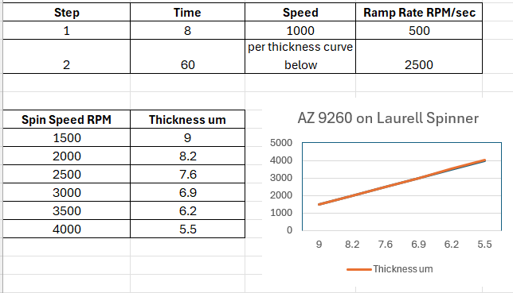

AZ nLOF 2035

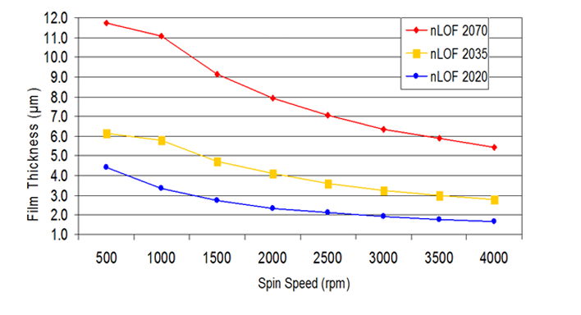

Microchem LOR 3A

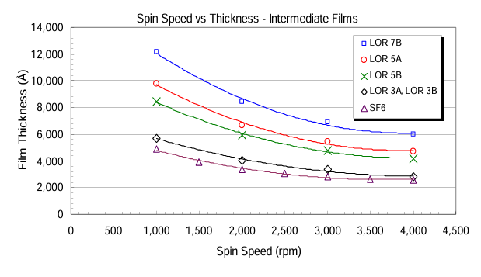

Kemlab K6008

