
Karl Suss MA6 Mask Aligner

Standard Operating Procedure
Rev. 2026-01

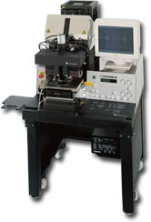

Contents
Safety 3
Description 3
Calculate Your Dose 4
Load Mask 4
Pre Exposure Operation 5
Load wafer 10
Wafer Alignment 10
Exposure 12
Supplemental Information 12
Exposure Programs 13
Proximity exposure 13
Soft contact exposure 13
Hard contact exposure 13
Vacuum contact exposure 13
Low vacuum contact exposure 13
Flood exposure 14
Multiple exposure 14
Wedge error compensation 14
Contact mode: 14

Safety
UV Exposure: The high energy light produced by the high pressure Mercury Xenon lamp can cause eye damage and skin burns. Be sure that the light guards around the exposure area are not removed, and that the high pressure lamp and exposure path are enclosed. Do not looking directly at the mask during exposure.
- Ozone: The high-pressure lamp produces ozone, which can result in pneumonia-like symptoms. The effects are cumulative. The lamp may only be “on” when the HEPA air flow is “on”.
- Lamp Explosion: If you suspect that the UV Lamp has exploded, evacuate the room immediately and notify UFNF Staff.
- High Power: The MA6 mask aligner uses ignition voltages of 30kV and operating voltages of 180V, with currents of 5 to 30amps. Ensure that the power line is disconnected before any system maintenance.
- Moving Components – The User should be aware at all times of the moving components associated with this tool. For instance, the topside microscope assembly moves up and down, and does present a potential hazard. The User must exert caution at all times such that a limb, finger, or article of clothing does not become trapped or entangled (or worse, violently detached) when components of the machine are in motion.

Description

The Karl Suss MA-6 Contact Aligner system can perform precision mask-to-wafer (sample) 1:1 contact printing in four modes; hard contact, soft contact, vacuum and proximity. It can accommodate exposure of irregularly shaped substrates and standard wafers to 6”. Features: Contact 1:1 aligner. DUV and IR capability Approximate Exposure Intensity: 8 mW/cm2@365 nm, 5 mW/cm2@405 nm Constant exposure intensity controller Two mask holder sizes are available, 4" and 5". Wafer size is 4" and pieces. Maximum wafer thickness 4.3mm Split field microscope for top-side viewing/alignment. resolution = down to .8um in vacuum contact mode @ 400nm

Calculate Your Dose

  - Prior to loading your mask, verify CH1 is green on the CIC controller
  - Depress the lamp check button on aligner and record the power value displayed on the CIC display. This is the power output of the lamp at 365nm in Watts/cm2.
  - To calculate dose, divide the desired dose by the power displayed on the RED LED readout. This is your exposure time in seconds. Example: 140mj / 10Watts = 14 seconds.

Load Mask

  - Warning: Watch out for the microscope movement!
  - Start mask loading sequence - CHANGE MASK key. NOTE: If the change lamp key is already blinking, press enter and change mask alternately to get the system out of the last mask change sequence. This may be needed when the last user does not complete the mask sequence. Take out the mask holder, flip it 180º and put it on the tray to the left. If a mask is loaded, press ENTER to toggle the mask vacuum off, retract the mechanical mask clamp by pushing down on the leaf spring until it stops in the detent and remove the mask.
  - Place the mask chrome oxide up (DARK SIDE UP, MIRROR FINISH SIDE DOWN, see pic below) onto the mask holder against the stop pins to the left and top of the mask. Toggle the mask vacuum on by pressing the ENTER key. Activate the mechanical mask clamp by pressing on the leaf spring until it contacts the edge of the mask.
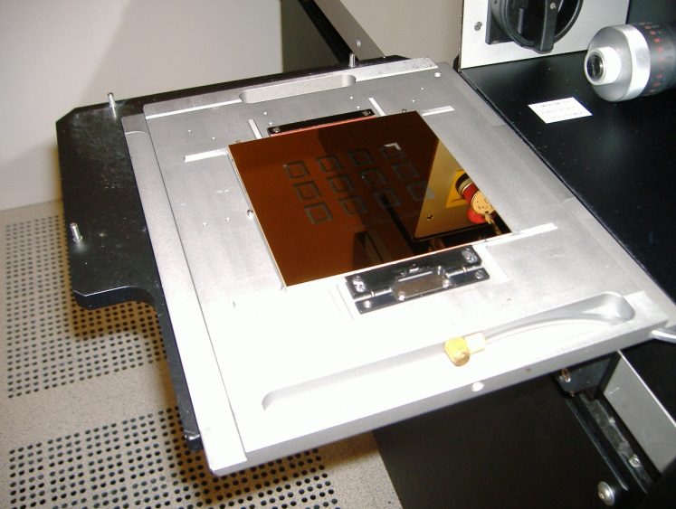

  - Flip the mask holder over and slide it into the machine. Lock the mask holder slide by pressing CHANGE MASK key again.

Pre Exposure Operation

  - If the “Change Mask” and “enter” buttons are blinking, press “change mask” and then “enter” to end the last users mask unload sequence.
  - Move all the stage micrometers to the center position. For the X axis (right side micrometer) the center is the 8mm position and for the Y micrometer (left side) the center is 8mm. Theta micrometer shall be adjusted so that the white line on the theta position indicator is parallel with the front of the stage.
  - Edit parameters - Press EDIT PARAMETER and use the Y keys to scroll through and change all necessary values and confirm by pressing EDIT PARAMETER key again. The following list shows each parameter.
    - Exp Time- Determined by formula
(dose = mw/cm² x time)
Note: For S1813 and AZ9260 resists, use the power reading at 365nm CH1. With no mask loaded, press “lamp test” to check power reading. Set lamp power supply to CH1.
Note: Multiple exposures with delays between exposures are possible. See the supplemental information section below.

    - Al Gap- 25-200um
sets the gap between the sample and the mask during alignment. setting this parameter too low may cause the sample to touch the mask during alignment. For most samples 30um is good.
    - WEC Offset- 0
    - WEC Type- cont
    - Exp Type- Hard, Vac, Low Vac, Flood, Proximity.
See the following explanation of each mode. If in doubt, contact Staff for instructions. As general rules of thumb….For masks with minimum feature sizes >4um, standard positive photoresist and flat substrates, use “Hard Contact” mode. For masks with feature sizes <4um use “Vac Mode” is best (always consult with Staff to use this mode).

Hard contact Mode-
The WEC unit physically presses the sample against the mask via springs and then locks this position with pneumatic brakes. The wafer then moves down in the Z axis to the alignment gap set in parameter setting. Alignment is performed by the user. During exposure, the wafer moves into contact with the mask. The vacuum securing the wafer to the holder switches to N2 pressure which presses the wafer into further contact with the chrome mask.

Soft Contact Mode-
Same as Hard Contact mode but without N2 pressure on the back of the wafer.

Vacuum Contact Mode-
Explanation: This mode provides the highest resolution but only works for whole 4” wafers, 2” wafers using the smaller sample chuck, or quartered 4” wafers using the smaller chuck. The outer orange rubber seal expands to create a seal with the mask surface and vacuum is pulled to remove air while contact is made between the 4” wafer and mask. The rubber seal pressure is adjustable by the VACUUM SEAL regulator. This chamber is evacuated in steps. Pre vacuum gently pulls vacuum into that mini chamber to enable a smooth contact between mask and wafer. Furthermore it prevents gas bubbles to be trapped between both. Full vacuum will be applied with the next step. The wafer will be brought to the closest contact position. The vacuum securing the wafer on the chuck is replaced by nitrogen. In this mode the best contact between mask and wafer is achieved. After the exposure nitrogen will be purged into the mini chamber to break the vacuum. All the parameter could be set using the EDIT PARAMETER key.
The settings for this mode are as follows:
- VACUUM SEAL SETTING -If the vacuum seal pressure is too high it will actually cause the sample to push away from the mask during the vacuum sequence. If this occurs, you will hear a quiet “pop” sound. It normally means you have the “vacuum seal” pressure too high. If you set the pressure too low, the vacuum bladder will not expand and the vacuum chamber will not be created. This is evident if you hear an air sound from between the mask and sample during the “vacuum sequence”. THE BEST SETPOINT FOR “VACUUM SEAL” IS APPROXIMATELY 0.1 BAR. Start with this setting and adjust it only if you hear a problem during vacuum sequence. A pop noise indicates the pressure is too high, or you hear leaking air sounds (without a pop noise) the air pressure is too low.
- WEC Pressure Setting – Normally 0.5 bar (center of the pressure gauge works well).
- Low Vacuum Time Setting (edited in parameters) – A long low pressure evacuation works best. Set this time for 30 seconds.
- Vacuum Time Setting (edited in parameters) – 5 seconds is enough.
Testing Vacuum Contact Mode Operation: The best way to test this mode is by using the “Alignment Check” button. When the sample is aligned and ready for exposure, pressing this button will bring the wafer into contact with the mask and the Vacuum sequence will run. If the result is good, you can then just press the “Exposure” button.

Low vacuum contact-
This mode is similar to vacuum contact with one difference: The vacuum level in the wafer chamber can be adjusted by the LOW VACUUM ADJUSTMENT regulator (205). So the high resolution level of the vacuum contact exposure can be combined with a minimum mechanical stress for wafer and mask. Set an appropriate vacuum with the vacuum chamber regulator (205) and test the result using the ALIGNMENT CHECK key.

Flood Expose-
It is possible to exposure the whole wafer without a mask. After this mode is selected, the exposure can be started from the initial state by pressing the EXPOSURE key (316). The exposure takes place as long as the exposure time was set independent if a mask(and mask holder) is loaded or not.

Proximity Exposure Mode- system does not have this option…do not use it.

    - Additional parameter information for each mode show in the table below

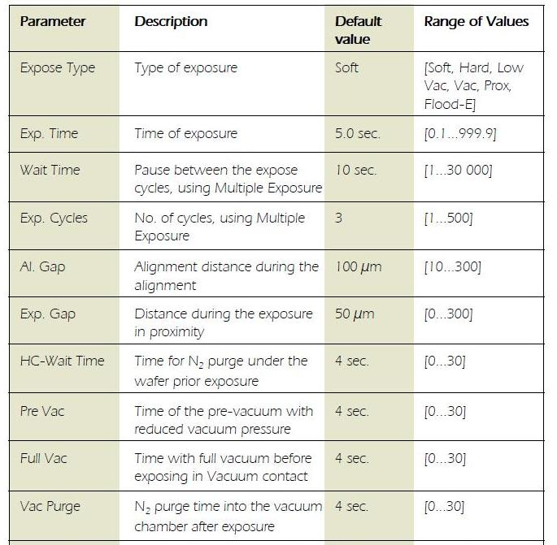
30 sec.
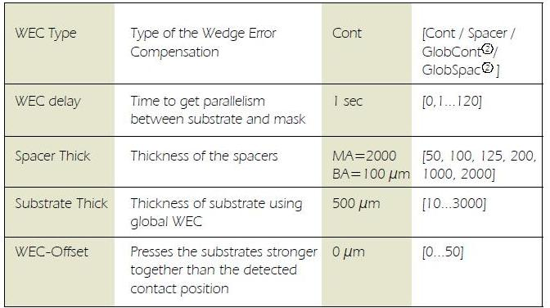
5 sec

Load wafer

  - Press the LOAD key. The machine instructs: “pull slide and load substrate onto chuck”. Pull out the transport slide completely. Insert the proper chuck and place the wafer against the pre-alignment pins. Confirm with ENTER key. Now the wafer is held by vacuum
  - Set the X and Y stage micrometers to center position per the label under the micrometer. Set the Theta micrometer so that the rotation indicator line is horizontal and visable.
  - The machine instructs: move slide into machine and confirm with ENTER. Watch out for the microscope movement! WEC starts automatically after the last action is completed. The wafer is adjusted parallel to the mask. If the microscope is not lowered automatically press F1 key, confirm with ENTER.

Wafer Alignment

  - For a first level print, no alignment is needed and you can continue to section 8.0.
  - The TSA-microscope image on the monitor is enabled by turning the SPLITFIELD switch to LEFT. Make sure the BSA MICROSCOPE key LED is off. It should stay off as this system has no BSA.
  - Turn ILLUMINATION switch to TSA and select the light intensity with the potentiometer underneath this switch. Separate intensity selection for the left/right objective is possible with the aperture located at the left/right microscope front.
  - Coarse focus is possible by using the large TSA Z-MOVEMENT knob behind the TSA-microscope. Make sure the TOP/BOTTOM key LED is on and adjust the fine focus separately using the TOP SUBSTRATE LEFT/RIGHT regulators.
  - Move the left and right microscopes (separately) to the mask alignment marks using the OBJECTIVE X-SEPARATION knobs (metal knobs to the sides of the microscopes).
  - Use the GRAB IMAGE key (option) to superimpose the mask alignment mark image on the monitor with the substrate live image. Here’s how. First keystroke grabs the present image and then moves the objectives to the substrate focal plane. The TOP/BOTTOM key LED goes off. The motor control of the microscope manipulator is disabled at this time to prevent you from changing the microscope image reference. Second keystroke deletes the stored image and enables the manipulator again.
  - Adjust the left/right microscope image fine focus with the BOTTOM SUBSTRATE LEFT/RIGHT regulator.
  - Caution: If mask and wafer are in contact (CONTACT INDICATOR LIGHT ON), don’t align the wafer!
  - Use the micrometer screws of the alignment stage for STG-X-Y-Θ-MOVEMENT. You may use the “SEP” up and down keys to change the alignment gap during alignment if needed.
  - Alignment check- Press the “Alignment Check” key and the sample will move the sample into the full contact position. If Vacuum Mode is being used, vacuum sequence will run. If satisfied with the alignment, press the expose button. If more alignment is needed press the button again and the sample will move back to alignment position.

Exposure

  - Pressing the Expose Key and wait for exposure to complete.
  - The system may hang up (i.e. not unload the sample) if the “theta” micrometer is to positioned all the way clockwise or counterclockwise. VERY IMPORTANT----- Return the sample Theta position micrometer to the center of travel so that the position indicator white line is visible as shown below. Then press the “Unload” button.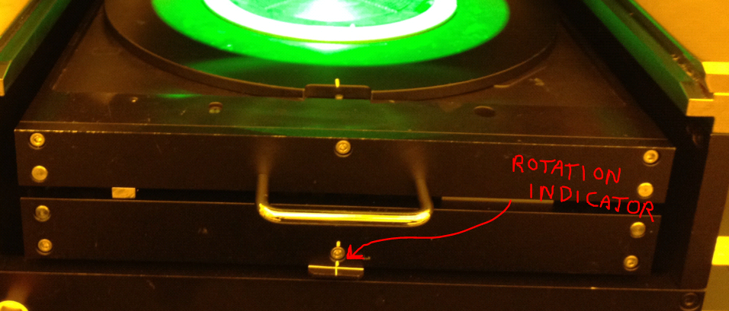

  - Unload the sample.
  - Press the CHANGE MASK key when done and the mask holder will be released. Pull the mask holder out, flip it by 180º and store it on the tray to your left. Press ENTER to switch the mask vacuum off. Retract the mechanical clamping and remove the mask. Press the “mask change” and “enter keys” to complete the unload.

Supplemental Information

Exposure Programs
The selection of the correct exposure method for your particular application is critical. See the following for details of each mode. The type of exposure program is selectable with the SELECT PROGRAM key. After this selection it is possible to edit all corresponding parameters by pressing the EDIT PARAMETER key.

Proximity exposure
Our system does not have the proximity option

Soft contact exposure
Mask and wafer are brought in contact. The structural resolution is better than in proximity exposure. The vacuum securing the wafer onto the chuck is maintained during exposure. The only force to press the wafer against the mask is the force applied during WEC.

Hard contact exposure
This is similar to soft contact mode. After the wafer has moved into contact, the vacuum underneath the wafer is switched off and nitrogen is purged under the wafer to allow close contact between wafer and mask.

Vacuum contact exposure
This mode performs the highest resolution levels. After the WEC and alignment the wafer is brought into contact with the mask. The rubber seal of a vacuum chuck is creating a mini chamber between mask and wafer. The rubber seal pressure is adjustable by the VACUUM SEAL regulator. This chamber is evacuated in steps. Pre vacuum gently pulls vacuum into that mini chamber to enable a smooth contact between mask and wafer i.e. it prevents gas bubbles to be trapped. Full vacuum will be applied with the next step. The wafer will be brought to the closest contact position. The vacuum securing the wafer on the chuck is replaced by nitrogen. In this mode the best contact between mask and wafer is achieved. After exposure, nitrogen will be purged into the mini chamber to break the vacuum. The larger the wafer the longer the vacuum and purge times. For best results start a test with long times and reduce them gradually. All the parameters can be set using the EDIT PARAMETER key.

Low vacuum contact exposure
This mode is similar to vacuum contact with one difference: the vacuum level in the wafer chamber can be adjusted by the LOW VACUUM ADJUSTMENT regulator. So the high resolution level of the vacuum contact exposure can be combined with a minimum mechanical stress for wafer and mask. Set an appropriate vacuum with the vacuum chamber regulator and test the result using the ALIGNMENT CHECK key.

Flood exposure
It is possible to expose the whole wafer without a mask. After this mode is selected, the exposure can be started from the initial state by pressing the EXPOSURE key. The exposure takes place as long as the exposure time was set independent if a mask (and mask holder) is loaded or not.

Multiple exposure
For special applications the numerical value for the overall exposure time can be segmented into equal exposure intervals alternating with wait time intervals in which the wafer is not exposed. One exposure time and one wait time is named as one exposure cycle. To perform Multiple Exposure, proceed as follows:
  - Select the corresponding exposure program by the SELECT PROGRAM key.
  - Press the MULTIPLE EXPOSURE key Press the EDIT PARAMETER key Edit the parameter for the exposure program. Edit the numerical value of the corresponding parameters wait time and cycles.  
  - Press the flashing EDIT PARAMETER key to finish editing and start alignment followed by the multiple exposure process.

Wedge error compensation
During this procedure the top side of the wafer will be set parallel to the bottom side of the mask i.e. sets the entire wafer surface on the (as close as possible with this method) same focal plane. Set the WEC type using the EDIT PARAMETER key. Two methods are standard:

Contact mode:
For the exact parallel setting the wafer will be moved against the mask.

