\
EVG 620 Mask Aligner

Standard Operating Procedure
Rev. 2026-01

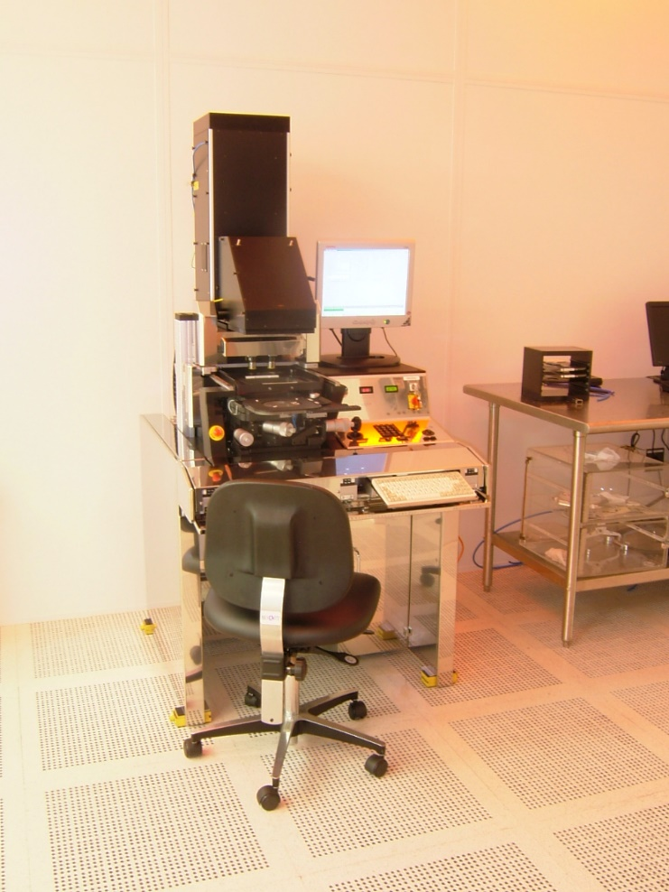

Table of Contents
Equipment Uses and Restrictions 2
Safety 2
Sample preparation 3
Pre-Operation 3
Operation 5
General / Expose / Contact Force - Parameters Setup 6
Camera Controls 11
TSA (skip to 2.17 if doing BSA) 13
BSA - Crosshair Mode 14
Wafer Bonder Alignment Operation 15

Equipment Uses and Restrictions

The EVG 620 is a semiautomatic contact photolithographic alignment and exposure tool with a 1000 watt light source ideal for exposure thick resists. It also has the capability of front to back alignment of patterns and aligning wafer stacks for the anodic bonder. Recipes for the exposure routines can be pre-written and run.

Safety

The machine utilizes high voltage current; automated movements, powerful pneumatics, has hot surfaces, and emits intense ultra-violet radiation. Users of this machine will ensure that they are wearing UV protective glasses on while working in the vicinity of this machine while exposure operations are in progress. Unprotected UV sensitive materials near this machine will be exposed; use a dark box! Gloves, of course (they should be fresh, clean and devoid of any PR residue) are required and all effort should be used to insure that the back sides of wafers are clean and dry and without PR residue; PR that gets on the wafer chuck should be cleaned off immediately. The on screen instructions should be followed to the letter and hands, loose clothing and other materials should be kept clear of the moving parts during the automated processes.

Sample preparation

The machine is configured to handle whole 4 inch wafers and 5 inch glass masks only; however, smaller wafers, pieces and overlay masks can be used by utilizing specialized carriers, see staff for advice. Pr coated wafers should be thoroughly soft baked cleaned of any residue on the surface that contacts the wafer chuck. It is necessary, when using small pieces on a carrier wafer, that some method of temporarily securing the pieces to the carrier so that they don’t stick to the mask during unloading. Pieces on a carrier should be surrounded by spacer pieces of equal thickness to insure good contact with the mask. Overlay masks attached to a carrier glass should never have tape in contact with the substrate or spacers as this will cause a wedge error.

Pre-Operation

  - Log onto the Tumi.
  - If not already on, turn the keyswitch below to the “On” position. 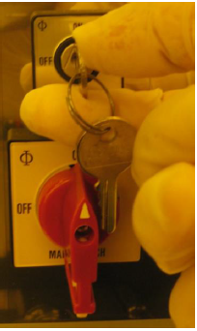
  - If the computer is not already on, open the lower stainless steel door (under the main control area) and press the computer “power” button. The computer should boot up.
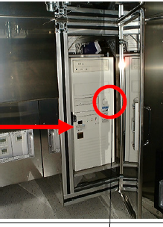
  - Click on the “Eye” icon on the computer desktop to initiate the program.
  - Drop the front panel down and gently slide the keyboard to the extended position
  - At the top of the window there is a “login” menu item. Log in to the software using nrfuser as the user name and the password.
  - The tool will initialize and the software will automatically load the last several recipes that were used; you may maximize and edit any of these at this time. If you did not create the recipe and are using it as a template then be sure that you save it as your own recipe, do not overwrite recipes that you did not create.
  - Check that the exposure lamp is lit and ready to use.
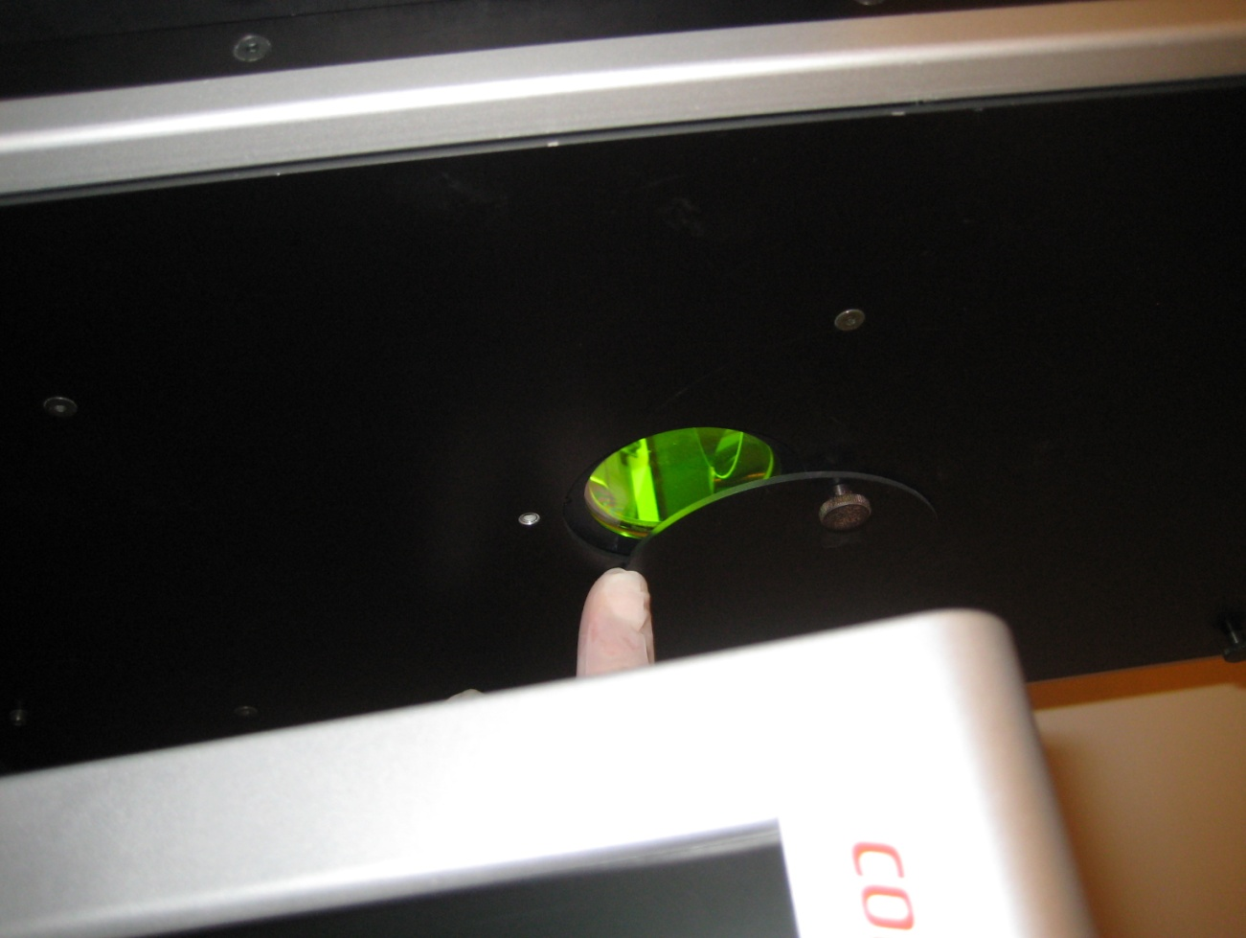
  - The exposure intensity at 365nm will be checked on a weekly basis. The energy value and date will be written in sharpie on the stainless cover near the black number keypad. The daily intensity reduction is approximately -1.6% but adjusting your dose is not needed to produce good exposures. If it has been longer than one week since intensity was checked, you should contact Staff to check the intensity for you.
  - Check that the power switches and electronics power key are on and that the machine power LEDs are lit.
  - Check that the machine is in a ready state. The lamp house and topside scopes to the rear and Loader tray in the out position. 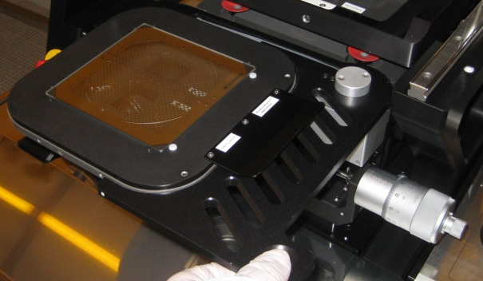

Operation

    - See the “Pre-Operation” section above before using this tool.
    - Check that the chuck pressure (right green digital pressure gauge) is 290mbar +/- 10. If adjustment is needed, the regulator is located behind the keyboard drop down panel.
    - Open a recipe, click on the File menu item and select Open, select a recipe (***.RCP) and click Open . The recipes __TSA.rcp, __BSA.rcp and should contain the initial parameters for most users. This includes the correct mask thickness for RSC purchased photomasks. If you edit these recipes please save the new recipe with you name etc…
    - DO NOT create your own file folder to store your files. They will cause issues with the video controller when run from any folder other than /EVG620.
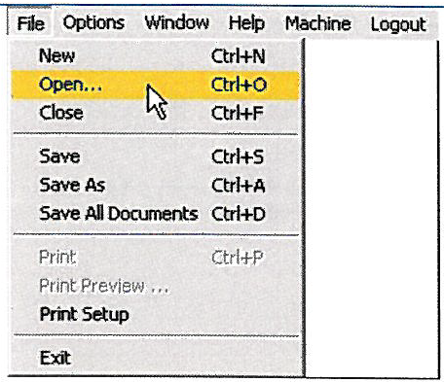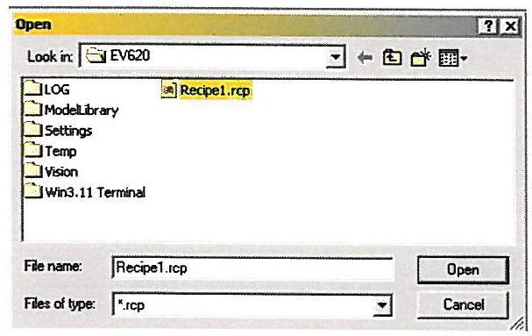

General / Expose / Contact Force - Parameters Setup

    - Maximize the chosen recipe to view the editing window. 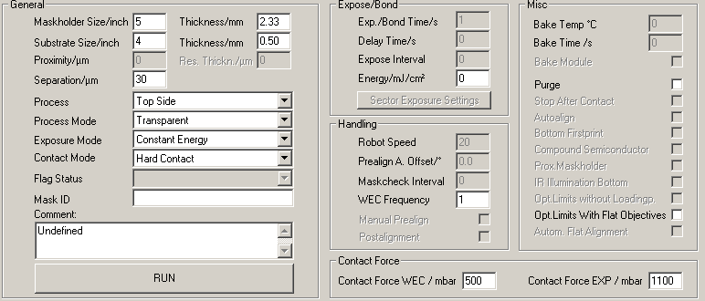
    - In the “General” Box, edit the parameters following the following guidelines. Our machine is configured for 4” substrates. Masks may be 5” or 4”. Each tool use will require you to configure Process, Process Mode, Exposure Mode and Contact Mode.
    - Photomask purchased from the RSC are all 2.89mm thick so set the mask thickness to that if that is where you purchased your mask.
    - Wafers sold to you by the RSC are usually 500-525um thick so set substrate thickness to 0.525mm.
    - Set separation to 25-30um. This is the separation between the mask and substrate during alignment. Note: this value may be adjusted later during wafer alignment by clicking on the “recipe” tab.
    - The exposure intensity at 365nm will be checked on a weekly basis. The energy value and date will be written in sharpie on the stainless cover near the black number keypad. The daily intensity reduction is approximately -1.6% but adjusting your dose is not needed if it has been less than 5 days since last check. If it has been longer, you should contact Staff to check the intensity for you.
    - Set Exposure Mode to “Continuous”. Calculate the exposure time by taking the exposure energy (mj) needed divided by the power written in Sharpie by RSC Staff on the control panel….i.e.
        - Dose in millijoule (mJ) / power written in sharpie (mW) = exposure time in seconds.
        - Refer to the “NRF_Photolithography_SOP” for help determining the exposure energy needed for your process”.
    - In the “Contact Force” window, set Contact Force WEC / mbar=500 and Contact Force EXP/mbar 1100
    - In the Process drop down select Topside or Bottom Side.
        - Definitions
        - Anodic is for the Anodic Wafer Bond process and will require the bonder aligned wafer transport tool.
        - Top Side refers to the alignment of substrates to a mask using the topside microscopes.
        - Flood allows exposure of a substrate without a mask inserted.
        - Bottom Side refers to the alignment of a substrate features bottom side to patterns on a photomask through the use of either registered captured images of the mask, crosshairs, or directly through a transparent substrate.
    - In the Process Mode dropdown you may have a choice of Overlay, Crosshair and Transparent depending on the machine Process that you selected above. 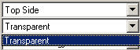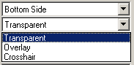
- Overlay (not recommended) mode is used for bottom side alignment. It requires the CCD brightness and gains to be set just perfectly which makes it almost unusable. It allows one to capture an image of the alignment mark. The image is then overlayed on the screen and used to align the substrate to the image.
- Crosshair mode is used for bottom side alignment. The bottomside microscopes are moved to the alignment marks on the photomask. Computer generated marks are then aligned on the screen by the user to represent the position of the mask alignment marks and frozen in place. The wafer is then loaded and aligned to the computer generated marks.
- Transparent mode changes meaning depending on the type of process selected. If Topside is selected, then transparent refers to the transparent mask that you will be aligning through. If Bottom Side is selected it refers to the transparent substrate that can be aligned to the mask directly using the bottom side microscopes i.e a glass wafer etc..
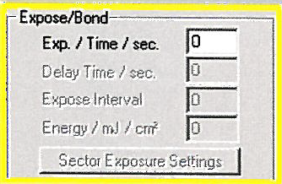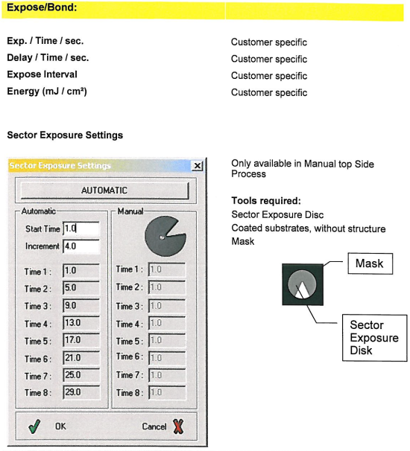
The Contact Mode should be set for “Hard Contact” for most exposures.

    - Click RUN to start the exposure sequence.

    - The software will begin to run the chosen routine starting with a machine initialization.
    - Follow the directions at the bottom of the screen; only do what the software directs.
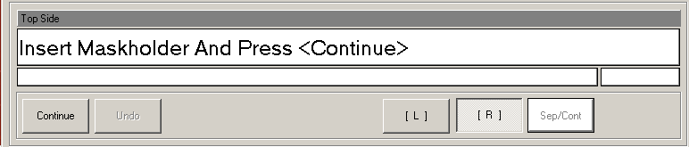
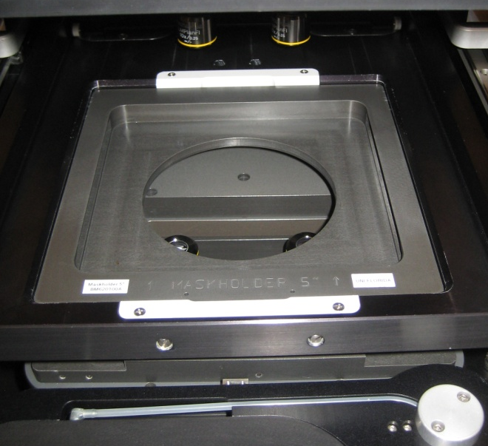
    - If the 5” mask holder is normally in place. If you need to use the 4” holder, grasp the holder inside the round opening and lift it straight up. Do not wait until later to do this as the holder will be clamped in place after this step. Check that the blue “O” rings are in place on the mask holder and the seating frame
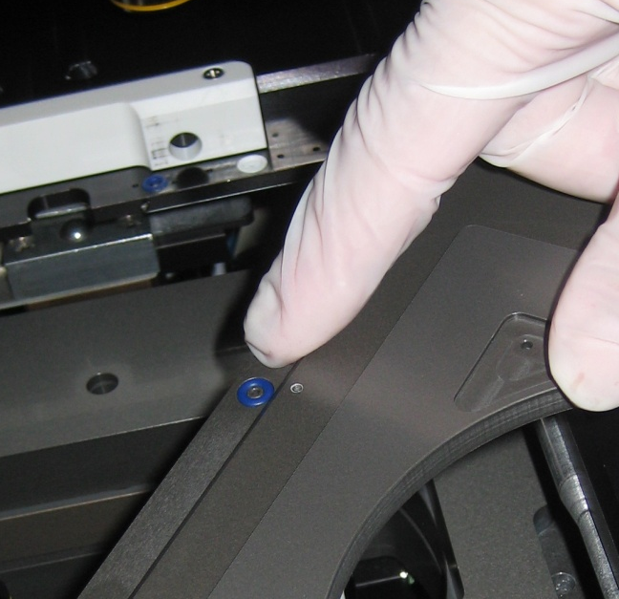
    - Carefully insert the mask holder so that the label is readable from the front by tilting it against the locking bar on the left then pressing firmly downward until snaps into place against the locking bar on the right.
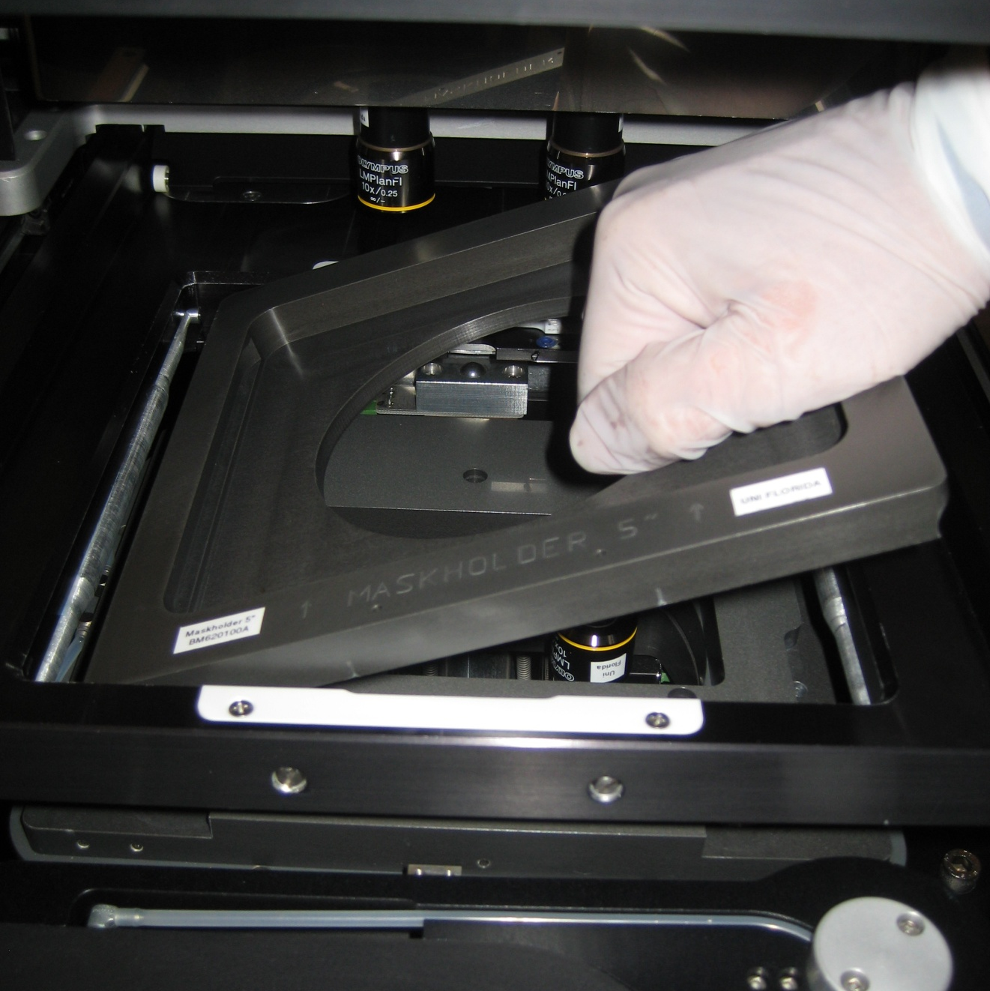
    - Set the stage micrometers as follows. X=5, Y=6, Theta=6. When adjusting, each revolution is 0.5mm.
    - Place the mask Load Frame on the tray ensuring that the registration pins fall into the holes on the tray chuck.
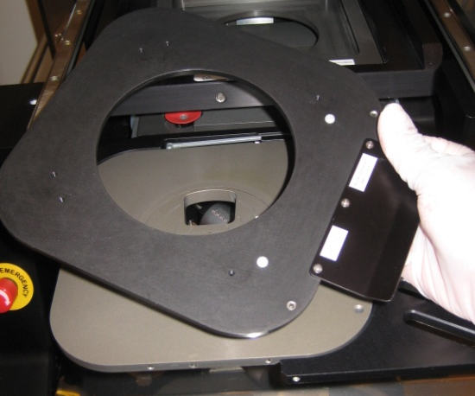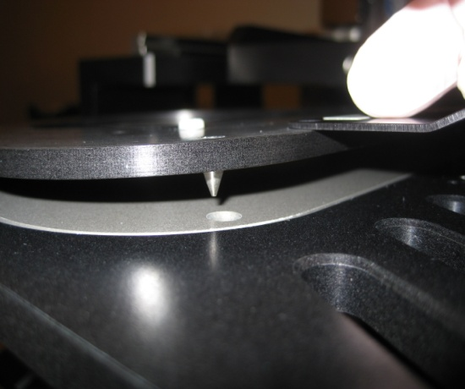
    - Place the mask on the Load Frame with the chrome side down. Gently push the mask edge against the Kapton tape. 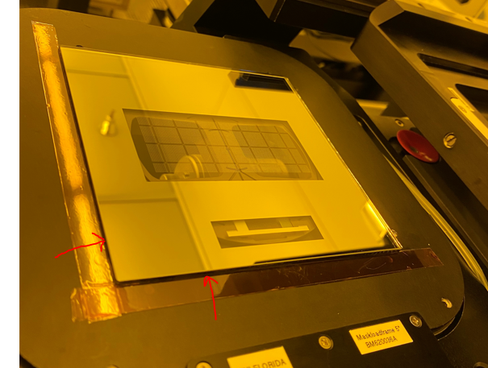
    - Click “Run”. The software will direct you to move the tray in. Pivot the tray into the machine slowly until it comes to a stop and hold it while the machine performs wedge error compensation (WEC) i.e. brings the substrate chuck up.
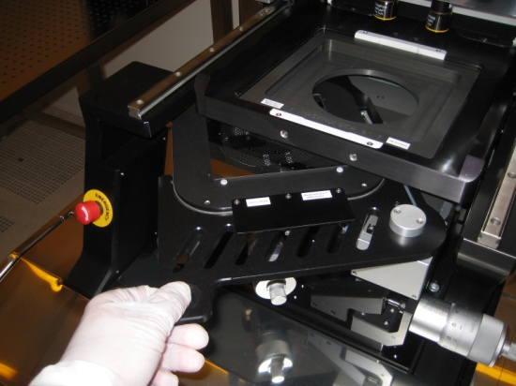

Camera Controls
    - The screen will display “Adjust Mask and Press Continue”. Click the “Controls” button. For TSA, adjust the camera control as shown below. For BSA lower the left and right sliders to 15-25%.
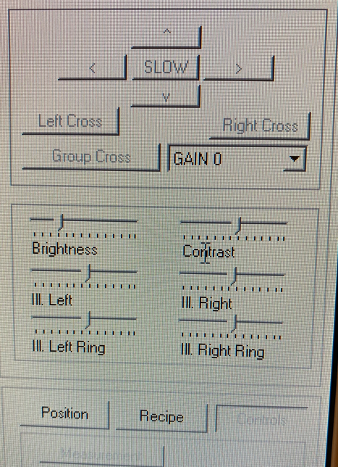

    - Refer to the pic and descriptions below for the next few steps.

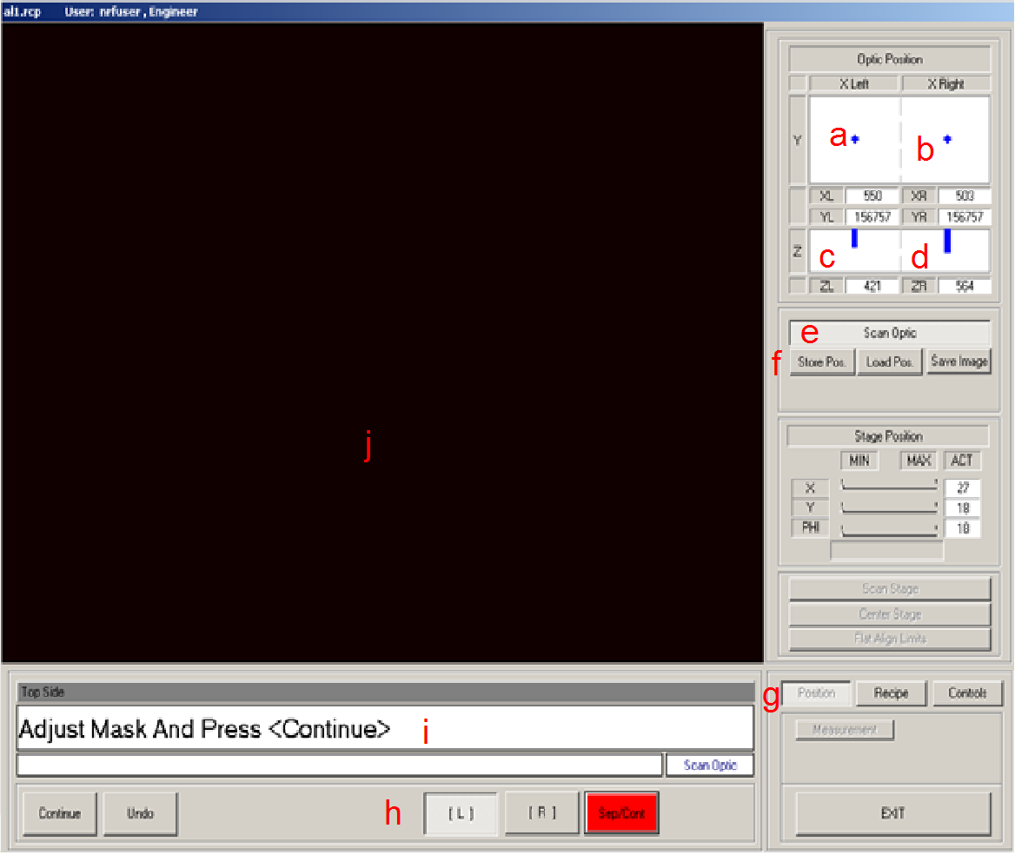
- Left microscope x and y position
- Right microscope x and y position
- Left microscope z (focus) position (note: that the cursor extends from the top for top side mode and from the bottom in bottom side mode)
- Right microscope z position
- Scan mode toggle to change from microscope movement to stage movement.
- These buttons are used to store the absolute position of the stage and scopes under specific names inside the recipe.
- Switches the bar between Position, Recipe, and Controls.
- Switches between control of the left and right scopes.
- This box communicates directions to the user.
- The video images from the scopes are displayed here.
- Right clicking inside the video window allows one to zoom the image or switch between all left, all right or split screen modes.

    - The Alignment Microscope X, Y, Theta and focus is accomplished using the joystick. Be sure the “Scan Optic” radio button is depressed on the screen, not the “Stage Position” radio button. This aligner does not have a motorized stage so “Stage Position” does not work. The substrate stage is moved by manual micrometers.

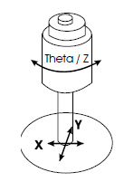

TSA (skip if using BSA)
    - When doing Top Side Alignment – Y axis microscope motor moves left and right microscopes together. X motors are independent. Click the “Position” button to get back to the microscope position screen. Click the [ R ] button on the keypad to enable the right microscope motors. Adjust ZR using joystick rotation. The focus motor position will be approx.. 450 +/- 50 (rotation of the joystick) when in focus. The mask pattern should now be visible if you are over a feature on the mask. Using the X and Y joystick find your left or right alignment mark. Adjust the mask rotation using the Theta substrate micrometer until the left and right alignment marks are aligned on the CDD cameras. There is no Theta adjustment for the CCD cameras. So, this step aligns the mask to the TSA microscopes horizontal axis. Press continue when the marks are aligned.
    - Load the substrate on the chuck using the small Teflon tabs to align the wafer flat and the edge. (Take care; these tabs are fragile).
    - Adjust the substrate micrometers X,Y,Theta wafer alignment. Note: The Z position alignment gap separation may be manipulated. Click the recipe tab and set the “sep” value and press “Move to”.
    - Align the marks. To improve alignment precision, press the “SEP/Cont” button. The substrate will move closer to the mask for better examination. The amount of mask/sub separation can also be controlled directly by clicking the “Recipe” tab and changing the “Seperation” value and then pushing the “Sep/Cont” button again. When the light is on, there is separation. When off, it brings the mask into light contact.
    - Press continue when the alignment is good. Hard contact will be initiated to allow one to inspect the quality and precision of the alignment; if it is good press continue, if not press undo to readjust the wafer. DO NOT align the wafer while in full hard contact with mask.
    - After continue is pressed the machine will expose the substrate.
    - After exposure you can move the tray out and replace the substrate with another or press “undo” to initiate the mask unloading procedure.
    - Notify RSC Staff when you are done with the aligner for the day so that the lamp may be powered off.

BSA - Crosshair Mode
    - Note: Unlike the TSA microscopes, each BSA microscope has its own Y axis motor.
    - Click the “Position” button. Click the [ R ] button to enable the right microscope motors. Adjust ZR using joystick rotation to focus the mask. The focus position will be approx.. 850 +/- 50 (rotation of the joystick). The mask pattern should now be visible if you are over a feature on the mask. Position the right microscope using the X and Y joystick to find your alignment mark. Enable the Left microscope and move the YL motor to be approximately the same as the right microscope YR coordinate.
    - Adjust the X, Y and Theta Stage Micrometers to align the “Left” and “Right” mask alignment marks. Press continue.
    - Move the tray out when prompted and remove the load frame. Store the frame on the screw extending out of the front of the illuminator.
    - Move the tray back in when prompted (without a wafer). When prompted “Adjust Microscope to Mask”, adjust focus for both microscopes to approximately 700 +/- 50 for best focus. Press continue.
    - Adjust the computer generated cursor position to match the mask alignment marks centers. Use cross length, cross thickness, arrow keys (slow,fast). Toggle between left and right cursors via the “left cross” and “right cross” buttons. Press continue.
    - Move tray out and load substrate with exposure side up and alignment side down. Press continue and move tray in.
    - Adjust the substrate micrometers X,Y,Theta wafer alignment. Note: The Z position alignment gap separation may be manipulated. Click the recipe tab and set the “sep” value and press “Move to”.
    - Align the marks. To improve alignment precision press the “SEP/Cont” button. The substrate will move closer to the mask for better examination. The amount of mask/sub separation can also be controlled directly by clicking the “Recipe” tab and changing the “Seperation” value and then pushing the “Sep/Cont” button again. When the light is on, there is separation. When off, it brings the mask into light contact.
    - Press continue when the alignment is good. Hard contact will be initiated to allow one to inspect the quality and precision of the alignment; if it is good press continue, if not press undo to readjust the wafer. DO NOT align the wafer while in full hard contact with mask.
    - After continue is pressed the machine will expose the substrate.
    - After exposure you can move the tray out and replace the substrate with another or press “undo” to initiate the mask unloading procedure.
    - Notify RSC Staff when you are done with the aligner for the day so that the lamp may be powered off.

Wafer Bonder Alignment Operation

    - Click file, open and select __Bond.rcp.
    - In the recipe selection screen set process to Anodic bond mode. This is for alignment of two 4” wafers prior to wafer bonding. Currently this only works for 4” wafers!!

    - Set Process mode to Anodic. Set process to crosshair. Set contact mode to normal. Set flag status to NO Flags. See below
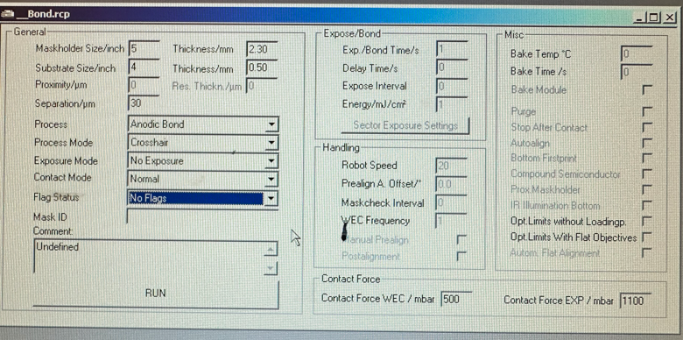

    - Click run and follow the instructions on the screen as they come.
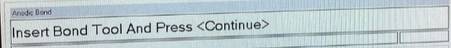
    - Remove the mask holder currently installed by lifting it straight up with 2 hands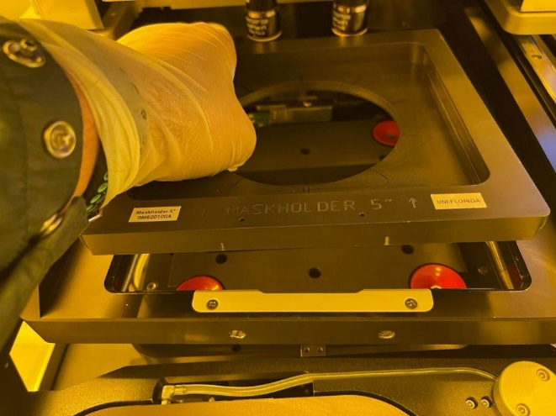
    - Store the mask holder in the mask holder rack on the table in front of the instrument.
    - Insert the wafer bonder bond tool. This is always to be stored with the EVG 501 machine in the hot processing bay.

    - Orientate the bonding fixture as shown below. The fixture label “CU5000107” goes in the back and is legible.

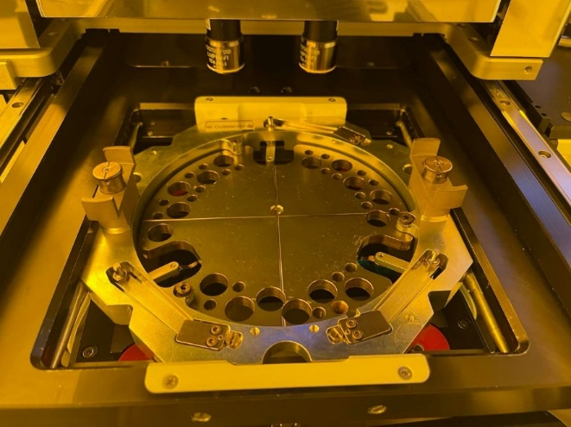

    - Press the fixture into place, it will snap into place.
    - Remove the vacuum line from the standard 4” wafer holder and exchange for 4” bonding wafer holder shown below. 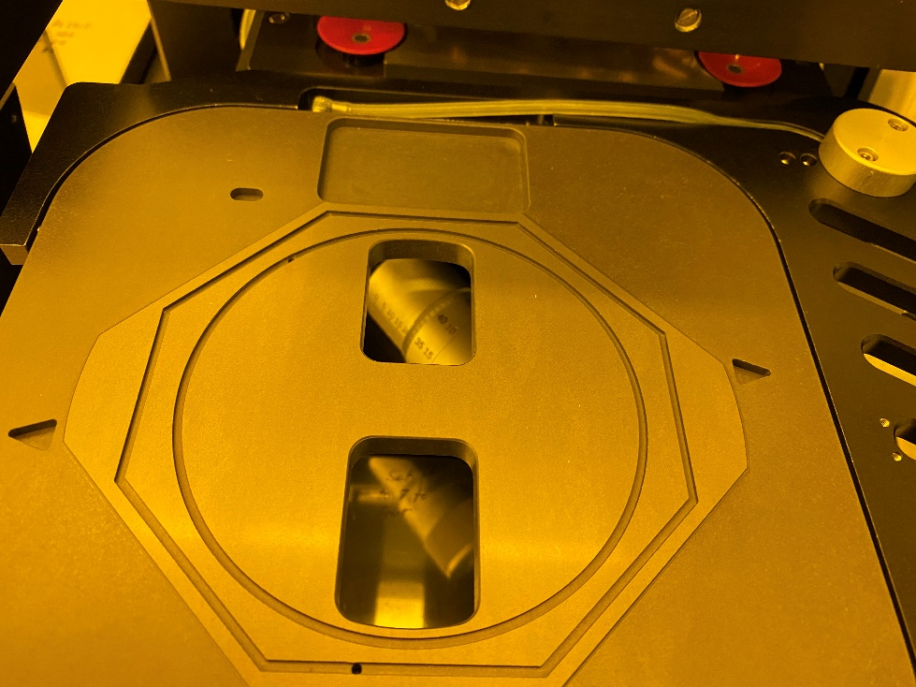

    - Press continue.

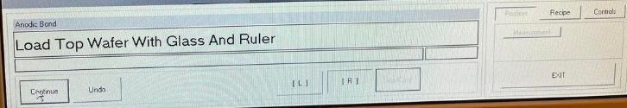

    - Set the stage micrometers as follows. X=5, Y=5, Theta=5.
    - Place the wafer alignment glass (with the label “TOP” on the right side) on the holder as shown below and then place the 1st wafer on top of the glass bonding side down. The flat goes to the right side as shown below. Center the glass to the outline lines on the holder and center the wafer to the glass plate.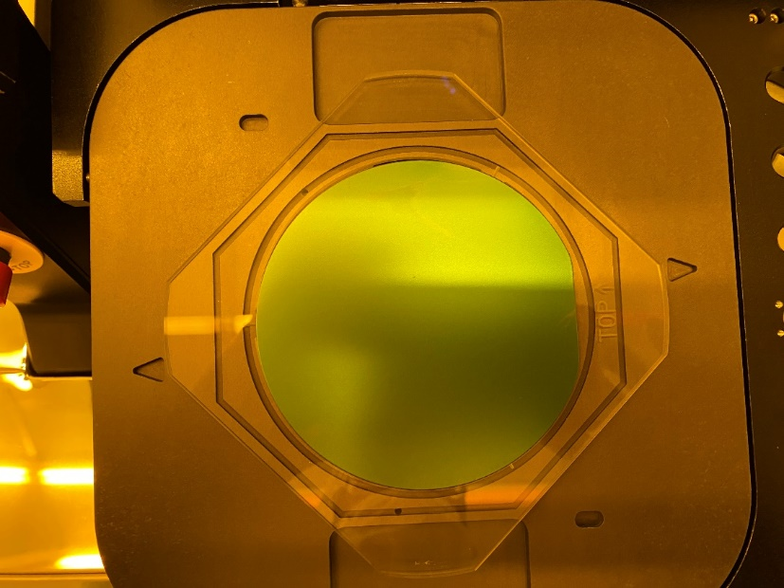
    - Click continue. This will cause a vacuum to be pulled down on the wafer holding the stack to the holder. You will then be prompted to “Remove the ruler and move the Tray In”. We are not using the ruler as it’s not needed. Move the tray in. Upon doing so the wafer will be brought up in close contact with the wafer bonder holder.
    - The prompt “Check flags – must be out” will appear. Check that flags are out and press continue, see pic below.
    - See section 2.19 for BSA for more details regarding microscope manipulations for the following steps.
    - Prompt “Adjust Microscope and Press <cont>”. Adjust focus of BSA microscopes left and right to approximately 750 +/-50 for best focus.
    - Find the left and right alignment marks on your wafer. Press continue.
    - Align the computer generated cursors for left and right marks to the wafer and press continue. Press continue.
    - Unload the wafer tray and load the 2nd wafer the same way you loaded the 1st wafer and press continue.
    - Prompt “Adjust Stage – Press Continue Or SEP/CONT To Move In Contact”. Adjust the wafer position X/Y/Theta and check the alignment by pressing the “SEP/Cont” button. This will move the 2 wafers into contact position and the red light will go out. To adjust alignment if unhappy with the results, press the Sep/Cont button (red light On). Readjust and try again. When happy press continue.
    - When prompted, press down on the two clamps (see pic below) and rotate 90 degrees and then release. The will clamp the 2 wafers together. Press continue.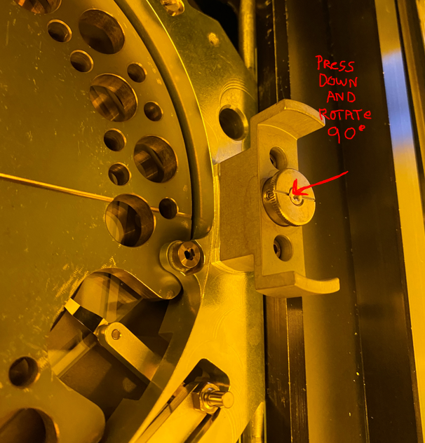
    - When prompted, remove the bond tool flip it over and place on a table.
    - Open the locking clamp on the bonding fixture holding clamp tool-see below.
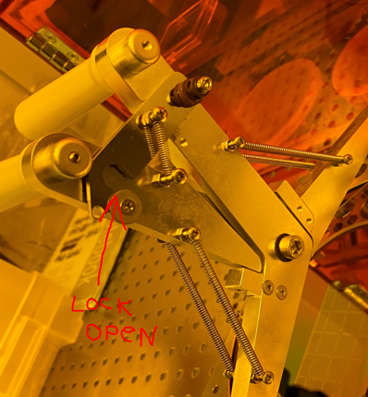
    - Attach the fixture holding clamp tool as shown below and squeeze the handles together to lock it in place, see below.
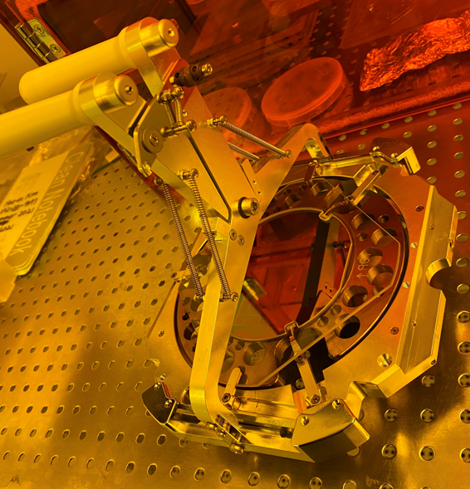

    - Remove the wafer holder and replace with the standard alignment wafer holder.
    - Replace the 5” mask holder that was removed. See below
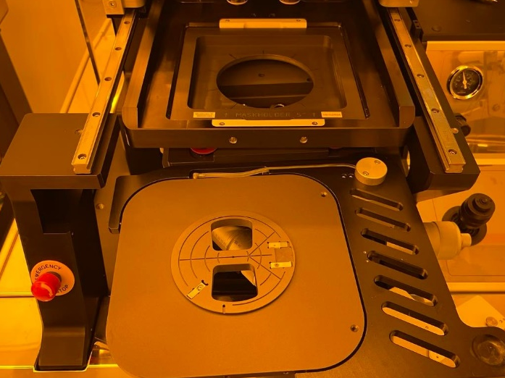
    - Exit the recipe.

