

Liftoff And Resist Strip Solvent Bench

Standard Operating Procedure Rev. 2026-01

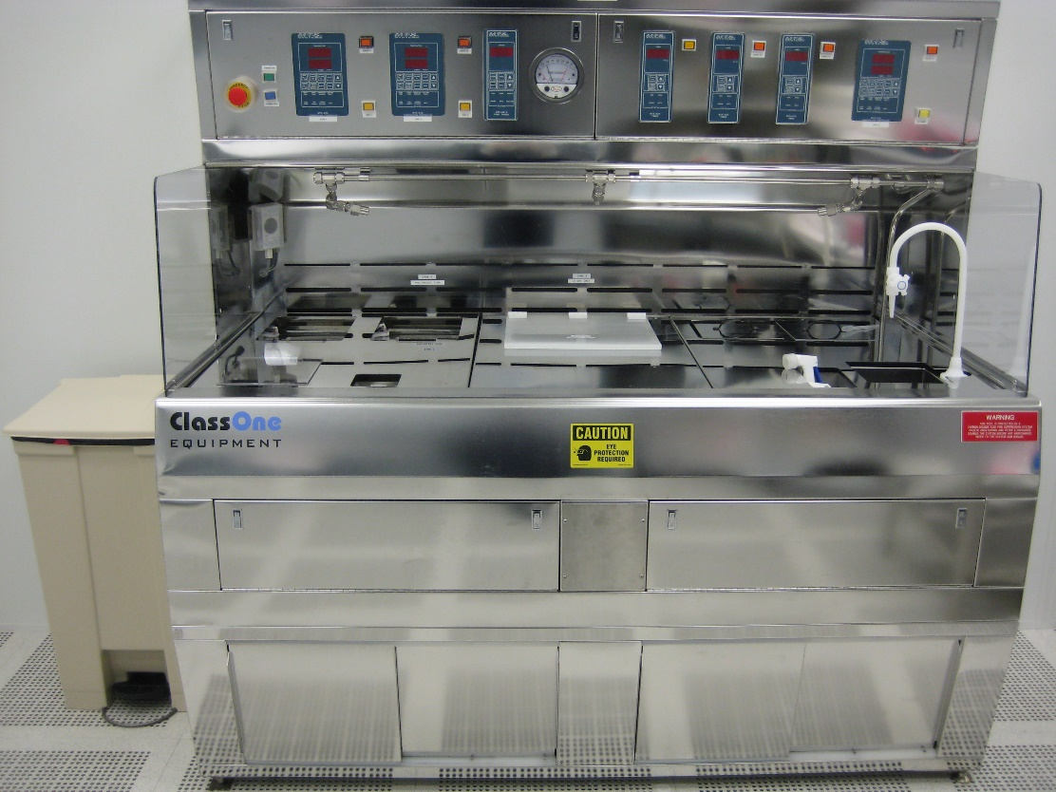

  - Application

This solvent bench is equipped with a static, heated bath and a heated, recirculated, filtered bath. Both baths use MLO-07 (DMSO based) solvent and are held at 60°C to aid in removing photoresists and dry etch by-products. The static bath is for photoresist stripping and the recirculated bath is for liftoff processes. The recirculated bath also has an ultrasonic wand to provide extra energy for the liftoff process. This bench also features and quick-dump rinse tank and sink for rinsing samples.
  - NRF Contact

David Hays
Table of Contents
1. Safety information 3
2. Prerequisites for use 3
3. Operation 4
3.1. Liftoff bath operation 4
3.2. Ultrasonic operation 5
3.3. Resist Strip Bath Operation 6
3.4. Quick Dump Operation 7
4. Ending The Session 7

- Safety information
- Do not change the bath temperature setpoints. The solvents used are flammable at higher temperatures.

- No acids or bases at this bench.
- Prerequisites for use
- User of the RSC facilities.
- Up-to-date hazardous waste training.
- Training by staff.
- User will be responsible for lost or damaged equipment due to negligence. Negligence means not following the SOP, not asking staff for assistance, intentionally damaging items, etc.
  - Do not perform liftoff in the photoresist strip bath.

  - Do not press any buttons labeled as “Drain”. They are not power buttons.

- Operation
  - Liftoff bath operation
Use this bath for performing liftoff processes. Photoresist stripping may also be done in this bath.

    - Log on to TUMI
    - Turn the liftoff bath timer dial clockwise
    - Press “PWR” button to turn on power.
    - Press the “HEAT” button and wait ~15-20 minutes for the bath to heat up.
    - When the bath reaches 70°C, place your samples in the bath until the metal lifts off. Liftoff time will vary but normally takes ~20-30 minutes.
    - If needed, ultrasonic agitation can be used to aid in removal of the liftoff layer. (See Ultrasonic Operation, Section 3.0)
    - When liftoff is complete, rinse your sample using the quick dump rinser. (See Quick Dump Operation, Section 5.0)
    - Dry your sample using the N2 gun.

CAUTION…Never place a wet sample back into the bath. The bath chemicals will react with water and become corrosive to metals and will etch the metal on your samples.

    - Press the “PWR” button to turn the tank off.
    - Wipe down the area when finished.
  - Ultrasonic operation
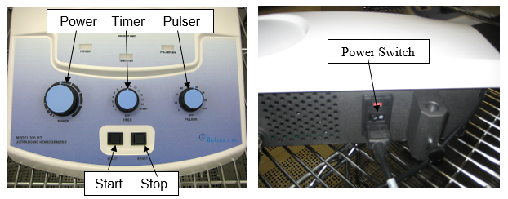
    - Attach the ultrasonic transducer to the steel rod as shown below. The transducer head should only be submerged a few millimeters. Be extremely careful with the transducer and do not drop it in the bath!
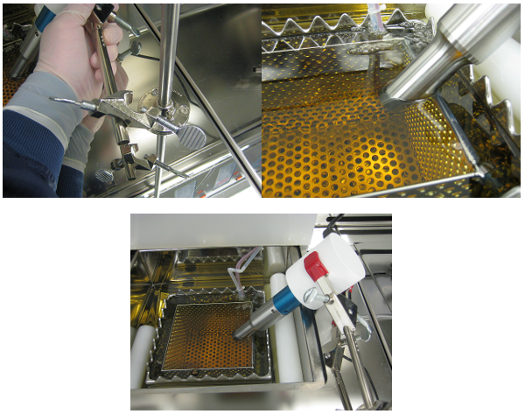
    - Turn on the controller. The switch is located on the back of the controller. See the picture at the beginning of this section.
    - Set the power (intensity), timer and pulser on the controller. Start at lower powers to ensure your sample is not damaged. The timer will stop the process when time is expired. The Pulser allows for two operation modes.
    - Mode 1 – Continuous output when pulser knob is set to off.
    - Mode 2 – Pulsed output with duty cycle set by the knob.
    - Press the “Start” button to begin the process.
- The region of ultrasonic action is rather small, so slowly move your sample in front of the rod about 1cm away from the end.
    - Press the “Reset” button to stop the process if your liftoff is complete before time expires.
    - When finished, remove the transducer from the rod and wipe down with a wet cleanroom wipe and place back on the white bottom off to the side.
    - Turn off the controller. The switch is located on the back of the controller. See the picture at the beginning of this section.
  - Resist Strip Bath Operation
This bath is used to strip photoresist from samples and is not to be used for liftoff.

    - Turn the resist strip bath timer dial clockwise
    - Press the “PWR” button to turn the tank on.
    - Press the “HEAT” button and wait ~15-20 minutes for the bath to heat up.
    - When the bath reaches 70°C, place your samples in the bath. Leave your sample in the bath for 5-10 minutes. Hardened, or burned, Photoresist may require longer times.
    - When liftoff is complete, rinse your sample using the quick dump rinser. (See Quick Dump Operation, Section 6.0)
    - Dry your sample using the N2 gun.
CAUTION…Never place a wet sample back into the bath. The bath chemicals will react with water and become corrosive to metals and will etch the metal on your samples.
    - Press the “PWR” button to turn the tank off.
    - Wipe down the area when finished.
  - Quick Dump Operation
    - Press the “RESET” button.
    - Press “START” to begin the dump and fill cycles.
    - When complete, the buzzer will sound. Press “RESET” to stop the alarm.
    - Press the “HOLD” button to drain the tank. (CAUTION…Never leave the rinse tank full of water. This promotes bacteria/algae growth and will contaminate your samples).
    - If you want to manually stop the tank before all of the cycles are complete then simply press the “HOLD” button. Then press “RESET”, followed by pressing “HOLD” to drain the tank.
- Ending The Session
    - Log off TUMI

