
Heidelberg DWL66fs Laser Writer

Standard Operating Procedure
Rev. 2026-01

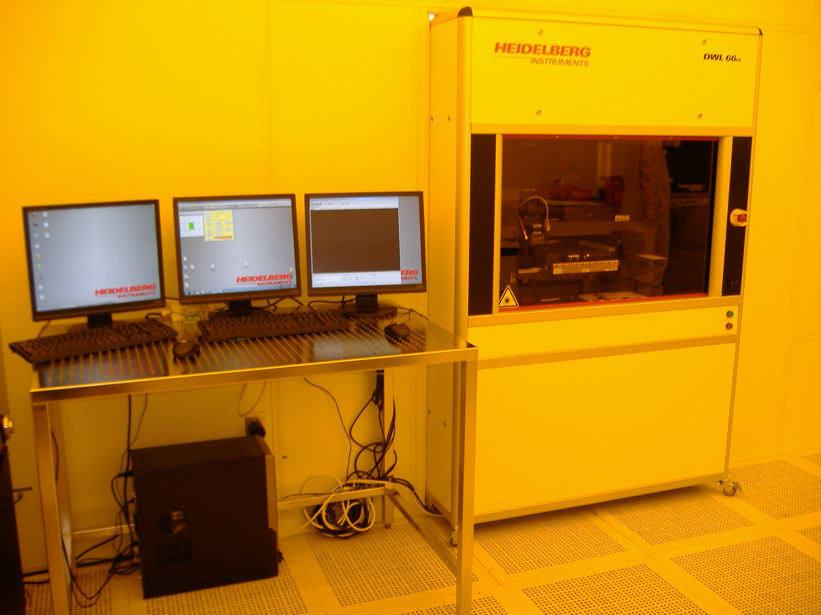

Contents
Safety 2
Equipment Restrictions 2
Equipment Specifications 3
Heidelberg FAQ’s and TIPS 5
Exposure Time Estimates 7
Pattern File Creation 8
Pattern File Conversion 9
Mask Exposure Procedure 14
Mask Post Exposure Processing 21
Pattern File Creation 26
General Design Rules 28
Rules for Autocad 30

Safety
Moving Components – The User should be aware at all times of the moving components associated with this tool. The system door is interlocked and tool will not operate with the door open. The stage will stop when the door is opened. Users are not allowed to adjust any mechanical devices within this machine and are prohibited from opening any doors except the main system door to load samples. If an error or problem occurs, put the system down in the NRF web site with comments and notify NRF Staff. Do not attempt to fix the problem.

Equipment Restrictions

Only 4” and 5” photomasks may be exposed by Users. All other exposures will be done with the supervision of NRF Staff.

Users are not allowed to run samples smaller than 20mm diameter any axis. It may ONLY be exposed by staff. Ignoring this policy may results in severe damage to the Heidelberg $40,000 write head.

Warning – Optical Autofocus mode may not be used. Only pneumatic mode may be used by NRF Users.

The autofocus system can only focus when there is 5mm of flat surface surrounding the focus nozzle which means the system can only expose 5mm from any one substrate edge. See below.
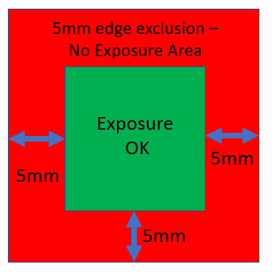

Sample Flatness – the Heidelberg 4mm write head only exposes on flat samples such as silicon wafers, photomasks, glass slides. The focal depth of the lens is 1.6um. The 20mm write head focal depth is 60um which means the laser will stay in focus for taller topography but there is an obvious limit to total flatness of the sample.

Equipment Specifications

The DWL 66FS is a high precision, maskless pattern generator for direct laser writing of microstructures on silicon, glass, film, or any other flat material, that is coated with a photo resist.
The following specs are for mask exposure with 5200A PR thickness. Similar results for <8000A on Silicon wafer.

- 4mm Standard Mode.
    - Minimum feature size = 1.0 microns
    - edge roughness = 70nm-3σ,
    - CD uniformity = 100nm-3σ
- 4mm HQ Mode.
    - Minimum feature size = 1.0 microns
    - edge roughness = 30nm-3σ,
    - CD uniformity = 50nm-3σ
- 20mm Mode.
    - Minimum feature size = 5.0 microns
    - edge roughness = 180nm-3σ,
    - CD uniformity = 440nm-3σ

Minimum resolution specs go up with increasing photoresist thickness.

- Substrate size: up to 9 x 9 inches
- Diode Laser, 405nm, 60mW
- conversion software (Linux) for DXF, CIF, GDSII, and Gerber file formats
- Metrology and alignment system with macro and micro camera
- X-Y-stage with linear motors and 8” x 8” write area
- Wafer/mask vacuum chuck for single plates up to 9” x 9”
- Optical Autofocus using 4mm write head
- Pneumatic focus for the 20mm write head

Heidelberg FAQ’s and TIPS

- If you only need to expose 1-2 samples, direct write patterning on your sample without a mask may be a more cost effective.
- NRF Staff can make your mask for you and is recommended if you only need ≤3 masks fabricated. A cost estimate may be provided by staff based on your needs.
- Computer pattern generation may also be done by NRF staff if you provide detailed design dimensions. Staff time is $50/hour and an estimate for the file design time can be given before work is done once the design is received.
- Mask Patterns with minimum feature sizes ≥5um will take from 15-90 minutes to expose and cost <$200.
- If your pattern includes features ≥2um, the cost for the mask will in most cases be reasonable but you should consult with NRF Staff to get a cost estimate before you begin work.
- If your pattern includes features <2um, consult with NRF Staff and they will provide you with a cost estimate for the mask. If your pattern is very large and feature sizes very small, it may be more cost effective to have the mask made externally.
- If you would like a cost estimate, you can use the “Mask Cost Estimator” spreadsheet located in the “Docs” section on the web site.
- GDSII software “Layout Editor” is the preferred design software. It is free and downloadable. https://layouteditor.com/
- The polarity of the mask does not need to be considered while designing your pattern. The pattern will be “inverted” during Heidelberg conversion if needed. Contact Staff for guidance.
- The tool setup time for mask exposure is approximately 15 minutes.
- The procedure for writing masks is fairly simple.
- It is not required that you be trained on the Heidelberg System to obtain a cost estimate, go to https://NRF.aux.eng.ufl.edu/ccb/resource.asp?id=63
And download the “mask cost estimator spreadsheet. Enter the height and width of your pattern and an estimate is generated for each write mode.
- If AutoCAD file is submitted, it must follow the rules for Autocad in section 5.2. The file must also be a .DXF file, NOT a .DWG file which is only usable by Autocad.

Masks can be purchased from NRF Staff

- Soda Lime and Quartz masks blanks may be obtained from NRF Staff. Both mask types are purchased from Nano-Film Technology. They are coated with low reflective chrome or iron oxide and 5300A of AZ1518 positive photoresist. The iron oxide mask is a good choice if your features are ≥3um and you would like to be able to see through the mask while aligning your sample in the mask aligner.
Procedure
- Email walewis@ufl.edu the day before or before 9am the day of your reservation. Include the mask size (4” or 5”) and type (chrome or iron oxide)
- Include in the email which write head (4mm or 20mm) write head you will be using.
- The mask will be placed in the blue box on the chrome rack to the left side of the Heidelberg along with the “Work Order” form for you to fill out and leave on top of the Heidelberg table. Please include “name, date, PI, project, number of masks requested”.

Before Using the tool or requesting Photomasks see the “Mask Making Presentation” which can be found by clicking the “Docs” button on the Heidelberg Tool page on the NRF web site, shown below.
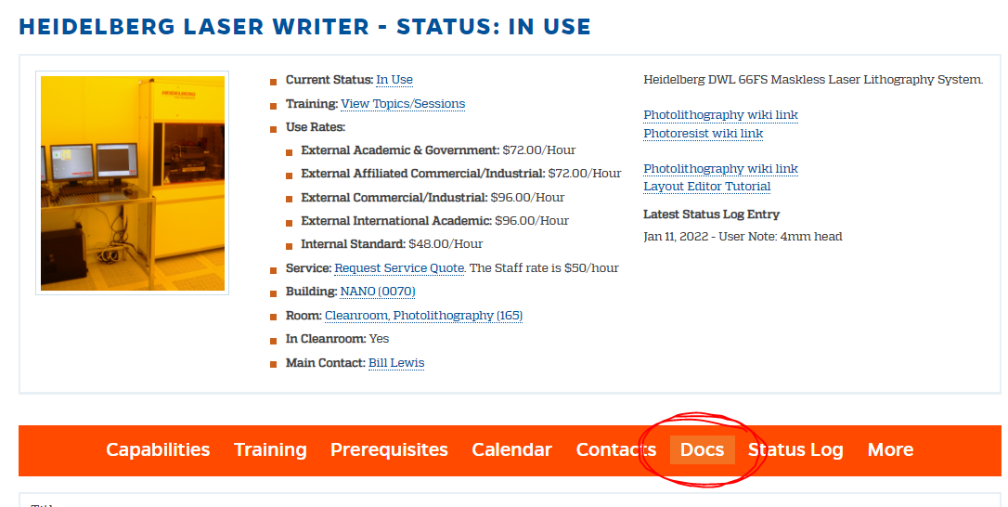

Exposure Time Estimates

  - Before starting your design you need to consider the implications of the write time costs. Generally, when your design features are all 5um or larger, the cost is low. Below 5um the exposure time goes up 8X for Standard 4mm mode and 16X for 4mmHQ mode. To get a better idea of the cost, select the write head you will need and use the “Exposure Time Table” below to estimate the exposure time.

4mm Standard Mode
Minimum feature size = 1.0 microns
edge roughness = 70nm-3σ,
CD uniformity = 100nm-3σ
Pixel Size = 400nm
4mm HQ Mode
Minimum feature size = 1.0 microns
edge roughness = 30nm-3σ,
CD uniformity = 50nm-3σ
Pixel Size = 200nm
20mm Mode
Minimum feature size = 5.0 microns
edge roughness = 180nm-3σ,
CD uniformity = 440nm-3σ
Pixel Size = 1000nm
- For exposure time estimates for your design, go to https://NRF.aux.eng.ufl.edu/ccb/resource.asp?id=63
And download the “mask cost estimator spreadsheet. Enter the height and width of your pattern and an estimate is generated for each write mode.

Exposure Time Table.
Test Pattern Used: 100x100mm area
Write Head - Mode Used | Minutes |  | Write Speed [mm2/minute] |  | Critical Dimensions
20mm write head | 82 |  | 121.95 |  | ≥ 5um features/spaces
4mm standard | 822 |  | 12.165 |  | ≥ 1.5um features/spaces
4mmHq | 1545 |  | 6.472 |  | ≥ 1um features/spaces
Test Pattern Used: 10x10mm area
Write Head - Mode Used | Minutes |  | Write Speed [mm2/minute] |  | Critical Dimensions
4mm standard | 15 |  | 6.66 |  | ≥ 1.5um features/spaces
4mmHq | 25 |  | 4 |  | ≥ 1um features/spaces
Test Pattern Used: 10x100mm area
Write Head - Mode Used | Minutes | Write Speed [mm2/minute] |  | Critical Dimensions
4mm standard | 81 | 12.34 |  | ≥ 1.5um features/spaces
4mmHq | 151 | 6.622 |  | ≥ 1um features/spaces

Pattern File Creation

    - GDSII software is highly recommended. And will cause you the least amount of trouble! Do not use special characters (such as spaces, #, , $, @ etc…),for cell names or file names. Stick to letters and numbers to be safe. Also, do not name a cell “main”.
“Layout Editor” is a downloadable GDSII design software that is also available at the NRF. It resides on the community computer located in the NRF bottom floor “break area” located at the NW corner of building (left computer) and on the Heidelberg Conversion computer in the cleanroom. NRF Staff is available to help you to quickly learn the basics of “Layout Editor”.
    - AutoCAD (.dxf, NOT .dwg) may be used but not recommended to generate design files but a strict set of rules must be obeyed. See section 5.2 below. Autocad files should be converted to GDSii using “Linkcad 7” (which is also loaded on the same NRF Community computer mentioned above) prior to entering the cleanroom and loaded on the Heidelberg Conversion Computer. If you must use “Autocad” See section 5.2 for basic Linkcad 7 instruction. If NRF Staff will be doing your exposure for you, they will perform the Linkcad conversion for you.
    - All file types are converted into Heidelberg .LIC format before actual exposure on the machine. The Heidelberg conversion software is only located in the cleanroom next to the Heidelberg. The conversion process consists of slicing your design into vertical stripes equal to the longest Y distance of your design. See pic below for explanation. The width of the strip is determined by the write head used…100um wide for the 20mm write head and 20um for the 4mm write head. Each strip is equal to one stage scan in the Y+ direction.
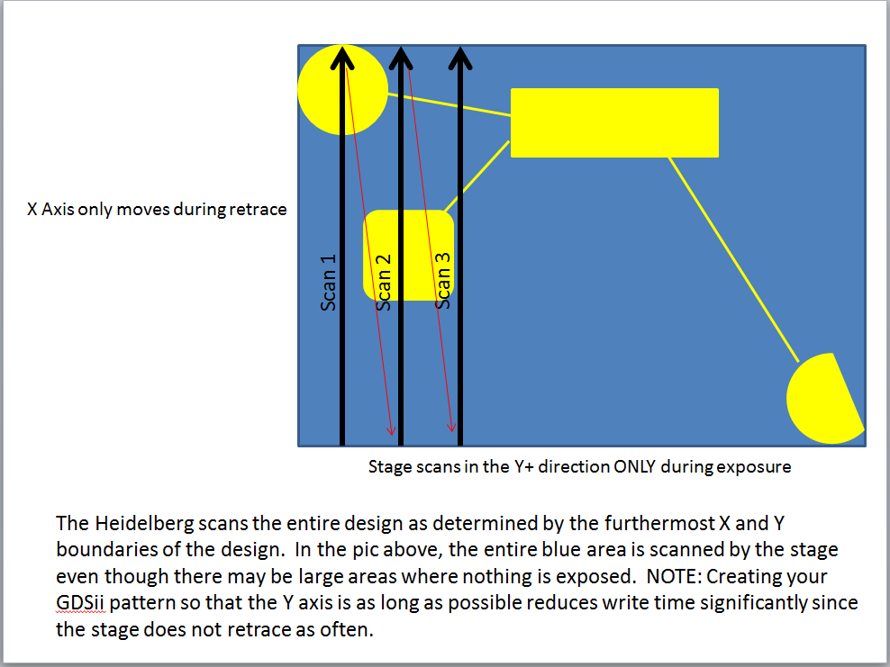

Pattern File Conversion

    - There is no charge when using the conversion computer in the cleanroom i.e. you do not need to log on to the TUMI to use it. If the Heidelberg is in use, the conversion computer may still be used provided the logged in user doesn’t need the conversion computer.
    - Rename your design file before transferring to the Linux computer. Use the following format….. (your initials+writehead+patternname). Example: bl_20mm_dotarray. There is a 20 character limit for the file name and don’t use special characters or spaces in the name.
    - Files are transferred via your virus free USB thumb drive. There is an USB extension cable near the left keyboard on the table. Click the “Dolphin” icon on the Linux computer (left keyboard) to open the file management utility to transfer your file. Single click your USB thumbdrive displayed in the file manager. Right click on the file you would like to transfer and select “move to GDSII” directory. Or, Copy and Paste files using right mouse click in the directory you need to transfer to/from. NOTE: file types must be stored in the correct directory for that file type.
    - Remove your USB thumb drive by right clicking the USB device in file manager and selecting “safely remove”. Close the file manager.
    - Start the conversion by clicking “X App” symbol on the desktop.
    - Click “file”>“new job” and create the job name as described above. Use your inititials, write head and layer name.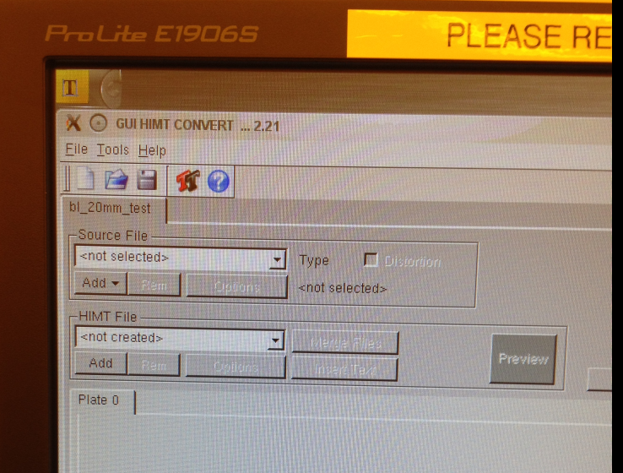
    - Insert a source file into the drop down list of source files by pressing the Add button of the Source File frame. Select GDSII from the pull down menu. Select your file in the pop up widow. Confirm by clicking on Open. The new file is now inserted in the source file list, and the Design Options window opens.
    - Select the needed GDSii structure name using the pull down box (referred to as “Cell” in Layout Editor software).

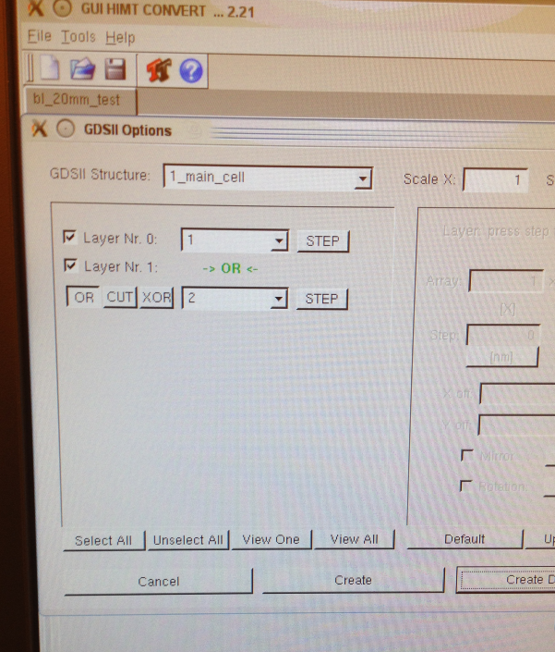

    - Select the appropriate layer. Layers may be added together, subtracted or XOR.
    - Click “Create Default”. This will create a file with the same name as the source file.
    - For each design format, options for design adaptation (e.g., magnification, layer selection, merging, stepping, rotation, mirroring) are available. See the “Conversion Job Manual” located on the desktop of the Linux conversion computer for more info. The most common basic options used will be covered here.
    - Write Lens: – select the write lens (mode) you will be using.
    - Borders and positioning on the plate are automatically taken from the design. Several additional options can be activated by selecting the corresponding checkboxes.
    - Automatic Centering: For most users, ON should be checked. This is especially true for masks. This will place stage coordinate 0,0 at the center of your design. The sample will normally also be aligned with 0,0 being the center of the sample for most users when this SOP is followed. In the screen shown below, the GSDII file pattern is not centered. Clicking “Automatic Centering” will offset the pattern by populating the “X off” and “Y off” fields. WARNING- if you press the auto center option and then change your mind, you must press the “reset” button inside the exposure window to remove the offset made by the software!
    - If you plan on printing your design more than one time on your sample, write down the “Expose Window” values. You will need these to step and repeat the pattern later.
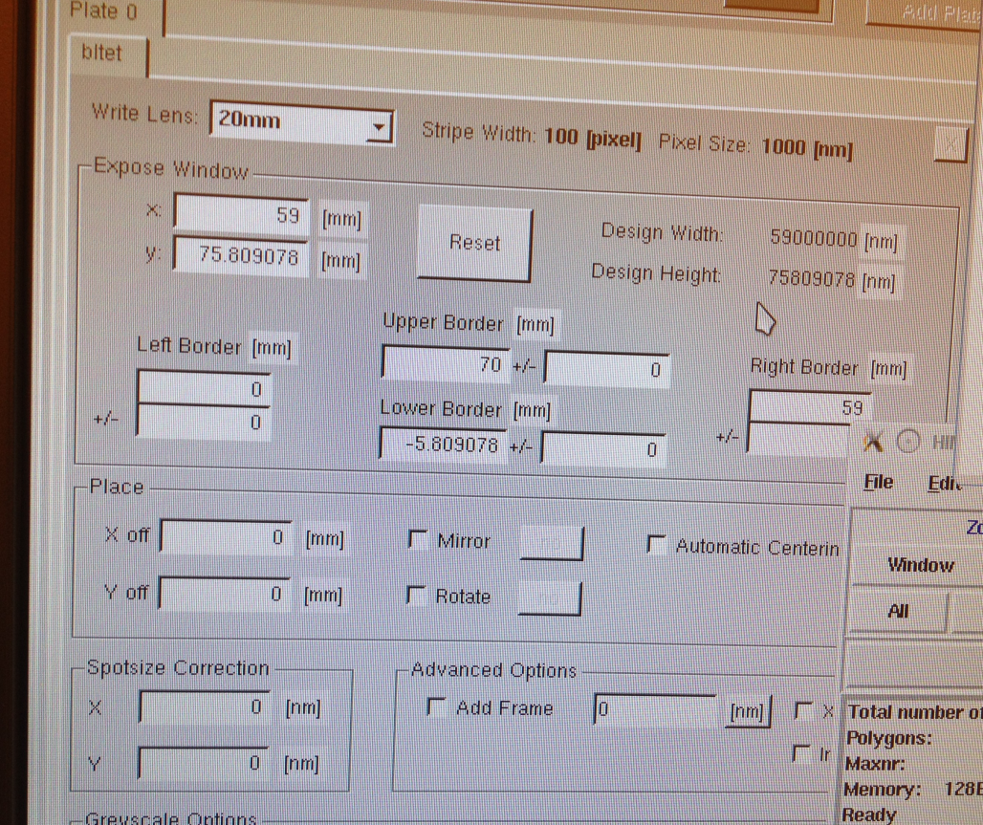

    - Mirror Option for MASKS: If you want the pattern orientation to appear the same on your samples as the GDSII design, you must “Mirror” the pattern in the “X” axis. This is because the mask will be flipped over in the X axis when loaded into the mask aligner tool. To do this, click the “Mirror” box one time. The screen will then display “at Y” next to the Mirror box, which is correct for mirroring at X. Yes, I know, a little confusing.
    - Pattern Inversion: To invert your pattern, check the “Inverted” box. You normally must also check the “Add Frame” box and input frame size. If unsure, just enter 1000um. This is needed so the software knows how far out to draw the frame i.e. you have to tell it where to stop.
    - Spotsize Correction: Open the “Exposure Conditions” spreadsheet located on the Conversion computer desktop. The “green” highlighted cells are the recommended settings. This setting may be used to improve the sizing accuracy of your pattern. It’s best to use SSC if recommended in the spreadsheet. There may be a different setting for X and Y axis, see spreadsheet. Recommended setting are highlighted green in the sheet. If the standard (non spot size corrected) conditions are highlighted green, do not use SSC. Normally, SSC is not needed for 4mmHQ mode but is recommended for all other modes. See the spreadsheet.
      - Spotsize Correction – User Determined: You can add bias to your design based on your process results. Consult with NRF Staff.
The pixel size dictates allowable spot size correction. Spot size corrections can be incrementally made as follows:
20mm head - increments of 500nm
4mm head - increments of 200nm
4mmHq - increments of 100nm

    - Once all your options are set up, click the “Preview” button to see how the design will appear. NOTE: The preview will not show the inverted image if you have selected this option, nor will it show the frame.
    - To examine the preview pattern, use the HIMT Viewer navigation window. Left click on “mouse” to enable zoom, then left and right mouse click to zoom in/out with the cursor in the pattern area. To release zoom mode click the center button (scroll wheel). Enable “Fill” mode (left mouse click) to see which parts of the design will be exposed with the laser i.e. resist removed for positive photoresists.
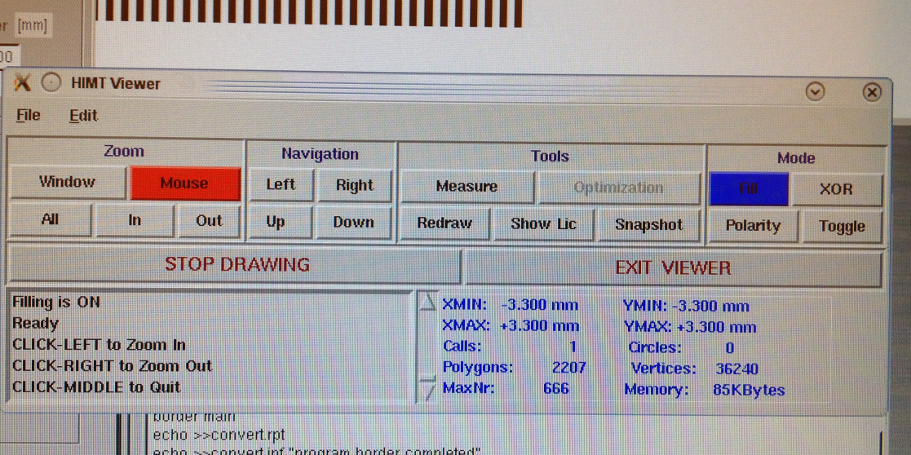
    - If your pattern does not appear to be correct or just does not appear at all, do not convert the file since it will not print correctly. This happens when rules listed in the “Conversion Manual” are not followed. Problems like unclosed polygons (i.e. lines were used in autocad) are common. Review your design files for problems and try again.
    - If everything looks correct, press the Complete Tasks button at the bottom to save the conversion job settings and proceed to the expose job setup.
    - In the Prepare Exposure window that opens after saving, click on OK to proceed to data conversion.
    - After conversion, transfer the LIC file to the DWL by pressing the “Transfer” button. Don’t click on anything while the conversion is taking place. Wait until the “Transfer” button shown below indicates it is done. The icon becomes “unraised”.

Mask Exposure Procedure

  - Verify the write head you need is physically loaded into the machine before logging into the Tumi. USERS ARE NOT ALLOWED TO CHANGE THE ACTUAL WRITE HEAD!!! . If the head needs to be changed, contact NRF Staff.
  - Logon to the Tumi.
  - The software needs to in the correct mode for the write head that is loaded. See the upper right corner of the DWL software toolbar for the current configuration. Staff normally sets the mode when the write head is changed but if you need 4mm HQ mode you will most likely need to change it. The mode can be changed by double clicking on the “WriteHead” box in the upper right corner and selecting the correct mode. Highlight the mode and click “load it”. The system software will close. Re-open the software using star icon on the desktop and click Ok when the white text box prompts.
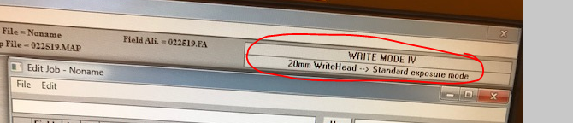
  - Turn the laser on by clicking the “laser on” button. Verify the focus mode. If the 4mm head is loaded, focus should be in “pnuematic” mode. If it is not, click the icon and change it. The system will default to pneumatic focus for the 20mm head since optical is not an option, or needed. If your sample is transparent, you must use “pneumatic” focus mode since there will be limited reflection of the autofocus laser.
  - Click “Setup” on the main task bar and then “New”.

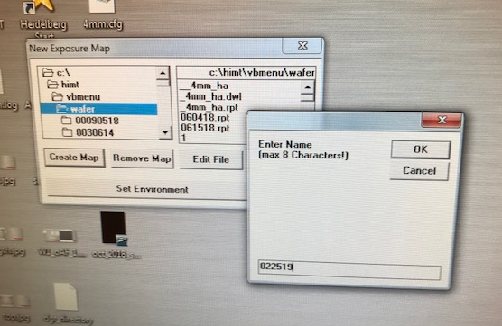
  - Click “Create Map” and enter todays date using 6 digit format and click OK. Enter “yes” to “do you want to create environment”.
  - Highlight Make Job located under Job in the Main Menu. The Edit Job spreadsheet will appear:
  - Enter “-1” under the “do” column to turn the exposure ON.
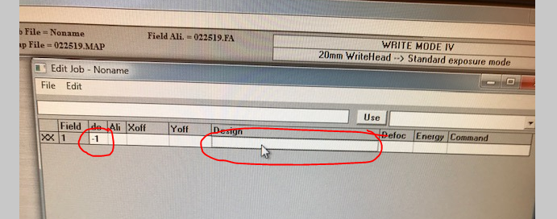
  - Click inside in the “Design” cell of the spreadsheet. To select your pattern file for exposure,
  - Click “File” (on the main task bar shown below, not in the spreadsheet above) and then “Design”. A box will pop up with a list of available LIC patterns. Click the “Refresh” button. Highlight your pattern file and press “To Job”. This will populate the “design” column of the spreadsheet with your file.
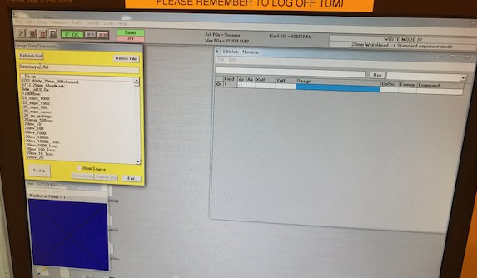
  - On the left Linux conversion computer. Open the “Exposure_Conditions” file located on the conversion computer desktop.
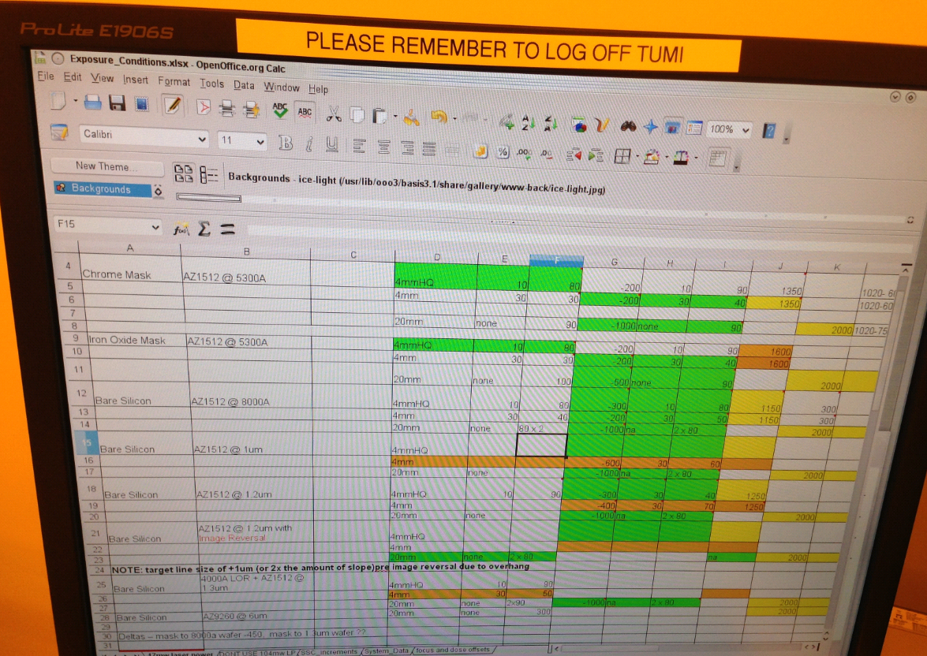
  - Find your mask type in column A of the worksheet. Find the correct write head in D column. Enter the correct defoc and energy for your sample from the spreadsheet into the “Edit Job” window on the Heidelberg computer. The following fields should be populated.
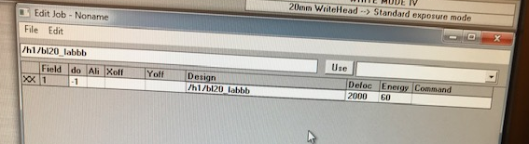
  - The “Exposure_Conditions” spreadsheet also lists the correct filter for the substrate to be exposed. Available ND filters are, 1%, 10%, 31% and 50% passing at 405nm.
  - Open the main system door, BLACK toggle switch on the right side of the front of the machine. DO NOT PRESS THE BIG RED BUTTON ABOVE THE DOOR TOGGLE SWITH. THAT IS THE EMO BUTTON.
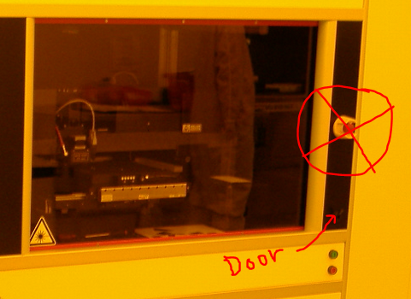
  - Verify the correct filter(s) are installed. To exchange or add filters, loosen the 2.5mm locking hex nut 3 full turns and remove from the mounting rail. Install the correct filters with the hex nut just tight enough to hold it in place, see pic below. Close the door.
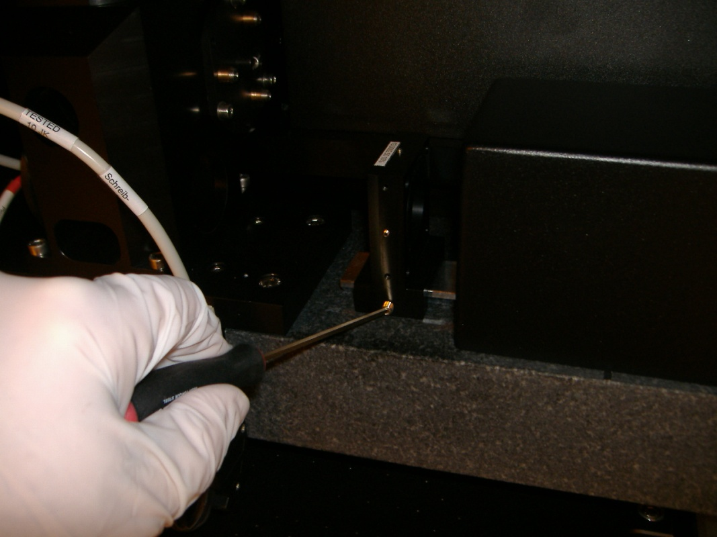

  - Open the Expose window by highlighting Run Job under Job in the Main Menu. Press “Load” and the stage will move to the load position. NOTE: the system door must be closed for the stage to move.
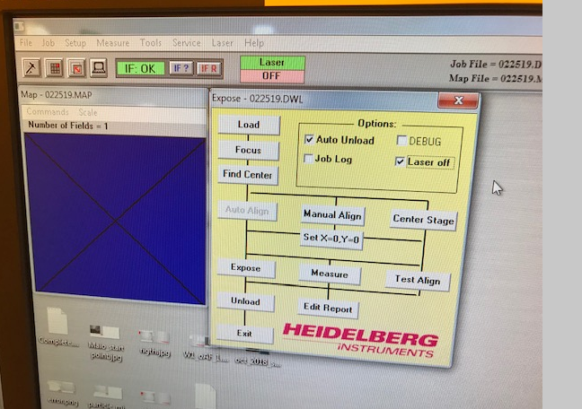

  - WARNING – DO NOT TOUCH THE RIGHT SIDE OF THE STAGE NEAR THE INTERFEROMETER MIRRORS OR HOLD ON TO THE RIGHT SIDE OF THE STAGE. SEE BELOW
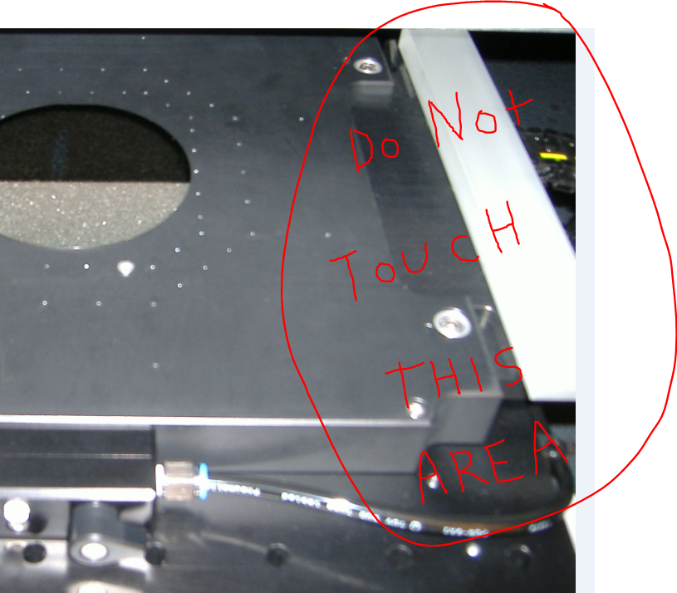
  - Verify 2 stage alignment pins are installed as shown below.
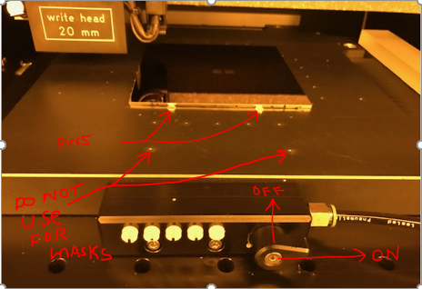
  - Load the plate as shown above with the photoresist up. The left side of the stage (standing in front) is the bottom to the sample.
  - Turn on the manual vacuum valve, it’s the teardrop shaped black knob. Pointing up is OFF, point right is ON (see below).

  - The five white vacuum port screws at the front of the chuck are used to adjust the size of the stage vacuum area to the plate size. When the slit is Horizontal, it’s ON, Vertical is OFF. NOTE: With only the only the main teardrop handle valve ON there is only vacuum to the 4 small holes in the center of the stage.
  - Turn on vacuum ports starting from the right most white screw until you hear vacuum leaking and then close the leaking screw.
  - Close the chamber door.
  - Click the “OK” button and the stage will move to the center of the stage.
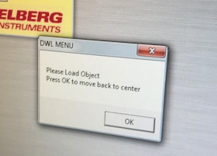

WARNING-------THE WRITE HEAD CAN ONLY FOCUS IF THE CENTER OF THE WRITE HEAD IS 5MM INSIDE THE OUTSIDE EDGE OF YOUR SAMPLE. !!!
  - Click “Focus” in the Expose window and wait for the write head to focus on the sample.
  - Click “Find Center” and “start”. The stage will automatically find the center of your sample. It will take 3-4 minutes. Answer “Yes” when prompted to change stage center.
  - Check the “Laser Off” and “Auto Unload” switches in the “Run Job” control window so that the laser will turn off when the exposure is done.
  - Click “Expose” button in the Expose sequence window to start exposure. The stage will move to the unload position when done.
  - When done exposing, open the door, turn off the stage mask vacuum and remove your sample. Shut the door.
  - Verify the LASER is OFF WHEN YOU ARE DONE.

Mask Post Exposure Processing

  - Develop
    - NOTE: Do not use clean room wipes at all while processing masks. The typed stocked in the cleanroom are not clean enough for processing masks or samples. The following procedure applies to soda lime and quartz masks purchased from Nano-film Technology. Masks may be obtained from NRF Staff.
    - Use the square glass dish located in the litho develop island drawer. Dispense just enough 300MIF developer to cover the top of the photomask, approximately 4mm deep. Develop for 1 minute total. It’s best to slowly slosh the liquid for 5-10 second in the middle of that 1 minute of develop time. Lift one side of the mask using tweezers and grasp the mask by the outer edges. Rinse the mask for 30 seconds, both sides, under flowing water from the develop island DI water gooseneck. Dry the mask completely using the N2 gun while holding with your hand. Dry from the inside out, with air blowing toward the edge of the mask.
    - Verify the pattern is developed completely using the microscope in the Litho bay. Don’t use a white light microscope. If it appears underdeveloped, you may try developing for another 20-30 seconds.

  - Mask Etch
    - In the Wet Processing Bay Log into the JST Wet Bench. Put on acid Personal Protective Gear. Rinse out the 9”x9” square glass dish. Place a 9”x9” square glass dish inside JST bench.
    - Place the mask with the resist/iron oxide (i.e. pattern side) up in the Nalgene basket provided. See below.
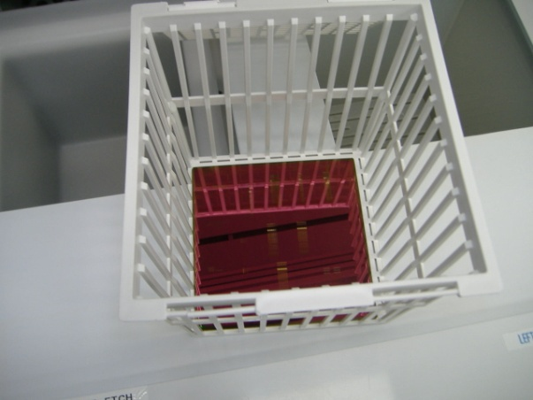
    - Place the Nalgene basket inside the the 9”x9” square glass dish.
    - Press the stop/reset button on the left cascade bath controller and press “start”. The “run” light should come on.
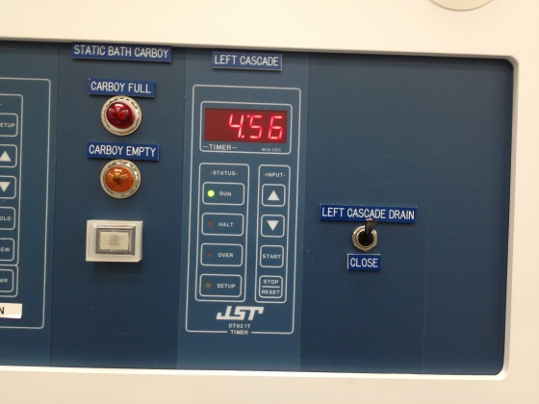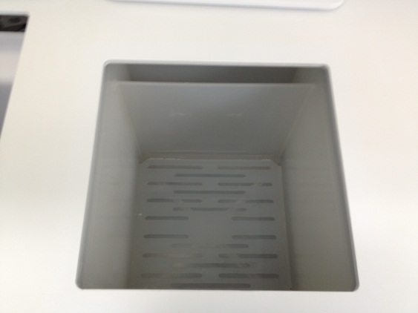

    - Obtain the proper etch supply bottle from the white chem cabinet. Trancene “Chrome Etch 1020” or Trancene “Iron Oxide Etch”.
    - The Etch time is 1:45 for Chrome and 3:00 for Iron Oxide. Note: iron oxide etchant etch rate will slow down over time as the bottle ages. If the bottle is less than ¼ full, take great care to make sure the mask is etched properly. See “Optional Inspection” procedure below.
    - Re-start the cascade rinser timer and pour in just enough acid to cover the mask.
    - At the end of the etch time, lift the basket from solution and allow the basket to drip for 2-4 seconds and immediately move the basket to the cascade rinse tank. Allow to rinse for at least 30 seconds. Slowly moving the basket up and down occasionally to promote rinsing.
    - Remove the basket and place the basket on the mask lift pin located behind the tank so that you can easily grasp the mask by the edges with your hand for removal.
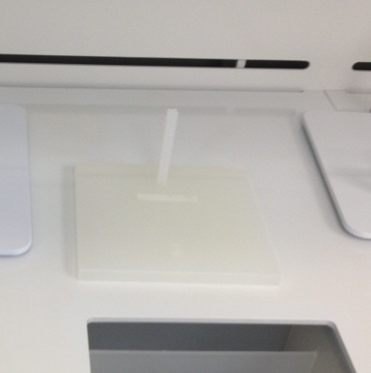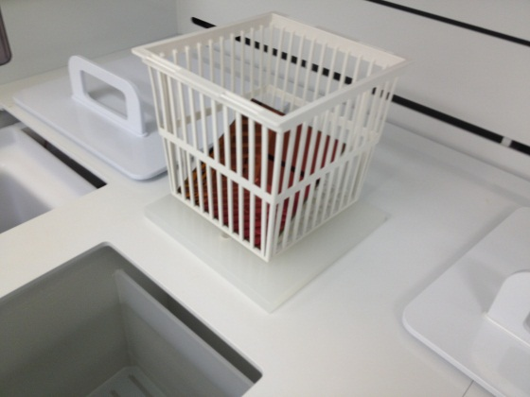

    - Completely dry the mask using the N2 gun. Make sure it is completely dry before proceeding. The water will tend to adhere to the edges of the mask.
    - Optional Inspection: Verify that the chrome or oxide has completely etched. Remove your acid protection gear and take the mask to the Bio bay for inspection. Using the Nikon Microscope in the Bio Bay to verify it has completely cleared in the etched areas. Use the bottom side illumination to look through the mask. Note: you may need to remove the clipped on wafer holder from the top of the microscope inspection platform. Set the bottom side illuminator power at 10 o-clock position. Light through the etched areas should be very bright. Using 50-100X objective focus on the unetched chrome or iron oxide and look for any fuzziness on the cleared glass. The fuzz will be gray for chrome masks and orange for IO masks. If more etch is required, etch the mask for 15 more seconds for chrome or 30 seconds for iron oxide.
    - Place the properly labeled etch waste container down inside dump rinse tank #2 (right side). Insert the funnel into the bottle. Hold the square glass beaker over the funnel and carefully pour the acid through the funnel into the waste bottle. Use the funnel and pour acid waste into the waste container. Lay the funnel inside the glass container and replace the waste bottle lid. Put the waste bottle away but only if not contaminated. Clean the waste bottle with rinse water and dry it if it becomes contaminated.
    - Hold the square glass container over the dump rinse bath. Rinse the top and bottom 3 times.
    - Using the DI water spray gun, rinse the ENTIRE top of the JST wet bench deck with DI water. The water will flow toward the back of the bench and into the plenum.
    - Rinse your hands in the glove wash station and take off the acid PPE.
    - Log off the JST Bench.
    - Log into the “PR Strip Bench” on the Tumi. There is no charge for this tool. Turn on the timer know for the PR Strip right side of the bench. Turn on the heater controller (see below) for the photoresist strip bath (Tank #2) so it heats up while you etch the mask. Press “PWR On/Off” to turn on the controller and “Heat On/Off” button to enable heating. The strip bath set point is 70 deg C.
    - Take the mask over to Solvent Bench #1 (Class One Equipment) located at the end of the bay. Place the mask in the solvent tank mask basket store inside the solvent bench. Continue when the temperature of tank 2 has reached the set point of 70 deg C.
    - Fill the rinse tank (see pics below) with water by pressing “start” on the “Dump Rinse” controller.
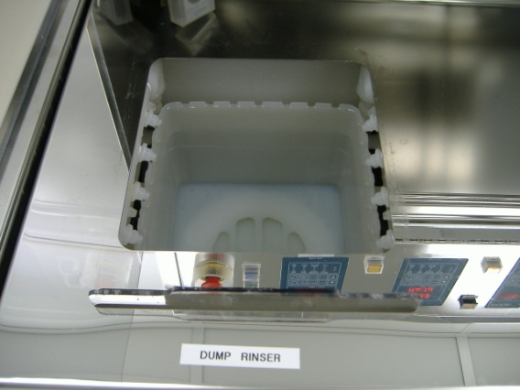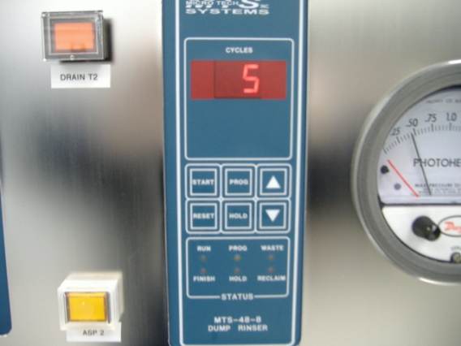

    - Remove the stainless lid from tank 2 (see below) and place basket in the solvent strip bath for 2 minutes.
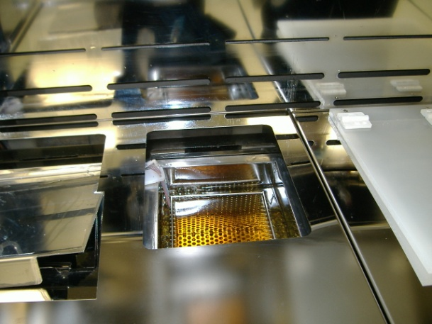
    - Remove and place the basket in the DI water rinse bath. Let the rinser complete 3 full rinse cycles.
    - Remove the basket and place the basket on the mask lift pin located in the JST wet bench for easy removal by hand. Hold the mask at the edges and completely dry the mask using the N2 gun. Make sure it is completely dry before proceeding. Water will tend to adhere to the mask edges. NOTE: Do not use clean room wipes at all while processing masks. The typed stocked in the cleanroom are not clean enough for processing masks or samples.
    - Turn the resist strip bath heater OFF.
    - Clean top of the solvent bench using a clean wipe.
    - Take the mask over to Solvent Bench #1 (Class One Equipment) located at the end of the bay. Place the mask in the solvent tank mask basket store inside the solvent bench. Continue when the temperature of tank 2 has reached the set point of 70 deg C.
    - Fill the rinse tank (see pics below) with water by pressing “start” on the “Dump Rinse” controller.

    - Remove the stainless lid from tank 2 (see below) and place basket in the solvent strip bath for 2 minutes.
    - Remove and place the basket in the DI water rinse bath. Let the rinser complete 3 full rinse cycles.
    - Remove the basket and place the basket on the mask lift pin located in the JST wet bench for easy removal by hand. Hold the mask at the edges and completely dry the mask using the N2 gun. Make sure it is completely dry before proceeding. Water will tend to adhere to the mask edges. NOTE: Do not use clean room wipes at all while processing masks. The typed stocked in the cleanroom are not clean enough for processing masks or samples.
    - Turn the resist strip bath heater OFF.
    - Clean top of the solvent bench using a clean wipe.
    - Log off the PR Strip tool.

Pattern File Creation

  - Documents to help with mask creation

    - Click on the “Docs” button on the Heidelberg tool NRF web page to see the following a list of downloadable documents.

    - Heidelberg 20mm Exposure Characteristics
    - Heidelberg Conversion Manual
    - Instructions for photomask CAD file submittal
    - Introduction to Layout Editor
    - Liftoff - S1813 Image Reversal
    - Mask Cost Estimator
    - Mask Making Presentation
    - NRF Lithography Processes SOP
    - Staff Processed Photomask Request

General Design Rules

    - All CAD designs must fulfill certain rules.
    - If using Autocad or Fusion ----To close line segments in AutoCAD and create a polygon, while drawing a polyline, simply press the "C" key on your keyboard at the final point to activate the "Close" option, which automatically connects the last point to the starting point, forming a closed polygon.
    - GENERAL Naming - Do not use 'main' as name for a layer, cell or any structure.
    - Do not use special characters such as (.>-=?<}[ or spaces in file names, cell names, structure names etc.. Use numbers, letters. UndeNRFores are OK also.
    - Line Segments – line segments are not allowed. Line segments grouped together on the screen to look like a box does not mean it’s a box that the machine can use. Autocad by default does not close polygons. Set the polyline to “closed” as shown below. You may also press the letter “c” when placing the last point in a polyline to close the polygon. 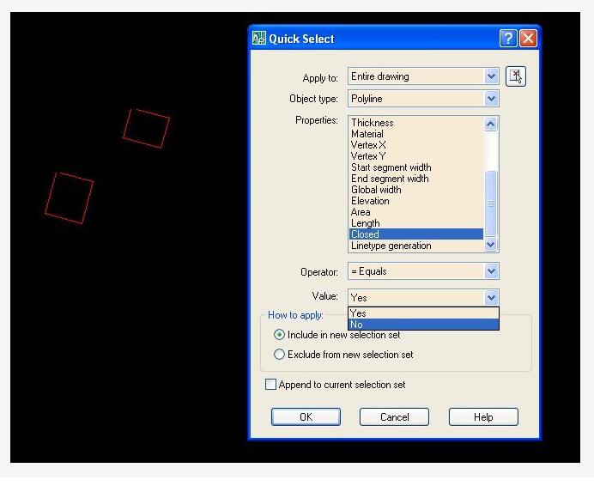The Laser Writer must know that the pixels within the box are to filled in. In the example below we have properly closed polygon box. The starting and ending coordinate are the same meaning it’s closed.
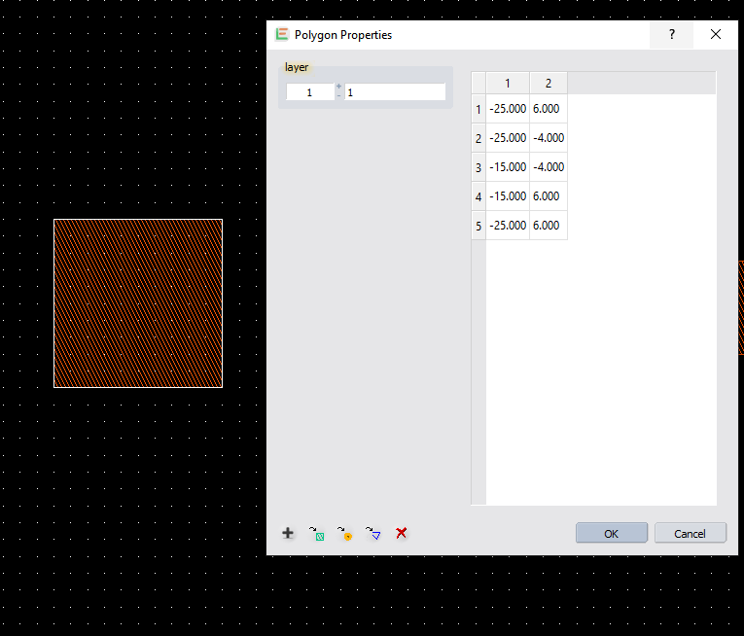

    - Nested features---- Shown below are 2 circles inside a square which means only the square exist since they are in the same mask layer. The circles are nested inside the square. When the box is written by the machine, the circles are ignored.
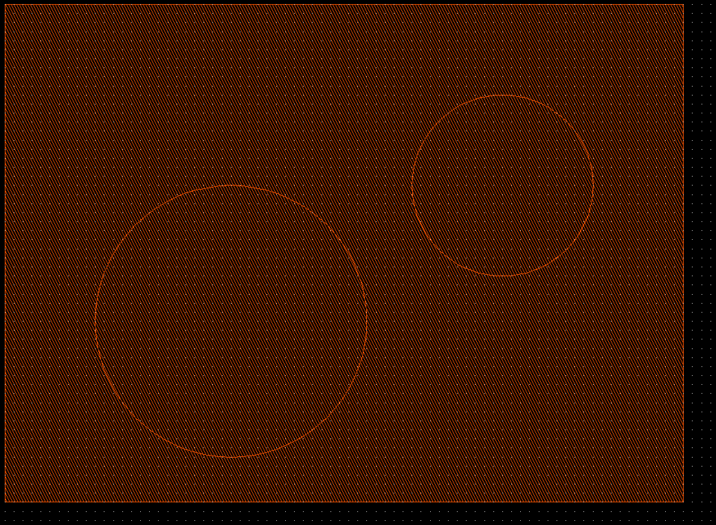

    - Most data formats allow automatic closing of polylines. It’s best to figure out how to do this automatically with the software you use. GDSii software closes polygons by default.
    - Do not cross polylines. Crossed polylines create ambiguities that can lead to data errors. Do not create double vertices. Double vertices are successive points with identical coordinates. These lead to data errors. The polygon below must be drawn as 2 triangles, not using the path shown.
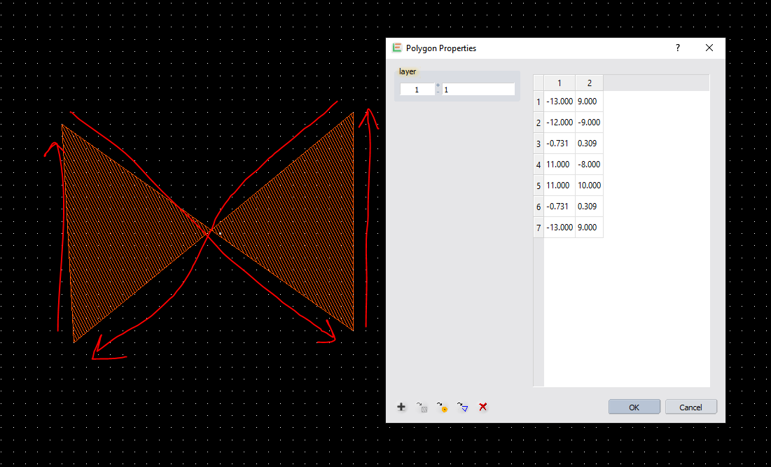

    - Designs may consist of no more than 1,000,000 vertices total.
    - The number of definitions or references can be at maximum 100,000.
    - Text must be converted to polygons if you want it to be printed in your design.
    - Designs must not exceed the limits 115mm in width and height for 5” masks or 90mm for 4” masks.

Rules for Autocad

    - If using Autocad or Fusion ----To close line segments in AutoCAD and create a polygon, while drawing a polyline, simply press the "C" key on your keyboard at the final point to activate the "Close" option, which automatically connects the last point to the starting point, forming a closed polygon.
    - Save all files as “AutoCAD R12/LT2 DXF format. The conversion software may not support newer file versions. Note: .dwg files are NOT supported. Save the file as .dxf.
    - Do not open and edit a .dxf file in a GDSII software such as “Layout Editor”, Ledit or Klayout. You may convert the file directly from Autocad (.dxf) using the Heidelberg Conversion software. Not advisable but works if these rules are followed.
    - Always turn on “Snap to Grid” i.e. Grid Snapping in Autocad. The grid size should be set to 1.0 or 0.5 micron.
    - Turn on “units” and set to microns.
    - No self-intersecting polygons.
    - Always join polylines. The closing polygon point should have the same exact coordinate. Be especially cautious when using arcs within a polyline.
    - Only one font is provided with the dxf conversion package. The dxf standard font will replace any font selected in the DXF-design.
    - Only the following attributes assigned to a text are supported: ROTATION, MIRRORING, SCALING
    - Avoid placing structures in layer 0.
    - Do not use special characters in the layer names.
    - Try to design by means of the metric system.
    - Use microns or mm as the standard unit. Do not use inches.
    - Polylines with widths must not have a change in its widths (tapered lines).
    - Various scaling in x and y when inserting a block is not supported.
    - External blocks are not supported.
    - Try to use only the following entities: CIRCLE, POLYLINE / LWPOLYLINE (with or without width), and TEXT.
    - Use a “grid snap” or “snap to grid” system when you design in Autocad. A minimum grid scale of 0.25um can be used but for most 1um is best.
    - Do not use “hatch” fill in Autocad. Which is different from closing polygons.
    - When done, email your file to walewis@ufl.edu for verification that it will work. We will convert the file to GDSii using “Linkcad 7” and send back to you if everything is OK.

