
JST Acids Bench

Standard Operating Procedure
Rev. 2026-01

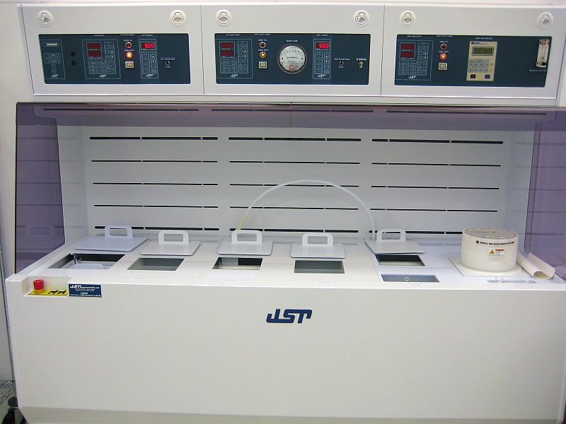

Contents
1
1
Description 2
Restrictions 2
Safety 2
Wet Bench Facts 3
Personal Protection Equipment (PPE) 3
NRF Approved Materials and User Material 3
Safe Operation Rules 4
Operation using beaker stands 5
Working safely with hydrogen peroxide mixtures 7
Piranha 7
Waste handling of piranha and solutions with hydrogen peroxide 8

Description

Acid bench consisting of 2 heated quartz baths, 1 heated teflon bath for BOE, 2 quick dumps, a glove rinse, and a spinner used for drying. The quartz baths are filled with water and heated to provide a safe means of heating various etchants/cleans in beakers.

Restrictions

No solvents at this bench. Only chemicals listed in Table 1 are allowed in this bench.
Table 1.0
ACIDS
HF – hydrofluoric acid
BOE – buffered oxide etch
H2SO4 - sulfuric Acid
HNO3 - nitric Acid
H3PO4 - phosphoric Acid
CH3COOH - acetic Acid
HCl – hydrochloric acid
Transene® Etchants (Aluminum A and D, Gold TFA, Nickel TFB, Chrome).
BASES
NH4OH - Ammonium hydroxide
OXIDIZERS
H2O2 – hydrogen peroxide

Safety

- The intent of this SOP is to provide specific information about this bench.
- All UF EH&S Safety practices and procedures must be followed. All wet bench procedures demonstrated during “NRF Safety Training” must also be followed.

Wet Bench Facts

Wet Benches are designed to protect you by providing an enclosed work area that has an air barrier between you and the hazardous materials you work with in the bench.

Personal Protection Equipment (PPE)

The following is a list of personal protection equipment required for use of any wet bench when working with acids or bases.
- Full length blue vinyl apron with sleeves. Use the orange belt to secure the apron around your waist. Tie or button the string to secure around your neck
- Long orange chemical resistant gloves
- Full face shield
Wearing the above PPE in areas outside the NRF Wet Processing Bay is not allowed so make sure you have everything you need before donning (putting on) your PPE.

Lack of PPE use is very dangerous and will result in suspension of access to the NRF.

NRF Approved Materials and User Material

    - You may not bring chemicals or substances of any type into the clean room without approval of NRF Staff. All NRF Approved materials will have a MSDS posted at http://nrf.aux.eng.ufl.edu/safety/msds.asp . If the MSDS for the material you would like to use is not listed you may submit a “New material Request Form” found at http://nrf.aux.eng.ufl.edu/safety/default.asp. Click and download the “MS Word” file “New Material Request Form”. Fill out the form and follow instructions on the form.
    - If you need to bring a container of your approved material into the clean room, fill out the Chemical log in/out sheet located in the NRF Gowning Room. NO USER CHEMICALS MAY BE STORED INSIDE YOUR GROUP BASKET.
    - Personal use chemicals/substances that have been approved by NRF Staff may be stored only in the appropriate chemical storage location. NRF Staff will show you where.

Safe Operation Rules

    - Before starting any chemical work, be sure to have the following in place:
- If you need to leave your sample in process inside the bench and leave the wet bay, you must fill out a pink laminated form and place it next to your breaker of solution. Write user contact information, date and chemicals. If your sample will need to stay in solution >1 hour, you may place the sample to the rear of the wet bench deck with proper pink form filled out and log out of the wet bench.
- Verify the correct waste bottle is placed inside the wet bench before you start.
- The waste bottle must have enough empty space to contain your waste liquid
- your samples
- sample containers
- proper forceps for sample handling
- wipes

    - Retrieving items during the processing can create accidents and spread contamination.

    - Do not use computers or telephones while wearing PPE to prevent contamination to other users.

    - The safety shower is located at the end of the bay, know the location of the water ON actuator just in case you need it in a hurry.

    - Chemicals should be placed no closer than 6 inches from the front opening of the wet bench. Placing them closer to the front opening interferes with the airflow and reduces the level of contaminant protection for individuals working at the wet bench.

    - Always keep your chemical beakers inside the double containment area within the wet bench.

    - Place equipment so that it does not block airflow to slots or vents in the baffle plate at the back of the wet bench. When possible, elevate bulky equipment to allow air to flow under the equipment, as well as around and over it.

    - Minimize the quantities of materials that might be involved in a fire or explosion by limiting the amount of chemicals used in the wet bench.

    - Do not lean into the wet bench to work with hazardous chemicals. This negates the protection the wet bench provides against inhalation of hazardous vapors.

    - Do not use the wet bench to evaporate hazardous wastes. This practice is illegal. It violates the Clean Air Act and is punishable by large fines.

    - Do not store chemicals inside a wet bench.

Operation using beaker stands

    - Place beaker stand in quartz bath.
    - Fill bath with DI water over the top of the red marks inside the tank.
    - Prepare your chemicals in either a 250mL or 500mL beaker and place in the stand. Use the small ring insert for a 250mL beaker.
Note: Always prepare the chemical solution before placing on the stand. Never pour chemicals into the beaker while in the quartz bath.
    - Continue filling the bath with DI water to just above the liquid level in the beaker for maximum heat transfer.
    - Press the “PWR” button for the quartz bath you want to use. It will come on in “Hold” status.
    - Press “Setup” button to enter setup mode. Pressing the button again will cycle through the available options.
    - Set the clock setpoint (if you don’t want to use your own stopwatch) and process temperature setpoint
Code | Description | Setting
CS | Clock setpoint | 0:00 to 99.59 Min:Sec
PA | Pre alarm | Do not adjust
PS | Process setpoint | 0 to 90 Degrees C
HI | High alarm setpoint | Do not adjust
LO | Low alarm setpoint | Do not adjust
DR | Drian setpoint | Do not adjust
DP | Drain period | Do not adjust
AC | Access code | Do not adjust
CR | Cycle rate | Do not adjust
Pb | Proportional band | Do not adjust
rE | Reset | Do not adjust
rA | Rate | Do not adjust
CA | Calibration | Do not adjust
CD | Clock direction | Do not adjust

    - Press the “Hold” button to start the bath heating
    - Wait for the solution in the beaker to reach the desired temperature, then place your sample in the beaker.
    - Press the “Start” button to start the timer (if needed).
    - When the process is complete, rinse your sample in the cascade bath.
    - Close the drain switch
    - Press “Start” on the controller. You should probably start this well before you need to rinse since it takes about 1 minute to fill.
    - When done rinsing, press the “Stop” button twice and open the drain switch.
    - Remove the beaker and allow it to cool before disposing in the proper waste bottle. Never pour hot chemicals into a waste container.
    - Press the “PWR” button to turn off the bath.
    - Remove the water from the quartz bath by turning on the aspirator and placing the wand into the tank. Be sure to remove as much liquid as possible.



Working safely with hydrogen peroxide mixtures

Piranha

Traditional piranha clean is a 3:1 mixture of sulfuric acid : hydrogen peroxide and is used to remove organics from substrates. Piranha solutions are extremely energetic and may result in injury from chemical or thermal burns if not handled with extreme caution. Please follow the safe handling and disposal procedures below.

• Slowly add the hydrogen peroxide to the sulfuric acid and not the other way around.
• Never add more than 50% (volume) of hydrogen peroxide as it may become explosive.
• Always use glass beakers because the solution attacks many plastics.
• Temperatures can exceed 100°C so never pick up the glass beaker once it is mixed, or your hands can be burned.
• Adding any acids or bases to piranha or spraying it with water will accelerate the reaction. This also includes photoresist, which is a strong base.

Waste handling of piranha and solutions with hydrogen peroxide

• Never add ANY hot solution to a waste bottle. The solution MUST be allowed to cool below 40°C which may take an hour or more depending on the volume used.
• Place a thermometer in the beaker and move it to the cooling area. Properly label with the date, time, chemical names, and your name.
• You may log off the TUMI, but continue to monitor the solution temperature.
• When the temperature is less than 40°C, log back into the bench and pour the solution into the appropriate waste bottle.
• The piranha waste bottle MUST be glass, MUST have a secondary containment jacket (which is also labeled), and MUST have a vented cap. The vented caps are on the waste rack, 3rd shelf from the bottom and have NRF written on them.

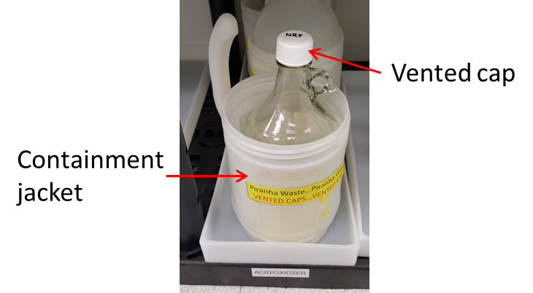
• There will be two other standard waste bottles for oxidizer solutions and these may be stored in poly bottles but also require containment jackets and vented caps;
- SC1 (mix of ammonium hydroxide and hydrogen peroxide)
- SC2 (mix of hydrochloric acid and hydrogen peroxide)
• Disposal of pure hydrogen peroxide, that has been used to etch certain materials, may be disposed of in the SC1 waste.
• If you generate your own mixture that contains hydrogen peroxide, you must contact staff to create a waste bottle for you.
• Do not fill any of these waste bottles past the “Full” mark(see image below). Contact staff when one is full and we will replace. Do not create your own waste bottle for these solutions.

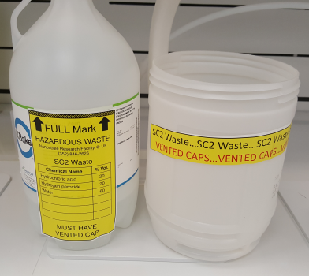
To rinse containers, tweezers, etc., place them inside the rinse bath.

